 CHEMICAL ENGINEERING TRANSACTIONS  VOL. , 2025 | A publication of  
The Italian Association
of Chemical Engineering
Online at www.cetjournal.it

Guest Editors:
Copyright © 2025, AIDIC Servizi S.r.l.
ISBN 979-12-81206-XX-X; ISSN 2283-9216

Physically Based Modelling of Particle Size Evolution
for Knife-milled Beech Chips
Michal Vtipil*, Lukas Kratky
Czech Technical University in Prague, Faculty of Mechanical Engineering, Department of Process Engineering, Technická 4 Prague 6, Dejvice 160 00, Czech Republic
Michal.Vtipil@fs.cvut.cz
Efficient milling of lignocellulosic waste biomass is critical for its valorisation in Waste-to-X processes. Mathematical modelling of particle size is important for optimising the milling process to produce particles of suitable size for subsequent processing. Currently, empirical models with a narrow range of validity are used mainly. General physically based models could solve this problem thanks to their wide range of validity. This work aimed to create a physically-based model of particle evolution in a knife mill and to validate it for knife-milled beech chips. The particle evolution model evinces an exponential dependence on screen sieve size, rotor rotational speed, mass flow rate, and the initial particle size of the biomass. The predictive model for output particle size D₅₀ was validated by experimental data on screen sieve size under constant rotor rotational speed and mass flow rate. The experimental validation was performed on a Retsch SM 300 laboratory knife mill using a linear rotor blade at different peripheral speeds, mass flow rates, and mesh sizes. The peripheral speed range was 13.6 and 20.4 m s⁻¹, the mesh size range was from 0.75 to 6 mm, and the mass flow range was 10 and 15 kg h⁻¹. The accuracy of created model was confirmed by R² values of 0.87-0.97 and RMSE values of 0.056-0.119. The proposed model provides a core basis for process optimisation and scale-up in biomass milling applications.

  - Introduction
Mechanical size reduction is the crucial technological step for efficient biomass conversion and valorisation in biorefineries. It is known that particle size distribution (PSD) strongly influences downstream biochemical and thermochemical processes. By milling to fine particles, the heat and mass transfer is significantly improved during the processes, significantly increasing the conversion of raw material to the final product and speeding up the whole process. In its natural state, lignocellulosic biomass occurs in sizes ranging from centimetres to meters. For efficient processing in the production of bioethanol, biogas, and pyrolysis, the optimal size is in the range of tenths to units of millimetres (Li et al., 2024). Mathematical modelling is of great importance for milling optimization in order to predict the comminution energy and the particle size distribution depending on the mill and biomass parameters. There are 3 main modelling approaches in out particle prediction of milled biomass.
Empirical models were applied to predict particle size for ball milled coffee waste (Fernández-Ferreras et al., 2023), knife milled wheat straw (Bitra et al., 2011), knife milled corn stover (Bitra et al., 2009b) and hammer milled switchgrass (Bitra et al., 2009a). Artificial neural networks were applied to predict particle size for hammer milled poplar chips and corn stover (Gil and Arauzo, 2014), for rod milled metallurgical coal (Otsuki and Jang, 2022) and for knife milled corn stover (Lu et al., 2024). Population balance models were applied to predict particle size for knife milled corn stover (Lu et al., 2024), for ball milled marble (Petrakis et al., 2023) and for hammer milled poplar chips and corn stover (Gil et al., 2015).
Empirical modelling approaches currently dominate, but their major disadvantage is their very narrow range of applicability. Physically based analytical complex models could have a very wide range of applicability, but so far they are very underdeveloped. The aim of this work is to create and validate a base physically based model that ensures the prediction of output particle size as a function of key process variables for knife-milled beech chips.
  - Materials and methods
All the experimental studies and modelling approaches were made applying such a methodology.
    - Raw material
The raw beech chips were used in this study. The chips of native moisture were firstly pre-milled using the knife mill SM 300 in configuration with a linear three-blade rotor with revolutions of 3000 rpm (peripheral speed 20.4 m/s) and the screen sieve with 10 mm square openings. Pre-milling is important to unify the particle size distribution of the raw material for experiments. The total solids were analysed by drying 6 samples in the dryer KBC-25W at 105 °C up to constant weight. The mass moisture content was 7.3 ± 0.3 wt %.
    - Experimental setup
First, the weight distribution of the particle size of the pre-milled input material was measured using sieve analysis. Screens of the following sizes in millimetres were used: 10, 7, 5, 3, 2.5, 1.2, 0.8, 0.71, 0.6, 0.45, 0.355, 0.2, 0.106. During milling, the wood chips were fed into the mill using a vibrating feeder to ensure a uniform mass flow. The mass flow was first regulated to 10 kg h⁻¹ and then to 15 kg h⁻¹ for the second set of measurements. A Retsch SM 300 knife mill with a linear rotor with 3 blades and a set of drop screens was used for milling. The screen sieves with 4 mm square openings and trapezoidal screen sieves with 1.5 and 0.75 mm openings were used. The rotor speeds used were 2000 rpm and 3000 rpm, which corresponds to 13.6 and 20.4 m s⁻¹, respectively. A cyclone-suction combination was used at the mill outlet to create negative pressure. Experimental setup was identical as used by (Krátký et al., 2023). The experiments themselves were carried out as follows. A 0.5 kg sample of pre-milled material was weighed, the vibrating feeder was set to regulate the mass flow to a given value, and the sample was then milled with a 4 mm screen. A sample was taken from the milled material for sieve analysis, and the rest was milled at the same parameters on a 1.5 mm sieve, and then the same was done for a 0.75 mm sieve. To verify the applicability of the mathematical model, the experiments were subsequently extended to include a configuration for milling a sample of the same pre-milled material using a sieve with square 6 mm openings, and then a configuration for milling a sample that had been pre-milled using a sieve with 2 mm square openings. The milling was performed using a screen with 1 mm trapezoidal openings. In this way, combinations of different mass flows and different speeds were measured.
    - Data evaluation and modelling
2.3.1 PSD analysis
Each biomass sample before and after milling was analysed in particle size using sieve analysis. Based on sieve analysis, cumulative distribution function values were calculated for individual sieves. The measured points were interpolated with the RRSB curve of the particle size distribution model, see Eq(1) and parameters D_{p}, n were identified.
$$F=1-e^{\left[-{\left(\frac{D_{F}}{D_{p}}\right)}^{n}\right]}$$ | (1)
In Eq(1) the symbol F (wt %) means a cumulative mass fraction lower than a given characteristic particle size D_{F} (mm), Rosin–Rammler size parameter D_{p} (mm) represents a characteristic particle size at the cumulative mass fraction 63.2 wt %, and Rosin–Rammler distribution parameter n (-) expresses an index of polydispersity.
The characteristic dimensions D₁₀, D₅₀ and D₉₀ for the RRSB model were calculated using Eq(2).
$$D_{F}={\left[-ln⁡(1-F)D_{p}^{n}\right]}^{\frac{1}{n}}$$ | (2)
2.3.2 Physically based model
The idea of physically based model is as follows. At the beginning there is one particle which is gradually being sheared and cut into smaller pieces between a pair of size reduction tools, i.e. between static and rotating pair of knives.
Each time it is cut between the stator and rotor blades, it splits into 2 smaller pieces. The number of particles N depending on the number of shear cycles n_{c} can be expressed by the Eq(3). Realistically the particles do not split exactly in half, a splitting factor b must be introduced to account for the number of times the particles split in one pass between the knives. The factor is defined by the splitting efficiency η.
$$N_{n}=N_{0}(1+{η)}^{n_{c}}=N_{0}{b_{s}}^{n_{c}}$$ | (3)

The model of particle size evolution over time is based on the law of mass conservation m during grinding and assumes that there is no change in the properties of the material, i.e. the density ρ is constant. The basic model is derived for spherical particles. The volume of a spherical particle is proportional to the cube of its diameter. Therefore, the product of the number of particles and the particle diameter to the third power must remain constant during milling, see Eq(4).
$$N_{0}d_{0}^{3}=N_{n}d_{n}^{3}$$ | (4)
Substituting Eq(3) into Eq(4) gives Eq(5).
$$d_{0}^{3}={b_{s}}^{n_{c}}d_{n}^{3}$$ | (5)
The relation for d_{n} is expressed by the Eq(6).
$$d_{n}={b_{s}}^{-\frac{n_{c}}{3}} d_{0}$$ | (6)
The particle size evolution in Eq(6) can be expressed using exponential functions by introducing a splitting coefficient 𝜆. Setting
$$e^{-λn_{c}}={b_{s}}^{-\frac{n_{c}}{3}}$$ | (7)
and taking natural logarithms gives
$$λn_{c}\ln{e}=\frac{n_{c}}{3}\ln{b_{s} →}λ=\frac{\ln{b_{s}}}{3}$$ | (8)
So that the particle diameter can be written as a simple exponential splitting:
$$d_{n}=d_{0}e^{-λn_{c}}$$ | (9)

It is assumed that the parameter 𝜆 depends on factors such as the peripheral speed of the knife mill rotor, the screen sieve size, the biomass moisture content, the mass flow rate and the ultimate shear strength of the biomass. This coefficient quantifies the intensity of particle fragmentation during milling. The biomass moisture content, and the ultimate shear strength were constant during milling, so it is possible to ignore their effect. The particle evolution model evinces an exponential dependence on screen sieve size, rotor rotational speed, mass flow rate, and the initial particle size of the biomass.
The model validation was done in reliance on screen sieve sizes due the fact that the output particle size is primarily dependent on screen sieve size that gives a proper size reduction ratio to milled biomass. Mass flow rate and peripheral rotor speed were treated as secondary process variables. Specific mass flowrate gives limited biomass flow through size reduction zone. Peripheral rotor speed affects particle size, i.e., higher speed rotor speed, finer particles. The data from the experiments were divided into four sets at constant peripheral speed and constant mass flow rate so that changes in peripheral speed and mass flow rate would not distort the model validation. To verify the model, a function was found that should be able to interpolate the data and that corresponds to the essence of the model for particle size, see Eq(10). This function describes the dependence of the output particle size D_{out} on the input using coefficients A and B, milling sieve size SC and input particle size D_{in}. The size D_{out} corresponds to d₀ and D_{out} corresponds to d_{n}. For a narrow range of parameters, coefficients A and B can be considered constant. If this function can approximate the measured data with sufficient accuracy, then it is clear, that the theoretically derived physically based model can be used, because it will approximate the experimental data with high accuracy. If the dependence of the lambda parameter on individual variables is later refined, the model will become more accurate.

$$D_{out}={A∙D}_{in}e^{B∙SC}$$ | (10)

  - Results and discussion
The measured data of the cumulative particle size distribution were fitted with the RRSB model curve, the parameters D_{p} and n were determined, and the coefficient of determination R² describing the accuracy of the model was calculated. The values for all 20 experiments are shown in Table 1. The values of the coefficient of determination R² clearly show that the RRSB model accurately describes the particle size distribution of lignocellulosic biomass during milling. The values of the polydispersity index n do not show a significant trend depending on the mesh size, rotor peripheral speed, or mass flow rate. The D_{p} parameter is predominantly influenced by the size of the milling sieve, with the peripheral speed and mass flow rate having a lesser influence. Based on the parameters of the RRSB model, the values of the characteristic dimensions D₁₀, D₅₀ and D₉₀ were calculated for all 20 experiments; the values show similar trends to the D_{p} parameter. The D₅₀ size was used to verify the applicability of the physically based model. For 4 sets of particle size data measured at constant peripheral velocity and constant flow rate, regression according to Eq(10) was performed to calculate the values of coefficients A and B for each case. At the same time, D₅₀ values were calculated for the regression-calculated values of coefficients A and B according to the Eq(10).
Table 1: Characteristic dimensions of particles
m (kg h⁻¹) | v (m s⁻¹) | SC (mm) | D_{p} (mm) | n | D₁₀ (mm) | D₅₀ (mm) | D₉₀ (mm) | R²

10 | 20.4 | 4 | 1.076 | 1.832 | 0.315 | 0.881 | 1.696 | 0.984
10 | 20.4 | 1.5 | 0.597 | 1.712 | 0.160 | 0.482 | 0.972 | 0.999
10 | 20.4 | 0.75 | 0.355 | 1.777 | 0.100 | 0.289 | 0.568 | 0.986
10 | 20.4 | 6 | 1.393 | 1.840 | 0.410 | 1.141 | 2.192 | 0.984
10 | 20.4 | 1 | 0.372 | 1.937 | 0.100 | 0.308 | 0.572 | 0.999
10 | 13.6 | 4 | 1.005 | 1.864 | 0.301 | 0.826 | 1.572 | 0.981
10 | 13.6 | 1.5 | 0.610 | 1.780 | 0.172 | 0.497 | 0.975 | 0.999
10 | 13.6 | 0.75 | 0.444 | 2.015 | 0.145 | 0.370 | 0.672 | 0.970
10 | 13.6 | 6 | 1.447 | 1.770 | 0.406 | 1.177 | 2.318 | 0.989
10 | 13.6 | 1 | 0.373 | 2.015 | 0.122 | 0.311 | 0.565 | 0.995
15 | 20.4 | 4 | 0.893 | 1.632 | 0.225 | 0.713 | 1.488 | 0.983
15 | 20.4 | 1.5 | 0.570 | 1.808 | 0.164 | 0.466 | 0.904 | 0.994
15 | 20.4 | 0.75 | 0.350 | 2.077 | 0.118 | 0.293 | 0.523 | 0.995
15 | 20.4 | 6 | 1.409 | 1.827 | 0.411 | 1.153 | 2.224 | 0.990
15 | 20.4 | 1 | 0.350 | 1.946 | 0.110 | 0.290 | 0.538 | 0.998
15 | 13.6 | 4 | 0.967 | 1.733 | 0.264 | 0.783 | 1.565 | 0.983
15 | 13.6 | 1.5 | 0.579 | 1.738 | 0.159 | 0.469 | 0.936 | 0.992
15 | 13.6 | 0.75 | 0.388 | 2.133 | 0.135 | 0.326 | 0.573 | 0.987
15 | 13.6 | 6 | 1.516 | 1.800 | 0.434 | 1.237 | 2.409 | 0.989
15 | 13.6 | 1 | 0.374 | 2.059 | 0.125 | 0.313 | 0.561 | 0.997
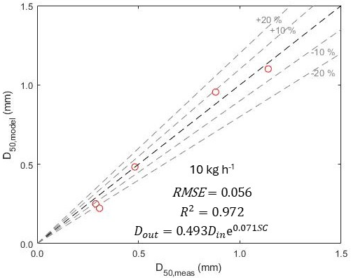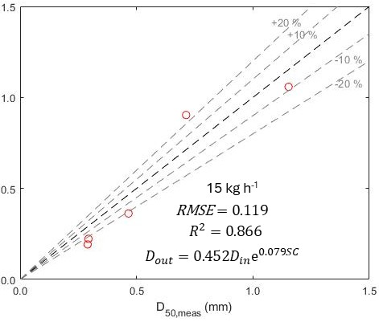
Figure 1: Comparison of measured and modelled data for model from Eq(10) for peripheral speed 20.4 m s⁻¹.

The comparison of D₅₀ for modelled and measured data was plotted in graphs for all 4 data sets, see Figure 1 and Figure 2. RMSE and R² were calculated for each data set to show accuracy of model. In order for coefficients A and B to be considered constant, only a narrow range of mill parameters has been used so far.The model is suitable for a range of peripheral speeds from 13.6 to 20.4 m s⁻¹, a range of mass flow rates 10-15 kg h⁻¹, it corresponds to flow rate from 106 to 160 kg h⁻¹ per meter of blade length. It is suitable for a range of milling sieves from 0.75 to 6 mm, and beech wood chips with a moisture content of 7.3 wt %. If the model works with sufficient accuracy, it is important in future research to address how the parameter λ will depend on mass flow rate and peripheral speed. Incorporating these dependencies into the model will significantly increase the model's range of applicability and accuracy. If the current model works, it makes sense to address the number of cuts in future research, which will also significantly increase the model's range of applicability.
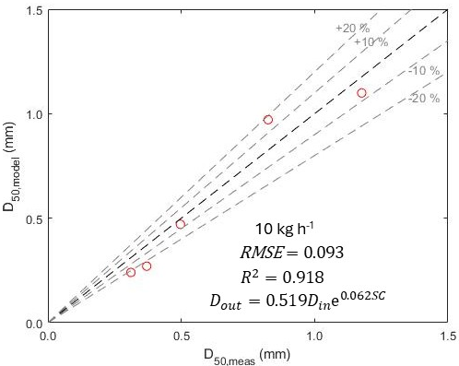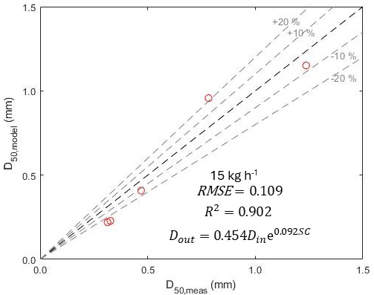
Figure 2: Comparison of measured and modelled data for model from Eq(10) for peripheral speed 13.6 m s⁻¹.

The model has very high accuracy according to both the R² parameter and the RMSE and can therefore be used to predict particle size within its range of validity. It has been confirmed that the size of the screen mesh has a dominant influence on the particle size at the outlet, and that the peripheral speed and mass flow rate also have a relatively significant influence. The dependencies in the model are consistent with empirically derived dependencies on screen sieve size that have been published (Bitra et al., 2009b). Therefore, it is important to address the influence of mass flow rate and peripheral speed on the value of the lambda parameter in the future. To demonstrate the dominance of the influence of the grinding screen size on the output particle size, the experimentally determined D₅₀ sizes were plotted together for all four data sets, see Figure 3.
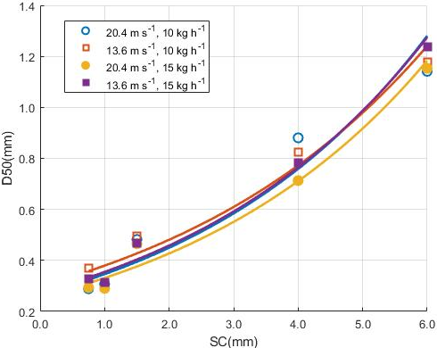
Figure 3: Experimentally determined D₅₀ for all 4 data sets.
4. Conclusions
It has been shown that the particle size distribution of milled beech chips corresponds to the RRSB model. Particle size can be predicted within a narrow range with high accuracy using empirical models depending on the peripheral speed of the rotor and the mesh size of the screen. For use in a wide range, it is necessary to develop theoretically derived physically based models, which can be very beneficial for optimizing milling processes in industry. Physically based models will be important for predictive mill control to achieve the appropriate particle size. The authors verified the validity of their own physically based model and succeeded in proving that the model corresponds to the dependencies measured in the experiment. The current experimentally confirmed model expresses the dependence of the output particle size on the input size and the size of the milling screen, which is the dominant parameter. When comparing the predicted and measured data, the R² and RMSE parameters achieved very good values. Further research to validate this model over a wider range of parameters is of great importance. In addition to the dominant parameter of screen mesh size, it will be necessary to introduce the exact influence of speed and mass flow on the exponent λ, and it will also be necessary to consider the influence of the number of cuts. The model will then be suitable for a very wide range of parameters, which will be much broader than the ranges of all current models. To apply the model to other lignocellulosic materials, it will be necessary to introduce the influence of moisture and ultimate shear strength. The resulting model can also be calibrated for other mill sizes, including the largest industrial mills.

Acknowledgments
This work was supported by the Grant Agency of the Czech Technical University in Prague, grant No. SGS25/130/OHK2/3T/12.

References
Bitra, V.S.P., Womac, A.R., Chevanan, N., Miu, P.I., Igathinathane, C., Sokhansanj, S., Smith, D.R., 2009a, Direct mechanical energy measures of hammer mill comminution of switchgrass, wheat straw, and corn stover and analysis of their particle size distributions, Powder Technology, 193, 32–45.
Bitra, V.S.P., Womac, A.R., Yang, Y.T., Miu, P.I., Igathinathane, C., Sokhansanj, S., 2009b, Mathematical model parameters for describing the particle size spectra of knife-milled corn stover, Biosystems Engineering, 104, 369–383.
Bitra, V.S.P., Womac, A.R., Yang, Y.T., Miu, P.I., Igathinathane, C., Chevanan, N., Sokhansanj, S., 2011, Characterization of wheat straw particle size distributions as affected by knife mill operating factors, Biomass Bioenergy, 35, 3674–3686.
Fernández-Ferreras, J., Gandarillas, L.P., Maza, Y.S., 2023, Study of the Grinding of Coffee Waste Prior to its Valorization, Chemical Engineering Transactions, 105, 307 – 312.
Gil, M., Arauzo, I., 2014, Hammer mill operating and biomass physical conditions effects on particle size distribution of solid pulverized biofuels, Fuel Processing Technology, 127, 80–87.
Gil, M., Luciano, E., Arauzo, I., 2015, Population balance model for biomass milling, Powder Technology, 276, 34–44.
Krátký, L., Arce, C., Llano, T., Dostál, M., Jirout, T., 2023, The Effect of Rotor Geometry on Particle Size Characteristics for Knife-milled Wheat Straw, Chemical Engineering Transactions, 100, 133–138.
Li, M., Wang, L., Chen, H., 2024, Evaluation of initial material particle size on the hydrothermal pretreatment of poplar powder, Biomass Conversion and Biorefinery, 14, 11265–11277.
Lu, M., Xia, Y., Bhattacharjee, T., Klinger, J., Li, Z., 2024, Predicting biomass comminution: Physical experiment, population balance model, and deep learning, Powder Technology, 441, 119830.
Otsuki, A., Jang, H., 2022, Prediction of Particle Size Distribution of Mill Products Using Artificial Neural Networks, ChemEngineering, 6, 92.
Petrakis, E., Varouchakis, E., Komnitsas, K., 2023, Reliability of the Non-linear Modeling in Predicting the Size Distribution of the Grinding Products Under Different Operating Conditions, Mining, Metallurgy and Exploration, 40, 1265–1278.

