 CHEMICAL ENGINEERING TRANSACTIONS  VOL. xxx, 2026 | A publication of  
The Italian Association
of Chemical Engineering
Online at www.cetjournal.it

Guest Editors: Leonardo Tognotti, Rubens Maciel Filho, Viatcheslav Kafarov
Copyright © 2026, AIDIC Servizi S.r.l.
ISBN 979-12-81206-xx-x; ISSN 2283-9216

Mapping optimal ethanol steam reforming plant operating conditions
Vitória C. Poletti*, Bruna G. Floriam, Aulus R. R. Bineli, Rubens M. Filho.
VALPET, School of Chemical Engineering, Universidade Estadual de Campinas. R. Josiah Willard Gibbs, s/n, Cidade Universitária, Campinas, SP, Zip code 13417-780, Brazil.
v238320@dac.unicamp.br

Steam reforming of ethanol (SRE) represents a prominent method for obtaining hydrogen, as it uses a renewable and non-toxic biofuel as a primary feedstock. In order to improve the industrial attractiveness of this catalytic pathway, this work aims to optimize reactor temperatures (°C), pressure (bar), steam-to-ethanol ratio, and feed flow rate (kg/h) to maximize yield and conversion while reducing the energy consumption and the use of raw materials. The plant was simulated using Aspen PlusⓇ software, considering a base case with three fixed-bed reactors in series, a simplified purification process, and compression up to 300 bar. Thermal integration minimized process energy requirements by implementing heat recovery from inter-reactor streams for feed preheating. Upon consolidation of the base case, a screening of key process parameters was conducted via a full 2^{k} factorial experimental design. As a result of this initial statistical analysis (p-value < 0.05), it was observed that the temperatures of the WGS reactors were not statistically significant. As this range was limited by the chosen reaction kinetics, these parameters were kept fixed at the minimum value of 250 °C for the second stage of the optimization study. A Central Composite Design (CCD) was implemented to derive surrogate models for ethanol conversion and hydrogen yield, while Response Surface Methodology (RSM) was employed to delineate optimal operating regions. The analysis revealed that maximizing both the temperature (500-600 °C) and the feed molar ratio (1:8-1:9) to their upper bounds yielded the highest performance metrics.
  - Introduction
According to the United Nations Framework Convention on Climate Change (UNFCCC), global efforts are increasingly focused on the mitigation of greenhouse gas emissions and the systematic addressing of climate change. As underscored by the International Energy Agency (IEA, 2023), achieving global net-zero carbon dioxide emissions by 2050 is imperative to constrain global warming to below 1.5°C. In this context, the search for sustainable alternatives that enhance energy capacity through renewable sources has intensified (Bokde; Lazić; Fanara, 2025).
Hydrogen (H₂) plays a pivotal role in the transition toward low-emission systems as a highly efficient and versatile energy vector (Taghizad-Tavana et al., 2025). The steam reforming of ethanol (SRE), Eq (1), is distinguished by its use of a renewable fuel with a well-established production scale in Brazil. Furthermore, ethanol offers advantages such as ease of transport and storage, low toxicity, and a high hydrogen-to-carbon ratio (Bineli; Tasic; Maciel Filho, 2016). This process constitutes a carbon-neutral alternative, as the CO₂ generated during H₂ production is offset by the carbon sequestered during the growth of the precursor biomass (Coors, 2025).

C₂H₅OH_{(g)} +3H₂0 _{(g)} → 6H_{2 (g)} + 2CO_{2 (g)} 𝛥𝐻 = +173.300 𝐽/𝑚𝑜l (1)

The Water Gas Shift (WGS) reaction, Eq (2), is noteworthy as a parallel reaction, especially in an industrial context, as it converts the generated carbon monoxide, thereby enhancing hydrogen selectivity (Palma et al., 2014).
CO_{(g)} + H₂0 _{(g)} $↔$ H_{2 (g)} + 2CO_{2 (g)} 𝛥𝐻 = -42.100 𝐽/𝑚𝑜l (2)
A study by Bineli and Filho (2016) found that ethanol steam reforming can achieve high yields, nearing 100%, provided that process variables—such as pressure, temperature, and the molar ratio of reactants—are appropriately selected. Consequently, process parameter optimization studies are essential to evaluate the influence of each variable on sustainable hydrogen production via SRE, thereby enhancing its competitiveness against environmentally detrimental alternatives (Phan et al., 2022).
The present work aims to simulate hydrogen production in an ethanol steam reforming plant utilizing fixed-bed reactors, assessing the impact of key process variables including temperature, pressure, reactant proportions, and flow rates. To achieve this, responses for ethanol conversion and hydrogen yield were analysed through the development of a surrogate model by Response Surface Methodology. This model was employed to identify optimal operating conditions for the process.
  - Methodology
A schematic overview of the methodology is available in Figure 1.
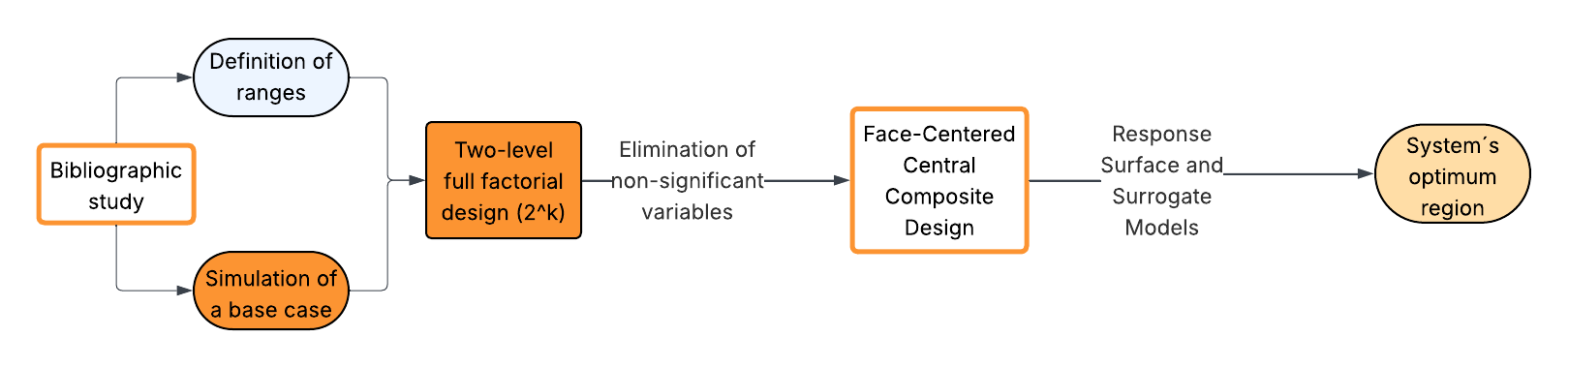
Figure 1: General outline of the methodology.
    - Simulation
The simulation of the ethanol steam reforming plant was performed using Aspen Plus® software. To ensure the simulation accurately represents the real process, an appropriate selection of the thermodynamic property package is essential (Carlson, 1996). Accordingly, the modified Predictive Soave-Redlich-Kwong (PSRK) equation of state was selected.
Reaction kinetics were adopted from Palma et al. (2014), who analyzed the performance of a bimetallic Pt (3 wt%) and Ni (10 wt%) sample supported on CeO₂, evaluating its catalytic activity, selectivity, and stability. Since promising results were reported between 250 and 600 °C, this temperature range was selected for the analysis of optimization parameters.
The plant was initially simulated considering a base case with three fixed-bed reactors in series: the first one for ESR, Eq (1), and the next two with lower temperatures in order to favor the WGS reaction, Eq (2). Next, simplified purification was performed using a flash process with water recovery, which was recycled, and a separation column. Finally, compression up to 300 bar of hydrogen with 99.99% purity was considered (Bouwkamp; Burgunder; Casey, 2017). Energy integration was also assessed in the simulation with the aim of reducing the energy consumption required in the process by taking advantage of the heat that would be lost between the reactors to preheat the feed.
A base case was initially established for the simulation, assuming an ethanol feed capacity of 40,000 t/y. This capacity was selected based on a commercial example of a second-generation bioethanol plant currently commercialized by the Biochemtex group (Martinov et al., 2015). Additionally, a feed mixture with an ethanol-to-water molar ratio of 1:6 was employed. Although this is lower than the ratio described as optimal (Patel; Jindal; Pant, 2013), this composition was defined because it is readily achievable in industrial settings through ethanol purification via distillation.
    - Factorial Design
The statistical study in this work, ranging from experimental design to response analysis and optimization, was performed using Statistica software (version 7.0). Based on the obtained results, Pareto charts were generated with a 95% confidence interval. Initially, a two-level full factorial design was conducted to screen the influence of each evaluated parameter: feedstock flow rate, temperatures in the ESR, HT-WGS, and LT-WGS reactors, pressure, and the Ethanol-to-Water reagent ratio. For this purpose, a two-level full factorial design (2^{k}) was employed (k = 6), totaling 64 experimental runs. The high and low levels for each factor are listed in Table 1.
Table 1: High and low levels for each operation factor.
Level | Flow rate | ESR Temp. | HT-WGS Temp. | LT-WGS Temp. | Pressure | Reagent Ratio
 | (kg/h) | (°C) | (°C) | (°C) | (bar) | (Ethanol : Water)
(-1) | 10,000 | 250 | 250 | 250 | 1 | 1:1
(+1) | 35,000 | 600 | 350 | 280 | 6 | 1:9

This preliminary analysis aimed to track parameter variation trends, validate pre-established ranges, and eliminate variables with no significant influence on the responses: ethanol conversion and H₂ yield. The equations used to calculate ethanol conversion and hydrogen yield are presented in Eq (3) and Eq (4), respectively.

$X\left(\%\right)=\frac{Moles of Ethanol comsulmed }{Moles of Ethanol fed}$ (3)

$Y\left(\%\right)=\frac{Moles of Hydrogen }{Moles of Ethanol fed}$ (4)

Subsequently, a Face-Centered Central Composite Design (FCCCD) was employed to identify the system's optimum region (Barros Neto; Scarminio; Bruns, 2001). For this purpose, parameters deemed statistically non-significant in the previous analysis were excluded.
From the FCCCD data, Pareto charts were generated for each response to determine the significant parameters for the analysis and the effects and coefficients used in the models. Response surfaces were constructed by varying the parameters pairwise while maintaining the remaining variables at their center points. Through this analysis, the optimum regions for conversion and yield were determined. Simplified mathematical models, known as Surrogate Models, were also defined for each response variable (Wu et al., 2025).
  - Results
This section is organized into two parts: the simulation base case and the mapping of optimal operating conditions.
    - Base Case
Upon comparing the configurations with and without energy integration, it was observed that the implementation of integration resulted in a reduction of 8,899.6 Mcal/h in hot utility and the complete elimination of cold utility, representing a significant result. It is noteworthy that, even with energy integration, the heat duty required to maintain reactor temperatures remains high. This is attributed to the high operating temperatures selected for the base case: 600 °C, 350 °C, and 280 °C for the ESR, HT-WGS, and LT-WGS reactors, respectively.
The reactor effluent flows into a Flash separator, where excess of water is removed and recycled back into the process, recovering 93% of the water that would otherwise be lost as wastewater. The product recovered from the top of the Flash unit is directed to the PSA column. It was observed that the simulation results aligned closely with literature expectations, showing a 70 mol% hydrogen feed to the PSA unit (Ruth; Laffen; Timbario, 2009), which supports the model's validation.
The simulated PSA purification step assumed a hydrogen recovery with 99.99% purity, as described by ISO/TC 197 (2019). The heat duty for this process was -184.72 Mcal/h. Finally, a compression stage was added to bring the purified hydrogen to 300 bar and 25 °C, requiring a power input of 7,308.62 kW.
The simulation base case resulted in 100% ethanol conversion, a yield of 88.71%, and a hydrogen production rate of 1,063.54 kg/h. These parameters will be compared with the results obtained from the optimization process. CO, CO₂, CH₄ and CH₃CHO were formed as byproducts.
The main simulation flowsheet is presented in Figure 2.
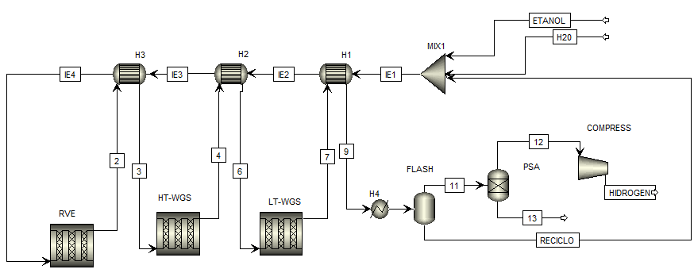
Figure 2: Flow Diagram at Aspen Plus® Software.
    - Mapping of optimal operating conditions
The initial analysis for the optimization using Surrogate Models consisted of screening the effects of each of the six evaluated parameters. Considering a 95% confidence interval, all main effects were found to be significant: ESR temperature, pressure, reagent ratio, and feed flow rate, with the exception of the HT-WGS and LT-WGS temperatures. Furthermore, several two-factor interaction effects were also deemed significant, excluding interactions involving WGS temperatures, as the main effects of these variables were not significant. The non-significance of the WGS temperatures is attributed to the narrow variation range defined for these reactors using the available literature, which was insufficient to significantly influence the observed results. Since this range was constrained by the selected reaction kinetics and could not be altered, these parameters were excluded from the subsequent optimization study. Instead, they were fixed at the minimum value of 250 °C to reduce the energy consumption.
Following the initial screening of parameter influence and the exclusion of the WGS reactor temperatures, FCCCD was conducted to generate response surfaces and identify optimal operating regions. The values used for the lower (-1), center (0), and upper (+1) levels of the design are listed in Table 2.
Table 2: High, low and center levels for each operation factor.
Level | Flow rate | ESR Temp. | Pressure | Reagent Ratio
 | (kg/h) | (°C) | (bar) | (Ethanol : Water)
(-1) | 10,000 | 250 | 1 | 1:1
(0) | 22,500 | 425 | 3.5 | 1:5
(+1) | 35,000 | 600 | 6 | 1:9

A total of 26 computational experiments were conducted and Pareto charts were obtained. Concerning ethanol conversion (Figure 3a), the most influential parameter was the ethanol-to-water ratio (p-value = 0.000114), followed by the interaction between the ethanol-to-water ratio and the ESR temperature (p-value = 0.029715).

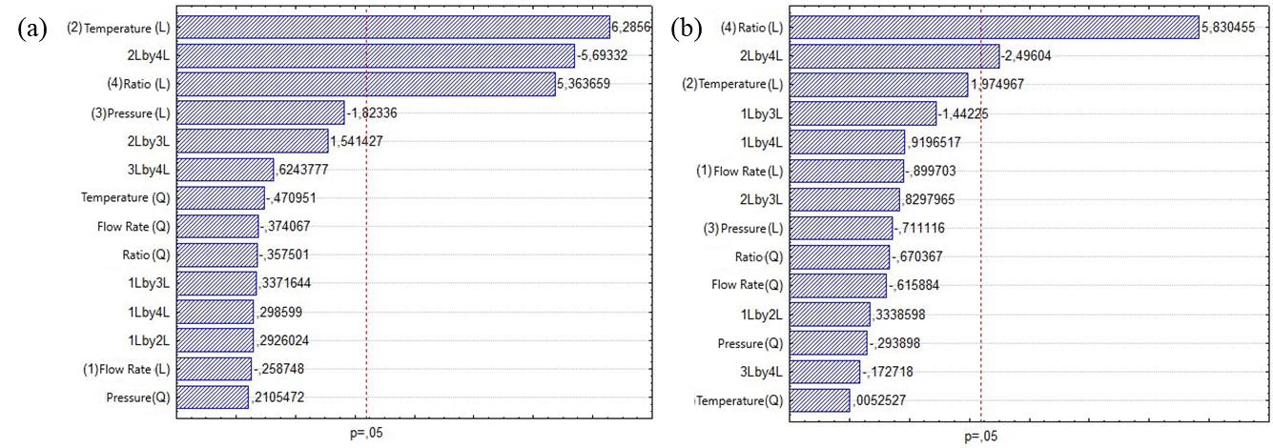
Figure 3: (a) Pareto Chart for conversion of ethanol; (b) Pareto Chart for yield of hydrogen.

The yield analysis (Figure 3b) revealed three statistically significant effects: temperature (p-value = 0.000060), the interaction between temperature and the ethanol-to-water ratio (p-value = 0.000140), and the ethanol-to-water ratio (p-value = 0.000229).
Thus, the surrogate model for conversion (X_{EtOH}) was defined as a function of the significant effects: reactant ratio (RR) and the interaction between reactant ratio and temperature (RR . T), as shown in Equation 4. Regarding yield, the surrogate model (Y_{H2}) was established as a function of the significant effects: temperature (T), reactant ratio (RR), and the combined effect of reactant ratio and temperature (RR . T), as presented in Equation 5. The models exhibited R² values of 0.9502 for conversion and 0.9542 for yield.

𝑋_{𝐸𝑇𝑂𝐻} = 84.5128+14.1109⋅R𝑅 – 12.5647⋅R𝑅⋅𝑇 (4)

Y_{𝐻2} = 89.0117 + 15.7123 ⋅ R𝑅 + 13.4090 ⋅ 𝑇 – 15.0818 ⋅ R𝑅 ⋅ 𝑇 (5)

Response surfaces were constructed by varying the parameters pairwise while maintaining the remaining variables at their center points, allowing for the mapping of optimal operating regions. The response surfaces for conversion (Figure 4a) and yield (Figure 4b) are presented as a function of the significant parameters: temperature and reactant ratio. Global optima could not be determined for all variables, as this would necessitate extrapolating beyond the validity range of the kinetic model employed, a procedure that cannot be performed.

- (b)
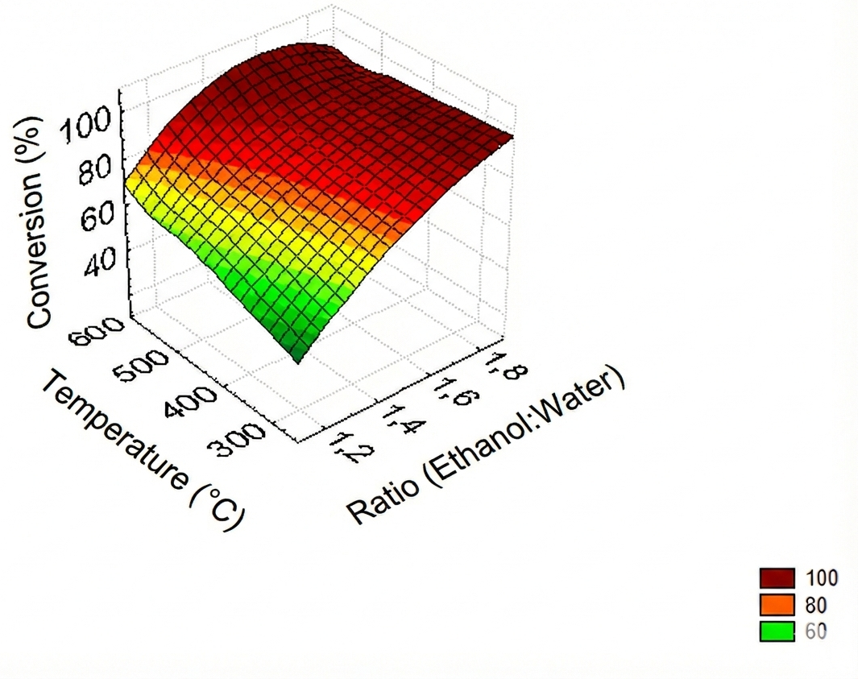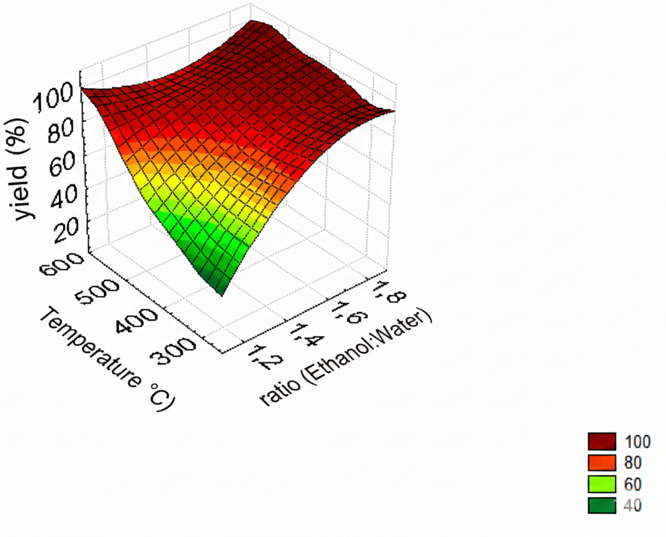
Figure 4: Response surfaces as a function of the significant parameters: temperature and reactant ratio (a) for conversion; (b) for yield.

Table 3 presents the local maximum obtained within the range established by the kinetic study. For all response parameters, lower pressures and higher temperatures yielded optimal results for the case under study. This behaviour was expected based on the literature (Rossi et al., 2009; Gasparetto; Gonçalves Salau, 2026), as high pressures hinder hydrogen formation and promote coke formation, whereas elevated temperatures favor ESR. Furthermore, more diluted ethanol-to-water ratios favored the reforming reaction, a result that also aligns with the literature (Paes; Silva, 2020).
Table 3: Local optima results obtained for the response parameters.
Parameters | Local maximum | Ratio | Pressure | Flow rate | Temperature
 | (%) | (Ethanol : Water) | (bar) | (t/h) | (°C)
Conversion | 100 | 1:8-1:9 | 1-3 | 16-28 | 500-600
Yield | 100 | 1:8-1:9 | 1-3 | 16-28 | 500-600
Conclusions
Herein, an optimization study of an ethanol steam reforming plant using fixed-bed reactors was conducted to evaluate the influence of process variables. To this end, ethanol conversion and hydrogen yield responses were analyzed through the development of a model aimed at identifying optimal operating regions.
Results from the Full Factorial Design statistical study indicated that the temperatures of the WGS reactors showed no statistical significance. Therefore, they were fixed at their minimum values in subsequent steps. Subsequently, using a CCF, response surfaces were generated, allowing for the determination of optimal operating regions, with temperatures ranging from 500 to 600 °C and an ethanol to water ratio between 1:8 and 1:9. It is noteworthy, however, that defining global optima for all variables was not possible, as this would imply extrapolating the validity limits of the adopted kinetic model, which is not permissible.
Finally, surrogate models, which linearly model response variables as a function of significant parameters, were established. Coefficient of determination R² values of 0.95022 and 0.95421 were obtained for conversion and yield, respectively, demonstrating that the developed models are valid for predicting the behavior of the responses.

Nomenclature
RR – reactant ratio, Ethanol:Water X_{EtOH} – conversion, %

T – temperature, °C Y_{H2} – hydrogen yield, %
Acknowledgments
The authors gratefully acknowledge the support from VALPET (UNICAMP) and to Vesta Greentech.
References
BARROS NETO, B.; SCARMINIO, I. S.; BRUNS, R. E. Como Fazer Experimentos: Pesquisa e Desenvolvimento na Ciência e na Indústria. 1. ed. Saarbrücken: Editora da Unicamp, 2001.
BINELI, A. R. R.; TASIC, M. B.; MACIEL FILHO, R. Catalytic steam reforming of ethanol for hydrogen production: brief status. Chemical Industry & Chemical Engineering Quarterly, v. 22, p. 327–332, 2016. DOI: https://doi.org/10.2298/CICEQ160216017B.
BOUWKAMP, N.; BURGUNDER, A.; CASEY, D. Hydrogen Delivery Technical Team Roadmap. [S. l.], jul. 2017.
CARLSON, E. C. Don’t Gamble With Physical Properties For Simulations. Chemical Engineering Progress, v. 92, p. 35–46, 1996. Disponível em: https://api.semanticscholar. org/CorpusID:38564725.
COORS, W. G. Hydrogen Production by Ethanol Steam Reforming. In: TAHIR, D. M. B.; RAFIQUE, D. M. S.; RAFIQUE, D. M.; SAGIR, D. M. (ed.). Advances in Hydrogen Energy Production, Storage, and Utilization. London: IntechOpen, 2025. cap. 0. DOI: 10.5772/ intechopen.1011963. Disponível em: https://doi.org/10.5772/intechopen. 1011963.
INTERNATIONAL ENERGY AGENCY. Net Zero Emissions by 2050: A Roadmap for the GlobalEnergySector.[S.l.], maio 2023. Disponível em: https://www.iea.org/reports/ net-zero-emissions-by-2050.
ISO/TC 197, T. C. Hydrogen fuel quality — Product specification- ISO 14687. [S. l.], nov. 2019.
MARTINOV, M. et al. Plant for lignocellulosic bioethanol production in Serbia: case study– final report. Novi Sad, Serbia, 2015.
PAES, A. V. D.; SILVA, F. A. Análise termodinâmica da reforma de etanol: efeito de temperatura e composição. In: SIMPÓSIO de Iniciação Científica e Tecnológica (SICITE). Toledo- PR: [s. n.], out. 2020.
PALMA, V.; CASTALDO, F.; CIAMBELLI, P.; IAQUANIELLO, G. CeO2-supported Pt/Ni catalyst for the renewable and clean H2 production via ethanol steam reforming. Applied Catalysis B: Environmental, v. 145, p. 73–84, 2014. Advances in Catalysis for Biomass Valorization. ISSN 0926-3373. DOI: https://doi.org/10.1016/j.apcatb.2013.01.053. Disponível em: https://www.sciencedirect.com/science/article/pii/S0926337313000738.
PATEL, M.; JINDAL, T. K.; PANT, K. K. Kinetic Study of Steam Reforming of Ethanol on NiBased Ceria–Zirconia Catalyst. Industrial & Engineering Chemistry Research, v. 52, n. 45, p. 15763–15771, 2013. DOI: 10.1021/ie401570s. eprint: https://doi.org/10.1021/ ie401570s. Disponível em: https://doi.org/10.1021/ie401570s.
PHAN, T. S. et al. Hydrogen production from biogas: Process optimization using ASPEN Plus®. International Journal of Hydrogen Energy, v. 47, n. 100, p. 42027–42039, 2022. Recent Advances in Hydrogen Economy Technologies: Hydrogen Generation, Storage and Utilization. ISSN 0360-3199. DOI: https://doi.org/10.1016/j.ijhydene.2022.01. 100. Disponível em: https://www.sciencedirect.com/science/article/pii/ S0360319922001872.
ROSSI, C. et al. Thermodynamic analysis of steam reforming of ethanol and glycerine for hydrogen production. International Journal of Hydrogen Energy, v. 34, n. 1, p. 323–332, 2009. ISSN 0360-3199. DOI: https://doi.org/10.1016/j.ijhydene.2008.09. 071. Disponível em: https://www.sciencedirect.com/science/article/pii/ S0360319908012779.
RUTH, M.; LAFFEN, M.; TIMBARIO, T. Hydrogen Pathways: Cost, Well-to-Wheels Energy Use, and Emissions for the Current Technology Status of Seven Hydrogen Production, Delivery, and Distribution Scenarios, set. 2009. DOI: 10.2172/966286.
TAGHIZAD-TAVANA,K.etal.Fromgreenhydrogenproductiontoartificial intelligence–driven energy management in hydrogen fuel cell electric vehicles: a comprehensive review of technologies, optimization techniques, international standards, and investment programs. Applied Energy, v. 399, p. 126534, 2025. ISSN 0306-2619. DOI: https://doi.org/10.1016/ j.apenergy.2025.126534. Disponível em: https://www.sciencedirect.com/ science/article/pii/S0306261925012644.
WU, Z. et al. Dveloping surrogate models for the early-stage design of residential blocks using graph neural networkse. Building Simulation, v. 13, p. 436–450, mar. 2025. DOI: https: //doi.org/10.1007/s12273-025-1237-7.

