 CHEMICAL ENGINEERING TRANSACTIONS  VOL. xxx, 2026 | A publication of  
The Italian Association
of Chemical Engineering
Online at www.cetjournal.it

Guest Editors: Leonardo Tognotti, Rubens Maciel Filho, Viatcheslav Kafarov
Copyright © 2026, AIDIC Servizi S.r.l.
ISBN 979-12-81206-xx-x; ISSN 2283-9216
Valorization of Banana Postharvest Agricultural Biomass Waste into Sustainable and Value-Added Biopolymers
Graziele V. B. Possenti^{a,b}, Laís M. dos Santos^{b}, Ana Carolini C. Zanette^{b}, Sthefani S. Luciano^{b}, Ricardo A. F. Machadoª, Cintia Marangoniª, Rodrigo Battisti^{b,}*
ªChemical Engineering Department, Federal University of Santa Catarina (UFSC), Florianópolis, Brazil
^{b}Federal Institute of Education, Science and Technology of Santa Catarina (IFSC), Criciúma, Brazil
*rodrigo.battisti@ifsc.edu.br
Large amounts of lignocellulosic-rich agricultural biomass waste are produced worldwide, making its proper management a key factor for a sustainable bioeconomy. Brazil is the fourth-largest banana producer in the world. After fruit harvesting, around four tons of wet biomass are generated for each ton of banana harvested. Converting these residues into value-added derivatives has attracted significant attention in recent years. In this context, this study proposes valorizing banana postharvest waste through cellulose extraction and purification, followed by the synthesis of Cellulose Acetate (CA) and Carboxymethylcellulose (CMC), highly versatile biomaterials that could potentially replace conventional polymers of industrial relevance. The efficiency of cellulose purification was evidenced by the low insoluble lignin (less than 2.18 %) and the high levels of α-cellulose (55.2 % to 79.5 %) in the bleached samples. The biopolymers synthesis was also confirmed by determining the degrees of substitution (DS) of CA (ranging from 2.87 to 2.89), and CMC (ranging from 0.77 to 0.85), as well as by identifying characteristic bands using Fourier Transform Infrared Spectroscopy (FT-IR), such as the peak at 1737 cm⁻¹ representing the stretching of the carbonyl ester of CA, and the peaks near 1587 cm⁻¹, confirming the elongation vibration of the carboxyl groups of CMC. These results demonstrate the viability of reusing lignocellulosic waste from banana postharvest processing to obtain high-value-added CA and CMC biopolymers, reinforcing their potential as a sustainable alternative in the valorization of agro-industrial waste.
  - Introduction
The global search for renewable resources has driven universities and industry to find new sources for materials and energy. The conversion of agricultural biomass into sustainable raw materials is vital to meet energy demand and reduce environmental damage. Despite logistical challenges, lignocellulosic biomass stands out as an abundant, carbon-neutral, and accessible resource, making it a strategic solution (Saravanan et al., 2023). Rich in cellulose, these postharvest wastes have been reused to create innovative biomaterials, transforming up to 60 % of plant biomass into sustainable solutions (Patil et al., 2024). The synthesis of biopolymers, such as CA and CMC, is becoming increasingly attractive, especially regarding the production of cellulosic derivatives. CA synthesis predominantly involves pretreatment to isolate cellulose, followed by acetylation via acid catalysis or ionic liquids, which enable higher control over DS (Liu et al., 2024). CMC, also derived from cellulose, stands out for its hydrophilicity and its excellent ability to form gas-barrier films, given that the predominant synthesis route remains etherification in a heterogeneous medium, involving alkalization with NaOH followed by reaction with chloroacetic acid (Candido & Gonçalves, 2016). Recent innovations focus on optimizing reaction variables, such as alkali concentration and reaction time, to improve the DS, generally between 0.4 – 1.2 for CMC, and 2.7 – 2.9 for CA, a parameter that determines the polymer's solubility, viscosity, and thermogelation (Florencio et al., 2024). Given the potential of these biopolymers and the availability of residual biomass, this study proposes the integral use of postharvest residues (pseudostem, rachis, and leaves) from the banana Musa paradisiaca as a source of cellulose for the synthesis of CA and CMC. This approach differs from most studies reported in the literature, which focus on the utilization of isolated fractions of the banana residues, giving to this proposal an innovative character. The integration of these different fractions into a single lignocellulosic valorization system expands the utilization of biomass and reduces waste generation. Furthermore, the transformation of an abundant and still little-explored resource into high value-added products reinforces sustainability principles, aligned with the principle of fully using renewable raw materials.
  - Methodology
The raw biomass processing steps were conducted according to the flowchart shown in Figure 1. Chemical characterization tests of the raw materials were performed according to TAPPI standard 222 om-02 (2002), while the methodological procedure described by Istirokhatun et al. (2015) was employed in the purification steps. For the synthesis of biopolymers, the methodologies proposed by Candido & Gonçalves (2016) for CA and by Kaewprachu et al. (2022) for CMC were adopted.

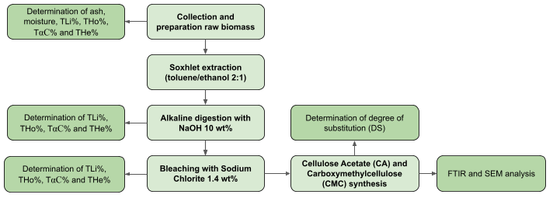Figure 1: Methodology applied for the processing of raw materials and the synthesis of the biopolymers
  - Results and discussion
    - Characterization of raw biomass
The characterization of the raw biomass as moisture and ash content, insoluble lignin (TLi%), and cellulosic fractions of α-cellulose (TαC%), hemicellulose (THe%), and holocellulose (THo%), are shown in Table 1. The raw materials had a high moisture content, ranging from 80 % to 92 %, indicating high water retention in the different fractions of the banana plant. These values ​​are consistent with data reported by Pereira et al. (2022) for the pseudostem (92.01±0.65 %); by Wisansakkul & Oupathumpanont (2026) for the leaves (66.05 % to 82.18 %); and by Guo et al. (2021) for the rachis (93.4 %). The ash contents also were within the expected values ​​in the literature, particularly those of the pseudostem and leaves, ranging from 7.3 % to 20.5 %, and 7.60 % to 18 % (Daimary et al., 2023; Singh et al., 2020). The higher ash content of the rachis (19.32 %) is due to its higher concentration of total minerals. Differences in banana species or cultivars, management and cultivation, and soil nutrient availability can also cause significant changes in the inorganic fraction and, consequently, in ash content (Lima Neto et al., 2020). The insoluble lignin reveals that the raw biomass, pseudostem (9.94 %), leaf (25.55 %), and rachis (33.66 %), have high lignin levels compared to the bleached samples: pseudostem (about 0.0 %), leaf (2.08 %), and rachis (2.18 %). This difference is associated with the anatomical characteristics of plant tissues, since the pseudostem is predominantly composed of thin tissues, whereas leaves and, above all, the rachis require higher support and lignification (Azriena et al., 2025). The bleaching process drastically reduced these levels, especially in the rachis, which dropped from 33.66 % to 2.18 %, indicating an effective breakdown of aromatic bonds, facilitated by the accessibility of the fibres or by the specific chemical composition of each plant fraction (Freitas et al., 2024). It is also worth noting that bleaching significantly increased the THo% and Tα-C% of the samples, confirming the effectiveness of the purification processes, which favor the solubilization of non-cellulosic constituents and promote selectivity and increased quality of the cellulosic fraction (Azriena et al., 2025; Freitas et al., 2024). The effectiveness of the treatment is more evident in the pseudostem samples, with a reduction in THe% from 25.11 % to 4.21 %, and in the rachis samples, with an increase in TαC% from 56.04% to 77.14%. Similarly, the pseudostem showed a substantial increase in TαC% from 34.25 % to 78.62 %, demonstrating that, despite its initially more resistant lignocellulosic matrix, the chemical treatment promoted a significant enrichment of the cellulosic fraction. The leaves also showed high α-cellulose content (73.02 %), indicating high delignification efficiency, consistent with the previously observed low TLi%. The results are in agreement with the literature, which reports α-cellulose contents between 65 % and 85 % for biomasses subjected to efficient delignification and alkaline extraction processes, reinforcing the suitability of the material for more demanding technological applications, such as the synthesis of cellulose derivatives and advanced biomaterials (Battisti et al., 2019; Pereira et al., 2022). Additionally, the yields from the bleached cellulose production process were 26.57 % for the pseudostem, 38.54 % for the rachis, and 54.07 % for the leaves, indicating variations related to the initial composition and structural resistance of each plant fraction. When compared to literature, the values ​​obtained are compatible with different processing methods. Hafemann et al. (2020) reported yields between 29.4 % and 34.3 % using H₂O₂ for rice husk, while Rosa et al. (2012) indicate an average efficiency of 28 %. Similar values ​​are also observed in processes with ionic liquids, with yields of up to 30 % (Paredes et al., 2025). On the other hand, Wang et al. (2021) reported significantly higher yield (92.6 %) in lignocellulosic biomass using sodium chlorite, which may be attributed to more intense reaction conditions.
Table 1: Moisture, ash, yield and cellulosic fraction contents of biomass: raw (R) pseudostem, bleached (B) pseudostem, raw (R) rachis, bleached (B) rachis, raw (R) leaf, and bleached (B) leaf
Samples | Moisture (%) | Ash (%) | THo (%) | TαC (%) | THe (%) | Yield (%)
(R) Pseudostem | 89.03±0.20 | 13.68±0.36 | 59.35±1.13 | 34.25±2.70 | 25.11±1.57 | 26.57
(B) Pseudostem | -- | -- | 82.83±1.24 | 78.62±4.33 | 4.21±3.09 | 26.57
(R) Rachis | 91.66±0.03 | 19.36±0.26 | 73.11±2.58 | 56.04±3.57 | 17.08±6.15 | 38.54
(B) Rachis | -- | -- | 86.32±0.52 | 77.14±1.20 | 9.18±0.68 | 38.54
(R) Leaf | 80.33±0.33 | 11.07±0.07 | 67.77±1.78 | 55.62±2.05 | 12.15±3.83 | 54.07
(B) Leaf | -- | -- | 84.61±0.28 | 73.02±0.49 | 11.59±0.77 | 54.07

Scanning Electron Microscopy (SEM) analysis, shown in Figure 2, reveals clear morphological differences between the raw biomass and the purified biomass. The raw samples of pseudostem, rachis, and leaves exhibit a compact morphology, with aggregated fibers and surfaces covered by non-cellulosic components, characteristic of a less accessible lignocellulosic matrix. After chemical purification, higher structural disaggregation is observed, with more individualized fibers, increased surface roughness, and higher porosity. These changes indicate the efficient removal of lignin, hemicellulose, and extractives, promoting the opening of the biomass matrix (Ardila et al., 2024). The treated pseudostem stands out for its high exposure of cellulosic fibrils, while the rachis presents cleaner and more defined fibers. The treated leaves, although more heterogeneous, also show significant surface modification (Sriwong et al., 2023). Overall, SEM results corroborate the chemical characterization analyses, confirming the enrichment of the cellulosic fraction and the increased accessibility of the fibers after the purification treatment.

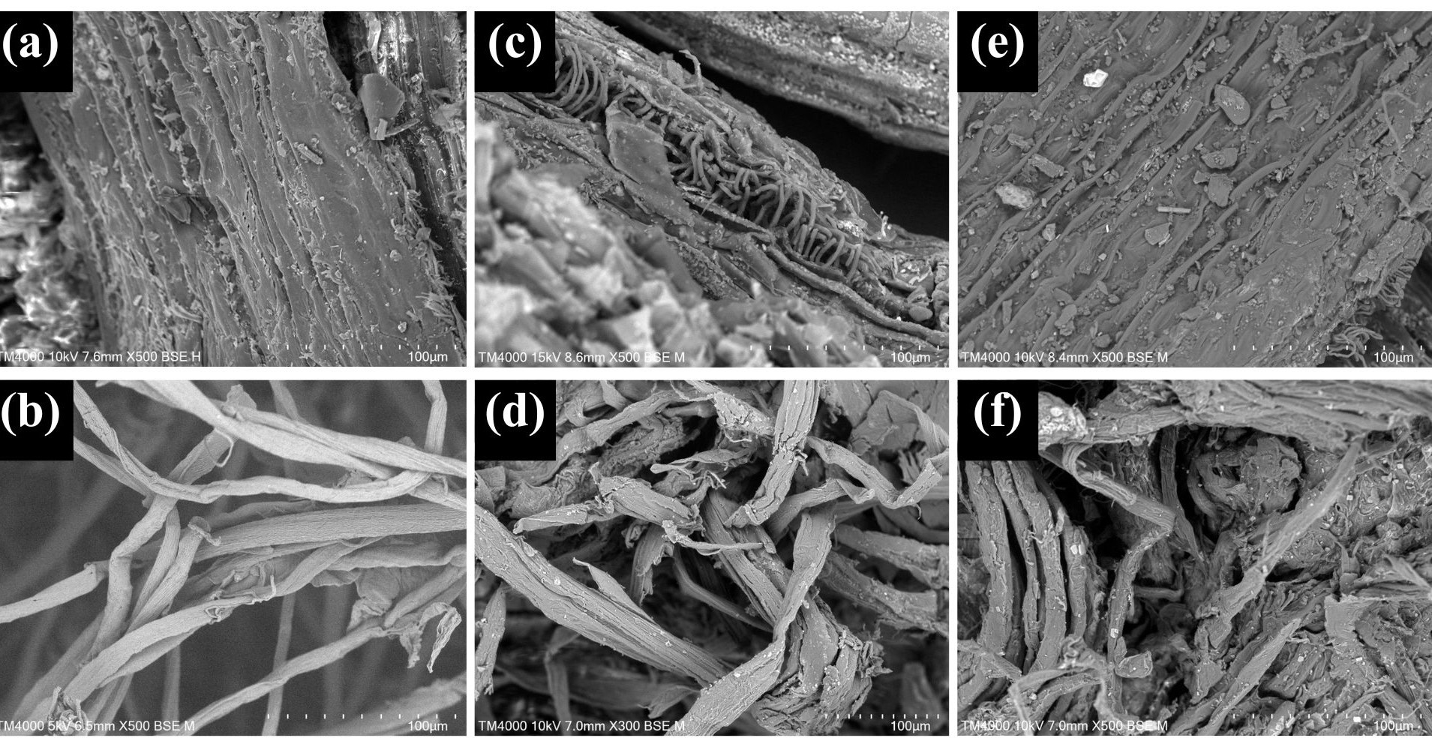
Figure 2: SEM images of materials at a scale of 100 µm: raw (a) and treated (b) pseudostem; raw (c) and treated (d) rachis; raw (e) and treated (f) leaf

    - Synthesis of the biopolymers CA and CMC
The DS was calculated to verify the conversion of cellulose into the biopolymers CA and CMC. Table 2 shows the DS values ​​of the biopolymers obtained from different fractions of banana residue. The DS of CA represents the average number of acetyl groups that replace hydroxyl groups per glucose unit. The maximum degree of acetylation is achieved when all OH groups are replaced by acetyl groups, yielding a DS of 3 (Freitas et al., 2017). The pseudostem (2.89±0.01), rachis (2.85±0.02), and leaf (2.87±0.04) DS confirm the synthesis of cellulose triacetate in all fractions, with good experimental reproducibility, evidenced by the low standard deviations (Candido & Gonçalves, 2016). The DS of CMC is defined as the average number of hydroxyl groups substituted by carboxymethyl groups, with values ​​ranging from 0.5 to 1.4. The experimentally determined values for the pseudostem (0.77±0.05), rachis (0.85±0.04) and the leaf (0.81±0.01) are consistent with the literature (Kinjo et al., 2026). The mass yields for CA were 126.22 % (pseudostem), 132.32 % (rachis), and 114.17 % (leaf), while for CMC were 103.0 % (pseudostem), 98.79 % (rachis), and 120.0 % (leaf). Values ​​above 100 % are expected due to the incorporation of functional groups (acetyl or carboxymethyl) into the cellulose structure, resulting in increased mass. The results demonstrate high efficiency of the chemical reactions for all fractions evaluated. Thus, DS and Yield results confirmed the potential of the different postharvest banana fractions as viable sources of cellulose for the synthesis of CA and CMC biopolymers, with suitable properties.
Table 2: Degree of substitution (DS) of Cellulose Acetate (CA) and Carboxymethylcellulose (CMC)
Degree of substitution (DS) | Pseudostem | Rachis | Leaf
CA | 2.89±0.01 | 2.85±0.02 | 2.87±0.04
CMC | 0.77±0.05 | 0.85±0.04 | 0.81±0.01

The FT-IR analysis, shown in Figure 3, confirms the structural differences between the raw cellulosic biomass and the acetylated products (CA) obtained from the pseudostem, rachis, and leaves. In the spectrum of the raw cellulosic biomass, a band is observed around 3401 cm⁻¹, attributed to the stretching of hydroxyl (OH) groups, characteristic of the extensive network of intramolecular and intermolecular hydrogen bonds, in addition to the band at 2914 cm⁻¹ related to C–H stretching. The presence of the band at approximately 1048 cm⁻¹ is associated with C–O stretching of glycosidic bonds, typical of the polysaccharide structure of cellulose. In the spectra of the CA products, a significant reduction in the intensity of the OH band is observed, indicating the substitution of these groups by acetyl groups during the acetylation reaction. The formation of CA is evidenced by the appearance of an intense band around 1737 cm⁻¹, attributed to the stretching of the carbonyl (C=O) of the ester group, absent in the raw cellulose spectrum. The presence of bands between 1230–1243 cm⁻¹ is associated with the C–O–C stretching of the acetyl groups, and around 1378 cm⁻¹, related to the C–H deformation of the methyl group (CH₃) (Jia et al., 2022).

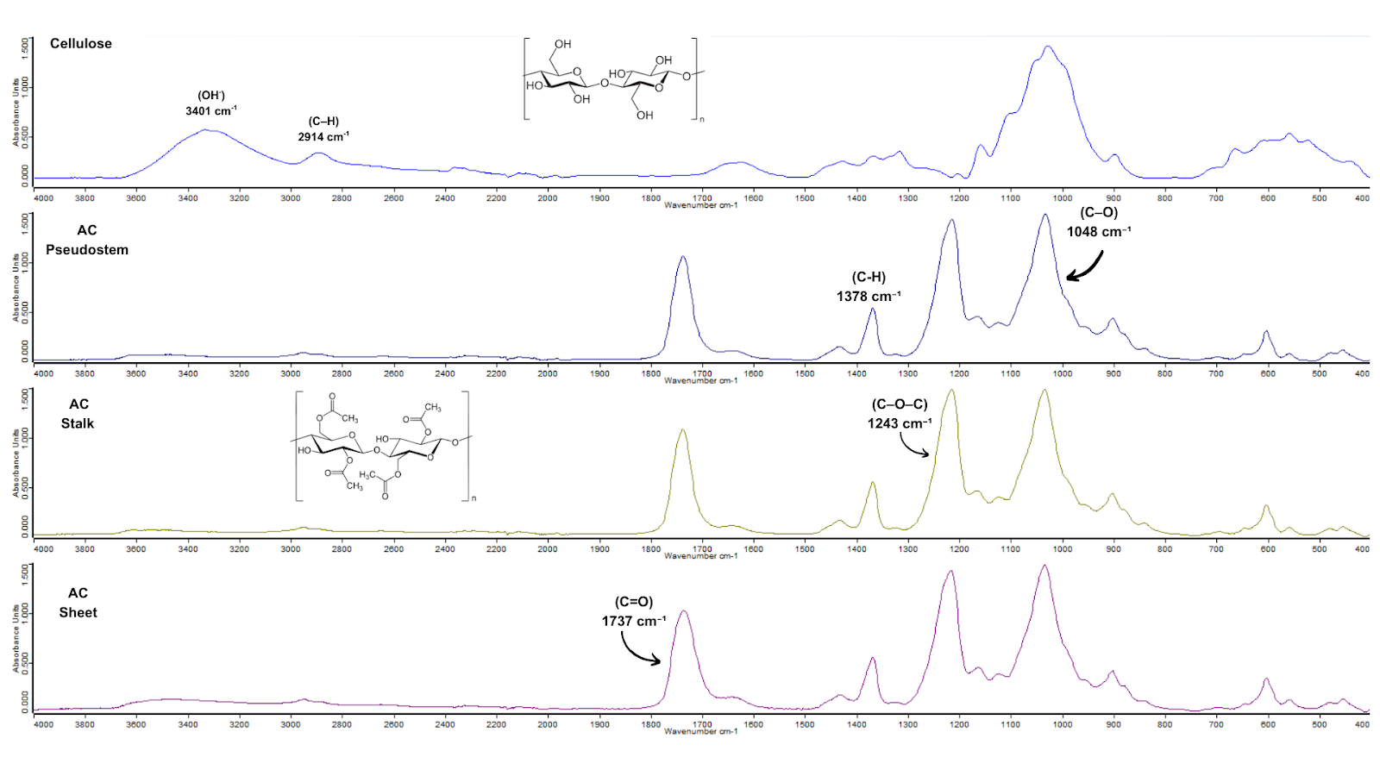
Pseudostem CA
Rachis CA
Leaf CA
Raw cellulosic biomass
Figure 3: FT-IR of the Cellulose Acetate (CA) biopolymers obtained
Figure 4 clearly shows the chemical modifications resulting from the conversion of cellulosic biomass into CMC, as evidenced by FT-IR spectra. In the spectra of CMC samples obtained from the pseudostem, rachis, and leaves, a reduction in the intensity of the OH band is observed, indicating the partial substitution of hydroxyl groups during the carboxymethylation reaction. The appearance of characteristic bands of carboxymethyl groups (COO⁻), especially the band around 1588 cm⁻¹, confirms the formation of CMC. The band at approximately 1415 cm⁻¹ is related to and associated with the CH₂–COOH group, confirming the introduction of the carboxymethyl substituent into the cellulosic chain (Florencio et al., 2024).

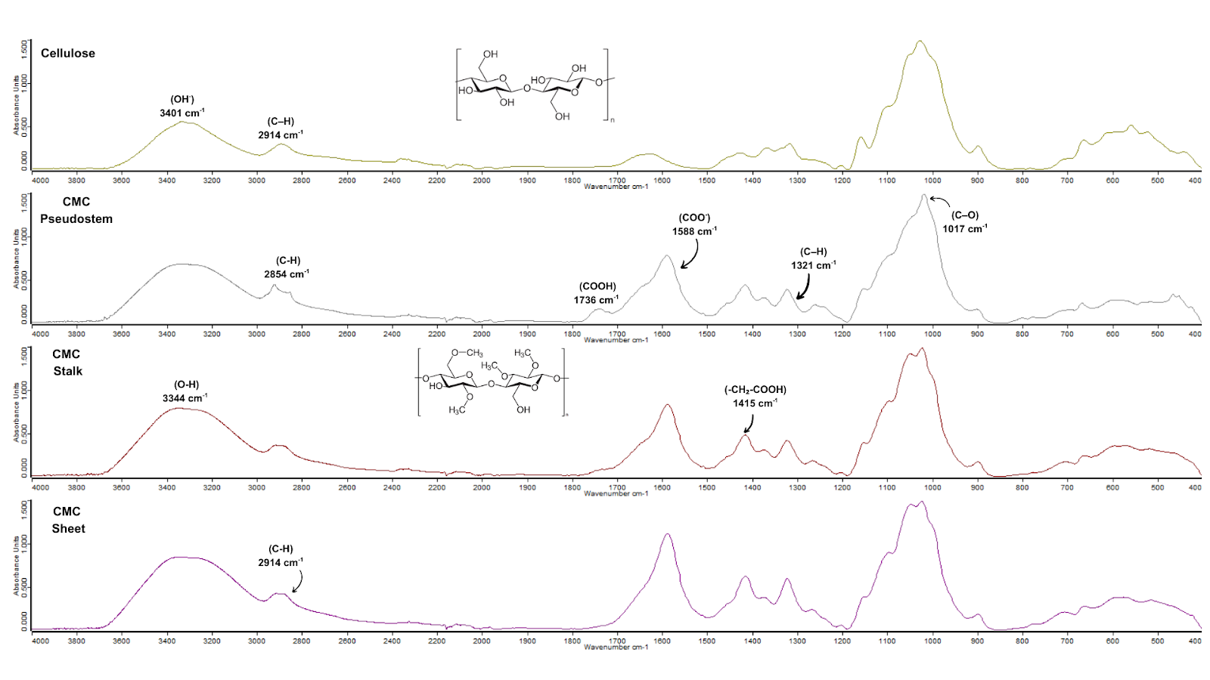
Leaf CMC
Pseudostem CMC
Rachis CMC
Raw cellulosic biomass
Figure 4: FT-IR of the Carboxymethylcellulose (CMC) biopolymers obtained
  - Conclusions
This study demonstrated the technical feasibility of transforming postharvest banana waste (pseudostem, rachis, and leaves) into high-value-added biopolymers, reinforcing the principles of the circular economy. Chemical characterization revealed that although the rachis had the highest lignin content, the purification processes were highly effective across all biomass fractions, drastically reducing non-cellulosic components and increasing α-cellulose content to levels above 73 %. Therefore, the reutilization of these biomass residues, which could represent a significant environmental liability for small farmers in the Criciúma region (SC) in Brazil, proved to be a promising strategy. Thus, the conversion of lignocellulosic biomass into CA and CMC offers a sustainable alternative to fossil-based polymers, adding value to the banana production chain.
Acknowledgments
The authors would like to thank the financial and technical support from the Funding Agency for Studies and Projects (Finep), the National Council for Scientific and Technological Development (CNPq), the Federal Institute of Santa Catarina (IFSC), and the Federal University of Santa Catarina (UFSC).
References
Ardila A.A.N., Arriola-Villaseñor E., González E.E.V., Guerrero H.E.G., Hernández-Maldonado J.A., Gutiérrez-Pineda E., Villa C.C., 2024, Enhanced Cellulose Extraction from Banana Pseudostem Waste: A Comparative Analysis Using Chemical Methods Assisted by Conventional and Focused Ultrasound, Polymers, 16, 2785.
Azriena H.A.A., Kaur K., Ilyas R.A., Kamaruddin Z.H., Neenu K.V., Dominic C.D.M., Wirawan W.A., Asrofi M., Dzulkifli M.H., Sulong M.A., Rased M.F.A., Sari N.H., Sapuan S.M., Mahardika M., 2025, Recent developments in lignocellulosic banana (Musa spp.) fiber-based biocomposites and their potential industrial applications: A comprehensive review, International Journal of Biological Macromolecules, 323, 147180.
Battisti R., Hafemann E., Claumann C.A., Machado R.A.F., Marangoni, C., 2019, Synthesis and characterization of cellulose acetate from royal palm tree agroindustrial waste, Polymer Engineering and Science, 59, 891.
Candido R.G., Gonçalves A.R., 2016, Synthesis of cellulose acetate and carboxymethylcellulose from sugarcane straw, Carbohydrate Polymers, 152, 679–686.
Daimary N., Eldiehy K.S.H., Bora N., Boruah P., Rather M.A., Mandal M., Bora U., Deka D., 2023, Towards integrated sustainable biofuel and chemical production: An application of banana pseudostem ash in the production of biodiesel and recovery of lignin from bamboo leaves, Chemosphere, 314, 137625.
Freitas R.R.M., Senna A.M., Botaro V.R., 2017, Influence of degree of substitution on thermal dynamic mechanical and physicochemical properties of cellulose acetate, Industrial Crops and Products, 109, 452.
Hafemann E., Battisti R., Bresolin D., Marangoni C., Machado R.A.F., 2020, Enhancing Chlorine-Free Purification Routes of Rice Husk Biomass Waste to Obtain Cellulose Nanocrystals, Waste and Biomass Valorization, 11, 6595–6611.
Lima Neto A.J., Deus J.A.L., Filho V.A.R., Natale W., Parent, L.E., 2020, Nutrient diagnosis of fertigated "prata" and "cavendish" banana (Musa spp.) at plot-scale, Plants, 9, 1–22.
Florencio C., Brondi M.G., Silva M.J., Bondancia T.J., Elias A.M., Martins M.A., Farinas C.S., Ribeiro C., Mattoso L.H.C., 2024, Carboxymethylcellulose production from sugarcane bagasse: A new approach in biorefinery concept, International Journal of Biological Macromolecules, 282, 136998.
Freitas P.A.V., Santana L.G., González-Martínez C., Chiralt A., 2024, Combining subcritical water extraction and bleaching with hydrogen peroxide to obtain cellulose fibres from rice straw, Carbohydrate Polymer Technologies and Applications, 7, 100491.
Guo J., Karkee M., Yang Z., Fu H., Li J., Jiang Y., Jiang T., Liu E., Duan J., 2021, Discrete element modeling and physical experiment research on the biomechanical properties of banana bunch stalk for postharvest machine development, Computers and Electronics in Agriculture, 188, 106308.
Istirokhatun T., Rokhati N., Rachmawaty R., Meriyani M., Priyanto S., Susanto H., 2015, Cellulose Isolation from Tropical Water Hyacinth for Membrane Preparation, Procedia Environmental Sciences, 23, 274–281.
Jia X., Guo D., Yan Q., Yu H., Lyu Q., Han L., Zhou C., Xiao W., 2022, Synthesis and Characterization of Corn Stover-Based Cellulose Triacetate Catalyzed by Ionic Liquid Phosphotungstate, International Journal of Molecular Sciences, 23, 6783.
Kaewprachu P., Jaisan C., Rawdkuen S., Tongdeesoontorn W., Klunklin W., 2022, Carboxymethyl cellulose from Young Palmyra palm fruit husk: Synthesis, characterization, and film properties, Food Hydrocolloids, 124, 107277.
Kinjo T., Tsuji M., Kusano T., Jinnouchi R., Makino S., Nakamura H., 2026, Effect of substitution degree and dissociation on adsorption behavior of carboxymethyl cellulose on graphite surfaces, Chemical Physics Letters, 883, 142514.
Liu Y., Zhang L., Ain Q., Tong Z., 2024, Efficient synthesis of cellulose acetate through one-step homogeneous acetylation of cotton cellulose in binary ionic liquids, International Journal of Biological Macromolecules, 281.
Paredes M.G., Pinto F., Olea F., Quijada-Maldonado E., Lavoratti A., Diejomaoh O.A., Laverock J., Eichhorn S.J., Pavez P., 2025, Production of cellulose nanocrystals using Brønsted Acidic Ionic Liquids (BAILs), based on anionic clusters with changes in the cation and anion's structure, Carbohydrate Polymers, 124030.
Patil H., Naik R., Paramasivam, S.K., 2024, utilization of banana crop ligno-cellulosic waste for sustainable development of biomaterials and nanocomposites, International Journal of Biological Macromolecules, 282.
Pereira N.R.L., Lopes B., Fagundes I.V., de Moraes F.M., Morisso, F.D.P., Parma G.O.C., Zepon K.M., Magnago R.F, 2022, Bio-packaging based on cellulose acetate from banana pseudostem and containing Butia catarinensis extracts, International Journal of Biological Macromolecules, 194, 32–41.
Rosa S.M.L., Rehman N., Miranda M.I.G., Nachtigall S.M.B., Bica C.I.D., 2012, Chlorine-free extraction of cellulose from rice husk and whisker isolation, Carbohydrate Polymers, 87, 1131-1138.
Saravanan A., Yaashikaa P.R., Kumar P.S., Thamarai P., Deivayanai V.C., Rangasamy G., 2023. A comprehensive review on techno-economic analysis of biomass valorization and conversional technologies of lignocellulosic residues, Industrial Crops and Products, 200, 116822.
Singh R.K., Pandey D., Patil T., Sawarkar A.N., 2020, Pyrolysis of banana leaves biomass: Physico-chemical characterization, thermal decomposition behavior, kinetic and thermodynamic analyses. Bioresource Technology, 310, 123464.
Sriwong C., Boonrungsiman S., Sukyai P., 2023, Sugarcane bagasse cellulose-based scaffolds incorporated hydroxyapatite for promoting proliferation, adhesion and differentiation of osteoblasts, Industrial Crops and Products, 192, 115979.
TAPPI T 222 om-02, 2002, Acid-Insoluble Lignin in Wood and Pulp Test Method, Technical Association of the Pulp and Paper Industry, TAPPI Press, Atlanta, GA.
Wang Y., Yang Y., Qu Y., Zhang J., 2021, Selective removal of lignin with sodium chlorite to improve the quality and antioxidant activity of xylo-oligosaccharides from lignocellulosic biomass, Bioresource Technology, 337, 125506.
Wisansakkul S., Oupathumpanont O., 2026, Physicochemical properties of banana leaves at different growth stages: Effects of bleaching and natural dyeing with lac, butterfly pea, and turmeric, South African Journal of Chemical Engineering, 55, 131–141.

