 CHEMICAL ENGINEERING TRANSACTIONS  VOL. xxx, 2026 | A publication of  
The Italian Association
of Chemical Engineering
Online at www.cetjournal.it

Guest Editors: Leonardo Tognotti, Rubens Maciel Filho, Viatcheslav Kafarov
Copyright © 2026, AIDIC Servizi S.r.l.
ISBN 979-12-81206-xx-x; ISSN 2283-9216

Comparative Study of Liquid Biofuel Production Pathways for a Sustainable Mobility Solution
Aristide Giuliano*, Antonio Ricca, Nicola Pierro, Pietro Garzone, Maria Teresa Petrone, Isabella De Bari
ENEA—Italian National Agency for New Technologies, Energy and Sustainable Economic Development, Rome, 00196, Italy
aristide.giuliano@enea.it
This study evaluates multiple biorefinery pathways for the production of liquid biofuels. Feedstocks considered include vegetable oils, lignocellulosic residues and wastes, and dedicated energy crops. Conversion schemes analyzed comprise technologies with high Technology Readiness Level (≥7) and scalable to commercial production: thermochemical routes followed by syngas synthesis for methanol; production of bioliquids via thermal liquefaction such as pyrolysis or hydrothermal liquefaction; bioethanol and transesterification or hydrogenation of vegetable oils/used cooking oils. Performance indicators include mass and carbon yields, energy conversion efficiencies, production costs expressed and environmental impact metrics such as CO₂‑equivalent emissions. The results quantitatively compare the techno-economic and environmental performance of the examined pathways, identifying feedstock type, plant scale, and integration conditions that boost competitiveness. Feedstock emerges as the key factor, influenced by energy density and water content, with vegetable-oil routes leading in drop-in biofuel production, energy efficiency, and carbon yield (>80%). Methanol and biocrude/pyro-oil pathways show promise using residues without hydrogen, achieving <30 kgCO₂/GJ and <50 €/GJ. These evaluations are intended to inform the feasibility assessment of an innovative sustainable mobility system, the Off‑Board Hybrid, consisting of a liquid‑biofuel‑fired electric generator operating in island mode and coupled to electric vehicle charging stations.
  - Introduction
Liquid biofuels remain essential for sustainable mobility, with their future deployment hinging on sustainable feedstock availability, technology maturity, and the EU's stringent emissions regulations. In 2024, they represented Europe's primary renewable transport energy source, delivering over 17 million tonnes of oil equivalent (Mtoe)—about 7% of final transport consumption (284 Mtoe total). Under RED III multiplication factors, total biofuel consumption is projected to reach 38–42 Mtoe by 2030 and ~80 Mtoe by 2050, including aviation and maritime sectors. Due to environmental concerns like food chain competition and indirect land-use change (ILUC), first-generation biofuels are capped at 7% of transport energy, with high-ILUC-risk fuels phasing out entirely by 2030. Georeferenced biomass data enables identification of local hotspots for targeted value chains, such as HEFA (Hydroprocessed Esters and Fatty Acids) from used cooking oil or hydrothermal liquefaction pathways using sewage sludge. Within this framework, many innovative biorefinery process approaches are being developed, particularly for the production of sustainable triglyceride sources (Caporusso et al., 2022).
    - Overview of Liquid Biofuels
Liquid biofuels can be classified by feedstock type (sugars/starches, lignocellulosics, lipids, wet wastes, solid residues) and conversion technology (biochemical, thermochemical, catalytic). First generation ethanol is produced via fermentation from sugary (sugarcane, molasses) or starchy (corn, wheat) feedstocks, through enzymatic hydrolysis of starches to glucose followed by alcoholic fermentation with yeasts. First-generation bioethanol uses food or feed crops, offering high yields and commercial technologies, but faces criticism over ILUC and food competition. Second generation bioethanol utilizes lignocellulosic biomass (agricultural residues, straws, wood, perennial grasses), requiring physicochemical pretreatments (steam explosion, organosolv, dilute acids) to break down the matrix. This is followed by enzymatic hydrolysis of cellulose to fermentable sugars and fermentation, with ongoing challenges in enzyme costs, inhibitors, and plant energy integration. Biomethanol is obtained thermochemically from syngas generated by gasification of solid biomass or wastes. FAME derives from transesterification of triglycerides with a light alcohol (typically methanol) using homogeneous or heterogeneous basic catalysts. Feedstocks are lipid mixtures: vegetable oils (soy, rapeseed, palm, sunflower), animal fats, UCO, yellow/brown grease, or non-edible oils (jatropha, carinata) to avoid food competition. HEFA are paraffinic hydrocarbons from lipid hydrotreatment (feedstocks match FAME). Conversion involves hydrodeoxygenation, decarboxylation, and decarbonylation of lipid chains with hydrogen and sulfide or noble catalysts, saturating double bonds and controlled cracking to target desired distillation ranges. Pyrolysis oil is a liquid intermediate from fast pyrolysis of dry lignocellulosics. In fluidized or circulating bed reactors, with seconds residence time and 450–550 °C, bio-oil yield is maximized alongside biochar and gas. Raw bio-oil is highly oxygenated, acidic, and unstable, unfit for direct use in internal combustion engines. In both cases, the "real" feedstock for final fuel is lignocellulosic biomass, with pyrolysis liquid as a bridge to existing infrastructure. HTL biocrude is produced by treating wet biomass (algae, sewage sludges, wet organic residues) in subcritical water. The key advantage is using high-water-content feedstocks without drying, unlike pyrolysis. The main product is dense, viscous biocrude with lower oxygen than pyrolysis oil but still requiring hydrotreatment upgrading for fuel standards.
    - Off-Board Hybrid system and aim of the work
The Off-Board Hybrid system integrates biofuels into an "island-mode" electric generator coupled to Electric Vehicle (EV) charging stations, ideal for remote areas. It leverages bio carbon neutrality, existing fuel infrastructure, and EV efficiency, outperforming full electric (unstable grids) or pure Internal Combustion Engines (ICE) (Giuliano et al., 2025a). The objective of this study is to quantitatively assess the techno-economic and environmental performance of multiple biorefinery pathways for liquid biofuel production, identifying feedstocks, scales, and integration conditions that maximize competitiveness. Key indicators include mass/carbon yields, energy efficiencies, costs and CO₂-eq emissions. The results support the feasibility evaluation of the innovative Off-Board Hybrid system for sustainable mobility: a liquid biofuel-powered electric generator in island mode, coupled to EV charging stations.
  - Methodology
To rigorously compare different liquid biofuels, it is essential to combine techno-economic analysis tools, biomass availability assessments, and environmental evaluations. The most established approach for cost comparison is Techno-Economic Analysis (TEA), based on a representative plant model with mass/energy balances and cost estimation. Process modeling yields, energy consumption, utility needs, and equipment sizing for each biofuel production pathway. To ensure comparability, costs are typically expressed in €/GJ of fuel, as different biofuel types have highly variable energy densities (e.g., 44 MJ/kg for renewable diesel vs. <20 MJ/kg for biomethanol). Pathway comparisons are meaningful only if feedstocks are realistically available and sustainable in the context considered. These approaches reveal, for example, that biofuels from dedicated crops face high cultivation emissions unless marginal/contaminated lands are valorized. Medium- to long-term potential will largely come from residues and wastes, directly impacting comparisons between Fatty Acids Methyl Esters (FAME) from virgin oils and HEFA/HTL from waste feedstocks.
Table 1: Studied feedstock dataset (Pierro et al., 2021; Djomo et al., 2023)
Type | Source | Biorefinery size  (kt_{DRY}/y) | Cost  (€/t_{DRY}) | Supply Emissions  (kg_{CO2eq}/kg_{DRY}) | Carbon into the Feedstock  (kmolC/t_{DRY}) | LHV  (MJ/kg_{DRY})
Vegetable Oil | Dedicated Crops | 100-700 | 600-1200 | 1.00-2.00 | 60-70 | 30-40
Vegetable Oil | Used Cooking Oil | 300-900 | 400-800 | 0.10-0.15 | 60-70 | 30-40
1st Gen. Sugars | Dedicated Crops | 200-600 | 200-400 | 0.40-0.80 | 30-40 | 15-20
Lignocellulosic | Dedicated Crops | 100-500 | 70-110 | 0.15-0.40 | 35-45 | 15-20
Lignocellulosic | Wastes and residues | 100-500 | 50-90 | 0.05-0.20 | 35-45 | 15-20
Lignocellulosic | High-moisture wastes | 10-50 | 30-60 | 0.01-0.10 | 35-45 | 15-20

Table 2: Target liquid biofuels dataset (International Energy Agency, 2025; Tito et al., 2023; Giuliano et al., 2025b)
Type | MW Biofuel (kg/kmol) | Carbon into the Fuel  (kmolC/t_{DRY}) | LHV (MJ/kg) | End life emissions (kg_{CO2}/kg)
HEFA | 212 | 71.0 | 44.0 | 3.1
FAME | 288 | 62.0 | 37.0 | 2.7
Methanol | 32 | 31.3 | 19.9 | 1.4
Ethanol | 46 | 43.5 | 26.0 | 1.9
Biocrude | - | 61.1 | 33.2 | 2.7
Pyro-oil | - | 54.2 | 30.0 | 2.4
    - Data Sources and Processing
Table 1 provides a comprehensive dataset of feedstocks studied for biorefineries, structured to facilitate comparative analyses on versatility, scalability, and economic-environmental sustainability. It catalogs representative feedstocks for liquid biofuel biorefineries, differentiated by chemical category: vegetable oils (from dedicated crops or waste cooking oil), first-generation sugars, and lignocellulosics subdivided into crops, wastes/residues, and high-water-content materials. For each feedstock, capacity ranges (kt/year on dry basis) of existing or scaled biorefineries are indicated, reflecting logistical and supply constraints: from small scale for wet/local wastes to medium/large for dedicated crops with structured supply chains. Supply costs (including production, collection, transport, and any shredding pretreatments) distinguish high-value feedstocks (oils from crops) from low-cost ones (lignocellulosic residues). Supply emissions (cradle-to-gate), molar carbon content, and dry-basis LHV are also reported. Oils stand out for high C content and calorific value (ideal for energy-dense biofuels), while lignocellulosics and sugars offer moderate values but potentially high volumes, with emissions decreasing from crops to residues or high-moisture materials. This structure enables rapid screening for techno-economic assessments and preliminary environmental evaluations in biorefinery design also by using data and approach of Giuliano et al. (2024). The IEA 2025 transport dataset (International Energy Agency, 2025) benchmarks key properties of advanced liquid biofuels (Table 2), spanning first-generation alcohols and esters to second-generation thermal and biological conversion products. HEFA and FAME stand out with higher molecular uniformity and carbon yields, reflecting lipid-derived pathways suited for drop-in diesel and jet fuels. Alcohols like methanol and ethanol show lighter profiles, enabling easier blending but with moderate energy content. Biocrude and pyro-oil exhibit broader compositional variability from biomass thermochemical routes, balancing yield potential against processing needs. Lower heating value correlates with oxygenated structures, positioning hydrotreated options favorably for aviation and heavy transport where density matters. End-life emissions vary by oxidation state and combustion completeness, with alcohols benefiting from cleaner profiles despite lower energy density. Table 3 provides a comprehensive overview of the main technological pathways for producing liquid biofuels from biomass, grouping combinations by final product type, feedstock, and biorefinery process category.
Table 3: Conversion technologies to liquid biofuels (Ge et al., 2025; Zhu et al., 2025; Vasilakou et al., 2023)
Liquid Biofuel | Type | Raw material | Main Processes | Biofuel yield (t/t_{F,DRY}) | H₂ demand (t/t_{F,DRY}) | MeOH demand (t/t_{F,DRY})
HEFA | Catalytic | Vegetable Oil | HydroDeOxygenation | 80% | 4% | 0%
FAME | Catalytic | Vegetable Oil | Transesterification | 96% | 0% | 11%
MeOH | Thermochemical + Catalytic | Lignocellulosic | Gasification + Synthesis | 20% | 0% | 0%
MeOH | Thermochemical + Catalytic | Lignocellulosic | Gasification + H₂ enrichment + Synthesis | 60% | 10% | 0%
EtOH | Biochemical | Lignocellulosic | Pretratment + Hydrolysis + Fermentation | 20% | 0% | 0%
EtOH | Biochemical | 1st Gen. Sugars | Fermentation | 40% | 0% | 0%
Biocrude | Thermochemical | Lignocellulosic | HydroThermal Liquefaction | 29% | 0% | 0%
Pyro-Oil | Thermochemical | Lignocellulosic | Pyrolysis | 30% | 0% | 0%

Two pathways converge on vegetable oil conversion via catalytic processes: one employs hydrodeoxygenation to produce HEFA using hydrogen, the other transesterification to yield FAME using methanol. Both are mature, selective processes targeted at drop-in biofuels (HEFA) or conventional biodiesel (FAME). Lignocellulosics can be converted through one-step thermochemical processes (pyrolysis for pyro-oil, hydrothermal liquefaction for highly wet matrices to produce biocrude) or combined routes (gasification followed by methanol synthesis, with or without H₂ enrichment). These chains prioritize syngas as a gaseous intermediate toward liquids, with variants modulating external hydrogen demand. Fermentation and biotechnological processes are central for ethanol production, from first-generation sugars (directly) or lignocellulosics (preceded by pretreatment and hydrolysis). These combinations leverage biological routes for oxygenated biofuels, distinct from thermochemical ones due to lower energy intensity but greater upstream complexity. Further, relevant quantities of reactants/energy carrier (methanol or hydrogen) have da be considered, in particular for the production of FAME (using methanol), HEFA or biomethanol (using hydrogen). Hydrogen can be obtained through electrolysis using renewable energy, typically with emissions ranging from 0 (if from renewable energy surpluses) to 2 kg_{CO₂eq}/kg_{H₂}, but at very high costs of 5-10 €/kg_{H₂}. In contrast, medium-to-high emission hydrogen—depending on whether CO₂ storage from Steam Methane Reforming (SMR) is used—can be produced at much lower costs of 2-3 €/kg_{H₂}. Methanol, as expected, can be derived from fossils with high emissions (2.2 kg_{CO₂eq}/kg_{MeOH}) or from biomass as assessed in this study, with wide ranges of costs and emissions.
    - Bioresource conversion performance indeces
Several performance indicators were evaluated and compared, such as the energy efficiency of different biorefinery pathways, considering two perspectives: biomass only, and biomass plus external vectors like hydrogen and methanol:
$$η_{E}=\frac{y_{Biofuel}{LHV}_{Biofuel}}{{LHV}_{Feedstock,dry}}$$ | (1)
$$η_{E,NET}=\frac{y_{Biofuel}{LHV}_{Biofuel}}{{LHV}_{Feedstock,dry}+d_{H2}{LHV}_{H2}+d_{MeOH}{LHV}_{MeOH}}$$ | (2)
In the first indicator (Eq. 1), the fraction of the original biomass energy transferred to the final biofuel is measured, excluding external energy contributions. Here, pathways with shorter conversion chains and lower thermal losses perform better. In the second indicator (Eq. 2), efficiency is "penalized" by energy from additional green hydrogen and methanol inputs, thus favoring configurations requiring fewer external inputs or using them highly efficiently. The final evaluated efficiency indicator is molar, calculating the amount of carbon from the feedstock successfully converted into biofuel, net of carbon lost to char, CO₂, and other by-products.
  - Results
    - Liquid biofuel analysis
Figure 1 compares the efficiencies (Eq. 1 and Eq. 2) of eight possible feedstock-process-biofuel combinations across three key metrics. Energy yield measures energy recovery from feedstock to biofuel, highlighting the clear superiority of catalytic processes from vegetable oils over thermochemical or biochemical routes from lignocellulosics. This is largely due to the higher energy content (LHV of the feedstock) and purity (triglycerides) of oils.
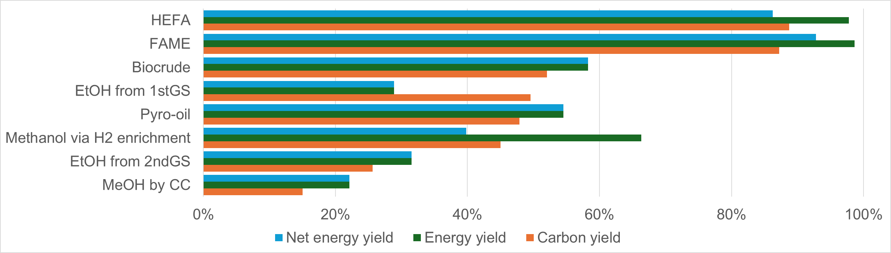
Figure 1: Biofuel production performances
As per Eq. 2, net yield incorporates external H₂ and MeOH energy contributions into the calculation, assuming the rest of the conversion process can be thermally self-sustained using waste (Gilardi et al., 2024) streams. Catalytic oil-based processes remain the best performers, but the gap with others narrows. Some thermochemical routes with targeted inputs (biocrude, pyro-oil, EtOH) gain competitiveness, showing sensitivity to reliance on supplementary energy vectors—even for non-oil biofuels (MeOH via enrichment). Carbon yield tracks C conservation from biomass to product, with patterns similar to gross yield but emphasizing atomic efficiency: drop-in oil processes excel, while gasification/synthesis requires optimization to minimize losses. Overall, the chart discriminates "autonomous" pathways (high gross/net yields with minimal extra inputs) from H₂-dependent ones, guiding choices for biorefineries integrated with green hydrogen.
    - Economic and environmental aspects
The scatter plot of Figure 2, vividly maps liquid biofuel pathways on cost-emissions axes, with ellipses denoting variability ranges for each type. Generally, the lower the quality (and thus supply emissions) of the raw material, the higher the costs associated with its use/conversion; conversely, higher-impact feedstocks correspond to lower costs. For example, ethanol's broad ellipse spans low-cost/high-emission (first-generation sugar crops) to high-cost/low-emission (second-generation lignocellulosic residues), illustrating feedstock-driven shifts in land-use and processing impacts. FAME's wide emissions but narrow cost ellipse highlights progression from high-impact oilseeds to low-impact UCO, with costs converging alongside emissions. HEFA overlaps similarly, with hydrogen (renewable vs. fossil) expanding its emissions footprint while minimally affecting costs due to low dosage. Methanol's compact, mid-range position signals cost resilience amid moderate emissions, challenged by conversion CO₂ and H₂ sourcing despite calorific drawbacks. Biocrude and pyro-oil are atypical liquid fuels, as they consist not of precise molecules but of mixtures of a wide range of organic compounds—mostly oxygenated—often unstable and unusable in internal combustion generation systems, neither alone nor blended with conventional fuels. Consequently, it is consistent that their costs and emissions are low. In contrast, their transformation into drop-in fuels (e.g., via hydrogenation) or energy (e.g., electricity) is far more complex than for the others described and analyzed so far. Regarding the conversion of the analyzed liquid biofuels into useful electricity to power EV charging stations, three main standalone electricity generation system types must be distinguished: ICE generators (ICE engine + alternator), fuel cells (direct electricity), and generators coupling an alternator with an external combustion engine (ECE).
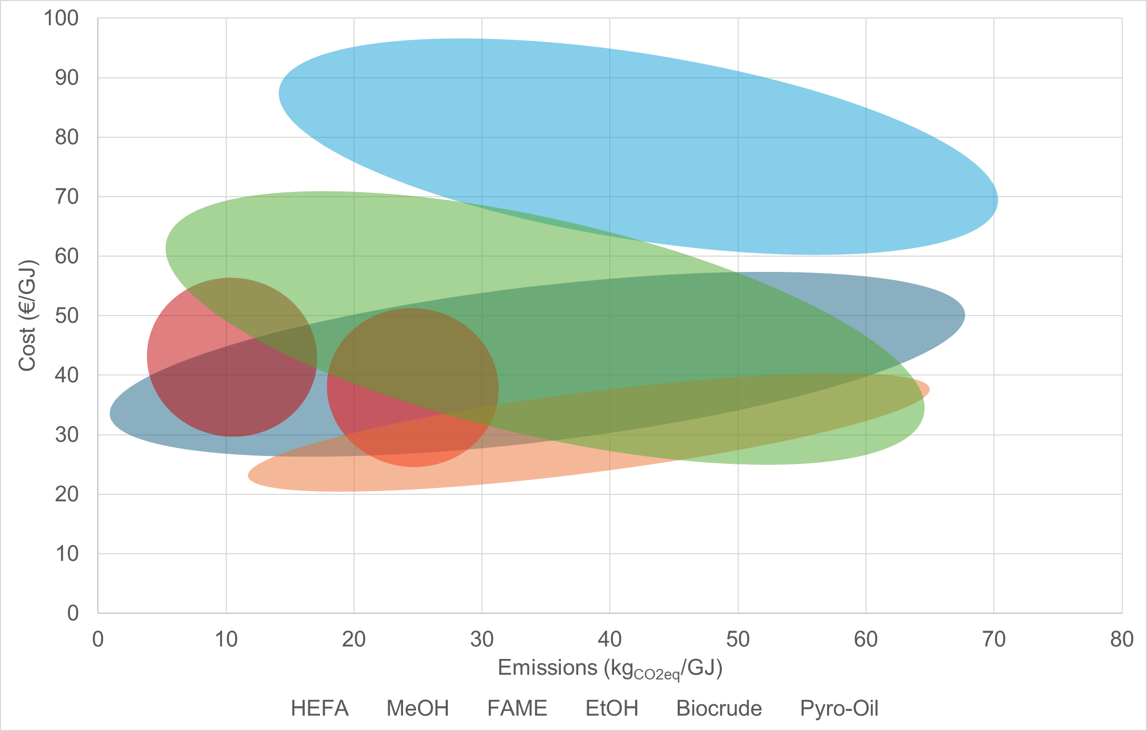
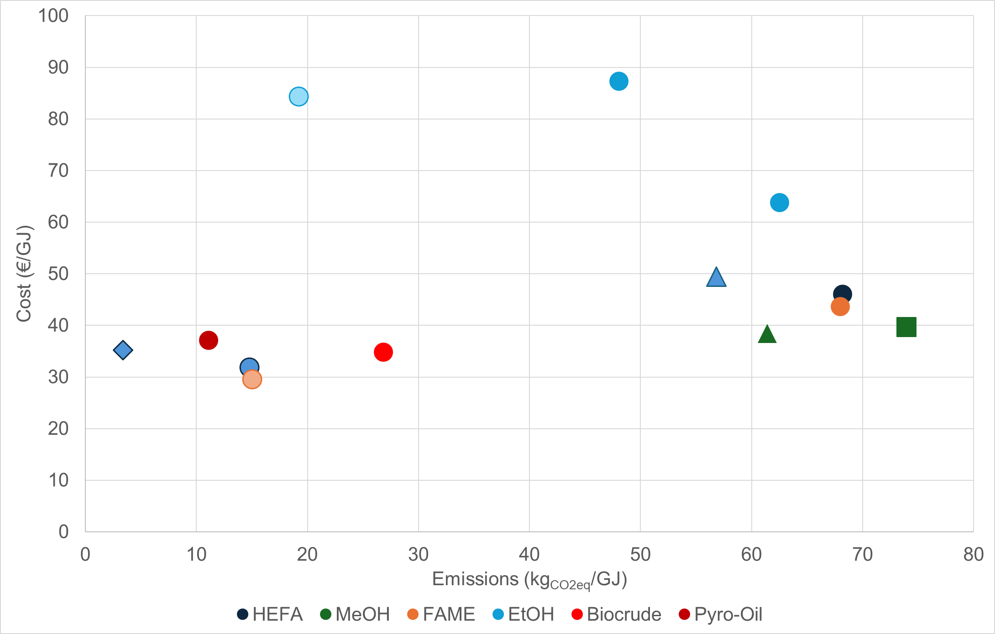
Figure 2: Liquid biofuel Cost-Emissions trade-off plot
  - Conclusions
This study evaluates eight feedstock-process-biofuel pathways, revealing clear efficiency hierarchies. Vegetable oil catalytic routes (HEFA, FAME) lead in gross energy yield due to high feedstock lower heating value and triglyceride purity, outperforming lignocellulosic thermochemical/biochemical conversions. Net yields narrow gaps with external hydrogen/methanol inputs, highlighting green hydrogen's role for non-oil pathways. Carbon conservation favors drop-in oils over gasification-synthesis losses. The cost-emissions trade-off shows inverse correlation: residues incur high processing costs but low emissions (e.g., ethanol's broad ellipse), while FAME/HEFA converge on used cooking oil. Biocrude/pyro-oil occupy low-cost/low-emission niches as non-drop-in intermediates. For off-board hybrid EV charging, internal combustion engines, fuel cells, and external combustion engines provide flexibility based on biofuel quality. Oil-based catalytic pathways offer near-term scalability; hydrogen-enabled thermochemical routes promise future advances, guiding biorefinery design with EU decarbonization goals.
Nomenclature

d_{i} – demand of hydrogen or methanol, kg_{i}/kg_{Feedstock,dry}
η_{E} – Energy efficiency, %
η_{E,NET} – Net energy efficiency, %
y_{Biofuel} – mass yield to biofuel, kg_{Biofuel}/kg_{Feedstock,dry}
Acknowledgments
The present work was funded by the Italian Ministry of Environment and Energy Security through the “National Electric System Research” Program–Project 1.10 “Bioenergie” 2025–2027 implementation plan.
References

Caporusso A., Giuliano A., Liuzzi F., De Bari I., 2022. Techno-economic Analysis of a Lignocellulosic Biorefinery Producing Microbial Oils by Oleaginous Yeasts. Chemical Engineering Transactions 92, 637–642. https://doi.org/10.3303/CET2292107
Djomo S.N., Staritsky I., Elbersen B., Annevelink B. (E. ), Gabrielle B., 2023. Supply costs, energy use, and GHG emissions of biomass from marginal lands in Brittany, France. Renewable and Sustainable Energy Reviews 181, 113244. https://doi.org/10.1016/j.rser.2023.113244
Ge L., Ali M.M., Osman A.I., Elgarahy A.M., Samer M., Xu Y., Liu Z., 2025. A critical review on conversion technology for liquid biofuel production from lignocellulosic biomass. Renewable and Sustainable Energy Reviews 217, 115726. https://doi.org/10.1016/j.rser.2025.115726
Gilardi M., Bisotti F., Berglihn O.T., Rücker T., Brück T., Wittgens B., 2024. Modelling of Biomass-to-X: Challenges and Strategies. Chem. Eng. Trans. 109, 271–276. https://doi.org/10.3303/CET24109046
Giuliano A., Brancaccio, D., Ricca, A., Polverino, P., De Bari, I., 2025a. Biofuels for an off-board hybrid solution avoiding the overloading of the electricity grid producing power for a more sustainable mobility. Chemical Engineering Transactions 119.
Giuliano, A., Robinson Medici A., Barletta D., 2025b. Integrating Techno-Economic and Environmental Criteria in the Design and Optimization of a Full Utilization Multiproduct Lignocellulosic Biorefinery. ACS Sustainable Chem. Eng. 13, 1961–1973. https://doi.org/10.1021/acssuschemeng.4c06590
Giuliano A., Stichnothe H., Pierro N., De Bari I., 2024. Techno-Economic Analysis of Territorial Case Studies for the Integration of Biorefineries and Green Hydrogen. Energies 17, 5966. https://doi.org/10.3390/en17235966
International Energy Agency, 2025. Delivering Sustainable Fuels; Pathways to 2035.
Pierro N., Giocoli A., Motola V., Dipinto S., 2021. Valutazione disponibilità biomasse agro-industriali a livello nazionale e loro pubblicazione sul portale Webgis atlante delle biomasse [WWW Document]. URL https://iris.enea.it/handle/20.500.12079/56881 (accessed 10.17.23).
Tito E., Zoppi G., Pipitone G., Miliotti E., Fraia A.D., Rizzo A.M., Pirone R., Chiaramonti D., Bensaid S., 2023. Conceptual design and techno-economic assessment of coupled hydrothermal liquefaction and aqueous phase reforming of lignocellulosic residues. Journal of Environmental Chemical Engineering 11, 109076. https://doi.org/10.1016/j.jece.2022.109076
Vasilakou K., Nimmegeers P., Thomassen G., Billen P., Van Passel S., 2023. Assessing the future of second-generation bioethanol by 2030 – A techno-economic assessment integrating technology learning curves. Applied Energy 344, 121263. https://doi.org/10.1016/j.apenergy.2023.121263
Zhu J., Feng L., Yu C., Wu L., 2025. Renewable methanol production from biomass gasification coupled with green hydrogen: Process design and economic assessment. International Journal of Hydrogen Energy 191, 151693. https://doi.org/10.1016/j.ijhydene.2025.151693

