 CHEMICAL ENGINEERING TRANSACTIONS  VOL. xxx, 2026 | A publication of  
The Italian Association
of Chemical Engineering
Online at www.cetjournal.it

Guest Editors: Leonardo Tognotti, Rubens Maciel Filho, Viatcheslav Kafarov
Copyright © 2026, AIDIC Servizi S.r.l.
ISBN 979-12-81206-xx-x; ISSN 2283-9216

Hydrothermal Carbonization of Residual Biomass for Functional Hydrochars in Emission Reduction of Bituminous Materials
Federica Barontini*, Hongjun Dong, Chiara Riccardi, Massimo Losa, Cristiano Nicolella, Sandra Vitolo, Monica Puccini
Dipartimento di Ingegneria Civile e Industriale, Università di Pisa, Largo Lucio Lazzarino 2, 56122 Pisa, Italy.
federica.barontini@unipi.it
This study investigates the use of hydrochar as a bio-based functional additive for the mitigation of volatile organic compound (VOC) emissions from bituminous binders. The work contributes to the development of more sustainable construction materials through the valorisation of locally available residual biomass and the reduction of hazardous fume emissions associated with asphalt production and paving operations. Hydrothermal carbonization (HTC) was applied to the invasive aquatic biomass Myriophyllum aquaticum, converting it into a carbon-rich hydrochar under operating conditions selected to maximise carbon yield (200 °C, 30 min, 25 wt% solid load). The produced hydrochar, characterised by 50.31 wt% carbon content and elemental ratios H/C = 1.11 and O/C = 0.42, was incorporated into bitumen at 10 wt% and evaluated through headspace gas chromatography–mass spectrometry analysis. Compared to virgin bitumen, the hydrochar-modified binder exhibited a 23.9% reduction in total VOC emissions and a 25.4% reduction in the cumulative content of the most toxic VOCs. The results demonstrate the potential of converting invasive biomass into functional carbon materials for internal emission control in bituminous products, supporting circular resource use and the transition toward lower-emission road infrastructure.
  - Introduction
The transition towards a competitive, climate-neutral and circular economy is a central pillar of the European Union’s policy framework, as reaffirmed by the updated EU Bioeconomy Strategy. In this context, replacing fossil-based resources with sustainable biological feedstocks and developing innovative bio-based materials are key enabling pathways. Biomass conversion technologies capable of valorising heterogeneous and low-value residual streams therefore play a strategic role in achieving environmental objectives while supporting industrial competitiveness.
Hydrothermal carbonization (HTC) is an emerging thermochemical conversion process that enables the direct treatment of wet residual biomass under subcritical conditions (typically 180–270 °C in aqueous media), producing a carbon-rich solid product known as hydrochar (Wang et al., 2018). Compared to conventional pyrolysis-based routes, HTC operates at lower temperatures, avoids biomass pre-drying and is particularly suited for processing heterogeneous and high-moisture feedstocks (Singh et al, 2024). While hydrochars have been widely investigated as solid biofuels (Sharma et al., 2020) and soil amendments (Islam et al., 2021), their potential as functional bio-based materials for gas-phase adsorption applications remains largely unexplored.
This work presents an integrated approach for the production of hydrochar from locally available residual biomass, and its use as a bio-based functional material for emission reduction. Hydrochar was incorporated as additive in bituminous binders, a sector still strongly dependent on fossil-derived materials and associated with significant emissions of volatile organic compounds (VOCs) and polycyclic aromatic hydrocarbons (PAHs) during the production, paving and service life of bituminous pavements.
The road construction sector represents a relevant and still unresolved environmental hotspot. In Europe alone, approximately 270 million tonnes of bituminous mixtures are produced annually. During the production, mixing and laying of hot mix asphalt, significant emissions of VOCs and PAHs are generated, primarily due to the devolatilization of organic components in the bituminous binder. These emissions pose documented occupational and environmental health risks, affecting asphalt plant workers, paving crews and populations exposed in urban environments.
Current mitigation strategies mainly rely on indirect approaches, most notably warm mix asphalt technologies, which reduce production temperatures and consequently lower emission rates. While effective in many cases, such strategies may present limitations related to mechanical performance, long-term durability, production costs and operational constraints. More recently, additive-based strategies have been explored, including polymers, recycled materials, zeolites and carbonaceous adsorbents (Deller et al., 2024). Among these, solid adsorbents such as biochar and activated carbon have shown promising reductions in selected VOC emissions under controlled laboratory conditions (Deller et al., 2024).
The present study proposes the innovative use of hydrochar for the internal mitigation of VOC and PAH emissions. The novelty of the proposed approach lies not only in the use of hydrochar as an adsorbent for gas phase pollutants, but especially in its application as a functional additive integrated within a complex solid matrix. The majority of hydrochar research has focused on adsorption in aqueous systems, targeting heavy metals, dyes, pesticides and pharmaceutical compounds (Jalilian et al., 2024). Only a very limited number of studies have investigated hydrochar performance in gas-phase VOC adsorption, typically using model compounds under simplified laboratory conditions (Zhang et al., 2019, 2020). Even more notably, there is currently no scientific evidence addressing the integration of HTC-derived hydrochar within bituminous matrices for the internal mitigation of VOC and PAH emissions.
The present work addresses this gap by proposing an integrated approach combining:
- the valorisation of locally available low-value residual biomass through HTC;
- the production of tailored hydrochars with adsorption functionality;
- the incorporation of hydrochar as a functional additive directly within bituminous binders to enable internal, source-level emission mitigation.
This approach introduces the concept of internal emission control, moving beyond conventional end-of-pipe or temperature-reduction strategies. By direct interaction with pollutants during their formation and release inside the binder, the system enables source-level mitigation of VOC and PAH emissions during asphalt production, paving and potentially throughout service life.
From a regulatory and policy perspective, the proposed approach is fully aligned with the European Union Green Public Procurement framework and the broader objectives of the European Green Deal, particularly those related to circular economy, resource efficiency and life-cycle environmental performance. At national level, it is consistent with the Italian Minimum Environmental Criteria (CAM) for road infrastructures, which promote the use of secondary raw materials, reduced life-cycle impacts and the mitigation of pollutant emissions in construction materials. Integrating HTC within local waste management systems further enables the development of short circular supply chains, reducing disposal costs and contributing to the decarbonisation of the asphalt production sector.
  - Materials and Methods
    - Raw materials
In this study, a 70/100 virgin bitumen was chosen as the reference binder.
The residual biomass selected for hydrochar production was Myriophyllum aquaticum (Vell.) Verdc., an invasive aquatic macrophyte widely distributed in water ecosystems. In Tuscany (Central Italy), this species has extensively colonized reclamation channels within the Lake Massaciuccoli catchment area, requiring periodic mechanical removal to preserve hydraulic efficiency. These maintenance operations generate significant quantities of wet biomass, currently managed as biological waste, representing a locally available low-value feedstock suitable for thermochemical valorisation. Biomass was collected from the Barra channel (Lake Massaciuccoli basin, Tuscany, Italy). After harvesting, the material was washed with tap water to remove sediments and adhering impurities, oven-dried at 105 °C, and milled prior to HTC processing. Biomass characterisation included proximate analysis (volatile matter (VM), fixed carbon (FC), and ash content) and ultimate analysis (C, H, N, O). The results are reported in Table 1.
Table 1: Results of biomass characterisation (dry basis)
VM [wt %] | FC [wt %] | Ash [wt %] | C [wt %] | H [wt %] | N [wt %] | O [wt %]
68.91 | 16.80 | 14.29 | 38.40 | 4.82 | 1.96 | 40.53

    - Hydrochar preparation
The HTC process was carried out in a 300 mL stirred stainless-steel reactor, equipped with temperature and pressure transducers and a process controller (Parr Instrument Company, Moline, Illinois, USA) (Figure 1). The reactor was initially loaded with biomass and deionised water. Additional details regarding the experimental setup and procedure are provided elsewhere (Barontini et al., 2026). Following the HTC process, the obtained slurry was retrieved from the reaction vessel, and the solid fraction, i.e., hydrochar, was separated by vacuum filtration, rinsed with water, and dried at 105 °C for 12 h.
    - Modified bitumen preparation
The hydrochar was blended with the base bitumen using a high shear mixer at 160 °C for 30 minutes to ensure homogeneous dispersion. A dosage of 10 wt% hydrochar, calculated with respect to the bitumen weight, was adopted for the modification. The reference binder was subjected to the same mixing procedure to account for thermal aging.

    - Bitumen emission evaluation
Fume emissions were analysed by headspace gas chromatography–mass spectrometry (HS-GC-MS). For each test, approximately 0.10 g of sample was introduced into a 22 mL headspace vial. The automated headspace sampler performed the extraction procedure by heating the vials at 180 °C for 30 min. Compound identification relied on mass spectral libraries, while quantification was based on the calibration of toluene used as the reference standard.
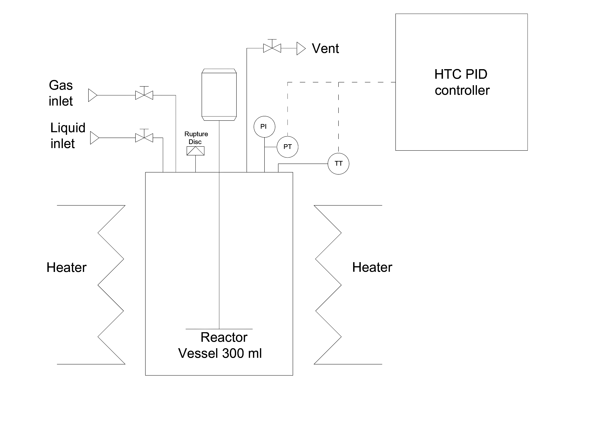
Figure 1: Scheme of the HTC reactor

  - Results and Discussion
    - Hydrochar production
Hydrothermal carbonization (HTC) of Myriophyllum aquaticum converts the invasive wet biomass into a carbon-rich solid product (hydrochar), together with an aqueous phase containing soluble organic intermediates and a minor gaseous fraction.
In their recent work, the authors systematically explored the HTC of Myriophyllum aquaticum by applying a Design of Experiments – Response Surface Methodology (DoE–RSM) approach, assessing the combined effects of temperature (200–260 °C), residence time (30–210 min), and solid load (5–25 wt%) on hydrochar yield and properties (Barontini et al., 2026). Statistically validated parametric models were developed, allowing prediction and optimisation of hydrochar yield, carbon yield, higher heating value, and energy yield.
The hydrochar was evaluated primarily for two valorisation pathways: use as a solid biofuel, based on heating value and energy yield; and use as a soil amendment, including agronomic suitability and phytotoxicity assessment (Barontini et al., 2024).
Building upon these results, the present study explores a further application, namely the use of M. aquaticum-derived hydrochar as a functional adsorbent for the mitigation of VOC emissions from bituminous materials. This represents a different valorisation pathway, shifting from energy and soil applications toward environmental emission control in construction materials.
To this aim, the HTC operating conditions were selected based on the optimisation results previously obtained (Barontini et al., 2026). In particular, the conditions that maximised carbon yield were adopted. Carbon yield, defined as the fraction of initial biomass carbon retained in the solid hydrochar, is a key parameter when targeting carbon-material applications, as it reflects carbon retention efficiency and structural development in the solid phase. According to the optimisation study, maximum carbon yield was achieved under low-severity and high-solid-load conditions (Table 2). These conditions were therefore employed for hydrochar production in the present work.
The hydrochar produced under these operating conditions exhibited a carbon content of 50.31 wt% (dry basis) and an ash content of 14.52 wt%. The elemental ratios (H/C = 1.11; O/C = 0.42) indicate a partially aromatized carbon structure with a significant presence of oxygen-containing surface functionalities. The moderate H/C value suggests the formation of incipient aromatic domains, while the relatively high O/C ratio reflects the retention of hydroxyl, carbonyl, and carboxyl groups typical of hydrochars obtained at moderate HTC severity. Such physicochemical characteristics are particularly relevant for adsorption applications, as both aromatic carbon domains and oxygenated surface groups can influence interactions with volatile organic compounds.
On this basis, the hydrochar produced under optimised HTC conditions was incorporated into bitumen to assess its effectiveness as an internal functional additive for VOC emission mitigation. A dosage of 10 wt%, calculated with respect to the bitumen weight, was selected as a reference concentration to evaluate its emission reduction potential. Although the influence of hydrochar content is expected to be significant, the effect of dosage was not systematically investigated in this study and will be explored in future work.
Table 2: Selected HTC operating conditions for hydrochar production from Myriophyllum aquaticum
Temperature [°C] | Time [min] | Solid load [wt%]
200 | 30 | 25

    - Emission evaluation
The compositional analysis of bitumen fumes indicated that aromatic hydrocarbons were the dominant fraction (64.77%), followed by alkanes and alkenes (32.37%), while aldehydes (2.19%) and acids/alcohols (0.67%) were present in minor amounts.
The VOC emissions from virgin bitumen (VB) were quantified and compared with those obtained after incorporation of Myriophyllum derived-hydrochar (HB). As shown in Figure 2a, total VOC emissions decreased from 1810 mg/kg (VB) to 1378 mg/kg (HB), corresponding to a reduction of 23.9 %.
When focusing on the most toxic VOCs identified in this study — namely ethylbenzene, p-xylene, o-xylene, styrene, phenylglyoxal, benzaldehyde, phenol, o-cresol, p-cresol, m-cresol, and 2-ethylhexanoic acid — the cumulative reduction reached 25.4 % relative to VB (Figure 2b). This indicates that the biomass derived hydrochar is particularly effective in suppressing hazardous aromatic and oxygenated aromatic compounds.
Most individual toxic VOCs showed a reduction trend after hydrochar incorporation. Significant decreases were observed for ethylbenzene, styrene, phenylglyoxal, benzaldehyde, phenol, p-cresol, m-cresol, and 2-ethylhexanoic acid. However, an increase was detected for o-xylene (markedly) and, to a lesser extent, for o-cresol.
These results can be interpreted considering the structural and surface characteristics of the produced hydrochar. The moderate H/C value suggests the development of incipient aromatic domains, while the relatively high O/C ratio reflects the retention of hydroxyl, carbonyl, and carboxyl groups typical of hydrochars produced at moderate HTC temperatures.
According to previous investigations on VOC adsorption onto hydrochars and carbon materials (Zhang et al, 2017), gas-phase VOC removal on carbonaceous adsorbents is predominantly governed by physical adsorption mechanisms. Adsorption capacity is strongly associated with specific surface area and microporosity, indicating that van der Waals interactions and pore filling represent the primary contributors (Zhang et al., 2020). In addition, the presence of partially developed aromatic domains in the hydrochar matrix may promote non-covalent π–π interactions with aromatic VOC species (Choma et al., 2024). Surface oxygen-containing groups may further influence adsorption behaviour by enabling dipole-related interactions with oxygenated VOCs, including phenolic derivatives (Zhang et al, 2017). Therefore, the combined contribution of microporosity, partially aromatized carbon domains, and residual oxygen functionalities provides a structural basis for the overall reduction of total and toxic VOC emissions observed in this study.
The observed increase in o-xylene and the moderate increase in o-cresol may be explained by competitive adsorption phenomena in multicomponent systems, where compounds with higher adsorption affinity displace weaker ones. Additionally, steric effects related to the ortho-substitution pattern of o-xylene and o-cresol may limit their diffusion into micropores. Finally, considering the moderate HTC temperature, the release of low-molecular-weight organic species from hydrochar under heating conditions cannot be excluded and may contribute to emission increases.
Overall, the results demonstrate that the Myriophyllum derived-hydrochar provides effective mitigation of total and toxic VOC emissions from bitumen.
In addition to emission reduction, the incorporation of hydrochar improved the high-temperature deformation resistance of the bituminous binder, as evidenced by an increase in the complex modulus and reductions in the phase angle and non-recoverable creep compliance (Jnr).
Figure 2: Effect of hydrochar incorporation on VOC emissions from bitumen. a) Total VOCs for virgin bitumen (VB) and hydrochar modified bitumen (HB). b) Relative change ratios for total VOCs and for the cumulative content of the most toxic VOCs after hydrochar modification.

  - Conclusions
This study demonstrated the feasibility of converting invasive aquatic biomass into functional hydrochar for internal mitigation of bitumen VOC emissions.
Hydrochar was produced from Myriophyllum aquaticum under optimised HTC conditions (200 °C, 30 min, 25 wt% solid load), selected to maximise carbon retention. The resulting material exhibited a carbon content of 50.31 wt%, and elemental ratios H/C = 1.11 and O/C = 0.42, indicating a partially aromatized and oxygen-functionalised carbon structure suitable for adsorption-related applications.
When incorporated into bitumen at 10 wt%, the hydrochar achieved a 23.9 % reduction in total VOC emissions and a 25.4 % reduction in the cumulative content of the most toxic VOCs. These results confirm the effectiveness of hydrochar as an internal emission-control additive, acting directly within the binder matrix rather than through conventional end-of-pipe mitigation strategies.
From a broader perspective, the integration of biomass conversion, waste valorisation and functional material production within local supply chains demonstrates the potential of hydrochar as a low-cost, bio-based alternative to conventional adsorbent materials. The use of locally available residual biomass contributes to circular economy principles, reduced dependence on fossil-derived additives, and the development of safer and more sustainable road infrastructure.
Future work will focus on optimising hydrochar dosage and assessing the rheological and mechanical performance of modified binders to ensure an optimal balance between emission reduction and material performance. Further studies will also explore the tailoring of hydrochar properties through controlled variation of HTC operating parameters to enhance emission mitigation efficiency. The extension of this approach to hydrochars derived from other residual feedstocks will also be investigated.

Acknowledgments
The study has been funded under the National Recovery and Resilience Plan (NRRP), Mission 4 Component 2 Investment 1.3 - Call for tender No. 1561 of 11.10.2022 of Ministero dell’Università e della Ricerca (MUR); funded by the European Union – NextGenerationEU; Project code PE0000021, Concession Decree No. 1561 of 11.10.2022 adopted by Ministero dell’Università e della Ricerca (MUR), CUP I53C22001450006, Project title “Network 4 Energy Sustainable Transition – NEST”.
The authors wish to thank Prof. Nicola Silvestri and Prof. Marco Landi from the Department of Agriculture, Food and Environment of Pisa University for providing Myriophyllum aquaticum.
References
Barontini F., Landi M., Silvestri N., Puccini M., 2024, Hydrothermal Carbonization of Aquatic Biomass: a Promising Solution for the Invasive Species Myriophyllum Aquaticum, Chemical Engineering Transactions, 109, 553–558.
Barontini F., Landi M., Silvestri N., Vitolo S., Puccini M., 2026, From Invasive Alien Species to Resource: Hydrothermal Carbonization of Myriophyllum Aquaticum, Energies, 19, 1108.
Choma J., Szczęsniak B., Kapusta A., Jaroniec M., 2024, A concise review on porous adsorbents for benzene and other volatile organic compounds, Molecules, 29, 5677.
Deller Z., Giustozzi F., Maniam S., 2024, Emission and odour reduction in bitumen at high temperature: A comprehensive assessment of 18 functional additives using HS-GC-MS, Journal of Cleaner Production, 476, 143742.
Islam Md.A., Limon Md.S.H., Romić M., Islam Md.A., 2021, Hydrochar-based soil amendments for agriculture: a review of recent progress, Arabian Journal of Geosciences, 14, 102.
Jalilian M., Bissessur R., Ahmed M., Hsiao A., He Q.S., Hu Y., 2024, A Review: Hydrochar as Potential Adsorbents for Wastewater Treatment and CO₂ Adsorption, Science of the Total Environment, 914, 169823.
Sharma H.B., Sarmah A.K., Dubey B., 2020, Hydrothermal carbonization of renewable waste biomass for solid biofuel production: A discussion on process mechanism, the influence of process parameters, environmental performance and fuel properties of hydrochar, Renewable and Sustainable Energy Reviews, 123, 109761.
Singh A., Bin Abu Sofian A.D.A., Chan Y.J., Chakrabarty A., Selvarajoo A., Abakr Y.A., Show P.L., 2024, Hydrothermal Carbonization: Sustainable Pathways for Waste-to-Energy Conversion and Biocoal Production, GCB Bioenergy, 16, 13150.
Wang T., Zhai Y., Zhu Y., Li C., Zeng G., 2018, A review of the hydrothermal carbonization of biomass waste for hydrochar formation: Process conditions, fundamentals, and physicochemical properties, Renewable and Sustainable Energy Reviews, 90, 223-247.
Zhang X., Gao B., Creamer A.E., Cao C., Li Y., 2017, Adsorption of VOCs onto engineered carbon materials: A review, Journal of Hazardous Materials, 338, 102–123.
Zhang X., Gao B., Fang J., Zou W., Dong L., Cao C., Zhang J., Li,Y., Wang H., 2019, Chemically activated hydrochar as an effective adsorbent for volatile organic compounds (VOCs), Chemosphere 218, 680–686.
Zhang X., Xiang W., Wang B., Fang J., Zou W., He F., Li Y., Tsang D.C.W., Ok Y.S., Gao B., 2020, Adsorption of acetone and cyclohexane onto CO₂ activated hydrochars, Chemosphere 245, 125664.

