 CHEMICAL ENGINEERING TRANSACTIONS  VOL. xxx, 2026 | A publication of  
The Italian Association
of Chemical Engineering
Online at www.cetjournal.it

Guest Editors: Leonardo Tognotti, Rubens Maciel Filho, Viatcheslav Kafarov
Copyright © 2026, AIDIC Servizi S.r.l.
ISBN 979-12-81206-xx-x; ISSN 2283-9216

Rice Husk Ash Valorization in Modulating the Metakaolin-based Geopolymer Binder Properties via High-volume Biomass Substitution
Floyd Rey P. Plando*, Dolores Eliche-Quesada
Department of Chemical, Environmental, and Materials Engineering, Higher Polytechnic School of Jaén, University of Jaén, Campus Las Lagunillas S/N, 23071 Jaén, Spain
fplando@ujaen.es
This study evaluates the valorization of rice husk ash (RHA) as a silica-rich precursor in metakaolin (MK)-based geopolymers, transforming a low-density agricultural residue into a functional mineral additive that reduces dependence on costly, energy-intensive synthetic silica sources. Three binary mix designs partially replacing MK with 5, 25, and 50% RHA, along with a control sample containing 100 wt % MK, were synthesized using a 10-M NaOH activator with a fixed silica modulus (Ms) of 1.68. Mechanical performance was assessed via compressive and flexural testing after 7 days of early curing. Results indicate that the optimum design, containing 25 wt % RHA, enhanced mechanical strength through supplemental reactive silica, whereas incorporation of 5 wt % RHA led to a strength decline due to increased porosity, as evidenced by microcracks. These findings were corroborated by XRD, FTIR, and SEM, which showed that the geopolymerization process was optimized by creating a more silica-rich amorphous network and a dense microstructural matrix, despite the presence of non-reactive quartz and cristobalite fillers. The findings establish an optimal substitution threshold for MK-RHA geopolymer binders, integrating biomass waste into a circular construction economy.
  - Introduction
The rising global demand for food has led to a significant increase in agricultural waste, posing a substantial economic challenge for waste management and environmental sustainability. While these biomass byproducts often end up in landfills or incineration, causing land degradation and air pollution, they can, however, be considered precursors with high amorphous silica and alumina content, important in various construction and industrial applications. Having no commercial value in itself, rice husk ash (RHA) is among the most abundant agricultural wastes in Spain, where rice production is concentrated. According to Villar-Cociña et al. (2021), the high amorphous silica content found in Spanish RHA makes it a premier sustainable alternative for high-performance pozzolanic materials and geopolymer synthesis within the Iberian construction sector. The mismanagement of this silica-rich precursor needs innovative upcycling strategies to mitigate its environmental footprint while discovering its mechanical and chemical potentials. Hence, efficient extraction of amorphous silica from RHA enhances its economic potential and aligns with circular economy principles by promoting sustainable waste valorization (Sawasdee and Pisutpaisal, 2022).
Geopolymers (GPs) have emerged as a sustainable alternative to Ordinary Portland Cement (OPC), providing a lower carbon footprint and better chemical resistance. These binders are formed through the polymerization of precursors in a highly alkaline environment, resulting in a dense, polymeric matrix (Davidovits, 2020). The mechanical and chemical properties of GPs, such as high early strength and excellent durability in aggressive chemical environments, make them suitable for modern construction. While various synthesis routes exist, GPs are primarily formulated by reacting aluminosilicate (Al-Si) precursors with concentrated alkali activators based on either sodium (Na) or potassium (K). While commercial activators are readily available, choosing what precursors to be added requires determining the chemical composition and mix proportions to understand the physico-mechanical and durability of the GP (Karayannis et al., 2018).
This study focuses on the development of a hybrid binder by valorizing RHA as a partial volume substitution for metakaolin (MK) in the synthesis of GP composites. While numerous studies highlighted RHA as a cementitious binder, this research uniquely optimizes the binder matrix by fine-tuning the silica modulus (Ms) to balance the rapid reactivity of MK with the high surface area of RHA. This specific Ms was selected to minimize excessive gel porosity often found in RHA geopolymer, providing densification, which differentiates this work from studies focusing solely on partial substitution. This MK-RHA combination aims to optimize the chemical activation process, facilitating a robust polycondensation that transforms the precursors into a resilient, inorganic polymer network with enhanced microstructural integrity. Despite extensive studies on RHA-based geopolymers, there is still a lack of research addressing the combined effect of high-volume substitution and controlled Ms on MK-based systems. Existing literature often reports the trade-off between strength and sustainability, but this demonstrates a synergistic threshold where RHA acts as a functional reinforcing silica source rather than an inert material. Through incorporating RHA with a specific Ms, a novel and green pathway can be established, maintaining good mechanical performance and structural characterization.
  - Methodology
    - Raw materials and pre-treatments
The as-received RHA was collected from Herba Ricemills S.L.U. in Sevilla, Spain. To optimize its reactivity within the geopolymer matrix, the raw RHA was processed in a ball mill and sieved to achieve a uniform particle size of < 100 μm to act as a pozzolanic filler and precursor, increasing the specific area and reaction rate when mixed with alkali activator. The MK was supplied by Caobar S.A. in Taracena, Spain. It was obtained by calcining kaolin for 2 h at 750 °C, and sieved to a particle size of < 100 μm. By doing so, the alumina and silica present become highly soluble in activators, which are essential in the geopolymerization process. While the alkali activator solution was a mixture of 10 M sodium hydroxide (SH or NaOH) and sodium silicate (SS or Na₂SiO₃). The NaOH was in pellets with 98% purity, while Na₂SiO₃ has the composition of 29.2% of SiO₂, 8.9% of Na₂O, and 61.9% of H₂O. Both were provided by Panreac S.A. in Barcelona, Spain. It was equilibrated for 24 h before mixing with GP to allow full dissociation and depolymerization of Na₂SiO₃ (Plando and Maquiling, 2023). The activation solution was stored in a plastic beaker, and the SS/SH ratio across all the samples was 2.45.
The chemical composition was obtained using X-ray fluorescence (XRF), specifically the Zetium Malvern Panalytical (USA), with results for both RHA and MK in Table 1. This proves that RHA contains a high amount of amorphous silica, but lacks alumina, while MK shows both silica and alumina important for geopolymerization.
Table 1: Chemical composition of MK and RHA
wt % | SiO₂ | Al₂O₃ | Fe₂O₃ | MnO | MgO | CaO | Na₂O | K₂O | TiO₂ | P₂O₅ | SO₃ | LOI
MK | 58.03 | 40.29 | 0.42 | 0.01 | 0.11 | 0.09 | 0.02 | 0.39 | 0.15 | 0.07 | 0.01 | 0.36
RHA | 73.60 | − | 0.29 | 0.08 | 0.72 | 0.78 | 0.14 | 1.63 | − | 1.75 | 0.05 | 20.83

    - Mix proportions preparation
All geopolymer pastes were designed to have an Ms of 1.68. This optimizes the GP by providing an ideal balance of reactive silica to stabilize the dissolution of MK and silica from RHA. In this study, four mix proportions were prepared with varying MK and RHA percentages, using MK as the base precursor, as shown in Table 2. Although the liquid-to-solid (L/S) ratio reduced from 0.93 to 0.80, the workability during the molding process was maintained similar across all mixtures. This adjustment was optimized to maintain the consistency, preventing the segregation and bleeding, and ensures the GP paste facilitates particle packing and densification in higher RHA mixtures. All samples are designated MK_{x}/RHA_{y}, where subscripts “x” and “y” denote the percentages of MK and RHA, respectively. Casting the GP paste began by mixing the dry ingredients for 2 min with a mortar and pestle until a homogeneous powder was obtained. The alkali activator was then added, and mixing continued for 1 min. A rapid 1-min mixing step was performed to achieve a workable consistency. In this instance, the mortar walls were thoroughly cleaned, ensuring no clumped precursors were left in the final paste.
Table 2: Mixture proportions of MK-RHA geopolymer pastes
Mixture | MK (g) | RHA (g) | SH (g) | SS (g) | H₂O (ml) | L/S
MK₁₀₀/RHA₀ | 180 | 0 | 14.07 | 118.85 | 34.47 | 0.93
MK₉₅/RHA₅ | 171 | 9 | 13.94 | 117.70 | 34.14 | 0.92
MK₇₅/RHA₂₅ | 135 | 45 | 13.10 | 110.67 | 32.10 | 0.86
MK₅₀/RHA₅₀ | 90 | 90 | 12.10 | 102.24 | 29.66 | 0.80
The fresh GP paste was subsequently poured into rectangular stainless-steel moulds with dimensions of 60 × 10 × 10 mm. Each mold was placed on a shaking table for 60 s to remove the air pockets and make the samples compact. Then, all mixtures were placed in a curing chamber for 24 h at 60 °°C and 80% relative humidity to accelerate dissolution while ensuring matrix stability and a high degree of geopolymerization, and to prevent premature moisture loss and subsequent drying shrinkage. These curing conditions are commonly reported in the literature as optimal for MK-based geopolymers. All experimental tests were conducted on a minimum of three replicate samples per mixture to ensure statistical significance, with the resulting mean values and corresponding standard deviations reported to validate the reliability of mechanical performance.
    - Mechanical and characterization techniques
The mechanical properties of the GP pastes were studied after 7 days of curing, as the early strength of the samples was observed. Compressive and flexural strengths were tested following the UNE-EN 1015-11:2020. The compressive strength was measured using a universal testing machine MST 8101 (100 kN), at a displacement rate of 2.0 mm/min, while the flexural strength was measured using an MTS Insight 5 machine (Eden Prairie, USA) with a 5-kN capacity and a displacement rate of 0.2 mm/min.
The mineralogical phases of the precursors and GP pastes were characterized using powder X-ray diffraction (XRD) with a PIXcel-3D detector from PANalytical (Malvern, UK). The analysis was done from 2θ range of 10-70° with a step size of 0.13, and the operation parameters at Cu-Kα radiation of 1.541 Å, 45 kV, and 40 mA.
The identification of functional groups was performed using a Vertex 70 Bruker Fourier transform infrared (FTIR) spectrophotometer (Massachusetts, US) with a frequency range of 400-4000 cm⁻¹ and a resolution of 4 cm⁻¹.
Morphological and microstructural images were obtained using scanning electron microscopy (SEM) JEOL SM 840 model (Tokyo, Japan). The samples were sputtered with a JEOL JFC 1100 coater (Tokyo, Japan).
  - Results and discussion
    - Mechanical properties
Figure 1 illustrates the 7-day compressive and flexural strengths of the MK-RHA-based geopolymer binder. The 25 wt % RHA substitution achieved superior strengths of 19.82 MPa and 5.54 MPa, respectively, attributed to the high particle filling of the voids, refining the pore structure, and inhibiting crack propagation. This dense microstructure improves the interfacial transition zone, producing an efficient connectivity between the geopolymer binder and the RHA particles. Mechanically, the RHA particles function as refined nucleation sites for geopolymer gel growth, while simultaneously acting as an internal armor that creates tortuous paths for crack propagation, thereby enhancing flexural strength (Hossain et al., 2021). This densification is further reinforced by Ms =1.68, which optimizes the dissolution and precipitation of the aluminosilicate gel, ensuring a stable poly(sialate-siloxo) network (Hwang et al., 2015). Beyond the amorphous gel dynamics, the presence of crystalline phases plays a nuanced role in the binder’s performance. While the geopolymerization relies on the amorphous reactive silica from RHA, the residual quartz and cristobalite phases derived from both MK and RHA serve as inert rigid inclusions. These crystalline phases effectively enhance the composite's durability through a bridge-reinforcement mechanism (Singh et al., 2025). Unlike lower substitution levels, the MK₇₅/RHA₂₅ ensures an optimal balance where these crystalline phases are fully encapsulated within the gel, contributing to the overall structural integrity without creating interfacial weak zones. The high early-age strength is not merely an effect of porosity reduction, but a complex interaction between a refined gel-matrix and the structural framework provided by the non-reactive crystalline phases.
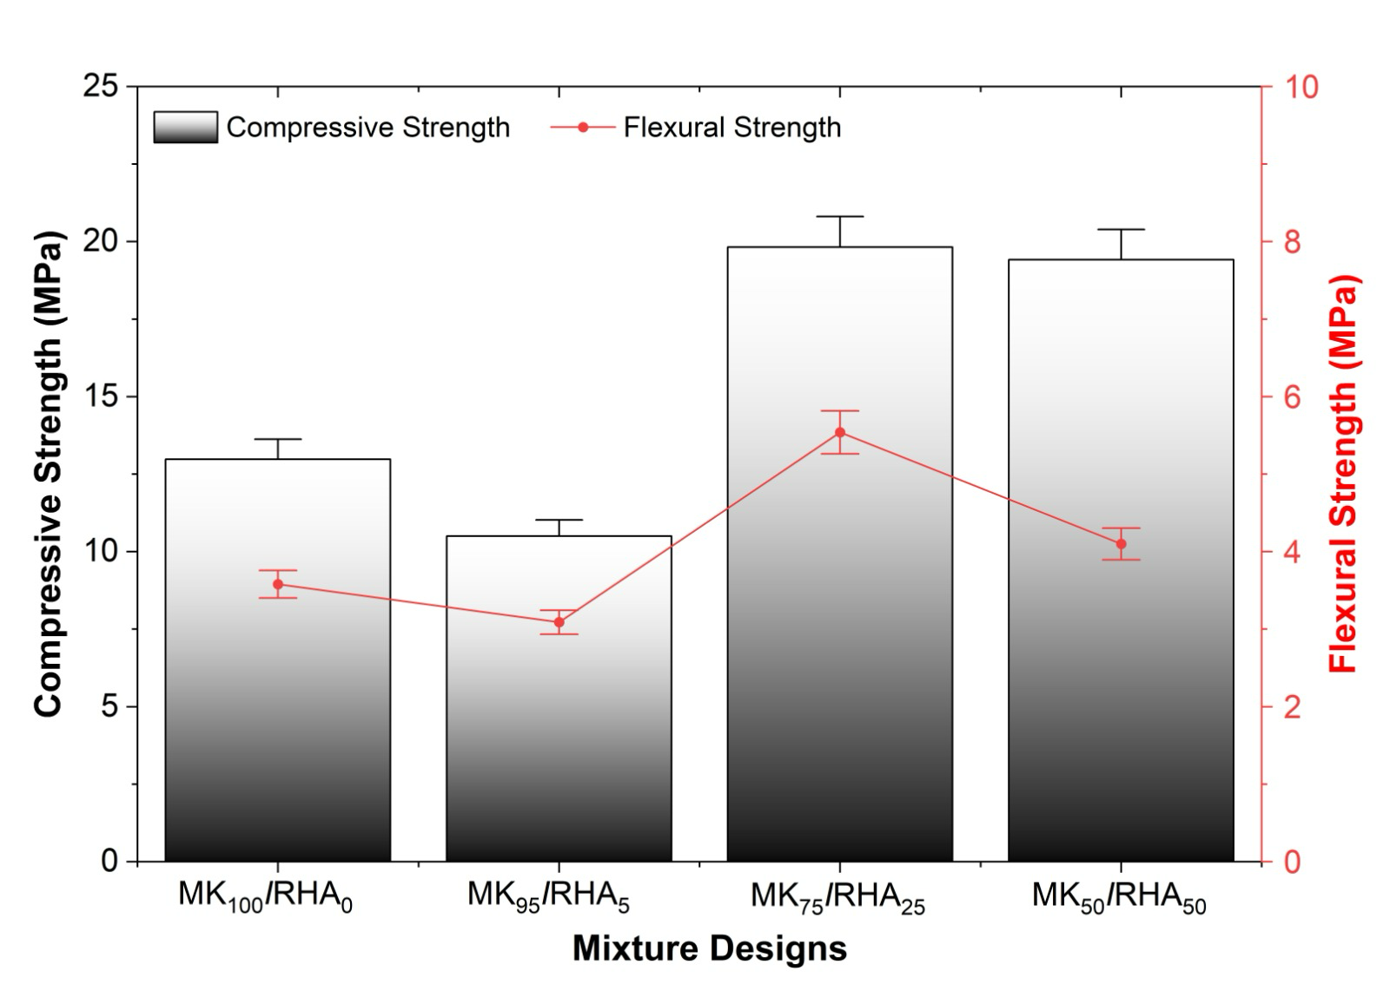

Figure 1: Compressive and flexural strengths of 7-day cured MK-RHA geopolymer
    - XRD analysis
XRD was conducted to assess the mineralogical phases of the precursors and their role in the structural evolution of the geopolymer samples. Figure 2 presents the XRD of MK, with quartz (Ref. code 95-500-0036) as the only semicrystalline phase, showing a broad peak at 26.8° in 2θ degrees. The disordered Al-Si network was formed through dehydroxylation of kaolinite (Iriarte et al., 2025). In contrast, RHA exhibits pure amorphous silica in the form of cristobalite (Ref. code 96-900-9687), with an evident hump at 22.4° in 2θ degrees. This characteristic of RHA usually appears between 15 and 30°, suggesting that it was calcined at a controlled temperature, preventing the formation of other crystalline phases (Rodríguez de Sensale et al., 2018). Regarding the geopolymer samples, the binary blend between MK and RHA revealed a complex transition from a quartz-containing Al-Si network to a binary amorphous-crystalline geopolymer phase. In MK₁₀₀/RHA_{0,} as a reference, quartz remains the sole mineralogical phase of this geopolymer, reflecting the MK peaks and indicating inherent MK impurities. As RHA was incorporated into the MK₉₅/RHA₅ through MK₅₀/RHA₅₀ geopolymer samples, a cristobalite phase appeared, reflecting the mineralogical peak position distinct to RHA. Although RHA was added, quartz remained a principal mineral phase across all these mix designs, signifying that MK-derived crystalline silica creates the dominant structural signature. Moreover, the intensity of the cristobalite peaks increased proportionally with the percent substitution of RHA in the mix design, while the amorphous peak underwent a slight shift as the Si/Al ratio of the total matrix was subsequently changed. Lastly, the presence of a broad amorphous halo between 20 and 35° in all geopolymer samples confirms the successful formation of a disordered Al-Si gel, which is essential for providing the high chemical reactivity and dense structural integrity required for superior mechanical performance.
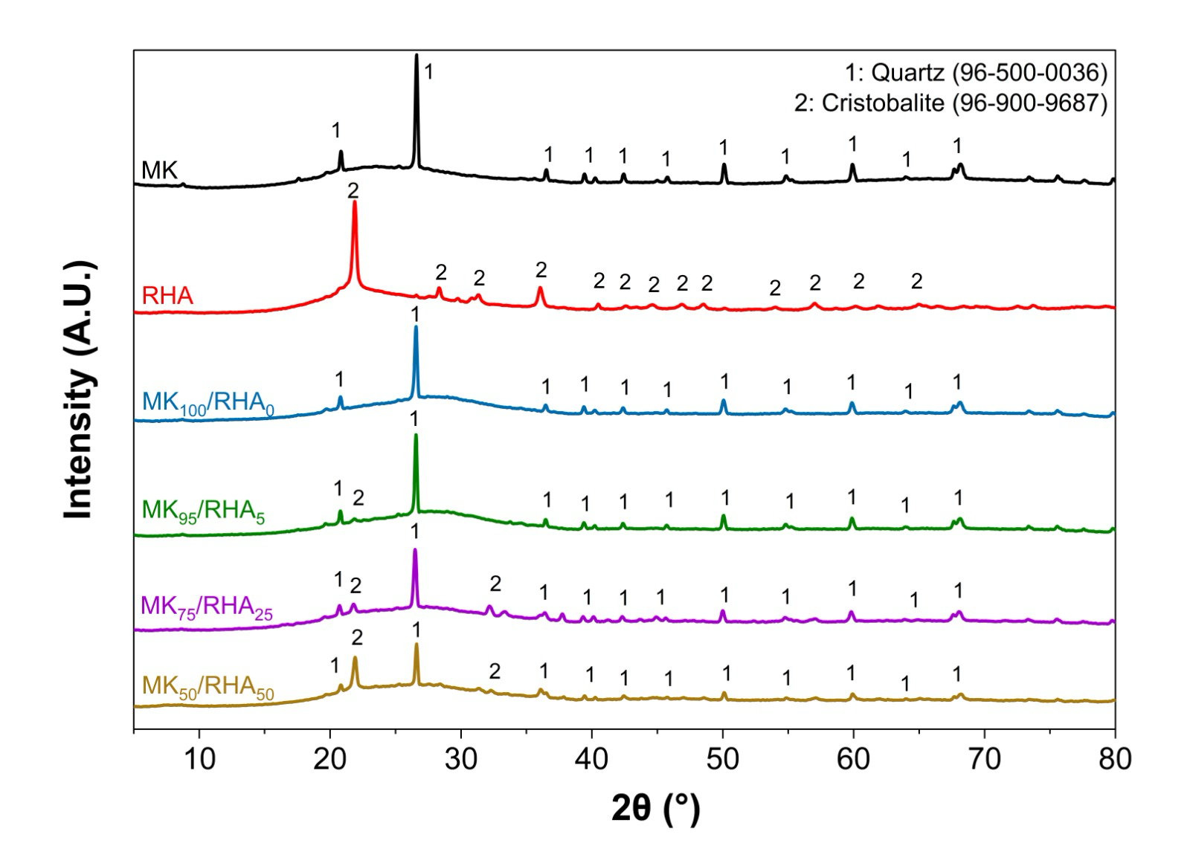

Figure 2: X-ray diffraction patterns of MK, RHA, and geopolymer samples

    - FTIR characterization analysis
A non-destructive FTIR technique was carried out to check the qualitative functional group information of the precursors and geopolymer samples. Figure 3 displays the spectral bands of MK with an intense peak at 1055 cm⁻¹, which corresponds to the asymmetric vibrations of Si−O−T (T = Al or Si) bondings. The auxiliary peaks located at 781, 619, and 435 cm⁻¹ can be attributed to the Al−O−Si and Si−O bending vibrations from the reactive amorphous phase of quartz present (El Alouani et al., 2019). In the case of RHA, an absorption band at 1063 cm⁻¹ indicates a Si−O−Si asymmetric stretching vibration produced from a high amount of polymerized silica within the RHA structure. The shift of Si−O−Si bending and symmetric stretching modes at 792, 617, and 449 cm⁻¹ shows a predominantly siliceous environment (Hamidu et al., 2025), correlating with the presence of crystalline cristobalite phase identified in the XRD. In the MK₁₀₀/RHA₀ sample, a principal Si−O−T stretching band shifted at 985 cm⁻¹, indicating a clear sign of geopolymerization reaction and the formation of Al-Si reaction gel (Eliche-Quesada et al., 2021). When RHA is added from MK₉₅/RHA₅ through MK₅₀/RHA₅₀ samples, this absorbance peak was moved towards higher wavenumbers until 1004 cm⁻¹, suggesting that an increase in RHA produces a silica-rich geopolymer matrix. While there were shoulder peaks observed around 1641-1652 cm⁻¹, representing H₂O bending vibrations that were trapped within the micropores of the matrix. Also, a weak spectral band located at 1458 cm⁻¹ in the MK₇₅/RHA₂₅ demonstrates atmospheric carbonation and formation of sodium carbonates during the curing phase. Lastly, the bands in the 400-800 cm⁻¹ region can be seen in all the samples. This cristobalite and quartz found in XRD serve as non-reactive fillers when the geopolymer hardens.
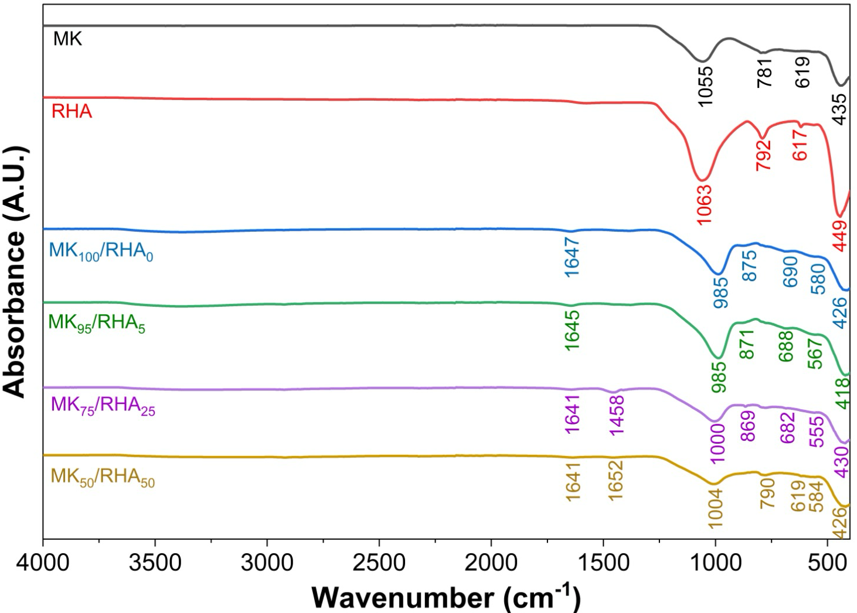

Figure 3: Fourier transform infrared spectroscopy patterns of MK, RHA, and geopolymer samples
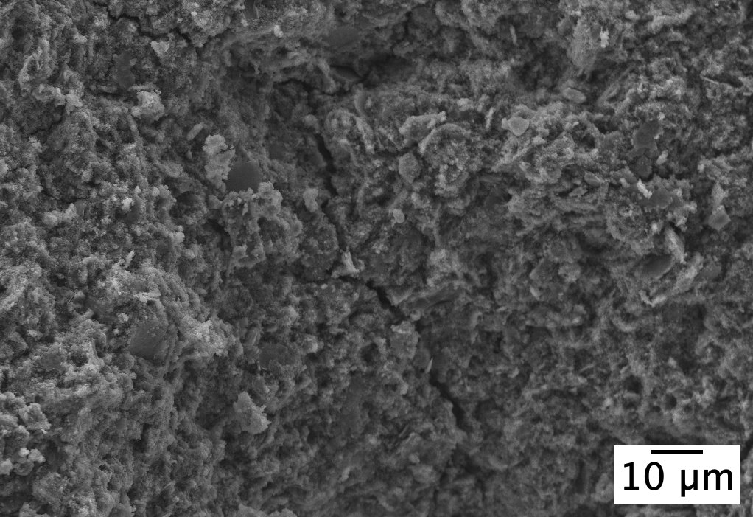
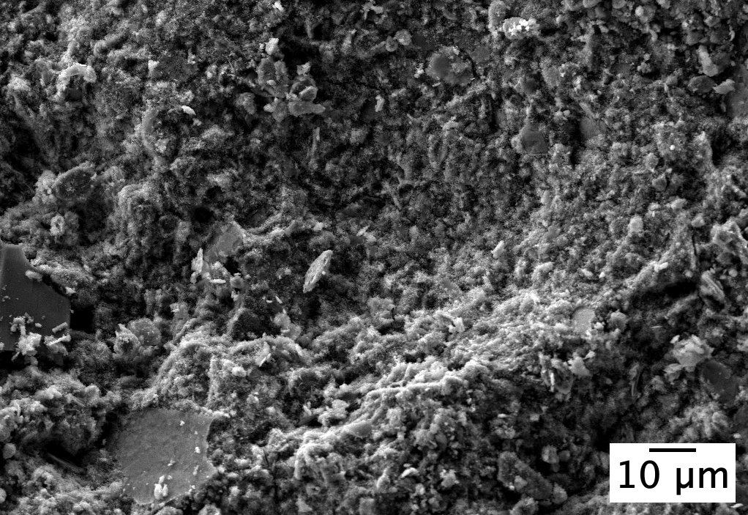
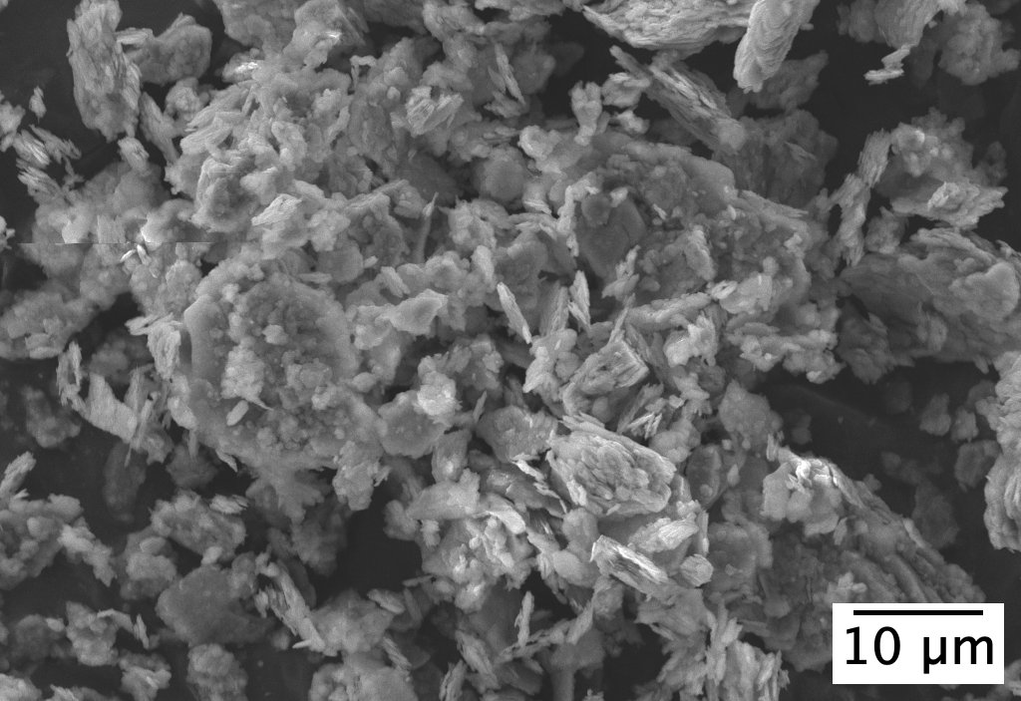
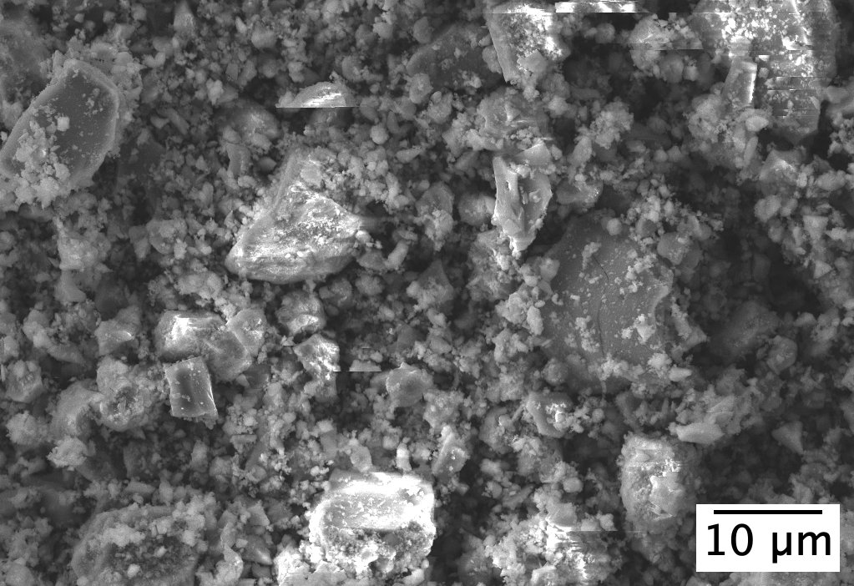
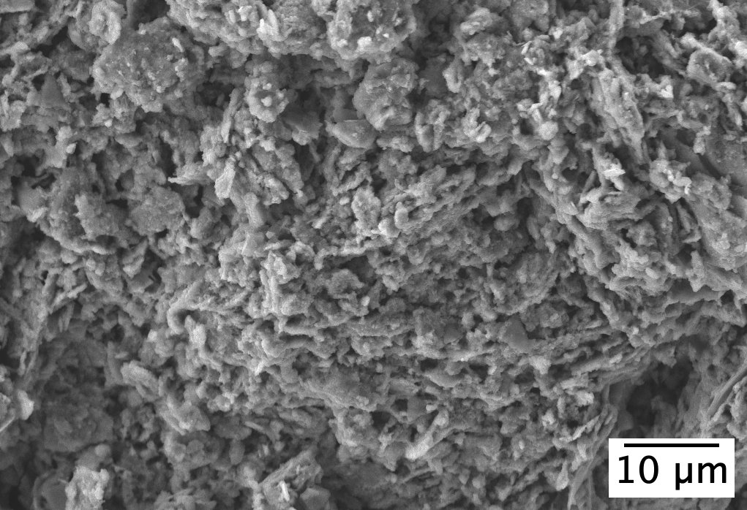
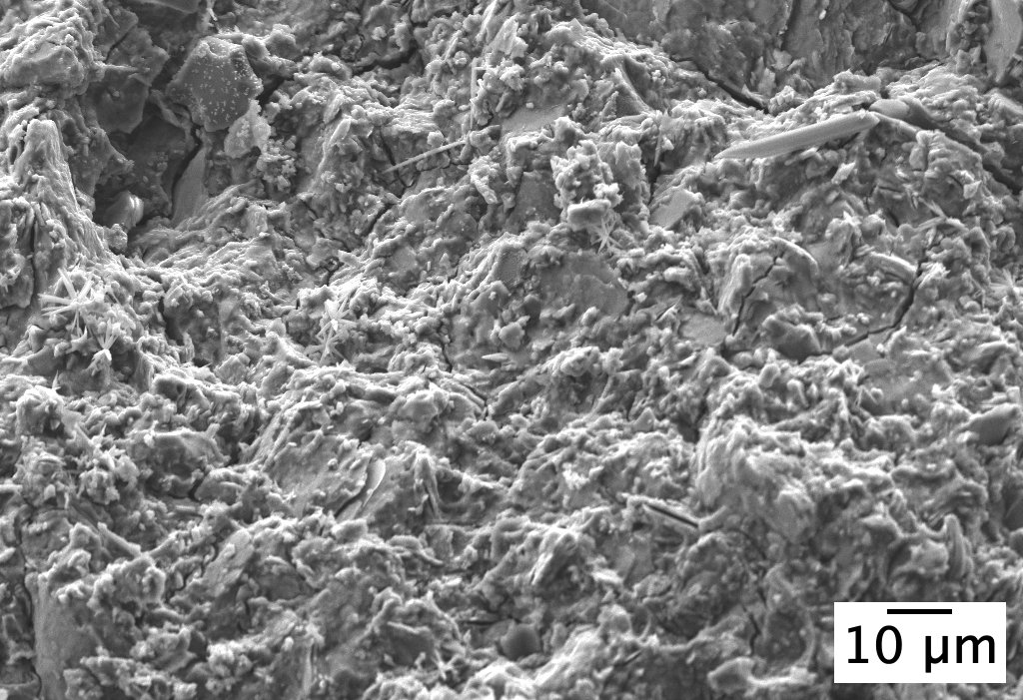
(a) MK
(c) MK₁₀₀/RHA₀
(b) RHA
(d) MK₉₅/RHA₅
(e) MK₇₅/RHA₂₅
(f) MK₅₀/RHA₅₀
microcrack
unreacted
MK
residual silica

Figure 4: Scanning electron microscopy (SEM) for (a-b) precursors, and (c-f) geopolymer samples

    - Microstructural analysis
Micromorphological observations of MK, RHA, and MK-RHA blend geopolymers are shown in Figure 4. These reveal distinct morphological transitions from precursors to hardened geopolymer pastes. MK shows a usual plate-like flaky structure (Figure 4a), while RHA exhibits highly angular and irregular morphology (Figure 4b). When activated by alkali solution, the MK₁₀₀/RHA₀ (Figure 4c) forms a relatively uniform gel matrix, although some unreacted MK particles can be observed. While MK₉₅/RHA₅ displays a more heterogeneous matrix with visible microcracks at 20 μm (Figure 4d), which directly influenced the compressive and flexural strength results. This 5 wt % RHA substitution is insufficient to effectively bridge pores and provide reinforcement as a microfiller. At this concentration, the RHA particles act as isolated inclusions that create localized stress concentrations, promoting crack propagation during the contraction of the reaction gel. The MK₇₅/RHA₂₅ (Figure 4e) shows the most compact microstructure amongst the geopolymer samples, affecting the mechanical strengths due to the optimal effect of RHA as a filler in the matrix. As the concentration increases to 25 wt %, the RHA particles achieve a synergistic packing density that effectively densifies the matrix and bridges the pores, demonstrating a threshold-dependent mechanism where a specific volume of RHA is needed to provide a functional reinforcing filler. Lastly, the MK₅₀/RHA₅₀ (Figure 4f) presents a mix of dense gel zones and residual silica from RHA, suggesting that high RHA substitution significantly depreciates the final binder density and mechanical strength.
  - Conclusions
This study demonstrates the feasibility of high-volume substitution of RHA with MK in a hybrid geopolymer and highlights its potential for sustainable binder development. Substituting 25 wt % of RHA produced the maximum compressive and flexural strengths related to the dense and compact microstructure observed by SEM, providing an optimal balance for particle packing and geopolymerization. In contrast, the microcracks observed in MK₉₅/RHA₅ were consistent with its reduced mechanical performance. At higher RHA incorporation levels (MK₅₀/RHA₅₀), the excess silica-rich phase hindered effective geopolymerization, resulting in a more heterogeneous matrix with residual unreacted particles. This indicates that an excessive silica content alters the chemical reaction of the binder, as confirmed by the shift of the Si–O–T band in the FTIR spectra. Overall, the results demonstrate that RHA, when incorporated at an optimized substitution level, can effectively serve as a source of reactive silica and crystalline filler.
Acknowledgments
This research has been funded by the EU’s Horizon Europe, through an MSCA Postdoctoral Fellowship, specifically the GEOSENSOR project (Project Number: 101198074). Technical and human support provided by CICT of Universidad de Jaén (UJA, MINECO, Junta de Andalucía, FEDER) is gratefully acknowledged.
References
Davidovits J., 2020, Geopolymer Chemistry and Applications 5th ed., Institut Géopolymère, Saint-Quentin, FR.
El Alouani M., Alehyen S., El Achouri M., 2019, Preparation, characterization, and application of metakaolin-based geopolymer for removal of methylene blue from aqueous solution, Journal of Chemistry, 4212901.
Eliche-Quesada D., Calero-Rodríguez A., Bonet-Martínez E., Pérez-Villarejo L., 2021, Geopolymers made from metakaolin sources, partially replaced by Spanish clays and biomass bottom ash, Journal of Building Engineering, 40, 102761.
Hamidu I., Afotey B., Kwakye-Awuah B., Anang D.A., 2025, Synthesis of silica and silicon from rice husk feedstock: A review, Heliyon, 11, e42491.
Hossain S.S., Roy P.K., Bae C.J., 2021, Utilization of waste rice husk ash for sustainable geopolymer: A review, Construction and Building Materials, 310, 125218.
Hwang C.L., Huynh T.P., 2015, Effect of alkali activator and rice husk ash content on strength development of fly ash and residual rice husk ash-based geopolymers, Construction and Building Materials, 101, 1−9.
Iriarte I.A.P., Mocciaro A., Rendtorff N.M., Richard D., 2025, Dehydroxylation of kaolinite: Evaluation of activation energy by thermogravimetric analysis and density functional theory insights, Minerals, 15(6), 607.
Karayannis V.G., Moustakas K.G., Baklavaridis A.N., Domopoulou A.E., 2018, Sustainable ash-based geopolymers, Chemical Engineering Transactions, 63, 505-510.
Plando F.R.P, Maquiling J.T., 2023, Microstructural characterizations and strength development of self-compacting concrete using rice husk ash, Romanian Journal of Physics, 68, 908.
Rodríguez de Sensale G., Rodríguez Viacava I., 2018, A study on blended Portland cements containing residual rice husk ash and limestone filler, Construction Building Materials, 166, 873−888.
Sawasdee V., Pisutpaisal N., 2022, Rice husk ash characterization and utilization as a source of silica material, Chemical Engineering Transactions, 93, 79-84.
Singh S., Vora T., Dasarathy A.K., Haq M.Z.U., Vanitha S.M.A.S., Das P., Shahin K., Kumar V.V., 2025, Optimization of Cementitious Composites Using Response Surface Methodology: Enhancing Strength and Durability with Rice Husk Ash and Steel Fibers, Journal of Natural Fibers, 22, 1.
Villar-Cociña E., Frias M., Savastano H., Rodier L., Sánchez de Rojas M.I., Sáez del Bosque I.F., Medina C., 2021, Quantitative Comparison of Binary Mix of Agro-Industrial Pozzolanic Additions for Elaborating Ternary Cements: Kinetic Parameters, Materials, 14, 2944.

