 CHEMICAL ENGINEERING TRANSACTIONS  VOL. xxx, 2026 | A publication of  
The Italian Association
of Chemical Engineering
Online at www.cetjournal.it

Guest Editors: Leonardo Tognotti, Rubens Maciel Filho, Viatcheslav Kafarov
Copyright © 2026, AIDIC Servizi S.r.l.
ISBN 979-12-81206-xx-x; ISSN 2283-9216

Chitosan-Based Hydrogels for Sustainable Biodiesel Dehydration
Guilherme F. Frascati^{a,}*, Bianca R. Estevamª, Isadora D. Perez^{b}, Marcelino L. Gimenes^{c}, Maria R. Wolf Macielª, Leonardo V. Fregolenteª
ªDepartment of Processes and Products Design – School of Chemical Engineering, University of Campinas (UNICAMP), 13083-852 Campinas-SP, Brazil.
^{b}Department of Chemical, Environmental and Materials Engineering, University of Jaen, 23071, Jaen, Spain
^{c}Department of Chemical Engineering, State University of Maringá (UEM), 87020-900 Maringá-PR, Brazil
*g251064@dac.unicamp.br
Biodiesel can absorb about ten times more water than diesel, which makes it challenging to control its water content according to the specifications set by regulatory agencies. Therefore, efficient water removal from biodiesel is essential to ensure fuel stability and performance. The novelty of this work is the analysis of the effect of post-synthesis alkaline hydrolysis of chitosan-graft-polyacrylamide hydrogels, investigated by immersing the material in sodium hydroxide solution (0.5 M) at 75 °C for 18 h. The hydrolysis significantly enhanced hydrogel performance, increasing the swelling degree from 11 g·g⁻¹ to 139 g·g⁻¹ and the biodiesel dehydration efficiency from 47 % to 65 %. SEM, FTIR, and TGA analysis confirmed the hydrogel formation and incorporation of both chitosan and hydrolysed polyacrylamide onto the desiccant network. Batch experiments revealed that dehydration occurs via chemisorption, with both mono and multilayer sorption occurring simultaneously. The system reached kinetic equilibrium after 24 h, with an optimal hydrogel dosage of 0.5 g per 25 mL of saturated biodiesel. The material maintained stable efficiency over three reuse cycles, demonstrating potential for sustainable application. The hydrolysed chitosan-polyacrylamide hydrogel reduced the biodiesel water content from 1,700 to 567 mg·kg⁻¹, approaching the international specification limit (<500 mg·kg⁻¹). The results highlight the potential of chitosan-based hydrogels for biodiesel dehydration as a sustainable and reusable material that combine simple separation process with the advantages of renewable biopolymers to improve biofuel quality.
  - Introduction
The use of biodiesel blended with fossil diesel has increased due to its environmental benefits. However, its ester-rich composition allows the absorption of around 2,000 mg.kg⁻¹ of water, which accelerates fuel degradation and impairs its quality along with engine performance. Since existing dehydration methods are often energy-intensive and costly, the development of efficient and practical biodiesel dehydration technologies is increasingly necessary. In this context, hydrogels have emerged as an efficient, low-energy alternative for water removal (Perez et al., 2022). Their hydrophilic and oleophobic nature enables selective water uptake from oils, while their properties can be tailored through synthesis and post-treatment. For fuel dehydration, hydrogels must combine high hydrophilicity, mechanical stability, and fast water uptake under (Arthus et al., 2024).
Among the synthetic polymers, polyacrylamide (PAAm) is widely used in hydrogel synthesis due to its highly hydrophilic amide groups and low cost, but it can exhibit brittleness and structural instability (Bonyadi and Dunn, 2020). Grafting hydrogels onto biopolymers can overcome these drawbacks by improving mechanical strength and matrix density (Arthus et al., 2024). Chitosan, a renewable and biodegradable polymer derived from crustacean shells, is widely used for grafting hydrogels (Ibrahim et al., 2019). The grafting process involves the activation of initiator species, leading to hydrogen abstraction from chitosan backbones and the subsequent generation of reactive free radicals, which enable propagation reactions that incorporate acrylamide (Aam) monomers (Kordjazi et al., 2020). Furthermore, a post-treatment of the grafted hydrogel by alkaline hydrolysis introduces ionic charges within the structure through the conversion of amide groups into carboxylates, increasing the hydrophilicity of the polymeric network via electrostatic interactions (Zhao et al., 2010).
This paper reports the first study on alkaline hydrolysis as a post-treatment strategy to modify chitosan-grafted-polyacrylamide hydrogels (C-g-PAAm) aiming biodiesel dehydration. Both C-g-PAAm and hydrolysed chitosan-grafted-polyacrylamide (H-C-g-PAAm) hydrogels properties and dehydration performance were systematically evaluated under batch conditions. The results indicate that the H-C-g-PAAm hydrogel is a novel and sustainable material, offering improved efficiency for biodiesel dehydration and contributing to the advancement of practical technologies that support the expanded use of this renewable fuel.
  - Methodology
The synthesis conditions of chitosan-grafted-polyacrylamide hydrogels were based on previous literature reports (Ibrahim et al., 2019; Kordjazi et al., 2020). The biodiesel was acquired commercially, reagents of analytical grade were used in all procedures, and experiments were run in duplicate.
    - Hydrogel synthesis and the effect of the hydrolysis post treatment
The chitosan-grafted-polyacrylamide (C-g-PAAm) hydrogel was synthesized by dissolving 1 wt% chitosan in a 1 vol% aqueous acetic acid solution at 500 rpm, for 25 min, at 25±3 °C. Subsequently, 4 wt% acrylamide and 0.13 wt% methylenebisacrylamide were added, followed by 10 min of stirring and centrifugation (5,000 rpm, 10 min) to remove bubbles. The mixture was divided into Falcon tubes and maintained at 60 °C in a thermostatic bath. Nitrogen was bubbled for 5 min, after which 4 vol% of a 0.01 g mL⁻¹ sodium persulfate solution (initiator) was added. Nitrogen purging continued for 15 min to minimize oxygen inhibition. The samples were then sealed and remained in rest for 24 h to complete gelation. The hydrogels were then cut into cylindrical discs of 0.4 cm height and 1.5 cm diameter. To assess the effect of post-synthesis hydrolysis, part of the samples was treated with 0.5 M NaOH at 75 °C for 18 h, resulting in the H-C-g-PAAm (Arthus et al., 2023). Both hydrolysed and non-hydrolysed samples were immersed in distilled water to wash the samples which has then dried at 60 °C until constant mass and stored in a silica desiccator. Hydrogel performance was statistically compared using Tukey’s test (95 % confidence), regarding swelling and biodiesel dehydration efficiency (described in Section 2.3). Swelling was determined by the mass difference between dry and swollen states, acquired after incubate dried hydrogels samples (0.10 g) in distilled water (200 mL) at 37 °C for 24 h.
    - Hydrogel characterization
The hydrogel with the best performance was characterized by scanning electron microscopy (SEM), Fourier Transform Infrared (FTIR) spectroscopy, and thermogravimetric analysis (TGA). For comparison, hydrolysed polyacrylamide (H-PAAm) hydrogels and chitosan were also submitted to FTIR and TGA. SEM analyses were conducted using a Quattro S microscope (10 kV and 23 pA) with samples prior sputter-coated with gold (20 mA, 90 s) to ensure surface conductivity. Both both surface morphology and internal structure of the hydrogels were evaluated, with the samples cryo-fractured in liquid nitrogen before coating. FTIR spectra were acquired on a Nicolet 6700 spectrometer in the range of 4,000–400 cm⁻¹ with a resolution of 2 cm⁻¹. Thermal stability and degradation behaviour were assessed by TGA (Mettler Toledo equipment) using a heating rate of 10 °C min⁻¹ from room temperature to 600 °C and nitrogen atmosphere (50 mL.min⁻¹).
    - Biodiesel saturation and batch experiments of biodiesel dehydration
Commercial biodiesel was homogenized with 5 vol% distilled water under constant stirring for 30 min at 300 rpm at room temperature (25±3 °C). Phase separation was carried out in a separatory funnel, followed by centrifugation of the oil phase at 5,000 rpm for 10 min. The resulting water-saturated biodiesel, containing approximately 1,780 mg kg⁻¹ of water, was used in the dehydration assays. Water-removal experiments used 0,5 g of hydrogel and 25 mL of water-saturated biodiesel, being under stirring at 150 rpm for 24 h at 25 °C in a shaker incubator. Water content was determined by coulometric Karl Fischer titration according to ASTM D6304-21 (2021). Control assays, containing only water-saturated biodiesel, were conducted under identical conditions to isolate the hydrogel effect and calculate dehydration efficiency.
To further evaluate the hydrogels performance under different operational conditions, additional dehydration tests were conducted using the formulation that exhibited the highest water removal efficiency. Kinetic experiments were performed in batch system using 0.5 g of hydrogel, at 25 ºC, and stirring at 150 rpm for 0.5, 1, 2, 6, 24, 48, and 72 h. Hydrogel performance was assessed by monitoring both its dehydration efficiency and water sorption capacity during time. Additionally, pseudo-first and pseudo-second-order kinetic models were fitted to the data using non-linear regression. The effect of the hydrogel dosage was evaluated at a fixed contact time (24 h), temperature (25 ºC) and water-saturated biodiesel volume (25 mL), varying the hydrogel mass within 0.10, 0.25, 0.50, 0.75, and 1.0 g. The responses were the dehydration efficiency and the water sorption data – which was further analysed by fitting the Langmuir and Freundlich sorption models to the data. The influence of the temperature on hydrogel sorption behaviour was evaluated by batch experiments conducted at 25, 35, 45, and 55 °C in an incubator shaker. In all cases, 0.5 g of hydrogel was contacted to water-saturated biodiesel for 24 h. Following each cycle, the material was recovered and regenerated through either (i) oven drying at 60 °C for 24 h after removal of surface oil using paper towels, or (ii) ethanol washing (25 mL, 150 rpm, 10 min), with subsequent drying at 60 °C for 24 h. The regenerated hydrogels were reused under identical conditions for three cycles of use and regeneration. The dehydration performance across the cycles, and by each regeneration methods, was statistically compared using 95 % confidence Tukey’s test.
  - Results and discussion
    - Effect of the hydrolysis post-treatment
Alkaline hydrolysis was responsible for a significant improvement in both swelling degree and biodiesel dehydration efficiency, as shown in Figures 1a and 1b, respectively. These results can be attributed to the generation of ionic sorption sites within the polymeric network, which enhance water-polymer interactions through hydrogen bonding and electrostatic attraction, increasing both the swelling degree and dehydration efficiency (Arthus et al., 2024). Similar results were reported by Zhao et al., (2010), who identified an increase of 16 to 90 g.g⁻¹ after alkaline hydrolysis of PAAm hydrogels; and by Arthus et al. (2024), that compared hydrolysed and non-hydrolysed cellulose-graft-polyacrylamide hydrogels and reported that hydrolysis improved from 27.2 to 714.1 g.g⁻¹ the swelling, and the saturated-biodiesel dehydration from 36.6 to 49.5 %. Thus, the formulation investigated in this work emerges as a promising alternative for water uptake, exhibiting one of the highest efficiency increases after alkaline hydrolysis, as well as one of the highest absolute efficiencies reported in the literature for water-saturated biodiesel.
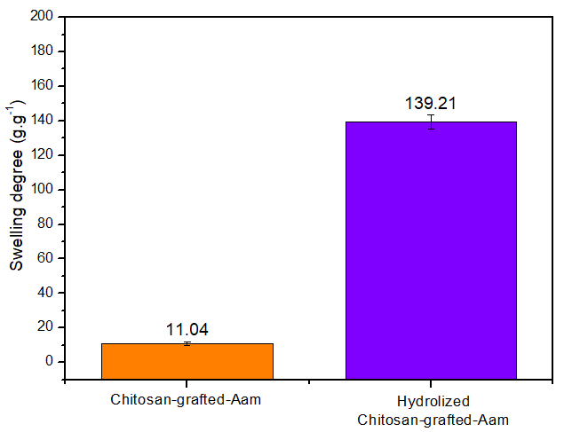a 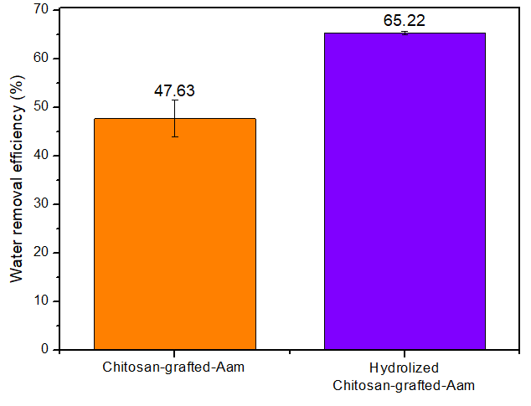b
Figure 1: Effects of alkaline hydrolysis for the swelling degree (a) biodiesel dehydration efficiency (b)
    - Hydrogel characterization
The morphology of the H-C-g-PAAm hydrogel in both the surface and cross-section regions is presented in Figure 2a and 2b, respectively. The surface of the hydrogel exhibits dispersed agglomerates, which are likely associated with chitosan domains interspersed within the PAAm chains. The aggregation of those chitosan regions increases the effective surface roughness and contact area, potentially exposing additional hydrophilic sorption sites. Analysis of the cross-sectional morphology reveals the presence of small bubbles within the hydrogel structure, which arise from nitrogen gas entrapment during hydrogel gelation (Abou-Okeil and Taha, 2024). Similar features were reported by Ibrahim et al. (2019) for C-g-PAAm hydrogels. Additionally, fissures were observed in the cross-sectional region, which may by derived from the shrinkage caused by the oven drying process.
The FITR spectra of the H-PAAm, chitosan and H-C-g-PAAm are depicted in Figure 2c, revealing that the grafted hydrogel presents characteristic peaks associated with both chitosan and polyacrylamide. The band identified at 890 cm⁻¹ can be attributed to the saccharide backbone of chitosan (Ibrahim et al., 2019). Notably, this band exhibited reduced intensity in the grafted hydrogel than the chitosan polymer, due to the incorporation PAAm into the hydrogel. Nitrogen groups were identified in both H-PAAm and H-C-g-PAAm hydrogels by the peak at 1,324 cm⁻¹, corresponding to C-N stretching vibrations (Lopes and Fascio, 2004). Carbonyl groups (C=O) were detected at 1,655 cm⁻¹ and 1,404 cm⁻¹, representing the stretching of the carbonyl double bonds and the stretching of the C-C bond between the C=O group and -CH₂ substituents, respectively (Lopes and Fascio, 2004). The presence of these carbonyl peaks, together with the absence of a band near 900 cm⁻¹ assigned to C=C stretching of unreacted acrylamide monomers indicates that polymerization proceeded effectively, with monomers covalently linked via σ-bonds formed by the homolytic cleavage of π-bonds (Kordjazi et al., 2020). C-H bonds were identified by the deformation vibration peak at 1,452 cm⁻¹ and the stretching vibration at 2,917 cm⁻¹ (Lopes and Fascio, 2004). The broad absorptions at 3,448 cm⁻¹ and 3,353 cm⁻¹ correspond to O-H and N-H stretching vibrations (Arthus et al., 2024), respectively, present in both base polymers and in the final hydrogel. Overall, the FTIR spectrum of the H-C-g-PAAm hydrogel exhibited combined features of both chitosan and H-PAAm, while also presenting grafting indications, which confirming the successful formation of the intended grafted hydrogel.
The TGA of H-PAAm (Figure 2d), chitosan (Figure 2e), and H-C-g-PAAm (Figure 2f), revealed that all samples demonstrated a gradual mass loss at low temperatures, which is attributed to the desorption of physically attached water within the polymeric networks (Braccini et al., 2024). The H-PAAm presented a peak at approximately 280 °C, corresponding to the breakdown of pendant amide groups and subsequent cyclization reactions followed by ammonia release (Ibrahim et al., 2019). A further degradation step occurred between 370 ºC and 440 °C, corresponding to polymer backbone scission, cleavage of crosslinking bonds, and the breakdown of the main network, indicating the material’s final decomposition stages (Ibrahim et al., 2019). Chitosan presents a single dominant degradation region between 280 ºC and 360 °C, in which occurs the complete degradation of the sample through depolymerization and breakage of amide groups (Braccini et al., 2024). The thermal response of H-C-g-PAAm hydrogel combines both chitosan and PAAm features, indicating the incorporation of both networks in the obtained material.
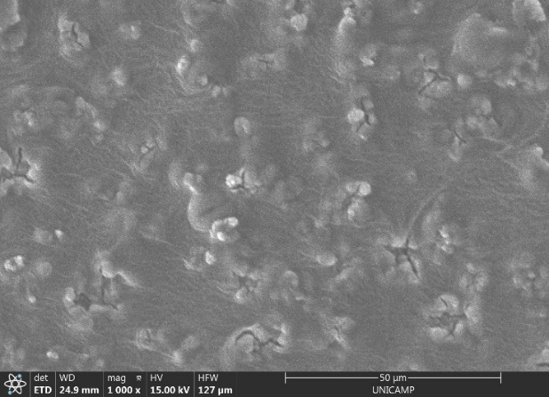 a 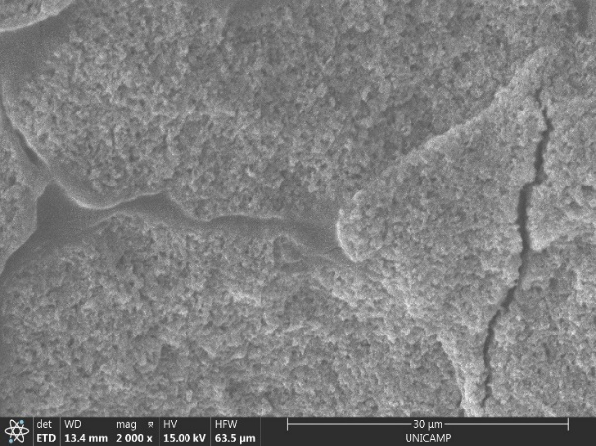 b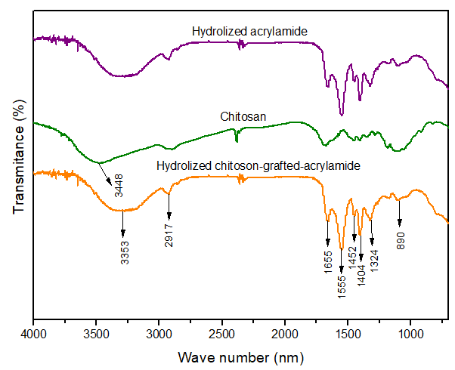 c
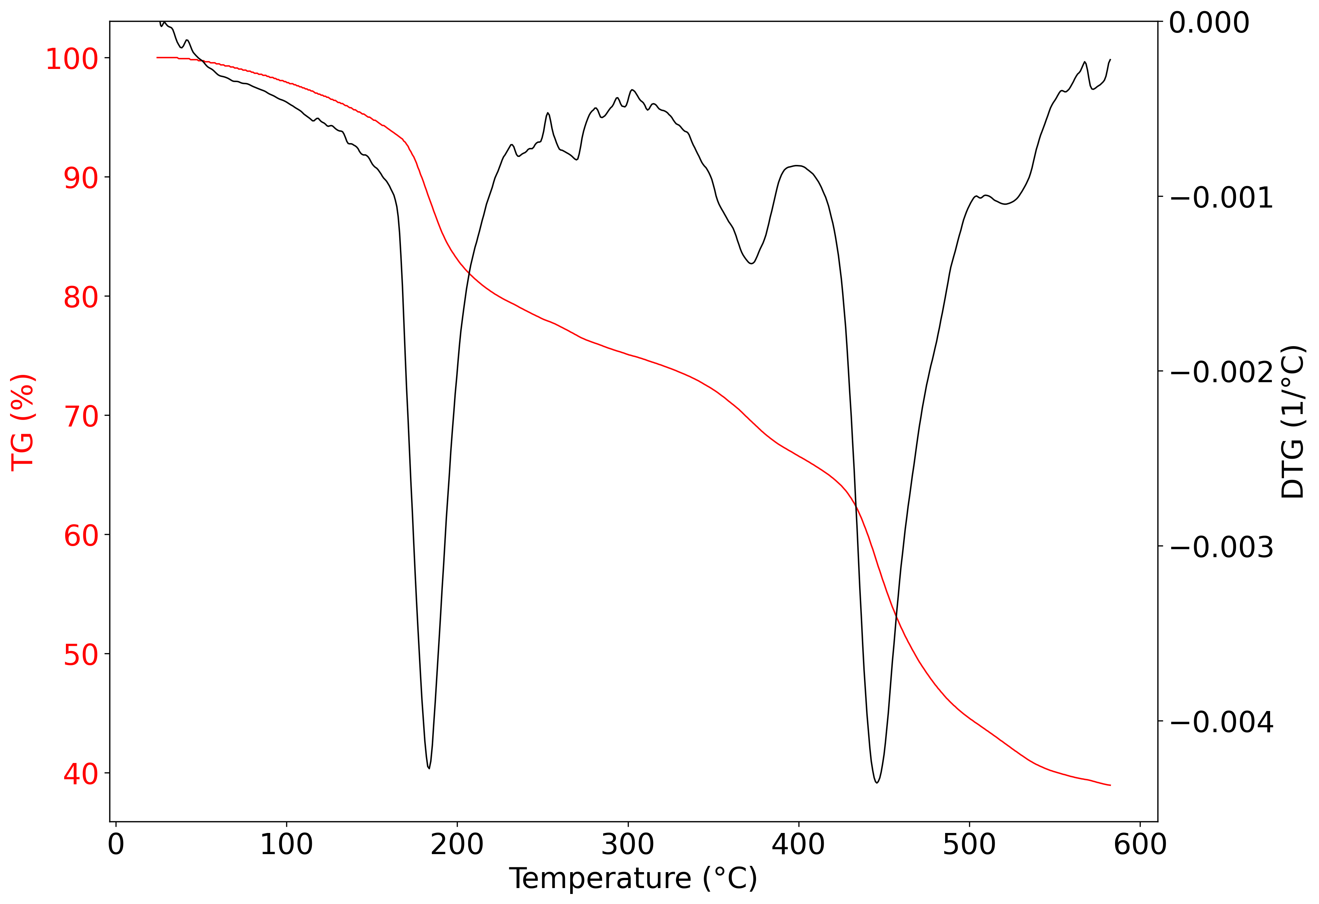d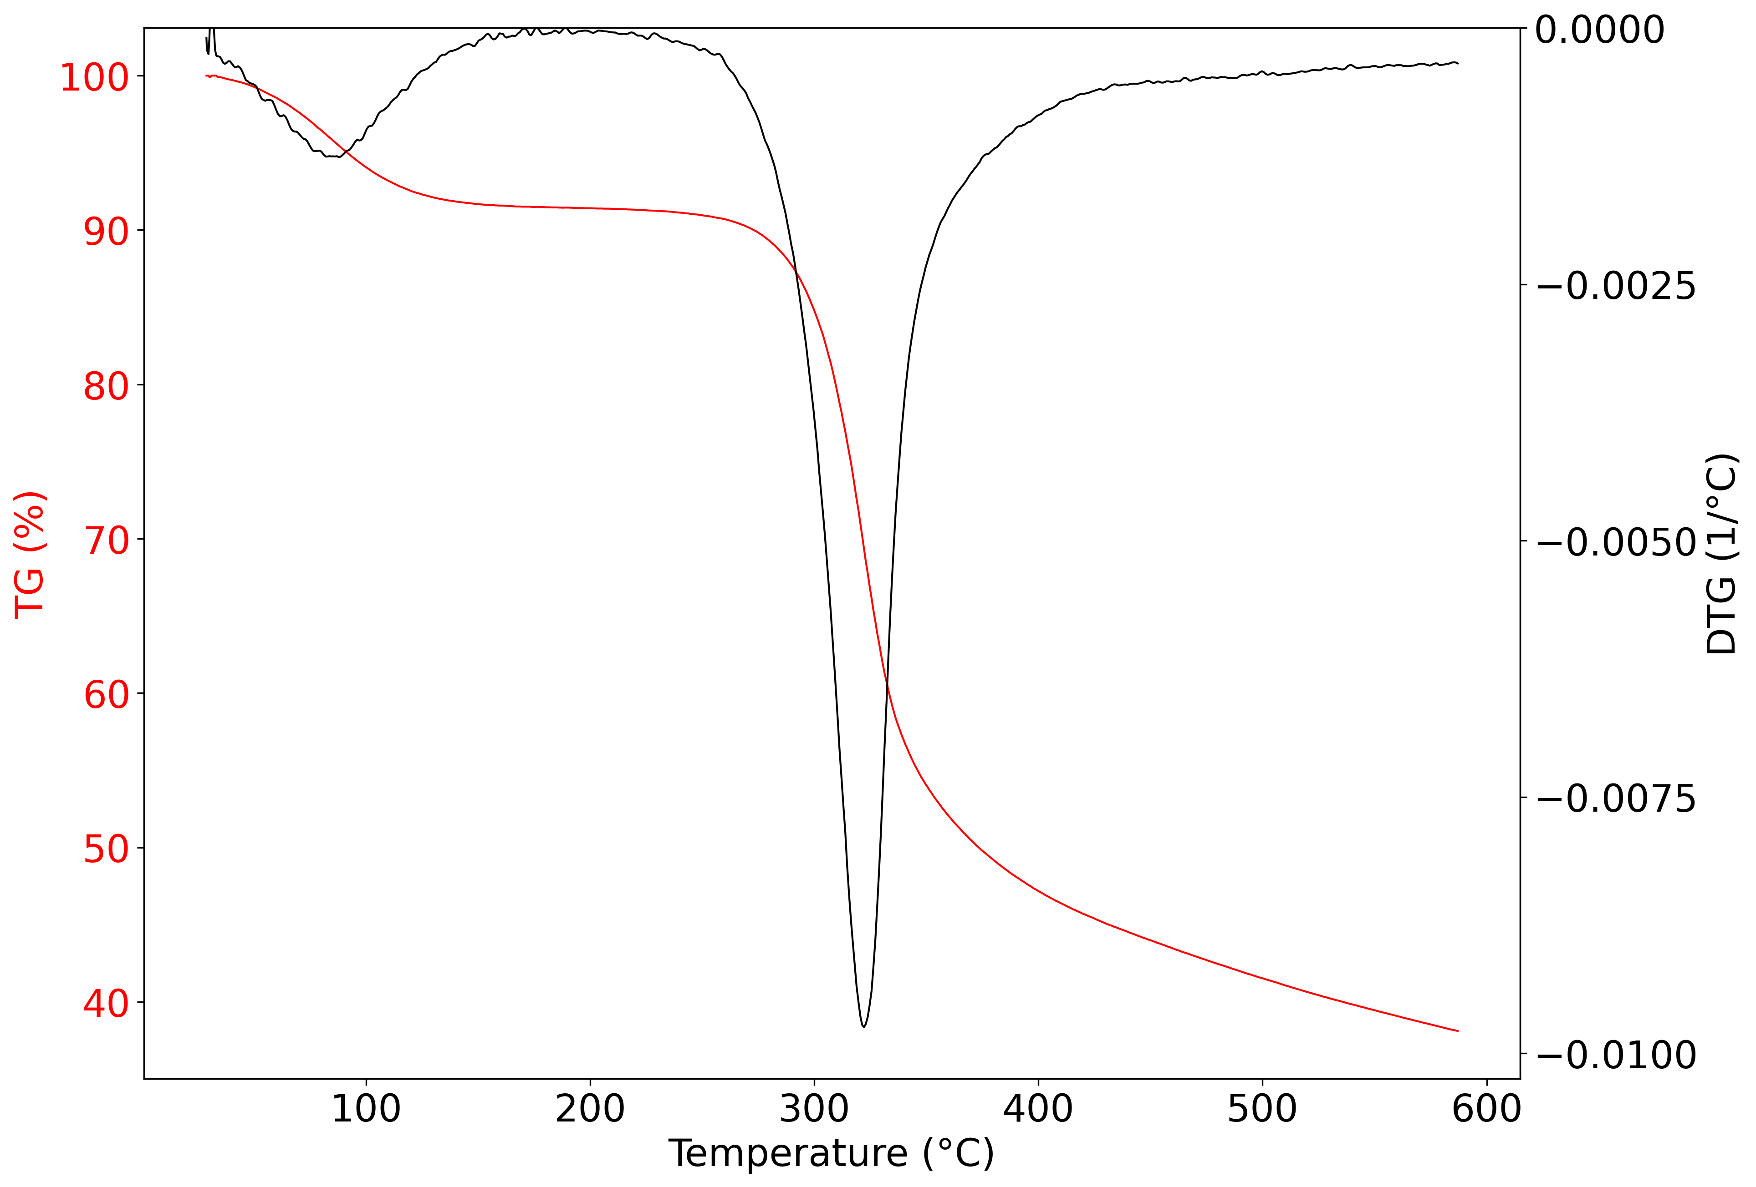 e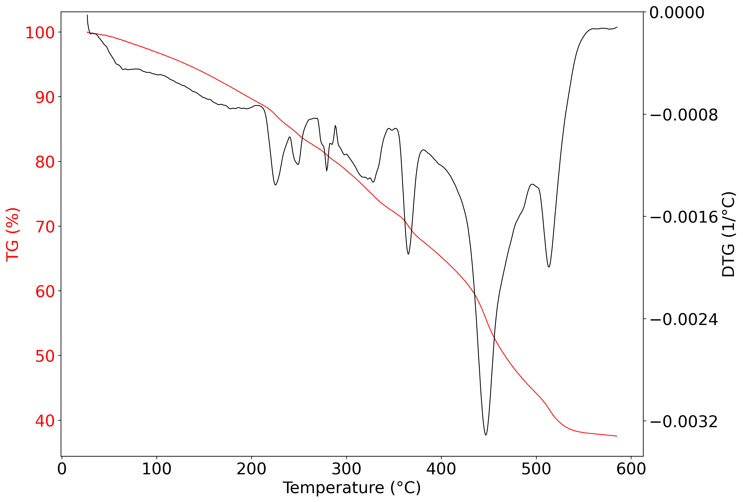f
Figure 2: SEM of H-C-g-PAAm at the surface (a) and cross-sectional region (b), FTIR spectra H-PAAm, chitosan, and H-C-g-PAAm (c), TGA of the H-PAAm (d), H-C-g-PAAm (e) and chitosan (f)
    - Batch experiments of biodiesel dehydration
The biodiesel dehydration kinetics using H-C-g-PAAm hydrogel, shown in Figure 3a, revealed that the system approached equilibrium within 24 h. At this point, the dehydration efficiency stabilized at approximately 63 %, corresponding to a final water concentration of 692±1 mg.kg⁻¹. Similarly to this study, Estevam et al. (2023) reported that cellulose hydrogels achieved an equilibrium water removal efficiency from biodiesel of approximately 51 % after 12 h. Consistent trends were also reported by Arthus et al. (2024), who observed an equilibrium biodiesel dehydration efficiency of 59 % after 12 h using cellulose-graft-polyacrylamide hydrogels. The kinetic data were more accurately described by the pseudo-second-order model (R²>0.84) than by the pseudo-first-order model (R²>0.52), supporting a chemisorption-controlled process. The best fit of pseudo-second-order for biodiesel dehydration was also reported by Arthus et al. (2024) using cellulose-graft-polyacrylamide hydrogels and by Estevam et al. (2023) using cellulose hydrogel. In this context, Estevam et al. (2023) explain that the low R² values occurs due to the mechanism by which hydrogels remove water is not limited to the adsorption processes outlined in the models, instead, it involves a complex array of sorption mechanisms.
The effect of the H-C-g-PAAm hydrogel dosage is depicted in Figure 3b. Water removal efficiency increased with greater dosages, as this provided a higher number of hydrophilic sites available for interaction with water. However, the sorption capacity decreased due to an expressive proportion of unoccupied active sites. Although increasing the hydrogel mass enhances dehydration efficiency, the gain decreases at higher dosages. Beyond 0.5 g, efficiency improvements become limited, with a 6.5 % marginal increase when the dosage is doubled to 1.0 g, rising from 56.86 % to 63.42 %. Arthus et al. (2024) reported a performance increase from 59.8 % to 68.8 % in biodiesel dehydration, using, respectively, 0.5 and 1.0 g of cellulose-graft-polyacrylamide hydrogels. However, the more pronounced increase of 9 % resulted in the recommendation of the 1.0 g dosage by the author. In this work, since H-C-g-PAAm hydrogel amounts above 0.5 g resulted in only marginal improvements in dehydration efficiency, this mass was considered adequate for the batch treatment of 25 mL of water-saturated biodiesel. Equilibrium sorption modelling revealed that both Langmuir and Freundlich isotherms provided similar fits to experimental data, with coefficients of determination of 0.913 and 0.911, respectively. This results a complex sorption process in which multiple mechanisms may coexist. According to the Langmuir model, water sorption occurs through the occupation of active sites with similar energetic characteristics, leading to monolayer coverage. In contrast, the Freundlich model describes sorption on heterogeneous surfaces, where the adsorption of one molecule can facilitate the subsequent binding of others, resulting in multilayer sorption behaviour. The comparable fit of both models indicates that the hydrogel surface can be energetically heterogeneous, as described by the Freundlich isotherm, while still containing uniform regions as described by the Langmuir isotherm. Therefore, monolayer and multilayer sorption phenomena occur simultaneously in distinct regions of the hydrogel.
Table 1 presents the effect of the temperature on the biodiesel dehydration using the H-C-g-PAAm hydrogel, revealing that higher temperatures resulted in lower water concentrations in the oil phase. It is noteworthy that the biodiesel saturation was performed at room temperature (around 25 ºC), with heating only during water-removal tests. Thus, the reduction in water content is primarily attributed to intensified water evaporation at elevated temperatures, which is supported by an approximately 5-fold increase in water vapor pressure within the investigated range of 25 to 55 °C. Similar trends were observed in other oil systems, which, following a similar test protocol, Perez et al. (2022) identified a reduction in water concentration in control experiments with naphthenic insulating oil from 1.605 mg.kg⁻¹ at 35 °C to 251.8 mg.kg⁻¹ at 55 °C, which the authors attributed to the evaporation. Elevated temperatures also affected the final water content after hydrogel treatment, indicating a reduced material’s ability to retain water at under these conditions. These results can be attributed to the increased affinity of biodiesel for water at higher temperatures, which enhances sorbate solubility in the oil phase and diminishes the driving force for mass transfer toward the hydrogel. Consistent behaviour has been reported for acrylamide-acrylonitrile copolymeric hydrogels applied to marine diesel dehydration, for which higher water concentrations after treatment were observed at elevated temperatures, reaching 203.7 mg.kg⁻¹ at 55 °C compared to 83.65 mg.kg⁻¹ at 25 °C (Perez et al., 2022). Therefore, due to the combined effects of reduced water availability in biodiesel and stronger water-oil interactions, it is recommended the use of 25 ºC for the biodiesel dehydration using H-C-g-PAAm hydrogel.
The dehydration performance of the H-C-g-PAAm hydrogel across multiple regeneration and reuse cycles is presented in Figure 3c. Statistical analysis at a 95 % confidence level indicated that the final water concentration in biodiesel was not significantly across the three use and regeneration cycles, nor between drying and ethanol washing regeneration methods. Given its operational simplicity and lower cost, oven drying was therefore selected as the preferred regeneration strategy. Similar behaviour has been reported for cellulose-graft-polyacrylamide hydrogels, for which neither oven drying and ethanol washing resulted in a statistically advantageous performance (Arthus et al., 2024). A stability upon reuse has also been reported for acrylamide-acrylonitrile copolymeric hydrogels, with oven-drying procedure also applied (Perez et al., 2022). The consistent dehydration performance observed across multiple cycles highlights the reusability of the hydrolysed chitosan-graft-polyacrylamide hydrogel, supporting its potential for practical biodiesel dehydration applications.
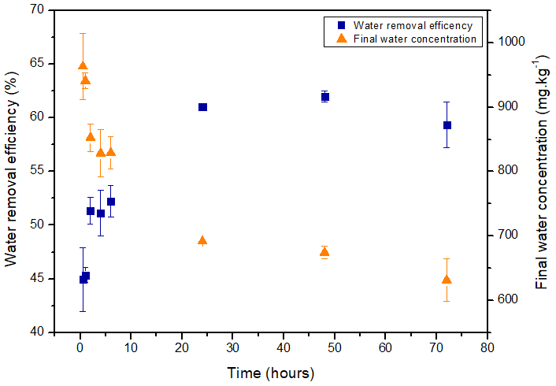a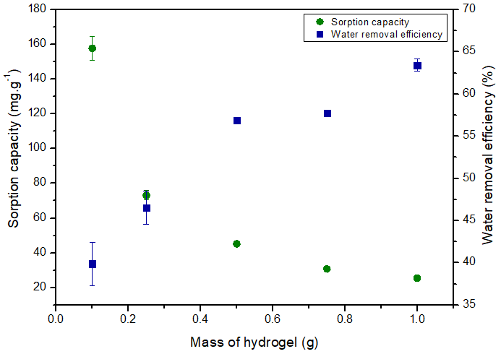b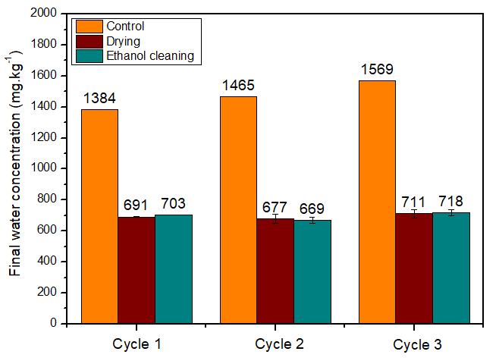 c
Figure 3: Biodiesel dehydration efficiency and final water concentration in oil as a function of time (a), water sorption capacity and biodiesel dehydration efficiency as a function of hydrogel dosage (b), and final water concentration in biodiesel for each regeneration method through three dehydration cycles (c)

Table 1: Temperature effect in the final water concentration in oil and in biodiesel dehydration efficiency
Batch temperature (°C) | Final water concentration (mg.kg⁻¹) |  | Water removal efficiency (%)
Batch temperature (°C) | Control | Treatment | Water removal efficiency (%)
25 | 1,774.8±1.0 | 691.7±1.1 | 61.03±0.06
35 | 1,468.8±41.5 | 762.4±20.3 | 48.1±1.4
45 | 1,377.9±19.9 | 849.0±39.1 | 38.4±2.8
55 | 1,592.0±1.0 | 869.2±9.5 | 45.4±0.6
  - Conclusion
This research demonstrate that the H-C-g-PAAm hydrogel is as a viable technology for biodiesel dehydration, indicating that it is progressing towards practical use. Alkaline hydrolysis of the hydrogel significantly increased its water removal efficiency from biodiesel, increasing from 47.6±3.8% to 65.22±0.38%, with a final water concentration of 567 mg.kg⁻¹. Morphological, chemical, and thermal analysis by SEM, FTIR, and TGA, respectively, confirmed the successful incorporation of polyacrylamide onto chitosan backbone, validating the synthesis and grafting method. The treatment conditions combining high performance with less materials required involved 0.5 g of hydrogel in 25 mL of oil, agitated for 24 h at 25 °C. Kinetic modelling highlighted chemisorption as the predominant sorption mechanism, and isothermal modelling indicate a complex structure in which mono and multilayer sorption may occur. The hydrogel maintained its efficiency over three consecutive dehydration-regeneration cycles, proving its reusability, which can add economic and sustainable advantages to the material. The renewable nature of chitosan, combined with these positive performance attributes, reinforces the feasibility of employing this technology for sustainable biodiesel treatment and potentially expanding the use of this biofuel.
Acknowledgments
The authors acknowledge the financial support provided by the Institutional Scientific Initiation Scholarship Program (PIBIC), Process No. 118316/2024-9, the São Paulo Research Foundation (FAPESP), grant number 2021/03472-7; the National Council for Scientific and Technological Development (CNPq), grant number 302888/2023-3; and the Program of Academic Excellence (PROEX), grant number 33003017034p8.
References
Abou-Okeil A., Taha G.M., 2024, Investigation and kinetics of hydrogel scaffold with sustained release ciprofloxacin hydrochloride, Polymer Bulletin, 81, 17393–17411.
Arthus L., Estevam B.R., Maciel M.R.W., Fregolente L.V., 2024, Design of mechanically stable polyacrylamide/cellulose hydrogel with high performance for biodiesel dehydration, Industrial Crops and Products, 218.
ASTM D6304-21, 2021, Standard Test Method for Determination of Water in Petroleum Products, Lubricating Oils, and Additives by Coulometric Karl Fischer Titration, ASTM International.
Bonyadi S.Z., Dunn A.C., 2020, Brittle or Ductile? Abrasive Wear of Polyacrylamide Hydrogels Reveals Load-Dependent Wear Mechanisms, Tribology Letters, 68.
Braccini S., Chen C.B., Łucejko J.J., Barsotti F., Ferrario C., Chen G.Q., Puppi D., 2024, Additive manufacturing of wet-spun chitosan/hyaluronic acid scaffolds for biomedical applications, Carbohydrate Polymers, 329.
Estevam B.R., Vieira F.F. dos S., Gonçalves H.L., Moraes Â.M., Fregolente L.V., 2023, Cellulose hydrogels for water removal from diesel and biodiesel: Production, characterization, and efficacy testing, Fuel, 347.
Ibrahim A.G., Sayed A.Z., El-Wahab A.H., Sayah M.M., 2019, Synthesis of Poly(Acrylamide-Graft-Chitosan) Hydrogel: Optimization of The Grafting Parameters and Swelling Studies, American Journal of Polymer Science and Technology 5, 55-62.
Kordjazi S., Kamyab K., Hemmatinejad N., 2020, Super-hydrophilic/oleophobic chitosan/acrylamide hydrogel: an efficient water/oil separation filter, Advanced Composite and Hybrid Materials, 3, 167–176.
Lopes W.A., Fascio M., 2004, Flow Chart for Infrared Spectra Interpretation of Organic Compounds, Química Nova, 27, 670–673.
Perez I.D., dos Santos F.B., Miranda N.T., Vieira M.G.A., Fregolente L.V., 2022, Polymer hydrogel for water removal from naphthenic insulating oil and marine diesel, Fuel, 324.
Zhao Q., Sun J., Lin Y., Zhou Q., 2010, Study of the properties of hydrolyzed polyacrylamide hydrogels with various pore structures and rapid pH-sensitivities, Reactive and Functional Polymers, 70, 602–609.

