 CHEMICAL ENGINEERING TRANSACTIONS  VOL. xxx, 2026 | A publication of  
The Italian Association
of Chemical Engineering
Online at www.cetjournal.it

Guest Editors: Leonardo Tognotti, Rubens Maciel Filho, Viatcheslav Kafarov
Copyright © 2026, AIDIC Servizi S.r.l.
ISBN 979-12-81206-xx-x; ISSN 2283-9216

Influence of MPC Tuning Parameters on the Closed-Loop Performance of Continuous Fermentation Systems
Beatriz E. A. Bressan, Rodolfo G. Pereira Filho, Luz A. Alvarez*
School of Chemical Engineering – University of Campinas (UNICAMP), CEP 13083-852 Campinas, SP, Brazil luz@feq.unicamp.br
The fermentation process is a key step in ethanol production from sugarcane and is characterized by highly nonlinear dynamics, making its control particularly challenging. The process engineer evaluates process, climatic, and economic variables to decide whether to maximize yield and productivity. In this work, a continuous fermentation plant with cell recycle is considered. This study aimed to evaluate different tuning parameters in the simulation of a multivariable MPC that controls the substrate concentration at the end of fermentation and the operating temperatures. In this context, three different scenarios were simulated in order to understand how disturbances affect fermentation productivity and yield in closed-loop. The results showed that increasing the output error weight of one variable can improve its control performance, while deteriorating the control of the others. The simulations demonstrated significant potential for future integration between an optimization layer and multivariable control aimed at maximizing reactor yield and productivity.
  - Introduction
According to the Renewable Fuels Association (2024), Brazil is one of the world’s largest producers of ethanol from sugarcane. Fermentation is the most important step in ethanol production from molasses, treated juice, and syrup. In this metabolic process, organic molecules are converted into ethanol, acids, and gases in the absence of oxygen (anaerobically). Several studies have investigated the fermentation process and proposed different control strategies, including studies by Nasimi et al. (2024), Petre et al. (2021), Fernandez et al. (2021), Violaro et al. (2018), and Herrera et al. (2016). In continuous fermentation, the main objective is to improve productivity without compromising yield. Productivity quantifies ethanol production per unit reactor volume, whereas yield measures ethanol generated per unit of substrate fed. In particular, the effect of multivariable MPC tuning on control performance, productivity, and yield has not been systematically addressed in the literature. In this context, this work compares different tunings of the controller proposed by Violaro et al. (2018) and evaluates the control performance, as well as the resulting yield and productivity, during closed-loop simulations in a continuous fermentation process. The remainder of this paper is organized as follows. Section 2 presents the continuous fermentation process considered in this study. Section 3 describes the MPC design. Section 4 presents the simulation scenarios. Section 5 discusses the results. Finally, Section 6 concludes the paper.
  - The continuous fermentation
Meleiro (2002) proposed a mathematical model for continuous ethanol fermentation based on the operating conditions of Brazilian distilleries. The kinetic parameters employed were previously determined and experimentally validated by Andrietta (1994) and Andrietta and Maugeri Filho (1994). Later, Violaro et al. (2018) used this model to develop a multivariable control strategy based on Model Predictive Control (MPC). This process is divided into three main stages: fermenters, a yeast separation unit, and an acid treatment unit. Initially, the process is fed with must, composed of reducing sugars, nitrogen sources, and mineral salts. Each reactor is equipped with an external heat exchange system designed to maintain a constant internal temperature. Following fermentation, the must is converted into the primary product, ethanol. Subsequently, the fermented wine containing yeast cells is sent to the separation unit. This unit consists of centrifuges that separate the crude wine into two products with different densities. The acid treatment unit receives the heavy phase, or yeast cream, while the light phase, called clarified wine, is sent to a buffer tank, where it awaits distillation. The acid treatment unit comprises two to four agitated tanks in which continuous treatment occurs. In this unit, the yeast cream is received in the first tank, where it is diluted with water. Thereafter, the pH is adjusted with concentrated sulfuric acid, and the treated yeast returns to the fermenters. The ratio between the treated yeast and the total feed flow to the fermenters is defined as the recycling rate. The process representation is illustrated in Figure 1.
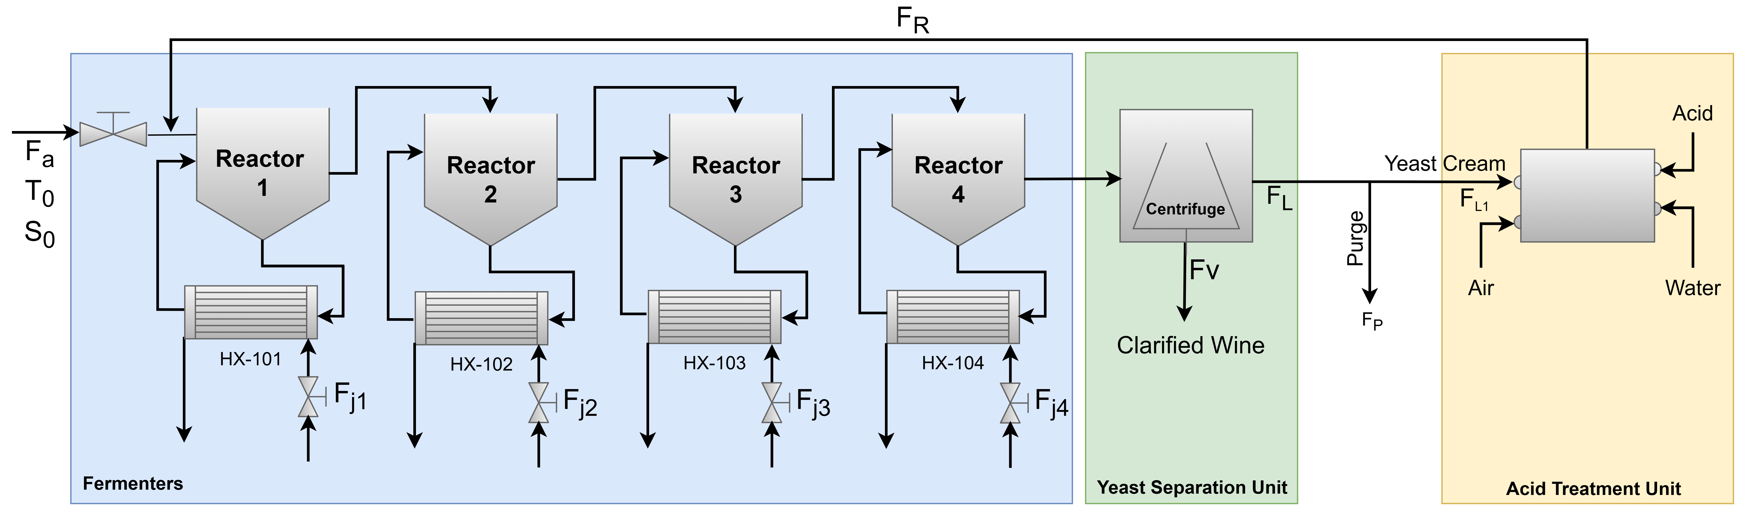
Figure 1: Schematic representation of a continuous alcoholic fermentation process.
Productivity (prod) and yield (yield) of the fermentation are defined by Eq(1) and Eq(2), respectively.
$$prod= \frac{(F_{v}+ F_{P}){ P}_{4}}{V_{total}}$$ | (1)
$$yield= \frac{\left(F_{v}+ F_{P}\right) P_{4}}{0.511 S_{0} F_{a}}$$ | (2)
Where $F_{v}$ is the clarified wine flow rate; $F_{P}$ is the wine output from the purge; ${ P}_{4}$ is the product concentration in the fourth reactor; $V_{total}$ is the total volume of the four reactors; $S_{0}$ is the substrate concentration in the must; and $F_{a}$ is the must feed flow rate. Yield refers to the efficiency of substrate conversion into ethanol, while productivity is defined as the amount of product generated per unit reactor volume. However, these objectives often involve a trade-off, as operating conditions that increase productivity may reduce yield.
  - Control strategy
    - Variables of interest
The main controlled variable in continuous fermentation is the substrate concentration at the outlet of the last reactor ($S_{4}$). This variable does not need to be maintained at a fixed value but must remain within a specified range (65–70 kg/m³) to ensure productivity and avoid distillation problems. The must feed flow rate ($F_{a}$) is the primary manipulated variable used to control $S_{4}$. The coolant flow rates ($F_{j,1}$ to $F_{j,4}$) maintain the reactor operating temperatures ($T_{1}$ to $T_{4}$) at 33.5 °C. The strategy proposed by Violaro et al. (2018) consists of a 5×5 multivariable control system in which $S_{4}$and the reactor temperatures are regulated through the corresponding manipulated variables.

    - MPC with the incremental state-space model
The MPC proposed by Violaro et al. (2018) is based on a state-space model for a system with $n_{u}$inputs and $n_{y}$outputs. The state-space model for incremental MPC is given in Eq(3) and Eq(4).
$$x\left(k+1\right)=Ax\left(k\right)+B∆u(k)$$ | (3)
$$y\left(k\right)=Cx(k)$$ | (4)
Where $x ∈ R^{n_{x}}$, $u ∈ R^{n_{u}}$, and $y ∈ R^{n_{y}}$, with $Δu(k) = u(k) - u(k - 1)$. $A$ represents the system matrix that determines the state dynamics; $B$ represents the input matrix that describes how the inputs affect the state; and $C$ represents the output matrix that relates the state to the system outputs. For a given time step $k$, the state $x(k)$ is assumed known, and the controller computes a control sequence $(Δu(k), Δu(k+1), . . . , Δu(k+m-1))$ that minimizes the objective function defined in Eq(5).
$$J_{k}= \sum_{j=1}^{p}{{\left(y\left(k+j | k\right)-y_{sp}\right)}^{T}Q\left(y\left(k+j | k\right)-y_{sp}\right)+ }\sum_{j=0}^{m-1}{{∆u\left(k+j | k\right)}^{T}R ∆u\left(k+j | k\right)}$$  $$s.t.$$  $$u_{min}≤u\left(k+j | k\right) ≤ u_{max}, j=1, 2, …, m-1$$  $${-∆u}_{min}≤∆u\left(k+j | k\right) ≤ ∆u_{max}, j=1, 2, …, m-1$$ | (5)

Where $p$ is the output prediction horizon; $m$ is the control (input) horizon; $y_{sp}$ is the desired value of the output;
$Δu(j + k) = u(j + k) - u(j + k - 1)$; $Q$ and $R$ are weighting matrices of appropriate dimensions. The cost function $J_{k}$ is composed of two terms. The first term penalizes the deviation between the predicted output and the setpoint over the prediction horizon $p$, weighted by the matrix $Q$. The second term penalizes the variation in the control action over the control horizon $m$, weighted by the matrix $R$. Minimizing this cost function helps ensure that the system follows the desired output smoothly, avoiding undesirable oscillations in the control inputs.
  - Simulations
Two different controller tunings were proposed using different values of the $Q$ parameter. This parameter penalizes the error between the controlled variables and their reference values (setpoints). Tuning 1 was obtained by increasing by a factor of three the penalty associated with temperature errors relative to the reference case reported by Violaro et al. (2018), whereas Tuning 2 was achieved by increasing the penalties associated with ${ S}_{4}$ errors relative to the same reference case. The $Q$ values are summarized in Table 1.
Table 1: Q values proposed for each tuning.
Tuning | S₄ | T₁ | T₂ | T₃ | T₄
Violaro et al. (2018) | 9500 | 65000 | 78000 | 13000 | 6000
1 | 9500 | 195000 | 234000 | 39000 | 18000
2 | 28500 | 65000 | 78000 | 13000 | 6000

Three scenarios were simulated for each of the three proposed tunings, and the closed- and open-loop responses were compared with the results obtained using the tuning reported by Violaro et al. (2018). The conditions of each scenario were defined based on Meleiro (2002) and real operating conditions, and are described as follows:

- Scenario 1: Disturbances were imposed on the process by varying the must temperature ($T_{0})$. The temperature initially started at 28 °C, changed to 29 °C after 50 h, decreased to 28 °C at 100 h, and finally reduced to 27 °C at 150 h.
- Scenario 2: The initial substrate concentration ($S_{0}$) was set to 180 kg/m³, increased to 185 kg/m³ after 50 h, returned to its initial value at 100 h, and then decreased to 175 kg/m³ at 150 h.
- Scenario 3: A servo control scenario was analyzed by changing the $S_{4}$ setpoint to 1.08, 0.98, 0.88, and 0.98 kg/m³ at 1 h, 50 h, 100 h, and 150 h, respectively.
  - Results
The must temperature directly influences the operating temperature. For this exothermic reaction, a temperature rise reduces substrate conversion, as observed at t = 50 h in Figure 2a. In closed-loop operation, the manipulated variables are adjusted simultaneously to maintain the controlled variables at their setpoints. As a result, the controller reduced the feed flow rate as a corrective action to compensate for the reduction in substrate concentration for all three tunings. Conversely, when the must temperature decreased, the substrate concentration increased, leading to a higher feed flow rate, as observed at t = 100 h. In the first reactor, which receives the must feed, lower must temperatures required lower coolant flow rates. However, in the remaining reactors, the coolant flow rate increased even though the temperatures of reactors 2–4 were below their setpoints. This behavior highlights the multivariable nature of the control system, in which one manipulated variable influences multiple controlled variables. The fermentation process is highly nonlinear, and the control strategy proposed by Violaro et al. (2018) was based on an imprecise model derived from transfer functions. Nevertheless, all tunings kept the substrate concentration and operating temperature close to setpoints. This behavior was confirmed by the ISE performance index values shown in Table 2. Tuning 1 reduced the temperature ISE but increased the substrate concentration ISE, whereas Tuning 2 exhibited the opposite trend. The substrate concentration is directly related to yield and productivity, and the corresponding profiles are presented in Figure 2b. Although the variations are small, yield exhibited opposite trends in the open- and closed-loop simulations. In open-loop operation, the temperature increase reduced yield at t = 50 h because the disturbance decreased substrate conversion and ethanol production. In closed-loop operation, the magnitude of the control error directly affected yield and productivity. During disturbances, productivity showed behavior opposite to that of yield because it was directly affected by variations in the feed flow rate.

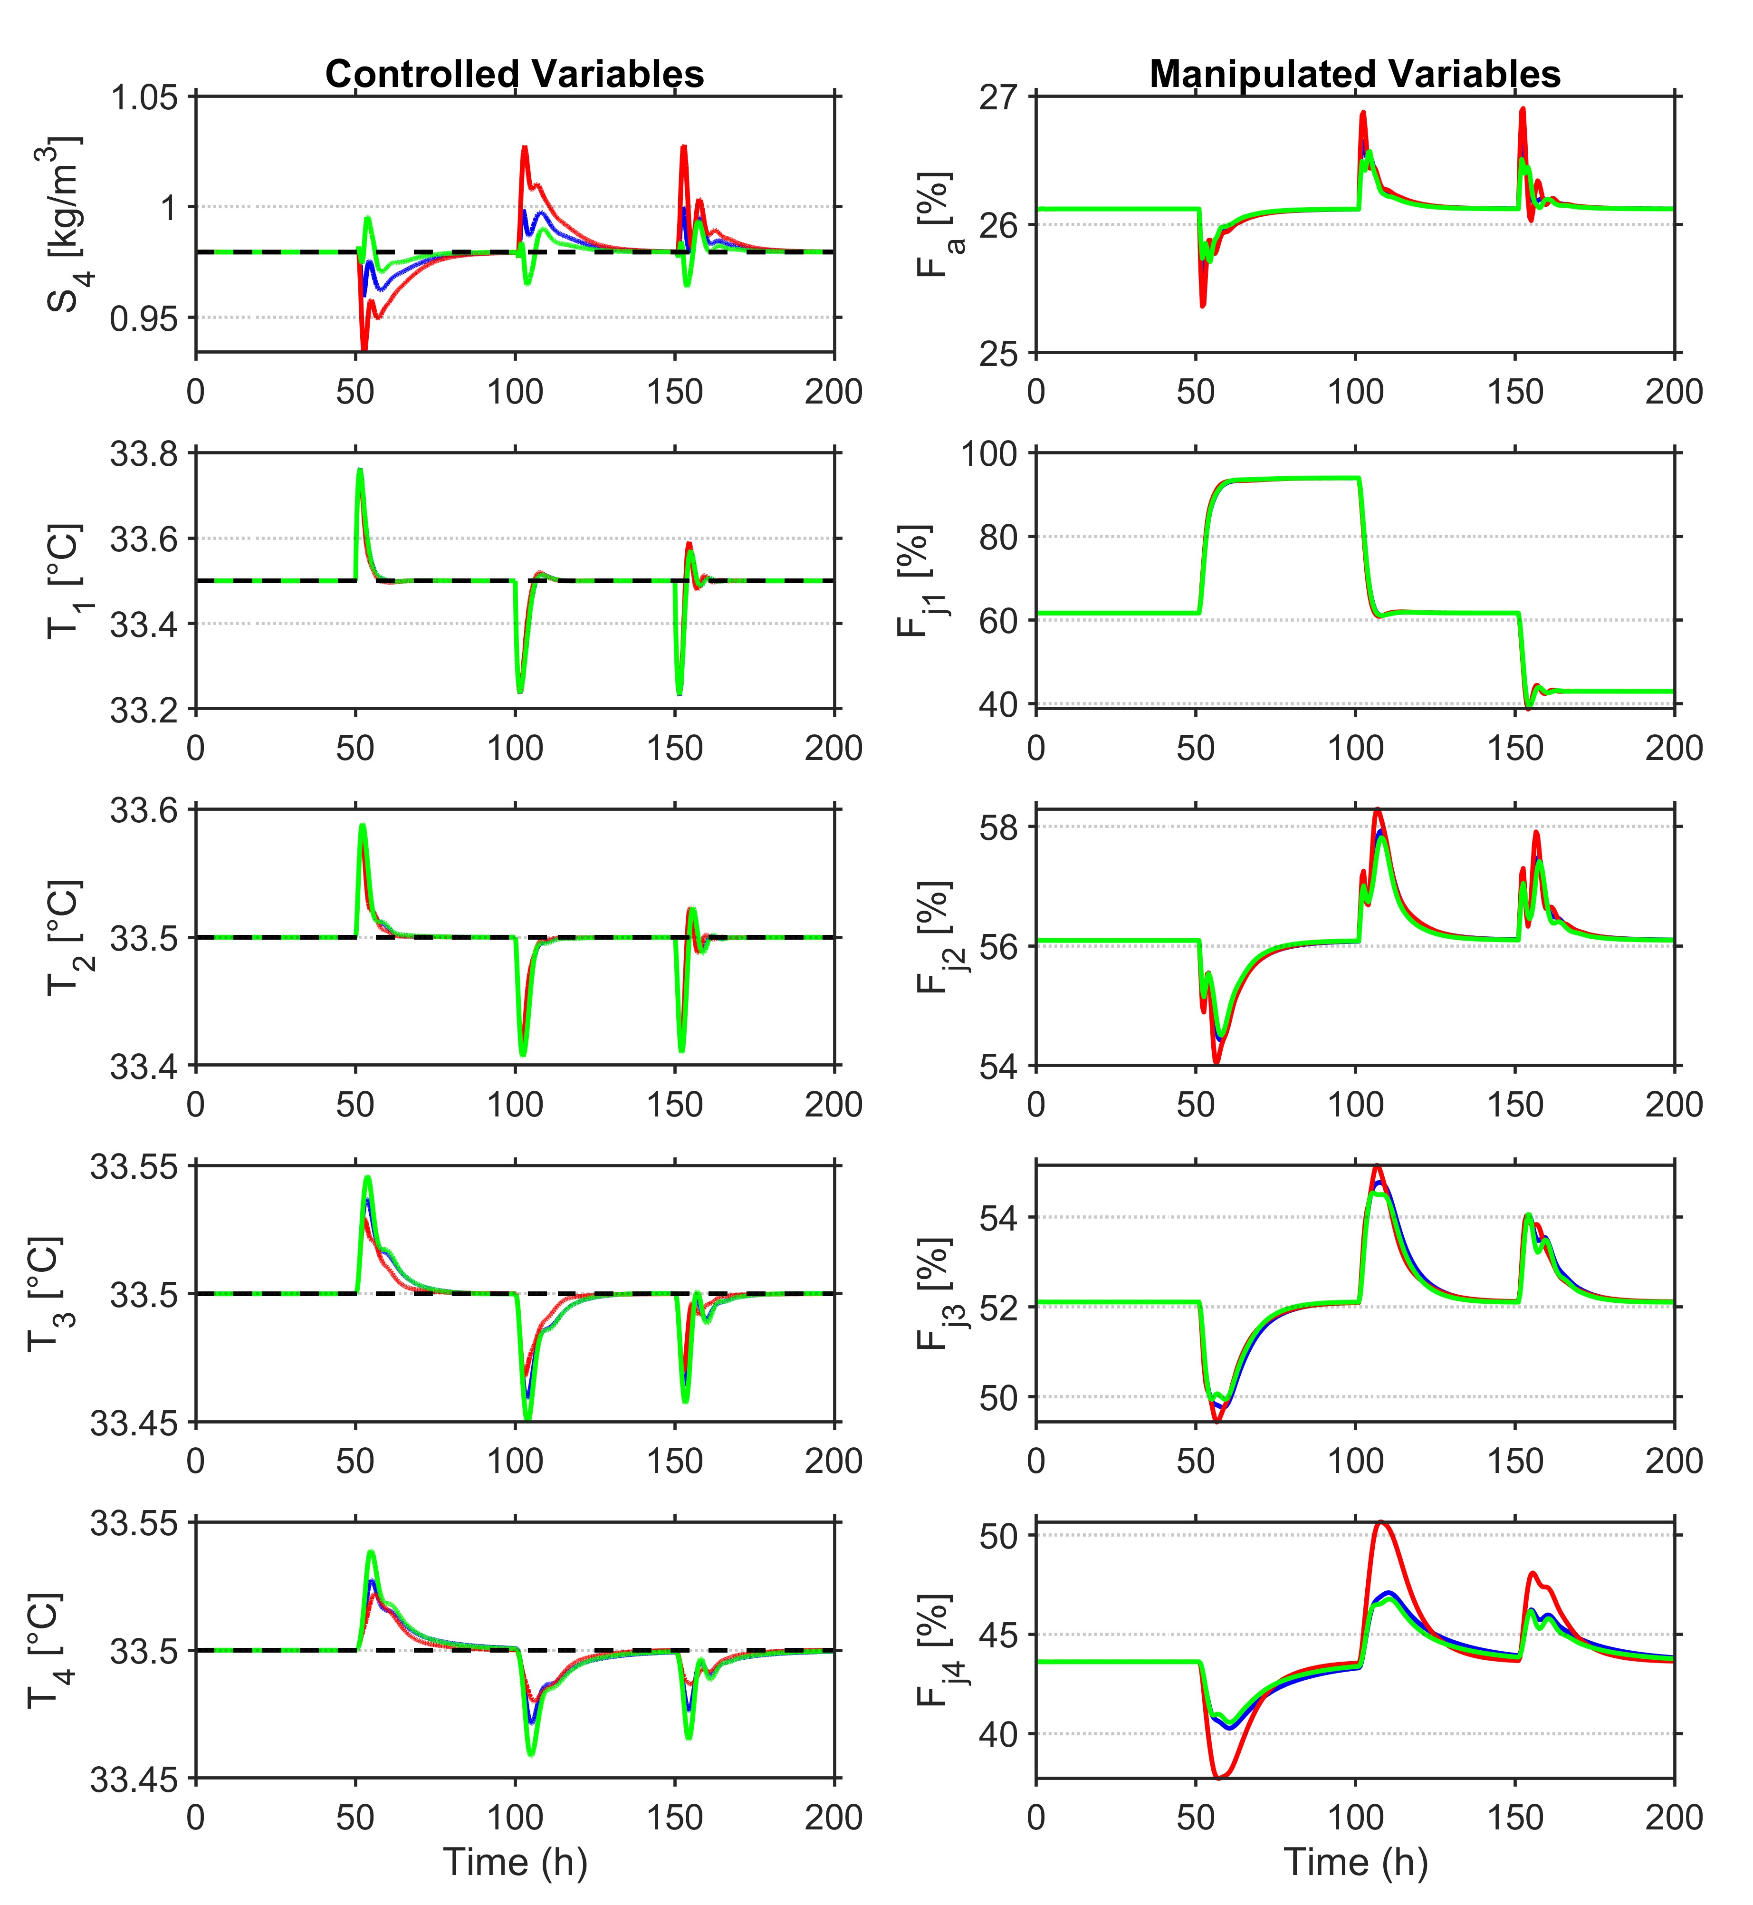 | 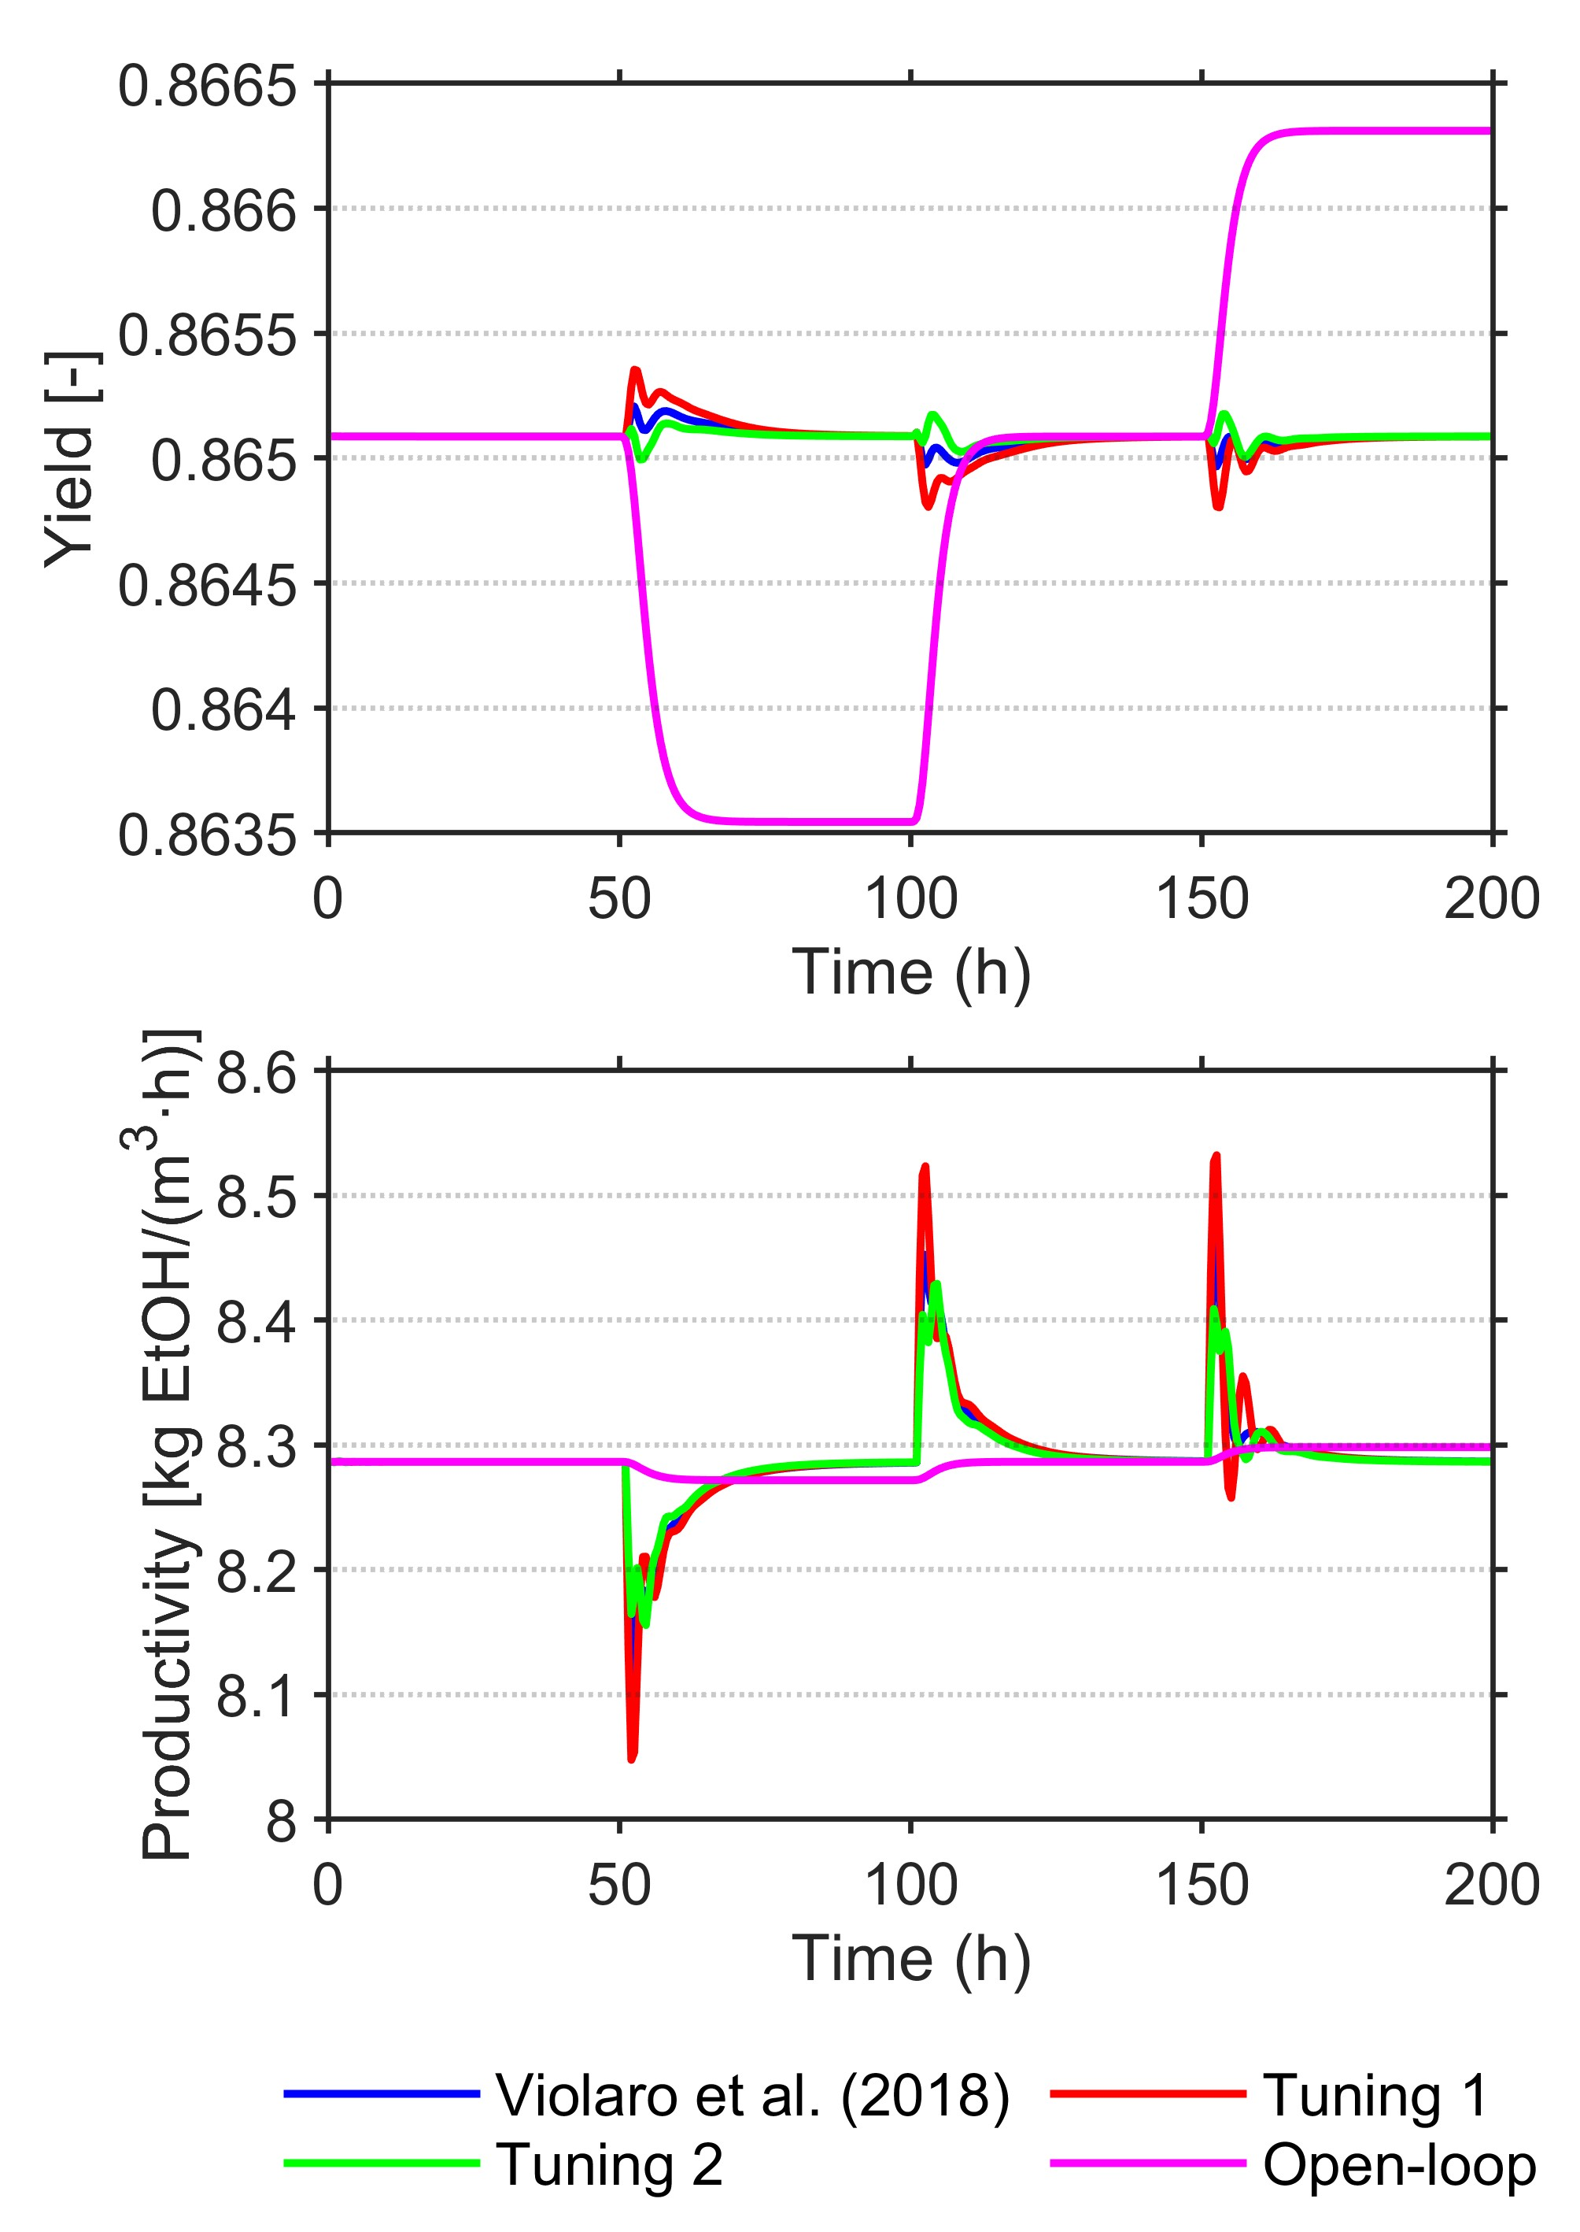
(a) | (b)
Figure 2: (a) Manipulated and controlled variables. (b) Yield and productivity for Scenario 1.
Table 2: ISE results for all scenarios.
 | Scenario 1 |  |  |  |  | Scenario 2 |  |  |  |  | Scenario 3
Tuning | S₄ | T₁ | T₂ | T₃ | T₄ | S₄ | T₁ | T₂ | T₃ | T₄ | S₄ | T₁ | T₂ | T₃ | T₄
Violaro et al. (2018) | 0.63 | 2.56 | 1.00 | 0.84 | 0.88 | 7.51 | 0.15 | 1.16 | 3.11 | 4.53 | 1.13 | 0.18 | 0.19 | 0.43 | 1.82
1 | 1.21 | 2.42 | 0.85 | 0.59 | 0.67 | 9.46 | 0.24 | 0.67 | 1.63 | 2.84 | 1.45 | 0.14 | 0.14 | 0.21 | 0.72
2 | 0.34 | 2.59 | 1.08 | 0.93 | 1.04 | 4.69 | 0.19 | 1.46 | 3.48 | 5.05 | 0.72 | 0.28 | 0.24 | 0.50 | 1.95

In Scenario 2, a control action opposite to that expected in a single-variable system can be observed. The feed flow rate $F_{a}$decreases even though the substrate concentration remains above its setpoint. This control action highlights the multivariable nature of the system, as the reduction in $F_{a}$is driven by the decrease in operating temperatures. As shown in the final disturbance, the use of feed streams with substrate concentrations below 175 kg/m³ is not recommended. Low $S_{0}$concentrations may lead to saturation of the temperature control in reactors 3 and 4. The three evaluated tunings exhibited similar behavior in terms of the manipulated variables. Consequently, yield and productivity, shown in Figure 3b, also presented comparable values. Scenarios 1 and 2 showed similar ISE results.

The system behavior with substrate setpoint variations is presented in Figure 4a. With an increase in the setpoint of the substrate concentration, an increase in the must feed and coolant flow rate is expected as a strategy to elevate the concentration of $S_{4}$ and at the same time to mitigate the temperature increase. As previously observed in Table 2, Tuning 1 presented better performance in reactor temperature control, whereas Tuning 2 achieved better performance in controlling the concentration of $S_{4}$. The tuning proposed by Violaro et al. (2018) presented intermediate behavior. The obtained values of yield and productivity in Scenario 3 are presented in Figure 4b. For the three evaluated tunings, the analysis of yield and productivity showed that an increase in the must feed $F_{a}$ after the increase of the setpoint resulted in an increase in productivity and a decrease in yield. In contrast, after the third disturbance, the opposite effect was observed, in which the increase in $F_{a}$ promoted an increase in yield and a reduction in productivity. This opposite behavior between yield and productivity in response to setpoint variations indicates that the process can be optimized to maximize either productivity or yield through setpoint manipulation. The possibility of optimizing these reaction performance metrics together has not yet been addressed in the literature, which represents a very promising research opportunity.

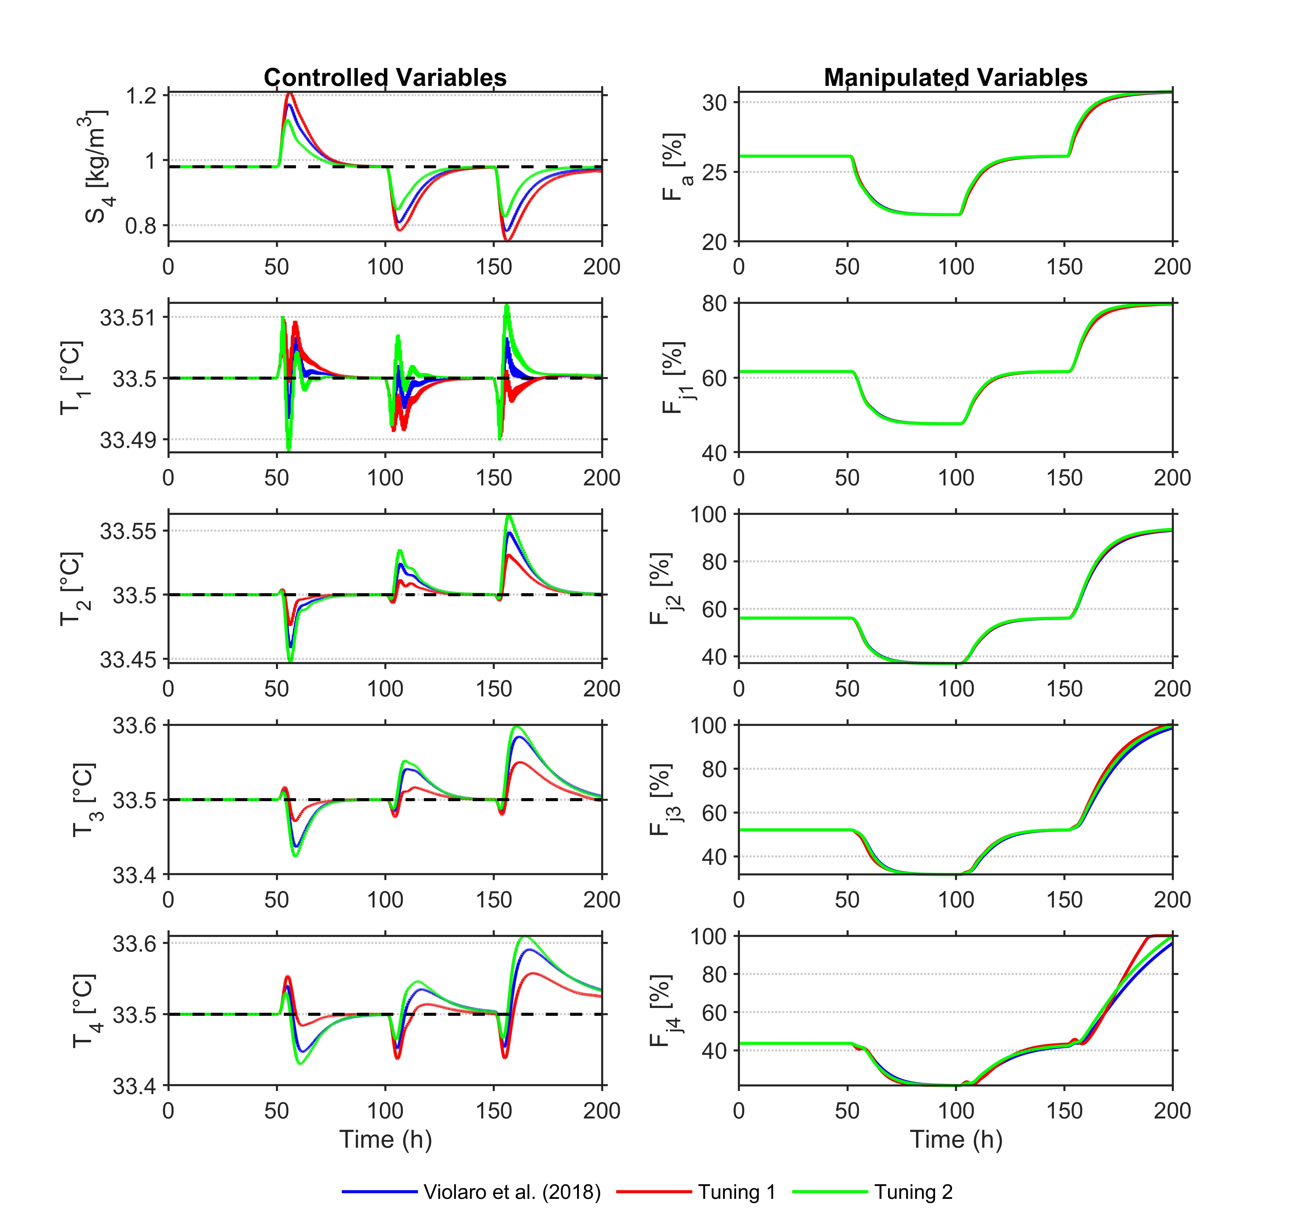 | 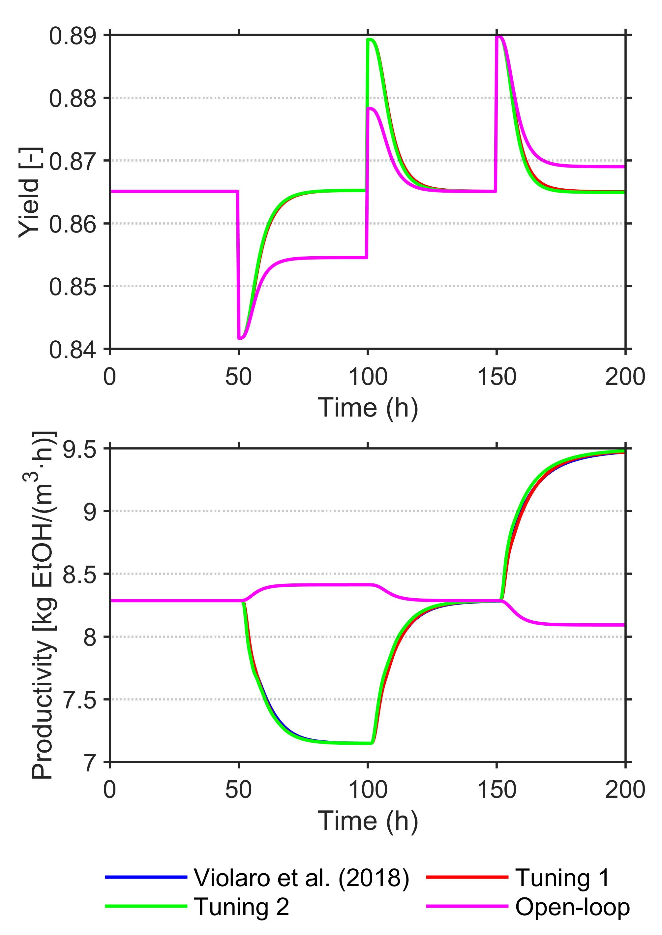
(a) | (b)
Figure 3: (a) Manipulated and controlled variables. (b) Yield and productivity for Scenario 2.
  - Conclusions
This study evaluated the use of different output error weights for the controlled variables and analyzed how controller performance and substrate concentration setpoint manipulation influenced yield and productivity. For the three scenarios analyzed, Tuning 1, which assigned a higher weight to the temperature error, showed lower ISE for temperature control, but at the expense of deterioration in substrate control. In contrast, Tuning 2 provided better performance in substrate control and a degradation in temperature control, as it assigned a higher weight to substrate error. It is concluded that increasing the output error weight of one controlled variable leads to a deterioration in the control of the others. Since the conversion of the substrate into ethanol is directly related to productivity and yield, a certain loss of performance in temperature control is acceptable in favor of more precise control of the substrate concentration. Therefore, a prior analysis of which disturbance is more frequent or which controlled variable is more important in the process can help define the appropriate tuning to be used. Further investigation is warranted to assess the integration of optimizing the productivity and yield of the fermentation process with the multivariate control of process variables. A relevant direction for future research is the assessment of the economic impact of productivity and yield in dynamic operating contexts, especially in closed-loop operation.

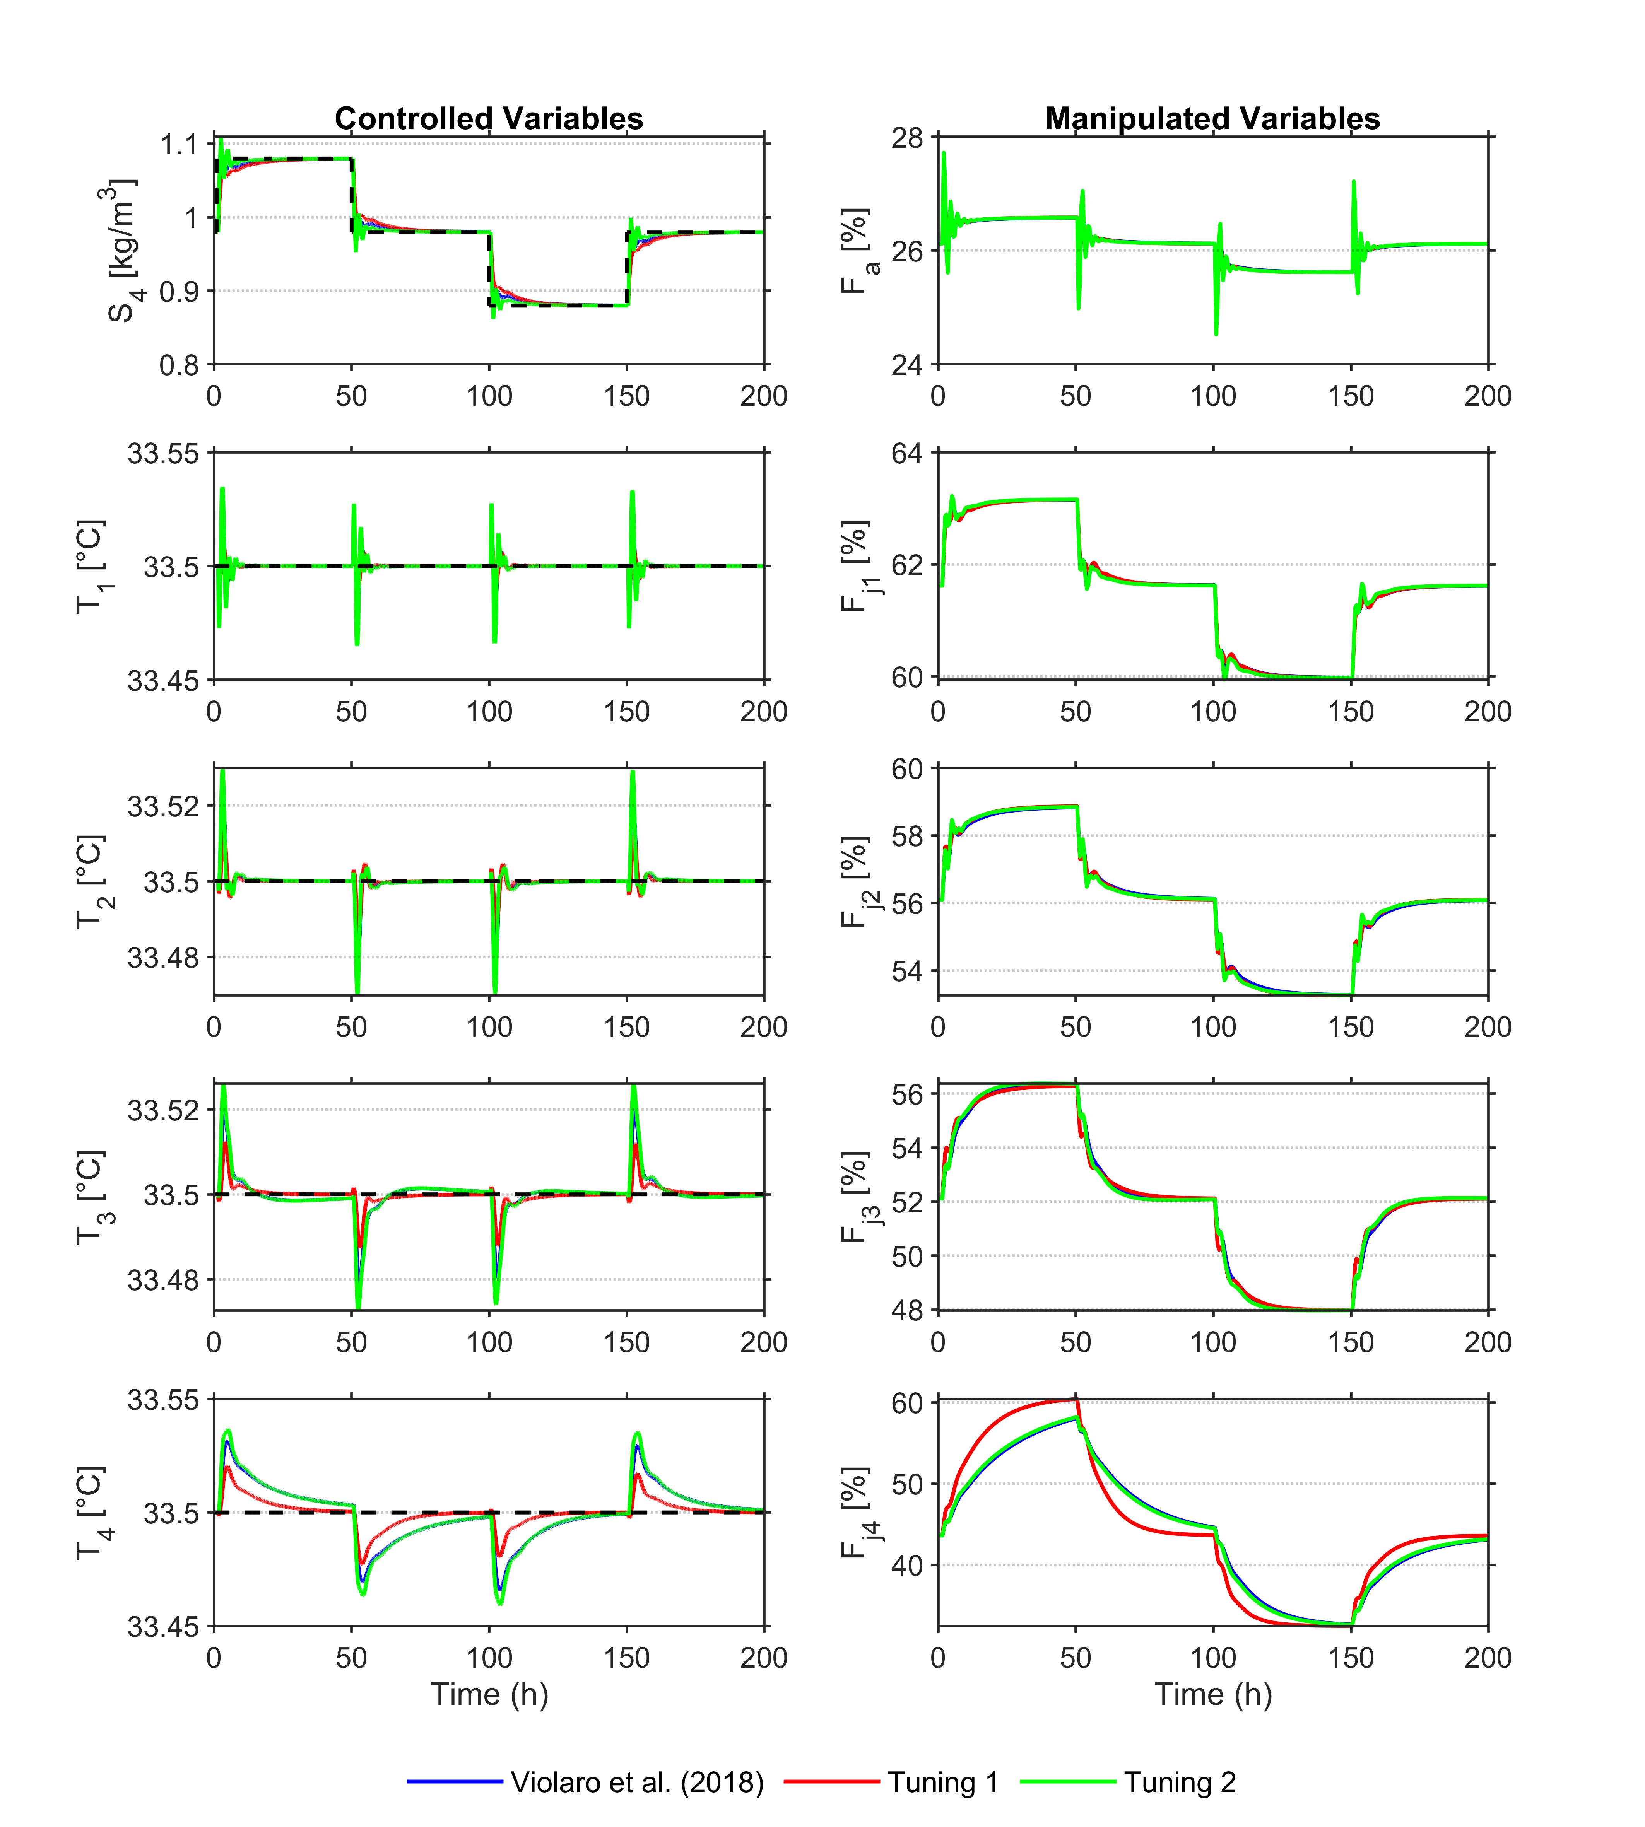 | 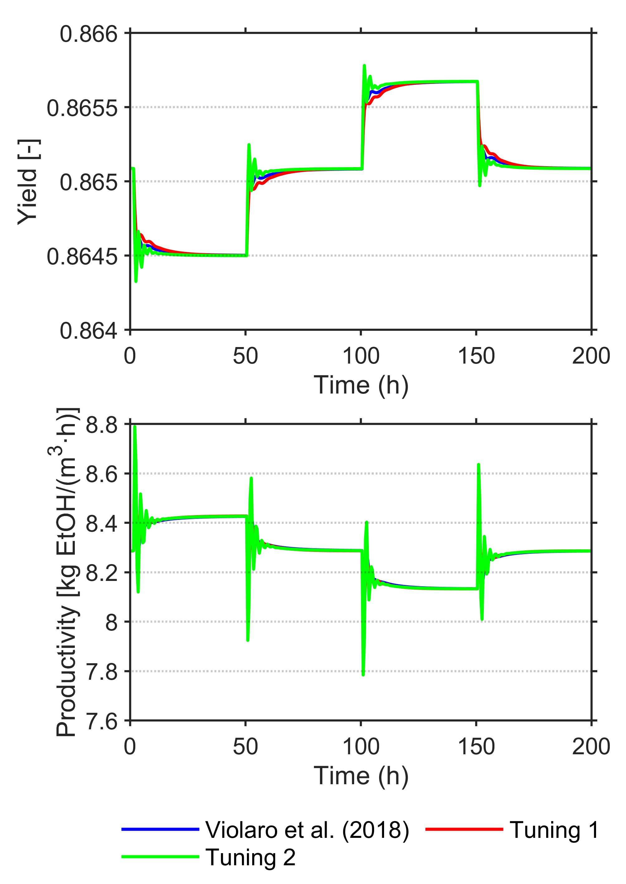
(a) | (b)
Figure 4: (a) Manipulated and controlled variables. (b) Yield and productivity for Scenario 3.
Acknowledgments
The authors acknowledge the support provided by CNPq (grant numbers 170997/2023-5 and 160006/2024-4).
References
Andrietta S., 1994, Modelling, Simulation and Control of Continuous Alcoholic Fermentation at Industrial Scale, PhD Thesis, Universidade Estadual de Campinas, Faculty of Food Engineering, Campinas, Brazil (in Portuguese).
Andrietta S., Maugeri Filho F., 1994, Optimum design of a continuous fermentation unit of an industrial plant for alcohol production, In: Galindo E., Ramirez O. (Eds.), Advances in Bioprocess Engineering, Kluwer Academic, Netherlands, 47–52.
Fernandez C., Pantano N., Rodriguez L., Scaglia G., 2021, Nonlinear control for bioprocesses with model uncertainties and external disturbances, Mathematical Problems in Engineering, 2021, 2865264.
Herrera W., Rivera E., Alvarez L., Plazas Tovar L., Tamayo Rojas S., Yamakawa C., Bonomi A., Maciel Filho R., 2016, Modeling and control of a continuous ethanol fermentation using a mixture of enzymatic hydrolysate and molasses from sugarcane, Chemical Engineering Transactions, 50, 169–174.
Meleiro L.A.C., 2002, Design and Application of Controllers Based on Linear, Neural and Fuzzy Models, PhD Thesis, Universidade Estadual de Campinas, School of Chemical Engineering, Campinas, Brazil (in Portuguese).
Nasimi R., Azadi S., Jazaeri M., Farzinfar M., 2024, Nonlinear model-based predictive control of a yeast fermentation bioreactor using new bee colony-WNN modelling structure, Journal of Engineering Research.
Petre E., Selișteanu D., Roman M., 2021, Advanced nonlinear control strategies for a fermentation bioreactor used for ethanol production, Bioresource Technology, 328, 124836.
Renewable Fuels Association, 2024, Annual ethanol production, ethanolrfa.org/markets-and-statistics/annual-ethanol-production, accessed 27.07.2025.
Violaro F., Rivera E., Alvarez L., 2018, Multivariable model predictive control of a continuous fermentation unit for first-generation ethanol production, Chemical Engineering Transactions, 65, 67–72.

