 CHEMICAL ENGINEERING TRANSACTIONS  VOL. xxx, 2025 | A publication of  
The Italian Association
of Chemical Engineering
Online at www.cetjournal.it

Guest Editors: Fabrizio Bezzo, Flavio Manenti, Gabriele Pannocchia, Almerinda di Benedetto
Copyright © 2025, AIDIC Servizi S.r.l.
ISBN 979-12-81206-17-5; ISSN 2283-9216

SDBS Adsorption on Palm Kernel Activated Carbon and Its Effect on API 80Q Steel Corrosion
Darío Peña^{*,a}, Oscar Higuera ª, Carlos Galán ª, Nicolas Santos ^{c}, Hugo Estupiñan ^{d} , Adan León ^{a,b}
ªUniversidad Industrial Santander, Escuela de Ingeniería Metalúrgica y Ciencia de los Materiales, Grupo de Investigaciones en Corrosión – GIC, cra 27 calle 9, Bucaramanga –Santander, Colombia
^{b}Universidad Industrial Santander, Escuela de Ingeniería de Petróleos, Grupo de Investigación Recobro Mejorado – GRM, cra 27 calle 9, Bucaramanga –Santander, Colombia
^{c}Universidad Industrial Santander, Escuela de Ingeniería de Petróleos, Grupo de Investigación en Tomografía Computarizada para Caracterización de Yacimientos GIT, cra 27 calle 9, Bucaramanga –Santander, Colombia.
^{d}Universidad Nacional de Colombia, Facultad de Minas, cra 80 No 65-223 - Campus Robledo Medellín, Colombia.

dypena@uis.edu.co

Approximately 300 million barrels of water are produced daily from hydrocarbon extraction worldwide, highlighting the need for improved treatment and disposal methods. In chemical oil recovery using SDBS (sodium dodecyl benzene sulfonate), surfactant-emulsified water is generated, which can affect the integrity of production and transport pipelines. This study evaluates activated carbon derived from palm kernel shells for two purposes: removal of SDBS from produced water and analysis of its impact on the corrosion of API N-80Q steel. Activated carbon was prepared using an H₃PO₄ impregnation ratio (0.2:1) and pyrolyzed at 430 °C for 30 minutes. Bet analysis showed a surfaces area of approximately 800 m²/g, while FTIR-ATR confirmed the presence of aromatic, alkyl, and carbonyl functional groups. In synthetic water containing 1000 ppm of SDBS, the activated carbon achieved around 90% removal efficiency, attributed to its pore distribution and active sites. Tests were conducted ad 25 °C and 65 °C. Electrochemical measurements, including open circuit potential (OCP), linear polarization, and Tafel extrapolation, were performed using an EMSTAT 4SHR potentiostat. Results indicate that temperature and SDBS concentration are the main factors influencing the corrosion rate of API N-80Q steel.

Approximately 300 million barrels of water are produced by the hydrocarbon extraction process worldwide each day. Therefore, new studies and tools are needed to treat and dispose of this water in surface projects. During the process of chemical oil recovery using SDBS (sodium dodecylbenzene sulfonate), surfactant-emulsified water is produced. The composition of this water can affect the integrity of production and transport pipelines. This research explores the use of activated carbons derived from palm kernel shells for two purposes: firstly, to remove the surfactant SDBS from production waters; and secondly, to analyses the impact of water quality on the integrity of API N-80Q steel. In the first stage, activated carbon was prepared from palm kernel shell with an H₃PO₄ impregnation ratio (0.2:1). The pyrolysis test was then performed in a tubular reactor at 430 °C for 30 minutes. The BET (Brunauer-Emmett-Teller) results showed that the surface area of the activated carbon was approximately 800 m²/g. Additionally, FTIR-ATR infrared spectroscopy data revealed the presence of functional groups associated with aromatic, alkyl, and carbonyl species. In synthetic water containing 1000 ppm of SDBS, activated carbon demonstrated an efficiency of around 90% in removing the substance. This can be attributed to the availability of active sites and the pore distribution of the activated carbon. The tests were performed at ambient (25 °C) and reservoir (65 °C) temperatures. To this purpose, an electrochemical cell was constructed for open circuit potential (OCP) measurements, linear polarization techniques and Tafel extrapolation using an EMSTAT 4SHR potentiostat. The electrochemical results revealed that temperature and SDBS are the key factors influencing the corrosion rate of API N80Q steel.

  - Introduction
During crude oil production, large volumes of produced water are generated, and water cut values can exceed 90% in mature reservoirs, as reflected by the water oil ratio (WOR). The water cut is strongly influenced by reservoir conditions and production strategy. Recent estimates indicate that global produced water generation in oil and gas operations has reached approximately 250 million barrels per day (Patni & Ragunathan, 2023). At the same time, increasing demand for fuels and petroleum-derived products, together with the decline of conventional hydrocarbon reserves, has driven the Oil & Gas industry to improve and develop technologies aimed at sustaining and enhancing crude oil recovery. In this context, enhanced oil recovery (EOR) methods are increasingly important. Among them, chemically enhanced oil recovery (CEOR) has received significant attention due to the use of chemical agents, such as surfactants, designed to improve the mobility ratio and ultimately increase the recovery factor (Quintella et al., 2025).
Produced water exhibits a complex chemical composition due to the presence of both organic and inorganic species. In addition, the use of surfactants in chemically enhanced oil recovery can increase the load of dissolved hydrocarbons, inorganic salts, and trace metals, among other constituents (Hussain et al., 2019). Sodium dodecylbenzene sulfonate (SDBS) is an anionic surfactant widely applied in the hydrocarbon sector to improve interfacial properties and fluid–rock interactions. However, during crude oil production, SDBS can alter the physicochemical characteristics of produced water. Moreover, the presence of such additives, together with dissolved ionic species and elevated operating temperatures, may intensify corrosion mechanisms in metallic materials continuously exposed to these environments (Luo et al., 1998; Branzoi et al., 2016). API N-80Q steel is commonly used in tubing, piping, and production equipment due to its high mechanical strength and adequate performance under reservoir conditions. Nevertheless, its behavior in complex aqueous media, particularly those enriched with surfactants and evaluated at representative operating temperatures, still requires detailed investigation. The interaction between the steel surface, the electrolyte composition, and operating conditions can promote both uniform and localized corrosion, ultimately compromising service life.
To address this issue, several studies have explored adsorbent materials based on activated carbons produced from the thermochemical processing of residual biomass (León et al., 2025). However, the removal of metals and other heavy contaminants using activated carbon can vary significantly depending on the physicochemical characteristics of the treated effluent. Although activated carbons are capable of removing high contaminant loads, their performance is strongly influenced by textural properties, such as specific surface area and pore volume, as well as by the availability of surface functional groups that act as active sites (Zeng et al., 2023; Zaini et al., 2023). Accordingly, this work investigates activated carbons derived from palm kernel shells as an alternative treatment approach with two objectives: (i) to evaluate the removal of the anionic surfactant SDBS from synthetic produced water and (ii) to assess the impact of the treated water on the integrity of API N-80Q steel using electrochemical techniques.
  - Materials and methods
    - Materials
In this study, residual palm kernel shell biomass was used as the precursor material. The biomass was milled using a TRAPP TRF 300 mill and then air-dried under ambient conditions for 70 h. The dried material was sieved using a Gran Test–Pinzuar sieve shaker to obtain a 20 – 40 mesh particle size fraction. Analytical-grade SDBS was purchased from Sigma-Aldrich.
    - Preparation of activated carbon from palm kernel shell
Chemical activation of the residual palm kernel shell biomass was performed using phosphoric acid (H₃PO₄) at an acid-to-biomass impregnation ratio of 0.2:1, with a contact time of 1 h. The impregnated material was then aged for an additional 8 h and dried at 150 °C. Subsequently, pyrolysis was conducted at 430 °C for 30 min in a tubular reactor placed inside a Carbolite UN 110 furnace under an inert nitrogen atmosphere at a flow rate of 50 mL min⁻¹. The selected operating temperature was based on prior thermogravimetric analysis (TGA). Both the precursor biomass and the resulting activated carbon were characterized by FTIR – ATR spectroscopy.
    - Characterization
Thermogravimetric analysis (TGA) was performed using a TA Instruments Discovery 5500 analyzer. Approximately 10 mg of dried biomass was analyzed in accordance with ASTM E1131. Measurements were conducted from 25 to 800 °C at a heating rate of 10 °C min⁻¹ under a nitrogen flow of 50 mL min⁻¹.
ATR–FTIR spectroscopy: The palm kernel biomass and the resulting activated carbon were characterized using a Thermo Scientific Nicolet Summit X spectrometer. Prior to each measurement, a background spectrum was collected using air, and spectra were acquired using 32 scans.
BET surface area analysis: Textural properties were determined by N₂ physisorption at 77 K using a Micromeritics 3Flex instrument. Before analysis, the activated carbon was degassed at 200 °C under vacuum (6 Pa) for 8 h.
  - Adsorption tests of sodium dodecylbenzene sulfonate SDBS
Adsorption experiments were conducted using synthetic solutions containing sodium dodecylbenzene sulfonate (SDBS) at concentrations of 50 and 250 mg L⁻¹. Activated carbon (0.05 g) was added to 5 mL of solution, and the suspensions were agitated on an orbital shaker at 150 rpm for 24 h to ensure equilibrium. The solid and liquid phases were subsequently separated by centrifugation at 6000 rpm for 10 min. The residual SDBS concentration was determined by UV–Vis spectrophotometry using a previously established calibration curve. Adsorption capacity and removal efficiency were calculated according to Eq (1) and (2).

$$q_{e}=\frac{\left(C_{o}-C_{f}\right)*V}{W}$$ | (1)
$$RE=\frac{\left(C_{o}-C_{f}\right)}{C_{o}}*100$$ | (2)

Where:
qe: adsorption capacity (mg/g)
Co: initial concentration (mg/L)
C_{f}: final concentration (mg/L)
W: mass of activated carbon (g)
V: solution volume (L)
RE: removal efficiency

  - Electrochemical tests in API N-80Q steel
API N-80Q steel coupons were prepared with dimensions of 2.0 × 1.5 × 0.3 cm. The coupons were sequentially ground using silicon carbide abrasive papers (grit 120, 400, and 600) to obtain a uniform surface finish. They were then rinsed with acetone and ultrasonically cleaned to remove residual impurities.
Initially, the corrosion potential (Ecorr) of API N-80Q steel was recorded for 15 min using a potentiostat coupled with PSTrace V5.11 software to ensure stabilization of the open-circuit potential under different water types, a surfactant concentration of 1000 mg L⁻¹, and temperatures ranging from 25 to 60 °C. Subsequently, anodic polarization tests were conducted by sweeping the potential from −0.25 V to +0.25 V relative to Ecorr, with 0.01 V increments, at a scan rate of 0.00016 V s⁻¹. Tafel extrapolation analysis was then performed using a ±250 mV interval around Ecorr to determine the corrosion current density (Icorr). The corrosion rate was calculated in thousandths of an inch per year (mpy) from the Icorr values in accordance with the procedure described in ASTM G102 (2023), applying the relationship presented in Eq (3).

$$CR=\frac{K*Icorr*EW}{ρ}$$ | (3)

Where K = 0.1288, Icorr denotes the corrosion current density (µA cm⁻²), EW = 55.84, and ρ = 7.87 g cm⁻³.

Upon completion of the electrochemical tests, the steel coupons were rinsed with distilled water and air-dried at room temperature. The specimens were subsequently characterized by scanning electron microscopy coupled with energy-dispersive X-ray spectroscopy (SEM–EDS) and X-ray diffraction (XRD).
  - Results and Discussion
Figure 1a illustrates the thermal decomposition behavior of palm kernel shells (PKS) as temperature increased. The thermogravimetric analysis curve exhibited cumulative mass losses of 12, 68, and 77.5 wt% within the temperature intervals of 20 – 200, 200 – 400, and 400 – 600 °C, respectively. These three regions were associated with moisture evaporation, release of volatile species, and primary pyrolysis. The results indicate that a pyrolysis temperature of approximately 400 °C led to the most significant mass loss and structural transformation of PKS, which may be attributed to secondary decomposition reactions of cellulose, hemicellulose, and certain lignin fractions. These findings are consistent with previous reports (Hussain et al., 2019).

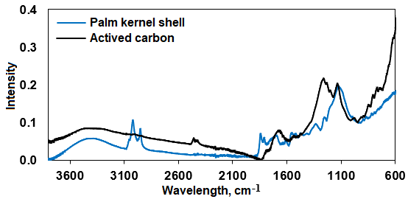
a b
Figure 1: Palm kernel shell characterization: (a) thermogravimetric analysis curve obtained at 10 °C min⁻¹; (b) ATR–FTIR spectra of palm kernel shells (PKS) and activated carbon.

Figure 1b presents the ATR–FTIR spectra of PKS and the corresponding activated carbon. PKS exhibited a broad band in the 3100 – 3600 cm⁻¹ region, attributed to O–H stretching vibrations associated with phenolic and carboxylic acid groups. Bands within the 900 – 1200 cm⁻¹ interval were assigned to C–O stretching vibrations characteristic of ether and hydroxyl functionalities. In contrast, the activated carbon showed a marked reduction in band intensity at 1350, 1450, 2850, and 2920 cm⁻¹, corresponding to C–H stretching and bending vibrations, as well as near 1710 cm⁻¹, associated with C=O stretching vibrations, indicating decomposition of oxygenated surface groups during thermochemical conversion. The persistence of a band around 1600 cm⁻¹ suggests the presence of aromatic structures with a graphitized arrangement.
The BET characterization results established that the activated carbon has a pore volume of 0.26 cm3/g and a surface area (ABET) close to 800 m2/g. Furthermore, the activated carbon has an average pore size of 2.98 nm, classifying it as a mesoporous material. These results are consistent with the literature, indicating that activation with H3PO4 contributes to the formation of materials with larger surface areas (Thommes et al., 2021). For the sodium dodecylbenzene sulfonate adsorption tests, it was necessary to measure the intensity at the maximum wavelength of 220 nm using a UV-VIS spectrophotometer. The residual concentration (RC) of the SDBS was determined by correlating absorbance (A) with concentration, as shown in Eq. (4).

$$A=0.0093+0.0282.C_{R}$$ | (4)

The adsorption performance of the activated carbon at contact times of 0.5, 1, and 2 h exhibited removal efficiency values of 52, 73, and 85%, respectively. After 2 h, the increase in removal efficiency became less pronounced, reaching an average value of approximately 90%. Based on these results, two synthetic produced water samples containing 0 and 1000 mg L⁻¹ of sodium dodecyl benzene sulfonate were prepared to simulate produced water treatment conditions. Electrochemical tests using API N-80Q steel coupons were subsequently conducted in these synthetic waters under reservoir-relevant thermal conditions. Accordingly, the temperature of the electrochemical measurements was set at 25 and 65 °C.
Figure 2 presents the anodic polarization curves. The profiles indicate charge transfer control, and none of the systems exhibited a tendency toward passivation in the anodic region. The API N-80Q steel coupon immersed in synthetic water without sodium dodecylbenzene sulfonate showed corrosion rates of 0.44 and 1.37 mpy at 25 and 65 °C, respectively. In contrast, the presence of 1000 mg L⁻¹ sodium dodecylbenzene sulfonate resulted in a marked increase in corrosion rate, reaching 1.37 and 1.46 mpy at 25 and 65 °C, respectively.
An interaction between the evaluated variables was observed, indicating that the corrosion rate depended on both thermal conditions and sodium dodecylbenzene sulfonate concentration in the electrolyte.
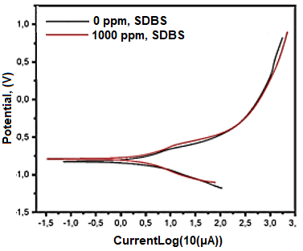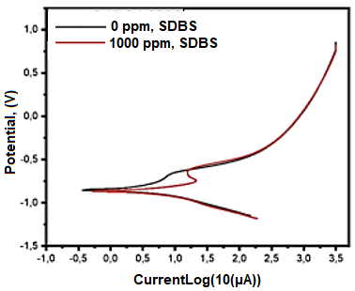
a b
Figure 2: Anodic polarization curves obtained in synthetic produced water containing 0 and 1000 mg L⁻¹ sodium dodecylbenzene sulfonate: (a) 25 °C and (b) 65 °C.

Figure 3 presents the SEM–EDS analysis of the base steel coupon and the coupon immersed in synthetic produced water containing 1000 mg L⁻¹ sodium dodecylbenzene sulfonate at 65 °C. The specimen exposed to 1000 mg L⁻¹ exhibited a surface covered with irregular deposits and an increased carbon (C) and oxygen (O) content, which may be attributed to the formation of corrosion products. Localized corrosion in the form of pitting was also observed, possibly associated with the presence of chloride species in the electrolyte.

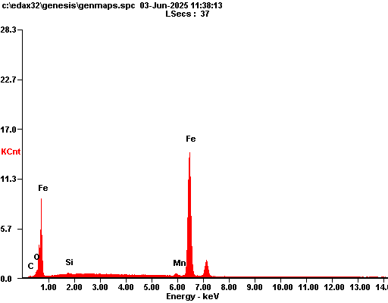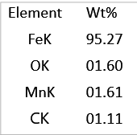
a
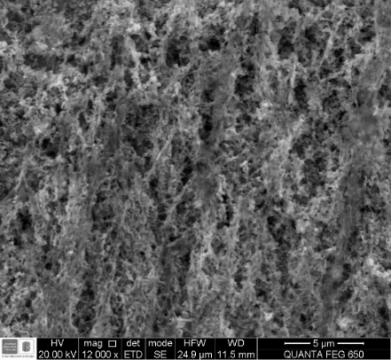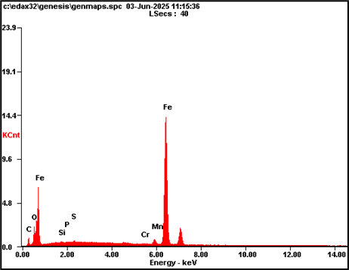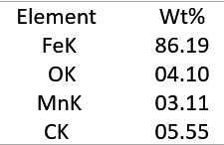
b
Figure 3: SEM–EDS analysis: (a) API N-80Q steel and (b) API N-80Q steel exposed to 1000 mg L⁻¹ sodium dodecylbenzene sulfonate at 65 °C.

For X-ray diffraction analysis, DIFFRAC.EVA software was used, which applies a mathematical search against the PDF-2 2021 database to identify the crystalline phases present. API N-80Q steel in contact with sodium dodecylbenzene sulfonate exhibited the characteristic peaks of the ferritic phase. The most intense peak at 2θ = 44° was assigned to the (110) crystallographic plane of α-Fe ferrite.
  - Conclusions
Activated carbon produced from palm kernel shells enabled sodium dodecylbenzene sulfonate removal with removal efficiency values exceeding 90%. This adsorption performance is consistent with the textural properties of the adsorbent. Accordingly, given the high adsorption performance and a BET surface area close to 800 m² g⁻¹, activated carbon derived from palm kernel shells represents a promising supplementary stage within produced water treatment schemes.
SEM–EDS analyses indicated the formation of oxide layers under all conditions, with increased oxygen and carbon contents as the aggressiveness of the medium increased. In addition, localized corrosion in the form of pitting was observed, which may be attributed primarily to chloride action and its synergy with temperature and sodium dodecylbenzene sulfonate. XRD analysis indicated that the predominant phase remained α-Fe ferrite, retaining the characteristic peaks of API N-80Q steel, while additional reflections were observed that are consistent with corrosion products such as magnetite (Fe₃O₄) and hematite (Fe₂O₃).
Acknowledgments
The authors acknowledge the financial support provided by the Universidad Industrial de Santander (UIS) and its professional team through the internal VIE project 4616. The authors express their gratitude to the “Ministerio de Ciencia y Tecnología (MINCIENCIAS)”, “Agencia Nacional de Hidrocarburos (ANH)”, Energy Frontera and Universidad Industrial de Santander for the financial support. This work was financially supported by Project 1102-1035-92931 contract 036 2023.
References
Branzoi F., Branzoi V., Stanca A., 2016, Corrosion inhibition of carbon steel by some anionic surfactants in 0.5 M H2SO4, Revue RoumaineChimie, 61(11–12), 837-850.
Husein N., Yunan M. H., Ismail I., Sulaiman W. R. W., Boyou N. V., 2018, Enhanced oil recovery by alkaline-surfactant-polymer alternating with waterflooding, Chemical Engineering Transactions, 63, 823-828.
Hussain M., Tufa L. D., Yusup S., Zabiri, H., 2019, Thermochemical behavior and characterization of palm kernel shell via TGA/DTG technique, Materials Today: Proceedings, 16, 1901-1908.
León A. Y., Contreras-Arenas J. D., Garnica-Fuentes C. F., Jiménez-Caballero M. A., Pinto-Hernández D. F., Ariza-León E., Molina-Velasco D. R., 2025, Removal of organic compounds in wastewater using cocoa shell‑based activated carbon–SiO2 nanoparticles, Environment, Development and Sustainability, 27(3), 6811-6830.
Luo H., Guan Y. C., Han K. N, 1998, Inhibition of mild steel corrosion by sodium dodecyl benzene sulfonate and sodium oleate in acidic solutions, Corrosion, 54(8), 619-627.
Patni H., Ragunathan B., 2023, Recycling and Re-Usage of Oilfield Produced Water—A review, Materialstoday: Proceedings, 77, 307-313.
Quintella C. M., Rodrigues P. D., Hanna S. A., Nicoleti J. L., Carvalho E. B., Medeiros A. C. G. D., Morais, V. C., 2025, Sustainable Enhanced Oil Recovery Fluid Based on Synergic Effects of Cationic, Anionic, and Nonionic Surfactants in Low Salinity: SLS; QA; and SDBS, ACS omega, 10(8), 8408-8419.
Thommes, M., Kaneko, K., Neimark, A. V., Olivier, J. P., Rodriguez-Reinoso, F., Rouquerol, J., & Sing, K. S. W. (2015). Physisorption of gases, with special reference to the evaluation of surface area and pore size distribution (IUPAC Technical Report). Pure and Applied Chemistry, 87(9–10), 1051–1069.
Zaini M. S. M., Arshad M., Syed-Hassan S. S. A., 2023, Adsorption isotherm and kinetic study of methane on palm kernel shell-derived activated carbon, Journal of Bioresources and Bioproducts, 8(1), 66-77.
Zeng, F., Meng, Z., Xu, Z., Xu, J., Shi, W., Wang, H., & Tian, H. (2023). Biomass-derived porous activated carbon for ultra-high performance supercapacitor applications and high flux removal of pollutants from water. Ceramics International, 49(10), 15377-15386.

