 CHEMICAL ENGINEERING TRANSACTIONS  VOL. xxx, 2026 | A publication of  
The Italian Association
of Chemical Engineering
Online at www.cetjournal.it

Guest Editors: Fabrizio Bezzo, Flavio Manenti, Gabriele Pannocchia, Almerinda di Benedetto
Copyright © 2025, AIDIC Servizi S.r.l.
ISBN 979-12-81206-17-5; ISSN 2283-9216

Analysis of the conversion of vegetable residual biomass into energy products through the pyrolysis process and FTIR-ATR infrared spectroscopy
Emiliano Ariza^{*,a}, Daniel Molina ª, Miller Salas ^{b}, Quevin Robles ^{c}, Adan León ^{c}
ªUniversidad Industrial Santander, Escuela de Química, Laboratorio de Espectroscopia Atómica Molecular - LEAM, cra 27 calle 9, Bucaramanga –Santander, Colombia
^{b}Universidad Industrial Santander, Escuela de Ingeniería Civil, Geomática, Gestión y Optimización de Sistemas - GEOMATICA, cra 27 calle 9, Bucaramanga –Santander, Colombia
^{u}niversidad Industrial Santander, Escuela de Ingeniería Metalúrgica y Ciencia de los Materiales, Grupo de Investigaciones en Corrosión – GIC, cra 27 calle 9, Bucaramanga –Santander, Colombia

*Email: earizal@uis.edu.co

In recent years, due to the growing environmental impact, various industrial sectors have shown interest in developing sustainable strategies for waste management and energy production. Agro-industrial waste has emerged as a promising source of raw materials for the synthesis of high-value-added materials and fuels. This work evaluates the transformation of vegetable residual biomass from oil palm and corn using thermochemical conversion processes. The thermal conversion tests by pyrolysis were carried out in a temperature-controlled stirred tubular reactor. The operating conditions of temperature and nitrogen flow were set at 750 °C and 50 ml/min, respectively, during the reaction time. The resulting bio-oil, gas, and biochar were characterized using complementary techniques, including infrared spectroscopy (FTIR-ATR), calorific value, thermogravimetric analysis (TGA), and gas chromatography (GC), to determine their potential applications. The results show that the yields of the liquid and gaseous fractions obtained from the residual biomass of oil palm and corn were in the range between 40-46% and 31-29% by weight, respectively.

The thermogravimetric analysis results showed that oil palm and corn residues exhibit moisture evaporation around 100 °C (mass loss 8–10% by weight), volatile production in the 100–200 °C range (mass loss 4–7% by weight), and high thermal decomposition in the 200–600 °C range (mass loss 65.5–74% by weight). Finally, complete carbonization occurs at temperatures above 600 °C. The thermogravimetric analysis results confirmed that the selected reaction temperature (~750 °C) was suitable for achieving thermal treatment and the generation of volatile species primarily dominated by CO, H₂, CH₄, and other light hydrocarbons. These gaseous compounds can be used as a highly sustainable alternative fuel. Additionally, infrared spectroscopy data revealed that the liquid fraction consists of compounds with aromatic, aliphatic, and oxygenated functional groups. Furthermore, the calorific value of the liquid products and biochar ranged from 20-30 MJ/kg to 22-28 MJ/kg, respectively. It is important to highlight that the energy value varies according to the nature of the biomass and the thermal testing conditions. However, the appropriate thermal treatment of different types of vegetable residual biomass can significantly contribute to the diversification of the energy mix through the use of renewable resources.

  - Introduction
The agro-industrial sector is a key economic activity, enabling both food supply and the generation of highly useful raw materials for various industrial sectors. On the other hand, the global agro-industrial sector also produces plant biomass waste, which can reach up to 33% by weight of its production. This figure implies the generation of large volumes of unusable residual biomass, which, without treatment, can generate significant environmental impacts. In Colombia, the main agro-industrial production corresponds to crops such as coffee, oil palm, sugarcane, corn, rice, bananas, and plantains, among others. However, the generation of residual biomass can exceed 50 million tons annually (Peñaranda et al., 2017; Pérez-Rodríguez et al., 2022; Salcedo-Puerto et al., 2025).
To reduce environmental impacts, multiple sectors have increasingly focused on developing technologies to valorize residual biomass by converting them into value-added materials. Among these approaches, thermochemical conversion has gained particular attention due to its potential to transform residual biomass into energy-related products (Dernbecher & Dieguez, 2022). In addition, the sustainable use of agro-industrial residues for biofuel production can complement fossil fuels and contribute to lower carbon dioxide (CO₂) and emissions and greenhouse gases (GHG) associated with methane, nitrous oxide and fluorinated gases, among others.

Overall, the thermochemical conversion of agricultural residues into biofuels requires continued research to further optimize and tailor the underlying technologies. Among thermochemical routes, pyrolysis is widely used because it converts residual biomass at elevated temperatures under oxygen-free conditions. During pyrolysis, biomass undergoes multiple decomposition reactions, producing bio-oil (liquid fraction), biochar (solid fraction), and non-condensable gases (gas fraction). The properties and yields of these products depend on both the feedstock characteristics and operating conditions such as temperature and residence time (Vilas et al., 2024). Plant biomass is mainly composed of cellulose, hemicellulose, and lignin, typically accounting for approximately 32–55 wt%, 16–40 wt%, and 13–36 wt%, respectively (Wang et al., 2024). Consequently, the thermal degradation of these components occurs over distinct temperature intervals and is predominantly endothermic. During heating, an initial drying stage occurs near 100 °C, followed by volatilization and progressive decomposition as temperature increases (El-Sayed, 2025). Figure 1 summarizes the main stages and configuration of thermochemical processes for converting residual biomass into liquid, solid, and gaseous products.
Pretreatment of plant residual biomass
Classification
Grinding

Sizing
Drying
Classification of pyrolysis techniques
Slow
Fast

Catalysis
Co-pyrolysis
Types of pyrolysis reactors
Fixed bed
Fluidized bed

Tube furnace
Packed bed
Products:
Bio-fuel
Bio - Gas

Bio - char
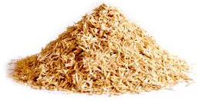

Lignocellulosic biomass

Figure 1: Types of pyrolysis and pyrolysis reactors used for the thermal treatment of residual biomass.

During the pyrolysis process of residual plant biomass between 200 and 300 °C, gas is produced consisting mainly of carbon monoxide and carbon dioxide with traces of methane. Nevertheless, with increasing temperature, there is a decrease in carbon dioxide and an increase in hydrogen and gaseous hydrocarbons such as methane, ethane, propane, etc. These conversions could be associated with the thermal degradation of lignin. Additionally, elemental analysis of the pyrolysis products reveals that the H/C and O/C ratios decrease with increasing temperature. This behavior is possibly due to the thermal decomposition of residual plant biomass into oxygen- and hydrogen-rich compounds (Yang et al., 2007; Park et al., 2014). This work aims to investigate the laboratory-scale pyrolysis of residual corn biomass and palm kernel shells at 750 °C. The study focuses on characterizing the resulting products and assessing their energy potential using complementary techniques, including ATR–FTIR spectroscopy and gas chromatography (GC).
  - Materials and methods
    - Materials
In this work, residual biomass from corn cobs and palm kernel shells was sourced from crops in the department of Santander (Colombia). Palm kernel shells were milled using a TRAPP TRF 300 mill and subsequently air-dried under ambient conditions for 70 h. The milled material was then classified into particle size fractions by sieving using a Gran Test–Pinzuar sieve shaker in the 8 – 120 mesh range.
    - Biomass pyrolisis experiments
Pyrolysis experiments were carried out in a tubular reactor placed inside a Carbolite UN 110 furnace under an inert nitrogen atmosphere at a flow rate of 50 mL/min. The reaction temperature was set to 750 °C based on the thermal decomposition behavior obtained from thermogravimetric analysis (TGA). Approximately 70 g of biomass (dry basis) was used in each experiment. The gaseous product was collected in Tedlar® bags for subsequent gas chromatography (GC) analysis. Liquid and solid products were analyzed by ATR–FTIR spectroscopy and calorific value measurements. The mass balance of the products was determined gravimetrically using eq 1 – 3.
$\% Liquid=\frac{100\left(m_{L}\right)}{m_{Initial}}$ (1)
$\% Solids=\frac{100\left(m_{S}\right)}{m_{Initial}}$ (2)
$\% Gas=\frac{100\left(m_{Initial }-m_{L}-m_{S}\right)}{m_{Initial}}$ (3)
Where m_{initial}, m_{L} y m_{S} correspond to the mass of the initial biomass and the masses of the liquid and gaseous products, respectively.
    - Characterization
    - Thermogravimetric analyses
Thermogravimetric analyses were performed in accordance with ASTM E1131 using a TA Instruments Discovery 5500. Approximately 10 mg of dried biomass was analyzed over a temperature range of 25 – 800 °C at a heating rate of 10 °C/min under a nitrogen flow of 50 mL/min.
    - FTIR-ATR spectroscopy
Infrared spectroscopy was used to verify the change in functional groups between residual plant biomass and its liquid and solid products. Biomass samples as well as the liquid and solid products were characterized by ATR–FTIR using a Thermo Scientific Nicolet Summit X spectrometer with 32 scans per spectrum. Prior to each measurement, a background spectrum was collected using ambient air to improve spectral quality and resolution.
    - Calorific Value
The higher heating value (HHV) was used to determine the energy potential contribution of the pyrolysis products. The analysis of the liquid samples was performed according to ASTM D5865 using a P.A. Hilton Ltd. C200 bomb calorimeter. Measurements were performed at room temperature under high-purity oxygen (99.99 vol.%).
    - Gas Chromatography (GC)
The composition of the gases produced during the pyrolysis of corn cob and palm kernel shell biomass was determined by gas chromatography (GC). Light hydrocarbons were quantified using a flame ionization detector (GC–FID) with helium as the carrier gas. Permanent gases (H₂, CO, O₂, and CO₂) were analyzed using a thermal conductivity detector (GC–TCD).
  - Results and Discussion
Table 1 summarizes the thermogravimetric (TGA) mass loss of corn cob and palm kernel shell biomass by temperature interval. The results indicate that an initial drying stage occurs within the 20 – 100 °C range, during which approximately 8 – 10 wt% mass loss is observed, mainly attributed to moisture evaporation. A subsequent mass loss between 100 and 200 °C corresponds to the progressive release of volatile compounds.
Table 1. Mass loss by temperature interval obtained from thermogravimetric analysis (TGA).
Temperature, °C | Palm Kernel Shell |  | Corn cob
Temperature, °C | Weight loss, % | Cumulative Weight loss, % | Weight loss, % | Cumulative Weight loss, %
20 – 100 | 8 | 8 | 10 | 10
100 – 200 | 4 | 12 | 7 | 17
200 – 400 | 56 | 68 | 55 | 72
400 – 600 | 9.5 | 77.5 | 19 | 91
600 – 800 | 2.7 | 80.2 | 6.8 | 97.8

The most significant degradation occurs in the 200 – 600 °C range, associated with primary pyrolysis reactions. Within this interval, corn cob biomass exhibits an additional 13.5 wt% mass loss compared to palm kernel shells. Furthermore, in the 600 – 800 °C range, cumulative mass losses of 80.2 wt% and 97.8 wt% were reached for palm kernel shells and corn cobs, respectively. This stage is generally related to the decomposition of more thermally stable lignin-derived compounds and secondary char reactions. Overall, the observed thermal decomposition behavior is strongly influenced by the composition and structural nature of each biomass. These results can be corroborated by the lignocellulosic characterization of residual plant biomass reported in the literature. For example, palm kernel shells contain approximately 26.3, 19.0, and 48.1 wt% cellulose, hemicellulose, and lignin, respectively (García et al., 2019), whereas corn cobs contain 45.5, 33.3, and 15.4 wt% of these components, respectively (Almeida et al., 2025).
Figure 2 shows the pyrolysis product yields obtained from palm kernel shells and corn cobs under a temperature of 750 °C. The results indicate that corn kernel residue produces lower yields of liquid and solid products. However, the gas yield is significantly higher compared to oil palm kernel biomass. Solid yield is generally associated with the lignin content and chemical structure. Meanwhile, gas product formation in plant biomass is influenced by the progressive decomposition of cellulose and hemicellulose, as well as secondary cracking reactions during solids formation.
Figure 2: Product yields from the pyrolysis of palm kernel shells and corn cobs at 750°C.

Figure 3 presents the ATR–FTIR spectra of the liquid and solid products obtained from the pyrolysis of palm kernel shells and corn cobs. The spectra were interpreted by assigning characteristic absorption bands to the functional groups of the compounds present in the feedstocks and their pyrolysis-derived liquids. The purpose of the infrared spectroscopy technique is to identify the evolution of functional groups such as hydroxyls (O-H), carbonyls (C=O), aromatic compounds (C=C) and aliphatic bonds (C-H), among others (Figures 3a and 3b).
Bands near 1450 and 1600 cm⁻¹ are associated with aromatic structures (C=C stretching). The broad band centered around 3300 cm⁻¹ corresponds to O–H stretching and may reflect hydroxyl-containing compounds as well as adsorbed moisture. The presence of aromatic and O–H bands suggests a mixture of aromatic moieties, including ester and phenolic type structures. In addition, the band near 1710 cm⁻¹ is attributed to C=O stretching (carbonyl groups), which may be associated with carboxylic acids and other oxygenated compounds.
Moreover, the liquid products obtained from both palm kernel shells and corn cobs exhibit bands around 1350 – 1455 cm⁻¹, which can be assigned to aliphatic C–H bending modes (–CH₂ and –CH₃) from alkyl chains. These assignments are supported by the C–H stretching bands observed at 2920 – 2850 cm⁻¹. Overall, the liquids from both biomasses show similar band assignments across the analyzed wavenumber range; however, the liquid derived from palm kernel shells exhibits comparatively stronger contributions from alkyl chain related bands and carbonyl (C=O) functionalities. Figure 3b and 3c present the FTIR–ATR spectra of the solid products (biochar) obtained under pyrolysis conditions at 750 °C. The spectra indicate a substantial reduction in bands associated with C–H and C=O functionalities, consistent with thermal degradation and deoxygenation reactions. Notably, the biochar derived from palm kernel shells exhibits a band near 1030 cm⁻¹, which may be attributed to SiO₂ related vibrations, suggesting the presence of trace amounts of silica. Infrared spectra of the solids show that at 750 °C there is a total loss of light species, leaving a solid with a graphitic structure. (Afanasjeva et al., 2018; Salawu et al., 2023).
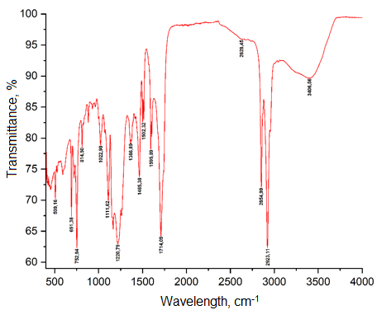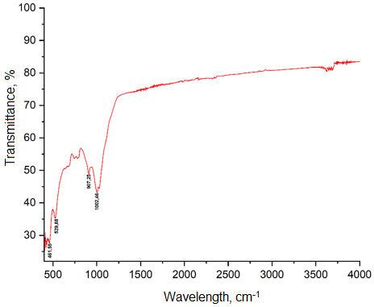
a b
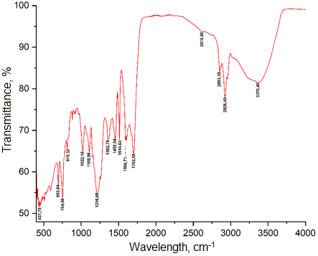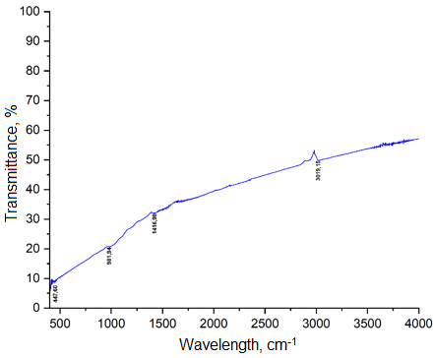
c d
Figure 3: ATR–FTIR spectra: (a) liquid product from palm kernel shells, (b) solid product (biochar) from palm kernel shells, (c) liquid product from corn cobs, and (d) solid product (biochar) from corn cobs.
Figure 4 shows the composition of the gases obtained from palm kernel shells and corn cob pyrolysis as determined by gas chromatography.
Figure 4: Composition of gaseous products obtained from the pyrolysis of palm kernel shells and corn cobs.

The results indicate that the gas fraction is mainly composed of a mixture of light hydrocarbons (C1–C4+), carbon monoxide (CO), carbon dioxide (CO₂), and hydrogen (H₂). The pyrolysis conditions promote thermal cracking reactions, favoring the formation of H₂ and CO. In contrast, the decrease in CO₂ and light hydrocarbons may be related to secondary reactions such as dehydrogenation as well as decarboxylation/decarbonylation pathways. Based on the chromatographic composition, the calorific values of the gaseous products derived from palm kernel shells and corn cobs were estimated at approximately 59.5 and 58.8 MJ/kg, respectively. Considering an average calorific value of 59 MJ/kg for pyrolysis gases from residual biomass, a theoretical electrical energy potential of approximately 4250 kWh/ton of residual plant biomass can be estimated. In addition, the calorific values of the liquid and solid fractions (biochar) ranged from 20–30 MJ/kg and 22–28 MJ/Kg, respectively. Although the heating value depends on the composition of each fraction, these results suggest that the thermochemical conversion of residual biomass may contribute to the diversification of the energy matrix through the utilization of renewable resources. Finally, the results of this work establish that pyrolysis at 750 °C valorizes residual plant biomass. Furthermore, the use of thermochemical processes with advanced characterization using FTIR, GC, and calorific value allows for the accurate determination of the efficiency and quality of the products.
  - Conclusions
The results demonstrate that pyrolysis at 750 °C effectively converts palm kernel shells and corn cobs into liquid and gaseous products enriched in hydrogen (H₂) and light hydrocarbons (C₁–C₄+). The yields of liquid, solid, and gaseous products ranged between 39.5–41.5, 24.3–28.1, and 30.4–36.2 wt%, respectively, depending on the biomass type. These differences highlight the influence of the lignocellulosic composition on both product distribution and quality.
ATR–FTIR analysis indicated a substantial reduction of C–H and C=O functionalities after pyrolysis, while the biochar derived from palm kernel shells exhibited a band near 1030 cm⁻¹ attributed to SiO₂.
The gaseous fraction showed a high hydrogen content, resulting in a calorific value between 58.8 and 59.5 MJ kg⁻¹. This energy content corresponds to a theoretical electrical potential of approximately 4250 kWh t⁻¹. Likewise, the liquid products exhibited calorific values in the range of 20–30 MJ kg⁻¹. Overall, these findings suggest that the thermochemical conversion of residual biomass represents a promising pathway for energy recovery and diversification of the energy mix through renewable resources.

Acknowledgments
The authors acknowledge the financial support provided by the Universidad Industrial de Santander (UIS) and its professional team through the internal VIE projects 4241, 4604, and 4616. The authors also express their special thanks to Industria Acuña (INAL S.A.S.) for its technical collaboration.
References
Afanasjeva, N., Castillo, L. C., & Sinisterra, J. C. (2018). Lignocellulosic biomass. Part II: Tendence in the biomass pyrolysis. Journal of Science with Technological Applications, 5(2018), 4-22.
Almeida-Naranjo C. E., Villamar-Ayala C., Daquilema A., Debut, A., 2025, Valorization of corn cobs: a sustainable filtration approach for caffeine and triclosan removal, Applied Water Science, 15(9), 235.
Dernbecher A., Dieguez-Alonso A., 2022. Advanced porous particle model in biomass pyrolysis, Chemical Engineering Transactions, 92, 685-690.
El-Sayed S. A., 2025, Chemical products yielded from different pyrolysis processes of rice waste residues: a comprehensive review, Biomass Conversion and Biorefinery, 15(14), 20615-20655.
García Núñez J. A., Varón Cárdenas D., Barrera Hernández J. C., 2019, Turning an Oil Palm Mill into a Biorefinery: The Passage of Technologies through the Valley of Death, Revista Palmas (40), 76-103.
Park J., Lee Y., Ryu C., Park Y. K., 2014, Slow pyrolysis of rice straw: analysis of products properties, carbon and energy yields, Bioresource technology, 155, 63-70.
Peñaranda Gonzalez L. V., Montenegro Gómez S. P., & Giraldo Abad P. A., 2017, Exploitation of agroindustrial waste in Colombia.
Pérez-Rodríguez C. P., Ríos L. A., Duarte González C. S., Montaña A., García-Marroquín C., 2022, Harnessing residual biomass as a renewable energy source in Colombia: a potential gasification scenario, Sustainability, 14(19), 12537.
Salawu J. D., Fadairo, O. O., 2023, Investigating the Potentials of Palm Kernel Shells Ash in Ceramic Glaze Development, Journal of Materials Science Research and Reviews, 6(1), 70-76.
Salcedo-Puerto O., Mendoza-Martinez C., Vakkilainen E., 2025. Colombian agroindustrial crop residues: Thermochemical characterization and evaluation of their energy potential, Energy Reports, 13, 1802-1816.
Vilas-Boas A. C. M., Tarelho L. A. C., Oliveira H. S. M., Silva F. G. C. S., Pio D. T., Matos M. A. A., 2024, Valorisation of residual biomass by pyrolysis: influence of process conditions on products. Sustainable Energy & Fuels, 8(2), 379-396.
Wang, Y., Zhang, Y., Cui, Q., Feng, Y., & Xuan, J. (2024). Composition of lignocellulose hydrolysate in different biorefinery strategies: nutrients and inhibitors. Molecules, 29(10), 2275.
Yang H., Yan R., Chen H., Lee D. H., Zheng C., 2007, Characteristics of hemicellulose, cellulose and lignin pyrolysis, Fuel, 86(12-13), 1781-1788.

