 CHEMICAL ENGINEERING TRANSACTIONS  VOL. , 2026 | A publication of  
The Italian Association
of Chemical Engineering
Online at www.cetjournal.it

Guest Editors:
Copyright © 2025, AIDIC Servizi S.r.l.
ISBN 979-12-81206-XX-X; ISSN 2283-9216

Organic Waste Recovery as a Circular Economy and Climate Change Mitigation Strategy in the Santa María Recicla Program, Santa María del Mar District (2023–2025)

Gianmarco Jorge Mendoza Mogollónª, Jhoana J. Rivera Murillo^{b}, Vanessa Johana
Caldas Garniqueª, Sixto Santiago Mendoza Vilcaª, Zanhy Leonor Valencia Reyes^{c*},
Fiorella Vanessa Güere Salazar^{c}, Alex Segundino Armas Blancas^{c}, Elba Prieto Rios^{c}, William Cesar Santos Tello^{d}, Giner Emerson Díaz Dávila^{e}

ª Universidad Universidad César Vallejo, Alfredo Mendiola 6232, Los Olivos 15314, Lima, Perú
^{b} Universidad Nacional Federico Villareal, Prolongación Camaná N° 1014, Lima, Perú
^{c} Universidad Nacional Mayor de San Marcos, Av. Universitaria cruce con Av. Venezuela cuadra 34, Lima, Perú
^{d} Universidad Continental, Av. Alfredo Mendiola 5210, Los Olivos 15306, Perú
^{e} Universidad Pontificia de Cataluña, Av. Dr. Marañón 44-50, Les Corts – Barcelona, España
*corresponding: zvalenciar@unmsm.edu.pe

This research analyzes the valorization of organic waste developed within the framework of the Santa María Recicla municipal program during the period 2023–2025, from the perspective of the circular economy applied to local solid waste management. The study examines the evolution of the tonnage valorized based on consolidated monthly records and estimates the potential reduction in greenhouse gas emissions resulting from diverting biodegradable waste to composting processes. The results demonstrate that transforming organic waste into compost not only reduces pressure on landfills and methane emissions, but also allows for the closing of nutrient cycles through its reincorporation into green areas and public spaces in the district.

Under this approach, the program is configured as an operational model of a circular economy at the municipal level, converting waste into useful resources, promoting citizen participation, and optimizing the use of materials within the territory. Furthermore, the research highlights the importance of having reliable monitoring systems and quantitative data to assess environmental impacts and strengthen decision-making in local public policies. Overall, the experience shows that the valorization of organic waste can be consolidated as a strategic axis for urban sustainability, climate change mitigation and the replicability of good practices in other local governments.
- Introduction
Municipal solid waste management has become one of the main environmental and administrative challenges for local governments in the context of population growth, urban sprawl, and changing consumption patterns. Within this framework, organic waste represents a significant fraction of the total waste generated in urban environments, and its improper disposal in landfills directly contributes to greenhouse gas emissions, particularly methane (CH₄), whose global warming potential far exceeds that of carbon dioxide (CO₂). Various international organizations have indicated that the proper management of the organic fraction is a priority measure for reducing environmental impacts and moving towards more sustainable urban systems (Intergovernmental Panel on Climate Change [IPCC], 2019; United Nations Environment Programme [UNEP], 2022).

In this context, the valorization of organic waste through composting emerges as a technically and environmentally efficient alternative. Composting transforms biodegradable waste into a useful product for soil restoration, the maintenance of green spaces, and the development of urban gardens, promoting the closure of nutrient cycles and reducing dependence on synthetic fertilizers. Furthermore, by preventing anaerobic decomposition in landfills, this practice significantly contributes to mitigating greenhouse gas emissions, potentially reducing them compared to traditional disposal methods (Wong, 2017).

Furthermore, composting is recognized as one of the most applicable technologies for the valorization of organic waste, as it allows its transformation into value-added products, such as biofertilizers, contributing to the efficient use of resources and the reduction of environmental impacts (Lim et al., 2017). Recent studies also highlight that, under appropriate segregation and treatment conditions, composting can achieve significant reductions in the carbon footprint, establishing itself as a key alternative within strategies for transitioning to circular economy systems (Klemeš et al., 2020).

From a local public management perspective, implementing organic waste segregation and valorization programs requires not only adequate infrastructure but also sustained environmental education processes, citizen participation, and monitoring systems based on quantitative evidence. Specialized literature highlights that the continuity and effectiveness of these initiatives depend on collaboration between municipal authorities, community stakeholders, and periodic evaluation mechanisms that allow for measuring results and adjusting strategies (Inter-American Development Bank [IDB], 2020).

In Peru, the environmental regulatory framework promotes waste valorization as part of integrated solid waste management, emphasizing the need to strengthen local capacities and foster shared responsibility between citizens and authorities (Ministry of the Environment [MINAM], 2021).

This research aims to evaluate the evolution of organic waste valorization within the framework of the Santa María Recicla program during the period 2023–2025, based on the analysis of consolidated monthly records and the estimation of the potential greenhouse gas emission reduction associated with diverting waste to composting processes. It also examines the program's contribution to consolidating a local circular economy model, providing technical evidence that contributes to strengthening environmental public policies and replicating best practices in other urban contexts.

- Methodology

2.1 Methodological Approach
The research was conducted using a quantitative approach, focused on the numerical analysis of operational data related to organic waste valorization. This approach allows for measuring trends, comparing periods, and estimating environmental impacts using verifiable indicators. Furthermore, the study has a descriptive-analytical scope, as it not only characterizes the volumes valorized but also interprets their potential contribution to mitigating greenhouse gas (GHG) emissions and strengthening the local circular economy (Hernández-Sampieri & Mendoza, 2018).

2.2 Type and Design of Research
This study is applied research, as it focuses on evaluating a specific municipal program for the purpose of improving public management and generating technical evidence.

- The design is non-experimental – retrospective longitudinal, since:
- Independent variables were not manipulated.
- Previously recorded historical data were analyzed.
- The temporal evolution was evaluated over a three-year period (2023–2025).

This type of design is suitable for environmental management studies based on administrative records, where the main objective is to observe behaviors and trends over time without direct intervention from the researcher (Creswell, 2014).

2.3 Scope and Context of the Study

The geographical scope corresponds to the district of Santa María del Mar, Lima, Peru, while the institutional scope is limited to the Municipal Program “Santa María Recycles,” which focuses on source separation, separate collection, and valorization of organic waste through composting. The context is framed within integrated solid waste management policies and local circular economy strategies promoted by municipal governments and guidelines from the Ministry of the Environment of Peru (MINAM, 2021).

2.4 Unit of Analysis

The unit of analysis consisted of the monthly quantity of organic waste recovered, expressed in metric tons (Tn). Each monthly record represents an independent observation within a time series, allowing for the evaluation of seasonal variations, year-on-year growth, and operational stability.

2.5 Data Collection Sources and Techniques

Secondary sources of information were used, specifically municipal administrative records consolidated in a digital database in Excel format. These records come from internal program reports and constitute official operational management information.

- The techniques employed were:
- Technical document review of operational reports.
- Data consistency validation (ranges, units, and time sequence).
- Internal cross-checking of records to avoid duplication or gaps in information.

Surveys and interviews were not conducted, as the study's objective is focused on the quantitative analysis of institutional data.

2.6 Study Variables
Variable | Type | Description | Unit
Valorized organic waste | Continuous quantitative | Monthly amount of organic waste processed through composting | Tons
Time period | Ordinal categorical | Month and year of record | Month / Year
Avoided CO₂e emissions | Derived quantitative | Estimated mitigation due to waste diversion | Tons CO₂e

2.7 Data Processing and Cleaning
Data processing was performed using spreadsheets and basic statistical analysis tools, following these steps:
- Data cleaning: removal of empty cells and verification of duplicates.
- Unit standardization: all measurements were converted to metric tons.
- Chronological ordering: organization by month and year to ensure temporal continuity.
- Aggregate calculations: annual totals, monthly averages, and year-over-year percentage changes.
These actions ensured the integrity and comparability of the database.

2.8 Data Analysis Techniques
Descriptive statistical techniques, considered appropriate for environmental management studies and operational time series (Field, 2013), were applied. These included:
- Annual cumulative total.
- Monthly average.
- Year-over-year percentage change.
- Identification of peaks and seasonality.
- Graphical representation using bar charts and line graphs.
These techniques allowed for the visualization of behavioral patterns and the evaluation of the program's stability over time.

2.9 Estimation of GHG Emission Reductions
The potential for emissions mitigation was estimated using CO₂e/ton conversion factors reported in international technical literature on waste management and composting (IPCC, 2019; UNEP, 2022). Two methodological scenarios were considered:
- Conservative Scenario: This scenario uses a low reduction factor, assuming lower process efficiency and variable organic composition.
- Optimistic Scenario: This scenario uses a high reduction factor, associated with greater diversion efficiency and methane reduction in landfills.
The general formula used was:
Emissions avoided (tCO₂e) = Tons recovered × Conversion Factor
This method is widely used in preliminary climate impact assessments when direct gas measurements are unavailable (IPCC, 2019).

2.10 Validity and Reliability Criteria
The reliability of the information is based on the official and administrative nature of the municipal records, used for institutional management reports. The following criteria were applied:
- Temporal consistency (monthly continuity).
- Interannual comparability.
- Coherence of operational ranges.
Internal validity is based on the correspondence between the analyzed data and the study objectives, while external validity is linked to the possibility of replicating the method in other similar municipal programs.

2.11 Ethical Considerations
This study does not involve personal data or sensitive information; therefore informed consent is not required. The information used is institutional in nature and is employed exclusively for academic, technical, and public environmental management improvement purposes.

2.12 Methodological Limitations
- Lack of direct field measurement of methane emissions.
- Reliance on estimated conversion factors.
- No evaluation of the physicochemical composition of the waste.
- Possible operational variability not recorded in the administrative database.

- Results and Discussion
3.1 Annual Organic Waste Valorization
Analysis of the Santa María Recicla program database for the period 2023–2025 shows sustained growth in the recovery of organic waste. The total annual tonnage recovered demonstrates a significant improvement in the program's operational capacity between the first and second years, followed by a stabilization phase.

Table 1. Tons of Organic Waste Valorized per Year
Year | Valorized Tons (Tn) | Year-to-Year Variation
2023 | 31,911.91 | —
2024 | 53,292.66 | +67%
2025 | 53,538.70 | +0.46%
Total | 138,743.27 | —
The largest increase is observed between 2023 and 2024, suggesting a phase of expansion and logistical consolidation for the program. In 2025, the volume remains similar to the previous year, indicating operational stability and system maturity.

Figure 1. Valorized Tons per Year
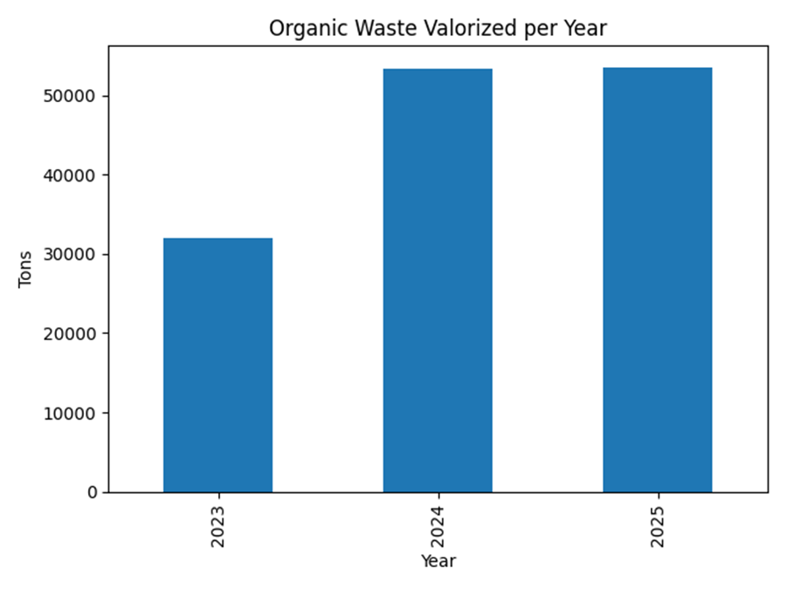

3.2 Monthly Valorization Trend
Monthly analysis allows for the identification of patterns of behavior and stability. While greater variability is observed in 2023, the years 2024 and 2025 present relatively homogeneous monthly ranges, with values ​​close to or above 4,300 tons per month.
Table 2. Average Monthly Valorization
Year | Monthly Average (Tn)
2023 | 2,659.33
2024 | 4,441.05
2025 | 4,461.56
The months with the highest valuation peaks are generally concentrated in the last quarter of the year (October–November), which could be associated with municipal campaigns, increased commercial activity, or reinforcement of household segregation.

Figure 2. Monthly Valorization Trend 2023–2025
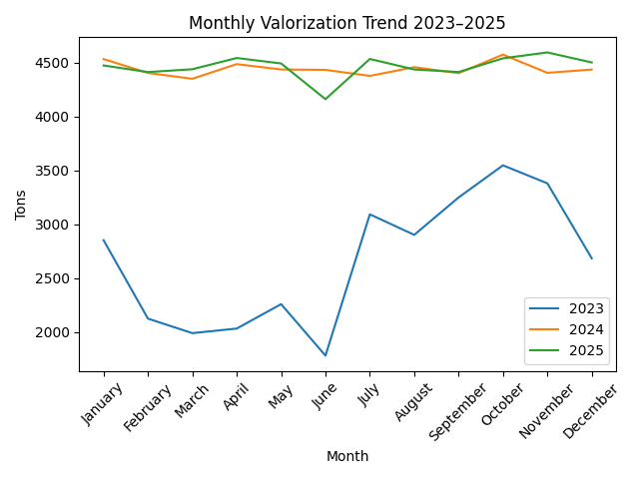
3.3 Environmental Implications – Estimated Emission Mitigation
Based on the total valued volume (138,743.27 Tn) and the application of international conversion factors, a greenhouse gas emissions mitigation range was estimated:
Scenario | Estimated Reduction
Conservative | ≈ 5,000 tCO₂e
Optimistic | ≈ 60,000 tCO₂e
This range shows that, even under prudent assumptions, the program generates a relevant positive climate impact, especially in the reduction of methane associated with anaerobic decomposition in landfills.

- Discussion
The results obtained allow us to affirm that the Santa María Recycles program has evolved from an initial implementation phase to a stage of operational consolidation. The 67% increase between 2023 and 2024 reflects not only logistical improvements but also likely greater citizen participation and institutional strengthening. The stability observed in 2025 suggests that the program reached a threshold of sustained efficiency, which is characteristic of municipal initiatives that have successfully integrated environmental education processes with adequate infrastructure.

- From a circular economy perspective, the data demonstrate three main impacts:
- Reduced final disposal: Less pressure on landfills and an extension of their lifespan.
- Resource utilization: Production of compost usable in municipal green spaces, reducing chemical inputs.
- Climate mitigation: Potential for a significant decrease in GHG emissions, especially methane.

Comparatively, the annual volumes recovered are high for a local-scale district, which positions the program as a benchmark for municipal environmental management. However, the discussion also reveals certain opportunities for improvement:
- Implementing direct emissions measurements for greater scientific precision.
- Incorporating waste composition analysis, which would allow for more refined impact estimates.
- Integrating social indicators (citizen participation, environmental education) to complement the quantitative analysis.
In short, the results not only demonstrate operational efficiency but also strategic coherence with the principles of urban sustainability and climate resilience, showing that the valorization of organic waste can become a structural pillar of local environmental management when there is institutional continuity and technical support.

- Conclusion
This study demonstrates that the valorization of organic waste through the Santa María Recicla program is an effective circular economy strategy at the municipal level, transforming waste into useful resources and reducing pressure on landfills. The positive trend and subsequent stabilization of the volumes recovered reflect a consolidated operational management system and adequate institutional support. Furthermore, the estimated emissions avoided confirm composting's contribution to climate change mitigation. Overall, the results show that the valorization of organic waste can be consolidated as a key local public policy for urban sustainability and efficient environmental management.

References
Creswell, J. W. (2014). Research Design: Qualitative, Quantitative, and Mixed Methods Approaches. SAGE Publications.
Field, A. (2013). Discovering Statistics Using IBM SPSS Statistics. SAGE Publications.
Hernández-Sampieri, R., & Mendoza, C. (2018). Research Methodology: Quantitative, Qualitative, and Mixed Approaches. McGraw-Hill.
IPCC. (2019). 2019 Refinement to the 2006 IPCC Guidelines for National Greenhouse Gas Inventories. Intergovernmental Panel on Climate Change.
MINAM. (2021). Guidelines for Municipal Organic Waste Management. Ministry of Environment of Peru.
UNEP. (2022). Global Waste Management Outlook 2022. United Nations Environment Programme.
Inter-American Development Bank (IDB). (2020). Integrated Solid Waste Management in Latin America and the Caribbean. IDB.
Intergovernmental Panel on Climate Change (IPCC). (2019). 2019 Refinement to the 2006 IPCC Guidelines for National Greenhouse Gas Inventories. IPCC.
IPCC. (2019). 2019 Refinement to the 2006 IPCC Guidelines for National Greenhouse Gas Inventories. Intergovernmental Panel on Climate Change.
Klemeš, J. J., Fan, Y. V., Jiang, P., & Van Fan, Y. (2020). The potential of carbon emission footprint reduction from waste management systems. Chemical Engineering Transactions, 81, 775–780.
Lim, L. Y., Lee, C. T., & Bong, C. P. C. (2017). Review on the current composting practices and the effectiveness of two-stage composting. Chemical Engineering Transactions, 56, 421–426
MINAM. (2021). Guidelines for Municipal Organic Waste Management. Ministry of Environment of Peru.
UNEP. (2022). Global Waste Management Outlook 2022. United Nations Environment Programme.

