 CHEMICAL ENGINEERING TRANSACTIONS | A publication of  
The Italian Association
of Chemical Engineering
Online at www.cetjournal.it
Guest Editors: Petar S. Varbanov, Yee Van Fan, Jiří J. Klemeš
Copyright © 2022 AIDIC Servizi S.r.l.
ISBN; ISSN

Removal of organic and inorganic salts from hydrocarbon contaminated water using activated carbon materials from agricultural residues
Julián Sanabriaª*, Sergio Castellanosª, Bryan Estévezª, Erika Riveraª, Edward Herrera^{b} Adan Leónª
ª | Universidad Industrial de Santander, Escuela de Ingeniería Metalúrgica y Ciencia de los Materiales, Grupo de Investigaciones en Corrosión – GIC, Cra. 27, Calle 9, Bucaramanga –Santander, Colombia.
^{b} | Universidad Industrial de Santander, Escuela de Ingeniería de Petróleos, Grupo de Investigación Modelamiento de Procesos de Hidrocarburos – GMPH, Cra. 27, Calle 9, Bucaramanga –Santander, Colombia.
 | *Email: julian2248101@correo.uis.edu.co
In the oil and gas industry, approximately 250 million barrels of water are produced daily worldwide, a number that may increase as producing fields decline and new methods are developed to improve hydrocarbon extraction. Due to the large volumes of water reaching the surface, there is a need to develop new treatment and reuse techniques. To address this need, many industries have shown increasing interest in using adsorbent materials. This study explores how effectively activated carbon can remove common organic and inorganic salts from polluted water, including substances like methylene blue, potassium dichromate, and silver. The adsorbent materials were created by thermally treating residual plant biomass from palm kernels, cocoa husks, and sugarcane bagasse. The activated carbons were produced through a chemical activation process using phosphoric acid (H₃PO₄), followed by heating at 430°C. Experiments took place in a tubular reactor with a steady flow of nitrogen gas at 50 mL/min. These materials were analyzed using Fourier transform infrared spectroscopy (FTIR-ATR) and BET surface area analysis with the Brunauer-Emmett-Teller method. The surface areas of activated carbons derived from palm kernels, cocoa husks, and sugarcane were approximately 890, 970, and 215 m²/g, respectively. Furthermore, the activated carbon from palm kernels showed the highest effectiveness in removing methylene blue, potassium dichromate, and silver sulfate, achieving average removal rates of 99.6%, 92.6%, and 57.7%. Finally. The adsorption model that best fit the results was the Freundlich model, confirming the kinetic behavior. Overall, activated carbons produced from residual plant biomass are seen as a good alternative to improve the removal of contaminants from polluted water produced by the oil & gas industry.
  - Introduction
Around the world, it’s estimated that for every barrel of oil taken out of the ground, there are between 3 and 5 barrels of produced water. In addition, as reservoirs become older, this ratio tends to increase, reaching between 10 and 14 barrels of water per barrel of oil in mature reservoirs. The management of produced water not only raises operational costs but also raises concerns about environmental sustainability in oil fields. Typically, produced water contains high levels of contaminants, such as heavy metals, dissolved organic compounds, and organic and inorganic salts (Reza et al., 2020). Conventional treatment methods like chemical precipitation, filtration, and reverse osmosis often face economic and environmental challenges, especially when scaled up, due to infrastructure and energy requirements. In fact, in Colombia, Ecopetrol reported an average of 13.8 barrels of water per barrel of oil in 2023. This situation highlights the ongoing challenges the hydrocarbon industry faces in managing, treating, and safely disposing of contaminated water that arrives at surface facilities. In response, recent research has evaluated the use of biomass as a raw material for the pyrolytic synthesis of biomaterials. Several authors have noted that these biocarbons exhibit excellent adsorptive properties, making them a sustainable alternative that valorizes agricultural waste and helps mitigate environmental problems, such as the treatment of production water, proving in their investigations the effectiveness in removing organic and inorganic pollutants, such as heavy metals and salts (Bamerdhah et al., 2025; Kakom et al., 2023; Nazbakhsh et al., 2025; Tejada et al., 2017).
In this context, valorizing the main agro-industrial residues in the department of Santander, such as sugarcane bagasse, cocoa husks, and palm kernel shells (PKS), offers an interesting and environmentally friendly approach to producing activated carbons via pyrolysis. These biomasses are of particular interest due to their physicochemical properties, especially their high cellulose, hemicellulose, and lignin content, which enable the conversion of raw materials into value-added products such as bio-oil and biochar. The thermal process applied is pyrolysis, which involves the thermal decomposition of biomass at elevated temperatures (typically 350–900 °C) under oxygen-free (inert) conditions. This not only allows the production of activated carbon materials but also yields pyrolytic liquids that may serve as renewable fuels and as green hydrogen production. (Mevira Setiawan et al., 2025; Nusrat Aman et al., 2023; Youssef et al., 2024). Furthermore, this biomass-to-materials approach supports the principles of a circular and green economy by encouraging the reuse of residues, reducing environmental impacts, and creating valuable products from renewable resources (Alonge & Obayopo, 2023). Therefore, focusing on solid pyrolytic products, biochar can be subjected to activation processes to create activated carbons with enhanced properties. Chemical activation with agents such as CO₂, KOH, or H3PO4 can significantly improve adsorption performance by developing a more complex pore network and increasing the specific surface area available for contaminant removal applications (Contescu et al., 2018). Previous research has demonstrated that combining pyrolysis with chemical activation creates activated carbons with highly developed micro- and mesoporosity, making them effective for removing heavy metals and organic pollutants from wastewater (Bamerdhah et al., 2025). Consequently, this study aims to synthesize activated carbons derived from three types of residual biomass: sugarcane bagasse, cocoa husks, and palm kernel shells, to evaluate the adsorption performance in the treatment of synthetic waters contaminated with methylene blue, potassium dichromate, and silver sulfate at concentrations representative of petroleum industry produced water. Finally, Activated carbons (AC) were characterized using infrared spectroscopy (FTIR-ATR) and BET surface area analysis. Adsorption experiments were quantified by UV–Vis spectroscopy and interpreted using adsorption isotherm models to identify the optimal residual biomass for conversion into an adsorbent material.
  - Methodology
    - Materials
Cocoa husks, sugarcane bagasse, and palm kernel shells were chosen as precursor materials for activated carbon because they are readily available and abundant agricultural residues. Model contaminants such as methylene blue, potassium dichromate (K₂Cr₂O₇), and silver sulfate (Ag₂SO₄) were used to represent the salinity and metal content commonly found in water produced by the petroleum industry. All chemicals used in the study were obtained from Sigma-Aldrich with a purity of 99%. The biomass was chemically activated using phosphoric acid (H₃PO₄, 95% purity).
2.2 Biomass preparation
The biomass was first ground and left to air-dry for 3 days (72h). Following that, it was oven-dried at 105 °C until its weight stabilized, which helped to reduce any residual moisture. The dried material was sieved with a Gran Test–Pinzuar sieve shaker to produce particles measuring between 40 and 50 mesh, ensuring consistency for the pyrolysis process.
    - Thermogravimetric analyses (TGA)
Thermogravimetric analysis (TGA) was performed using a TA Instruments Discovery 5500 series analyzer to determine optimal pyrolysis temperatures for each type of biomass. Approximately 10 mg of each sample was heated from 30 to 950 °C at a rate of 10 °C/min in a nitrogen atmosphere (inert).
    - Synthesis and carbon activation
Activated carbons were synthesized using a combined process of chemical activation and thermal treatment. Biomass was soaked in phosphoric acid (H₃PO₄) at a ratio of 1:5 for 1 hour. After impregnation, the material was pre-dried at 150 °C to remove moisture, then subjected to pyrolysis in the experimental setup shown in Figure 1, where a horizontal tubular reactor was placed inside a Carbolite UN 110 furnace to control and maintain a specific operating temperature, and pyrolysis experiments were carried out under an inert nitrogen atmosphere at a flow rate of 20 mL/min and 430 °C for 30 minutes. After the reaction, the resulting solid was washed with distilled water until the pH stabilized around 6 to 7, indicating neutrality, and then dried at 100 °C for 24 hours.
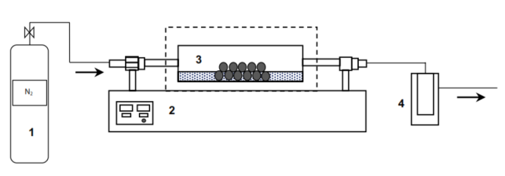
Figure 1: Experimental setup for pyrolysis tests in a tubular reactor. 1) Nitrogen cylinder. 2) Carbolite furnace. 3) Tubular reactor. 4) Liquid collector (León et al., 2022).
    - Characterization of the activated carbons
The structural and chemical properties of the solid materials were evaluated through two main methods. Initially, ATR–FTIR spectroscopy was performed using a Thermo Scientific Nicolet Summit X spectrometer operating over 400–4000 cm⁻¹, with 32 scans collected to obtain absorption spectra of the analytes and identify functional groups such as O–H, C=O, and C–O–C. Subsequently, BET surface area analysis was carried out to measure the specific surface area through nitrogen physisorption at 77 K using a Micromeritics 3Flex instrument. Prior to analysis, the samples were degassed at 200 °C under vacuum (6 Pa) for 8 hours.
2.6 Adsorption tests and modeling
Adsorption experiments were carried out using synthetic solutions varying the salt concentrations from 50 to 250 mg/L. Then, 0.1 g of activated carbon was added to 10 mL of each solution, and the mixture was stirred on an orbital shaker at 150 rpm for 24 hours to reach equilibrium. The solid and liquid phases were then separated by centrifugation at 6000 rpm for 20 minutes. Finally, the resultant waters were measured using UV–Vis spectroscopy at 608 nm for methylene blue, 352 nm for potassium dichromate, and 210 nm for silver sulfate. The data obtained were analyzed using Langmuir, Freundlich, and Temkin isotherm models to understand the adsorption behavior. The adsorption capacity and removal efficiency were determined based on the Beer–Lambert law, which is shown in equations (1) and (2). In these equations, q_{e} represents the adsorption capacity in mg/g, C_{o} is the initial concentration in mg/L, C_{f} is the final concentration in mg/L, W is the mass of the adsorbent in grams, V is the volume of the solution in milliliters or liters, and RE represents the removal efficiency as a percentage.

$$q_{e}=\frac{\left(C_{o}-C_{f}\right)*V}{W}$$ | (1)
$$RE=\frac{\left(C_{o}-C_{f}\right)}{C_{o}}*100$$ | (2)
The three models analyzed in this study are shown in equations (3), (4), and (5). The Langmuir model (3) assumes that molecules form a single layer on a flat, even surface, with a limited number of attachment sites and no interactions between them. The Freundlich model (4) describes how molecules stick to rough or heterogeneous surfaces, where the strength of attachment increases as more molecules adhere, allowing multiple layers to form. The Temkin model (5) considers how the interactions between the molecules and the surface affect the process, suggesting that the energy involved decreases steadily as more molecules attach.
$q_{e}=\frac{\left(q_{max}*b*C_{e}\right)}{1+b*C_{e}}$ | (3)
$$q_{e}=k*C_{e}^{1/n}$$ | (4)
$$q_{e}=n_{T}Ln\left(K_{T}\right)+n_{T}Ln\left(C_{e}\right)$$ | (5)
Where $q_{max}$ and $b$ are the Langmuir constants, $C_{e}$ is the equilibrium concentration, $K_{f }$ is the Freundlich constant related to adsorption capacity, $n_{f}$ is the Freundlich intensity parameter associated with the affinity between the solute and the adsorbent (activated carbon) y $K_{T}$ is the Temkin equilibrium constant.

  - Results and Discussion
    - Biomass TGA and pyrolysis yield
The thermogravimetric profiles helped identify the different stages where biomass components break down. For cocoa husks, the highest mass loss occurred between 300 and 380 °C, with a peak around 350 °C, mainly due to the breakdown of hemicellulose and cellulose. For sugarcane bagasse, the main degradation occurred between 240 and 370 °C. Palm kernel shells showed mass loss across roughly 150 to 400 °C, with the biggest breakdown near 290 °C. Considering these results, the thermal behavior supported selecting 430 °C as the optimal pyrolysis temperature, which allows the biomass conversion into vapor and develops the carbon structure of the adsorbent. Additionally, the pyrolysis results showed that the product yields varied significantly depending on the type of biomass. PKS produced the most solid material at 51.6%, followed by cocoa husks at 44.4%, while sugarcane bagasse had the lowest at 30.2%. These results are directly related to the lignocellulosic content of each type of biomass, with palm kernel shells having the highest lignin content (28.35% on a dry basis), generating a higher proportion of solid products (AC) with a more stable structure after heating at 430 °C.
    - Physicochemical Characterization of carbons (BET and FTIR)
Figure 2 (a) shows the obtained results for the surface area, pore volume, and average pore size of each sample. The AC made from cocoa husks had the highest surface area (971 m²/g) and pore volume (0.6888 cm³/g). Its average pore size was 3.9 nm. The AC from PKS had a slightly lower surface area of 890 m²/g, a pore volume of 0.1935 cm³/g, and the smallest average pore size at 3.0 nm. Finally, Sugarcane bagasse had a surface area of 215 m²/g, a pore volume of 0.1359 cm³/g, and an average pore size of 4.0 nm. According to IUPAC, all these materials are considered mesoporous, with average pore sizes ranging from 3.0 to 4.0 nm. Figure 2 (b) also shows the N₂ adsorption–desorption isotherms for each biomass, which, in general, exhibit Type IV behavior with a characteristic hysteresis loop, indicating capillary condensation in the pores. AC derived from cocoa husk had the highest adsorption capacity, indicating greater availability of active sites, attributable to its surface area and porosity volume, which allow solutes and contaminants to pass through or be absorbed.
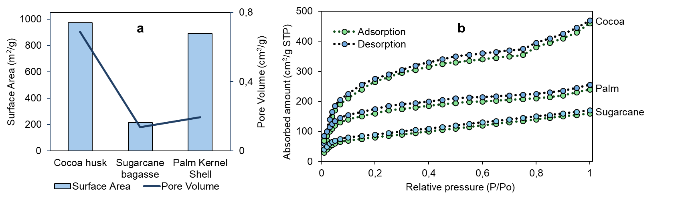
Figure 2: a) BET characterization results of the three biomasses. b) N₂ adsorption–desorption isotherm of cocoa husk-derived activated carbon.
The surface chemistry of the activated carbons and their original materials was analyzed using Fourier Transform Infrared Spectroscopy in ATR mode (ATR–FTIR). This method helped to identify functional groups that could be involved in the adsorption process. Figure 3 shows the infrared spectra of the cocoa husk biomass and the activated carbon obtained after pyrolysis. It is observed that strong bands between 3400 and 3100 cm⁻¹, which are related to O–H stretching vibrations from surface groups such as phenolic and carboxylic groups. Other bands appeared between 1550 and 1650 cm⁻¹, indicating C=O stretching and aromatic C=C vibrations. There were also strong signals between 980 and 1200 cm⁻¹, assigned to C–O stretching in ether and alcohol groups. Comparing the spectra of the original biomass and the activated carbon, there is a clear decrease in aliphatic C–H bands, including stretching vibrations from 2840 to 2920 cm⁻¹ and bending modes between 1370 and 1470 cm⁻¹. This decline suggests that during heating at 430 °C, the material undergoes dehydrogenation and structural changes, leading to a more carbon-rich structure. The breakdown of volatile parts in the original biomass helped create a stable carbon-based material.
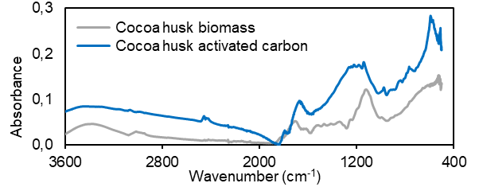
Figure 3: ATR–FTIR spectrum of cocoa husk biomass and its AC.
Finally, the results show that the amount and variety of oxygen-based groups, like carboxylic, phenolic, and ester groups, are important in shaping the surface chemistry of each adsorbent. These surface groups are key to removing salts because they serve as active sites that can interact with dissolved substances.

    - Evaluation of adsorption capacity and isotherm modeling.
Equations (6), (7), and (8) present the calibration curve correlations used to determine the concentration of each salt.
$C_{e}Blue methylene=935.66{Abs}_{λ}-2.0894$ | (6)
$$C_{e} K_{2}{Cr}_{2}O_{7}=90.149{Abs}_{λ}-0.5844$$ | (7)
$${ C}_{e} {Ag}_{2}SO_{4}=181,51{Abs}_{λ}-3.619$$ | (8)
Considering the results obtained with the three isotherm models described above, the R² values for each model indicated that the Freundlich model is optimal, with R² values above 0.97 in most cases. These results suggest adsorption on a heterogeneous surface with sites of different energies, which is consistent with multilayer adsorption within the pore structure of the carbons. In addition, Figure 4 shows the removal efficiency of the analyzed salts for the three synthesized biochars.
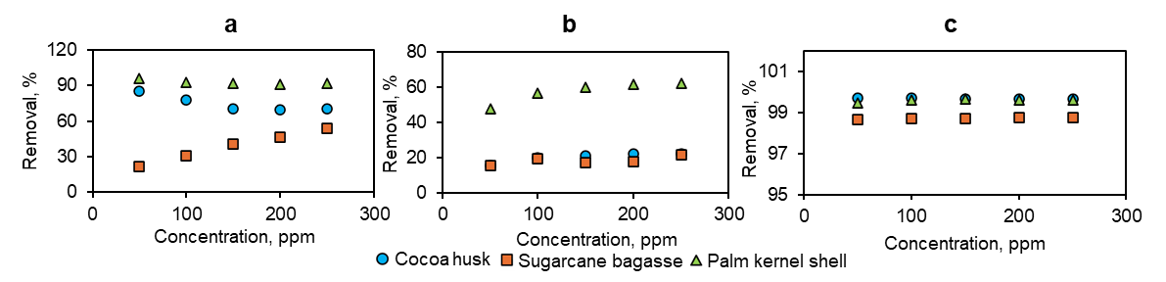
Figure 4: Percentage of potassium dichromate (a), silver sulfate (b), and methylene blue removal (c).

Analyzing the results in Figure 4, activated carbon made from PKS showed the best overall results, with average removal efficiencies of 92.6% for dichromate, 57.7% for silver sulfate, and 99.6% for methylene blue. In comparison, AC made from cocoa husks reached 74.5%, 20.2%, and 99.7%, respectively. Moreover, AC from sugarcane bagasse had the lowest performance, removing no more than 39% of these inorganic substances. These findings indicate that the porous structure and surface features of palm kernel shells give it an advantage for treating complex or contaminated water. Regarding adsorption performance, the Freundlich parameters (K_{f} and n) indicated stronger interactions with methylene blue, with removal efficiencies exceeding 99% for all three types of activated carbon. Additionally, most tests showed n values greater than 1, indicating favorable adsorption under the tested conditions, which usually indicates that the process is mostly due to physical attraction. For the PKS carbon, the linearized Freundlich model for potassium dichromate yielded an R² of 0.9783, supporting the idea that adsorption occurred on a porous surface with layer formation. The calculated values (K_{f} = 2.939 and n = 1.577) show a strong affinity between the material and the dissolved substances.
  - Conclusions
Activated carbon made from palm kernel shells showed the best overall performance among the tested materials. It removed 99.6% of methylene blue, 92.6% of potassium dichromate, and 57.7% of silver sulfate on average.
The Freundlich isotherm model was an optimal fit with the adsorption results, indicating that the material's surface is heterogeneous and that the adsorption process is favorable. These results suggest that residual biomass from Santander, Colombia, can be a good, sustainable source of activated carbon for effectively removing pollutants from oil industry waste.
  - Acknowledgments
The authors acknowledge the financial support provided by the Universidad Industrial de Santander (UIS) and its professional team through the internal VIE projects 4241, 4604, and 4616.
  - References
Alonge, O. I., & Obayopo, S. O. (2023). Optimization Study on Carbonization of Palm Kernel Shell Using Response Surface Method. International Journal of Integrated Engineering, 15(7), 135–144. https://doi.org/10.30880/IJIE.2023.15.07.013
Bamerdhah, S. S., Kumar, N. S., Al-Ghurabi, E. H., Boumaza, M., & Asif, M. (2025). Optimized synthesis of activated carbon from date palm seeds for efficient crude oil adsorption in wastewater treatment. Scientific Reports, 15(1). https://doi.org/10.1038/s41598-025-16831-7
Contescu, C. I., Adhikari, S. P., Gallego, N. C., Evans, N. D., & Biss, B. E. (2018). Activated Carbons Derived from High-Temperature Pyrolysis of Lignocellulosic Biomass. C, 4(3), 51. https://doi.org/10.3390/c4030051
Kakom, S. M., Abdelmonem, N. M., Ismail, I. M., & Refaat, A. A. (2023). Activated Carbon from Sugarcane Bagasse Pyrolysis for Heavy Metals Adsorption. Sugar Tech, 25(3), 619–629. https://doi.org/10.1007/s12355-022-01214-3
León, A. Y., Rincón, J. R., Rodríguez, N., & Molina, D. R. (2022). Optimization of preparation conditions for cocoa shell-based activated carbon and its evaluation as a salt adsorbent. International Journal of Environmental Science and Technology, 19(8), 7777-7790.
Mevira Setiawan, N., Yusfinda, B., Nazilatul Aziz, A., & Stephanie, S. (2025). ⁠ Recycling Palm Shell Waste into Biochar Using Biomass-Based Pyrolysis Method for Sustainable Energy Transition: A Review.
Nazbakhsh, M., Nabavi, S. R., & Jafarian, S. (2025). Optimized Production of High-Performance Activated Biochar from Sugarcane Bagasse via Systematic Pyrolysis and Chemical Activation. Sustainability (Switzerland), 17(4). https://doi.org/10.3390/su17041554
Nusrat Aman, A. M., Selvarajoo, A., Lau, T. L., & Chen, W. H. (2023). Optimization via response surface methodology of palm kernel shell biochar for supplementary cementitious replacement. Chemosphere, 313. https://doi.org/10.1016/j.chemosphere.2022.137477
Ortega, A., Arcila, Y., Vargas, L. (2019). Review of the diagnosis of production water treatment in Colombian petroleum fields.
Reza, M. S., Yun, C. S., Afroze, S., Radenahmad, N., Bakar, M. S. A., Saidur, R., Taweekun, J., & Azad, A. K. (2020). Preparation of activated carbon from biomass and its’ applications in water and gas purification, a review. In Arab Journal of Basic and Applied Sciences (Vol. 27, Number 1, pp. 208–238). Taylor and Francis Ltd. https://doi.org/10.1080/25765299.2020.1766799
Tejada, C. N., Almanza, D., Villabona, A., Colpas, F., & Granados, C. (2017). Caracterización de carbón activado sintetizado a baja temperatura a partir de cáscara de cacao (Theobroma cacao) para la adsorción de amoxicilina. INGENIERÍA Y COMPETITIVIDAD, 19(2). https://doi.org/10.25100/iyc.v19i2.5292
Youssef, W. M., El-Maadawy, M. M., Masoud, A. M., Alhindawy, I. G., & Hussein, A. E. M. (2024). Uranium capture from aqueous solution using palm-waste based activated carbon: sorption kinetics and equilibrium. Environmental Monitoring and Assessment, 196(5). https://doi.org/10.1007/s10661-024-12560-y

