 CHEMICAL ENGINEERING TRANSACTIONS  VOL. xxx, 2026 | A publication of  
The Italian Association
of Chemical Engineering
Online at www.cetjournal.it

Guest Editors: Leonardo Tognotti, Rubens Maciel Filho, Viatcheslav Kafarov
Copyright © 2026, AIDIC Servizi S.r.l.
ISBN 979-12-81206-xx-x; ISSN 2283-9216

Efficient Routes for the Purification of Polyhydroxyalkanoates from Mixed Cultures in Wastewater Sludge
Cuevas Nª, Gracia J^{b}, Cabeza I^{c*}
^{a,b} Universidad Distrital Francisco José de Caldas, Faculty of Environment and Natural Resources, 5th Avenue East # 15-82, Bogotá, Cundinamarca
^{c}Energy, Materials and Environment Laboratory, Faculty of Engineering, Universidad de la Sabana, Puente del Común Campus, Km. 7, Bogotá North Motorway, Chía, Cundinamarca, Colombia
ivan.cabeza@unisabana.edu.co
To address the pressing need for sustainable alternatives to conventional plastics, this research developed a route for extracting and purifying polyhydroxyalkanoates (PHAs) using wastewater treatment plant sludge and mixed cultures, thereby promoting a circular economy and reducing sterilisation costs. The methodology began with the design of a fermentation process for selecting producing microorganisms based on a literature review. Three cell lysis reagents were experimentally evaluated 18% SDS, 4% NaOH, and 20% H₂SO₄, followed by three acetic acid concentrations for extraction and two methanol purification methods (solvent casting and precipitation). Results, analysed via gravimetry, HPLC, and multifactorial ANOVA, determined that lysis and purification are the critical factors in process efficiency. The optimal route consisted of lysis with SDS 10 ml/g, extraction with acetic acid 15 ml/g, and purification with methanol 100 ml/g, achieving a yield of 1.22%, a recovery of 54.61%, and a purity of 19.62%. This study optimises PHAs recovery compared to other methods, establishing a solid foundation for the scalable production of biopolymers capable of replacing traditional synthetic plastics.
Keywords: Polyhydroxyalkanoates, extraction, purification, mixed cultures.
  - Introduction
Although, fossil-based plastics constitute an ubiquitous and indispensable material for various industrial applications; however, they simultaneously represent a primary source of global pollution. According to data from Plastics Europe (2023), of the 400.3 million tonnes produced in 2022, over 90% originated from petrochemical sources, while bio-based plastics reached a market share of a mere 0.5%. In response to this environmental emergency, polyhydroxyalkanoates (PHAs) have emerged as a promising alternative due to their mechanical versatility and biodegradability (Zhou et al., 2023). Nevertheless, their commercial deployment faces a critical economic barrier: while conventional plastics have production costs below €1/kg, PHAs costs range between €2.2–5/kg (Sabapathy et al., 2020). The biosynthesis of PHAs occurs through the fermentation of various substrates using native or modified strains that accumulate the biopolymer as an alternative carbon source. Given that raw materials account for approximately 40% of production costs, recent research has pivoted towards the utilisation of renewable sources and industrial waste, such as lignocellulosic biomass, wastewater treatment plant sludge, and residues from the dairy, paper, and wine industries (Chavan et al., 2021; Fu et al., 2023; Banu et al., 2021). To optimise these costs, the use of mixed microbial cultures (MMC) derived from activated sludge has consolidated as an effective strategy over pure cultures, as it eliminates the need for rigorous sterilisation and simplifies bioprocess maintenance (Cabrera et al., 2019; Dias et al., 2008; Johnson et al., 2009; Jarillo, 2018; Silva et al., 2017).
While early research prioritised genetic engineering to increase intracellular PHAs accumulation in bacteria, the current paradigm is shifting towards microbial ecology and MMC (Valentino et al., 2018; Bengtsson et al., 2017). These consortia offer a more robust alternative to pure cultures, as they demonstrate superior resilience when processing complex substrates in non-sterile industrial environments (Sabapathy et al., 2020).
Recent studies confirm that PHAs production via the MMC method using volatile fatty acids (VFAs) achieves yields between 0.3 and 0.6 g PHA g_substrate, with accumulation levels reaching up to 90% of the cell dry weight (CDW); these figures are competitive with the standards obtained in pure cultures (Cabrera et al., 2019; Corsino et al., 2022; Cui et al., 2016; Montiel-Jarillo et al., 2017; Silva et al., 2017). Operational control remains critical to maximising system efficiency. In this context, identifying efficient purification pathways and chemical valorisation processes for effluents represents both an important research opportunity and an industrial necessity (Cha et al., 2016; Gracia et al., 2023; Valentino et al., 2017). Although these schemes reduce costs through alternative raw materials, enhancing efficiency in the accumulation and extraction stages remains a challenge due to the inherent complexity of the feedstock (Chavan et al., 2021; Kannah et al., 2022).
Therefore, this study addresses the urgent need for sustainable bioplastics as an alternative to conventional plastics by developing an optimised process for the extraction and purification of PHA from sludge at the El Salitre wastewater treatment plant (Bogotá) using renewable MMC and VFA, thereby eliminating sterilisation costs, which account for approximately 40% of total expenditure. The novelty lies in the systematic evaluation of three lysis agents (SDS, NaOH, H₂SO₄), three concentrations of acetic acid and two methanol-based purification methods using factorial design and multifactorial ANOVA to identify critical efficiency factors in subsequent stages, overcoming the limitations of complex substrates described in the literature (Chavan et al., 2021; Kannah et al., 2022). This approach not only facilitates the reduction of pollutant loads in aqueous effluents but also positions the scalable production of PHAs as a strategic pillar of the circular bioeconomy and the transition towards a decarbonised chemical industry.
  - Materials and methods
Based on the literature review, the experimental procedures were designed to evaluate three sequential stages: (i) cell lysis, (ii) extraction, and (iii) purification.
In the lysis stage, three chemical treatments were assessed: SDS at 18 % (10 mL g⁻¹ dry biomass) (Mannina et al., 2019), NaOH at 4 % (10 mL g⁻¹ dry biomass) (Jiang et al., 2015), and H₂SO₄ at 20 % (10 mL g⁻¹ dry biomass). During extraction, glacial acetic acid was applied at three different ratios (10-, 15-, and 20-mL g⁻¹ of lysed biomass) (Aramvash et al., 2018). In the purification stage, two approaches were evaluated: solvent casting using Industrial methanol at 11 mL g⁻¹ (Gracia et al., 2024), and PHA precipitation from the acetic acid extract by adding methanol in a volume equal to that of the acetic acid used.
The experimental process was carried out using biomass obtained from a previously enriched mixed microbial culture. VFAs used as substrate were produced via acidogenic fermentation of wastewater treatment plant sludge under nitrogen-limited mineral medium and feast–famine conditions, applied over 10 cycles of 3 days each.
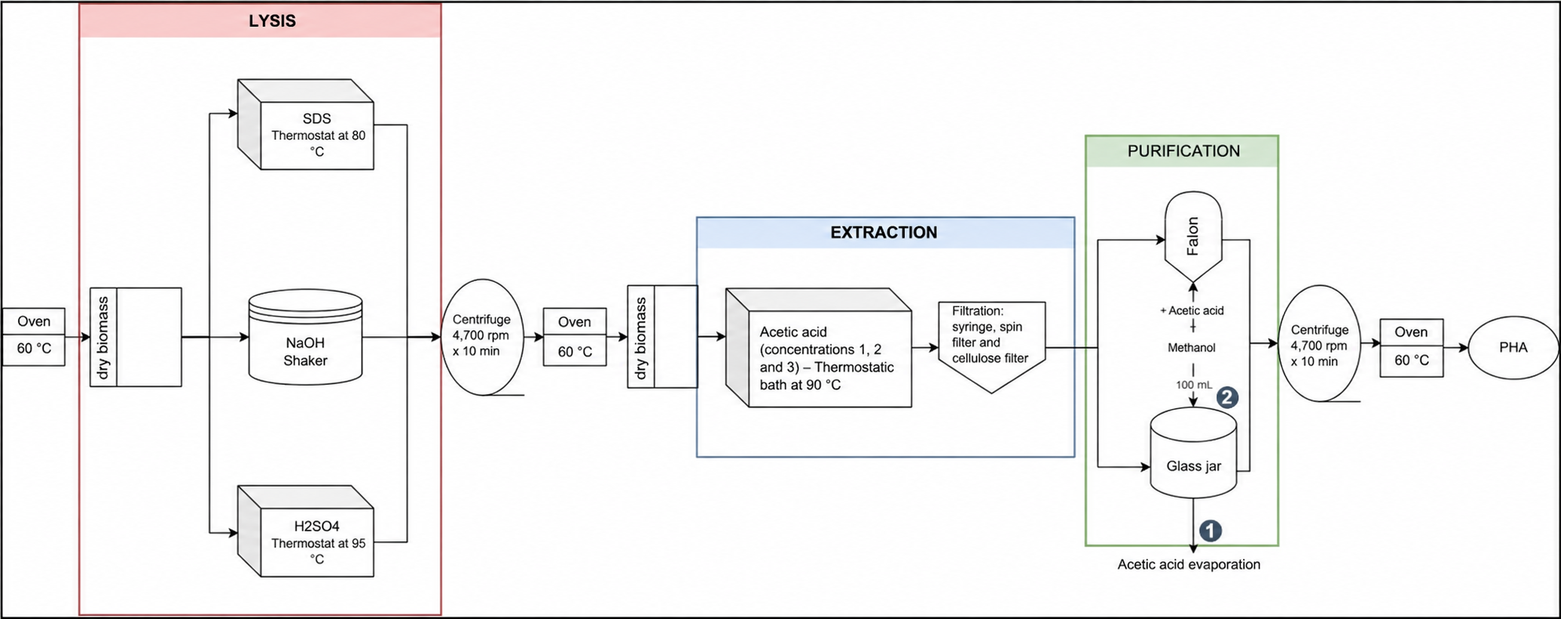
Figure 1. Methodological scheme
  - Results and Discussion
Each experimental route was assigned a treatment code, as shown in Table 1, to ensure systematic identification and traceability of the evaluated conditions.

Table 1. Definition of treatment codes.
Treatment No. | Lysis Agent | Extraction Condition | Purification Method | Treatment Code
1 | SDS | Acetic acid 1 (10 mL g⁻¹) | Solvent casting | S1M
2 | SDS | Acetic acid 1 (10 mL g⁻¹) | Precipitation with methanol | S1AM
3 | SDS | Acetic acid 2 (15 mL g⁻¹) | Solvent casting | S2M
4 | SDS | Acetic acid 2 (15 mL g⁻¹) | Precipitation with methanol | S2AM
5 | SDS | Acetic acid 3 (20 mL g⁻¹) | Solvent casting | S3M
6 | SDS | Acetic acid 3 (20 mL g⁻¹) | Precipitation with methanol | S3AM
7 | NaOH | Acetic acid 1 (10 mL g⁻¹) | Solvent casting | N1M
8 | NaOH | Acetic acid 1 (10 mL g⁻¹) | Precipitation with methanol | N1AM
9 | NaOH | Acetic acid 2 (15 mL g⁻¹) | Solvent casting | N2M
10 | NaOH | Acetic acid 2 (15 mL g⁻¹) | Precipitation with methanol | N2AM
11 | NaOH | Acetic acid 3 (20 mL g⁻¹) | Solvent casting | N3M
12 | NaOH | Acetic acid 3 (20 mL g⁻¹) | Precipitation with methanol | N3AM
13 | H₂SO₄ | Acetic acid 1 (10 mL g⁻¹) | Solvent casting | H1M
14 | H₂SO₄ | Acetic acid 1 (10 mL g⁻¹) | Precipitation with methanol | H1AM
15 | H₂SO₄ | Acetic acid 2 (15 mL g⁻¹) | Solvent casting | H2M
16 | H₂SO₄ | Acetic acid 2 (15 mL g⁻¹) | Precipitation with methanol | H2AM
17 | H₂SO₄ | Acetic acid 3 (20 mL g⁻¹) | Solvent casting | H3M
18 | H₂SO₄ | Acetic acid 3 (20 mL g⁻¹) | Precipitation with methanol | H3AM
19 | Sodium hypochlorite | Chloroform | Methanol | W
The performance of the extraction and purification routes was assessed using sample purity (Pm) and real yield (Rr) as the main selection criteria. These response variables were chosen because they directly reflect both the quality of the recovered polymer and the efficiency of the overall downstream process.
PHA quantification was performed by gas chromatography (GC) to ensure high analytical accuracy and reproducibility. Chromatographic analysis was prioritized over exclusively gravimetric determination to minimize potential errors associated with residual moisture, impurities, or incomplete solvent removal, which may affect mass-based measurements. This approach allowed a more reliable determination of the actual PHA content in the recovered samples.
For quantification, a five-point calibration curve was prepared using pure polyhydroxybutyrate (PHB) standards in the concentration range of 0–1,000 mg L⁻¹. Each calibration point was analyzed in triplicate to ensure statistical robustness and to reduce instrumental variability. The calibration curve showed adequate linearity within the selected range, providing a consistent analytical baseline for the determination of PHB concentration in the experimental samples.
The concentration values obtained from chromatographic analysis were subsequently used to calculate sample purity and real yield. In this way, chromatographic quantification served as the reference method for evaluating process efficiency across treatments. The response variables were calculated according to Eq(1) and Eq(2), ensuring consistency in the comparative assessment of all experimental routes.
Sample purity was determined as:
$$Pm=\frac{PHAr (mg L⁻¹) × V (L)}{PHAs (g)}x100$$ | (1)
Where PHAr is the PHA concentration determined by chromatography (mg L⁻¹), V is the sample volume (L), and PHAs is the mass of the recovered PHA sample (g), weighed using an analytical balance.
Real yield was calculated as:
$$Rr=\frac{PHAs \left(g\right)}{Db \left(g\right)}xPm$$ | (1)
Where PHAs is the mass of the recovered PHA sample (g), weighed using an analytical balance, and Db is the dry biomass (g) obtained from the fermentation treatment.

Table 2. Purity and real yield obtained for the evaluated treatments.
Treatment code | Pm (%) | Rr (%)
S1AM | 24,53  +/- 0,57 | 0,58  +/- 0.01
S1M | 15,64  +/- 0,69 | 0,78  +/- 0.03
S2AM | 30,37  +/-3,36 | 0,55  +/- 0.06
S2M | 15,62  +/- 0,28 | 1,22  +/- 0.02
S3AM | 15,06  +/- 0,95 | 0,23  +/- 0.01
S3M | 19,24  +/- 0,38 | 1,05  +/- 0.02
N1AM | 6,02  +/-0,66 | 0,07  +/- 0.01
N1M | 0,00  +/- 0 | 0,00  +/- 0
N2AM | 4,56  +/- 0,10 | 0,07  +/- 0
N2M | 0,00  +/- 0 | 0,00  +/- 0
N3AM | 5,65  +/- 0,42 | 0,05  +/- 0
N3M | 0,00  +/- 0 | 0,00  +/- 0
H1AM | 0,00  +/- 0 | 0,00  +/- 0
H1M | 4,61  +/- 0,11 | 0,10  +/- 0
H2AM | 0,00  +/- 0 | 0,00  +/- 0
H2M | 3,91  +/- 0,21 | 0,17  +/- 0.01
H3AM | 0,00  +/- 0 | 0,00  +/- 0
H3M | 6,47  +/- 0,33 | 0,14  +/- 0.01
W | 74,31 | 2,24
The evaluated treatment combinations defined in Table 1 are consistent with previously reported strategies for PHA recovery from mixed microbial cultures, where variations in lysis agents, solvent ratios, and purification methods significantly influence process performance. Previous studies have highlighted that the selection of appropriate downstream conditions is critical due to the complex nature of sludge-derived biomass, which contains non-PHA cellular material and recalcitrant compounds that hinder efficient extraction (Kannah et al., 2022; Mannina et al., 2019).The highest performance was obtained for the SDS treatment combined with glacial acetic acid extraction and methanol solvent casting purification. The optimal condition corresponded to SDS (10 mL g⁻¹) (Mannina et al., 2019)., glacial acetic acid (20 mL g⁻¹) (Aramvash et al., 2018) and industrial methanol (100 mL g⁻¹) (Gracia et al., 2024). In contrast, NaOH and H₂SO₄ treatments resulted in negligible PHA recovery. The poor performance observed for NaOH and H₂SO₄ treatments can be attributed to polymer degradation and structural disruption under harsh chemical conditions. Alkaline treatments may promote partial depolymerisation of PHAs, while strong acids can induce hydrolysis and carbonization effects, reducing recoverable fractions (Kannah et al., 2022). On the other hand, surfactant-based lysis using SDS enables effective cell disruption while preserving polymer integrity, which explains the higher recovery obtained.
The results presented in Table 2 show a high degree of experimental consistency in the determination of actual return (Rr). The standard deviations recorded for returns across all the routes evaluated were less than 0.06 percentage points. Specifically, the route selected as optimal, designated S2M, not only achieved the highest actual yield, at 1.22%, but also demonstrated remarkable precision, with a standard deviation of just +/- 0.02. This standard deviation value confirms the reproducibility of the surfactant-based extraction methodology.
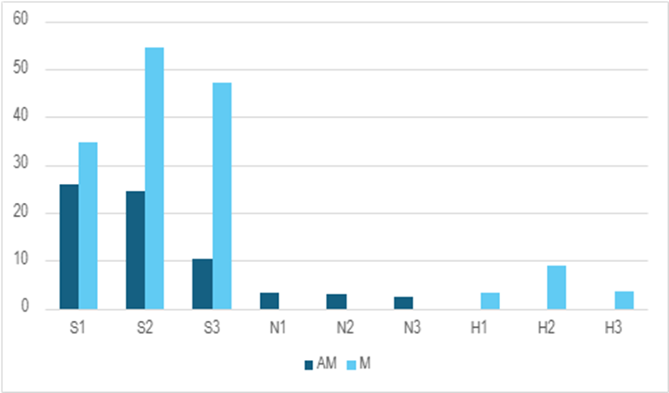
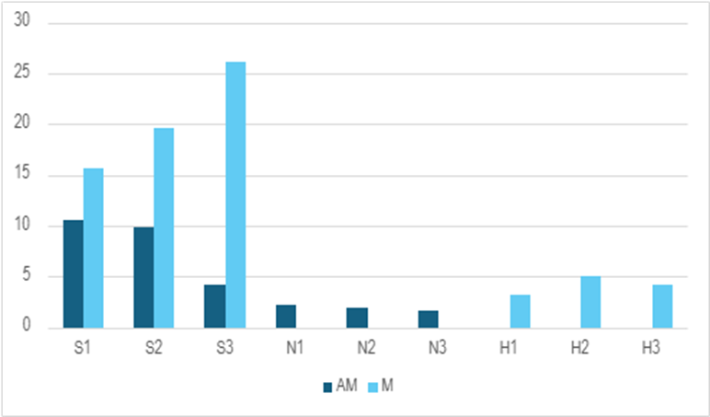
b
a

Figure 2. Real yield of the treatments (a) and Treatment purity (b).

Figure 2a shows that treatment S2M achieved the highest real yield. However, Figure 2b indicates that the highest purity values were obtained for treatments S3M, S2M, which represent the most favourable purification routes. This behaviour reflects the well-documented trade-off between purity and recovery in PHA downstream processing. Higher recovery conditions often lead to increased co-extraction of impurities, whereas more selective purification routes improve polymer purity at the expense of yield. Similar trends have been reported in MMC-based systems, where the optimization of both parameters requires a balance between solvent strength and selectivity (Corsino et al., 2022; Valentino et al., 2017). The difference between these treatments was below 0.2 percentage points, indicating that the combination of SDS with at least 15 mL g⁻¹ of glacial acetic acid is sufficient to enhance polymer recovery.
Considering operational and environmental criteria, this route is preferable as it reduces acid consumption without significantly affecting yield. This reduction improves process sustainability by lowering chemical usage and decreasing the generation of residual acidic vapours during extraction. From a circular economy perspective, reducing chemical consumption in downstream processing is a key factor for improving the overall sustainability of PHA production. Previous studies have emphasized that solvent use and recovery represent a significant fraction of operational costs and environmental impact in biopolymer production processes (Chavan et al., 2021; Valentino et al., 2018). Therefore, optimizing reagent dosage without compromising performance is critical for future scale-up.
A multifactorial ANOVA analysis revealed that lysis and purification were the most significant factors affecting process performance, with F-values of 6481.714 (p < 2.2×10⁻¹⁶) and 1264.706 (p < 2.2×10⁻¹⁶), respectively, confirming that cell disruption efficiency plays a dominant role in PHA recovery. These results confirm that the type of lysis agent largely determines PHA recovery, as evidenced by the superior performance of SDS compared to NaOH and H₂SO₄ treatments, while purification mainly influences the final polymer quality. These results confirm that cell lysis and purification are the most influential stages in the overall efficiency of PHA recovery, which is consistent with previous findings identifying downstream processing as the main limitation in MMC-based systems. In particular, the effectiveness of the lysis step directly determines polymer accessibility, while purification governs final product quality (Cha et al., 2016; Kannah et al., 2022).
  - Conclusions
The operational conditions of the selected methodologies were subsequently evaluated through an experimental design to determine their actual performance. Treatment efficiency was assessed using yield, recovery and purity as response variables. The results demonstrated that the SDS-based treatment combined with the Solvent Casting methodology was the most effective option, achieving the highest recovery and purity values among the evaluated routes. In contrast, treatments based on NaOH and H₂SO₄ did not enable significant PHA recovery under the tested conditions.
The most favourable route corresponded to the use of SDS at 10 % in a ratio of 10 mL g⁻¹, combined with glacial acetic acid at 20 mL g⁻¹ for extraction, followed by purification with industrial methanol applied through Solvent Casting at 100 mL g⁻¹. These findings confirm that the optimisation of reagent concentration and solvent ratios plays a decisive role in enhancing polymer recovery, supporting the technical feasibility of PHA production from volatile fatty acids and mixed sludge cultures within a circular bioeconomy framework.
Acknowledgments
The authors would like to thank ICETEX-MINCIENCIAS for funding project 1016-2021, the IBUN Biotechnology Institute for lending its facilities to carry out the research, and the University of La Sabana's INGPHD-60-2023 project.
References
Anjum A., Zuber M., Zia K. M., Noreen A., Anjum M. N., Tabasum S., 2016, Microbial production of polyhydroxyalkanoates (PHAs) and its copolymers: A review of recent advancements, International Journal of Biological Macromolecules, 89, 161–174.
Aramvash A., Moazzeni Zavareh F., Gholami Banadkuki N., 2018, Comparison of different solvents for extraction of polyhydroxybutyrate from Cupriavidus necator, Engineering in Life Sciences, 18(1), 20–28.
Banu J. R., Ginni G., Kavitha S., Kannah R. Y., Kumar V., Kumar S. A., Gunasekaran M., Tyagi V. K., Kumar G., 2021, Polyhydroxyalkanoates synthesis using acidogenic fermentative effluents, International Journal of Biological Macromolecules, 192, 942–956.
Cabrera F., Torres A., Campos J. L., Jeison D., 2019, Effect of operational conditions on the behaviour and associated costs of mixed microbial cultures for pha production, Polymers, 11(2), 1–15.
Cha S. H., Son J. H., Jamal Y., Zafar M., Park H. S., 2016, Characterization of polyhydroxyalkanoates extracted from wastewater sludge under different environmental conditions, Biochemical Engineering Journal, 112, 1–12.
Chavan S., Yadav B., Tyagi R. D., Drogui P., 2021, A review on production of polyhydroxyalkanoate (PHA) biopolyesters by thermophilic microbes using waste feedstocks, Bioresource Technology, 341, 125900.
Corsino S. F., Trapani D. D., Traina F., Cruciata I., Calabrisotto L. S., Lopresti F., Carrubba V. L., Quatrini P., Torregrossa M., Viviani G., 2022, Integrated production of biopolymers with industrial wastewater treatment, Journal of Water Process Engineering, 47, 102772.
Dias J. M., Oehmen A., Serafim L. S., Lemos P. C., Reis M. A., Oliveira R., 2008, Metabolic modelling of polyhydroxyalkanoate copolymers production by mixed microbial cultures, BMC Systems Biology, 2(59), 1–15.
Fu X., Xu H., Zhang Q., Xi J., Zhang H., Zheng M., Xi B., Hou L., 2023, A review on polyhydroxyalkanoates production from various organic waste streams, Resources, Conservation and Recycling, 198, 107166.
Gracia J., Espinosa A., Moreno N., Cabeza I., 2024, Evaluation of the production and extraction of polyhydroxybutyrate from volatile fatty acids by means of mixed cultures and B. cepacia, Environmental Research, 250, 118448.
Gracia J., Montenegro C., Moreno N., Cabeza I., 2023b, Production of Polyhydroxyalkanoates using Volatile Fatty Acids from Municipal Wastewater Treatment Plant Sludge, Chemical Engineering Transactions, 100, 559–564.
Jarillo G. M., 2018, Polyhydroxyalkanoates production alongside wastewater treatment by mixed microbial cultures, Tesis Doctoral, Universitat Autònoma de Barcelona, 1–250.
Johnson K., Jiang Y., Kleerebezem R., Muyzer G., van Loosdrecht M. C. M., 2009, Enrichment of a Mixed Bacterial Culture with a High Polyhydroxyalkanoate Storage Capacity, Biomacromolecules, 10, 670–676.
Jiang Y., Mikova G., Kleerebezem R., van der Wielen L. A. M., Cuellar M. C., 2015, Feasibility study of an alkaline-based chemical treatment for the purification of polyhydroxybutyrate produced by a mixed enriched culture, AMB Express, 5,(5) 1-12
Kannah R. Y., Kumar M. D., Kavitha S., Banu J. R., Tyagi V. K., Rajaguru P., Kumar G., 2022, Production and recovery of polyhydroxyalkanoates (PHA) from waste streams - A review, Bioresource Technology, 359, 128203.
Mannina G., Presti D., Montiel-Jarillo G., Suárez-Ojeda M. E., 2019, Bioplastic recovery from wastewater: A new protocol for polyhydroxyalkanoates (PHA) extraction from mixed microbial cultures, Bioresource Technology, 282, 361–369.
Sabapathy P. C., Devaraj S., Meixner K., Anburajan P., Kathirvel P., Ravikumar Y., Zabed H. M., Qi X., 2020, Recent developments in Polyhydroxyalkanoates (PHAs) production–A review, Bioresource Technology, 306, 123132.
Silva L. F., Gomez J. G., Oliveira M. S., Torres B. B., 2000, Propionic acid metabolism and poly-3-hydroxybutyrate-co-3-hydroxyvalerate (P3HB-co-3HV) production by Burkholderia sp., Journal of Biotechnology, 76, 165–174.
Valentino F., Gottardo M., Micolucci F., Pavan P., Bolzonella D., Rossetti S., Majone M., 2018, Organic Fraction of Municipal Solid Waste Recovery by Conversion into Added-Value Polyhydroxyalkanoates and Biogas, ACS Sustainable Chemistry and Engineering, 6, 16375–16385.
Valentino F., Morgan-Sagastume F., Campanari S., Villano M., Werker A., Majone M., 2017, Carbon recovery from wastewater through bioconversion into biodegradable polymers, New Biotechnology, 37, 9–23.
Zhou W., Bergsma S., Colpa D. I., Euverink G.-J. W., Krooneman J., 2023, Polyhydroxyalkanoates (PHAs) synthesis and degradation by microbes and applications towards a circular economy, Journal of Environmental Management, 341, 118033.

