 CHEMICAL ENGINEERING TRANSACTIONS  VOL. xxx, 2026 | A publication of  
The Italian Association
of Chemical Engineering
Online at www.cetjournal.it

Guest Editors: Leonardo Tognotti, Rubens Maciel Filho, Viatcheslav Kafarov
Copyright © 2026, AIDIC Servizi S.r.l.
ISBN 979-12-81206-xx-x; ISSN 2283-9216

Ex situ bioremediation of PCBs-contaminated soils through microbial immobilization on coconut fiber
Juliana P. Quintero-Pérez^{a*}, Álvaro E. Villamizar-Villamizarª, Ángela M. Cajiao-Pedraza^{b}
ªChemical Engineering Program, Universidad de Pamplona, km 1 vía Bucaramanga; Pamplona-Colombia
^{b}Microbiology Program, Universidad de Pamplona, km 1 vía Bucaramanga; Pamplona-Colombia *juliana.quinterojul@unipamplona.edu.co

This study addresses the environmental and health risks arising from soil contamination with polychlorinated biphenyls (PCBs) from dielectric oils associated with abandoned electrical transformers. An ex-situ bioremediation strategy was implemented based on the immobilization of microorganisms on coconut fiber, conceived as an environmentally sustainable alternative. To this end, indigenous microorganisms capable of metabolizing dielectric oil as their sole carbon source were isolated, and two biological pathways were compared: Pseudomonas spp. and a native microbial consortium. The coconut fiber was previously characterized and used as an organic support to promote cell stability and enhance metabolic activity. The experiments were carried out under controlled conditions, evaluating the process using respirometry, enzyme activity determination, and gas chromatography with electron capture detection (GC-ECD) for PCBs quantification. The results showed a decrease in the contaminant, with removal efficiencies of 32.20% and 27.96% for Pseudomonas spp. and the microbial consortium, respectively, with no statistically significant differences between the two routes. Likewise, partial improvements were recorded in some soil properties, suggesting functional recovery and confirming the technical and environmental viability of microbial immobilization on coconut fiber.
  - Introduction
Soil plays a central role in terrestrial ecosystems as the physical substrate for vegetation, a strategic reservoir of organic matter, and the medium where biogeochemical processes essential to the balance of the biosphere take place. Through the regulation of hydrological, carbon, and nutrient cycles, and its capacity to sustain diverse biological communities, soil ensures essential ecological functions such as fertility, environmental stability, and water regulation. However, this functional complexity makes it a system that is particularly susceptible to alterations caused by human activity, which introduces contaminants capable of modifying its physicochemical properties, reducing biodiversity, and generating environmental and health risks. In this context, industrial expansion drove the use of dielectric oils in electrical equipment, many of which, especially those manufactured before strict regulations were introduced, incorporated polychlorinated biphenyls (PCBs) to improve their thermal and dielectric performance. The abandonment of transformers and systems containing these oils promotes leaks and spills which may result in the direct transfer of PCBs to the soil and their subsequent dispersion into the environment. As persistent organic contaminants, PCBs possess high chemical stability, have an affinity for lipids, are resistant to degradation, and are capable of bioaccumulation and biomagnification, as well as long-range transport, which intensifies their impact on ecosystems and human health (United Nations Environment Program, 2022). These characteristics prompted the Stockholm Convention to establish their global phase-out, recognizing the risk they pose to natural systems and exposed populations.
To address this problem, conventional remediation methods have been used that have proven highly effective in eliminating persistent organic contaminants; however, their application often involves high energy consumption, irreversible alterations to the physicochemical properties of the soil, and the generation of secondary waste, which limits the ecological recovery of the treated areas. These restrictions have driven the development of more sustainable strategies aimed at reducing the contaminant load without compromising soil functionality or biodiversity. In this regard, bioremediation has become an environmentally compatible alternative by taking advantage of the metabolic capacity of microorganisms to transform persistent contaminants, although its efficiency may be affected by the low bioavailability of compounds and unfavorable edaphic conditions. Recent studies show that integrating biological processes with advanced materials, particularly carbonaceous supports derived from residual biomass such as biochar, improves hydrocarbon retention and optimizes soil parameters such as pH, organic matter and nutrient availability, promoting microbial activity (Díaz Agüero et al., 2025). Similarly, the functionalization of organic materials with inorganic nanoparticles increases porosity, active sites, and the adsorption of persistent compounds, highlighting the importance of a microporous structure and surface of the functional groups in removal processes (León-Bermúdez et al., 2025). Nevertheless, despite advances in PCBs bioremediation, limitations in removal efficiency remain, and there is still a need to evaluate strategies that improve the stability and degradative activity of microorganisms, as well as to compare the performance of individual strains and microbial consortia. For this reason, the present study evaluates an ex-situ bioremediation strategy through the immobilization of native microorganisms on coconut fiber, comparing the PCBs removal capacity of Pseudomonas spp. against a microbial consortium, with the aim of providing experimental evidence on the potential of microbial immobilization as a sustainable alternative for the remediation of contaminated soils.
  - Methodology
The research was carried out using an ex-situ bioremediation process, employing soil artificially contaminated with dielectric oil containing PCBs and microorganisms immobilized on coconut fiber as an organic support. The experiments were conducted under controlled laboratory conditions to ensure the reproducibility of the system. The experimental design included two biological pathways, one based on Pseudomonas spp. and the other on a native microbial consortium, both evaluated in triplicate. The initial concentration of the contaminant was defined by applying the principle of mass conservation, establishing an initial oil content of 10.5% (w/w) in the soil and through a mass balance, the weight increase corresponded only to the added oil. During the process, variables such as soil mass, moisture, temperature, incubation time, and microbial composition were kept under control, while the response variables considered were microbial metabolic activity and the decrease in PCBs concentration.
    - Soil characterization
Prior to the bioremediation experiments, the contaminated soil was subjected to characterization in order to establish its initial conditions and evaluate its influence on microbial activity. Characterization parameters are presented in Figures 1 and 2.

Figure 1: Parameters of soil size distribution and physical properties.

Figure 2: Parameters of soil physicochemical characterization.
    - Microorganism selection and identification
The microorganisms used were isolated from contaminated soil, prioritizing those previously adapted to the presence of dielectric oil. Isolation was carried out from soil extracts and serial dilutions using general, selective, and differential media. Strains were selected based on their ability to grow in minimal media using dielectric oil as the sole carbon source, evaluating their tolerance to increasing concentrations of the contaminant. Presumptive identification was performed by Gram staining, growth in selective media, and biochemical tests, which allowed the selection of strains compatible with Pseudomonas spp. and the formation of a microbial consortium composed mainly of Pseudomonas spp., Bacillus spp., and enterobacteria.
    - Characterization of coconut fiber as an immobilization support
Coconut fiber was used as an organic support for microbial immobilization due to its lignocellulosic nature and high porosity. Its characterization included the evaluation of functional properties such as water absorption and retention capacity, oil absorption capacity, and ion adsorption capacity, which are parameters related to the availability of active sites and the interactions between the support and microorganisms. Additionally, basic chemical characterization was performed using proximate analysis, determining moisture, ash, protein, ether extract, and crude fiber content, in order to assess the material structural stability and its compatibility with microbial activity (AOAC, 1990).
    - Bioremediation experiments and analyses
Bioremediation experiments were carried out using contaminated soil, coconut fiber as a support, and microbial suspensions standardized according to the McFarland scale. Immobilization was implemented by impregnating the support with the inoculum and mixing it homogeneously with the soil to promote adsorption and microbe-contaminant contact. Metabolic activity was evaluated by respirometry, quantifying the CO₂ generated and determined by acid-base titration. On the other hand, the enzymatic activities of catalase, dehydrogenase, and peroxidase were measured as indicators of metabolic status using volumetric and spectrophotometric methods. The PCBs concentration was determined by gas chromatography with an electron capture detector (GC-ECD), estimating the final concentration (Bernabé et al., 2025) and the initial concentration based on the known concentration of the contaminating oil and the mass balance applied. For the statistical analysis of the respirometry and enzyme activity data, ANOVA or nonparametric tests were applied as appropriate, supplemented with box plots with notches and principal component analysis (PCA), in order to identify significant differences between replicates and treatments and determine the most favorable evolution, all processed using Python.
  - Results and discussion
This section presents and discusses the obtained results during the research phases.
    - Soil physicochemical characterization
Physicochemical analysis of the soil carried out before, during, and after contamination, summarized in Table 1, evidenced changes attributable to both the incorporation of dielectric oil and the bioremediation process, suggesting a partial recovery of its properties after treatment. Particle-size analysis indicated a predominantly sandy texture, with a predominance of fine to very fine sand and a gravel fraction of around 28%. This confirmed a macroporous structure which, together with low bulk density values and a high void fraction, promote the permeability and mobility of hydrophobic compounds, although it increases susceptibility to moisture loss (Weil y Brady, 2016). From a chemical point of view, the soil initially had an acidic pH, which decreased after contamination, probably due to the coating of active sites with hydrophobic compounds that limit ion exchange. Subsequently, the pH increased after bioremediation, associated with biological activity and the mineralization of organic compounds, indicating a progressive improvement in the system (Ghosal et al., 2016). Moisture content decreased after contamination due to the hydrophobic nature of the oil, but increased after treatment, suggesting a recovery of water retention capacity. Similarly, organic matter content showed an apparent increase during contamination due to analytical interference from the oil, followed by a moderate decrease, indicating a partial removal of the contaminant. Finally, electrical conductivity remained low at all stages, classifying the soil as non-saline, while phosphorus concentration was in moderate range, compatible with microbial development and without significant nutritional limitations for bioremediation.
Table 1: Soil physicochemical properties before, during and after contamination with dielectric oil.
Parameter | Before contamination | Contaminated soil | Post-bioremediation with Pseudomonas spp. | Post-bioremediation with consortium
Temperature (°C) | 19 | 19 | 19 | 19
pH | 5.05 | 4.83 | 6.93 | 7.46
Electrical conductivity (μS/cm) | 52 | 45 | 47 | 47
Moisture content (%) | 13.54 | 10.53 | 16.57 | 15.91
Organic matter (%) | 15.28 | 17.20 | 11.15 | 11.23
    - Selection and presumptive identification of microorganisms
The evaluation of native soil microbiota revealed marked differences in the ability of microorganisms to tolerate and metabolize dielectric oil as a carbon source. While fungal isolates showed no growth at any concentration, indicating limited metabolic affinity for hydrophobic and recalcitrant compounds, several bacterial strains exhibited growth even at the highest concentration evaluated (20.88% w/w). The phenotypic characterization revealed a diverse community of Gram-positive and Gram-negative bacilli, reflecting different structural and metabolic mechanisms associated with tolerance to organic contaminants. Through differential growth in selective media, the isolates were related to bacterial groups relevant to hydrocarbon degradation, including Bacillus spp., enterobacteria, and Pseudomonas spp. Presumptive identification, based on biochemical tests and carbohydrate fermentation, suggested that the bacterial consortium included possible strains of Klebsiella spp., Proteus spp., Salmonella spp., Escherichia coli, Bacillus coagulans, and Bacillus cereus, while the specific pathway was dominated by Pseudomonas putida (Koneman et al., 2017).
    - Characterization of coconut fiber as an immobilization support
The results of the functional and chemical characterization demonstrated that coconut fiber is a suitable support for microbial immobilization in bioremediation processes. Its highly porous structure and high-water retention capacity promote microenvironment stability, ensuring adequate moisture and aeration conditions for the metabolic activity of immobilized microorganisms. Furthermore, its lignocellulosic composition and the presence of active surfaces promote cell adhesion and reduce microbial desorption, ensuring the retention of microorganisms during treatment. These properties, together with a natural affinity for hydrophobic organic compounds, enable for greater availability of the contaminant on the support, thus improving the efficiency of the biodegradation process.
    - Bioremediation performance
The bioremediation results showed similar metabolic behaviors among the replicates of the treatment with Pseudomonas spp. (M1, M3, and M5) and those of the microbial consortium (M2, M4, and M6). This reflected an active and sustained intracellular metabolism, as indicated by dehydrogenase activity, which is related to the respiratory processes involved in contaminant transformation. Catalase activity remained low and comparable in both treatments, indicating the presence of oxidative stress derived from the metabolization of dielectric oil. Complementarily, peroxidase activity was significantly activated in both systems, demonstrating the oxidative capacity necessary for the initial degradation of the biphenyl rings present in PCBs and the progressive decomposition of these recalcitrant compounds.
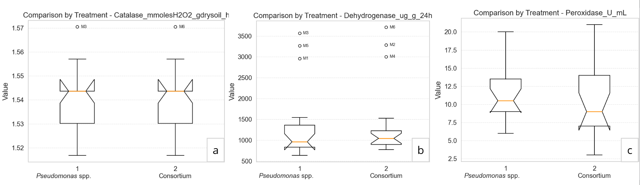
Figure 3: Statistical comparison of enzymatic activity between Pseudomonas spp. and the microbial consortium.
The comparison of enzyme activity between treatments is presented in Figure 3 using box plots with notches for catalase (a), dehydrogenase (b), and peroxidase (c). For all three indicators, data dispersion is observed between treatments and replicates; however, the medians and confidence intervals overlap widely, indicating similar central values between Pseudomonas spp. and the microbial consortium. This behavior was supported by the ANOVA performed, where both parametric and nonparametric tests confirmed the absence of significant differences between treatments and between replicates (p > 0.05). This finding was supported by a one-way ANOVA, which revealed no significant differences in metabolic indicators between treatments for catalase (F ≈ 0; p = 1.000), dehydrogenase (F = 0.026; p = 0.872), or peroxidase (F = 0.520; p = 0.476). Shapiro–Wilk tests revealed deviations from normality in some cases, while the homogeneity of variances was maintained (Levene, p > 0.05). Therefore, the nonparametric Kruskal–Wallis test was applied, which also confirmed the absence of significant differences between Pseudomonas spp. and the microbial consortium (p > 0.05). This indicated that both treatments maintained similar levels of enzymatic activity during the degradation process.
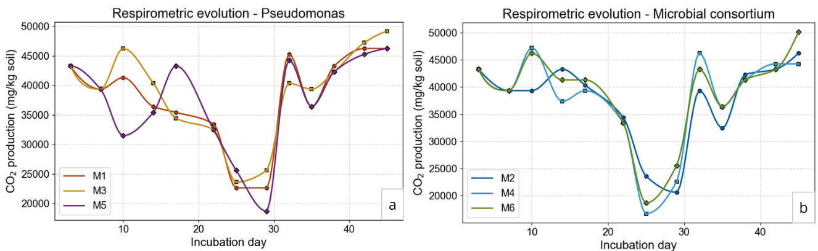
Figure 4: Respirometric evolution of treatments with Pseudomonas spp. and the microbial consortium.
The respirometric evolution of both treatments presented in Figure 4, shows the temporal behavior of CO₂ for Pseudomonas spp. (a) and the microbial consortium (b). In both cases, the curves show similar patterns between replicates, characterized by phases of adaptation, sustained respiratory activity, and recovery after a disturbance, with no marked differences between treatments, which demonstrates an active mineralization of the contaminant. Similarly, the respirometry analysis also showed no significant differences between treatments (ANOVA: F = 0.003; p = 0.956). Although Shapiro–Wilk tests indicated deviations from normality in both treatments, the homogeneity of variances was maintained (Levene, p = 0.830). Consequently, the Kruskal–Wallis test confirmed the absence of significant differences (p = 0.972), suggesting similar metabolic activity in both systems during bioremediation. PCA presented in Figure 5, enabled for the integration of metabolic indicators and the evaluation of functional similarity between replicates. PC2 grouped the replicates of each treatment in the same direction, evidencing similar metabolic signatures for both Pseudomonas spp. and the microbial consortium. PC1 reflected differences in the relative contribution of enzymatic activities, where samples M3 and M6 shifted toward the axis associated with greater peroxidase activation, indicating a stronger orientation toward oxidative processes of persistent aromatic compounds. This behavior supported their selection as representative samples for chromatographic analysis.
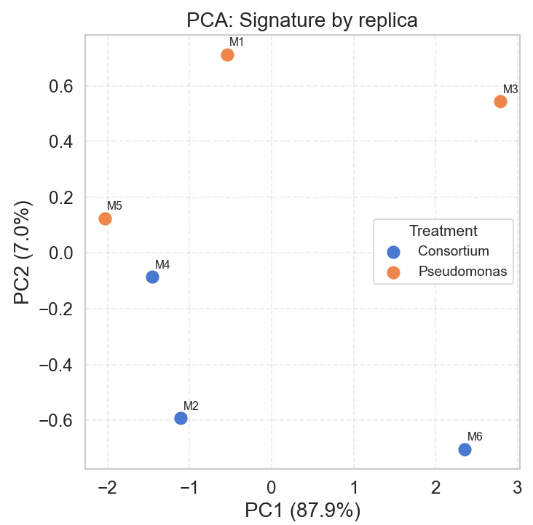
Figure 5: PCA of metabolic indicators.
The initial concentration of PCBs in the untreated soil was 4.72 mg of PCBs/kg of soil. After the bioremediation, the chromatographic results (Figure 6) showed clear differences in removal efficiency between the routes evaluated. Sample M3 (a), corresponding to the treatment with Pseudomonas spp. immobilized on coconut fiber, reached a final concentration of approximately 3.2 mg of PCBs/kg, indicating a removal of 32.20%. In contrast, sample M6 (b) had a final concentration of 3.4 mg of PCBs/kg, equivalent to a removal of 27.96%, showing a slightly lower elimination of the contaminant. These values fall within the ranges reported for PCBs bioremediation processes, where previous studies have documented efficiencies of approximately 23–34% in bacterial treatments lasting around 60 days, while other studies have reported up to 47% for microbial consortia and 54% for individual external strains over periods of 8 to 9 weeks. Therefore, the present study demonstrates significant potential for optimization by achieving these removal levels in just six weeks through the use of immobilized indigenous microorganisms, whose protection and adaptation to the contaminated environment promote their stability and efficacy throughout the process.

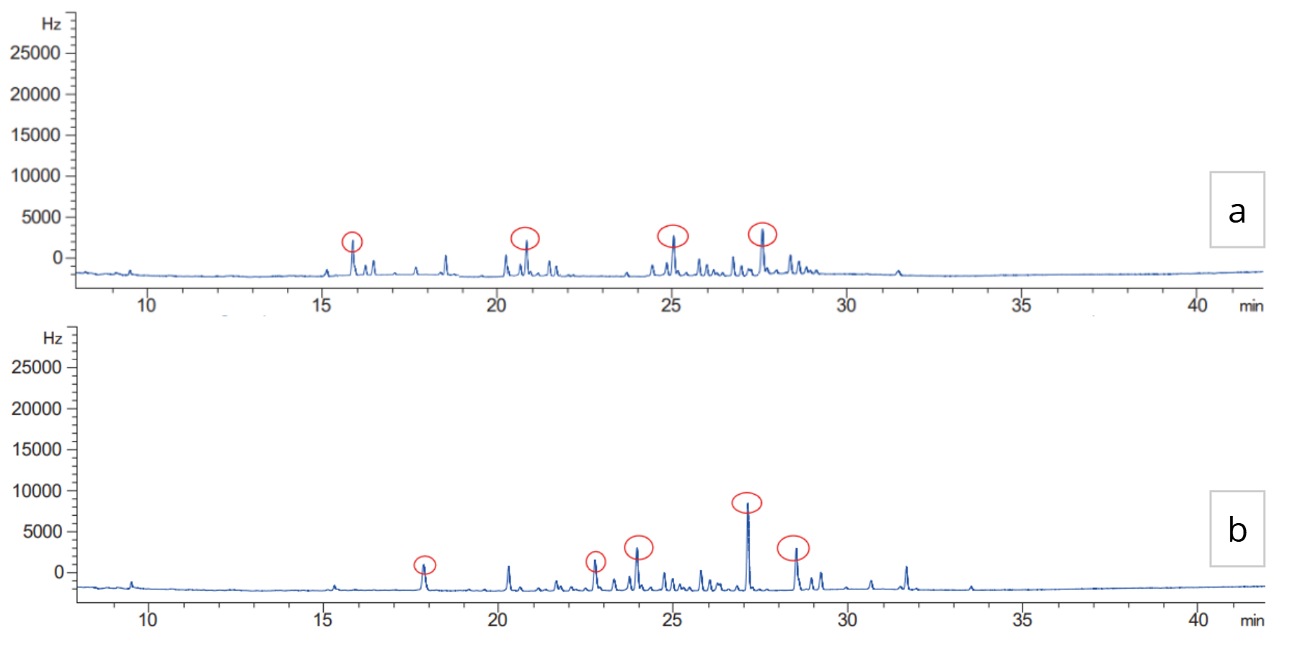
Figure 6: PCBs chromatograms for samples M3 and M6.
  - Conclusions
Bioremediation using immobilized microorganisms proved effective in reducing PCBs in contaminated soils, allowing adequate metabolic activity despite unfavorable initial physicochemical conditions and promoting improvements in soil properties such as pH, moisture, and organic matter content. Immobilization on coconut fiber promoted the adaptation and stability of the microbial biomass, helping to protect the strains from oxidative stress and ensuring the continuity of their degradation activity. The use of indigenous microorganisms allowed for removal rates comparable to those reported in the literature without requiring the introduction of external strains. This represents a potentially more sustainable and viable alternative for field applications. Under the evaluated conditions, Pseudomonas spp. achieved the highest PCBs removal rate at 32.20%, while the microbial consortium achieved 27.96%, suggesting a greater degradation capacity of the individual strain compared to the evaluated consortium.

Acknowledgments
The authors would like to thank the University of Pamplona, for their support.
References
Association of Official Analytical Chemists (AOAC). (1990). Official methods of analysis (15th ed., Vol. 1). AOAC.
Bernabé, M. W., Rodríguez, L. R., López, R. D., Egúzquiza, M. J., Luján, R. O., & León, M. A. (2025). PCB contaminated oils and the detection of transformer aging, according to IEEE STD C57.104-2019. Chemical Engineering Transactions, 118, 385–390. https://doi.org/10.3303/CET25118068
Díaz Agüero, J. A., Pérez Pérez, M. A., Lizarzaburu-Aguinaga, D., Benites-Alfaro, E., Cabrera Carranza, C., Jave Nakayo, J., & Suca-Apaza, G. R. (2025). Biochar from wastewater treatment plant sludge: Efficiency in the removal of hydrocarbons from contaminated soil. Chemical Engineering Transactions, 117, 133–138. https://doi.org/10.3303/CET25117022
Ghosal, D., Ghosh, S., Dutta, T. K., & Ahn, Y. (2016). Current state of knowledge in microbial degradation of polycyclic aromatic hydrocarbons (PAHs): A review. Frontiers in Microbiology, 7, 1369. https://doi.org/10.3389/fmicb.2016.01369
Koneman, E. W., Allen, S. D., Janda, W. M., Schreckenberger, P. C., & Winn, W. C. (2017). Color atlas and textbook of diagnostic microbiology (7th ed.). Wolters Kluwer.
León-Bermúdez, A. Y., Jiménez-Caballero, M. A., Castellanos-Amador, S. F., Peña-Ballesteros, D. Y., & Salas-Rondón, M. H. (2025). Use of activated carbon from vegetable residual biomass with SiO₂ nanoparticles for the removal of organic compounds in wastewater from the hydrocarbon sector. Chemical Engineering Transactions, 117, 199–204. https://doi.org/10.3303/CET25117029
United Nations Environment Programme (UNEP). (2022). Guidance on the management and elimination of polychlorinated biphenyls. UNEP.
Weil, R. R., & Brady, N. C. (2016). The nature and properties of soils (15th ed.). Pearson.

