Computer-Aided Exergy Assessment of a Biorefinery from Avocado Hard Waste
Joshua H. Carmona-Sierra, Manuel A. Upegui-Hernández, Ángel Darío González-Delgado*
Nanomaterials and Computer Aided Process Engineering Research Group (NIPAC), Chemical Engineering Department, Faculty of Engineering, University of Cartagena, Av. del Consulado Calle 30 No. 48-152, Cartagena, Colombia.
agonzalezd1@unicartagena.edu.co
In Colombia, the rapid expansion of Hass avocado cultivation has increased the availability of the fruit across different regions. During avocado processing operations, residues, such as the seed or peel, account for the most significant waste fraction, resulting not only in environmental challenges associated with their elimination but also a decrease in potential economic returns. In this study, an exergy analysis was performed for a biorefinery based on hard avocado waste to produce high-value products comprising starch and biodegradable biofilms. This enabled detailed mass and energy balance calculations and the determination of thermodynamic properties for both pure compounds and mixtures. Considering this information, chemical and physical exergies were additionally obtained, and exergy parameters were quantified per stage and for the whole process. The obtained results indicate satisfactory exergy performance, with an overall exergy efficiency of 68% and a total irreversibility of 5453.58 MJ/h. Exergy analysis revealed significant sources of exergy destruction in starch production during seed drying, and starch drying-1 and 2. These stages contribute 5% and 7.20% (each), respectively, to the total exergy destruction of the process. In biofilm production, flash separation-1, fermentation, and biofilm drying exhibit the greatest exergy destruction, each contributing approximately 6% of the total process exergy destruction. The main improvement opportunities are identified in stages such as drying, flash separation, fermentation, and neutralization; thus, optimizations of these stages are suggested to maximize the overall performance of the process.
  - Introduction
In recent decades, the accelerated depletion of natural resources and the increasing economy that relies heavily on their use have promoted a global shift toward sustainable products in the industrial sector. Within this context, it is crucial to coordinate the relationship between economic development and environmental protection to ensure sustainable development of the industry-environment system and provide energy, biomaterials, and chemicals to society (Wan et al., 2020). Across Colombia, driven by increasing sector demand, processes related to Hass avocado manufacturing have led to a widespread expansion, accounting for 20% of the total planted crop area (Garcia, J et al., 2021). Therefore, Hass avocado (Persea Americana Mill) has become a key component of Colombian agricultural exports. According to recent figures reported by Analdex (2024), Hass avocado exports experienced a 54.3% annual increase and sales exceeding USD 300 million, indicating a total growth of more than 2700 percent in export revenue. However, despite its great market recognition, the supply chain of this fruit only focuses on the pulp, leaving both the avocado peel and seed unused. This waste is approximately 15% of the total weight, and it is usually discarded or used as compost (Lara-Valencia et al., 2018). Exergy analysis is used in the biorefinery to measure and quantify irreversibilities, as well as the exergy inflows and outflows through each process unit. Previous research, such as the study by Alviz-Meza et al. (2025) has explored the valorization of avocado residues through process simulation in this topology, focusing mainly on process design and production yields of starch and biodegradable biofilms. While some other studies have addressed single-product systems such as avocado oil extraction (Herrera et al., 2022), In contrast, the present work evaluates the system performance through an exergy analysis, identifying irreversibilities and stages with the highest exergy destruction and also focuses on analyzing the feasibility of an avocado solid-residue biorefinery that simultaneously produces starch and two different biodegradable biofilms. This approach is novel because it enables a more comprehensive evaluation of resource utilization and thermodynamic efficiency compared with single-product systems. In this context, exergy analysis serves as a solid decision-making tool for the sustainable management of agro-industrial waste, considering the small number of studies related to exergy evaluation based on avocado waste from southern Colombia.

Materials and methods
    - Process description
The biorefinery process based on hard avocado waste was reproduced based on the previous study by Alviz-Meza et al. (2025). The simulation was developed in Aspen Plus software with the Redlich-Kwong thermodynamic model for the vapor phase and NRTL for liquid-phase mixtures. The process was evaluated using an operational feed rate of 240.02 tons per year, assuming a 50% yield in seed production for the analyzed region (Southern Colombia). This assumption considers realistic post-harvest operational constraints documented in Colombian avocado supply chains, where a significant fraction of seeds is discarded during fruit processing operations prior to reaching the biorefinery gate. Table 1 summarizes the main process stream conditions, including mass flow rate, pressure, and temperature.
Table 1: Operating conditions of the main streams
Streams | 1 | 11 | 22 | 30 | 25 | 44 | 48 | 53 | 54
m (t/y) | 240.02 | 144.93 | 6671.70 | 16.86 | 2.43 | 46.17 | 33.41 | 27.71 | 30.13
T (K) | 298.20 | 291.65 | 333.20 | 333.20 | 328.84 | 373.20 | 373.20 | 473.20 | 452.97
P (bar) | 1.01 | 1.01 | 1 | 1.00 | 1.00 | 0.50 | 0.50 | 2.00 | 1.00

The simplified process flow diagram of the starch and biofilm production is presented in Figure 1, showing the main process stages considered in the simulation. For the first process aimed at starch production, avocado hard wastes are washed, dried, and cut. Then, starch extraction is carried out with a sodium metabisulfite solution for 24 h. The mixture is then homogenized and filtered to separate the starch from the non-starch solids. The resulting starch-water suspension is then decanted. The starch is washed and dried to separate into three streams: Two intended for biofilm production, while the remaining one is dried to isolate the starch.
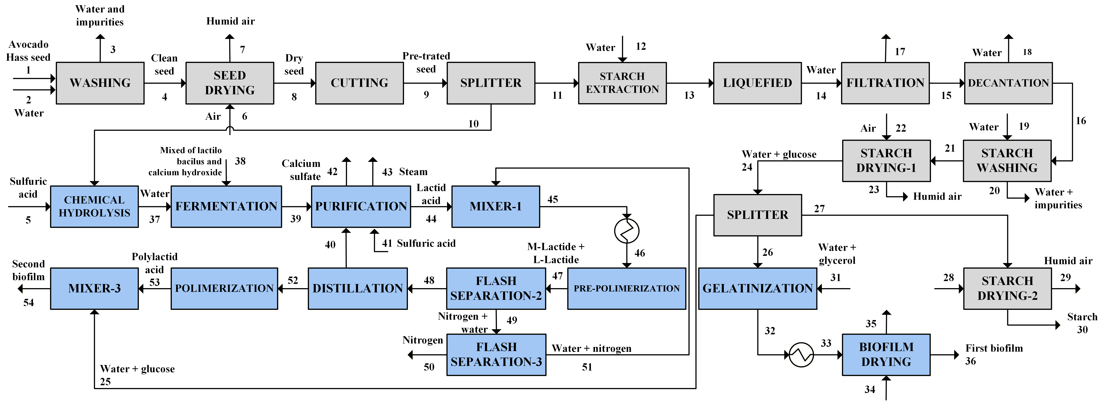
Figure 1: Simplified block diagram of the Biorefinery from Avocado Hard Waste
As previously mentioned, a fraction is derived during starch production for the manufacture of the first biofilm. This material is gelatinized, generating a mixture that is dried at 100 °C to obtain the biodegradable film. The second biofilm requires the production of polylactic acid (PLA), which is obtained through the steps of hydrolysis, fermentation with Lactobacillus bacteria, and pre-polymerization, where L-lactide and M-lactide are formed. These stereoisomers act as monomeric units in the synthesis of polylactic acid (Aliev et al., 2024).
According to Alviz-Meza et al. (2025), the formation of L-Lactide and M-Lactide via pre-polymerization is carried out in an inert nitrogen medium, which is recovered, purged, and reintroduced into the process through Flash separation-1 and Flash separation-2. Subsequently, distillation is performed to separate the non-reactive lactic acid and reintroduce it into the process. The lactides then enter the polymerization process to form polylactic acid, which is mixed with the starch from stream 25 for the production of the second biofilm.
    - Exergy analysis methodology
Exergy is the maximum work that can be obtained from a thermodynamic system during a reversible change of state until it reaches equilibrium with its surroundings, which is defined by a reference state (Gungor and Aydemir, 2025). In this sense, exergy analysis is an indicator that allows us to determine the irreversibilities of the system and the utilization of energy (Liu et al., 2024). To perform the exergy analysis, it was necessary to identify the input and output streams of each process, categorizing the output streams as products. This helped identify the process stages where exergy destruction was most significant. Table 2 shows the equations for the exergy analysis.
Table 2: Fundamental equations for exergy assessment
Name | Equation | Number
Exergy destroyed | $$Ex_{destroyed }= Ex_{heat}+ Ex_{work}+ Ex_{mass}$$ | 1
Exergy by work | $$Ex_{work}=W$$ | 2
Exergy by heat | $$Ex_{heat}=∑\left(1-\frac{T_{0}}{T}\right)Q_{i}$$ | 3
Exergy by mass | $$Ex_{Mass}=E{x_{physical }}_{ }+Ex_{chemical}+Ex_{potential}+Ex_{kinetic}$$ | 4
Physical exergy | $${Ex}_{physical}=m_{i}\left[\left(h_{i}-h_{0}\right)-T_{0}\left(s_{i}-s_{0}\right)\right]$$ | 5
Chemical exergy of process stream | $$Ex_{ch-mixture}=∑y_{i}Ex_{ch-i}+RT_{0}∑y_{i}\ln\left(y_{i}\right)$$ | 6
Chemical exergy | $$Ex_{ch-i}=ΔG_{f}^{0}+∑v_{j}Ex_{ch-j}$$ | 7
Unavoidable exergy losses | $$Ex_{losses} = ∑Ex_{in} - Ex_{total-out}$$ | 8
Exergy output | $$Ex_{total-out} = ∑Ex_{products} +∑Ex_{residues}$$ | 9
Irreversibilities | $${Loss}_{ex} = ∑Ex_{in} - ∑Ex_{products}$$ | 10
Exergy efficiency | $$η_{exergy}=1-\left(\frac{Loss_{total-ex}}{Ex_{total-in}}\right)$$ | 11
Exergy destroyed (%) | $${Ex}_{destroyed}=\left(\frac{Loss_{ex}}{{Loss}_{total-ex}}\right)*100\%$$ | 12
Following the identification of the streams, an exergy balance is performed to determine the exergy destroyed using Eq (1), which combines the first and second laws of thermodynamics, taking into account the net exergy from work, heat, and mass transfer across the system boundaries, Eq (2), (3), and (4), respectively. The contributions from kinetic and potential exergies are neglected in the mass transfer exergy, considering only physical and chemical exergy (Fontalvo-Morales et al., 2025). The physical exergy was taken from the Aspen Plus software and represented by equation (5). The chemical exergy of the streams was calculated using Eq (6), which considers the chemical exergy of each component of the mixture, the mass fraction, the reference state temperature (25 °C), and the universal gas constant (R).
Alternatively, the chemical exergy can be determined from equation (7), which considers the standard Gibbs free energy, the number of atoms of the constituent elements, and their standard chemical exergies. Standard chemical exergy values ​​for the elements were obtained from Szargut (2005), while some standard Gibbs free energies of formation were taken from Tai, Matsushige and Goda (1986). Exergy losses were identified using Eq (8), defined as the difference between the input exergy and the output exergies (Eq (9), which combines the exergy of products and waste). Irreversibilities were identified using Eq (10), which includes input exergies (by mass and by utilities) and the final products obtained per stage. The exergy efficiency was determined using Eq (11). Finally, the exergy destroyed is calculated using the Eq (12).
The following assumptions were adopted to carry out the exergy analysis of the process. First, the reference state was defined at 25 °C and 1 atm, which corresponds to standard ambient conditions commonly used in exergy studies. These reference conditions provide a consistent thermodynamic baseline for the calculation of physical exergy and allow meaningful comparison with results reported in the literature. Second, the process was assumed to operate under steady-state conditions, implying that all mass, energy, and exergy flows remain constant over time. This assumption neglects transient effects such as start-up and shutdown phases and enables a simplified yet robust evaluation of exergy efficiencies, irreversibilities, and losses within the system. Together, these assumptions ensure thermodynamic consistency while maintaining the analytical tractability of the exergy assessment.
Table 3. Chemical exergy of pure substances in the avocado hard waste biorefinery.
Component | Chemical exergy  (kJ/kg) | R Specific  (Ideal Gas Constant in Mass Units) | Source
n(Glucose) | 16539.17 | 0.05 | Deng et al. (2024)
Lactid acid | 15780.67 | 0.09 | Tai and Goda (1986)
M-Lactide | 20903.35 | 0.06 | Calculated from Szargut (2005)
Water | 42.74 | 0.46 | Peralta-Ruiz et al. (2013)

  - Results and discussion
The exergy assessment was performed in stages. It was necessary to determine the exergy by work, which was obtained from the literature. Additionally, the information required to carry out the assessment includes heat duties, temperature, pressure, mass flow rate, and composition. Table 4 shows the values of exergy by work, heat, and unavoidable exergy losses that were determined using Eq (8).
Table 4. Exergy of utilities and unavoidable exergy losses per stage for the avocado hard waste biorefinery.
Stage | Exergy of work  (MJ/h) | Heat Duty  (MJ/h) | Unavoidable exergy losses  (MJ/h)
Washing | 14.40 | 0.00 | 15.21
Seed drying | 272.00 | 0.02 | 275.9
Cutting | 3.60 | 0.00 | 3.6
Starch Extraction | 0.00 | 0.00 | 1.5
Liquefied | 26.85 | 1.8 | 0.00
Solid removal | 39.60 | 0.00 | 39.58
Decantation | 0.00 | 0.00 | 0.00
Starch washing | 14.40 | 0.00 | 14.67
Starch drying-1 | 378.00 | 0.01 | 380.33
Starch drying-2 | 378.00 | 1.36 | 379.85
Gelatinization | 0.00 | 2.67 | 3.07
Biofilm drying | 272.00 | 0.31 | 345.61
Hydrolysis | 0.00 | 268.25 | 213.05
Fermentation | 0.03 | 266.14 | 328.31
Neutralization | 0.00 | 86.78 | 131.45
Filtration | 39.60 | 0.00 | 130.36
Flash separation-1 | 16.25 | 269.39 | 244.12
Mixing-1 | 0.00 | 0.00 | 0.25
Heating | 0.00 | 3.65 | 0.00
Pre-polymerization | 0.00 | 4.21 | 0.00
Flash separation-2 | 16.25 | 4 | 21.61
Flash separation-3 | 16.25 | 3.77 | 20.16
Distillation | 8.36 | 3.36 | 11.31
Polymerization | 2.47 | 3.62 | 6.32
Mixing-2 | 0.00 | 0.00 | 0.04
The exergy assessment revealed that most unavoidable exergy losses were attributed to the seed drying stage, starch drying, fermentation, and Flash separation-1. This finding indicates that the drying stage requires temperatures close to 50 °C, implying a deviation from the reference state. Furthermore, both fermentation and flash evaporation are carried out at 121 °C and 100 °C, respectively, which deviates significantly from the thermal state reference. In addition, these stages have high energy demands and consequently an inherent generation of irreversibilities associated with heat transfer or with sustaining vacuum pressures (0.5 bar) in the case of the flash evaporation stage.
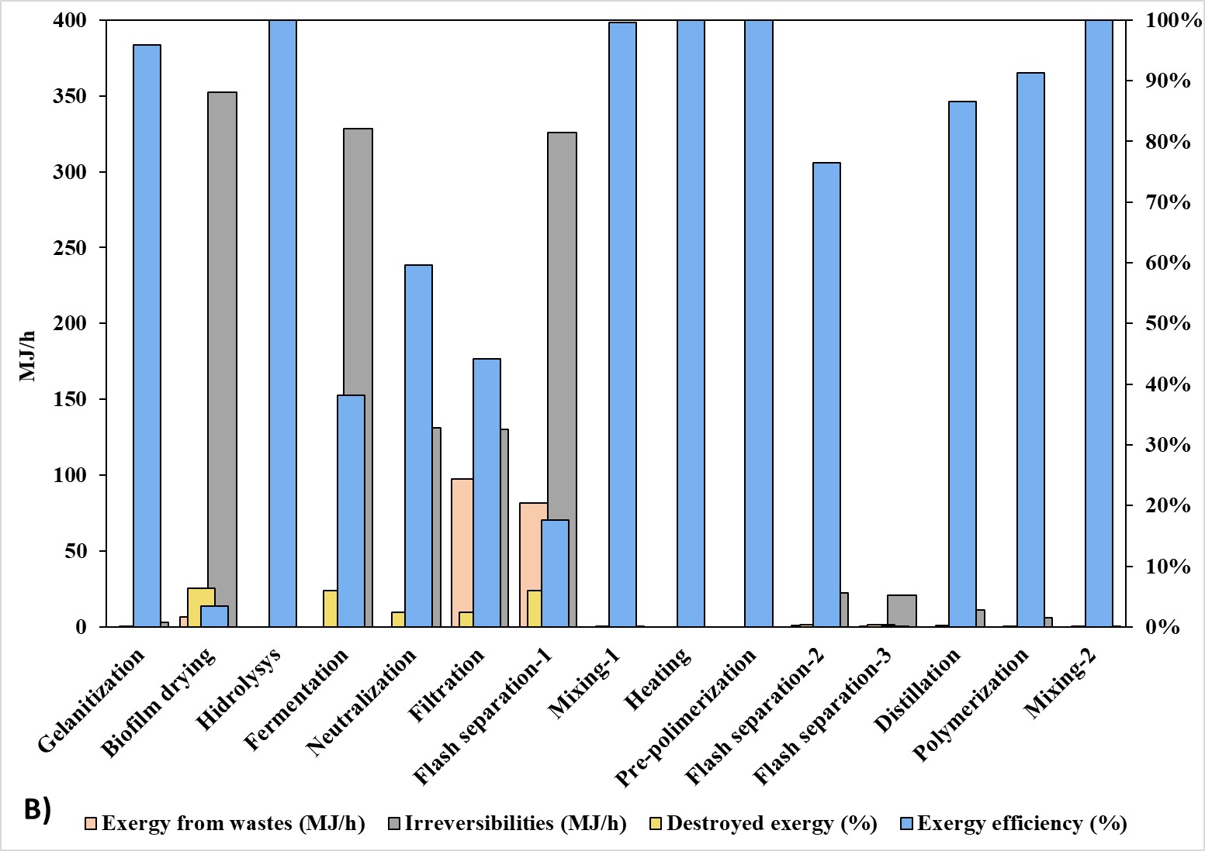
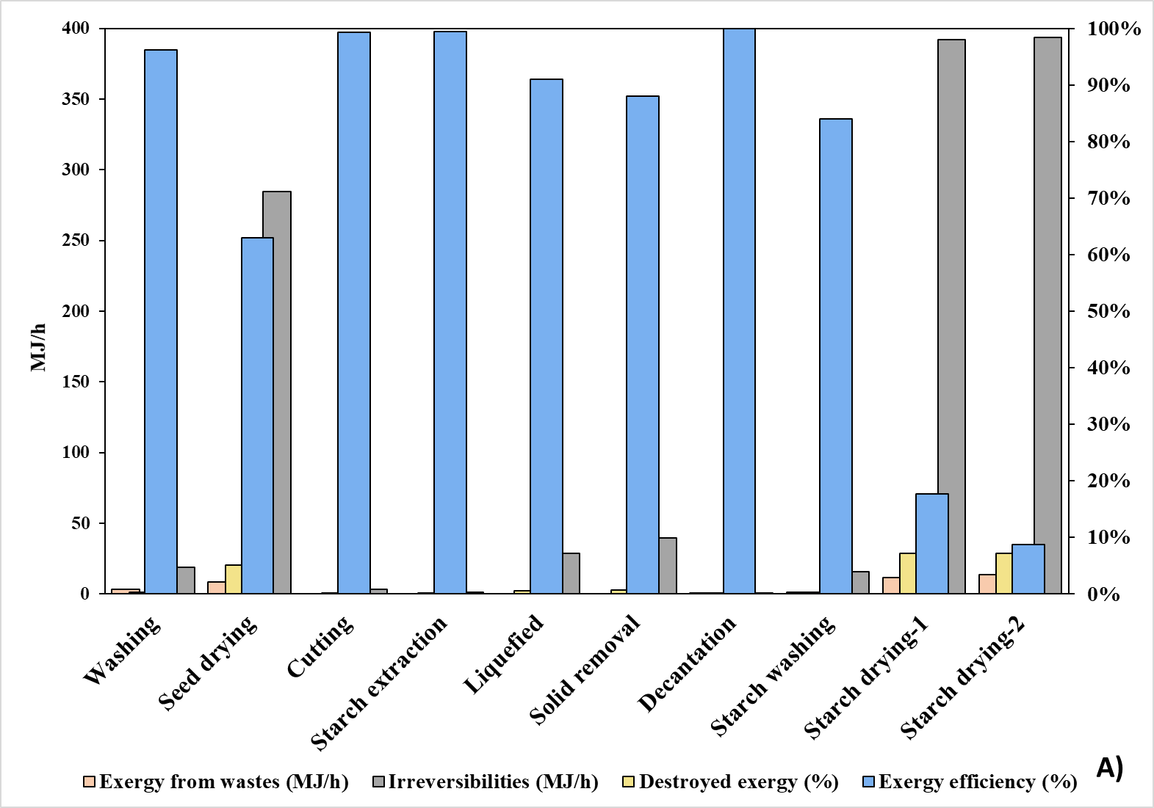
Figure 2: Exergy analysis resultys by stage for A) starch production and B) biofilm production.
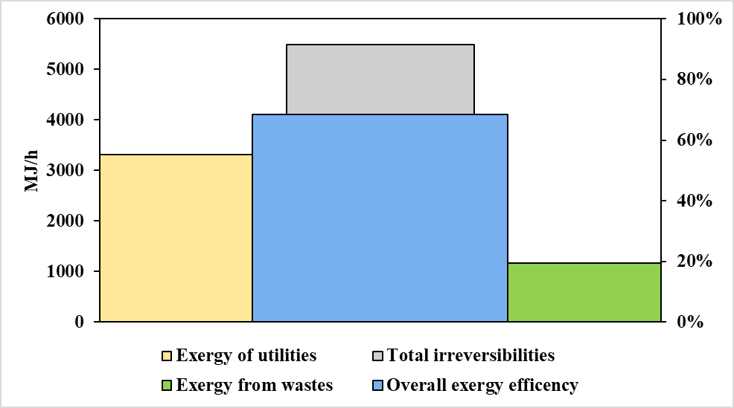
The exergy yield of the starch production process by stage is shown in Figure 2A. The seed and starch drying stages account for the largest exergy loss due to waste streams and irreversibilities. The seed drying stage accounts for 5% of the total exergy destroyed in the system, while each starch drying stage (Starch drying-1 and drying-2) accounts for 7% of the total exergy destruction. This is due to the large amount of exergy required by the equipment, as well as the use of hot air streams that are released into the environment as humid air with temperatures reaching up to 60 °C. Consequently, the stages with the lowest exergy efficiency are seed drying (63%), Starch drying-1 (18%), and Starch drying-2 (9%). Figure 2B, on the other hand, illustrates the yield in biofilm production. It clearly shows how stages such as filtration (97.7 MJ/h) and Flash separation-1 (81.88 MJ/h) exhibit the greatest exergy loss due to waste. This behavior is attributed to the fact that gypsum is obtained as a by-product during the filtration stage, while high-temperature, low-pressure water vapor is released during Flash separation-1. This confirms the untapped potential of these streams in the process. Furthermore, the most significant irreversibilities are observed in biofilm drying, fermentation, and Flash evaporation-1, each representing 6% of the total system exergy destruction. The results suggest a strong dependence on external utilities and operating conditions that limit the effective use of the supplied exergy; likewise, they indicate waste streams that could be utilized or recirculated into the process.
Figure 3: Exergy analysis results for the avocado hard waste biorefinery.
The overall exergy behaviour of the process is depicted in Figure 3. The total process irreversibilities amount to 5453.58 MJ/h and an overall efficiency of 68%, which is considerably higher than reported for Creole-Antillean avocado oil extraction (Herrera et al., 2022), which reported an efficiency of 26.80%. However, these findings still have room for improvement, especially in stages associated with auxiliary utilities that are responsible for the highest irreversibilities across the global process. A large fraction of the exergy losses is mainly related to thermal inefficiencies and the dissipation of heat to the environment. Therefore, the use of energy integration techniques would further improve this efficiency, especially by leveraging heat recovery from hot, humid air streams discharged during the drying stages.
  - Conclusions
Exergy assessment of the avocado hard waste biorefinery was carried out, identifying the process units characterized by high irreversibilities, high utility demands, and inherent exergy losses, highlighting the limitations of the process. By integrating avocado valorization to produce starch and biofilm, the presented topology improves resource utilization and thermodynamic performance. Based on the extracted results, the system achieves an overall exergy efficiency of 68%, showing that the highest irreversibilities are seen at the seed drying and starch drying stages for the starch production process, while the largest irreversibilities for the biofilm production are seen during stages such as biofilm drying, fermentation and Flash separation-1; therefore these stages become the main exergy bottlenecks of the global process, largely driven by the high demand for external utilities. Consequently, the recovery and reuse of thermal energy from hot humid air streams represents a key opportunity to reduce the exergy destruction; in this sense, the implementation of energy integration strategies is proposed to enhance heat recovery within the exchange and reduce overall energy consumption.
Acknowledgments
The authors thank the University of Cartagena, the Colombian National Planning Department, and the Colombian Ministry of Science, Technology, and Innovation (MINCIENCIAS) for the supply of equipment and software necessary to conclude this work via project SIGP 100307, contract 442-2023.
References
Analdex (2024). Annual report of agricultural exports: Hass avocado 2015–2024. National Association of Foreign Trade. Available online at: https://analdex.org (Accessed January 2, 2026).
Aliev, G., Toms, R., Melnikov, P., Gervald, A., Glushchenko, L., Sedush, N., & Chvalun, S. (2024). Synthesis of L-lactide from lactic acid and production of PLA pellets: Full-cycle laboratory-scale technology. Polymers, 16(5), 624. https://doi.org/10.3390/polym16050624
Alviz-Meza A., Valdez-Valdes S.A., Gonzalez-Delgado A.D., 2025, Computer-aided Simulation of a Cascade. Biorefinery: Case Study of the Colombian Amazon’s Hass Avocado Waste, Chemical Engineering Transactions, 117, 67-72, DOI:10.3303/CET25117012
Deng, L., Adams II, T.A., & Gundersen, T. (2024). Exergy Tables: A Comprehensive Set of Exergy Values ​​for Optimizing Energy Efficiency Analysis. 1st ed. New York: McGraw-Hill. Available at: https://www.accessengineeringlibrary.com/content/book/9781264715725
Fontalvo-Morales, A., Rojas-Flores, S., & González-Delgado, Á. D. (2025). Computer-aided exergy analysis of a Creole avocado extractive-based biorefinery and sustainable utilization in Montes de Maria, Colombia. Sustainability, 17(12), 5451. https://doi.org/10.3390/su17125451
García, J. S. A., Hurtado-Salazar, A., & Ceballos-Aguirre, N. (2021). Current overview of Hass avocado in Colombia: Challenges and opportunities. Ciência Rural.
Gungor Celik, A., & Aydemir, U. (2025). Energy, exergy analysis and sustainability assessment of a thermal power plant operating in various environmental conditions using real operational data. Sustainability, 17(4), 1417. https://doi.org/10.3390/su17041417
Herrera, T., Parejo, V., & González-Delgado, A. (2022). Quality of Energy Conservation in an Avocado Oil Extraction Process via Exergy Analysis. Chemical Engineering Transactions, 91, 241–246. https://doi.org/10.3303/CET2291041
Peralta-Ruiz, Y., González-Delgado, A.-D. and Kafarov, V. (2013). Evaluation of alternatives for microalgae oil extraction based on exergy analysis. Applied Energy, 101, pp. 226–236. DOI:10.1016/j.apenergy.2012.06.065
Szargut, J. (2005) Exergy method: technical and ecological applications. WIT Press.
Tai, S., Matsushige, K. and Goda, T. (1986) ‘Chemical exergy of organic matter in wastewater’, International Journal of Environmental Studies, 27(3–4), pp. 301–315. DOI: 10.1080/00207238608710299.
Wan, X., Yang, X., Wen, Q., Gang, J., & Gan, L. (2020). Sustainable development of industry-environmental system based on resilience perspective. International Journal of Environmental Research and Public Health, 17(2), 645. https://doi.org/10.3390/ijerph17020645

