 CHEMICAL ENGINEERING TRANSACTIONS  VOL. xxx, 2026 | A publication of  
The Italian Association
of Chemical Engineering
Online at www.cetjournal.it

Guest Editors: Leonardo Tognotti, Rubens Maciel Filho, Viatcheslav Kafarov
Copyright © 2026, AIDIC Servizi S.r.l.
ISBN 979-12-81206-xx-x; ISSN 2283-9216

Optimization of biomass-to-biofuels supply chains in geographical target areas
Aristide Giuliano^{a,}*, Nicola Pierroª, Maria Letizia Farabella^{b}, Diego Barletta^{b}, Isabella De Bariª
ªENEA, C.R. Trisaia, S.S. 106 Ionica, km 419+500, Rotondella (MT), Italy
^{b}Department of Industrial Engineering, University of Salerno, Fisciano (SA), 84084, Italy
aristide.giuliano@enea.it]
In this study, an integrated Geographic Information System – Mixed Integer Linear Programming framework was developed for the spatial analysis and optimization of biomass-to-biofuels supply chains across four Italian regions, supporting European Renewable Energy Directive III and Italy's National Integrated Energy and Climate Plan targets for advanced biofuels by 2030. High-resolution data from Italian National Agency for New Technologies, Energy and Sustainable Economic Development's Atlante delle Biomasse mapped municipal-level availability of residual feedstocks—pruning residues (Emilia-Romagna), vegetable oils from contaminated soils (Marche), Organic Fraction of Municipal Solid Waste (Campania), and cereal straw (Puglia)—alongside transport networks and conversion sites. A multi-period Mixed Integer Linear Programming model then optimized biorefinery locations, capacities, and logistics to minimize production costs under resource, infrastructure, and scale constraints. Results reveal feedstock-driven topologies: low-density/wet Organic Fraction of Municipal Solid Waste favors distributed networks (7 plants at 80 kt/y in Campania); high-density oils enable single large-scale facilities (92 kt/y fatty acid methyl ester in Marche); concentrated prunings yield two 84 kt/y methanol plants (Emilia-Romagna); northern Puglia straw supports one 400 kt/y ethanol plant. Total output reaches 234 kt/y advanced biofuels from ~20% regional potentials, cutting logistics costs up to 40% of operating costs. The Web Geographic Information System – Mixed Integer Linear Programming approach captures interactions between biomass traits, terrain morphology, and supply-chain design, outperforming prior models through granular multi-feedstock flexibility. It provides actionable decision support for regional biofuel strategies, circular economy deployment, and net-zero infrastructure planning.
  - Introduction
The European Union's energy strategy, as defined by the revised Renewable Energy Directive III (RED III) [] and the Italian National Integrated Energy and Climate Plan (PNIEC) establish highly ambitious targets for renewable energy penetration by 2030 to fulfill the EU’s commitment to becoming the first continent with net-zero emissions by 2050. Among the most challenging objectives are those in the transport sector, where according to RED III, at EU scale, Member States are required to choose either a binding share of at least 29% renewables in final energy consumption for transport or a binding reduction of greenhouse gas intensity in transport by 14.5% by 2030. Specifically, the plan foresees achieving a 34.2% share of energy from renewable sources in final consumption in transport by 2030, with a contribution of 11.6% from advanced biofuels and renewable fuels of non-biological origin (RFNBOs) to gross final consumption. By 2030, liquid biofuels are expected to represent approximately 64% of renewable energy in the transport sector. This emphasizes the importance of the availability of sustainable biomass suitable for energy use in order to achieve the set targets. Within this framework, many innovative biorefinery process approaches are being developed, particularly for the production of sustainable triglyceride sources (Caporusso et al., 2022). For several years, Italian National Agency for New Technologies, Energy and Sustainable Economic Development (ENEA) has been developing national estimates, with provincial-level detail, on the potential availability of sustainable residual biomass that can be used for energy purposes at the national scale (Pierro et al., 2021). According to the most recent data available from the ENEA Web Geographic Information System (GIS) portal Atlante delle Biomasse, nearly 20 million tonnes of biomass (dry matter) are potentially available in Italy. Due to the spatial dispersion of the biomass on the territory, the development of a mathematical model is required to optimize the logistical aspects of supply chains within biorefinery networks (Jegede et al., 2025). In fact, the design and the optimization of biorefinery processes involve the choice of the optimal size of the plants, accounting for the supply chain of feedstock and products. In particular, the transportation costs and the topology of the territory must be carefully considered (Giuliano et al., 2024). One of the most suitable optimization approaches is a multiperiod Mixed-Integer Linear Programming (MILP) (Giuliano et al., 2014), which integrates decision-making across multiple temporal and spatial scales, enabling the identification of the optimal network design, facility locations and logistics management decisions. Galanopoulos et al. (2018) developed a biomass supply chain model for the region of Lower Saxony and Bremen, in Germany, in order to valorize the wheat straw produced to obtain levulinic acid, which is the main product, and bioethanol, considered ad a byproduct. The mathematical model obtained was Non-Linear Programming, which became a Mixed-Integer Linear Programming using the λ-formulation as piecewise linearization method; the objective of the mathematical model was to maximize the annual profit. Čuček et al. (2014) developed a MILP model taking account of different types of biomass and considering first, second and third generation biofuels, in order to maximize the economic profit. Kostin et al., (2018) formulated a MILP model for the maximization of the Net Present Value (NPV) in order to optimize the supply chain of the bioethanol in Brazil, taking into account seven different production technology, two different storage facilities, three types of transportation modes and seven exportation options. However, the scientific literature has not yet succeeded in examining biorefinery supply chains based on actual bioresource availability and rigorous modeling approaches, in terms of feedstock conversion yields and costs, to identify optimal plant locations and scales. The purpose of this work is precisely to make available an application of a methodology that integrates real or potential data on the availability of bioresources with supply chain models, in order to identify the optimal location and scale of biorefineries. Specifically, four Italian regions (Emilia Romagna, Marche, Campania, and Puglia) were analyzed with biomass availability at the municipal level and four types of biorefinery processes (methanol synthesis, transesterification, anaerobic digestion and alcoholic fermentation).
  - Methodology
The methodology applied in this study is depicted like this, in a first phase, Italian regions with a significant presence of the bioresources were identified. The related biowaste streams were quantified and georeferenced at the municipal scale. Subsequently, the conversion technologies were assessed considering both their technical performance and their capital and operating costs. Target products were then defined, and the corresponding process yields were incorporated. Finally, the algorithm carried out an initial optimization of the supply chain network for a territory divided into municipalities, using data obtained from the national “Atlante delle Biomasse” database (Pierro et al., 2021).
    - GIS-Based Forecasting of Regional Biomass Supply for Biorefineries
The selection of case studies was performed using a multi-criteria approach, considering not only the highest absolute values in the dataset but also indicators reflecting the structural relevance and spatial distribution of each biomass or waste stream. In particular, the analysis considered territorial density (t/km²), per-capita availability (t/ab), and average quantity per municipality (t/municipality), which together provide an indication of resource concentration, logistical feasibility, and potential supply chain organization. In addition, the selection aimed to ensure a geographically balanced and analytically comparable set of cases, avoiding the concentration of all analyses within the same macro-regional context. Within this framework, Puglia was selected for straw residues due to its high overall availability and particularly large mass per municipality (3966 t/municipality), which indicates strong aggregation potential and favorable conditions for the development of a structured biomass supply chain. Campania was chosen for Organic Fraction of Municipal Solid Waste (OFMSW) because it presents the highest territorial density among the regions analyzed (64.10 t/km²), making it a particularly relevant context for assessing collection logistics and treatment infrastructure in high-intensity organic waste systems. Emilia-Romagna was selected for pruning residues not because it represents the maximum value in the dataset, but because it combines substantial resource availability (214,694 t) with well-established agricultural and organizational conditions, making it a representative and potentially replicable context for biomass valorization pathways. Similarly, the Marche region was selected for oil from contaminated land as an intermediate yet significant case (4.95 t/km²), contributing to the inclusion of a central Italian territorial context and supporting the development of a balanced and diversified set of case studies. The methodology developed and applied in this study enabled the assessment of the potential availability of different biomass streams across Italian regions.
Table 1: Biomass availability (*potentials in contaminated soils) in the analyzed target regions
Heading1 | Emilia Romagna  (prunings) | Marche  (vegetable oil*) | Campania  (OFMSW) | Puglia  (straw)
Total availability (kt_{DRY}/y) | 168 | 93 | 133 | 411
Humidity considered (%_{wet}) | 35-40% | 0% | 22% | 15-20%

Data on the production of the organic fraction of municipal solid waste (OFMSW) were obtained from the Italian Institute for Environmental Protection and Research (ISPRA), the national public authority responsible for monitoring and reporting waste generation. The potential oil production from energy crops cultivated on contaminated land was estimated using georeferenced data on heavy metal concentrations in European soils provided by the European Soil Data Centre (ESDAC). Using GIS tools, the dataset was filtered for the regions of interest and limited to agricultural land through the Corine Land Cover (CLC) map. Legal threshold values for heavy metal concentrations were applied to identify contaminated soils. Brassica carinata was then considered a potential energy crop. Assuming a seed yield of 2.96–3.55 t/ha and an oil content of 35–50%, the potential oil production for the Marche region was estimated. Finally, provincial biomass quantities were spatially disaggregated to the municipal level using land-use data from the 7th ISTAT Agricultural Census, allocating biomass proportionally to crop areas while preserving provincial totals (Table 1).
    - Biomass-to-Biorefinery supply chain modelling
The residual biomass is assumed to be transported from its municipality of origin to a biorefinery, where it is converted into target products: biomethanol, fatty acid methyl ester (FAME), biomethane and bioethanol. The problem is formulated as follows: given a one-year time horizon divided into 12 months, the available waste quantities and their locations each month, the types of bioproducts, and the distances between all possible location pairs are known. Each municipality is constrained to host at most one biorefinery. The biorefinery locations and processing capacities, storage capacities, and monthly biomass flows from collection sites to biorefineries are determined in such a way as to maximize the total annual profit. The mathematical model is formulated as a Mixed Integer Linear Programming (MILP) problem, following the approach of (Galanopoulos et al., 2018).
    - Biorefinery process performances
The biorefinery processes considered are listed in Table 2, which shows that the fermentable feedstock (OFMSW) was assumed to be converted into biomethane through anaerobic digestion and biogas upgrading processes (Caposciutti et al., 2020). Moreover, starting from pruning residues, a syngas with an H₂/CO/CO₂ composition of 1/1/1 can be obtained via gasification (Lombardelli et al., 2024), which is then directed to methanol synthesis. Methanol was considered as a reactant in the transesterification reactor of vegetable oil for the production of FAME (Fiore et al., 2022). Straw, on the other hand, can be valorized through the second-generation sugar platform (i.e., steam explosion pretreatment, enzymatic hydrolysis, and alcoholic fermentation) to produce ethanol (Giuliano et al., 2025).
  - Results
    - Bioresource availability
Figure 1's municipal georeferencing from ENEA's Atlante delle Biomasse and ISPRA datasets exposes profound spatial disparities that dictate biorefinery siting in the four case studies. In Emilia-Romagna (panel a), pruning residues exhibit bimodal clustering primarily in Ravenna, Reggio Emilia, and Bologna provinces, driven by intensive fruit arboriculture and urban green maintenance, with many municipalities contributing negligibly due to sectoral specialization over blanket rural productivity.
Table 2: Main parameters and key information on biorefinery processes
Biofuel | Raw material | Main Processes | Biofuel yield (t/t_{F,DRY}) | Baseline size (kt_{F,DRY}/y)
MeOH | Pruning | Gasification + Purification & Conditioning + Synthesis | 20% | 100
FAME | Vegetable Oil | Transesterification | 96% | 600
Methane | OFMSW | Anaerobic Digestion + CO₂ removal | 5% | 40
EtOH | Straw | Pretreatment + Hydrolysis + Fermentation | 20% | 250

Marche (panel b) presents Brassica carinata oil potentials confined to Macerata's contaminated or marginal soils, strategically avoiding prime cropland and exemplifying land-use complementarity in circular systems. Campania's OFMSW (panel c) surges in Naples and Salerno's urban agglomerates, where demographic density correlates directly with organic waste volumes, contrasting sharply with hinterland sparsity. Puglia's straw (panel d) consolidates in Foggia's cereal heartland, diminishing seaward amid urbanization, reflective of rainfed arable dominance. These anisotropies territorial density, per-capita yields, municipal aggregates prefigure MILP solutions, where Table 2's process envelopes collide with logistics realities. Table 3 crystallizes MILP outputs: average capacities, plant counts, and biofuel yields benchmarked against Table 2 baselines. Methanol from Emilia-Romagna prunings averages 84 kt/y across two facilities (37 kt/y total MeOH); FAME from Marche oils hits 92 kt/y in one plant (88 kt/y FAME); methane from Campania OFMSW averages 80 kt/y over seven sites (28 kt/y CH4); ethanol from Puglia straw reaches 400 kt/y in solitary mode (81 kt/y EtOH). These diverge strategically from baselines gasification's 100 kt/y, transesterification's 600 kt/y, digestion's 40 kt/y, ethanol's 250 kt/y revealing constraint navigation artistry. Emilia-Romagna's dual 84 kt/y methanol plants epitomize nuanced optimization artistry. Correggio anchors Ravenna-Reggio's pruning epicenter (Figure 1a), minimizing haulage from high-density orchards via Euclidean-optimal radii. Alto Reno Terme, offset southward by 50-70 km, aggregates Bologna's secondary cluster plus southern fringes, achieving scale synergies without municipal overreach. At 84 kt/y 16% below 100 kt/y baseline each exploits 20% gasification yield (syngas H2/CO/CO2 = 1/1/1), their separation optimizing procurement against one-plant-per-municipality caps while yielding 37 kt/y MeOH primed for downstream FAME via inter-regional methanol piping or trucking. Figure 2a's transverse placement captures pruning bimodality perfectly, balancing capital cost (CAPEX) amortization with transport operating cost (OPEX)CAPEX in a manner unmatched by provincial aggregates.

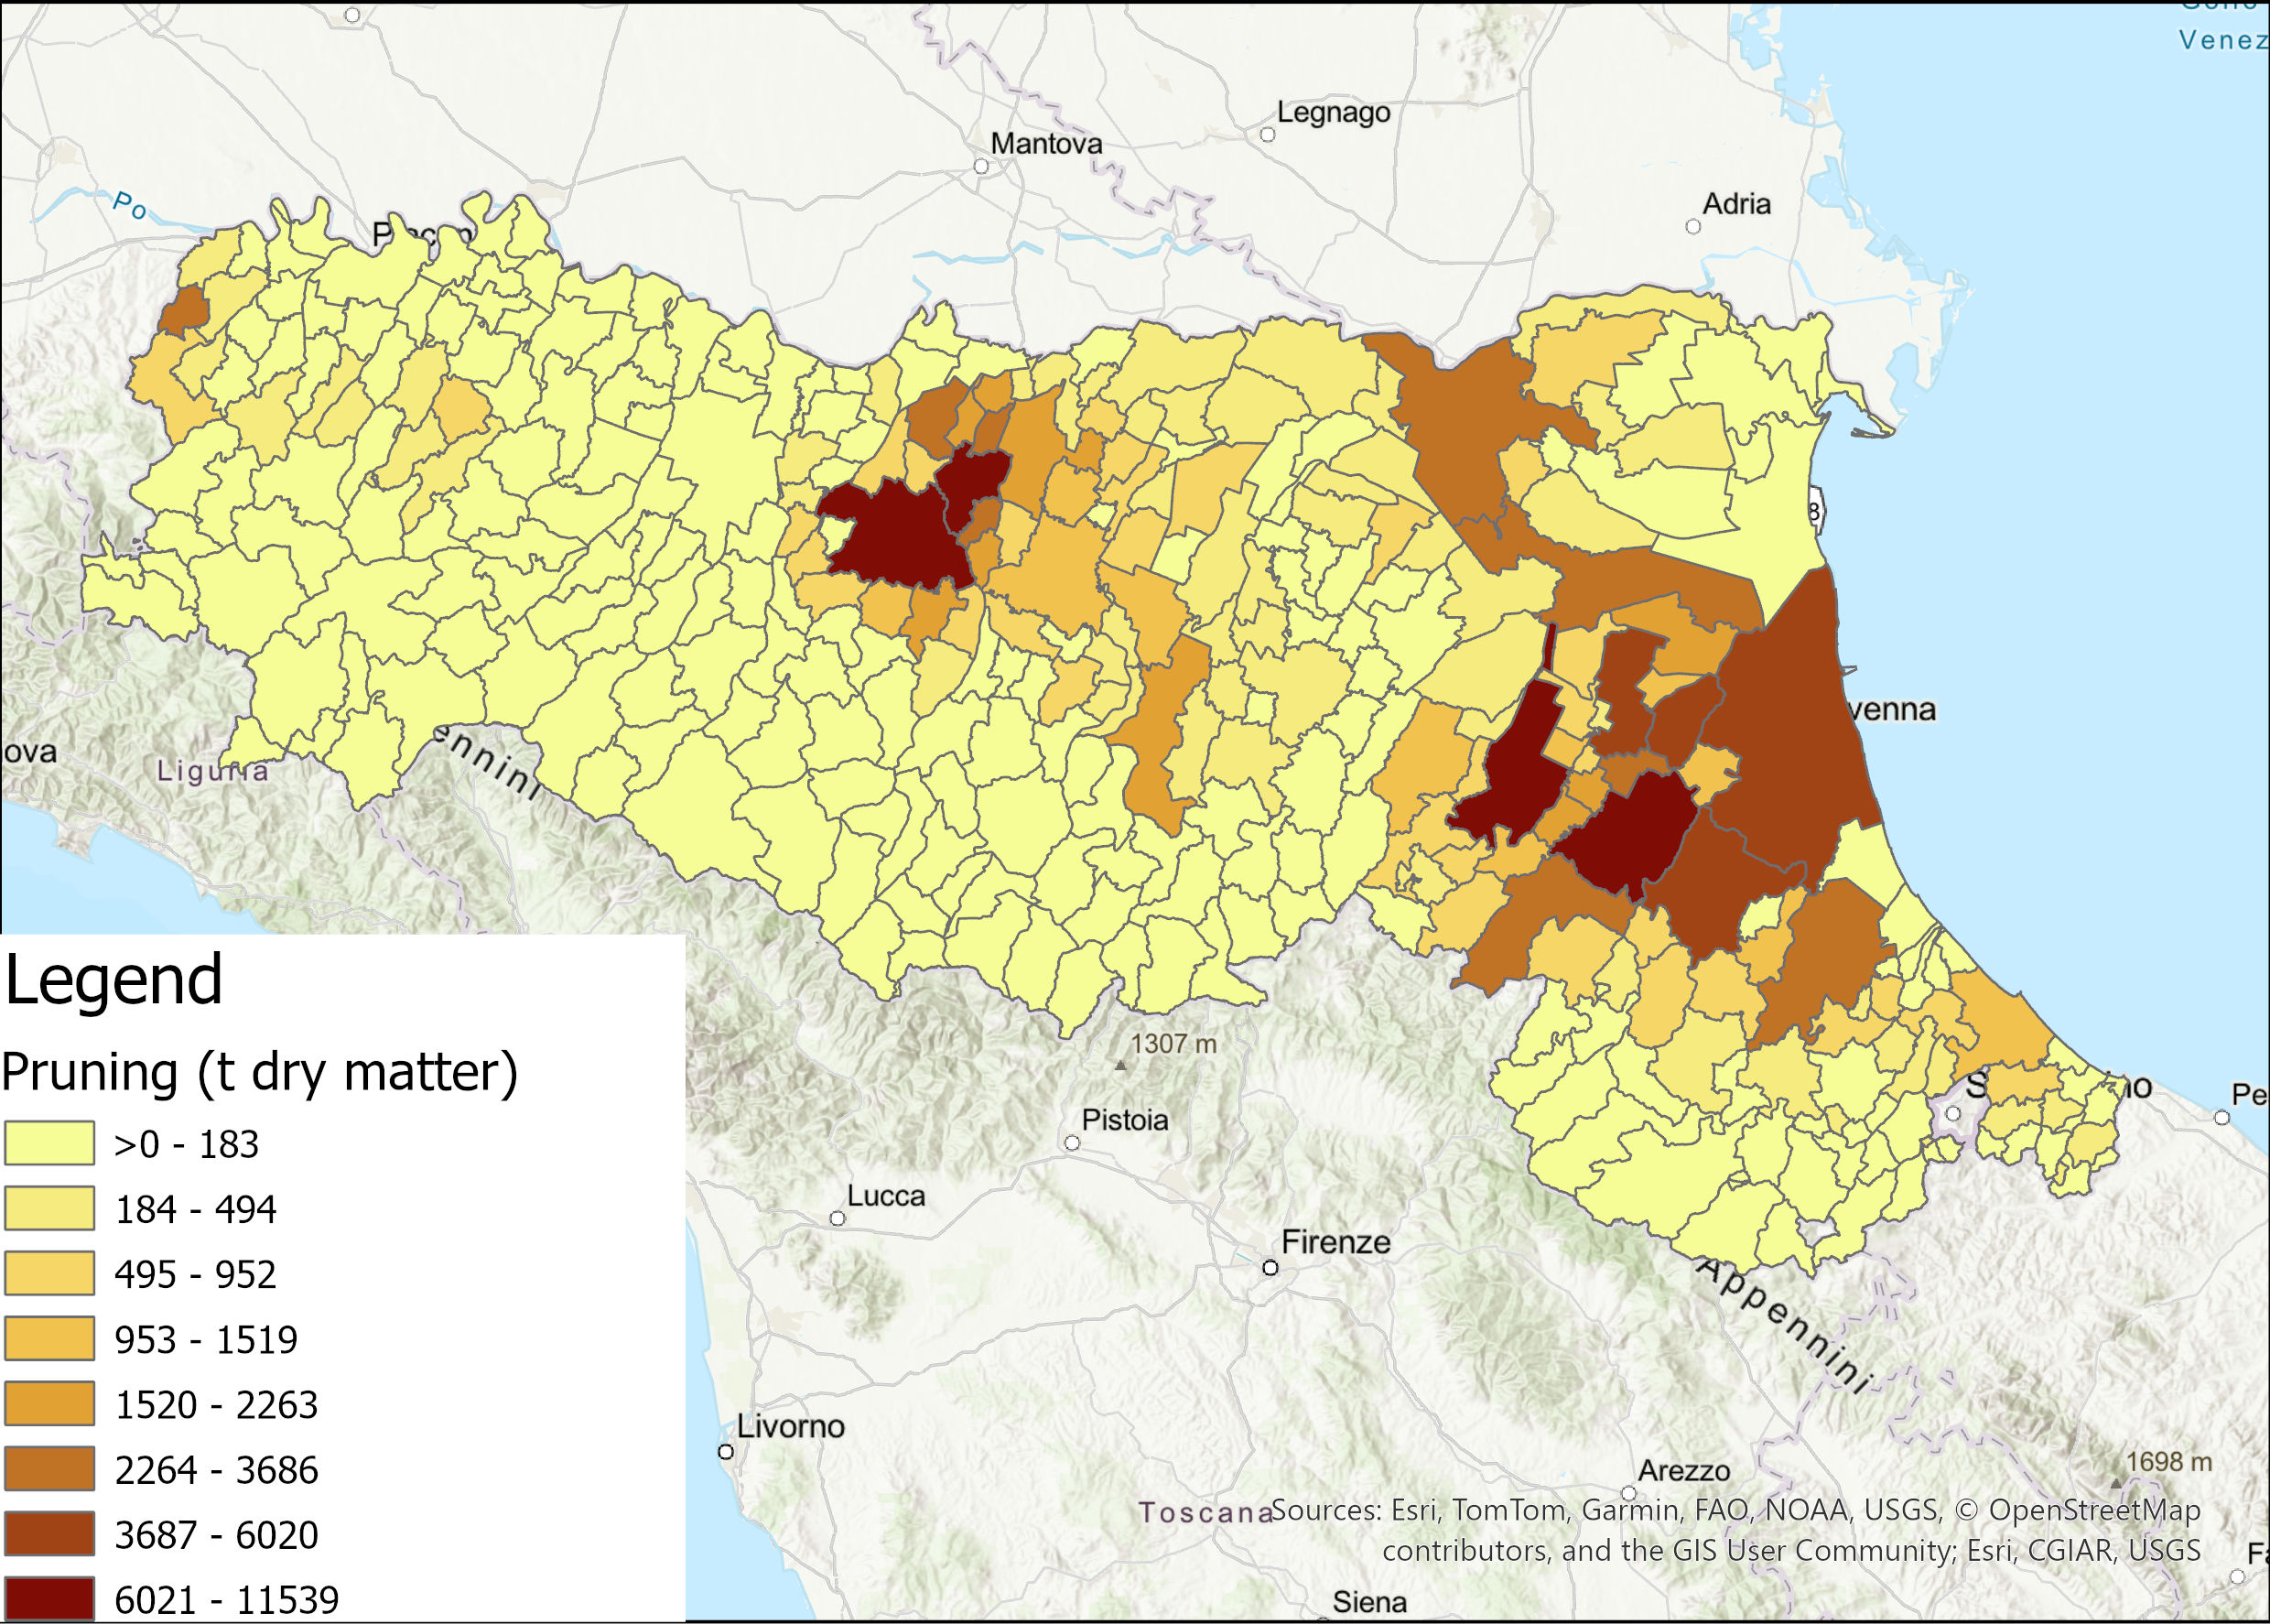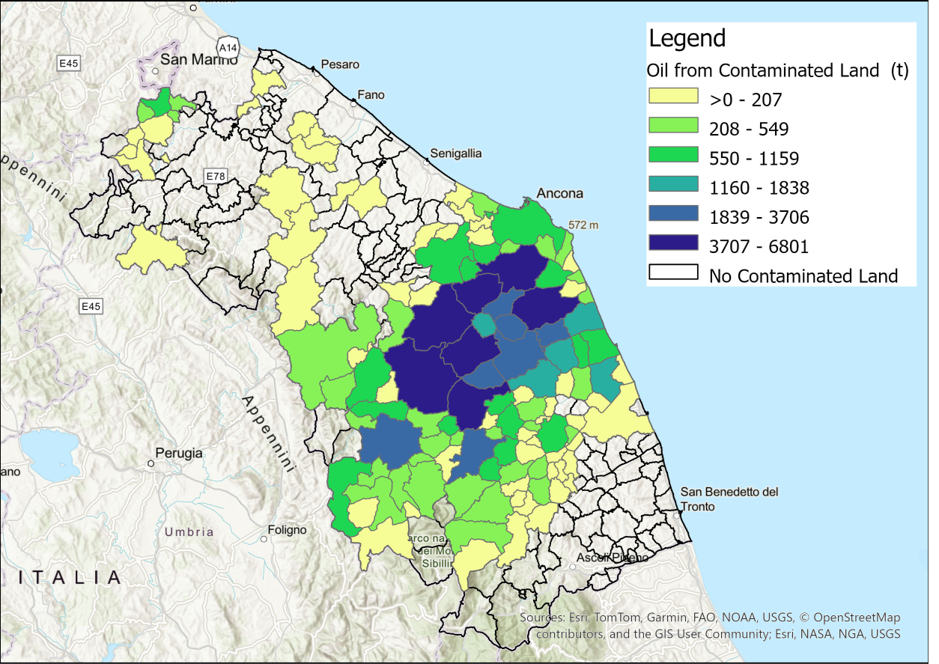
(b)
(a)
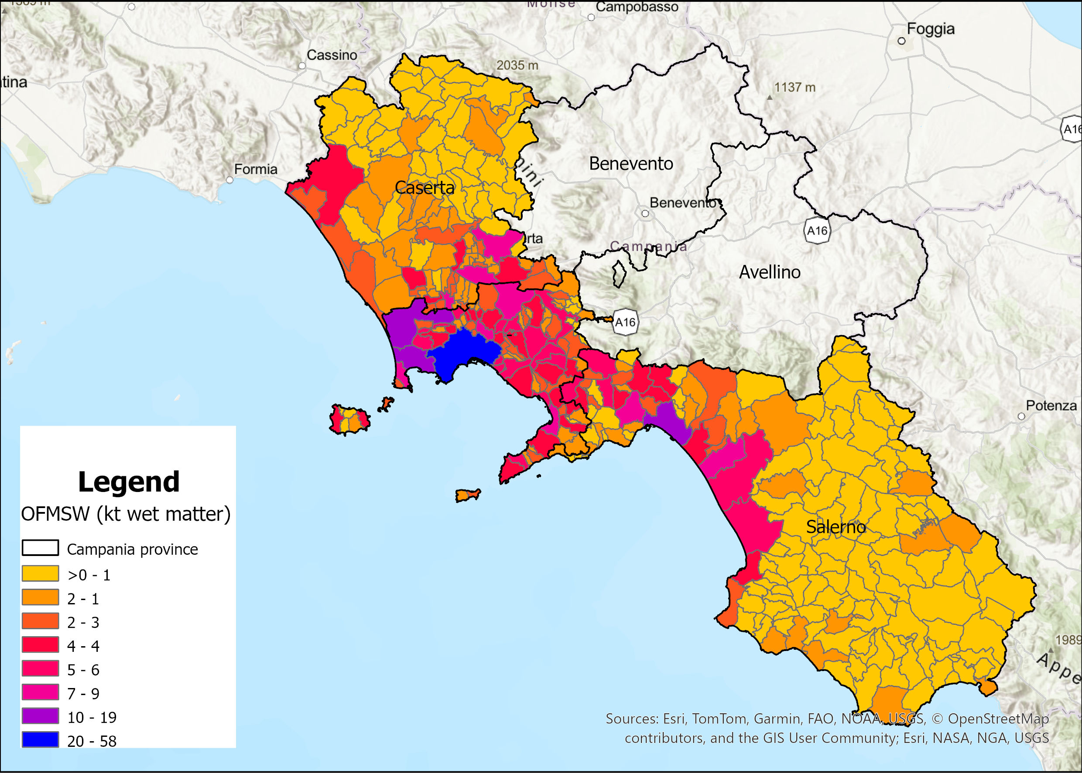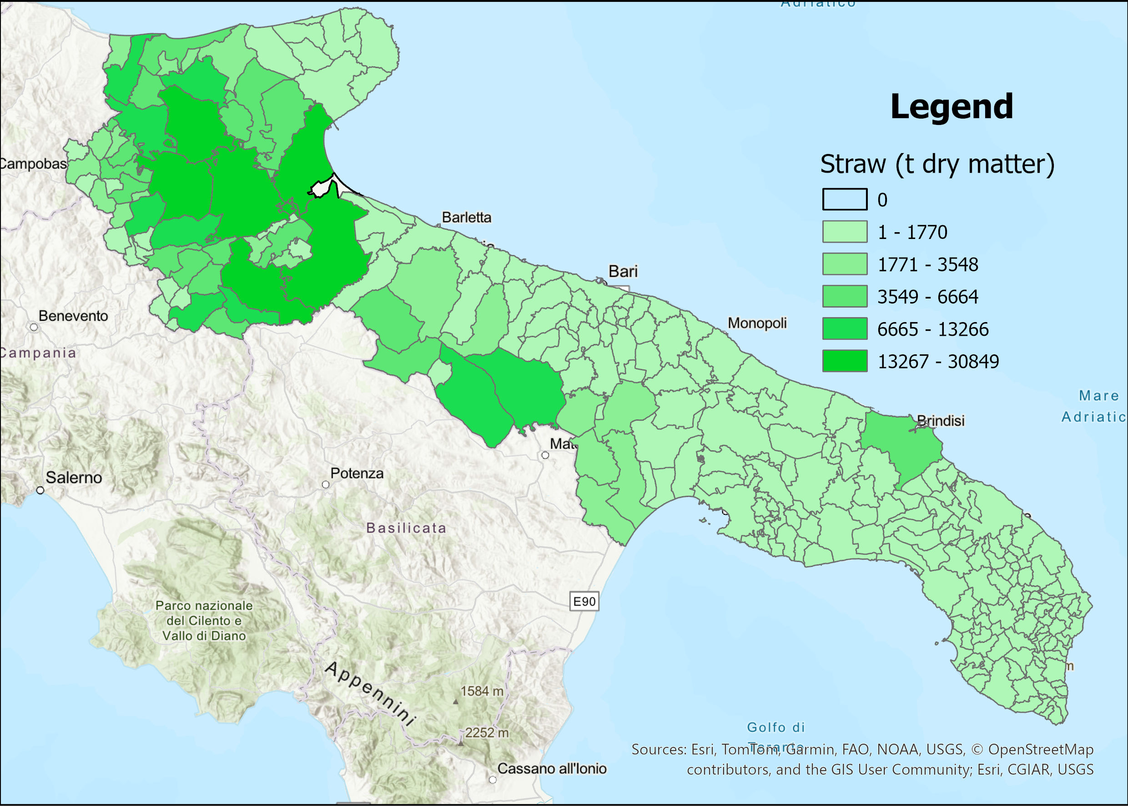
(d)
(c)
Figure 1: Case studies indicating the type and municipal quantities of biomass for (a) Emilia Romagna, (b) Marche, (c) Campania and (d) Puglia
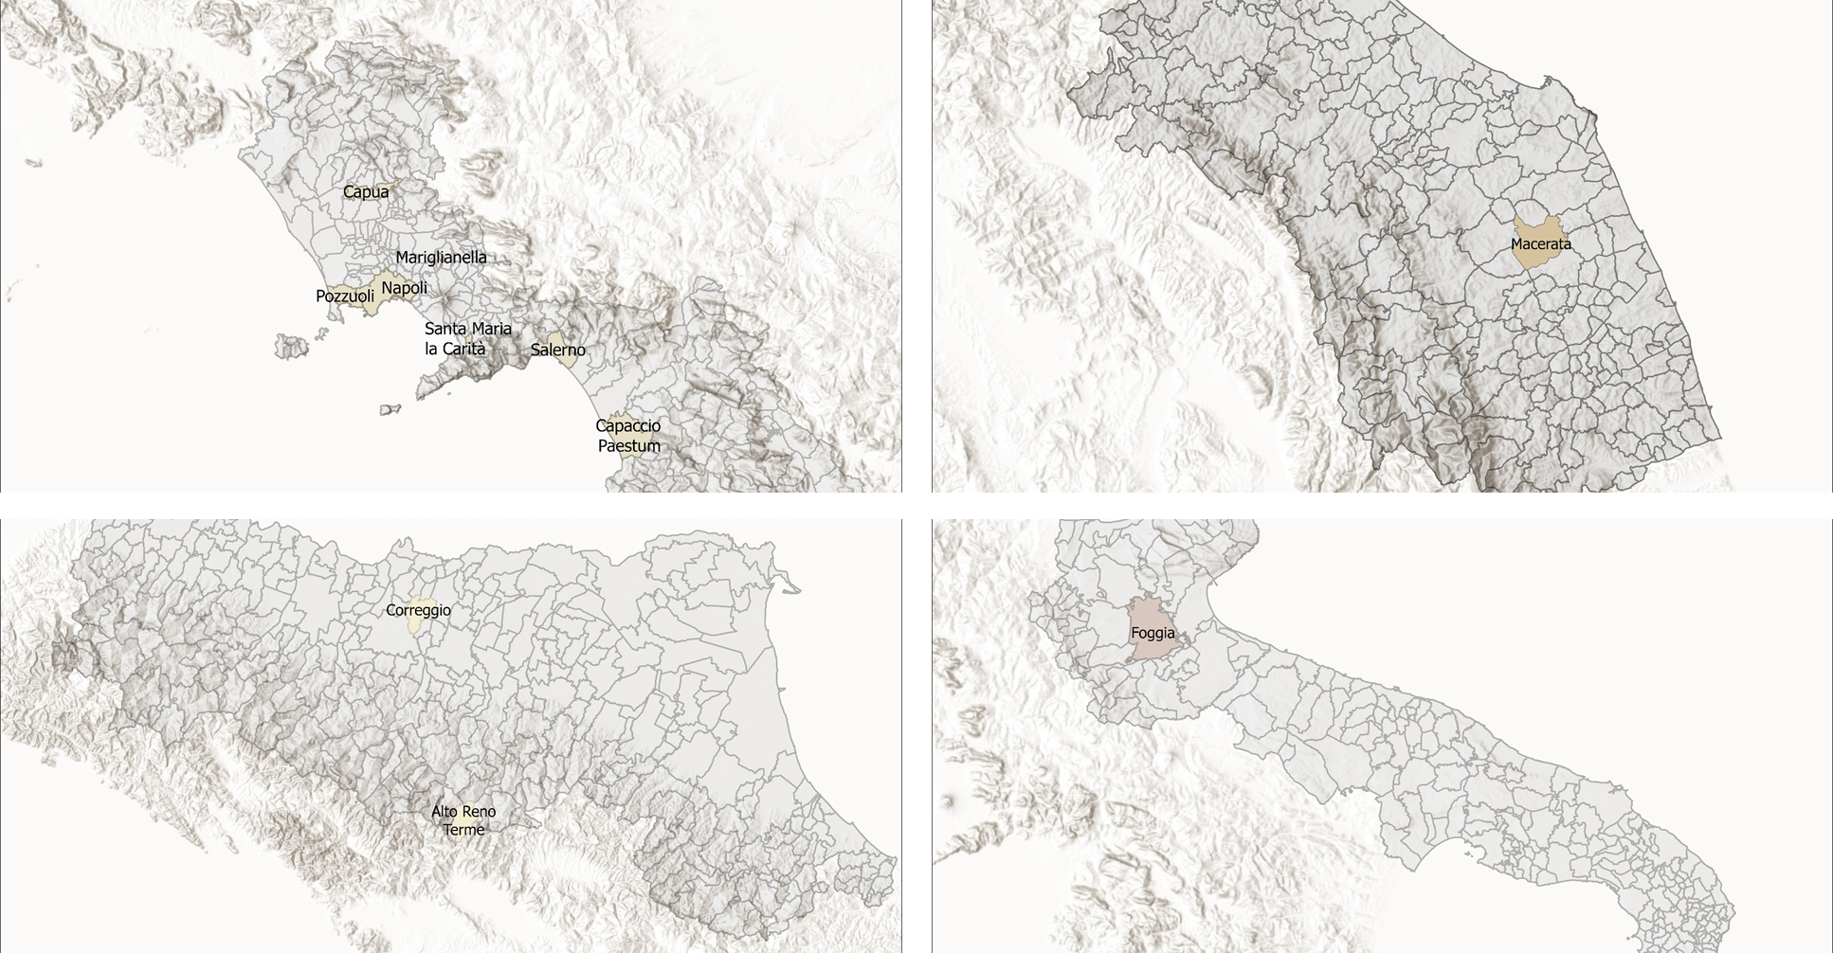
(c)
(d)
(b)
(a)
Figure 2: Optimal Biorefinery localization in (a) Emilia Romagna, (b) Marche, (c) Campania and (d) Puglia
Marche's lone 92 kt/y transesterification plant, despite 600 kt/y baseline, maximizes regional oil potentials from contaminated lands (Figure 1b, 93 kt/y total). Sited amid Macerata's high-yield pockets, it leverages 96% yields, zero-humidity logistics (Table 1), and minimal methanol reagent needs, undercutting scale via finite feedstock yet delivering 88 kt/y FAME nearly matching input mass. Figure 2b's central-adjacent locus affirms high-density centralization canon transport OPEX 5-10% of total vs. 40% elsewhere with regional constraints dominating CAPEX leverage. This undersizing 85% below reference reflects supply-limited reality, positioning Marche as FAME hub consuming Emilia-Romagna MeOH. Campania's seven 80 kt/y digesters double Table 2's 40 kt/y norm, clustering near Naples-Salerno OFMSW peaks (Figure 1c-d). Each doubles baseline to counter 5% methane yields and 22% moisture Table 1, but proliferation slashes wet-haul costs (1.22 t/m3 bulk, 40-50% OPEX). Positioned in high-waste municipalities or adjacencies, they mirror demographic gradients Figure 2c's dispersion vs. hypothetical singular 560 kt/y prioritizes proximity, where bulk penalizes distance exponentially (cost/km 3-5x oils). Yielding 28 kt/y biomethane, this grid embodies wet-feed imperatives, co-locating conversion with generation to abate landfill emissions under RED III waste hierarchy. Puglia's 400 kt/y ethanol behemoth, 60% above 250 kt/y baseline, crowns Foggia's straw nucleus (Figure 1d). Despite 15-20% wet and low density (0.25 GJ/ton vs. oils' 37 GJ/ton), northern concentration Foggia-Bari-Barlett enables oversizing, amortizing steam-explosion pretreatment energetics via 20% yields for 81 kt/y EtOH. Figure 2d's northern locus exploits regional elongation, trading peripheral dilution Bari-Andria-Trani for CAPEX leverage (unit cost 20-30% below decentralized). This outlier singular despite sprawl validates aggregation where spatial autocorrelation trumps physics, with 411 kt/y straw sustaining full utilization.
Table 3: Optimal average size of the biorefineries
Biofuel | Region | Main Processes | Average Size (kt_{F,DRY}/y) | Regional Biofuel production (kt_{Biofuel}/y)
MeOH | Pruning | Gasification + Purification & Conditioning + Synthesis | 84 (on 2 plants) | 37
FAME | Vegetable Oil | Transesterification | 92 | 88
Methane | OFMSW | Anaerobic Digestion + CO₂ removal | 80 (on 7 plants) | 28
EtOH | Straw | Pretreatment + Hydrolysis + Fermentation | 400 | 81

  - Conclusions
This study integrates ENEA's Atlante delle Biomasse GIS data with multi-period MILP optimization to design optimal biorefinery networks in four Italian regions. Results show feedstock-driven topologies: centralized 92 kt/y FAME plant (Marche); seven 80 kt/y digesters (Campania); two 84 kt/y methanol plants (Emilia-Romagna); single 400 kt/y ethanol facility (Puglia). Total output: 234 kt/y advanced biofuels from ~20% regional potentials. These support Italy's PNIEC (34.2% transport renewables; 11.6% advanced fuels) and RED III targets (≥5.5% advanced biofuels), advancing circular bioeconomy and net-zero goals. The granular, flexible approach aids policy and investment; future extensions may include dynamic pricing or carbon costs.
Acknowledgments
The present work was funded by the Italian Ministry of Environment and Energy Security through the “National Electric System Research” Program–Project 1.10 “Bioenergie” 2025–2027 implementation plan and is part of the PNRR project Network 4 Energy Sustainable Transition (NEST) – Spoke 3.
References
Caporusso A., Giuliano A., Liuzzi F., De Bari I., 2022, Techno-economic Analysis of a Lignocellulosic Biorefinery Producing Microbial Oils by Oleaginous Yeasts, Chemical Engineering Transactions, 92, 637–642.
Caposciutti G., Baccioli A., Ferrari L., Desideri U., 2020, Biogas from Anaerobic Digestion: Power Generation or Biomethane Production?, Energies, 13, 743.
Čuček L., Martín M., Grossmann I.E., Kravanja Z., 2014, Multi-period synthesis of optimally integrated biomass and bioenergy supply network, Computers & Chemical Engineering, Selected papers from ESCAPE-23 (European Symposium on Computer Aided Process Engineering - 23), 9-12 June 2013, Lappeenranta, Finland 66, 57–70.
Fiore A.M., Romanazzi G., Leonelli C., Mastrorilli P., Dell’Anna M.M., 2022, Partial Hydrogenation of Soybean and Waste Cooking Oil Biodiesel over Recyclable-Polymer-Supported Pd and Ni Nanoparticles, Catalysts, 12, 506.
Galanopoulos C., Barletta D., Zondervan E., 2018, A decision support platform for a bio-based supply chain: Application to the region of Lower Saxony and Bremen (Germany), Computers and Chemical Engineering, 115, 233–242.
Giuliano A., Cerulli R., Poletto M., Raiconi G., Barletta D., 2014, Optimization of a Multiproduct Lignocellulosic Biorefinery using a MILP Approximation, Computer Aided Chemical Engineering, 1423–1428.
Giuliano A., Robinson Medici A., Barletta D., 2025, Integrating Techno-Economic and Environmental Criteria in the Design and Optimization of a Full Utilization Multiproduct Lignocellulosic Biorefinery, ACS Sustainable Chem. Eng.,13, 1961–1973.
Giuliano A., Stichnothe H., Pierro N., De Bari I., 2024, Techno-Economic Analysis of Territorial Case Studies for the Integration of Biorefineries and Green Hydrogen, Energies, 17, 5966.
Jegede K., Isafiade A.J., Short M., 2025, Integrated Off-Grid Resource Sharing and Energy Network Optimisation for Several Co-Located Rural Communities in Namibia, Chem. Eng. Trans., 120, 25–30.
Kostin A., Macowski D.H., Pietrobelli J.M.T.A., Guillén-Gosálbez G., Jiménez L., Ravagnani M.A.S.S., 2018, Optimization-based approach for maximizing profitability of bioethanol supply chain in Brazil, Computers & Chemical Engineering, 115, 121–132.
Lombardelli G., Scaccabarozzi R., Conversano A., Gatti M., 2024, Bio-methanol with negative CO2 emissions from residual forestry biomass gasification: Modelling and techno-economic assessment of different process configurations, Biomass and Bioenergy, 188, 107315.
Pierro N., Giocoli A., Motola V., Dipinto S., 2021, Valutazione disponibilità biomasse agro-industriali a livello nazionale e loro pubblicazione sul portale Webgis atlante delle biomasse [WWW Document]. URL https://iris.enea.it/handle/20.500.12079/56881 (accessed 10.17.23).

