 CHEMICAL ENGINEERING TRANSACTIONS  VOL. xxx, 2026 | A publication of  
 | The Italian Association of Chemical Engineering Online at www.cetjournal.it
Guest Editors: Leonardo Tognotti, Rubens Maciel Filho, Viatcheslav Kafarov Copyright © 2026, AIDIC Servizi S.r.l.
ISBN 979-12-81206-xx-x; ISSN 2283-9216

Design of an Artificial Intelligence Agent for Inherent Safety Assessment: Analysis of the Effectiveness and Cost- Efficiency of Large Language Models for Avocado Biorefineries
Anibal Alviz-Meza* and Ángel Darío González-Delgado
Chemical Engineering Department, Nanomaterials and Computer-Aided Process Engineering Research Group (NIPAC),
Universidad de Cartagena, Cartagena 130014, Bolívar, Colombia aalvizm1@unicartagena.edu.co

Valuing agroindustrial residues within the biorefinery framework promotes the bioeconomy by offering alternatives to traditional processes. Conducting early risk assessments is crucial for guiding decisions and identifying safe production methods, covering biomass handling, solvent transfer, reactive and separation processes, and operational conditions. Challenges include limited data and the manual effort to compute safety indices. This paper introduces an AI agent for autonomous estimation of the Inherent Safety Index from simulated data from two avocado biorefineries. It compares ChatGPT-based language models —Economy (GPT-4.1 mini), Balanced (GPT-5.1), and Advanced (o4-mini-deep-research)— against expert calculations. The advanced model achieved 92.9% accuracy in a simple biorefinery, though with higher costs. The balanced model reached 98.7% accuracy in a complex biorefinery, reducing latency and costs. These findings highlight the trade-offs among cost, accuracy, and speed, showing that auditable AI can enhance safety screening and support expert judgment.

Introduction
The valorization of agro-industrial waste through biorefineries has emerged as a promising option for the circular bioeconomy, enabling the conversion of heterogeneous biomass into diverse bioproducts and energy carriers (Tesfaye et al., 2018). However, the technological complexity and the variety of substances and processes involved often generate risks; therefore, incorporating safety into waste avocado valorization processes from the initial design stage is essential to prevent environmental and economic impacts from being exacerbated by increased operational vulnerability (Aguilar-Vasquez et al., 2025). In such biorefineries, safety/risk includes the storage and handling of biomass, the transfer and use of flammable or corrosive solvents and reagents, unwanted chemical interactions between process substances, hazardous inventory within and outside the battery boundaries, and harsh operating conditions in the process units, such as high temperatures, pressures, and equipment-related hazards (Herrera-Rodríguez & González- Delgado, 2025).
Inherent safety is often addressed early on using index-based methods that combine multiple risk factors into scores to rank process routes and guide design. However, these methods are data-intensive, requiring physicochemical, toxicological, operational, and equipment data, often scattered across databases and the literature, creating bottlenecks (Heikkilä, 1999). In other words, evidence remains relatively scarce compared to the universe of possible routes, and opportunities persist to standardize and accelerate the extraction and validation of safety data. Artificial intelligence (AI) and Large Language Models (LLMs) have emerged as disruptive tools in chemical engineering for literature synthesis and property prediction (Yang et al., 2025). Recent research includes conceptual design approaches using safety indices, simulation-integrated tools, and automated methodologies for process evaluation (Pelucchi et al., 2025). However, the literature also highlights remaining gaps in standardization, data management, interoperability, and phase-specific guidance, especially for digitally integrated and autonomous safety assessment environments (Ab Rahim et al., 2024). Therefore, this work addresses a research gap—not by proposing another safety index, but by developing an AI-driven agentic workflow that enhances traceability, scalability, and operational integration of inherent safety assessment during early process design. This study examines avocado-waste biorefineries using Aspen Plus V12.0 and simulates data. The agent combines chemical reasoning with automated extraction of safety data. It also compares different ChatGPT-based architectures in terms of accuracy in chemical reasoning, consistency in safety calculations, and resource usage to identify the best setup for safe design processes.

Materials and methods
This section presents a brief description of the biorefineries explored, the ISI analysis, and the AI agent design.

Processes description
Aguilar-Vásquez et al. (2025) propose a cascade biorefinery to valorize Hass avocado seeds —complex process— and produce starch, biofilms, and a biocontrol agent. In contrast, Herrera-Rodríguez and González- Delgado (2025) propose an extractive biorefinery to utilize non-marketable Creole-Antillean avocados and their fractions —simple processes— to produce bio-oil, a biopesticide, and chlorophyll. The details of both processes, along with their ISI analyses, are presented in these open-access papers.

Inherent Safety Analysis
This metric enables an objective comparison of design alternatives in the early stages of development. The ISI is calculated using Eq(1), where 𝐼𝑐ℎ represents the index associated with the chemical properties of the materials, including factors such as heat of reaction, toxicity, flammability, explosivity, and the possibility of unwanted reactions, while 𝐼𝑝𝑠 evaluates the risks related to the design and operation of the process, considering parameters such as maximum temperature and pressure, the inventory of hazardous substances, the complexity of the system, and the degree of integration between operations. The Chemical Inherent Safety index (𝐼𝑐ℎ) is determined from Eq(2) while the Process Safety Index (𝐼𝑝𝑠) is determined from Eq(3).
In Eq(2), 𝐼𝑟s𝑚𝑎𝑥 represents the main chemical reaction indicator, 𝐼𝑟s𝑚𝑎𝑥 secondary chemical reaction, 𝐼𝑖𝑛𝑡𝑚𝑎𝑥 chemical interaction, (𝐼𝑓𝑙 + 𝐼𝑒𝑥 + 𝐼𝑡𝑜𝑥)𝑚𝑎𝑥 the maximum sum of flammability, explosiveness, and toxicity of the substances, and 𝐼𝑐𝑜𝑟𝑚𝑎𝑥 represents corrosivity. In Eq(3), 𝐼𝐼 represents the inventory indicator, 𝐼𝑇𝑚𝑎𝑥 maximum process temperature, 𝐼𝑝𝑚𝑎𝑥 maximum process pressure, 𝐼𝐸𝑄𝑚𝑎𝑥 equipment risk factor, and 𝐼𝑆𝑇𝑚𝑎𝑥 safe process structure. Each sub-index's value is computed using the specific weights outlined in Table 1.

𝐼𝑆𝐼 = 𝐼𝑐ℎ + 𝐼𝑝𝑠 | (1)
𝐼𝑐ℎ = 𝐼𝑟𝑚𝑚𝑎𝑥 + 𝐼𝑟𝑠𝑚𝑎𝑥 + 𝐼𝑖𝑛𝑡𝑚𝑎𝑥 + (𝐼𝑓𝑙 + 𝐼𝑒𝑥 + 𝐼𝑡𝑜𝑥)𝑚𝑎𝑥 + 𝐼𝑐𝑜𝑟𝑚𝑎𝑥 | (2)
𝐼ps = 𝐼𝐼 + 𝐼𝑇𝑚𝑎𝑥 + 𝐼𝑝𝑚𝑎𝑥 + 𝐼𝐸𝑄𝑚𝑎𝑥 + 𝐼𝑆𝑇𝑚𝑎𝑥 | (3)

Table 1: Summary of the inherent safety subindices and their score ranges

Subindice | Symbol | Score
Heat of primary reaction | 𝐼𝑟𝑚 | 0-4
Heat of secondary reaction | 𝐼𝑟𝑠 | 0-4
Chemical interaction | 𝐼𝑖𝑛𝑡 | 0-4
Flammability | 𝐼𝑓𝑙 | 0-4
Explosiveness | 𝐼𝑒𝑥 | 0-4
Toxic exposure | 𝐼𝑡𝑜𝑥 | 0-6
Corrosivity | 𝐼𝑐𝑜𝑟 | 0-2
Inventory | 𝐼𝐼 | 0-5
Process temperature | 𝐼𝑇 | 0-4
Process pressure | 𝐼𝑃 | 0-4
Equipment safety | 𝐼𝐸𝑄 | 0-4 (ISBL); 0-3 (OSBL)
Safe structure | 𝐼𝑆𝑇 | 0-5

Chemical reactivity is assessed based on the enthalpy of reaction (∆𝐻𝑓), using the highest values observed for both the primary (main product formation) and secondary reactions (not involved in the main product). These sub-indicators evaluate the exothermicity of a reaction, with scores ranging from 0 for endothermic reactions (∆𝐻𝑓>0 𝑗/𝑔) to 4 for highly exothermic reactions (∆𝐻𝑓≤−3000 𝑗/𝑔). Chemical interactions describe unintended reactions among chemicals outside the reactors; the score depends on the severity of possible interactions such as fire (score 4), formation of flammable or toxic gases (score 2 or 3), explosions (score 4), rapid polymerization (score 2 or 3), heat release (score 1 or 3), or none (score 0). Flammability assesses how easily a substance can ignite, based on its flash point or boiling point (°C), from nonflammable (score 0) to very flammable (score 4, flash point below 0°C). Explosiveness gauges a gas’s propensity to create explosive air mixtures, measured by the difference between upper and lower explosion limits (UEL-LEL %) — from 0 for nonexplosive to 4 for highly explosive, with a 70–100% difference. Toxicity is assessed using the threshold limit value (TLV), expressed in ppm; lower TLV values indicate greater hazard, ranging from 0 for TLV ≥10,000 ppm to 6 for TLV
≤0.1 ppm. Corrosivity reflects the risk of material degradation in equipment, with higher-resistance materials scoring higher (0 for carbon steel to 2 for specialized materials). The inventory subindex assesses risks associated with maintaining specific quantities of substances, applicable within the internal or inside battery limit (ISBL) and the external or outside battery limit (OSBL). These geographical zones define the boundaries of particular processes. The ISBL covers core operations that convert raw materials into products, characterized by dense equipment and piping in a confined space. Conversely, the OSBL includes auxiliary systems, such as storage and utilities, which typically occupy larger open areas. It is based on equipment capacities or flow rates over time (t/h), with the ISBL score ranging from 0 for flows under 1 t/h to 5 for flows of 500 t/h or more. For the OSBL, it is 0 for flows of 10 t/h or less and 5 for flows of 5000 t/h or more, indicating a higher risk. Temperature indicates the system's thermal energy and is classified by the highest process temperature: 1 for temperatures below 0°C, 0 for 0–70°C, and 4 for temperatures above 600°C. Pressure assesses potential leakage risks, with scores based on vacuum or process pressure: 1 for pressures between 0.5 and 0 bar, 0 for pressures between
0.5 and 5 bar, and 4 for pressures exceeding 200 bar. The equipment safety subindex assesses risk by equipment type, including both ISBL and OSBL. Values range from 0 for handling nonflammable, non-toxic materials, up to 4 for furnaces and fired heaters, and 3 for flares, boilers, and furnaces. The safe process structure subindex evaluates operational risks from a system engineering perspective, focusing on how well the system functions as a whole. This complex score depends on historical data like safety audits, inspection reports, maintenance records, and accident reports. It ranges from 0 for processes with extensive knowledge and established configurations to 5 for setups with a confirmed high risk of minor and major accidents, as indicated by past incidents. The ISI estimates are conducted using a worst-case scenario approach, which assumes the most hazardous possible conditions. A lower index indicates an inherently safer process. Calculations account for the maximum values of the flammability, explosivity, and toxicity sub-indices, as well as the highest expected inventory, process temperature, and pressure. The worst interaction between chemicals or equipment and the most severe process structure determines these sub-indices. Finally, an 𝐼𝑆𝐼 value below 24 indicates an intrinsically safer process, while a higher value indicates an unsafe operation (Heikkilä, 1999).

AI agent design
The agentic workflow was developed using the latest stable version of the n8n orchestration platform (v2.0) and deployed in Docker (v29.2.0) containers to ensure reproducible environments. The agent's cognitive core relied on OpenAI's commercial API for semantic reasoning and data extraction. To perform a comparative cost-efficiency analysis, three LLM architectures (the top options in their categories) were chosen and tested. The Economy option (GPT-4.1 mini) served as the low-cost, high-speed baseline. The Balanced option (GPT-5.1) was the standard, general-purpose model, striking a balance between logical reasoning and cost per token. The Advanced option (o4-mini-deep-research) was the most technically sophisticated, designed for deep research. The workflow architecture adopts a hybrid approach that integrates these AI capabilities with vector databases and deterministic Java algorithms, ensuring that critical calculations are performed outside the generative model's black box. The data flow is both sequential and parallel, ensuring traceability of information from raw data ingestion to risk quantification. The agent begins execution by reading a structured Excel file (Google Sheet) that defines the biorefinery's battery limits. This file acts as the main input vector and contains four mandatory data sheets. One: a descriptive narrative of the process, the target product, and the base units used. Two: an inventory of chemical compounds identified by their CAS (Chemical Abstracts Service) number. Three: details of the reaction enthalpies of the main and secondary reactions. And four: equipment parameters, such as mass flow rate, temperature, and pressure, for each process unit. to address ISI's complexity, a modular AI architecture was created with two sub-agents under centralized orchestration in n8n. This Task Decomposition approach assigns specific roles, reducing interference and boosting accuracy over a single model.

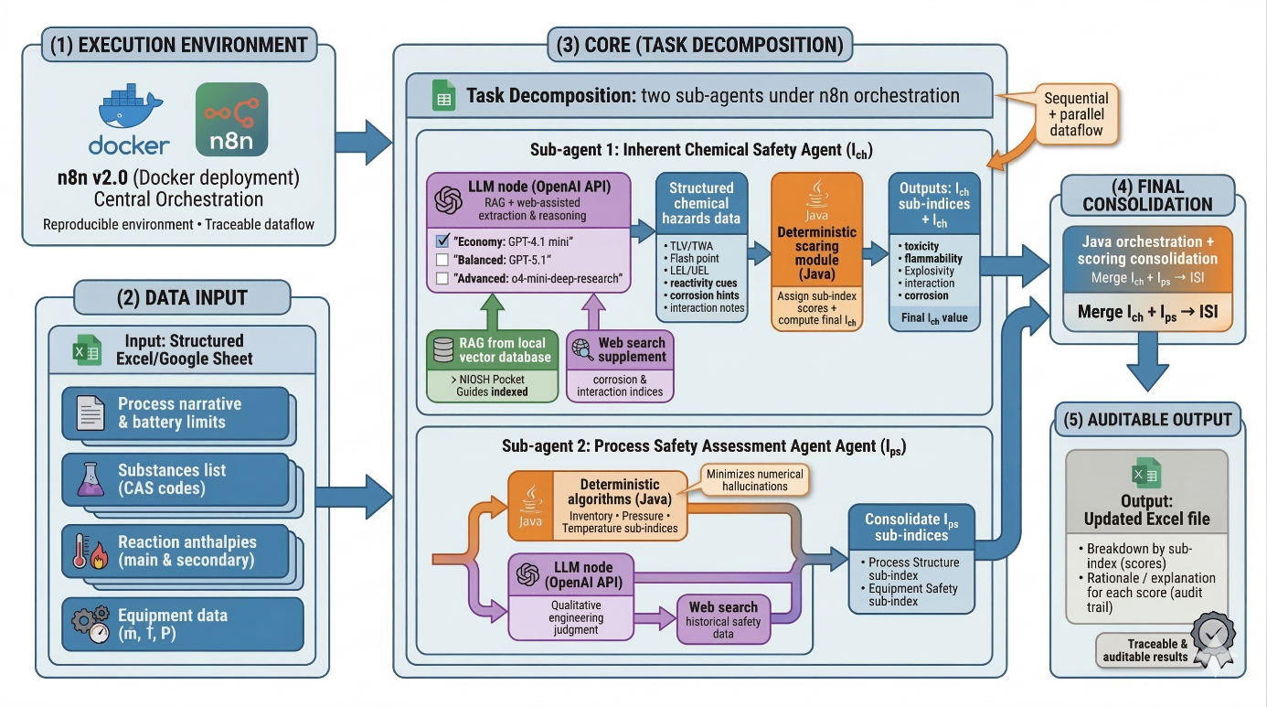
The inherent chemical safety assessment agent executes the following subroutines. Knowledge extraction is performed using Retrieval-Augmented Generation (RAG) and CAS codes from the substance data sheet. For each compound, a query is made to a local vector database, built from the NIOSH (National Institute for Occupational Safety and Health) Pocket Guides. This ensures that the base information comes from a validated source. The local vector database was built from the 2007 version of the NIOSH Pocket Guide, and the RAG index was updated only through controlled reindexing when the source corpus was updated, keeping the same fixed snapshot for all experiments. An LLM model is invoked to receive raw extracts from NIOSH, interpret toxicological and physicochemical property data for the substances, and supplement this with information from its training and real-time web searches to derive corrosion and interaction sub-indices. The LLM structures the information in an Excel spreadsheet and determines the values of all inherent-safety chemical subindices. The Inherent Process Safety Assessment agent implemented a bifurcated strategy to minimize the numerical hallucinations typical of generative models. Deterministic algorithms (Java code) were used for parameters that depend strictly on numerical variables, such as the inventory, pressure, and temperature sub-indices. For parameters requiring engineering judgment and qualitative analysis, an LLM node was activated. This model processes the process description and equipment list to estimate the Process Structure sub-index —by consulting historical safety data for the process type on the web— and the Equipment Safety sub-index, drawing on its training knowledge and web resources. Finally, the nodes with Java code orchestrate and consolidate the results from both agents, obtaining the process's ISI. The system generates an updated output file that shows the final breakdown of each score by sub-index, along with an explanation of the rationale for assigned values. This allows the user to audit which sub-index contributed most to the overall risk and why. Finally, for this study, each experiment with the different LLM were performed in triplicate. The optimal configuration was evaluated in terms of reasoning accuracy, data-extraction consistency, and computational efficiency.
Figure 1: Scheme of the AI agent’s architecture (Image created by Nano Banana Pro)

Results and discussion
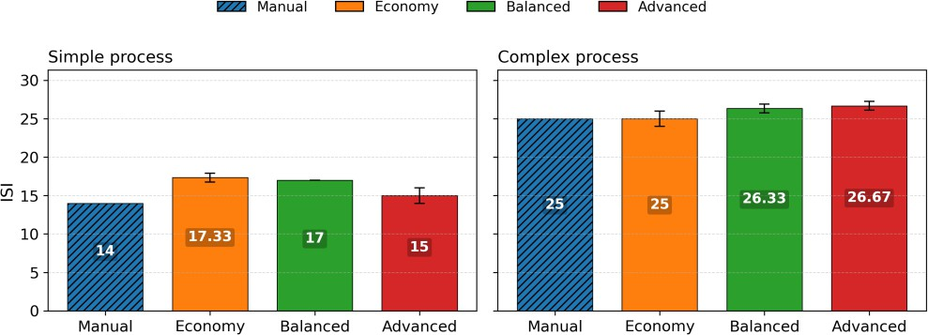
The results in Figure 2 show the ISI for each of the studied process complexities. In the simple process (Creole- Antillean avocado biorefinery), LLM-based estimates tend to yield higher ISI values than the expert benchmark, whereas in the complex process (Hass avocado biorefinery), the models converge more closely to the reference. The overall ISI results for both processes are very close to those achieved by the agent in both scenarios. In this respect, it would have been preferable to compare with multiple experts who performed the same analyses to obtain a weighted score and standard deviation. These results can be analyzed from different perspectives, considering what the agent does in terms of RAG and what it does based on its training to “reason”. When RAG is used, this work is performed deterministically, taking into account the scoring rules and biorefinery data, leaving little room for ambiguity and achieving 100% accuracy (see Figure 3). However, some categories require agent reasoning —the corrosion sub-index, the chemical interaction sub-index, the safe equipment sub-index, and the safe structure sub-index— thereby necessitating subjective assessments that can lead to both conservative and riskier responses —this time, more conservative, which is beneficial (see Figure 4). In these sub-indices, the assignment rules may be less clear and may require searching the scientific literature for further information.

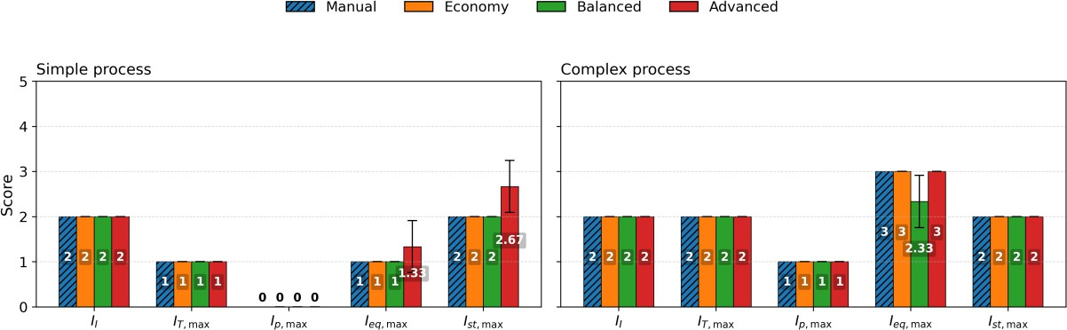
Figure 2: ISI values delivered by the reference studies —manual— and the different LLM explored models
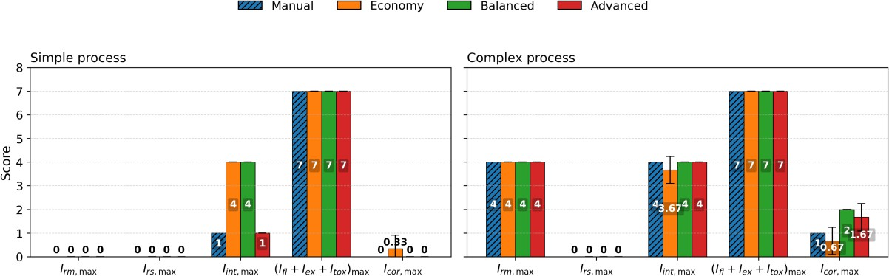
Figure 3: Ich values delivered by the reference studies —manual— and the different LLM explored models

Figure 4: Ips values delivered by the reference studies —manual— and the different LLM explored models

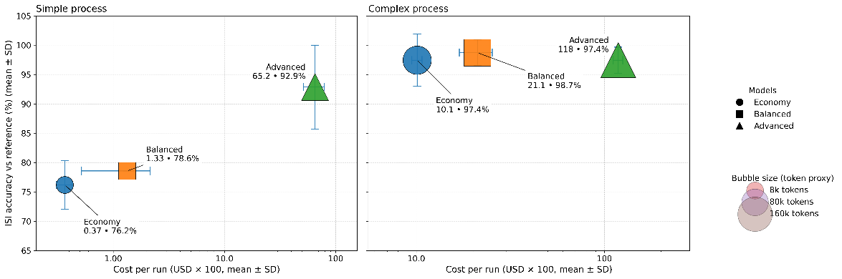
In the literature on inherent security, these indices have traditionally been calculated by analysts who interpret the process and manually complete the sub-indices (Hurme & Rahman, 2005). However, integrated quantitative proposals (e.g., I2SI) also exist that structure assessment and cost, though their typical execution remains procedural—templates, rules, and engineering judgment—without automation layers that integrate traceable evidence extraction and end-to-end, reproducible orchestration (Khan & Amyotte, 2005). This approach combines RAG from a validated source with LLMs to collect relevant literature from specific websites, thereby enabling agentically quantified assessment of security indices and delegating scoring and consolidation to deterministic code. This reduces variability, improves auditability, and enables explicit comparison of the cost-performance trade-off across models. When comparing the time and overall performance of the ISI, a noticeable trade-off exists between increased thinking and the actual benefits gained (see Figure 5). In the simple process, on average, GPT-4.1 mini required 0.75 minutes to achieve 76.2%; GPT-5.1 required 1 minute to achieve 78.6%; and o4-mini-deep-research required 5.07 minutes to achieve 92.9%. Here, deep research offers a relevant improvement but exhibits greater variability, suggesting that performance gains may outweigh time and cost. In the complex process, GPT-4.1 mini required 2.92 minutes (97.4%), GPT-5.1 required 3.73 minutes (98.7%), and o4-mini-deep-research required 24.57 minutes (97.4%). In this case, GPT-5.1 achieves the best performance with minimal time increase, whereas o4-mini-deep-research yields no significant efficiency gains due to the large time and cost consumed.

Figure 5: Cost vs ISI precision quantification of the different AI models

This study enhanced agent performance by refining prompts through trial and error rather than relying on a single metric, such as agreement with an expert benchmark. When the training agent lacks specificity and scenarios are limited, models tend to overreact and become overly fatalistic. Future work should include evaluations by several independent experts to gauge inter-rater variability and confidence. Using a comprehensive, up-to-date database of safety data sheets, especially for complex substances such as those from NIOSH, is recommended. The autonomous agent aims to help security analysis experts better understand processes, not replace them, thereby increasing productivity.

Conclusions
This work demonstrates the automation of Inherent Safety Index evaluation using an AI agent in n8n and Docker, combining RAGs based on NIOSH and deterministic Java calculations for scoring, with OpenAI LLMs for engineering judgment. Comparing with expert calculations from two avocado biorefineries highlights trade-offs among cost, accuracy, and time. The o4-mini-deep-research model improves accuracy but adds latency, while the 4.1-mini and 5.1 models offer competitive accuracies with lower time and cost in complex biorefineries. Discrepancies mainly occur in corrosivity, chemical interactions, equipment, and structural safety, indicating that future steps should include expanding the use of verifiable sources and validating the approach through more independent processes and evaluators to assess uncertainty and robustness.

References
Aguilar-Vasquez E.A., Rojas-Flores S., González-Delgado Á.D., 2025, Inherent Safety Analysis of a Cascade Biorefinery for the Utilization of Avocado Hard Waste from the South Colombian Region, Sustainability, 17, 8103
Ab Rahim, M. S., Reniers, G., Yang, M., & Bajpai, S., 2024, Risk assessment methods for process safety, process security and resilience in the chemical process industry: A thorough literature review, Journal of Loss Prevention in the Process Industries, 88, 105274
Heikkilä A.-M., 1999, Inherent safety in process plant design: an index-based approach, VTT Publications, Vol 384, Espoo, Finland
Herrera-Rodríguez T.C., González-Delgado Á.D., 2025, Inherent Safety Index Evaluation of an Extractive-Based Creole-Antillean Avocado Biorefinery in Montes De María, Colombia, Sustainability, 17,168
Hurme M., Rahman M., 2005, Implementing inherent safety throughout process lifecycle, Journal of Loss Prevention in the Process Industries, 18, 238–244
Khan F.I., Amyotte P.R., 2005, I2SI: A comprehensive quantitative tool for inherent safety and cost evaluation, Journal of Loss Prevention in the Process Industries, 18, 310–326
Pelucchi, S., Bonomo, E. M., Carretta, F., Mocellin, P., & Galli, F., 2025, Automated evaluation of safety at the conceptual stage: An index-based methodology for units and processes, Process Safety and Environmental Protection, 107979
Tesfaye T., Gibril M., Sithole B., Ramjugernath D., Chavan R., Chunilall V., Gounden N., 2018, Valorisation of avocado seeds: extraction and characterisation of starch for textile applications, Clean Technologies and Environmental Policy, 20, 2135–2154
Yang Y., Shi R., Li Z., Jiang S., Lu B.-L., Zhao Q., Yang Y., Zhao H., 2025, BatGPT-Chem: A Foundation Large Model for Chemical Engineering, Research, 8:0827

