 CHEMICAL ENGINEERING TRANSACTIONS  VOL. xxx, 2026 | A publication of  
The Italian Association
of Chemical Engineering
Online at www.cetjournal.it

Guest Editors: Leonardo Tognotti, Rubens Maciel Filho, Viatcheslav Kafarov
Copyright © 2026, AIDIC Servizi S.r.l.
ISBN 979-12-81206-xx-x; ISSN 2283-9216

Biohydrogen production from biomass by integrated pyrolysis and steam reforming: process studies and design of an experimental prototype
Elshaday Mulu Feteneª, Maurizio Troiano^{a,}*, Matteo Girardi^{b}, Claudio Amorese^{b}, Roberto Solimene^{c}, Piero Salatinoª
ªDipartimento di Ingegneria Chimica, dei Materiali e della Produzione Industriale, Università degli Studi di Napoli Federico II, Piazzale Vincenzo Tecchio 80, 80125, Napoli, Italy
^{b}ICMEA SRL, Via Gravina 156, 70033, Corato (Bari), Italy
^{c}Istituto di Scienze e Tecnologie per l’Energia e la Mobilità Sostenibili, Consiglio Nazionale delle Ricerche, Piazzale Vincenzo Tecchio 80, 80125, Napoli, Italy
maurizio.troiano@unina.it
This study deals with the design and construction of a lab-scale prototype plant integrating a fluidized bed pyrolytic converter of solid residual biomass with a fluidized bed steam reformer of pyrolytic bioliquids. The system consists of the following main components: a pyrolytic converter, a continuous biomass feeder with a feed rate of 5 kg/h, a three-stage condensation system and a steam reforming reactor equipped with a liquid feeding system. The pyrolytic converter was designed as an internally circulating fluidized bed with a gas residence time of 1 s and a reactor height of 0.6 m. The reforming reactor height is 0.8 m with a diameter of 0.078 m. The operation of the plant is flexible as it encompasses both in-line and off-line operation modes as well as different bio-oil feedstock types for the steam reforming stage. Furthermore, thermodynamics analysis indicated that the maximum hydrogen yields at 650ºC for in-line and off-line steam reforming were 0.11 and 0.10 kg H₂ per kg of biomass, respectively. Increasing the temperature above 650°C led to a decrease in H₂ production.
  - Introduction
Hydrogen is a key part of the energy transition and has the potential to decarbonizing hard-to-abate sectors (Bampaou and Panopoulos, 2025). It can be generated from renewable and non-renewable energy sources. The existing data show that about 40% of H₂ is produced from natural gas, 30% from heavy oils and naphtha, 18% from coal, 4% from electrolysis and about 1% from biomass. However, the fossil fuel resources are limited and have a huge environmental impact. For instance, in 2020, 90 Mt of H₂ were used and produced nearly 900 Mt of CO₂ emissions (Nnabuife, 2023). Therefore, global energy transition is essential to address climate change. Biomass represents an alternative way to reduce reliance on fossil fuel (El-Emam and Özcan, 2019). Hydrogen production from biomass can be achieved through thermochemical, biological and electrolytic processes. Thermochemical methods are currently the most widely used approaches, due to their feedstock agnostic, potentially for net negative CO₂ emissions and integration with the biorefinery production. Gasification and steam reforming are the most employed processes and can be configured as either directly or staged process layout. Direct biomass gasification has higher energy and exergy efficiency compared to indirect gasification (Buelvas et al., 2024). It has the potential to find H₂-rich syngas, which can be used for heat, power generation and other applications (Ren et al., 2020). However, a major challenge that prevents from commercialization is tar formation which leads to fast catalyst deactivation and operational problems (Yung et al., 2009). Moreover, biomass gasification concentrates most of the available energy into syngas. However, this process results in the loss of some biomass. In contrast, pyrolysis distributes energy among multiple products including bio-oil, syngas and char which largely preserves their chemical exergy. This characteristic offers greater flexibility for integration with biorefinery concept. For instance, bio-oil from pyrolysis can be further processed for hydrogen production. However, due to the complexity of the bio-oil and presence of heavy compounds such as phenols, it faces challenges related to fast catalyst deactivation. Previous literature highlighted that catalyst deactivation can be mitigated by purifying bio-oil through liquid-liquid phenol extraction (Garcia-Gomez et al., 2022). These findings feature the potential of integrated pyrolysis systems in exploiting the chemical energy stored in biomass, producing hydrogen and high-value chemical compounds simultaneously. Integration of pyrolysis and steam reforming can be carried out in two ways: as an in-line scheme, where gases and vapors from the pyrolytic converter are directly processed in the steam reformer (Santamaria et al., 2020) or as an off-line process, where bioliquids from pyrolysis are collected and stored after condensation, to be separately processed in the steam reformer.
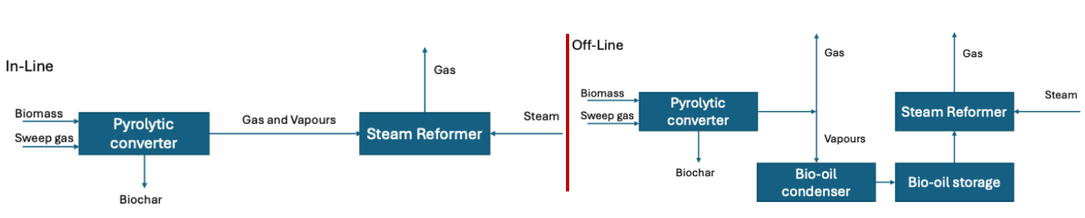

Figure 1: Conceptual scheme of integrated pyrolysis/reforming process; in-line and off-line layouts.

Offline process configuration offers higher flexibility in terms of feedstocks nature including crude bio-oil, aqueous fraction and treated bio-oil, but it is scarcely studied in the literature, due to the difficulties related to liquid injection. Bio-oil feeding system plays a crucial role in the steam reforming process. It directly influences the mixing and dispersion of the feedstock and catalysts, which impacts both product yields and catalysts performance. This study presents the design of a lab-scale integrated pyrolysis/reforming process for biohydrogen production. Thermodynamic equilibrium simulations using Gibbs free energy minimization method were also carried out to assess the optimal operating conditions and performance for both configurations. Furthermore, the design was validated through inline pyrolysis - steam reforming experiments using dolomite as bed material in the reformer reactor.
  - Methodology
    - Design
An integrated pyrolysis-reforming process for biohydrogen production was designed to achieve high H₂ yield and conversion efficiency. The reforming process was designed to be flexible, to investigate both in-line and off-line process configurations. The reactor design focused on the selection of reactor type, size and configuration. The main units were the pyrolysis reactor, condensation system, reforming reactor and bio-oil feeding methods. The design of the pyrolytic converter was based on previous results obtained by the research group (Troiano et al., 2024). The nominal biomass feed rate was assumed to be 5 kg/h. In addition, the design considered staged condensation to fractionate the bio-oil components. Governing equations are:
$m_{H,stage}=f_{stage}xW_{biomass}$ (1)
$Q=m_{H}C_{p}(T_{H,in}-T_{H,out})$ and $∆Q=UA∆T$ (2)

where, $m_{H}$, is the mass flow rate of hot stream, $C_{p}$is the heat capacity, $T_{H,in} and T_{H,out}$ are temperature in and out (Papari and Hawboldt 2018).
The design of the steam reformer was supported by results from previous literature. Several studies provided a detailed chemical composition of the bio-oil, with more than 30 components identified (Paasikallio et al., 2015) (López et al., 2020). In the design, the entire bio-oil, aqueous fraction and pyrolysis vapour were considered as reference to calculate key dimensions of the reactor such as its height and diameter. In addition, a mass flow rate of 500 g/h, space time of 0.3 gcat h gvol⁻¹, and gas superficial velocity of 0.4 m/s were considered. Note that the design assumes steady state operation and uniform bed temperature. Gas volumetric flow rate $Q_{in}$fed into the steam reformer was based on feedstock speciation:
$Q_{in}=\frac{w_{s}}{ρ_{s}}+\sum_{i}{\frac{w_{i}}{ρ_{i}}}$, (3)
where $w_{s}$ and $ρ_{s}$ are the mass flow rate and the density of steam and $w_{i}$ and $ρ_{i}$ are the mass flow rate and the density of the i-th compound in the feedstock.
The cross-sectional area of the reformer: $A=\frac{Q_{in} }{U}$, and the mass of catalysts $m_{cat}=τ x W_{biooil}$ (4)

The determination of the volume of the settled fluidized bed, overall volume of the reactor volume and height is obtained by equation 5.
$V_{bed}=\frac{m_{cat}}{ρ_{bulk}}$, ${V=V_{bed}+V}_{fb}$, and the height $H=\frac{V}{A}$ (5)

    - Thermodynamic analysis
The integrated pyrolysis-reforming process was simulated following a thermodynamic analysis using the Gibbs free energy minimization method. This method was applied to determine the maximum theoretical conversion under ideal conditions and considering no coke deposition onto the catalysts surface. It was helpful to evaluate the influence of the main operating conditions, as temperature and S/C ratio on gas product composition and hydrogen production (López et al., 2020). RK-SOAVE state equation was used. For this analysis, the reactor has been considered isothermal and constant pressure. Hydrogen production is calculated as the ratio between the H₂ mass flow rate measured at the outlet of the reforming process ($m_{H_{2}}$) and the biomass flow rate in the feed of the pyrolysis step ($m_{0}$):
$P_{H2}= \frac{m_{H_{2}}}{m_{0}}x100$ (6)
The hydrogen yield is defined as the ratio between the H₂ molar flow rate ($F_{H_{2}}$) and the maximum one allowed by stoichiometry ($F_{H_{2}}^{0}$):
$Y_{H2}= \frac{F_{H_{2}}}{F_{H_{2}}^{0}(Bio oil+Syngas)}x100$ (7)
  - Results and discussion
Fluidized bed reactors were selected as the reference technology for both pyrolysis and reforming steps. This is due to their excellent thermal properties and enhanced mobility of bed solids in fluidized state. Furthermore, in a steam reforming reactor, controlling the fluidization patterns ensures effective contact between bio-oil vapours and catalysts that improve the H₂ yield and conversion.
    - The pyrolyzer and the condensation system
An internally circulating fluidized bed reactor (ICFB) was selected for the pyrolysis process. The reactor system consists of a biomass feeding unit, a main reactor body, a fluidizing gas distribution, a windbox and discharge valve/duct, as illustrated in Figure 2a. The main reactor body consists of two sections with the upper section measuring 100x100mm and the lower section measuring 50x100mm and an overall height of 0.6 m. The reactor walls have a thickness of 5 mm and constructed from AISI310S stainless steel selected for high temperature strength and corrosion resistance. The reactor is designed to operate within a temperature range of 500-800ºC. The core of the system is the main reactor body, which is an internally circulating fluidized bed equipped with an internal baffle that divides the reactor into two distinct zones: the first zone is a bubbling fluidized bed, where bubbling ensures thorough mixing of solid particles and keeps them well mixed; the second zone is a moving bed, where solids move downward under the influence of gravity, facilitating continuous circulation. An opening ratio of 0.4 was selected to ensure high solids circulation rates, high heating rates of biomass particles and low gas residence times (Troiano et al., 2024). The biomass feeding system employs a hopper and an electrically driven screw dosing mechanism. Granular biomass with particle sizes up to 1 mm is continuously fed into the pyrolytic converter. To avoid blockages in the inlet pipe, the feeder is equipped with a cooling jacket connected to the chiller circuit to regulate the temperature. The vapours produced by the pyrolysis process pass through a cyclone separator which removes any entrained solid particles. The cleaned vapour then flows directly into the steam reforming reactor containing the catalysts bed, in the case of inline configuration, or is sent to condensation unit.
A three-stage condensation system was selected with a nominal vapor flow rate of 20 kg/h, aiming to condensation of the volatile vapours into liquid products including heavy bio-oil, medium and aqueous or light fraction. The system is comprised of three single-tube shell and tube heat exchangers connected to water chiller for the cooling and condensation circuit. The first stage operates at 180ºC, aiming at condensation of heavy fraction of bio-oil. The second stage works at 90°C handling the medium fraction from remaining vapour plus liquid mixture and medium fraction. The third stage has been designed to condense aqueous or light fraction of bio-oil at 34ºC. The aim of the three-stage condenser with different temperatures is to convert the volatile vapour into multiple liquid products (Papari and Hawboldt, 2018). The condensation sequence is arranged according to boiling points the pyrolysis products to ensures the products are separated effectively. Temperature is the key factor in controlling separation efficiency and selection of the tube size.

a
b

Figure 2: Pyrolyzer (a) and steam reformer (b)

    - The steam reformer
The fluidized bed steam reformer was designed based on parameters taken from literature data such as chemical composition, catalyst space time and optimal temperature. The reformer is electrically heated to operate within a temperature range of 600-800ºC. It comprises a windbox, a perforated plate gas distribution system, a main reactor body and a bed discharge line, as presented in Figure 2b. The main reactor body was sized with a height of 0.8 m and a diameter of 0.078 m. The reformer is equipped with lateral ports for feedstock feeding and catalyst loading. Steam is fed in the windbox, while bio-oil, in the case of off-line configuration, is fed in the bed by means of an on-purpose designed cooled probe inserted horizontally in the bed. The probe has an inner diameter of 3 mm, a length of 490 mm and a wall thickness of 0.5 mm. The design provides flexibility that allow the study of the effect of probe insertion length on liquid dispersion and mixing in the fluidized bed.
In the inline process configuration, the pyrolysis vapours and the steam are introduced into the reforming reactor in the bed and in the windbox, respectively. The fabrication of the equipment and the development of the system were completed at ICMEA in Corato, Italy. Figure 3 presents the layout of the integrated pyrolysis-reforming process.

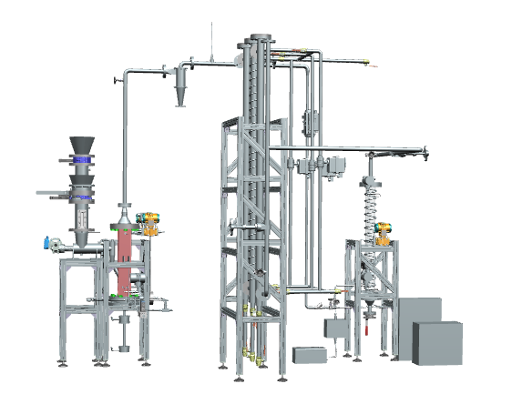
Figure 3: Assembly of the equipment for pyrolysis-steam reforming integrated process

    - Assessment of the integrated process
Figure 4a reports hydrogen production as a function of operating reforming temperature, for in-line and off-line process configurations. Results showed that hydrogen production increased significantly when temperature was increased from 500°C to 650°C. Increasing the temperature above 650°C decreased the H₂ production due to the nature of the reactions. The maximum H₂ production for in-line and off-line were 0.11 and 0.1 H₂/kg biomass respectively. The in-line process showed a slightly higher H₂ production than off-line process due to the presence of gaseous hydrocarbons in the vapours such as CH₄, C₂H₄ and other gas compounds. The maximum hydrogen yield for both in-line and off-line configurations using steam-to-carbon ratio S/C of 1, 5 and 10 was found be at around 800°C, 650°C and 600°C respectively, as illustrated in Figure 4b. This indicates that with low S/C ratio, high temperature is required to achieve high hydrogen yield. Low S/C disfavours water-gas-shift reaction and might cause incomplete reforming that reduces the H₂ yield. Furthermore, low S/C ratio results in non-efficient contact between steam and volatiles which can lead to coke deposition and catalyst deactivation (Remiro et al., 2013). These results are useful to determine the optimal operating conditions for steam reforming of pyrolysis products, both in in-line and off-line configurations.

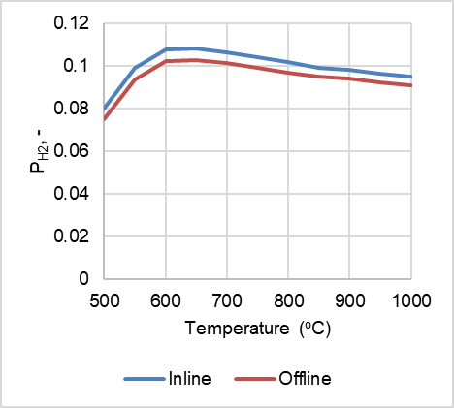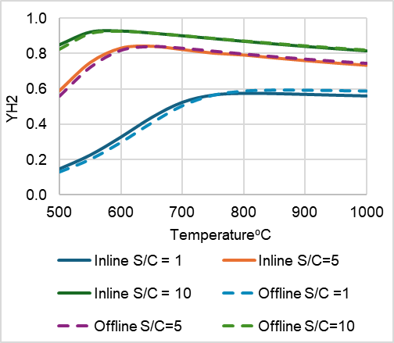
b
a

Figure 4: Hydrogen production at different temperatures (a) and yield at S/C 1, 5 and 10 (b)
  - Conclusions
In this study, a lab-scale integrated pyrolysis-steam reforming process for biohydrogen production was successfully designed and constructed. The design of both the pyrolyzer and reformer was guided by key criteria aimed at: enhancing feedstock dispersion, minimizing vapor segregation with respect to the catalyst bed, preventing secondary pyrolysis of the vapours prior to steam reforming, ensuring the required contact time and flow pattern of the steam/vapor mixture in the bed. The designed system offers operational flexibility, allowing both in-line and off-line operation modes as well as different bio-oil feedstock types for the steam reforming stage. A detailed quantitative experimental analysis will be addressed in future work. Furthermore, a thermodynamic analysis of both in-line and off-line scheme was conducted. The maximum hydrogen productions of 0.11 and 0.10`kg H₂/Kg biomass were obtained for the in-line and off-line steam reforming processes at 650ºC, respectively. The analysis also showed that decreasing the S/C ratio decreases the hydrogen yield due to insufficient steam availability, which disfavors of water gas shift reaction and leads to incomplete reforming.

Acknowledgments
Elshaday Mulu is grateful to the Eni for the scholarship awarded to her through the university of Naples Federico II, Italy. The study was financially supported by the Italian National Recovery and Resilience Plan (NRRP), Mission 4 Component 2 Investment 1.3 - Call for tender No. 1561 of 11.10.2022 of Ministero dell’Università e della Ricerca (MUR) funded by the European Union – NextGeneration EU; Project code PE0000021, Concession Decree No. 1561 of 11.10.2022 adopted by Ministero dell’Università e della Ricerca (MUR), Project title “Network 4 Energy Sustainable Transition – NEST”. This study was carried out within the Agritech National Research Center and received funding from the European Union Next-GenerationEU (PIANO NAZIONALE DI RIPRESA E RESILIENZA (PNRR) – MISSIONE 4 COMPONENTE 2, INVESTIMENTO 1.4 – D.D. 1032 17/06/2022, CN00000022).
References
Bampaou M., Panopoulos K.D., 2025, An overview of hydrogen valleys: status, challenges and their role in increased renewable energy penetration, Renewable and Sustainable Energy Reviews, 207, 114923.
Buelvas A., Quintero‐Coronel D.A., Vanegas O., Ortegon K., Bula A., Mesa J., González‐Quiroga A., 2024, Gasification of solid biomass or fast pyrolysis bio‐oil: Comparative energy and exergy analyses using AspenPlus®, Engineering Reports, 6(7), e12825.
El-Emam R.S., Özcan H., 2019, Comprehensive review on the techno-economics of sustainable large-scale clean hydrogen production, Journal of Cleaner Production, 220, 593-609.
Garcia-Gomez N., Valecillos J., Valle B., Remiro A., Bilbao J., Gayubo A.G., 2022, Combined effect of bio-oil composition and temperature on the stability of Ni spinel derived catalyst for hydrogen production by steam reforming, Fuel, 326, 124966.
López G., Zabalbeitia L., García González Arregi A., Joaristi L., Santamaría Moreno M., Amutio Izaguirre M., Artetxe M., Bilbao J., Olazar M., Aurrecoechea, 2020, Thermodynamic assessment of the oxidative steam reforming of biomass fast pyrolysis volatiles, Energy Conversion and Management, 214,112889.
Nnabuife S.G., Oko E., Kuang B., Bello A., Onwualu A.P., Oyagha S., Whidborne J., 2023, The prospects of hydrogen in achieving net zero emissions by 2050: A critical review, Sustainable Chemistry for Climate Action, 1-2,100024.
Papari S., Hawboldt K., 2018, A review on condensing system for biomass pyrolysis process, Fuel Processing Technology, 180, 1-13.
Paasikallio V., Kihlman J., Sánchez C.A.S., Simell P., Solantausta Y., Lehtonen J., 2025, Steam reforming of pyrolysis oil aqueous fraction obtained by one-step fractional condensation, International Journal Hydrogen Energy. 40, 3149-3157.
Remiro A., Valle B., Aramburu B., Aguayo A.T., Bilbao, & Gayubo A.G., 2013, Steam reforming of the bio-oil aqueous fraction in a fluidized bed reactor within situ CO₂ capture, Industrial Engineering Chemistry Research. 52, 17087-17098.
Ren J., Liu Y.L., Zhao X.Y., Cao J.P., 2020, Biomass thermochemical conversion: A review on tar elimination from biomass catalytic gasification. Journal of the Energy Institute, 93(3), 1083-1098.
Santamaria L., Arregi A., Lopez G., Artetxe M., Amutio M., Bilbao J., Olazar M., 2020, Effect of La2O3 promotion on a Ni/Al2O3 catalyst for H₂ production in the in-line biomass pyrolysis-reforming, Fuel, 262, 116593.
Troiano M., Padula S., Cammarota A., Solimene R., Salatino P., 2024, Physical modelling and hydrodynamic characterization of an internally circulating fluidized bed for biomass fast pyrolysis, Powder Technology, 438, 119596.
Yung M.M., Jablonski W.S., Magrini-Bair K.A., 2009, Review of catalytic conditioning of biomass-derived syngas, Energy & fuels, 23(4), 1874-1887.

