 CHEMICAL ENGINEERING TRANSACTIONS  VOL. xxx, 2026 | A publication of  
The Italian Association
of Chemical Engineering
Online at www.cetjournal.it

Guest Editors: Leonardo Tognotti, Rubens Maciel Filho, Viatcheslav Kafarov
Copyright © 2026, AIDIC Servizi S.r.l.
ISBN 979-12-81206-xx-x; ISSN 2283-9216

Life cycle assessment of a heat-integrated thermal-extractive avocado oil biorefinery
Samir Meramo*, Tamy Herrera-Rodriguez, Angel Dario Gonzalez-Delgado
ª Nanomaterials and Computer Aided Process Engineering Research Group (NIPAC), Chemical Engineering Department, Faculty of Engineering, University of Cartagena, Av. del Consulado Calle 30 No. 48-152, Cartagena, Colombia.
smeramoh@unicartagena.edu.co.
This study evaluates the environmental performance of a heat-integrated avocado oil biorefinery using a combined process-integration and life cycle assessment (LCA) approach. Heat-integration strategies were implemented to improve resource efficiency and reduce the environmental impacts associated with the valorization of avocado processing side streams. Foreground data were obtained from detailed process simulations, while background systems were modeled using the ecoinvent database under a cradle-to-gate system boundary. The heat-integrated design achieves substantial reductions in utility demand, with external heating and cooling requirements decreased by approximately 90–95%, resulting in significantly lower steam and cooling-water consumption in the life cycle inventory. Compared with a previously published non-integrated baseline, the integrated system demonstrates marked environmental benefits, including an approximately 50% reduction in climate-change impacts, with similar reductions across other impact categories driven by decreased energy use. Overall, the results highlight the importance of energy optimization and heat integration in improving the sustainability of emerging biorefinery systems and circular agri-food value chains.
  - Introduction
The global demand for avocado-derived products has increased rapidly due to their nutritional value and expanding applications in the food, cosmetic, and pharmaceutical industries. This growth has intensified processing activities, leading to higher energy consumption and the generation of significant organic residues. As a result, improving the environmental sustainability of avocado-processing systems has become a critical priority under rising energy costs and stricter environmental regulations. Avocado processing is inherently energy intensive, involving multiple heating, cooling, and solvent recovery stages that strongly influence its environmental footprint (Solarte-Toro et al., 2023). Life Cycle Assessment (LCA) is widely used to evaluate the environmental performance of agro-industrial and bio-based systems, enabling identification of hotspots and comparison of process configurations. Its relevance is particularly high for emerging technologies, where early design choices strongly affect long-term sustainability (Riondet et al., 2024). In the agri-food sector, LCA is increasingly applied within circular economy frameworks, especially for biomass valorization systems (Mondello et al., 2024).
The integration of LCA with process modeling enables environmental impacts to be directly linked to mass and energy balances, allowing the effects of design improvements—such as energy optimization—to be quantified at the system level (Gamero et al., 2024). Previous LCA studies of avocado biorefineries have identified energy consumption as a dominant contributor to environmental impacts, with results highly sensitive to process configuration and utility demand (Solarte-Toro et al., 2023; Garcia-Vallejo et al., 2023; Marques et al., 2025). Building on this background, this study evaluates the environmental performance of a thermal–extractive avocado oil biorefinery using LCA integrated with process simulation. The effect of heat integration on reducing utility consumption and associated environmental impacts is assessed under a cradle-to-gate system boundary, providing insights for the development of more sustainable avocado biorefineries.
2.Materials and methods
  - Process description
The thermal-extractive avocado biorefinery is designed to valorize avocado side streams unsuitable for human consumption through the integrated production of avocado oil as the main product, alongside biochar, a chlorophyll-rich extract, treated peel, and defatted pulp. The conceptual basis and early-stage assessment of this process were previously developed and reported by the authors, including thermodynamic, exergy, and sustainability-oriented evaluations of avocado oil extraction systems (Herrera et al., 2022). In the present work, the previously proposed process is further expanded and consolidated through detailed life cycle assessment, considering a plant capacity of approximately 10,605 t·y⁻¹ of avocado, based on feedstock availability in Northern Colombia. In addition, the process was optimized through heat integration. The process simulation and heat integration results enabled the generation of detailed mass and energy balances, which were used to complete the life cycle inventory for the LCA. The process, illustrated in Figure 1, begins with feedstock conditioning, where avocados are washed, disinfected, and mechanically separated into pulp, peel, and seed fractions. The pulp is directed to thermal-extractive oil production, while the peel undergoes chlorophyll extraction using ethanol followed by solvent recovery. The two chlorophyll-rich extract streams shown in Figure 1 correspond to intermediate and concentrated streams within the extraction–distillation sequence. Residual peel after extraction is handled as a separate stream for further valorization or disposal, explaining the additional peel-related block in the diagram. The seed fraction is processed independently through drying and pyrolysis to produce biochar.
  - Life Cycle Assessment
LCA was applied as a standardized framework to quantify the environmental impacts associated with the avocado oil biorefinery, following the principles and requirements defined in ISO 14040 and ISO 14044. LCA provides a structured approach comprising goal and scope definition, life cycle inventory (LCI) analysis, life cycle impact assessment (LCIA), and interpretation, enabling consistent evaluation of environmental burdens across complex agro-industrial systems.
Goal and Scope definition
The goal of this study is to evaluate the environmental performance of a thermal–extractive avocado oil biorefinery and quantify the effect of energy-oriented process improvements using LCA. The assessment supports sustainability-oriented process design by identifying environmental hotspots and the benefits of reduced external utility demand. The functional unit is 1 kg of refined avocado oil at the biorefinery gate, serving as the reference for LCI and LCIA results. A cradle-to-gate system boundary was adopted, including raw material supply, transportation, processing and extraction, utility generation, and on-site emissions up to the production stage. Downstream stages (distribution, use, and end-of-life) were excluded, as they are not influenced by the evaluated process design. The study follows the cut-off approach, assigning environmental burdens of waste to the generating system; thus, avocado side streams enter the system without upstream burdens. The geographical scope corresponds to northern Colombia, reflecting regional feedstock availability and background conditions. The multiproduct system was addressed through subdivision, with economic allocation applied where necessary. The overall system boundary is shown in Figure 1.

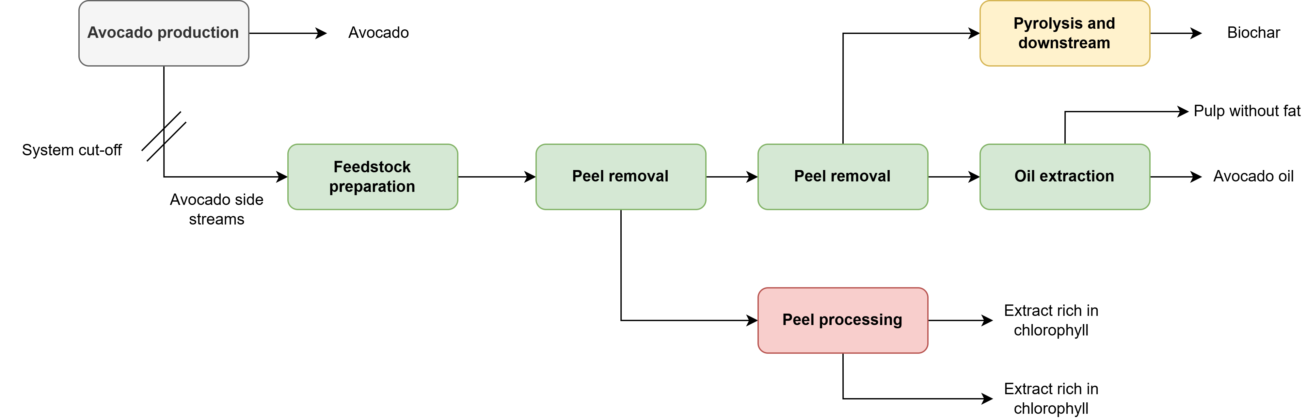
Figure 1: System boundary of heat-integrated thermal-extractive avocado oil biorefinery.
Life Cycle Inventory
The life cycle inventory (LCI) was developed by combining foreground process data from detailed simulations with background datasets from established life cycle databases. Foreground data describe mass and energy balances for all major processing units in the thermal–extractive avocado oil biorefinery and were refined through heat integration using a pinch-based approach. This included identification of hot and cold streams, determination of minimum utility requirements, and synthesis of a heat exchanger network (HEN), achieving reductions of approximately 90–95% in cooling demand and 14% in heating demand compared to the non-integrated case. These improvements were incorporated into the LCI through reduced utility consumption. The inventory includes raw material inputs, intermediate flows, energy use, and direct emissions. Utility demands were calculated from the optimized simulations and reflect the heat-integrated configuration. Background processes, such as electricity, steam, cooling water, transportation, and auxiliary materials were modeled using ecoinvent datasets, selected to match the geographical scope where possible. Wastewater treatment was modeled using average market datasets from ecoinvent, representing conventional treatment processes and associated emissions. All inventory data were scaled to the functional unit of 1 kg of avocado oil at the biorefinery gate and verified for mass and energy balance consistency prior to impact assessment. Table 1 summarizes the LCI and corresponding background data sources.
Table 1: LCI of the heat-integrated thermal-extractive avocado oil biorefinery
Input material flows | Unit | Value | Source of background data
Feedstock | kg/h | 1097.50 | Solarte-Toro et al. 2023
Water | kg/h | 2779.09 | ecoinvent 3.10
Hexane | kg/h | 32.00 | ecoinvent 3.10
Ethanol | kg/h | 321.63 | ecoinvent 3.10
Sodium hypochlorite | kg/h | 0.45 | ecoinvent 3.10
Air | kg/h | 1070.00 | ecoinvent 3.10
Energy input flows
Electricity | kg/h | 76.3 | ecoinvent 3.10
Cooling water | kg/h | 3956.76 | ecoinvent 3.10
Refrigerant | kg/h | 23.17 | ecoinvent 3.10
Steam | kg/h | 18.08 | ecoinvent 3.10
Natural gas | kg/h | 20.87 | ecoinvent 3.10
Nitrogen | kg/h | 9.72 | ecoinvent 3.10
Product flows |  |  | ecoinvent 3.10
Biochar | kg/h | 52.24 | co-product
Avocado oil | kg/h | 103.5 | product
Treated peel | kg/h | 128.078 | co-product
Pulp without fat | kg/h | 82.31 | co-product
Rich chlorophyll extract | kg/h | 3.24 | co-product
Output waste flows
Wastewater | kg/h | 2704.78 | ecoinvent 3.10
Emissions to water
Hexane | kg/h | 11.3165 | elementary flow
Ethanol | kg/h | 20.857 | elementary flow
Oils | kg/h | 17.9 | elementary flow
Emissions to air
H2 | kg/h | 6.50 | elementary flow
CO | kg/h | 18.59 | elementary flow
CO2 | kg/h | 5.29 | elementary flow
CH4 | kg/h | 1.70 | elementary flow
Ash | kg/h | 0.01 | elementary flow
C | kg/h | 0.04 | elementary flow
Life Cycle Impact Assessment
Impact categories were selected to reflect key environmental drivers in agri-food processing systems, where supply-chain burdens are often governed by energy use, agricultural land occupation, and emissions linked to nutrient management. (Voglhuber-Slavinsky et al., 2022). Climate change was included because utility-intensive food and biorefinery processes typically show strong sensitivity to greenhouse-gas impacts to external heat and power requirements. (Ioannou et al., 2021). Land use was included to capture potential pressures associated with upstream avocado cultivation and biomass sourcing in agricultural value chains. (Solarte-Toro et al., 2023). Eutrophication (nitrogen and phosphorus) was included due to the relevance of nutrient-related emissions in agricultural supply chains and residue-based upgrading routes. (Solarte-Toro et al., 2023). Water use was included because water demand is frequently a relevant hotspot in avocado-related systems and agri-food chains. (Solarte-Toro et al., 2023). Characterization was conducted using the Environmental Footprint (EF) 3.1 method to ensure harmonized and comparable LCIA indicators across the selected impact categories (Andreasi Bassi et al., 2023).
Interpretation of results
Result interpretation focused on assessing the robustness of the environmental outcomes by addressing uncertainty and key methodological assumptions. Uncertainty in foreground inventory data was estimated using the Pedigree Matrix approach, accounting for data quality aspects such as reliability and representativeness. Background uncertainty was modeled using the default uncertainty parameters provided in the ecoinvent database. A sensitivity analysis was also conducted to evaluate the influence of co-product handling on the results. Three allocation approaches were considered: subdivision, mass allocation, and economic allocation. Comparison of results across these scenarios allowed assessment of the sensitivity of impact indicators to allocation choices and supported a robust interpretation of the environmental performance of the heat-integrated avocado oil biorefinery. Table 2 shows allocation factors for evaluated allocation scenarios.
Table 2: Allocation factors for product and co-products
flows | unit | value | price (USD/kg) | market value (USD/h) | economic factor | mass factor
Biochar | kg/h | 52.24 | 2.8 | 146.272 | 6.84% | 14.14%
Avocado oil | kg/h | 103.5 | 15 | 1552.5 | 72.61% | 28.02%
Treated peel as fertilizer | kg/h | 128.078 | 1.3 | 166.5014 | 7.79% | 34.67%
Pulp without fat | kg/h | 82.31 | 2.45 | 201.6595 | 9.43% | 22.28%
Rich chlorophyll extract | kg/h | 3.24 | 22 | 71.28 | 3.33% | 0.88%
- Results and discussion
The life cycle impact assessment results for the production of 1 kg of refined avocado oil at the biorefinery gate indicate mean impacts of 1.83 kg CO₂-eq for climate change, 0.0069 kg P-eq for freshwater eutrophication, 0.0019 kg N-eq for marine eutrophication, 0.046 m²·a crop-eq for land use, and 0.51 m³ world-eq deprived for water use. Median values were close to the means across all categories, suggesting representative central tendencies under typical operating conditions. Uncertainty analysis revealed relatively large standard deviations and wide ranges, particularly for climate change and water use, reflecting sensitivity to background datasets, utility provision, and allocation assumptions; however, the 5th–95th percentile intervals were considerably narrower, indicating that extreme values are unlikely. Table 3 summarizes mean and uncertainty values of the evaluated process and additionally shows a contribution analysis of impact drivers.
Table 3: Impact assessment results and contribution analysis of heat-integrated thermal-extractive avocado oil biorefinery.
Category | Unit | Mean | 5th value | 98th value | Transport | Materials | Energy | Waste
Climate change | kg CO₂-eq | 1.83 | 1.54 | 2.12 | 23.66% | 15.29% | 20.48% | 30.70%
Freshwater eutrophication | kg P-eq | 6.90E-3 | 3.94E-3 | 1.17E-2 | 0.51% | 0.68% | 0.95% | 86.36%
Marine eutrophication | kg N-eq | 1.90E-3 | 1.52E-3 | 2.23E-3 | 12.19% | 12.00% | 12.14% | 52.53%
Land use | m²·a crop-eq | 4.60E-2 | 2.82E-2 | 6.34E-2 | 35.90% | 0.49% | 3.53% | 22.42%
Water use | m³ world-eq | 5.10E-1 | 4.27E-1 | 5.77E-1 | 5.35% | 23.65% | 22.85% | 37.18%

The contribution analysis indicates that waste treatment, energy supply, raw material inputs, and transportation jointly shape the environmental profile, with their relative importance varying by impact category. Waste treatment is the dominant contributor to eutrophication impacts, accounting for 86% of freshwater eutrophication and 53% of marine eutrophication and represents a major share of water use (37%) and climate change (31%) impacts. Energy provision contributes consistently across categories, representing approximately 20% of climate change, 23% of water use, and 12% of marine eutrophication impacts, despite the implementation of heat integration. Transportation plays a relevant role in climate change (24%) and land use (36%), reflecting the logistical burden of feedstock collection, while raw material inputs—primarily hexane—significantly influence water use (24%) and contribute to climate change (15%). Overall, the results highlight that upstream processes dominate the environmental performance of the system, underscoring the importance of optimizing wastewater management, energy sourcing, solvent use, and feedstock logistics to further improve the sustainability of the avocado biorefinery.
When compared with the non-heat-integrated base case reported by Meramo-Hurtado et al. (2025), the heat-integrated configuration evaluated in this study shows substantial environmental improvements. Specifically, the climate change impact is reduced from 3.71 kg CO₂-eq/kg oil in the base case to 1.83 kg CO₂-eq/kg oil (a 51% reduction), and water use decreases from 0.83 to 0.51 m³ world-eq deprived (approximately a 39% reduction), reflecting the effectiveness of heat integration in lowering energy- and utility-related burdens.
The effect of allocation methodology on the environmental performance of the heat-integrated avocado oil biorefinery was assessed by comparing economic allocation, mass allocation, and subdivision under gate-to-gate conditions. Climate change impacts were similar for economic allocation (1.65 kg CO₂-eq) and subdivision (1.65 kg CO₂-eq), while mass allocation reduced the result by approximately 45% (0.90 kg CO₂-eq). A similar trend was observed for freshwater eutrophication, where mass allocation yielded the lowest impact (0.0021 kg P-eq), corresponding to 35% of the subdivision result, whereas economic allocation reached 90%. In contrast, marine eutrophication increased under economic allocation, reaching 135% of the subdivision value, while mass allocation again resulted in lower impacts (61%).
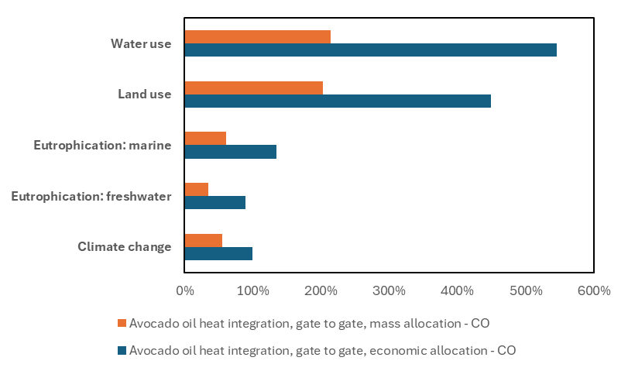
Figure 2: Analysis of different allocation scenarios for heat-integrated thermal-extractive avocado oil biorefinery.
- Conclusions
This study demonstrated the technical and environmental feasibility of a heat-integrated thermal-extractive avocado biorefinery for the valorization of avocado side streams in Northern Colombia, supported by detailed process simulation, techno-economic assessment, and life cycle assessment. To produce 1 kg of refined avocado oil at the biorefinery gate, the LCA results showed moderate impacts across climate change, eutrophication, land use, and water use, with environmental performance largely driven by upstream processes, particularly wastewater treatment, energy supply, solvent production, and feedstock transportation. Heat integration effectively reduced energy-related burdens, although uncertainty analysis highlighted sensitivity to background datasets, especially for climate change and water use. The comparison of allocation approaches revealed that while climate change results were relatively robust, land and water use impacts were highly sensitive to allocation choice, with subdivision providing a transparent and physically meaningful basis for multiproduct system assessment. Overall, the results confirm the potential of the proposed biorefinery as a sustainable pathway for agro-industrial residue valorization, while emphasizing that further environmental improvements should focus on wastewater management, low-carbon energy sourcing, solvent recovery, and logistics optimization.
Nomenclature
EF – Environmental Footprint

LCA – Life Cycle Assessment

LCI – Life Cycle Inventory

LCIA – Life Cycle Impact Assessment
Acknowledgments
Authors want to thank Universidad de Cartagena and Ministerio de Ciencia, Tecnologia e Innovacion de Colombia for their support to conduct this research project.
References
Andreasi Bassi, S., Biganzoli, F., Ferrara, N., Amadei, A., Valente, A., Sala, S., Ardente, F. (2023). Updated characterisation and normalisation factors for the Environmental Footprint 3.1 method. Publications Office of the European Union, EUR 31414 EN (JRC130796). DOI: 10.2760/798894.
Ioannou, I., D’Angelo, S. C., Galán-Martín, Á., Pozo, C., Pérez-Ramírez, J., Guillén-Gosálbez, G. (2021). Process modelling and life cycle assessment coupled with experimental work to shape the future sustainable production of chemicals and fuels. Reaction Chemistry & Engineering, 6, 1179–1194. DOI: 10.1039/D0RE00451K.
Gamero, E., Ruppert, S., Miehe, R., & Sauer, A. (2024). Process modeling and life cycle assessment of biorefinery concepts using agricultural residues. Energies, 17, 4282. DOI: 10.3390/en17174282
Garcia-Vallejo, M. C., et al. (2023). Alternatives for the valorization of avocado waste based on a life-cycle analysis approach. Agronomy, 13, 2229. DOI: 10.3390/agronomy13092229
Marques, C., et al. (2025). Life-cycle assessment in agri-food systems and the wine sector. Foods, 14, 1553. DOI: 10.3390/foods14091553
Meramo-Hurtado, S., Herrera-Rodríguez, T. C., & González-Delgado, Á. D. (2025). Economic and environmental hotspots of new thermal-extractive avocado biorefinery. Biomass and Bioenergy, 207, 108724. https://doi.org/10.1016/j.biombioe.2025.108724
Mondello, G., Niero, M., Falcone, G., et al. (2024). Life cycle–based assessment methods for circular economy strategies in the agri-food sector. International Journal of Life Cycle Assessment, 29. DOI: 10.1007/s11367-024-02336-4
Riondet, L., Rio, M., Perrot-Bernardet, V., & Zwolinski, P. (2024). Emerging technologies upscaling: Matching LCA practices with upscaling archetypes. Sustainable Production and Consumption, 50, 347–363. DOI: 10.1016/j.spc.2024.07.032
Solarte-Toro, J. C., Ortiz-Sanchez, M., Cardona Alzate, C. A. (2023). Environmental life cycle assessment (E-LCA) and social impact assessment (SIA) of small-scale biorefineries implemented in rural zones: the avocado (Persea Americana var. Americana) case in Colombia. Environmental Science and Pollution Research, 30(4), 8790–8808. DOI: 10.1007/s11356-022-20857-z.
Voglhuber-Slavinsky, A., Zicari, A., Smetana, S., Moller, B., Dönitz, E., Vranken, L., et al. (2022). Setting life cycle assessment (LCA) in a future-oriented context: the combination of qualitative scenarios and LCA in the agri-food sector. European Journal of Futures Research, 10, 15. DOI: 10.1186/s40309-022-00203-9

