 CHEMICAL ENGINEERING TRANSACTIONS  VOL. xxx, 2026 | A publication of  
The Italian Association
of Chemical Engineering
Online at www.cetjournal.it

Guest Editors: Leonardo Tognotti, Rubens Maciel Filho, Viatcheslav Kafarov
Copyright © 2026, AIDIC Servizi S.r.l.
ISBN 979-12-81206-xx-x; ISSN 2283-9216

Numerical Evaluation and Theoretical Insights of In-Situ Water Removal in DME Synthesis via CO₂ Hydrogenation
Emílio E.X. Guimarães Filho^{a,}*, Victor H.S. Ramosª, Julles M.S. Júniorª, Adriano P. Marianoª, Rubens M. Filhoª
ªUniversidade Estadual de Campinas (Unicamp), School of Chemical Engineering, Albert Einstein Avenue, 500, 13083-852, Campinas, São Paulo, Brazil.
emilioguimaraesf@gmail.com
Dimethyl ether (DME) is a promising alternative fuel, particularly when synthesized via CO₂ hydrogenation. Conventional processes are limited by water formation, which reduces conversion and selectivity. This study develops a kinetic model in MATLAB to evaluate the impact of in situ water removal on DME synthesis. Model validation against literature data showed excellent agreement (R² ≈ 0.999). Results indicate that partial water removal of around 30% is sufficient to enhance DME production by ≈ 37%, with diminishing gains beyond this point. The use of 2-cyanopyridine (2-CP) is theoretically discussed as an alternative for selective membranes for water removal as it gets formed. Even though 2-CP offers a conceptually simple alternative, regeneration and safety issues must be addressed. Overall, the numerical findings highlight that partial water removal can significantly intensify DME synthesis, and that the approach of using 2-CP requires further experimental investigation to assess its practical feasibility. Overall, the present work provides a methodological basis for evaluating and optimizing intensified DME synthesis routes from renewable CO₂.
  - Introduction
The production of dimethyl ether (DME) from synthesis gas has gained increasing attention as a promising route to incorporate biomass and other alternative feedstocks into the fuel sector. By enabling the generation of a synthetic fuel with physicochemical properties similar to fossil diesel, this pathway offers an attractive bridge between renewable resources and existing energy mix. Among the available process configurations, the single-step route, where syngas is converted to methanol and subsequently dehydrated to DME within the same reactor, stands out for its synergistic interaction of the involved reactions.

The chemistry of this system is typically described by the three reactions summarized in Eqs (1) to (3): CO hydrogenation, CO₂ hydrogenation, and methanol dehydration. The first two compete for the same catalytic sites during methanol formation, while the third governs its conversion into DME, forming a linear and self-contained reaction network that does not require explicit inclusion of the water–gas shift reaction, whose effect emerges naturally as a combination of the two methanol-forming equations.

$CO+2H_{2}↔{CH}_{3}OH$ (1)
${CO}_{2}+3H_{2}↔{CH}_{3}OH+H_{2}O$ (2)
$2{CH}_{3}OH↔{CH}_{3}O{CH}_{3}+H_{2}O$ (3)

Although membrane-assisted packed-bed reactors have been widely investigated for multiple purposes, their application to one-step DME synthesis lacks industrial maturity. Studies by Iliuta et al. (2010) and Diban et al. (2013) proposed numerical approaches to estimate membrane permeability parameters capable of selectively removing water, thereby enhancing DME formation. Despite the promising results, the practical realization of such reactors at large scale remains a substantial challenge, including its economic estimation for such equipment.

In this context, 2-cyanopyridine (2-CP) emerges as a conceptually attractive alternative for in-situ water removal in one-step DME synthesis, sequestrating the produced water. Rather than relying on selective transport through membranes, 2-CP can act as a homogeneous dehydrating agent, chemically binding the water formed during methanol synthesis and dehydration and thereby lowering its activity in the reacting medium. This additional reaction pathway has the potential to shift the overall equilibrium toward higher DME yields, while being, in principle, compatible with conventional packed-bed reactor designs. Building on this idea, the present work develops a numerical framework to quantify the impact of different degrees of water removal on DME production and to provide theoretical insights into the use of 2-CP as a reactive water trap, highlighting operational windows in which such an approach could be particularly advantageous.

  - Methodology
    - Kinetic model

The mechanism for DME formation from synthesis gas containing both CO and CO₂ is often associated with the model presented by Nie et al. (2005), who considered a bifunctional catalyst and the presence of N₂ in laboratory-scale experiments. Over time, some modifications in kinetic parameters were proposed: Shim et al. (2009) introduced changes to better fit their experimental data, and Luu et al. (2016) incorporated Shim’s adjustments while adding a more detailed description of the simulated plug-flow reactor. Although these contributions aimed at refining the model, certain aspects remain less transparent in terms of parameter justification and overall consistency. In contrast, Vakili et al. (2011) and Scognamiglio et al. (2024) adopted Nie’s framework with remarkable clarity, presenting kinetic parameters and model terms in a mathematically coherent and well-structured manner.

The kinetic model proposed by Nie et al. (2005) is presented in Eqs 4 to 6, where “r_{CO}”, “r_{CO2}” and “r_{DME}” are the formation reactions of CO hydrogenation, CO₂ hydrogenation, and DME formation from methanol dehydration, respectively. The clustered terms “β(i)” are key for better understanding which components can favor the forward and reverse reactions in each case. Table 1 and Eqs 7 to 9 are those proposed by Vakili et al. (2011) and Scognamiglio et al. (2024) for the kinetic parameters, adsorption terms and Kf(i) equilibrium constants derived from its thermodynamics.

$r_{CO}=\frac{k_{1}f_{CO}f_{H2}^{2}(1-β_{1})}{{\left(1+K_{CO}f_{CO}+K_{CO2}f_{CO2}+K_{H2}f_{H2}\right)}^{3}} β_{1}=\frac{f_{CH3OH}}{K_{f1}f_{CO}f_{H2}^{2}}$ (4)
$r_{CO2}=\frac{k_{2}f_{CO}f_{H2}^{3}(1-β_{2})}{{\left(1+K_{CO}f_{CO}+K_{CO2}f_{CO2}+K_{H2}f_{H2}\right)}^{4}} β_{2}=\frac{f_{CH3OH}f_{H2O}}{K_{f2}f_{CO}f_{H2}^{3}}$ (5)
$r_{DME}=\frac{k_{3}f_{CH3OH}(1-β_{3})}{{\left(1+\sqrt{K_{CH3OH}f_{CH3OH}}\right)}^{2}} β_{3}=\frac{f_{DME}f_{H2O}}{K_{f3}f_{CH3OH}^{2}}$ (6)

Table 1: Kinetic parameters and adsorption terms.
k = A*exp(B/RT) | A | B
k₁ | 1828 | -43723
k₂ | 44.95 | -30253
k₃ | 193.9 | -24984
K_{CO} | 8.252 x 10⁻⁴ | 30275
K_{CO2} | 2.1 x 10⁻³ | 31846
K_{H2} | 0.1035 | -11139
K_{CH3OH} | 1.726 x 10⁻⁴ | 60126

$K_{f1}=exp⁡(21.84+\frac{9040}{T}-7.66×Ln\left(T\right)+54.07x10^{-4}T)$ (7)
$K_{f2}=exp⁡(-24.08+\frac{7012.4}{T})$ (8)
$K_{f3}= exp⁡(-9.76+\frac{3200}{T}+1.07×Ln\left(T\right)-6.57x10^{-4}T)$ (9)

    - Matlab base algorithm

The academic version of Matlab 2023 was used for implementing the DME kinetics, validate the model and perform simulations. The algorithm allows the user to define overall process conditions such as operating temperature (“T”), pressure (“P”), molar flow rate and fractions in the inlet stream, and catalyst weight. The ‘ode15s’ is a solver for stiff differential equations commonly used to solve reactional models and is employed to integrate the molar flow and the catalyst weight per tube. Additionally, a “non-negative” instruction was given to the differential solver to force the molar fraction of each component to be a positive number.

As for model validation, it was considered a plug-flow reactor with 1 m length, 0.02 m diameter, 10 tubes, and catalyst density of 1380 kg/m³ as proposed by Luu et al. (2016) that claims to be an optimized configuration to host the reactional system. Also, the molar flow rate in the inlet was set to be 0.1205 mol/h, same value adopted by Nie et al. (2005) in their lab scale trials. To validate the model, the inlet molar fraction composition given by Shim et al. (2009) and Luu et al. (2016) was used for comparison. The feed stream is composed of 37.8 % CO, 14.2 % H₂, 8 % CO₂, and 40 % N₂. The plug-flow reactor was isothermal, operating under 250 °C, 50 bar.

Lastly, a final subroutine is implemented to estimate the components’ fugacity in any pair of T and P along with a Soave-Redlich-Kwong equation of state (“EoS”) – same EoS adopted by Shim et al. (2009), Luu et al. (2016) and Scognamiglio et al. (2024). All values of critical temperature, pressure, and acentric factors were taken from Perry et al. (1997). Some statistic metrics were employed to compare the obtained values with literature, including the mean absolute error (“MAE”), root mean square error ("RMSE”), and the coefficient of determination, R², represented in Eqs 10 to 12, respectively.

$MAE= \frac{1}{n}\sum_{i=1}^{n}{|y_{i}-\check{y_{i}}|}$ (10)
$RMSE= \sqrt{\frac{1}{n}{\sum_{i=1}^{n}{\left|y_{i}-\check{y_{i}}\right|}}^{2}}$ (11)
$R^{2}=1-\frac{\sum_{i=1}^{n}{{\left(y_{i}-{\check{y}}_{i}\right)}^{2}}}{\sum_{i=1}^{n}{{\left(y_{i}-{\overline{y}}_{i}\right)}^{2}}}$ (12)

Regarding the water removal condition, only two minor modifications were introduced into the base algorithm: i) a water removal rate was set sufficiently high to supress water formation in its stoichiometry (ΔH₂O = r_{CO2} + r_{DME} – r_{Remova}l) adopting a value of 10⁻³ mol kg⁻¹ s⁻¹ for this purpose. Its magnitude was then varied as a percentage of this reference value (0 – 100%), where 100% corresponds to the proposed rate, this enabling the investigation of different removal efficiencies across various plug-flow reactors; ii) to increase the inlet molar flow rate to 25 mol/h in order to slightly increase the scale and have a clearer view of the expected effects.
  - Results and discussion
    - Model validation

The results obtained with the proposed algorithm exhibit a strong agreement with those reported by other authors employing the same kinetic model (Table 1). When comparing this work with Shim’s simulation data, the calculated Mean Absolute Error (MAE) was 0.0034, the Root Mean Squared Error (RMSE) was 0.004, and the coefficient of determination (R²) reached 0.9994.
Table 2. Comparison between outputs obtained in this work versus other works.
Species | Inlet | Shim et al. (2009) – Exp. | Shim et al. (2009) – Sim. | Luu et al. (2016) – Sim. | This work – Sim.
CO | 0.378 | 0.313 | 0.316 | 0.314 | 0.314
CO₂ | 0.080 | 0.134 | 0.134 | 0.137 | 0.136
H₂ | 0.142 | 0.029 | 0.026 | 0.026 | 0.034
H₂O | 0.000 | 0.000 | 0.003 | 0.001 | 0.000
N₂ | 0.400 | 0.466 | 0.473 | 0.472 | 0.470
MeOH | 0.000 | 0.002 | 0.007 | 0.008 | 0.002
DME | 0.000 | 0.044 | 0.042 | 0.042 | 0.043
Exp: Experimental.
Sim: Simulated.

Figure 1 indicates that the conversion profiles reach equilibrium, suggesting that no further reaction progress is expected. Considering the reactor geometry and catalyst density, the estimated reactor volume is 0.31 L, with approximately 3.47 kg of total catalyst distributed across the 10 tubes. Overall, the results obtained thus far are sufficiently robust to justify advancing to subsequent refinement and optimization steps.

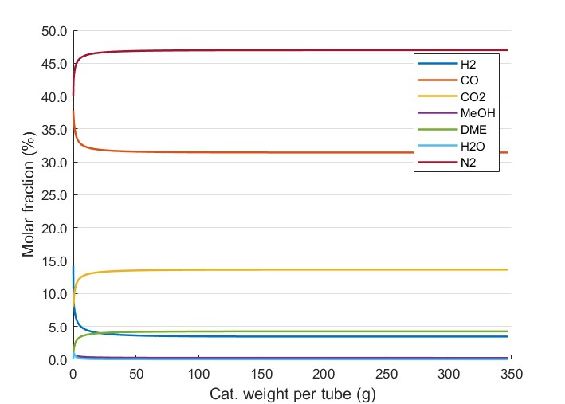

Figure 1. Conversion profiles in mol fraction for each component over the catalyst weight per tube (g).
    - Water removal
Figure 2 illustrates the molar composition of each component under varying water removal rates. The DME mol fraction increases almost linearly with water removal up to 30 % of the total produced, after which it reaches a plateau, indicating that further removal is possible but less effective. Figure 2 also provides a clearer view of DME production, expressed in mol/h, across various water removal percentages. Production rises from 0.51 to 0.70 kmol/h with only 30 % water removal (+37.25 % in DME production), followed by a less significant additional gain, reaching 0.72 kmol/h under complete water removal. This is an important finding since it shows that, numerically, an ideal adsorbent is not necessary to promote highly positive effects in DME production.

In the work of Iliuta et al. (2010), the authors did find a similar increase in theoretical DME yield around 30-35% (depending on the feed’s composition, i.e., H₂/CO ratio = 1 or 1.5, etc) when simulating an ideal and highly selective membrane for H₂O removal. Diban et al. (2013) mentioned that the dimethyl-ether yield was closely related to H₂O permselectivity, enabling a scenario where DME production can be actually lower than the conventional process if methanol gets permeated along with the produced water. Their so-called ideal zeolite membrane showed an improvement in DME yield of only 12.8%.
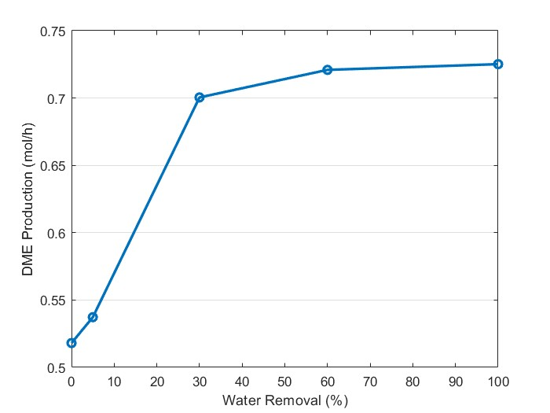
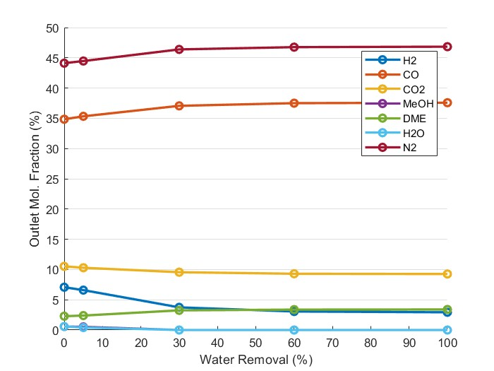
Figure 2. Effect of water removal over product composition (molar fraction) and DME production (kmol/h).
Considering Le Chatelier’s principle, the adsorption of water as it is formed within the reactional system helps mitigate its inhibitory effect, particularly under CO₂-rich feeds. This prevents the reverse conversion of CO₂ and H₂ into H₂O and CO, which would otherwise hinder both CO₂ hydrogenation pathway and DME formation via methanol dehydration (Eqs 2 and 3). Consequently, it is hypothesized that, in the absence of such inhibition effects, reactor design and sizing could be optimized to be smaller than those in conventional processes since equilibrium can be more readily achieved. On the other hand, experimental validations may reveal different outcomes, as the simultaneous presence of both catalyst particles and adsorbent materials can introduce additional complexities.

    - Theorical and practical discussions over the 2-cyanopyridine (2-CP)
The use of 2-cyanopyridine (2-CP) as a reactive dehydrating agent provides a chemical alternative to membrane or sorption-based water removal. In CO₂-to-dimethyl-carbonate (DMC) systems, 2-CP is well established as a benchmark water scavenger: it undergoes in-situ hydration to 2-picolinamide (and related species) over CeO₂, efficiently consuming the co-produced water and shifting the equilibrium toward higher carbonate yields. Continuous and batch studies consistently report drastic improvements in CO₂ conversion and DMC productivity when 2-CP is present, including packed-bed operation with CeO₂ catalysts and recent morphology-engineered ceria systems (Ohno et al, 2024; Ramos et al, 2024). By analogy, coupling the DME network with a 2-CP hydration reaction in a single reactor creates an internal chemical sink for water formed in CO₂ hydrogenation and methanol dehydration, lowering its activity and, in principle, driving the equilibrium toward higher DME yields without changing the overall reactor design.

When compared to membrane-assisted DME synthesis, this approach avoids the need for highly selective, hydrothermally stable water-permeable layers. Separation-enhanced and membrane-assisted DME concepts have demonstrated that in-situ steam removal can push single-pass CO₂ conversion and DME yield far beyond conventional packed beds, but they rely on membranes that must selectively transport water in the presence of H₂, CO₂, CO, methanol and DME. Any co-permeation of methanol directly penalizes DME formation, since a key intermediate is removed together with water, and material. In this landscape, a homogeneous water trap such as 2-CP is attractive because, at least conceptually, it can be dosed into a conventional packed-bed reactor and deliver an “equilibrium boost” without additional separation inside the reactor shell.

However, experience from the DMC literature also underscores important caveats that must be addressed before 2-CP can be considered a realistic option for DME synthesis. The use of 2-CP introduces extra species and reactions into the system, requiring additional downstream separation and, crucially, a viable route to regenerate 2-CP from its hydrated products (for example, via catalytic dehydration of 2-picolinamide back to the nitrile) (Li et al, 2019).

In addition, 2-CP hydration typically requires oxide surfaces, which may compete with DME catalysts for active sites and open new deactivation pathways, while the intrinsic toxicity and handling risks of nitriles must be considered in any scale-up scenario. Therefore, the present numerical exploration of “idealized” in situ water removal with 2-CP should be viewed as an upper-bound scenario: future work must explicitly quantify regeneration energetics, additional unit operations, catalyst stability and safety aspects.

  - Conclusions

This proposed numerical approach for investigation of water removal effects on dimethyl-ether synthesis successfully aligned with both literature and expected thermodynamic outcome. The kinetic model implemented in Matlab 2023a demonstrated good agreement with experimental and simulation data of previous studies.

The water removal algorithm brought two key findings: i) complete removal of water is not necessary, as removing only 30% is sufficient to significantly enhance the DME production in 37.25 %, with small improvements beyond this point; ii) the mitigation of inhibitory effects caused by water may lead to an opportunity for CO₂-rich streams, as proposed in the literature, representing a promising pathway for CO₂ valorization.

The theoretical exploration of 2-cyanopyridine (2-CP) as a reactive water trap provides a complementary route to achieve such partial in situ water removal while preserving a conventional packed-bed reactor configuration. By chemically binding a fraction of the water formed during CO₂ hydrogenation and methanol dehydration, 2-CP could internally shift the equilibrium toward higher DME yields without relying on membranes or large sorbent inventories. However, the practical feasibility of this concept will ultimately depend on the development of efficient regeneration schemes for 2-CP and the safe handling of its reaction products. Future work should therefore integrate the water-removal algorithm with detailed process flowsheets including 2-CP recycle, energy penalties and potential impacts on catalyst stability and DME’s downstream process.

Nomenclature

r(i) – reaction rate of species “i”, mol kg⁻¹ s⁻¹ | MeOH, CH₃OH – Methanol
k(j) – pre-exponential factor of reaction “j” | N₂ – Nitrogen
K(i) – Adsorption terms of species “i” | 2-CP – 2-cyanopyridine
Kf(j) – Equilibrium constant of reaction “j” | MAE – Mean absolute error
f(i) – Fugacity of species “i”, bar. | RMSE – Root mean squared error
CO – Carbon monoxide | EoS – Equation of state
CO₂ – Carbon dioxide | yi – observed value
H₂ – Hydrogen | ${\check{y}}_{i}$ – real value
H₂O – Water | ${\overline{y}}_{i}$ – mean of observed values
T – Temperature, K.

Acknowledgments

This study was financed by the Human Resources Training Program of the Brazilian National Agency for Petroleum, Natural Gas and Biofuels – PRH/ANP, under the management of the São Paulo Research Foundation (FAPESP), Brazil, Process N. 2025/20397-0.

References

Diban, N., Urtiaga, A.M., Ortiz, I., Ereña, J., Bilbao, J., Aguayo, A.T., 2013. Influence of the membrane properties on the catalytic production of dimethyl ether with in situ water removal for the successful capture of CO2. Chemical Engineering Journal 234, 140–148.
Iliuta, I., Larachi, F., Fongarland, P., 2010. Dimethyl ether synthesis with in situ H₂O removal in fixed-bed membrane reactor: Model and simulations. Industrial and Engineering Chemistry Research 49, 6870–6877.
Li, Y., Zhao, Y., Wang, S., Ma, X., 2019. Silica supported potassium oxide catalyst for dehydration of 2-picolinamide to form 2-cyanopyridine. Chinese Chemical Letters 30, 494–498.
Luu, M.T., Milani, D., Wake, M., Abbas, A., 2016. Analysis of di-methyl ether production routes: Process performance evaluations at various syngas compositions. Chemical Engineering Science 149, 143–155.
Nie, Z., Liu, H., Liu, D., Ying, W., Fang, D., 2005. Intrinsic kinetics of dimethyl ether synthesis from syngas. Journal of Natural Gas Chemistry 14, 22–28.
Ohno, H., Ikhlayel, M., Tamura, M., Nakao, K., Suzuki, K., Morita, K., Kato, Y., Tomishige, K., Fukushima, Y., 2021. Direct dimethyl carbonate synthesis from CO₂ and methanol catalyzed by CeO₂ and assisted by 2-cyanopyridine: A cradle-to-gate greenhouse gas emission study. Green Chemistry 23, 457–469.
Perry, R.H., Green, D.W., Maloney, J.O., 1997. Perry’s Chemical Engineers’ Handbook, International student edition. McGraw-Hill.
Ramos, V.H.S., Budin, A.E.L., Fregolente, L.V., Maciel Filho, R., Wolf Maciel, M.R., 2024. Insights on the separation process of the diethyl carbonate plant obtained by ethanol and CO₂. Chemical Engineering Research and Design 210, 289–300.
Scognamiglio, S., Ciccone, B., Ruoppolo, G., Landi, G., 2024. Design and Simulation of Methanol and Dimethyl Ether (DME) Production from Biomass-Derived Syngas 109, 277–282.
Shim, H.M., Lee, S.J., Yoo, Y.D., Yun, Y.S., Kim, H.T., 2009. Simulation of DME synthesis from coal syngas by kinetics model. Korean Journal of Chemical Engineering 26, 641–648.
Vakili, R., Pourazadi, E., Setoodeh, P., Eslamloueyan, R., Rahimpour, M.R., 2011. Direct dimethyl ether (DME) synthesis through a thermally coupled heat exchanger reactor. Applied Energy 88, 1211–1223.

