 CHEMICAL ENGINEERING TRANSACTIONS  VOL. , 2026 | A publication of  
The Italian Association
of Chemical Engineering
Online at www.cetjournal.it
Guest Editors:
Copyright © 2025, AIDIC Servizi S.r.l.
ISBN 979-12-81206-XX-X; ISSN 2283-9216
FP²O Techno-economic resilience assessment of a cascade biorefinery for the valorization of Hass avocado seed in the Colombian amazon
Tamy Carolina Herrera-Rodríguez*, Ángel Darío González-Delgado
Nanomaterials and Computer Aided Process Engineering Research Group (NIPAC), Chemical Engineering Department,
Faculty of Engineering, University of Cartagena, Av. del Consulado Calle 30 No. 48-152, Cartagena, Colombia.
therrerar@unicartagena.edu.co

The valorization of agro-industrial residues reduces environmental impacts and generates economic benefits by producing high-value products such as bioplastics and bioactive compounds. Avocado processing produces about 35% residues, with seeds rich in vitamins, lipids, polysaccharides, flavonoids, phenolics, and tannins. A cascade biorefinery based on Hass avocado seeds (Persea americana Mill.) is proposed to produce starch, biofilms, and biocontrol agents. A FP²O (Feedstock–Processing–Product–Operation) techno-economic resilience analysis was conducted for a biorefinery with a processing capacity of 255 t/y of avocado seeds in the Colombian Amazon. Results show the process remains viable under variations in operational costs, raw material prices, product prices, and processing capacity, demonstrating resilience under specific operational conditions. Profitability indicators confirm economic feasibility, with ROI of 47.67%, NPV of USD 0.75 million, and PBP of 1.09 years, allowing full capital recovery in less than five years.
1. Introduction
The energy transition has promoted the design of sustainable production systems, where valorizing agro-industrial residues is a key strategy for bioeconomy and circular economy development. Avocado production generates significant by-products, with the seed accounting for 13–20% of the fruit weight (Sandoval et al., 2023). Improper disposal causes environmental impacts and wastes valuable resources. Avocado seeds are rich in lignocellulosic material, starch, and bioactive compounds, making them promising feedstocks for bioplastics, biofuels, and biocomposites (Féliz et al., 2024; Saratale et al., 2025). The biorefinery concept enables integrated biomass valorization, producing multiple products while minimizing waste (García-Maza et al., 2025).
Recent studies have assessed the technical and economic feasibility of avocado seed biorefineries using simulation tools like Aspen Plus®, estimating key indicators such as ROI, NPV, and payback period. García-Maza et al. (2025) reported an ROI of ~37.6% and payback periods below two years for a biorefinery in the Colombian Amazon, demonstrating economic viability. Malagón et al. (2025) evaluated pyrolysis of avocado seeds to produce biochar, bio-oil, and gas, identifying energy consumption as a major factor affecting feasibility. Saratale et al. (2025) explored bioplastics and nanocomposites production, highlighting the potential of these systems within circular economy frameworks. Rodríguez et al. (2022) emphasized opportunities to obtain polyphenolic extracts, pectooligosaccharides, and succinic acid from avocado residues, stressing process integration. Dávila et al. (2017) proposed a biorefinery model utilizing pulp, seed, and peel, showing that product diversification and energy integration improve profitability. Techno-economic resilience has become a critical evaluation tool, assessing system robustness under uncertainties such as market fluctuations and raw material costs. González-Delgado et al. (2023) highlighted its importance in hydrogen production via gasification, while Cheali et al. (2016) demonstrated that multiproduct biorefineries better withstand variations in raw material and energy prices. Similar trends are observed in other biomass systems, such as grape pomace, where Jin et al. (2021) found that product diversification enhances economic sustainability.
In this study, resilience is assessed through an FP²O analysis applied to a cascade avocado seed biorefinery producing starch, a biofilm, and a biocontrol agent. This approach evaluates process stability under varying product prices, raw material costs, and operating conditions. Developing biorefineries in regions like the Colombian Amazon represents a strategic opportunity to foster sustainable development, technological innovation, and strengthen local economies based on natural resources. Avocado waste valorization reduces environmental impacts while promoting value creation, employment, and productive diversification in rural areas (Herrera-Rodríguez et al., 2025). Cascade biorefineries integrate multiple conversion pathways to produce high-value products in successive stages, improving overall system efficiency and economic resilience.
2. Materials and methods
2.1 Process description
The evaluated cascade biorefinery uses Hass avocado seeds cultivated in southern Colombia. From this biomass, three main products are obtained: starch, a biocontrol agent, and a biofilm. Figure 1 shows the process flow diagram, which is divided into four sections.
Section 1 (seed conditioning): in this stage, the seeds are washed with water to remove impurities and pulp residues. Subsequently, they undergo a cutting process to reduce their size and facilitate their transformation in the subsequent stages.
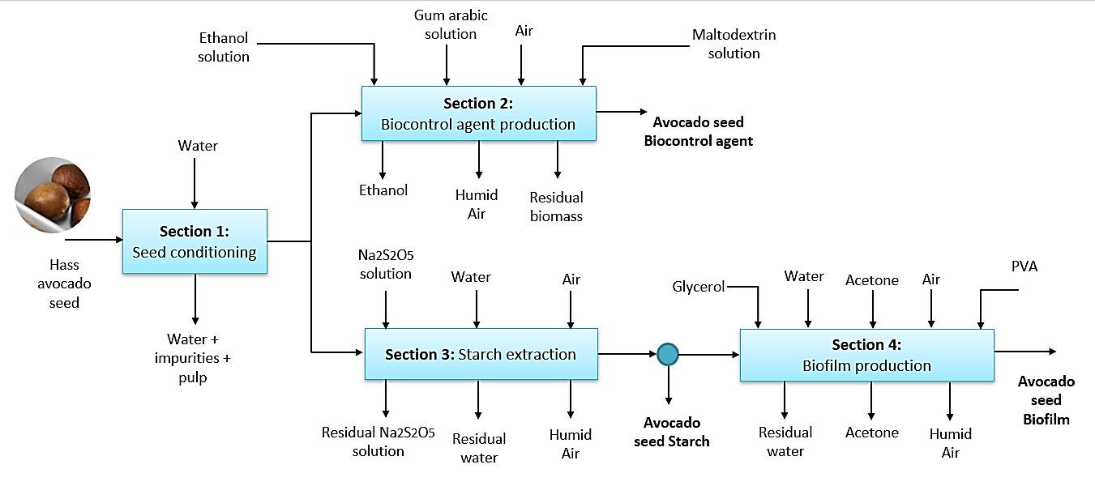
Figure 1: Sectional block diagram of the avocado seed cascade biorefinery in the Colombian Amazon
Section 2 (Biocontrol agent production): A fraction of the conditioned seeds is ground and freeze-dried, then macerated with ethanol. The mixture is filtered, partially evaporated, and spray-dried to yield the biocontrol agent, with humid air as a residual stream.
Section 3 (Starch extraction): The remaining seeds are treated with sodium metabisulfite (Na₂S₂O₅), ground, and filtered. Starch is separated by sedimentation, washed, centrifuged, and dried. Part of the starch is stored as product, and the rest goes to Section 4.
Section 4 (Biofilm production): Starch is mixed with water, glycerol, acetonic avocado seed extract, and PVA (polyvinyl alcohol) solution, then dried to produce biofilm, with humid air as a residual stream. From 255.92 t/y of Hass avocado seeds in the Colombian Amazon, the process yields approximately 28 t/y of biocontrol agent, 4.25 t/y of starch, and 14.75 t/y of biofilm.
2.2 Resilience Techno-economic Analysis
This analysis builds on the techno-economic evaluation, varying parameters such as raw material costs, product prices, operating costs, and processing capacity to assess system behavior under potential changes and determine resilience. Known as FP²O (Feedstock–Processing–Product–Operation), it is a key tool for process design, supporting decisions from energy, environmental, technical, and safety perspectives. Its application requires detailed data on equipment, raw materials, labor, utilities, interest rates, and all plant-related expenses. Some relevant equations for techno-economic and resilience evaluation are presented below.
Eq. (1) is used to calculate the Total Capital Investment (TCI), which includes the Fixed Capital Investment (FCI), Working Capital Investment (WCI), and Start-Up Costs (SUC). Eq. (2) is used to determine the Annual Operating Cost (AOC), which corresponds to the recurring expenses required to operate the plant. These costs can be further divided into Variable Annual Operating Cost (VAOC), which includes raw materials and utilities, and Fixed Annual Operating Cost (FAOC), associated with direct production costs, fixed charges, plant overhead, and general services. Eq. (3) and (4) are used to calculate the Annual Fixed Cost (AFC) and the Total Annualized Cost (TAC), respectively (El-Halwagi, 2011; Romero et al., 2017).
$$TCI=FCI+WCI+SUC (1)$$
$$AOC=RM+U+ DPC+FCH+POH+GE (2)$$
$$AFC=\frac{FCI_{0}-FCI_{s}}{N} (3)$$
$$TAC=AFC+AOC (4)$$
$$ROI=\frac{PAT}{TCI}x100 \% (5)$$
$$NPV=\sum_{n}{AFC_{n}}{\left(1+i\right)}^{-n} (6)$$
$$PBP=\frac{FCI}{PAT} \left(7\right)$$
$$DGP=\sum_{i}{m_{i}C_{i}^{v}}-TA (8)$$
$$PAT=DGP\left(1-itr\right) \left(9\right)$$
$$IRR= \sum_{T=0}^{n}{\frac{AFC_{n}}{{\left(1+i\right)}^{n}}}=0 (10)$$
$$EBITDA=EBIT+AFC (11)$$
Additionally, several economic and profitability indicators are considered, such as Return on Investment (ROI), Net Present Value (NPV), and Payback Period (PBP), which are determined using Eq. (5), (6), and (7), respectively (El-Halwagi, 2011). These indicators account for the time value of money and allow the evaluation of process performance under different scenarios. Furthermore, the Depreciation-Adjusted Profit (DPG) is calculated using Eq. (8), while the Profit After Taxes (PAT) is obtained using Eq. (9). The Internal Rate of Return (IRR), defined as the rate at which the Net Present Value equals zero, is calculated using Eq. (10). Finally, EBITDA (Earnings Before Interest, Taxes, Depreciation, and Amortization) is an indicator used to evaluate process profitability excluding non-cash expenses such as depreciation and amortization, and it is calculated using Eq. (11) (Herrera-Rodríguez et al., 2024).
3. Results and discussion
For the techno-economic and resilience assessment, a raw material cost of 22 $/t, a processing capacity of 255.92 t/y of avocado seed, and a selling price of 61,958.33 $/t were considered. The resilience analysis was performed by varying the product selling price, raw material cost, processing capacity, and normalized annual variable operating costs (NVAOC).
3.1 Resilience considering Raw Material Cost
Figure 2 shows the effect of avocado seed cost on economic indicators such as EBITDA, net income (PAT), internal rate of return (IRR), and normalized annual operating cost (NVAOC), with base values of 0.28 MM$/y, 0.17 MM$/y, 35.15%, and 1326.7 $/t-RM, respectively. The results reveal a high sensitivity of the economic performance to the raw material cost, even though it is an agro-industrial residue. In Figure 2a, both PAT and EBITDA decrease linearly as the seed cost increases; the raw material cost considered was 22 $/t-RM. A critical point was identified as 1100 $/t-RM, beyond which the process ceases to be profitable. However, the considered cost is significantly below this threshold, indicating that the cascade biorefinery maintains profitability even under considerable increases in raw material price.
Meanwhile, in Figure 2b, the IRR remains at 34% for costs below the considered base value, but decreases significantly as this parameter increases, while the NVAOC shows an upward trend. This behavior confirms that costs associated with the collection, transport, and conditioning of the residue are key factors in the system’s viability. These results are consistent with those reported in the literature for other processes, such as PVC production and the valorization of palm rachis for hydrogen production. In the case of PVC, an IRR of 18% with an NVOC of 855.66 $/t is reported for a raw material cost of 605.93 $/t (Herrera-Rodríguez et al., 2024), whereas in biomass-based systems, increases in feedstock cost have been observed to reduce the IRR to values close to 10%, although under favorable conditions values above 38% can be achieved (Herrera-Rodríguez et al., 2026).

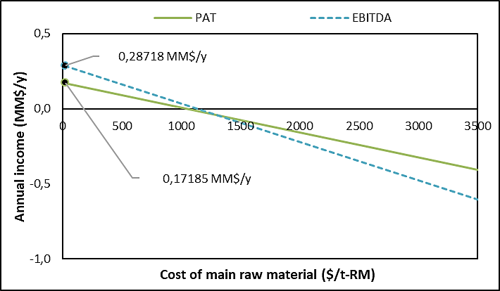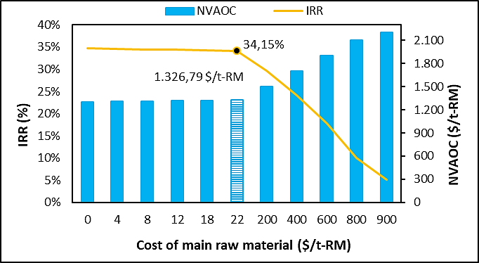
Figure 2: Resilience of (a) EBITDA and Profit After Taxes (PAT) and (b) Operating Costs and Internal Rate of Return (IRR) to variations in raw material costs
3.2 Resilience considering Selling Price
Figure 3 shows the influence of the selling price on the economic performance of the system, considering a value of 61,958 $/t. In Figure 3a, the On-Stream Efficiency at the breakeven point is 80.55 %, indicating that the plant must operate at more than 50 % of its capacity to generate profit. Three zones can be identified according to the product price: between 35,000 and 100,000 $/t, the efficiency ranges from 80.55 % to 75 %; between 100,000 and 315,000 $/t, efficiency decreases from 75 % to 25 %, corresponding to a transition zone; and above 315,000 $/t, efficiency remains around 25 %. Achieving low efficiency values requires more than doubling the selling price.
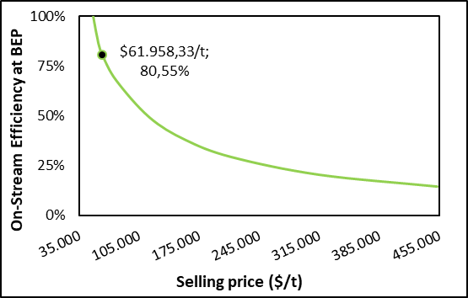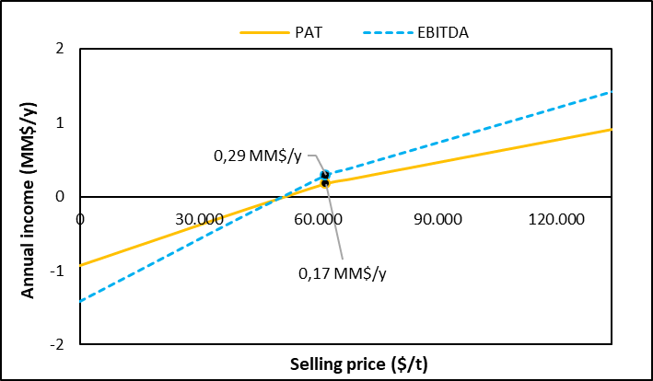
Figure 3: Resilience of (a) On-Stream Efficiency at the BEP and (b) Annual Income to variations in product selling price
Figure 3b shows that the considered price allows for positive PAT and EBITDA values (0.17 MM$/y and 0.29 MM$/y, respectively), confirming the process’s viability. The increasing trend of these metrics with selling price highlights the system’s dependence on generated revenue. From a techno-economic resilience perspective, the process exhibits moderate resilience, as its stability relies on favorable market conditions. This behavior is consistent with other biorefinery processes, such as hydrogen production from lignocellulosic biomass, where the final product price is a key determinant of profitability (Hamedani Rajabi et al. 2016).
3.3 Resilience Considering Processing Capacity
In Figure 4a, annual sales increase linearly with processing capacity, while annual operating costs (AOC) remain relatively constant. This results in a breakeven point close to 0.26 kt-RM/y, where revenues (1.69 MM$/y) equal costs (1.42 MM$/y). The results indicate that the process is highly sensitive to capacity reduction; a decrease in the processing capacity of the avocado seed biorefinery causes annual sales to fall below operating costs.

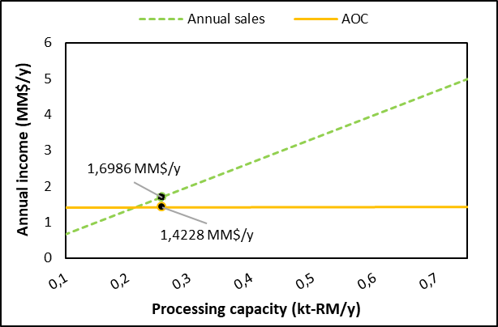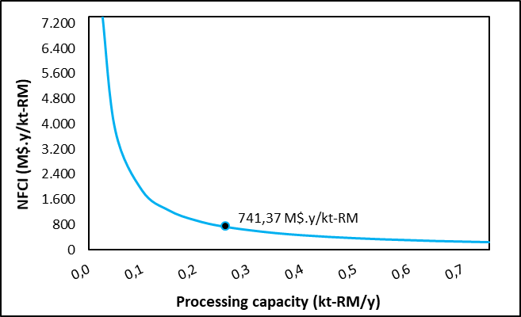
Figure 4: Resilience of (a) Annual Sales and Operating Costs and (b) Normalized FCI to variations in processing capacity of the biorefinery
In Figure 4b, the normalized fixed cost (NFCI) decreases with increasing capacity, reflecting economies of scale, with an approximate value of 741.37 M$/kt-RM at the reference capacity. These results show that the system behaves favorably with scaling, contributing positively to its techno-economic resilience by allowing increased capacity to offset cost rises. However, this resilience depends on operating at sufficiently high scales, so the system can be considered moderately resilient and conditioned on optimal operating conditions.
3.4 Resilience Considering NVAOC
Figure 5 shows the relationship between normalized annual operating costs (NVAOC) and two key profitability indicators: return on investment (ROI) and payback period (PBP).
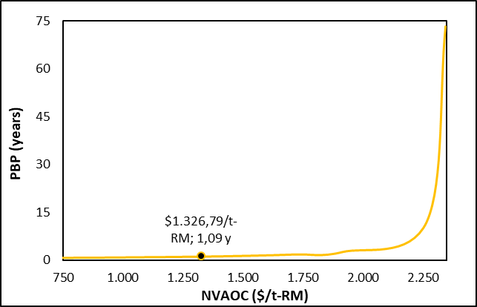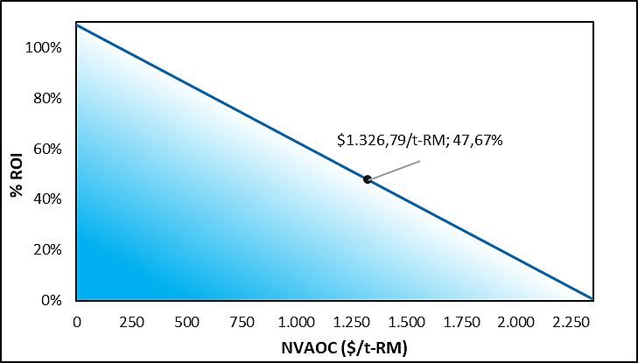
Figure 5: Resilience of a) Payback Period and b) Return on Investment to variations in Normalized Annual Operating Costs (NVAOC) of the biorefinery
In Figure 5a, the PBP increases nonlinearly with rising NVAOC, reaching very low values (1.09 years) under favorable conditions, but rising sharply as operating costs increase, reflecting a significant deterioration in investment recovery. Additionally, Figure 5b shows an inverse relationship between ROI and NVAOC, where increasing operating costs progressively reduce project profitability, from values above 100% down to near zero. The biorefinery exhibits an NVAOC of 1,326.79 $/t-RM with an ROI of 47.67%, indicating attractive profitability under base conditions. Overall, these results demonstrate that the system is highly sensitive to operating costs, which limits its techno-economic resilience, as small variations in NVAOC can significantly affect profitability indicators. According to García-Maza et al. (2025) evaluated avocado biorefineries considering economies of scale and reported an ROI of 37.58% with a PBP of nearly two years. This comparison highlights that the biorefinery configuration and operational considerations in the present study contribute to improved economic performance, supporting the viability and efficiency of the proposed system.
4. Conclusions
The valorization of agro-industrial residues, particularly Hass avocado seeds (Persea americana Mill.), represents a strategic alternative for advancing sustainable production models under the biorefinery concept. This study proposed the comprehensive utilization of this biomass, generating high-value-added products such as starch, bioplastics, and biocontrol agents, while simultaneously reducing the environmental impacts associated with improper disposal. Resilience analysis using the FP²O methodology revealed that the economic performance is sensitive to variations in operating costs, selling price, raw material cost, and processing capacity. While the use of an agro-industrial residue reduces input costs, expenses related to collection, transport, and conditioning significantly affect profitability. The joint production of multiple products and increased processing capacity generate stable revenues and economies of scale; however, indicators such as IRR, ROI, and PBP demonstrate moderate resilience against market fluctuations. Therefore, the avocado seed biorefinery constitutes a promising technological alternative for waste valorization, promoting sustainability, value-added generation, and the strengthening of local economies, provided that operational stability and favorable market conditions are maintained.
Acknowledgments
The authors gratefully acknowledge the financial support provided by the Universidad de Cartagena and the Colombian Ministry of Science, Technology, and Innovation (MINCIENCIAS) for this research. This work was funded under the project “Desarrollo de un modelo de bioeconomía para la obtención de productos derivados de la semilla de aguacate Hass con aplicabilidad en el sector agrícola y alimentario en el departamento del Putumayo” with project code SIGP 100307, contract 442-2023.
References
Cheali, P., Posada, J.A., Gernaey, K.V., Sin, G., 2016, Economic risk analysis and critical comparison of optimal biorefinery concepts, Biofuels, Bioproducts and Biorefining, 10(4), 368–384.
Dávila, J.A., Rosenberg, M., Castro, E., Cardona, C.A., 2017, A model biorefinery for avocado (Persea americana Mill.) processing, Bioresource Technology, 243, 17–29.
El-Halwagi, M., 2011, Sustainable Design Through Process Integration: Fundamentals and Applications to Industrial Pollution Prevention, Resource Conservation, and Profitability Enhancement, Elsevier, Amsterdam, The Netherlands.
Féliz-Jiménez, A., Sanchez-Rosario, R., 2024, Bioactive Compounds, Composition and Potential Applications of Avocado Agro-Industrial Residues: A Review, Applied Sciences., 14, 10070.
Garcia-Maza, S., Alviz-Meza, A., Gonzalez-Delgado, A.D., 2025, Economies of scale and resilience assessment of avocado biorefineries using FP²O methodology, Chemical Engineering Transactions, 119, 253–258.
González-Delgado, Á.D., Vargas-Mira, A., Zuluaga-García, C., 2023, Economic evaluation and technoeconomic resilience analysis of two routes for hydrogen production via indirect gasification in North Colombia, Sustainability, 15, 16371.
Hamedani Rajabi, S., Bocci, E., Villarini, M., Di Carlo, A., Naso, V., 2016, Techno-economic analysis of hydrogen production using biomass gasification – A small scale power plant study, Energy Procedia, 101, 806–813.
Herrera-Rodríguez, T.C., Rojas-Flores, S., González-Delgado, Á.D., 2025, Bioeconomy model for avocado valorization in Colombia, Processes, 13, 3561.
Herrera-Rodríguez, T.C., Ramos-Olmos, M., González-Delgado, Á.D., 2024, A joint economic evaluation and FP²O techno-economic resilience approach for evaluation of suspension PVC production, Results in Engineering, 24, 103069
Jin, Q., O’Keefe, S.F., Stewart, A.C., Neilson, A.P., Kim, Y.-T., Huang, H., 2021, Techno-economic analysis of a grape pomace biorefinery: Production of seed oil, polyphenols, and biochar, Food and Bioproducts Processing, 127, 139–151.
Malagón-Romero, D.H., León-Caballero, N.D., Velasco-Peña, M.A., Arrubla-Vélez, J.P., Quintero-Naucil, M., Aristizábal-Marulanda, V., 2025, Pyrolysis of Hass avocado (Persea americana) seeds: Kinetic and economic analysis of bio-oil, gas, and biochar production, BioEnergy Research, 18, 33.
Romero, J., Vergara, L., Peralta, Y., González, A., 2017, A Techno-Economic Sensitivity Approach for Development of Palm-Based Biorefineries in Colombia, Chemical Engineering Transactions, 57, 13–18.
Rodríguez-Martínez, B., Romaní, A., Eibes, G., Garrote, G., Gullón, B., del Río, P.G., 2022, Potential and prospects for utilization of avocado by-products in integrated biorefineries, Bioresource Technology, 364, 128034.
Sandoval-Contreras, T., González Chávez, F., Poonia, A., Iñiguez-Moreno, M., Aguirre-Güitrón, L., 2023, Avocado Waste Biorefinery: Towards Sustainable Development, Recycling, 8, 81.
Saratale, R.G., Cho, S.K., Bharagava, R.N., Vivekanand, V., Bhatia, S.K., Ferreira, L.F.R., Shin, H.S., Jeon, B.-H., Kumar, R., Saratale, G.D., 2025, Biorefinery of avocado seed waste for sustainable production of bioplastics and functionalized silver nanocomposites, International Journal of Biological Macromolecules, 323, 147042.

