 CHEMICAL ENGINEERING TRANSACTIONS  VOL. , 2026 | A publication of  
The Italian Association
of Chemical Engineering
Online at www.cetjournal.it
Guest Editors:
Copyright © 2025, AIDIC Servizi S.r.l.
ISBN 979-12-81206-XX-X; ISSN 2283-9216
Exergy Sensitivity Assessment of a Seed-Based Cascade Biorefinery for Hass Avocado Valorization in the Colombian Amazon
Tamy Carolina Herrera-Rodríguez*, Ángel Darío González-Delgado
Nanomaterials and Computer Aided Process Engineering Research Group (NIPAC), Chemical Engineering Department,
Faculty of Engineering, University of Cartagena, Av. del Consulado Calle 30 No. 48-152, Cartagena, Colombia.
therrerar@unicartagena.edu.co

Colombia is among the five main exporters of Hass avocado worldwide. This fruit is supplied to more than 38 international markets, including Spain, France, the United Kingdom, China, Japan, and the Netherlands. While the avocado pulp is widely consumed, the seed anred peel are usually discarded despite their high content of antioxidants, phytochemicals, and compounds with anti-inflammatory properties. In this study, the exergy sensitivity associated with the valorization of Hass avocado seed cultivated in the Colombian Amazon was evaluated through the application of the biorefinery concept. This approach integrates simultaneous valorization routes to produce starch, a biocontrol agent, and a biofilm. The objective of this assessment is to determine the optimal conditions to improve the overall exergy efficiency and reduce the unavoidable losses of the system through the analysis of different scenarios and process variations. The exergy analysis yielded an overall exergy efficiency of 68.6%. Furthermore, the sensitivity analysis showed that the drying and separation stages have the greatest influence on system performance, as the drying efficiencies of starch and biofilm can reach values between 95–99% under optimized conditions. The results also indicate that avoidable losses contribute more significantly to the reduction of system sensitivity than irreversibilities associated with the second law of thermodynamics. These findings highlight the potential of cascade biorefineries to reduce energy demand and associated greenhouse gas emissions, contributing to the development of more sustainable and low-carbon production systems.
1. Introduction
In recent years, avocado consumption has increased due to its nutritional value, generating significant agro-industrial residues such as seeds and peels that can be converted into bioproducts and energy. These residues can be valorized through cascade biorefineries, which prioritize the sequential extraction of compounds and support circular economy strategies. To ensure the sustainability and efficiency of these systems, exergy analysis and exergetic sensitivity studies are used to evaluate energy quality, identify irreversibilities, and detect critical stages with high exergy losses that can be optimized (Hernández, 2023; Silva et al., 2024).
However, studies on exergetic sensitivity applied to biorefineries remain limited. Herrera et al. (2025) analyzed an avocado biorefinery in Colombia, identifying distillation and pyrolysis as the main sources of exergy destruction. Similarly, Meramo et al. (2020) evaluated chitosan production from shrimp exoskeleton, showing that improvements in the depigmentation stage can significantly increase the overall exergy efficiency. Other studies have applied exergetic sensitivity analysis to processes outside biorefineries. Hashemi et al. (2019) reported that reducing temperature improves exergy efficiency in a modified Claus process, while Qureshi and Zubair (2016) identified relationships between operating variables and exergy destruction in reverse electrodialysis systems. Exergetic sensitivity analysis evaluates the response of a system to variations in operating conditions (Pérez et al., 2023). In contrast, exergetic resilience refers to the ability of a system to maintain or recover its performance under disturbances, whereas sensitivity analysis evaluates the effect of parameter variations. In this study, the focus is on exergetic sensitivity. However, existing studies have mainly identified critical variables without fully addressing system behavior under variable and uncertain conditions, particularly in agro-industrial biorefineries. In this context, the present study evaluates the exergetic sensitivity of a cascade biorefinery based on avocado seeds from the Colombian Amazon region for starch and biofilm production. The system promotes progressive use of biomass chemical exergy, improving efficiency compared to single-valorization approaches. The study identifies stages with the highest exergy destruction and evaluates the impact of operational variations on system performance, supporting process optimization and design from technical and environmental perspectives.
2. Materials and methods
2.1 Process description
The evaluated biorefinery uses Hass avocado seeds produced in the Colombian Amazon region. It was simulated in Aspen Plus software by selecting the Non-Random Two-Liquid (NRTL) thermodynamic model for the liquid phase and the Redlich-Kwong (RK) equation of state for the vapor phase. The process begins with washing the seeds to remove impurities, followed by drying at 50 °C and size reduction to facilitate subsequent processing. The seed stream is divided into two flows: one for starch and biofilm 1 production, and the other for biofilm 2. For starch production, the chopped seeds are contacted with a sodium metabisulfite solution for 24 h, followed by liquefaction, filtration, and decantation to separate the starch. The recovered starch is washed, dried, and divided into three fractions: one corresponds to the final starch product, and the other two are used as raw material for biofilm production.

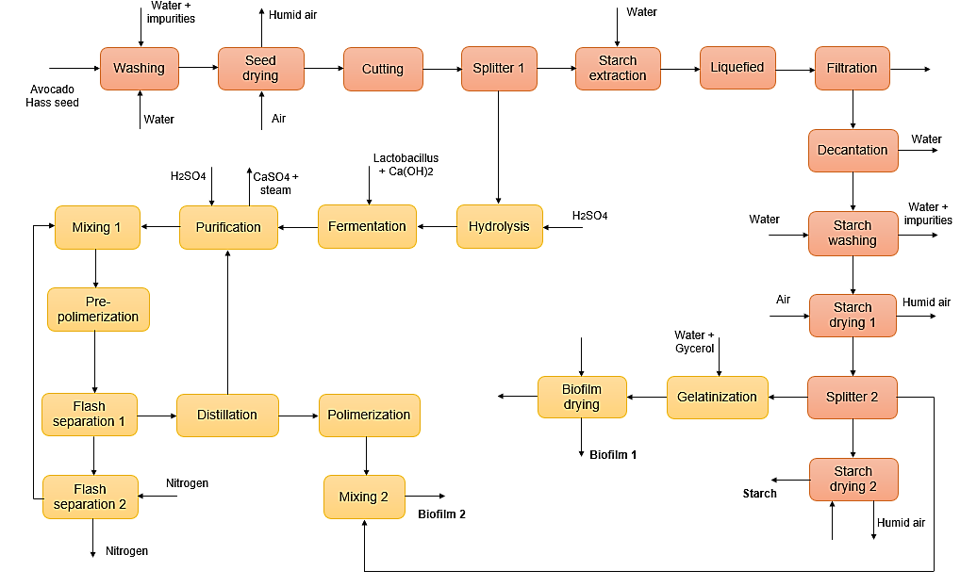
Figure 1: Process flow diagram of the cascade biorefinery for Hass avocado seed
Meanwhile, the seed stream from splitter 1 is hydrolyzed at 120 °C with a 5 wt.% H₂SO₄ solution and fermented with Lactobacillus and Ca(OH)₂ to produce lactic acid (Alvíz et al., 2025). Undesired compounds are removed through neutralization, filtration, and flash separation, generating steam and gypsum as residual streams, while the concentrated lactic acid proceeds to pre-polymerization to form L-lactide and M-lactide monomers for PLA production (Swetha et al., 2023). Pre-polymerization is carried out under nitrogen, which circulates through the flash separation units and is purged from the system. The stream from flash separator 1 is distilled to recover unreacted lactic acid, which is recycled to purification, while the remaining stream is polymerized to produce PLA. Finally, PLA is combined with starch (mixing stage 3) to obtain biofilm 2. Figure 1 shows the block flow diagram of the cascade biorefinery, where the yellow section corresponds to biofilm production and the orange section to starch production.
2.2 Exergy analysis and exergy sensitivity
Exergy analysis is a method based on the second law of thermodynamics used to evaluate the quality of energy and quantify system irreversibilities by determining the maximum useful work obtainable at equilibrium with the environment. It helps identify thermodynamic losses, exergy destruction, and improvement opportunities, and is widely applied to optimize chemical, thermal, and biomass conversion systems (Bejan, 2016; Dincer & Rosen, 2013; Kotas, 2013). Equation (1) corresponds to the exergy associated with work, which is equivalent to the useful work transferred within the system. The exergy associated with heat is calculated using Equation (2), which considers the heat flow transferred at a given temperature and the temperature of the reference environment. Meanwhile, the exergy of mass streams is calculated using Equation (3) as the sum of the physical, chemical, potential, and kinetic contributions (Herrera et al., 2025a). Chemical and physical exergies were calculated using Equations (4) and (5), respectively. Biomass was represented by conventional compounds (leucine, catechin, calcium oxide, water, oleic acid, and glucose), and its chemical exergy was determined as a weighted sum based on molar fractions and standard literature values.
$$Ex_{work}=W (1)$$
$$Ex_{heat}=∑\left(1-\frac{T_{0}}{T}\right)Q_{i} (2)$$
$Ex_{mass}=Ex_{phy}+Ex_{chem }+Ex_{potential}+Ex_{kinetic} (3)$
$Ex_{chem}=∑y_{i}Ex_{ch-i}+RT_{0}∑y_{i}\ln\left(y_{i}\right) (4)$
$Ex_{phy}=m_{i}\left[\left(h_{i}-h_{0}\right)-T_{0}\left(s_{i}-s_{0}\right)\right] (5)$
$$Ex_{destroyed }= Ex_{heat}+ Ex_{work}+ Ex_{mass} (6)$$
Exergy destruction, output, and losses were calculated using Equations (6), (7) and (8), considering heat, work, and mass flow contributions. Product-related losses and the percentage of exergy destruction were determined using Equations (9) and (10), respectively. Finally, the overall exergy efficiency was calculated using Equation (11), accounting for the exergy effectively utilized after process irreversibilities. (Herrera et al., 2025a).
$$Ex_{total-out} = \sum{Ex_{products}}+\sum{Ex_{residues}} (7)$$
$$Ex_{losses} = \sum{Ex_{in}}- Ex_{total-out} (8)$$
$${Loss}_{ex} = \sum{Ex_{in} }- \sum{Ex_{products} } (9)$$
${Ex}_{destroyed}=\left(\frac{Loss_{ex}}{{Loss}_{total-ex}}\right)*100\% (10)$
$$η_{exergy}=1-\left(\frac{Loss_{total-ex}}{Ex_{total-in}}\right) (11)$$
Exergetic sensitivity refers to the analysis that evaluates changes in process parameters that affect the exergetic indicators of a system (e.g., exergy efficiency, exergy destruction, among others), allowing the identification of variables or stages that generate the highest irreversibilities and thereby facilitating opportunities for process improvement and optimization (Dincer & Rosen, 2013; Kotas, 2013). Recent studies have developed exergetic sensitivity analyses to evaluate the performance of complex energy systems in petrochemical processes and biorefineries, enabling the quantification of critical parameters related to exergy and sustainability metrics (Herrera et al., 2025a)
3. Results and discussion
The overall exergy performance of the biorefinery is presented below, with respect to irreversibilities and the most critical process stages. Table 1 summarizes the process stages along with their corresponding irreversibilities and exergetic efficiencies. The total irreversibilities for the biorefinery were 5453.56 MJ/h, the overall exergetic efficiency was 68.66 %, and the exergy associated with the waste streams was 1169.51 MJ/h. The reference state was taken as 25 °C and 1 atm. Table 1 presents the names of the stages considered in the exergetic sensitivity analysis.
Table 1: Exergy of waste streams, irreversibilities, and exergetic efficiency by stage for the biorefinery
No. | Stage | Exergy from waste (MJ/h) | Irreversibilities (MJ/h) | Exergetic Efficiency (%)
1 | Washing | 3.59 | 18.80 | 96,26%
2 | Seed drying | 8.53 | 284.43 | 62,99%
3 | Cutting | 0.00 | 3.60 | 99.26%
4 | Starch Extraction | 0.00 | 1.50 | 99.49%
5 | Liquefied | 0.00 | 28.65 | 91.05%
6 | Filtration | 0.00 | 0.00 | 100.00%
7 | Decantation | 0.47 | 0.07 | 99.92%
8 | Starch washing | 1.32 | 16.00 | 84.02%
9 | Starch drying 1 | 11.77 | 392.10 | 17.67%
10 | Starch drying 2 | 13.57 | 393.42 | 8.80%
11 | Gelatinization | 0.00 | 3.07 | 95.92%
12 | Biofilm drying | 6.52 | 352.14 | 3.45%
13 | Hydrolysis | 0.00 | 0.00 | 100.00%
14 | Fermentation | 0.00 | 328.31 | 38.20%
15 | Purification | 89.79 | 195.93 | 40.46%
16 | Mixing 1 | 0.00 | 0.25 | 99.64%
17 | Pre-polymerization | 0.00 | 0.00 | 100.00%
18 | Flash separation 1 | 0.08 | 22.41 | 76.43%
19 | Flash separation 2 | 0.66 | 20.82 | 0.06%
20 | Distillation | 0.00 | 19.20 | 79.20%
21 | Polymerization | 0.00 | 6.32 | 91.28%
22 | Mixing 2 | 0.00 | 0.04 | 99.94%

3.1 Exergy Sensitivity
Figure 2 shows the influence of the process stages on the total irreversibilities and the overall exergetic efficiency of the cascade biorefinery. The bars represent the total irreversibilities, while the lines indicate the overall exergetic efficiency obtained for each evaluated stage. The stages considered correspond to those in which exergy from waste streams is generated. Irreversibilities show relatively small variations for stages 1, 2, 7, 8, 9, and 10, with values ranging between 5440 and 5449 MJ/h. A similar trend is observed for the overall exergetic efficiency, which fluctuates between 68.68–68.74%. These results indicate that the modifications applied to the selected stages produce limited changes in the thermodynamic performance of the system.

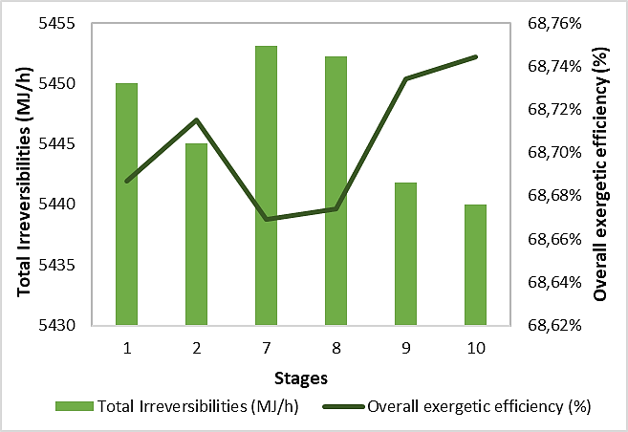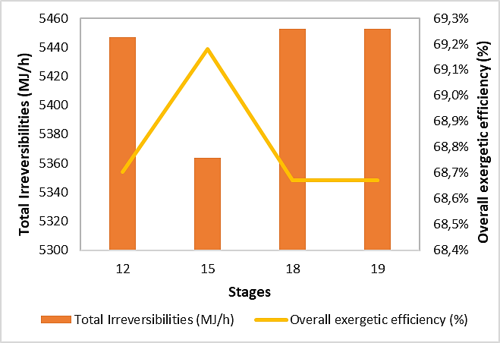
Figure 2: Influence of the biorefinery stages on irreversibilities and overall exergetic efficiency
Stages 9 and 10, corresponding to starch drying steps 1 and 2, show a slight increase in overall exergetic efficiency, likely due to more efficient energy use within the biorefinery. In contrast, stages 12, 15, 18, and 19 exhibit more pronounced variations, with irreversibilities ranging from 5363 to 5453 MJ/h; stage 15 shows the largest reduction, contributing to the increase in overall efficiency. The near 70 % overall exergetic efficiency of the Hass avocado seed-based biorefinery, compared with 46.26 % reported for a whole avocado biorefinery (Herrera et al., 2025b), can be primarily attributed to the use of thermodynamically favorable processes, such as fermentation and polymerization, to produce starch and biofilms. In contrast, seed pyrolysis and oil extraction require high temperatures, resulting in greater exergy losses. These results highlight the competitiveness of the system relative to other biomass conversion processes, such as bioethanol production from macroalgae (15.3 %) (Loh et al., 2023) or lactic acid and electricity biorefineries (up to 22 %), where fermentation and purification stages have a significant influence on exergy destruction.

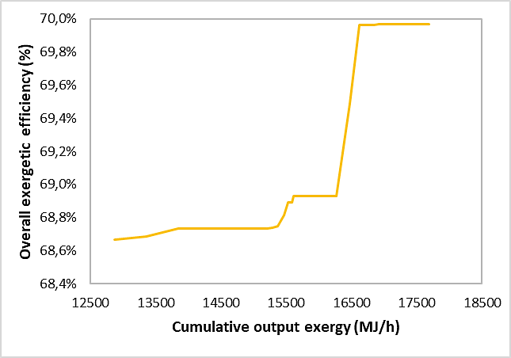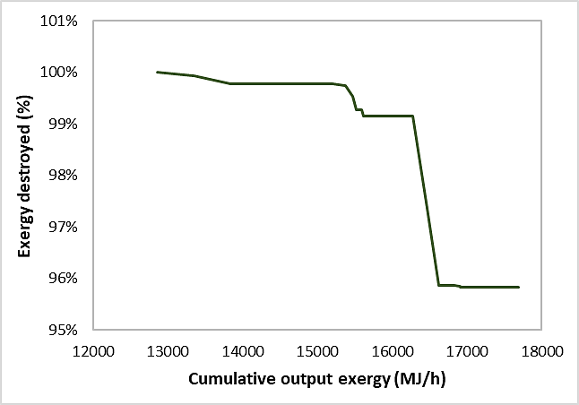
Figure 3: Effect of cumulative output exergy on Overall exergetic efficiency and exergy destruction
Figure 3 illustrates the biorefinery’s ability to maintain performance under possible variations. As cumulative output exergy increases from 13,352 to 17,690 MJ/h, the overall exergetic efficiency rises from 68.6 % to 69.97%, reflecting improved resource utilization. Concurrently, exergy destruction decreases from 100 % to 95.84% due to reduced irreversibilities. This confirms that considering the output streams enhances the thermodynamic performance of the cascade biorefinery. Comparable biomass conversion processes, such as biodiesel and bioethanol production from safflower, have reported exergetic efficiencies of 72.7 % (Khounani et al., 2021), similar to the present study.

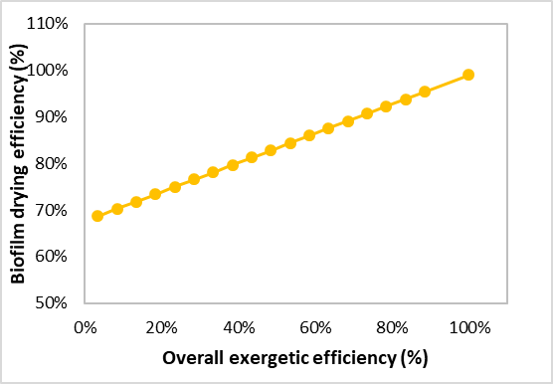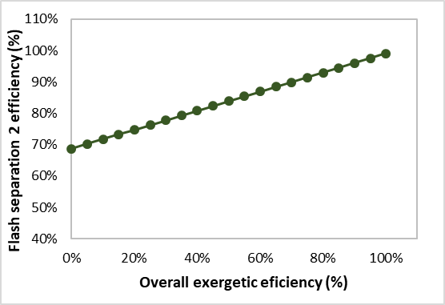
Figure 4: Effect of biofilm drying efficiency and flash separation 2 efficiency on overall exergetic efficiency
Figure 4 illustrates the relationship between overall exergetic efficiency and the performance of the lowest-efficiency stages. A directly proportional trend is observed: improving the biofilm drying stage (currently 3.45 %) could raise the overall efficiency from 68.66 % to nearly 99 %. Similarly, increasing the efficiency of flash separation 2 from 0.06 % toward 100 % significantly improves system performance. Drying and separation stages often contribute heavily to irreversibilities due to high energy demands and gradients in temperature, pressure, and composition (Dincer & Rosen, 2013; Szargut et al., 1988). Incorporating heat exchangers could reduce these losses and energy consumption, further increasing the overall exergetic efficiency of the biorefinery.

4. Conclusions
The exergetic sensitivity analysis applied to the cascade biorefinery based on Hass avocado seed enabled the identification of the operational variables with the greatest influence on the overall exergetic efficiency and exergy destruction of the system. The results demonstrate a favorable exergetic performance, with overall efficiencies of up to 70%, confirming the potential of proper resource management to enhance process efficiency. It was found that an increase in cumulative output exergy simultaneously contributes to improving the overall exergetic efficiency and reducing exergy destruction, indicating greater system stability under variations in operating conditions. Furthermore, the starch drying and biofilm drying stages, together with flash separation stage 3, were identified as the main sources of irreversibility, representing key opportunities for process optimization. In this context, the cascade configuration proved to be an effective strategy for the progressive utilization of the chemical exergy of biomass, reducing losses associated with waste streams compared to conventional single-valorization schemes.
Finally, exergetic sensitivity analysis is established as a robust tool not only for identifying critical stages but also for improving the design, efficiency, and thermodynamic sensitivity of biomass-based biorefineries, particularly under scenarios of operational uncertainty. From an environmental perspective, the improvement of exergetic efficiency and the reduction of irreversibilities are associated with lower energy requirements, which may contribute to a decrease in greenhouse gas emissions. Therefore, the proposed approach supports the development of more sustainable and low-carbon biorefinery systems.
Acknowledgments
The authors gratefully acknowledge the financial support provided by the Universidad de Cartagena and the Colombian Ministry of Science, Technology, and Innovation (MINCIENCIAS) for this research. This work was funded under the project “Desarrollo de un modelo de bioeconomía para la obtención de productos derivados de la semilla de aguacate Hass con aplicabilidad en el sector agrícola y alimentario en el departamento del Putumayo” with project code SIGP 100307, contract 442-2023.
References
Alviz-Meza A., Valdez-Valdes S.A., Gonzalez-Delgado A.D., 2025, Computer-aided simulation of a cascade biorefinery: Case study of the Colombian Amazon’s Hass avocado waste, Chemical Engineering Transactions, 117, 67–72.
Bejan A., 2016, Advanced Engineering Thermodynamics, Wiley.
Chung M.R.W.Y., Tan I.S., Foo H.C.Y., Lam M.K., 2022, Exergy analysis of a biorefinery process for co-production of third-generation L-lactic acid and electricity from Eucheuma denticulatum residues, Energy, 242, 122968.
Dincer I., Rosen M.A., 2013, Exergy: Energy, Environment and Sustainable Development, 2nd ed., Elsevier.
Hashemi M., Pourfayaz F., Mehrpooya M., 2019, Energy, exergy, exergoeconomic and sensitivity analyses of modified Claus process in a gas refinery sulfur recovery unit, Journal of Cleaner Production, 220, 1071–1087.
Hernández J., 2023, Aprovechamiento de residuos de aguacate, Universidad de Antioquia, Colombia.
Herrera-Rodriguez T.C., Parejo-Palacio V., González-Delgado A.D., 2025a, Evaluación exergética y de sensibilidad del proceso de producción de microperlas de quitosano modificadas con nanopartículas verdes de TiO₂, Revista Ontare, 12(1).
Herrera-Rodriguez T.C., Parejo-Palacio V., González-Delgado A.D., 2025b, Exergetic evaluation of an avocado (Persea L.) biorefinery in northern Colombia, Chemical Engineering Transactions, 117.
Khounani Z., Hosseinzadeh-Bandbafha H., Nazemi F., Shaeifi M., Karimi K., Tabatabaei M., Aghbashlo M., Lam S.S., 2021, Exergy analysis of a whole-crop safflower biorefinery: A step towards reducing agricultural wastes in a sustainable manner, Journal of Environmental Management, 279, 111822.
Kotas T.J., 2013, The Exergy Method of Thermal Plant Analysis, 2nd ed., Butterworth-Heinemann.
Loh S.R., Tan I.S., Foo H.C.Y., Tan Y.H., Lam M.K., Lim S., 2023, Exergy analysis of a holistic zero waste macroalgae-based third-generation bioethanol biorefinery approach: Biowaste to bioenergy, Environmental Technology & Innovation, 30, 103089.
Meramo-Hurtado S., Alarcón-Suesca C., González-Delgado Á.D., 2020, Exergetic sensibility analysis and environmental evaluation of chitosan production from shrimp exoskeleton in Colombia, Journal of Cleaner Production, 248, 119285.
Perez D., Galan A., Contreras M.M., Castro E., 2023, Integrated techno-economic and environmental assessment of biorefineries: Review and future research directions, Sustainable Energy & Fuels, 7, 4031–4050.
Qureshi B.A., Zubair S.M., 2016, Exergy and sensitivity analysis of reverse electrodialysis desalination plants, Desalination, 394, 195–203.
Silva P., Oliveira Jr. S., Pinto Mariano A., Jocher A., Posada J., 2024, Exergy-based improvements of sustainable aviation fuels: Comparing biorefinery pathways, Processes, 12(3), 510.
Swetha T.A., Ananthi V., Bora A., Sengottuvelan N., Ponnuchamy K., Muthusamy G., Arun A., 2023, A review on biodegradable polylactic acid (PLA) production from fermentative food waste: Its applications and degradation, International Journal of Biological Macromolecules, 234, 123703.
Szargut J., Morris D.R., Steward F.R., 1988, Exergy Analysis of Thermal, Chemical and Metallurgical Processes, Hemisphere Publishing, New York, USA.

