CHEMICAL ENGINEERING TRANSACTIONS  VOL. 92, 2022 | A publication of
The Italian Association
of Chemical Engineering
Online at www.cetjournal.it
Guest Editors: Rubens Maciel Filho, Eliseo Ranzi, Leonardo Tognotti
Copyright © 2022, AIDIC Servizi S.r.l.
ISBN 978-88-95608-90-7; ISSN 2283-9216

Evaluation of Macrolobium acaccifolium and Inga nobilis seeds in coagulation/flocculation processes
Letícia Pedrão Correiaª, Ana Paula Peron^{b}, Nathalia Bordon Pironato Siaª, *Flávia Vieira da Silva Medeirosª
ªAcademical Department of Environmental, Federal University of Technology, Campo Mourão, Brazil;
^{b}Department of Biodiversity and Nature Conservation, Federal University of Technology, Campo Mourão, Brazil
e-mail: flaviav@utfpr.edu.br
Macrolobium acaccifolium and Inga nobilis species, found in Amazon forest, are used for local timber purposes. In this context, the seeds can be considered waste. Thus, this work proposes the application of these seeds in coagulation/flocculation processes. The efficiency of organic coagulants extracted from seeds of Macrolobium acaccifolium and Inga nobilis species was evaluated using the Jar Test equipment. Coagulation/flocculation assays were performed and the Parameters: color, turbidity, organic matter and pH parameters were measured to raw and the treated water. For Inga nobilis seeds, the best results were achieved using Treatment 2, with an efficiency of 14.81% in color removal was obtained; 51.28% of turbidity removal efficiency; pH remained within the range between 6 and 8. On the other hand, in Treatment 4, the pH remained at an average of 5. For Macrolobium acaciifolium seeds, using Treatment 3, an efficiency of 39.33% and 78.72% in color and turbidity removal was obtained, respectively. For this seeds, pH presented values within the range between 5 and 6. Therefore, it can be concluded that the coagulant extracted from Macrolobium acaciifolium was more effective compared to the coagulant extracted from Inga nobilis. However, treated water cannot be considered as potable water as it is out of potability standards.
Key words: Organic coagulant, water treatment, efficiency.
1. Introduction
Water is essential for plant and animal life. Mankind needs water with adequate quality and in sufficient quantity to meet its needs, protect health and promote economic development. The water supply system can be conceived and designed to serve small villages or large cities, varying in the characteristics and size of their facilities (BRASIL, 2006).
The world population is constantly growing and rapidly developing, dramatically increasing water consumption. At the same time, there is a growth in the disposal of waste, making an efficient basic sanitation system necessary. By having access to water and sewage treatment, the population has the opportunity to eliminate or at least minimise the effects of possible contamination by pathogenic agents, in which the transmitting vehicle is water. (ZIMMERMAN, 2001).
The water treatment process has as one of the first steps the coagulation, which consists in the destabilisation of colloidal and suspended particles present in raw water. The purpose of coagulation is to significantly increase the sedimentation rate of colloids present in raw water. In the health context, the importance of coagulation is evident in the removal of microscopic particles, associated with pathogenic microorganisms, usually found in natural waters and with very low sedimentation rates (LIBÂNIO, 2010).
The use of chemical coagulants may cause a plenty of healthy issues. A counter-proposal to chemical coagulants is the application of natural materials for water clarification, which is an ancient practice used for centuries in rural areas. Recently, studies have been carried out with the use of natural coagulants, with special emphasis on chitosan and Moringa oleifera Lam (Divakaran, and Pillai, 2002). Several legumes were also evaluated as a natural coagulant, including some species of beans, peas, peanuts and lupines.
In order to evaluate and confirm the efficiency of organic coagulants as an alternative in the coagulation process, seeds of Macrolobium acaccifolium and Inga nobilis species were tested.
Macrolobium acaccifolium (Benth.) Benth., popularly known as Araparí, is a tree legume that occurs in wetlands in Brazil, Colombia, Peru and Venezuela. This species is found in the flooded forests of the Central Amazon, at low elevations in the floodplain and igapó (PIO CORRÊA, 1926; DUCKE, 1939).
Araparí seeds (Figure 1) present palmitic acid, linoleic acid, traces of myristic acid (common acids in some types of cosmetics) and lignoceric acid or tetracosanoic acid (BEHRENS et al., 2006).

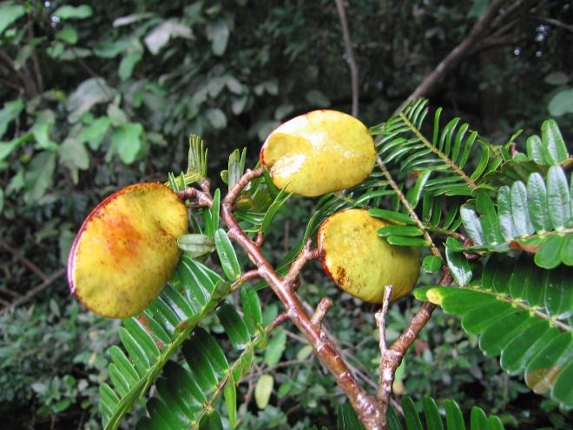
Figure 1 – Macrolobium acaccifolium (Benth.) Benth. seeds

    - Inga nobilis Willd.
It is an exclusively neotropical genus, with seven main distribution areas, including the coast, the interior of Brazil, southeastern Central America and western South America, which constitute the main centers of diversity for the genus (Pennington 1997; Mata & Felix 2007). Popularly known as Ingá, ingazeiro, angá and angazeiro, Inga nobilis (Figure 2) is basically characterized by having paripinnate leaves, with nectary in the leaf rachis, located between each pair of leaflets and vegetables, with seeds surrounded by fleshy and sweet sarcotesta. (Bentham and Hooker, 1876).

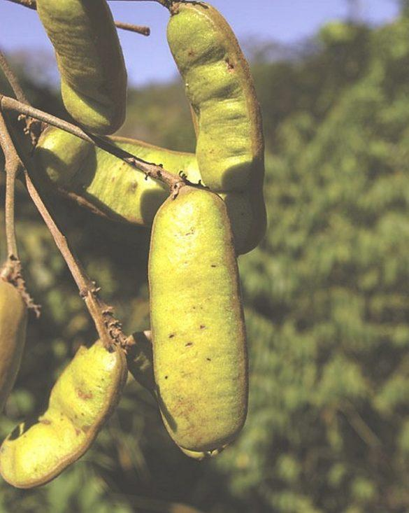
Figure 2 – Inga nobilis Willd seeds

This species has economic potential in reforestation, phytotherapy, energy production and food. Despite being a well-represented group in the Amazon region, there are still few works focusing on the Amazon, especially in an area of natural and anthropic clearings such as the Urucu Oil Base (SOUSA; BASTOS; GURGEL, 2011). It is widely used in the woodworking area. Inga Nobilis is easily found in the flora of the mid-lower Xingu River region (Vieira et al., 2008).
Considering the above, the objective of this work was to analyse the coagulant potential of Macrolobium acaciifolium (Benth.) Benth. and Inga nobilis seeds.
2. Methodology
The raw water used in the tests was collected at the Water Treatment Station of SANEPAR (Sanitation Company of Paraná), located in the city of Campo Mourão.
Its characterization was based on the parameters of color, turbidity, UV₂₅₄, pH, besides UV₂₇₂ for determination of dissolved organic matter (DOM). The methodology described in the Standard Methods (RICE et al, 2012) was followed all over this work.
In order to determine the concentration of dissolved organic matter from the absorbance in UV₂₇₂, Equation (1) was used, according to Khan et al. (2014).

$DOM (mg.L^{-1})=518,93×Absorbance (272 nm)+1,065$ (1)

The seeds used were kindly provided by the Instituto de Pesquisas da Amazônia (INPA). To prepare the coagulants, seed husks was manually removed and the seeds were grounded in a domestic blender. The powder was defatted in absolute ethyl alcohol, using an Ultrasonic Cleaner model DC200H, at a frequency of 40 kHz, extraction time of 60 minutes, temperature of 25ºC, and sample mass/solvent volume of 1:10. The supernatant was manually separated, and the remaining material was placed in porcelain capsules and left in the desiccator for three days.
The preparation of the coagulant in saline solution consisted of adding 1.0 g of the desiccated seeds in 1.0 L of saline solution, or 10.0 g of the desiccated seed in 1.0 L of saline solution into a glass beaker, as shown in Table 1. These treatments were performed using Macrolobium acaciifolium and Inga nobilis seeds.
Table 1: Classification of treatments used in the treatment of raw water
Treatment 1 | Treatment 2 | Treatment3 | Treatment 4
1g of seed with saline solution | 10g of seed with saline solution | 1g of seed without saline solution | 10g of seed without saline solution

Coagulant extraction was performed by turbolysis for 3 minutes with saline solution in a domestic blender, followed by agitation using a magnetic stirrer for 30 minutes. The solution obtained was vacuum filtered on quality filter paper. The coagulant was also prepared in distilled water, without the addition of salt, for later comparison.
The coagulation/flocculation assays were carried out in a Jar Test equipment (Nova Ética), with a rotation regulator of the mixing rods and six jars with a capacity of 2 liters. The use of the Jar Test makes it possible to determine the ideal dosage of coagulant or coagulation aid needed to clarification of raw water. Raw water was used at room temperature, ranging between 25 and 35ºC.
The fast mixing time (FMT) was 1 minute and the speed gradient was 120 rpm, while the slow mixing time (SMT) was 15 minutes and the speed gradient was 60 rpm. After this procedure, the samples remained to settle for 15 minutes, for the sedimentation of the formed flocs (Bazzo et al., 2021).
Subsequently, the parameters color, turbidity, UV₂₅₄, UV₂₇₂ and pH were measured for the treated water in order to verify the efficiency of the process.
For the characterization of the coagulants used, the total proteins were quantified, as previous studies indicate that some proteins present in the seeds may have a coagulant effect. The quantification of the total proteins extracted from the seeds was performed by the salicylate method in a Hach spectrophotometer, for 10 mL of coagulant sample. In order to express the result in protein, it was necessary to multiply the amount of total nitrogen found through the method by 6.25.

3. Results (comparar com dados usando coagulantes tradicionais)
  - Characterization of raw water
Table 2 shows the values of the parameters obtained for the raw water that was used in the coagulation/ flocculation assays with the coagulants extracted from Inga nobilis and Macrolobium acaciifolium.

 | Color (mg/LPt-Co) | Turbidity (NTU) | UV₂₅₄  (nm) | DOM  (mg/L) | pH
Raw water | 50.77 | 13.63 | 0.091 | 59.18 | 6.82

Through the results of these parameters, it can be concluded that the river in which the raw water was collected can be classified by CONAMA Resolution nº 357 (2005), as a class II freshwater river, since the turbidity does not exceed the value of 100 UNT, the true color is less than 75 mg/L Pt-Co and the pH is within the range of 6.0 to 9.5.
  - Coagulation/flocculation assays with coagulant extracted from Inga nobilis seeds
Assays were performed using the coagulant extracted from Inga nobilis seeds, defined as Treatment 1, 2 3 and 4, and the results of the analyzed parameters mentioned above are described below.
As can be verified through the results obtained, pH values were slightly higher when compared to raw water result, remaining closer to 7,0 (Table 2). Similar results were found Moringa oleifera based coagulants were employed (Ballestrin et al., 2020). Otherwise, pH values were close to 6,0 when alum was used as coagulant to treat raw water with pH maintained at 7,0 (Malik, 2018).

Table 2 – pH using coagulant extracted from Inga nobilis seeds.
Coagulant Volume (mL) | 10 | 20 | 30 | 40 | 50 | 60 | 100 | 150 | 200 | 250
Treatment 1 | 7.6 | 7.9 | 7.6 | 7.5 | 7.4 | 7.3 | 7.1 | 6.9 | 6.8 | 6.8
Treatment 2 | 6.9 | 6.7 | 6.5 | 6.0 | 6.4 | 6.0 | 6.2 | 6.2 | 6.2 | 6.2
Treatment 3 | 8.5 | 8.3 | 8.2 | 8.0 | 8.0 | 7.8 | 7.7 | 7.6 | 7.5 | 7.3
Treatment 4 | 7.3 | 7.1 | 7.0 | 6.8 | 6.5 | 6.3 | 6.0 | 5.6 | 5.4 | 5.1

The results of the color removal and turbidity efficiency are presented in Figures 3 and 4, respectively:

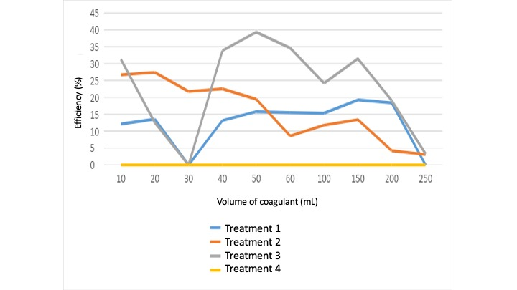
Figure 3 - Color removal efficiency using organic coagulant extracted from Inga nobilis.

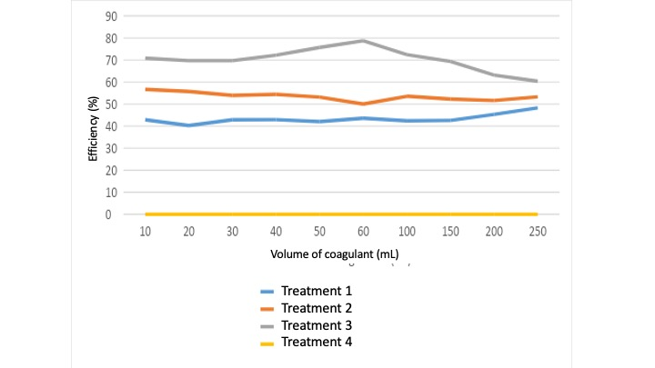
Figure 4 - Turbidity removal efficiency using organic coagulant extracted from Inga nobilis.

The best color removal results achieved were: 10.11% and 14.81%, respectively for Treatments 1 and 2. Color removal was lower than expected, considering that organic coagulants obtained from Moringa oleifera seeds reached color removal between 20 and 59%, as previously reported (Ballestrin et al., 2020).
Likewise, it was possible to verify that the best turbidity removal results were also obtained with Treatments 1 and 2, with 35.63% for Treatment 1 and 51.28% for Treatment 2, which is comparable to turbidity removal observed to moringa coagulants, that varied from 18.6 to 67.8% (Ballestrin et al., 2020).
Malik (2018) employed alum coagulant to treat surface water and observed turbidity removals in the range of 80 to 96%, which suggests that studies with organic coagulants must be improved.
Otherwise, the UV₂₅₄ and DOM values increased after all treatments, indicating an increase in the concentration of organic matter in the treated water.
  - Coagulation/flocculation assays with coagulant extracted from Macrolobium acaciifolium seeds
Assays were performed using the coagulant extracted from Macrolobium acaciifolium seeds, defined as Treatment 1, 2, 3 and 4, and the results of the parameters analyzed above are described below.
In this study, it was possible to verify that the pH value has changed, remaining within the range between 5 and 6 using Treatments 2, 3 and 4, similar to results obtained when alum coagulants were used (Malik, 2018). However, using the Treatment 1, the pH remained within the range between 6 and 8, close to pH values achieved when moringa based coagulants were employed (Ballestrin et al., 2020).
It was also observed that the best result for color removal was obtained using Treatment 3, showing 39.33% efficiency. Treatment 2 presented color removal of 27.38%. Therefore, these results are in the same range as observed to moringa based coagulants (Ballestrin et al., 2020).
Considering the turbidity removal, the best results were: 78.72%, 56.68% and 48.25%, respectively for Treatments 3, 1 and 2, which is also close to values observed to moringa based coagulants according to Ballestrin et al. (2020), and lower than achieved to alum based coagulants (Malik, 2018).
However, the UV₂₅₄ and DOM values increased after all treatments, indicating an increase in the concentration of organic matter in the treated water, as observed for the coagulant obtained from Inga nobilis seeds.
According to previous studies (Lima, 2018; Siqueira et al., 2018), Macrolobium acaciifolium and Inga nobilis seeds showed similarities to Moringa oleifera seeds in relation to water treatment, considering the increase in the amount of organic matter in the water and low percentages of removal of the other parameters evaluated, as color and turbidity.
  - Total proteins
The total proteins in the seeds were 109.375 mg/l for Macrolobium acaciifolium and 58.125 mg/l for Inga nobilis, indicating that the greater amount of proteins found in the seeds of Macrolobium acaciifolium would justify this species presenting the best results in the treatment, when compared to Inga nobilis.
- Conclusions
Considering the results found in this work, color and turbidity removal using Macrolobium acaciifolium coagulant presented the best results in Treatment 3, with removal percentage of 39.33% and 78.72%, respectively. while Inga nobilis coagulant showed 14.81% of color removal and 51.28% of turbidity removal, in Treatment 2. These values are comparable to other organic coagulants, however, lower when compared to alum based coagulants, which indicates that organic coagulants must be better studied for water treatment.
Therefore, it can be concluded that the coagulant extracted from Macrolobium acaciifolium was more effective compared to the coagulant extracted from Inga nobilis, probably due to its higher protein content.
References
Ballestrin, C.S., Consolin-Filho, N., Souza, W.E., Silva-Mdedeiros, F.V., 2020, Natural coagulants (Moringa oleifera) extracted by different solvents and possible application in water treatment, Revista Virtual de Química, 13(2), 1-14.
Bazzo, F.P., Sia, N.P.B., Março, P.H., Valderrama, P., Peron, A.P., Silva-Medeiros, F.V., 2021, Multivariate optimization approach applied to natural polymers from Ceratonia siliqua L. and Moringa oleifera Lam as coagulating/flocculating agents, Environmental Technology, 42, 1-14.
Bentham, G., Hooker, J.D., 1876, Genera Plantarum, London, UK.
Divakaran,R,Pillai,S.,2002, Flocculation of river silt using chitosan, Water Research, 36, 2414-2418.
Khan, S., Yaoguo, W., Xiaoyan, Z., Jingtao, L., Jichao, S., Sihai, H., 2014, Estimation of concentration of dissolved organic matter from sediment by using uv–visible spectrophotometer, International Journal of Environmental Pollution and Remediation, 2, 24-29.
Libânio, M, 2005, Fundamentos da qualidade e tratamento de água, Editora Átomo, São Paulo, Brasil.
Lima, Júnior R.N., 2018, Natural Products Used as Coagulants and Flocculants for Public Water Supply: A Review of Benefits and Potentialities, Revista Virtual de Química, 10(3), 709-735.
Malik, Q.H., 2018, Performance of alum and assorted coagulants in turbidity removal of muddy water, Applied Water Science, 8, article number: 40.
Pennington, T.D., 1997, The genus Inga botany. Royal Botanic Gardens, Kew. 844p.
Pio Corrêa, Μ, 1926, Dicionário das Plantas Úteis do Brasil e das Exóticas Cultivadas Imprensa Nacional, Rio de Janeiro, Brasil.
Rice, E.W., Baird, R.B., Eaton, A.D. and Clesceri, L.S. (Eds.), 2012, Standard Methods for the Examination of Water and Wastewater. 22nd Edition, American Public Health Association, American Water Works, Water Environment Federation, Washington DC, USA.
Siqueira, A.P.S.; Silva, C.N.; Rezende, L.C.S.H.; Milani, R.G.; Yamaguchi, N.U., 2018, Análise da performance dos coagulantes naturais Moringa oleifera e tanino como alternativa ao sulfato de alumínio para o tratamento de água, Enciclopédia Biosfera, 15(27), 18-30.
Sousa, J.S., Bastos, M.N.C., Gurgel, E.S.C., 2011, The genus Inga (Leguminosae-Mimosoideae) in the Urucu Petroleum Province, Coari, Amazonas, Brazil.
Vieira, I.C.G., Ferreira, L.V., Salomão, R.P, 2008, Descrição e análise da flora da região do médio-baixo Rio Xingu, Museu Paraense Emílio Goeldi, Belém, Brasil.
Zimmerman, R.H., 2001, Wetlands and infectious diseases, Caderno Saúde Pública, Rio de Janeiro, Brasil.

