CHEMICAL ENGINEERING TRANSACTIONS  VOL. 92, 2022 | A publication of
The Italian Association
of Chemical Engineering
Online at www.cetjournal.it

Guest Editors: Rubens Maciel Filho, Eliseo Ranzi, Leonardo Tognotti
Copyright © 2022, AIDIC Servizi S.r.l.
ISBN 978-88-95608-90-7; ISSN 2283-9216

Selectivity and Separation Factor for Components during Multicomponent Membrane Gas Separation
Petr Seghman*, Lukáš Krátký, Tomáš Jirout
Czech Technical University in Prague, Faculty of Mechanical Engineering, Department of Process Engineering, Technická 4, Prague 160 00, Czech Republic
petr.seghman@fs.cvut.cz
The membrane separation process offers a promising solution for syngas components separation and adjusting the ratio of the components. The multicomponent separation process is however complex and cannot be easily described. The presented study offers a comparison of ideal and real selectivities for three H₂-CO-CO₂ model mixtures containing 15-35 mol% H₂, 35 mol% CO, and 30-50 mol% CO₂. The mixtures were tested with total pressure drops 0.5-8 bar (retentate pressure from 2 to 10 bar with the permeate pressure levels of 1.2 bar, 2.5 bar, and 4 bar). The membrane module used in the study is a hollow fiber polyimide membrane module with 3000 hollow fibers with an inner diameter of 0.188 mm and a length of 290 mm with an active separation layer. The ideal selectivities for are α(H₂/CO₂) = 3.21 and α(CO₂/CO) = 14.77. The experimental results show that with increasing stagecut, the selectivities drop to below 1.3 for H₂/CO₂ (40 % of the ideal selectivity) and to below 1.4 for CO₂/CO (9.5 % of the ideal selectivity). Also, the selectivity decreases at a different rate for both different feed compositions and different permeate pressures. The H₂/CO₂ selectivity drops faster for lower permeate pressure, the CO₂/CO selectivity drops faster for higher permeate pressure. The separation factors increase both for H₂/CO₂ and CO₂/CO with increasing pressure differences. Also, with the lower permeate pressure (p_{P} = 1.2 bar) both separation factors (for H₂/CO₂ and CO₂/CO) increase at a greater rate.
  - Introduction
One of the most trending topics in the field of chemical and process engineering is the environmental and ecological effects. Also, a huge effort is being put into the development of sustainable processes for chemicals and fuels production. One of the suitable processes for sustainable fuels and chemicals production is biomass gasification. However, the main obstruction preventing its industrial application are the gas treatment processes that must be both economic and ecological. One of the promising methods is the membrane separation that can both purify the syngas and also adjust the ratio of the main components – H₂, CO, CO_{2,} and CH₄.
For a proper application of the membrane separation processes, it is necessary to obtain a deep description of the process. However, multicomponent mixture separation is a complex process affected by many parameters. Some scientific papers suggest that ideal behavior can be utilized for the description of the multicomponent mixtures separation process. As earlier suggested by Li et al. (1990), the ideal behavior (independent process for each component) can be used only under certain restrictions such as small concentration of the most permeable component, perfect mixing at the surface of the membrane, and others. However, multiple studies have shown that the process is affected by various process parameters and the interaction of the components. Zhou et al. (2008) used a numerical simulation method to describe a CO₂/N₂ separation process and describe the parameters affecting the process. Their results suggest that the composition of the feed (along with other parameters) affects the results of the process.
The current approach used for describing the multicomponent gas membrane separation are the numerical simulations. As expressed by Medi and Nomvar (2020), it is possible to simulate the process in the hollow fiber modules so that the final simulation is both robust and fast. In their work, they tested multiple numerical models for the gas mixture separation and suggested a variable order numerical differentiation formula. One of the specific approaches to modeling the separation is to study the molecular behavior of the permeating components. Azizi and Mousavi (2015) developed a simulation method based on molecular dynamics. Among their conclusions, dominant mechanisms for the transport of both polar and nonpolar molecules were classified. Also, the results suggest that the molecules interact with each other. Ahmad et al. (2012) simulated a process of CO₂ capture from the natural gas and suggested a numerical model based on several reasonable assumptions (constant pressure along the membrane, pressure independent permeabilities for components). As the studied mixture contained only two components, their results agree with experimental data obtained by the experiment.
The multicomponent (three and more components) gas separation was described by Casado-Coterillo (2019) who described the separation of a ternary mixture containing CO₂, N_{2,} and CH₄. Their conclusions suggest deeper studies in the field of the non-ideal behavior of mixtures during membrane separation. A recent paper presented by the authors (Seghman et al., 2021) also indicates that the feed composition of the gas affects the results of the process. In the paper, four different ternary mixtures (containing H₂, CO, and CO₂) were studied and the recoveries R_{i} of CO₂ and H₂ were compared for different permeate pressure levels.
As seen in the mentioned papers, multicomponent gas separation using membranes is a complex and undescribed process. One of the main parameters used for simulations is the selectivity of the membrane (ratio of the permeabilities of two components). The present paper offers a quantitative comparison of ideal selectivity (obtained from the pure components permeabilities) and the actual selectivity obtained experimentally. Such dependency can lead to more accurate simulations and to a better understanding of the process.
  - Methods
All experiments were performed with the following conditions and using the following equipment.
    - Model gas
For the experiments, three different model mixtures of H₂, CO, and CO₂ were used. The basis for the composition of the feed was a synthesis gas (syngas) produced by the woody biomass gasification process. However, as the span of the concentration for each product is rather narrow (for H₂ ranging between 10 %mol and 25 %mol and for CO₂ between 30 to 45 %mol), the composition was changed to magnify the possible differences. Therefore, the composition of the mixtures was chosen as stated in Table 1. Also, labels for the mixtures are shown in the table – these will be used further in the paper.
Table 1: Labels and compositions (c_{F}) of the feed gases used in the study.
Mixture label | c_{F (H2)} (%mol) | c_{F (CO)} (%mol) | c_{F (CO2)} (%mol)
15-35-50 | 15 | 35 | 50
25-35-40 | 25 | 35 | 40
35-35-30 | 35 | 35 | 30

    - Experimental setup
The experiments were performed using a laboratory unit for membrane separation of gases Ralex GSU-LAB-200 (manufactured by MemBrain) with interchangeable modules. The unit operates at a pressure range of 1-10 bar in the retentate branch, 1-5 bar in permeate branch, and can maintain the temperature of the module between the room temperature and 60 °C. Gas composition is analyzed in an implemented gas analyzer (manufactured by EMERSON). A simple scheme of the measurement setup is shown in Figure 1 below.
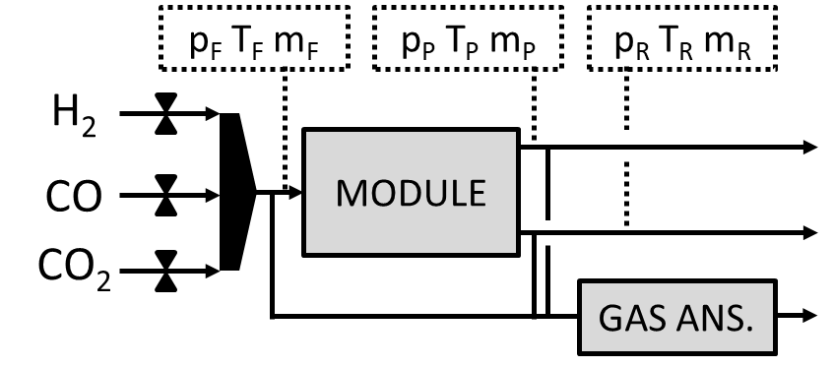
Figure 1: Experimental setup – the measured quantities are p_{i} (pressure in bar), T_{i} (temperature in °C), m_{i} (mass flow in each branch in kg/h) and c_{i,j} (concentrations of each component in each flow in mol%) using the gas analyzer, where F – Feed, P – Permeate, and R – Retentate.
The membrane module that was used for this study was a polyimide hollow fiber module (manufactured by MemBrain) consisting of 3000 fibers with an inner diameter of D_{i} = 0.188 mm, the active length of the fiber L = 290 mm, wall thickness W = 6 μm. The total area of the module is 0.514 m².
The feed flow rate was kept constant F = 4.5 mol h⁻¹ (~100 Nl h⁻¹) for all three mixtures and all pressure combinations. The temperature was kept at room temperature T_{M} = 22 °C (± 0.5 °C). The permeate pressure was used for defining different pressure levels and was kept at three different levels: p_{P} = 1.2 bar, p_{P} = 2.5 bar, and p_{P} = 4.0 bar. The retentate pressure ranged from 2 to 10 bar.
    - Used definitions
Ideal gas behavior was considered for the mixture. The deviation from the ideal behavior was estimated to reach a maximum of 2% (with an average of less than 1 %). Also, several assumptions were made considering the separation – the permeate and the retentate pressure is constant along the fibers, the permeance of the material for each component is also constant, and the permeability is independent of the pressure (within the range defined above – up to 10 bar). These assumptions are valid for the defined module and process conditions and are also used across scientific publications in the membrane separation field (see Ahmad et al., 2012).
Permeance (P/L)_{i} (which is the permeability P_{i} related to the length of the module L) of each pure component was used to describe the module’s properties. The permeance equals to the molar amount of the gas flux permeating through a unit of area of the membrane per unit of time caused by a unit of pressure. Permeance is defined in Eq. 1 and was used by Driolli and Giorno (2012) and others:
$${P/L}_{i}=\frac{n_{i}}{S∙Δp}$$ | (1)
where P_{i}/L is the permeance of component i (mol m⁻² s⁻¹ Pa⁻¹), n_{i} is the measured molar flow (mol s⁻¹), L is the length of the module (m), S is the total area of the module fibers (m²), and Δp is the pressure difference defined as:
$Δp=p_{R}-p_{P}$ | (2)
where p_{R} is the retentate pressure (Pa) and p_{P} is the permeate pressure (Pa).
The main observed quantity is the selectivity α(i/j) expressing the ratio of permeabilities (and or permeances) of components i and j:
$$α\left(i/j\right)=\frac{P_{i}}{P_{j}}=\frac{{\left(P/L\right)}_{i}}{{\left(P/L\right)}_{j}}$$ | (3)
where P_{i} is the permeability of component i (mol m⁻¹ s⁻¹ Pa⁻¹) and can also be expressed as the ratio of permeances (P/L)_{i}. The selectivity can be defined both for the ideal case (where the permeabilities or permeances refer to processing the pure components i and j) and for the real case (evaluated from permeabilities or permeances measured).
One of the main parameters that can be used for comparing different modules is the molar stagecut θ:
$$θ=\frac{n_{P}}{n_{P}+n_{R}}$$ | (4)
where n_{P} and n_{R} are the total molar flows in the permeate (index P) and retentate (R) in mol s⁻¹.
To calculate the total molar flow in a stream from the mass flow and the concentrations, the following equation can be used:
$$n_{x}=\frac{m_{x}}{\sum{c_{i}∙M_{i} }}$$ | (5)
where n_{x} is the total molar flow in branch x (mol s⁻¹), m_{x} is the measured mass flow in branch x (g s⁻¹), c_{i} is the molar fraction of component i (mol/mol) and M_{i} is the molar weight of component i (g s⁻¹).
Another observed quantity is the separation factor SF(i/j) which defines how well is the component i separated compared to component j. It is defined as follows:
$$SF\left(i/j\right)=\frac{(c_{iP}/c_{jP})}{(c_{iR}/c_{jR})}$$ | (6)
where SF(i/j) is the separation factor of components i to j (-), c_{iP} is the molar fraction of component i in permeate, c_{jR} is the molar fraction of component j in retentate (mol/mol). The separation factor is also often used in the scientific field for modules behavior comparison.
  - Results and Discussion
Firstly, the pure components permeances (P/L)_{i} were obtained and then ideal selectivities α_{ideal}(H₂/CO₂) and α_{ideal}(CO₂/CO) were evaluated.
    - Ideal selectivity
Using Eq. 1., the permeances of pure gases were evaluated for different pressure conditions and then averaged. The spread of the data for the permeances is shown in Table 2. As presented in the authors’ previous publication (Seghman et al., 2021), the data reflect a similar trend as published by other authors using polymeric hollow fiber modules. Table 2 shows the permeances for our module and values presented by Sharifian et al. (2019) and by Huang et al. (2020) that both used a module with similar properties.
Table 2: Pure components permeances compared to similar studies in the literature presented by Sharifian et al. (2019) and by Huang et al. (2020). (Units from literature sources converted to match.)
Component | (P/L)_{i} (nmol s⁻¹ m⁻² Pa⁻¹)  measured | (P/L)_{i} (nmol s⁻¹ m⁻² Pa⁻¹)  Sharifian et al. (2019) | (P/L)_{i} (nmol s⁻¹ m⁻² Pa⁻¹)  Huang et al. (2020)
H₂ | 61.40 ± 2.80 | 97.10 | 241.0
CO | 1.00 ± 0.03 | 1.28 | 8.7
CO₂ | 15.20 ± 0.50 | 31.10 | 67.0

Based on the pure components’ permeances, the ideal selectivity for the combinations H₂/CO₂ and CO₂/CO can be evaluated as shown in Eq. 3. The values for the ideal selectivities are α_{ideal}(H₂/CO₂) = 3.21 and α_{ideal}(H₂/CO₂) = 14.77. Similar values were obtained by Abdul Hamid et al. (2019) with α(H₂/CO₂) ranging from 1.5 to 4 for different polymers (polyimide, polysulfone, and their mixture).
    - Selectivity for varying permeate pressure
The permeate pressure is one of the parameters that affect the overall separation process. Three different permeate pressure levels were tested for the three model mixtures. Figure 2 show the differences in selectivities for three permeate pressure levels (p_{P} = 1.2 / 2.5 / 4.0 bar) tested on mixture 15-35-50.
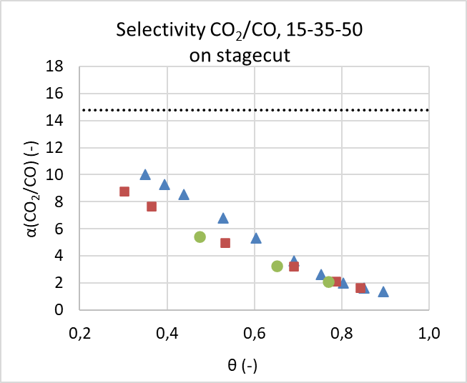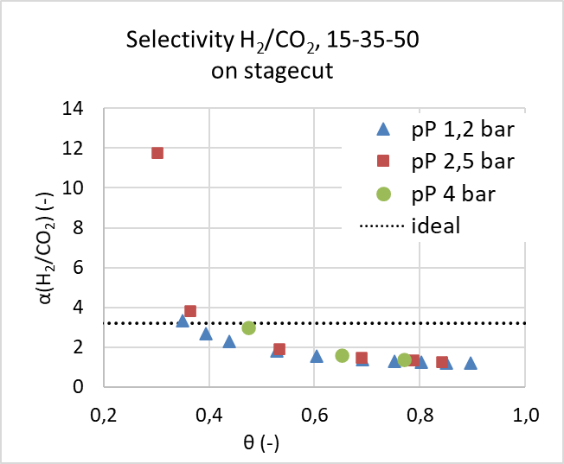
Figure 2: Selectivity for H₂/CO₂ and CO₂/CO on stagecut for mixture 15-35-50 on stagecut.
The permeate pressure appears to have a small effect on the shift of selectivity. As can be seen, the actual selectivities are decreasing with increasing stagecut, and for the whole range for CO₂/CO and most of the range for H₂/CO₂, the values are below the ideal selectivity – the values for H₂/CO₂ drop to approx. 40 % of the ideal value (from 3.21 to 1.3) and to around 10 % for the CO₂/CO selectivity (from 14.77 to 1.5). The same trend was reported by Kapantaidakis et al. (2003) who worked with polyimide membranes with similar ideal selectivities and reported a decrease in ‘real’ selectivity with increasing stagecut.
A similar trend can be observed for the three different mixtures 15-35-50, 25-35-40, and 35-35-30. As can be seen in Figure 3, the selectivities drop for all three mixtures at a similar rate. The data shown in the figure are all for the same permeate pressure p_{P} = 2.5 bar. As can be observed in the figures, it appears that with increasing concentration of the H₂ in the feed the selectivity α(H₂/CO₂) drops faster and this trend can be applied to CO₂ and α(CO₂/CO) selectivity.
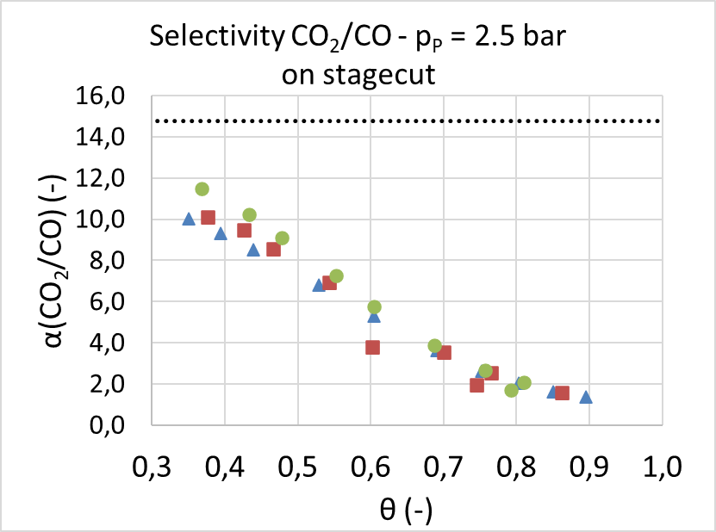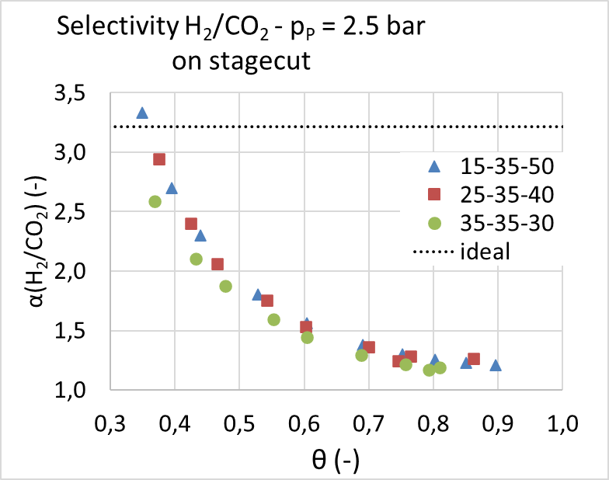
Figure 3: Selectivity for H₂/CO₂ and CO₂/CO on stagecut for the three mixtures with permeate pressure p_{P} =2.5 bar on stagecut.
    - Separation factor
The separation factor SF expresses the ratio the effectiveness for two components. Its dependency can be described both for increasing total pressure difference Δp and for increasing stagecut θ. As can be seen in the following Figure 4, the permeate pressure p_{P} has a great effect on the separation factor SF(CO₂/CO). The same dependency was observed for SF(H₂/CO₂). Similarly, the dependency between the separation factor and the composition of the feed can be observed. The following Figure 5 shows the dependency of separation factors SF(H₂/CO₂) and SF(CO₂/CO).
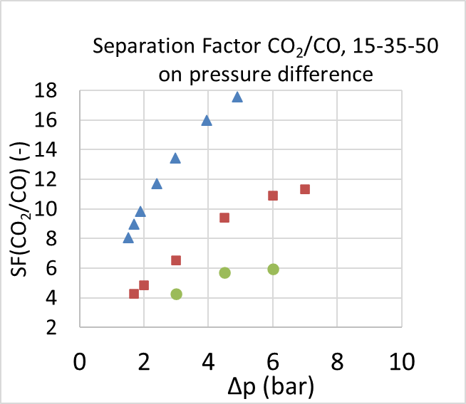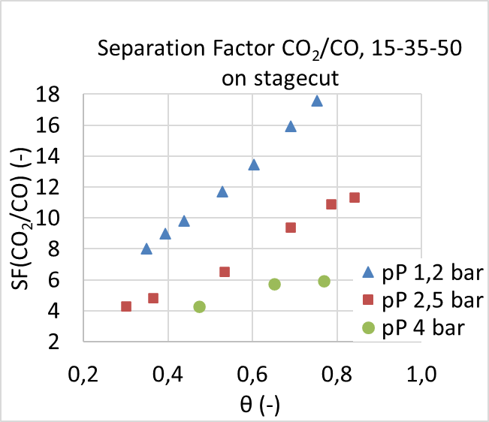
Figure 4: Separation factors CO₂/CO for three permeate pressures on pressure difference and stagecut.
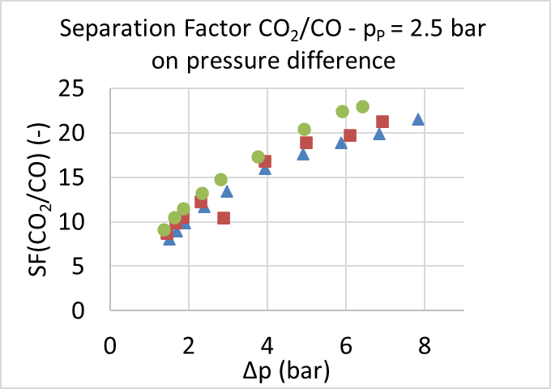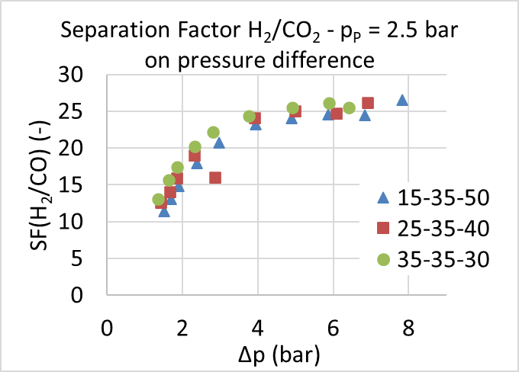
Figure 5: Separation factors on total pressure drop for three different mixtures.
As can be seen, the separation factors vary with the composition of the feed. With a higher content of the most permeable compounds (H₂), the separation factors rise at a greater rate. This can be caused by the overall higher permeation of the gas through the membrane. Also, the rate of growth is smaller with increasing total pressure drop (Δp).
  - Conclusions
The experimental results have shown that the ideal selectivity should not be considered in the numerical simulations and other computations of the multicomponent membrane separation process. The data suggest that the ‘real’ selectivity obtained during multicomponent separation decreases significantly – for the H₂/CO₂, the selectivity dropped to below 40 % of the ideal selectivity (from α_{ideal}(H₂/CO₂) = 3.21 to α(H₂/CO₂) < 1.3), for the CO₂/CO selectivity, the values dropped to less than 10 % of the ideal selectivity with increasing stagecut. The permeate pressure and the composition of the feed gas also affect the selectivity.
Another observed dependency is that separation factor SF for both H₂/CO₂ and CO₂/CO increases at a greater rate for lower permeate pressure at a given total pressure drop. With increasing content of the most permeable component (H₂ in this study), the separation factor for both H₂/CO₂ and CO₂/CO increase at a greater rate. This was observed in the whole range of total pressure drops and for all three mixtures. Also, with increasing total pressure difference, the rate of growth of separation factor decreases.
This paper suggests a deeper study of selectivity behavior in multicomponent mixtures. The important dependencies (on permeate pressure and composition of the feed) were demonstrated and should be considered for future simulations and computations.
Acknowledgments
This work was supported by the Ministry of Education, Youth and Sports of the Czech Republic under OP RDE grant number CZ.02.1.01/0.0/0.0/16_019/0000753 "Research center for low-carbon energy technologies„
and by Student Grant Competition of CTU as part of grant no. SGS20/118/OHK2/2T/12.
References
Abd. Hamid, M.A, Chung, Y.T., Rohani, R., Mohd. Junaidi, M.U., 2019, Miscible-blend polysulfone/polyimide membrane for hydrogen purification from palm oil mill effluent fermentation, Separation and Purification Technology, 209, 598-607.
Ahmad, F., Lau, K.K., Shariff, A.M., Murshid, G., 2012, Process simulation and optimal design of membrane separation system for CO₂ capture from natural gas, Computers and Chemical Engineering, 36, 119-128.
Azizi, M., Mousavi, S.A., 2015, CO2/H2 separation using a highly permeable polyurethane membrane: Molecular dynamics simulation, Journal of Molecular Structure, 1100, 401-414.
Casado-Coterillo, C., Fernandez-Barquin, A., Irabien, A., 2019, Effect of Humidity on CO₂/N₂ and CO₂/CH₄ Separation using Novel Robust Mixed Matrix Composite Hollow Fiber Membranes, Membranes, 10.
Drioli, E., Giorno, L. (Eds.), Encyclopedia of Membranes, Springer, Berlin, (DE).
Huang, W., Jiang, X., He, G., Ruan. X., Chen, B. et al., 2020, A Novel Process of H2/CO2 Membrane Separation of Shifted Syngas Coupled with Gasoil Hydrogenation, Processes, 8, 590.
Kapantaidakis, G.C., Koops, G.H., Wessling, M., Kaidis, S.P., CO₂ Plasticization of polyethersulfone/polyimide gas‐separation membranes, AIChE Journal, 49, 1702-1711.
Li, K., Acharya, D.R., Hughes, R., 1990, Mathematical Modelling of Multicomponent Membrane Permeators, Journal of Membrane Science, 52, 205-219.
Seghman, P., Krátký, L., Jirout, T., 2021, Syngas Components Recovery during Membrane Gas Separation, Chemical Engineering Transactions, 88, 763-768.
Sharifian, S., Asasian-Kolir, N., Harasek, M., 2019, Process Simulation of Syngas Purification by Gas Permeation Application, Chemical Engineering Transactions, 76, 829-834.
Zhao, L., Reinsche, E., Menzer, R., Blum, L., Stolten, D., 2008, A parametric stuy of CO₂/N₂ gas separation membrane processes for post combustion capture, Journal of Membrane Science, 325, 284-294.

