|  |  |
| --- | --- |
| cetlogo ***CHEMICAL ENGINEERING TRANSACTIONS***  ***VOL. 92, 2022*** | A publication of  aidiclogo_grande |
| The Italian Association  of Chemical Engineering  Online at www.cetjournal.it |
| Guest Editors: Rubens Maciel Filho, Eliseo Ranzi, Leonardo Tognotti  Copyright © 2022, AIDIC Servizi S.r.l. **ISBN** 978-88-95608-90-7; **ISSN** 2283-9216 | |

Elucidating the effects of superficial gas velocity on Poly(3-hydroxybutyrate) production

Claudia Amabilea, Teresa Abatea, Carmen De Crescenzoa,\*, Simona Sabbaresea, Giuseppe Capeceb, Renato Ciampac, Simeone Chianesea, Dino Musmarraa

aDepartment of Engineering, University of Campania “Luigi Vanvitelli”, Via Roma 29, 81031, Aversa, Italy

bProgest S.r.l., Zona ASI Aversa-Nord, Via della Stazione s.n.c., CE, Gricignano d'Aversa, 81030, Italy

cCentro Diagnostico Baronia S.r.l., Località Taverna Annibale SNC, Area PIP, Lotto n°7, AV, Frigento, 83040, Italy

[carmen.decrescenzo@unicampania.it](mailto:carmen.decrescenzo@unicampania.it)

Polyhydroxyalkanoates (PHAs) are a very promising alternative to traditional plastic materials since they are biobased and can degrade in soil, water, and sediments. Among all the existing PHAs, Poly-3-hydroxybutyrate (PHB) is the most well-known homopolymer. However, to the current state, PHAs represent only about 2% of the total bioplastics produced because their diffusion on a large scale is still limited due to their high market price. Techno-economic assessments showed that raw materials, such as sugars and oils account for up to 40% of the total costs. In this work, an innovative PHB production process scheme is presented. The expensive carbon sources are replaced by methane, which is cheap, abundant, and can be found as natural gas and in the biogas derived from the anaerobic digestion, thus allowing an integrated biorefinery. Process simulations were carried out to estimate the Poly-3-hydroxybutyrate production yields. Two aerobic fermentations were simulated into 400L semi-continuous reactors: the first for biomass growth in the presence of micro and macro-nutrients; the second for the PHB accumulation in a nutrient-deprived medium. Since both the biomass growth and PHB accumulation reactions take place in the liquid phase, the mass transfer from a gas to a liquid need to be maximised to increase biopolymer production. In this context, the effects of the superficial gas velocity (*Ug*) on the mass transfer rates and PHB yields were assessed. Several values of *Ug*, in the range 0.004 to 0.027 m s-1, that does not limit the viability of the cells, were tested. The PHB production increased with the superficial gas velocity.

* 1. Introduction

Fossil-based plastics represent one of the major causes of environmental pollution (Koller et al., 2010). Biopolymers such as Polyhydroxyalkanoates (PHAs) might represent an effective solution in this regard since they are biodegradable, can be produced biologically by many microorganisms and are suitable to be used in several sectors, such as medicine, packaging, electronic and agriculture, among the others (Lee, 2000). To date, the market price of PHAs is still much higher than that of conventional plastics, but since the oil price increased in 2003, the interest has been redirected on the industrial expansion of PHAs with the aim of reaching a commercially viable price (Lee, 2000). In this context, several techno-economic assessments showed that substrates represent up to 40% of the total production cost (Khosravi-Darani et al., 2013), thus implying the need for cheaper carbon sources, such as methane (Rostkowski et al., 2013). This natural gas is particularly suitable for the production of Polyhydroxyalkanoates and can be assimilated as the sole carbon source by Type II methanotrophs. Zhang et al. (2019), for example, reported up to 55% w/w of PHAs when using methane as substrate; others obtained 25 %w/w of PHB in a bubble column when operating in the presence of methane ( Khosravi-Darani et al., 2019); still, the use of CH4 lead to 35.6% w/w of PHB (García-Pérez et al., 2018). However, when dealing with methane, one of the major obstacles in PHAs production processes is the low solubility of the substrate, which limits its availability in the culture medium. In fact, during the process, both bacteria growth and PHAs accumulation reactions take place into the liquid phase, but the main reactants (i.e. methane and oxygen) are fed as a gas stream and need to be transferred to the liquid to be metabolised by the selected strain. In other terms, process yields are linked to the mass transfer conditions. In this context, high superficial gas velocities (*Ug*) can enhance the methane mass transfer, thus improving biomass and PHB yields (Toma and Systems, 1991). Anyway, despite this could be an attractive aspect when designing the PHB production process, it should be noted that, if *Ug* overcomes the limit from the transition to the turbulent regime, the shear forces induced by the turbulence can compromise the viability of the biomass (García-Pérez et al., 2018). In fact, biological processes are operated at low superficial gas velocities (in the order of 10-2-10-3 ms-1) to avoid turbulent flows. For instance, Yoon and Park (2008) demonstrated that the best condition for batch culture of *Anabena variabilis* in bubble column was to operate with a superficial gas velocity of 0.02 ms-1; Barbosa et al. (2003) reported that the death rate was higher than zero for *D. tertioleta* when working at *Ug* = 0.034 ms-1. In view of the above statements, major investments were paid to provide the development of efficient fermentation strategies (Serafim et al., 2008). The process simulated in this work consists of a two-step aerobic fermentation in bubble column bioreactors: the first one for the growth of *Methylocystis hirsuta* under nutrients balanced conditions; the second one for the accumulation of Poly(3-hydroxybutyrate) under induced metabolic stress. The impact of the superficial gas velocity on process performance was analysed. Note that, not to compromise the viability of the biomass, the turbulent regime was avoided and thus the study was limited to the homogeneous regime.

* 1. PHB production process simulation

In this study, the Poly(3-hydroxybutyrate) production process from methane in bubble column bioreactors was simulated. The main flowsheet, consisting of two semi-continuous reactors working in series (D=0.4m, V=400L, A=8), is shown in Figure 1. The liquid stream entering the first bioreactor contained an initial amount of biomass, grown in block SCR1 under balanced nutrient conditions for 15 days; the stream L2 entering the second bioreactor contained the grown biomass, which was subjected to metabolic stress to induce PHB accumulation within 10 days. The stream L-OUT2 resulted rich in PHB, while G1 and G2 contained methane and air at 4 %v/v and 96 %v/v, respectively.

Other blocks, such as separators, were included in the process scheme to separate the gas and liquid contained in the output streams (R1OUT and R2OUT). The components involved in the process are reported in Table 1.

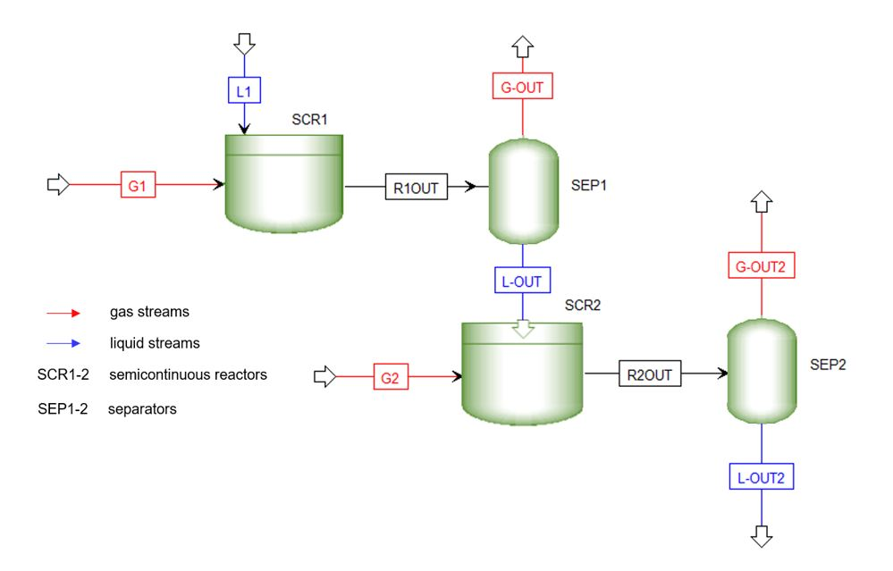

Figure 1: Process simulation setup

Eventually, both growth and accumulation reactions were assigned to the bubble columns according to Rostkowski et al. (2013), which reported the stoichiometry of the reactions based on an electron balance (Eq.1 and 2).

$\frac{\text{1}}{\text{4}}\text{C}{\text{H}}_{\text{4}}\text{+}\left(\frac{\text{1}}{\text{4}}\text{+}\frac{{\text{f}}_{\text{e}}}{\text{4}}\right){\text{O}}_{\text{2}}\text{+}\frac{{\text{f}}_{\text{s}}}{\text{28}}\text{N}{\text{O}}_{\text{3}}^{\text{-}}\text{+}\left(\frac{\text{29}}{\text{28}}{\text{f}}_{\text{s}}\text{+}{\text{f}}_{\text{e}}\text{-1}\right){\text{H}}^{\text{+}}\text{→}\left(\frac{\text{1}}{\text{4}}\text{-}\frac{\text{5}{\text{f}}_{\text{e}}}{\text{28}}\right)\text{C}{\text{O}}_{\text{2}}\text{+(}\frac{{\text{f}}_{\text{e}}}{\text{2}}\text{+}\frac{\text{11}{\text{f}}_{\text{s}}}{\text{28}}{\text{)H}}_{\text{2}}\text{O+}\left(\frac{{\text{f}}_{\text{s}}}{\text{28}}\right){\text{C}}_{\text{5}}{\text{H}}_{\text{7}}{\text{O}}_{\text{2}}\text{N }$ (1)

$\frac{\text{1}}{\text{4}}\text{C}{\text{H}}_{\text{4}}\text{+}\left(\frac{\text{1}}{\text{4}}\text{+}\frac{{\text{f}}_{\text{e}}}{\text{4}}\right){\text{O}}_{\text{2}}\text{→}\left(\frac{\text{1}}{\text{4}}\text{-}\frac{\text{4}{\text{f}}_{\text{s}}}{\text{18}}\right)\text{C}{\text{O}}_{\text{2}}\text{+}\left(\frac{{\text{f}}_{\text{e}}}{\text{2}}\text{+}\frac{{\text{f}}_{\text{s}}}{\text{3}}\right){\text{H}}_{\text{2}}\text{O+}\left(\frac{{\text{f}}_{\text{s}}}{\text{18}}\right){\text{C}}_{\text{4}}{\text{H}}_{\text{6}}{\text{O}}_{\text{2 }}$ (2)

Table 1: Components involved in the process

|  |  |  |
| --- | --- | --- |
| Component | Liquid stream | Gas stream |
| Water | ● |  |
| Biomass | ● |  |
| PHB | ● |  |
| Carbon dioxide |  | ● |
| Methane |  | ● |
| Oxygen |  | ● |
| Nitrate | ● |  |
| Nitrogen |  | ● |

* + 1. Mass transfer study

Gas-liquid mass transfer is one of the major hindrances in methanotrophic fermentations because the low solubility of methane limits the availability of the carbon source in the culture medium. Therefore, the estimation of the parameters that control the mass transfer is paramount.

In this work, the liquid side mass transfer coefficient (*kL*) was estimated according to Higbie’s equation for bubbles larger than 2.5 mm (Eq.3) (Wang et al., 2020); while the interfacial contact surface (*a*) (Eq.4) was estimated as a function of the gas hold-up (*ε*) and the size of the bubbles (*db*), which are the main features affecting the mass transfer in bubble column bioreactors.

${\text{k}}_{\text{L}}^{\text{0}}\text{=2}\sqrt{\frac{{\text{D}}_{\text{CH4,H2O}}}{{\text{t}}_{\text{e}} \text{π}}}$ (3)

$\text{a}\text{=}\frac{\text{6}{\text{ε}}_{\text{g}}}{{\text{d}}_{\text{b}}\left(\text{1-}{\text{ε}}_{\text{g}}\right)}$ (4)

The gas hold-up in Eq.4 can be calculated according to Eq.5:

${\text{ε}}_{\text{g}}\text{=}\frac{{\text{U}}_{\text{G}}}{\text{2+0.3 }{\text{U}}_{\text{G}}}$ (5)

Since the gas hold-up is related to *Ug*, the volumetric mass transfer coefficient depends on it. For this purpose, the effect of the variation of the superficial gas velocity in the range 0.004-0.027 ms-1 was tested. It is worth highlighting that, not to compromise the viability of the biomass, the turbulent regime was avoided, and the maximum *Ug* was set under the limit for the transition, which was achieved at *Ug*=0.03 ms-1 according to Reilly et al. (1994).

* 1. Results and discussion

The results of the simulations are reported in terms of productivity of PHB (PHBprod), yields of PHB on the selected substrate (yPHB), content of polymer accumulated into the biomass (*%*PHB) and substrate consumption (SC). All parameters were assessed as a function of the superficial gas velocity.

The productivity of PHBwas calculated according to Rodríguez et al. (2020) and ranged from 0.08 to 0.8 kgPHB m-3h-1 (Figure 2). Previous studies showed that values ranging from 0.03 kgPHB m-3h-1 to 1.4 kgPHB m-3h-1 were measured when producing PHB from methane under different strategies (García-Pérez et al., 2018).

It should be noted that the PHB produced increased linearly with the superficial gas velocity, thus demonstrating the beneficial effect of working at higher *Ug*: more specifically, it resulted that higher superficial gas velocities are responsible for enhanced transfer capacities, thus leading to higher process yields. This is particularly evident in Figure 3, in which the effect of the superficial gas velocity on the mass transfer is reported in terms of methane consumed by the active biomass. It can be stated that the methane consumption capacity linearly increases when ranging from 0.004 to 0.027 ms-1 because of the higher *kLa* linked to higher velocities. The trend shown in Figure 3 was previously reported and supported with experimental results, thus being consistent with the literature. For instance, Rodríguez et al. (2020) reported a substrate consumption from 7 gCH4 m-3h-1 to 74 gCH4 m-3h-1 when inducing PHB accumulation in a bubble column reactor under several operating conditions. Others reported a methane consumption ranging from 6 gCH4 m-3h-1 to 56 gCH4 m-3h-1 in a bubble column reactor during the accumulation of Poly(3-hydroxybutyrate) (García-Pérez et al., 2018).

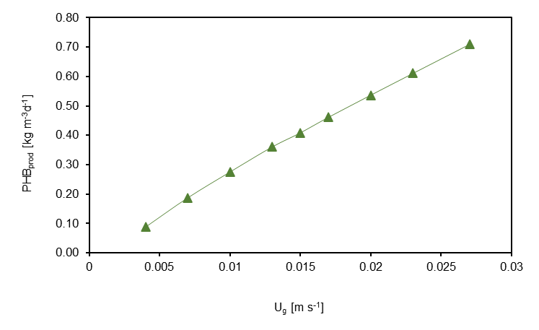

Figure 2: Productivity of PHB as a function of the superficial gas velocity

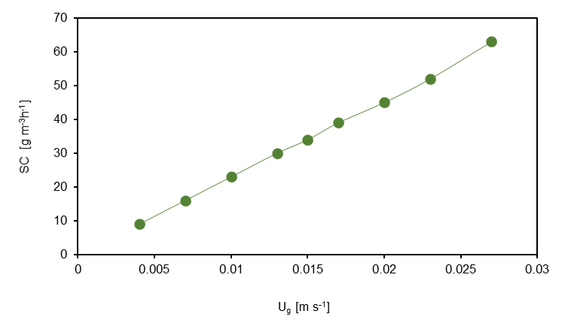

Figure 3: Substrate consumption as a function of the superficial gas velocity

The fraction of polymer accumulated into the biomass remained almost constant at 42% (Figure 4), with little variation only in correspondence of lower superficial gas velocities. The values obtained are in agreement with the literature. García-Pérez Teresa et al. (2018), for example, reported 34.6% of PHB when working with methane as the sole carbon source; Myung et al. (2015) obtained 39% of PHB when employing mixed methane utilising culture to accumulate PHB; Rostkowski et al. (2013) showed the possibility to accumulate up to 60% of dry cell weight when accumulating PHB in *Methylocystis parvus OBBP* with methane fed as the sole carbon source.

In terms of PHB yield, it can be noted from Figure 5 that an increase was observed in the range of *Ug* from 0.004 to 0.015 ms-1, while for higher values of the superficial gas velocity, the parameter was almost stable at 0.5. Previous studies showed that the yields of PHB on methane can reach up to 1.13, but the most reported values are in the range between 0.2 and 0.5. For instance, 0.24 and 0.34 gPHB/gCH4 were reported with *Methylocystis parvus OBBP* accumulating PHB in two different conditions (Pieja et al., 2011); a yield coefficient of 0.45 was found during the accumulation of PHB in mixed methane utilising culture (Helm et al., 2008); still, Wendlandt et al. reported a ratio of PHB to the relative consumed methane of 0.54 (Wendlandt et al., 1998).

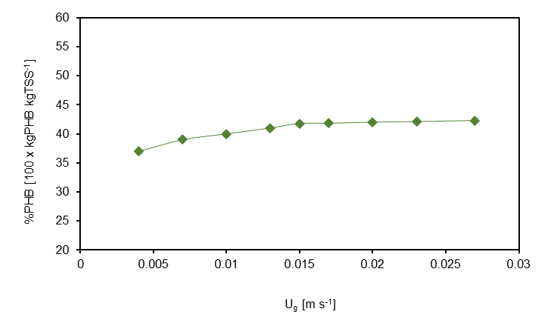

Figure 4: Content of PHB accumulated after 10 days as a function of the superficial gas velocity

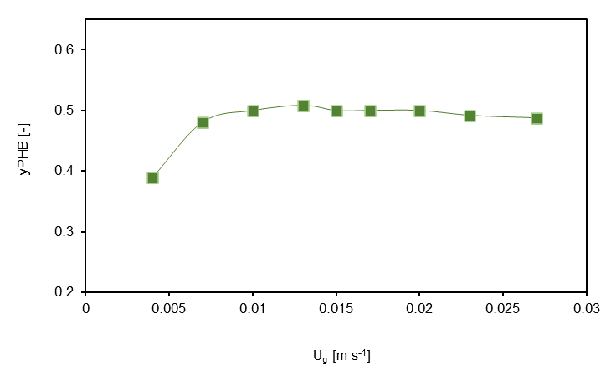

Figure 5: Yield of PHB on methane as a function of the superficial gas velocity y

* 1. Conclusion

In this work, a model of a double-stage process to produce Poly(3-hydroxybutyrate) from methane is proposed. Both the bacterial growth and the accumulation of the polymer took place into semi-continuous bubble column bioreactors, where the liquid was fed initially, and the gas stream was continuously supplied at superficial gas velocities ranging from 0.004 ms-1 to 0.27 ms-1. The effect of *Ug* on mass transfer parameters and process performance was evaluated. Results show that the volumetric liquid side mass transfer coefficient, as well as the productivity of PHB and the methane consumption, grows with the superficial gas velocity and reach the highest values at 0.027 ms-1. The content of PHB, on the other hand, was almost stable at 42% w/w after 10 days of fermentation. It can be stated that it would be advisable to work at higher superficial gas velocity when producing PHB, with the aim of increasing the mass transfer rate of the carbon source and improving the process performance. However, when dealing with biological systems, also the fluid-dynamic conditions should be carefully evaluated to avoid high turbulence that damages the cells and then lowers the concentration of the active biomass.

Nomenclature

*A*: aspect ratio

*a*: specific contact surface

*db*: bubble mean dimension

*DCH4, H2O*: diffusivity of methane in water

*εg*: gas hold-up

*fe, fs:*partition coefficients

*kL*: liquid side mass transfer coefficient in presence of chemical reaction

*kLa*: liquid side volumetric mass transfer coefficient

*te:* gas-liquid exposure time

*Ug*: superficial gas velocity

*V*: volume

Acknowledgments

This work was supported by “Fondo per la Crescita Sostenibile – Sportello “Agrifood” PON I&C 2014-2020”, di cui al D.M. 5 marzo 2018 Capo III. Prog. n. F/200125/01-03/X45.

Authors would like to thank VALERE “VAnviteLli pEr la RicErca” PROGRAMME by the University of Campania Luigi Vanvitelli.

References

Barbosa, M.J., Albrecht, M., Wijffels, R.H., 2003. Hydrodynamic stress and lethal events in sparged microalgae cultures. Biotechnol. Bioeng. 83, 112–120.

García-Pérez, T., López, J.C., Passos, F., Lebrero, R., Revah, S., Muñoz, R., 2018, Optimization of CH4 removal from diluted emissions and continuous PHB production by methylocystis hirsuta: Towards GHG biorefineries, Chem. Eng. Trans., 68, 439–444.

García-Pérez Teresa, C.López Juan, Passos Fabiana, Lebrero Raquel, Revah Sergio, M.R., 2018. Simultaneous methane abatement and PHB production by Methylocystis hirsuta in a novel gas-recycling bubble column bioreactor. Chem. Eng. J. 334, 691–697.

Helm, J., Wendlandt, K.D., Jechorek, M., Stottmeister, U., 2008. Potassium deficiency results in accumulation of ultra-high molecular weight poly-β-hydroxybutyrate in a methane-utilizing mixed culture. J. Appl. Microbiol. 105, 1054–1061.

Khosravi-Darani, K., Mokhtari, Z.B., Amai, T., Tanaka, K., 2013. Microbial production of poly(hydroxybutyrate) from C1 carbon sources. Appl. Microbiol. Biotechnol. 97, 1407–1424.

Khosravi-Darani, K., Yazdian, F., Babapour, F., Amirsadeghi, A.R., 2019. Poly(3-hydroxybutyrate) production from natural gas by a methanotroph native bacterium in a bubble column bioreactor. Chem. Biochem. Eng. Q. 33, 69–77.

Koller, M., Salerno, A., Dias, M., Reiterer, A., Braunegg, G., 2010. Modern biotechnological polymer synthesis: A review. Food Technol. Biotechnol. 48, 255–269.

Lee, S.Y., 2000. Bacterial polyhydroxyalkanoates. Biotechnol. Bioeng. 49, 1–14.

Myung, J., Galega, W.M., Van Nostrand, J.D., Yuan, T., Zhou, J., Criddle, C.S., 2015. Long-term cultivation of a stable Methylocystis-dominated methanotrophic enrichment enabling tailored production of poly(3-hydroxybutyrate-co-3-hydroxyvalerate). Bioresour. Technol. 198, 811–818.

Pieja, A.J., Sundstrom, E.R., Criddle, C.S., 2011. Poly-3-hydroxybutyrate metabolism in the type II Methanotroph Methylocystis parvus OBBP. Appl. Environ. Microbiol. 77, 6012–6019.

Reilly, I.G., Scott, D.S., Debruijn, T.J.W., Macintyre, D., 1994. The role of gas phase momentum in determining gas holdup and hydrodynamic flow regimes in bubble column operations. Can. J. Chem. Eng. 72, 3–12.

Rodríguez, Y., Firmino, P.I.M., Arnáiz, E., Lebrero, R., Muñoz, R., 2020a. Elucidating the influence of environmental factors on biogas-based polyhydroxybutyrate production by Methylocystis hirsuta CSC1. Sci. Total Environ. 706, 135136.

Rodríguez, Y., Firmino, P.I.M., Pérez, V., Lebrero, R., Muñoz, R., 2020b. Biogas valorization via continuous polyhydroxybutyrate production by Methylocystis hirsuta in a bubble column bioreactor. Waste Manag. 113, 395–403.

Rostkowski, K.H., Pfluger, A.R., Criddle, C.S., 2013. Stoichiometry and kinetics of the PHB-producing Type II methanotrophs Methylosinus trichosporium OB3b and Methylocystis parvus OBBP. Bioresour. Technol. 132, 71–77.

Serafim, L.S., Lemos, P.C., Albuquerque, M.G.E., Reis, M.A.M., 2008. Strategies for PHA production by mixed cultures and renewable waste materials. Appl. Microbiol. Biotechnol. 81, 615–628.

Toma, M.K., Systems, F., 1991. Inhibition of microbial growth and metabolism by excess turbulence 38, 552–556.

Wang, Z., Guo, K., Liu, H., Liu, C., Geng, Y., Lu, Z., Jiao, B., Chen, D., 2020. Effects of bubble size on the gas–liquid mass transfer of bubble swarms with Sauter mean diameters of 0.38–4.88 mm in a co-current upflow bubble column. J. Chem. Technol. Biotechnol. 95, 2853–2867.

Wendlandt, K., Jechorek, M., Helm, J., Stottmeister, U., 1998. Production of PHB with a high molecular mass from methane 3910, 191–194.

Yoon, J.H., Shin, J., Park, T.H., 2008. Characterization of factors influencing the growth of Anabaena variabilis in a bubble column reactor 99, 1204–1210.

Zhang, T., Zhou, J., Wang, X., Zhang, Y., 2019. Poly-β-hydroxybutyrate production by Methylosinus trichosporium ob3b at different gas-phase conditions. Iran. J. Biotechnol. 17, 10–16.