|  |  |
| --- | --- |
| cetlogo ***CHEMICAL ENGINEERING TRANSACTIONS***  ***VOL. 92, 2022*** | A publication of  aidiclogo_grande |
| The Italian Association  of Chemical Engineering  Online at www.cetjournal.it |
| Guest Editors: Rubens Maciel Filho, Eliseo Ranzi, Leonardo Tognotti  Copyright © 2022, AIDIC Servizi S.r.l. **ISBN** 978-88-95608-90-7; **ISSN** 2283-9216 | |

A critical review and discussion on emission factors for wood stoves

Øyvind Skreiberg\*, Morten Seljeskog, Franziska Kausch

Thermal Energy Department, SINTEF Energy Research, Trondheim, Norway

oyvind.skreiberg@sintef.no

Small scale heating appliances such as wood stoves, significantly contribute to domestic heating and energy security in many European countries. However, emissions from wood stoves remain a significant concern, even though modern wood stoves are continuously improved to reduce emissions due to incomplete combustion. Most State-Of-The-Art (SOTA) stoves after the 1990s, achieve significantly lower emissions than stoves produced in the period 1940-1990. The main reason being the introduction of emission limits and test standards both in Norway and other European countries. SOTA stoves today, including catalyst stoves and the more recent downdraft concepts, all apply a strategic and more or less optimized staged air supply. In stoves without catalyst, optimized air supply and combustion chamber geometry as well as combustion chamber insulation, are the main reasons modern stoves achieve better burnout. When comparing national emission inventories, we find unacceptable large variations in emission factors for most reported compounds in all official stove categories. There are in some cases plausible reasons for such differences, but for some cases the differences can hardly be justified. Both stove categories, old and new, suffers from differences of up to two magnitudes, when comparing emission factors used in the national emission inventories in the Nordic countries. Hence, there is a real need to correct and align these for inclusion in national emission inventories, which should be reflecting real-life emissions as accurately as possible. As stoves are continuously being improved, we also suggest yearly updates accounting for such improvements, in the annual national emission inventories reports.

* 1. Introduction

Emissions from wood stoves remain a significant concern, even though modern stoves are continuously improved regarding emissions due to incomplete combustion, e.g. particles (PM) of organic origin [Skreiberg and Seljeskog, 2018]. Today, all SOTA stoves apply some optimized air supply strategy to comply with the ever more stringent emission regulations. Currently there is a large variation in the emission factors used for different emission compounds and for different wood stove categories when reported in official national emission inventories. These national emission inventories are further reported at international levels, e.g. EU, as a basis for further elaborations and estimations of e.g. health and climate impacts related to wood stove emissions. The large discrepancies in some emission factors, even within the Nordic countries, justify an updated review and discussion around current emission factors, with the final aim of recommending corrected and aligned factors and as well as advice for further work, accounting for the impact severity of the reported components. Today’s SOTA stoves outperform the first generation staged air stoves introduced in the 1990s [Skreiberg and Seljeskog, 2018], as producers continue to optimize them. Further reductions are expected, also due to the development of secondary emission reduction measures as catalytic converters, automated air supply and distribution control and electrostatic filters. All these efforts have the potential to bring emissions down to very low levels, close to those of pellet stoves, e.g. well below 1 g/kg for PM emissions. As stoves reach such low emission levels, they become a much stronger complement to other small-scale heating appliances for households such as e.g. heat pumps and solar thermal solutions. Combinations of such systems also becomes much more defendable for future home heating systems, to achieve a sustainable 100% renewable heating within 2050. The aim of this study is to contribute to this future through a critical review.

* + 1. Wood stove development history

In the late 1980s development of new concepts was addressed to make stoves more environmentally friendly, user-friendly and cost-efficient. In parallel, regulations on emissions from wood stoves were introduced in Norway on 1 July 1998. To comply with these emission limits, the stove manufacturers introduced staged air combustion where fuel is gasified in the primary combustion zone and additional air is injected in the secondary combustion zone for complete combustion. Following the introduction of the staged air technology, continuous optimization has led to important reductions of emissions and increased efficiency. This holds true when testing the stoves according to different test standards, however, the individual emission levels typically can vary significantly depending on the test standard.

* + 1. Wood stove test standards

Since the 1990s, introduction and development of test standards for required type approvals have taken place individually in many countries around the world, resulting in a variety of different standards and emission regulations. Many of the standards do not even produce comparable results, as they are physically different in their approach. In Norway, NS 3058-1/2:1994 and NS 3059:1994 was, and still is, the prevailing test standard since 1998, applying the principle of a full flow dilution tunnel in combination with a gravimetric method to determine the mass of emitted PM. In Europe, the prevailing standard was the EN 13240:2001, to determine CO emissions and efficiency, in combination with DINplus:2004, for OGC, NOx and PM. PM is sampled gravimetrically directly in the chimney on a heated filter (70°C). Ecodesign (2015) and its associated EN 16510 (2018) standard takes over from the previously mentioned test standards from 2022. However, still three different PM measurement methods are included in the standard, sampling on a hot filter, in a full flow dilution tunnel or with an electrostatic precipitator. Comparing stoves between different standards might be very difficult, as both testing procedures, measurement methods and wood species vary. I.e., the test standards are primarily useful for comparing stoves, and not for assessing real-life emissions. Some test standards try to account for real-life operation, through testing at different operating conditions, e.g. loads, however, they fail in accounting for real-life behaviour, as when ordinary people operate their wood stoves in their homes. Creating a test standard that accounts for real-life behaviour is very difficult, maybe impossible, so the key question will then be to what extent wood stoves should be tested to ensure low real-life emissions, in a cost-efficient way.

* + 1. Environment, climate and health related emission compounds

Wood log combustion in wood stoves results in emissions of many emission compounds, gaseous and particulate. Their levels vary, depending for some compounds mainly on the fuel composition, and for others mainly on the combustion conditions. For the first category, avoiding using the fuels containing high levels of minor and trace elements, especially N and some ash elements, is an option, while for the second category, combustion process optimisation is key, enabling reducing emission levels of unburnt resulting from mainly the C and H content of the fuel, down to very low levels. Climate impacting emissions includes CH4, N2O and black carbon as climate forcers while aerosol forming compounds (organic carbon, SOx, NOx) contribute to reversed climate impact. Particles of different origins, especially the smallest particles, contribute to adverse health effects as do CO, Polycyclic Aromatic Hydrocarbons (PAH), dioxins and heavy metals. Minor species (N, S, Cl) and ash elements contribute to environmental impacts, e.g. acid rain. When type approving a wood stove, the emission levels of many of these harmful emissions are not measured, and hence determining such emission levels depends on specific projects where such measurements have been included, and the representativeness of the values can be questioned if there are testing deviations compared to type approval testing.

* 1. Emission factors

Emission factors are typically developed to represent a technology category, and are used e.g. in national emission inventories. Commonly, the emission factor is kept for a number of years, while relative technology stock changes between technology categories (as replacing old stoves with new stoves) leads to overall emission reduction. For wood stoves, the typical technology categories are old stoves, new stoves including fireplace inserts, and open fireplaces. As technology improves through continuous development, a differentiation within a technology category with respect to year makes sense, but this is only to a low degree done in practice. Such a differentiation will also showcase the actual technology improvements, which is a central driver for replacing older and (much) less performant technology.

* + 1. Wood stoves in the national emission inventories - The case of Norway

Wood stoves in the Norwegian national emission inventory (2021) are represented by emission factors for TSP, PM10, PM2.5, CO, CH4, NMVOC, PAH-4 (LRTAP), SO2, NOx, NH3, N2O, Cd, Pb, Hg, As, Cr, Cu and dioxins, while additional emission factors, e.g. for the climate forcer black carbon, have been derived but are not yet accounted for in the Norwegian national greenhouse gas inventory. Emission factors have been updated through the years based on new knowledge, and the last major revision was based on a work published in 2017 (Seljeskog et al., 2017). Even after many years of research activities, still significant uncertainties exist with respect to the accuracy and representativeness of emission factors. Main uncertainties in emission factors are caused by different test standards or procedures used, different measurements methods, different fuels as well as operator influence. In the end, the real life emissions when people are using the stoves might be quite different for some emission compounds due to less skilled operators and the influence of several building related and atmospheric factors and also a wider spread in the fuel quality (e.g. moisture content) and the stove condition (e.g. tightness). Figure 1 shows the current and earlier emission factors for wood stoves in Norway.



*Figure 1: Current (from 2017) and earlier emission factors for wood stoves in Norway*

Before 2001 a limited set of emission factors was implemented in the national emission inventory and no differentiation was made between open fireplace, old stove and new stove. As new stoves, based on the staged air combustion principle, had clearly lower emission levels than old stoves, a distinction between open fireplace, old stove and new stove was made from 2001. The new stoves had much lower emissions of PM10, CO and PAH compared to old stoves. Interestingly, the open fireplaces had significantly lower values for the same emission compounds compared to old stoves. There is no logical reasoning behind this, but merely a lack of own data, and then choosing emission factors from literature that are not derived in a comparable manner. This can be seen also for NOx, where the emission factor for open fireplaces is much higher than for old and new stoves, due to different wood species used. For CH4, NMVOC and NH3, products of incomplete combustion, no differentiation between the stove categories was made, which was hardly a correct assumption. For SO2, N2O and Cd, also no differentiation between the stove categories was made, which is reasonable, as these emissions are mainly influenced by the fuel composition. In 2013, based on the BLACKOut project (2013), the emission factors for PM10 for old and new stoves were revised based on experiments with two assumed representative stoves, and the PM10 value for open fireplaces was now set as the TSP value. Based on TSP measurements, the PM10 emission factors were derived as a percentage (98%) of TSP, and for PM2.5, 95% of TSP. Such an assumption is commonly applied, however, with much uncertainty connected to it as the particle size distribution depends on a number of factors. The new emission factors for PM were significantly lower for old stoves and higher for new stoves than the previous emission factors. In fact, the emission factor for new stoves well exceeded the allowable emission level when type approving stoves according to NS 3058/59. The reasoning behind it was that the new emission factors derived from measurements in the SINTEF lab, were more realistic compared to emission factors derived from type approval testing, where type approval testing experts are able to get significantly lower emission levels than a non-expert would. In 2013 also emission factors for NH3, dioxins and heavy metals were introduced. No distinction between the stove categories was made, which is hardly correct for NH3 and dioxins since their emission levels depend on also the combustion conditions. For the heavy metals, the emission factors were set identical to emission factors for quite different fuels, which is hardly correct. In addition, emission factors for BC and Organic Carbon (OC) were established for old and new stoves, with slightly lower BC value and significantly lower OC value for new stoves, which is reasonable. In 2017, based on work (Seljeskog et al., 2017) carried out in CenBio (The Norwegian Bioenergy Innovation Centre), a number of new emission factors were derived for old and new stoves, and they are still used today. The reasoning behind it was to derive representative emission factors based on a wider set of stoves and experiments, while taking into account a user distribution between part load and nominal load operation. For fuel composition dependent emission factors (NOx, N2O, NH3, SO2 and heavy metals), they were derived based on fuel analysis and a wood species distribution. For Cr and Cu the old emission factors were kept, due to lack of analysis data. An assumption was also made regarding the dioxin emission levels for old and new stoves at part load and nominal load operation, with highest level for old stoves at part load operation and lowest level for new stoves at nominal load operation. However, the weighted average dioxin emission factor was maintained. Overall, it can be said that the changing emission factors through the years are a result of the use of more representative data and more logical assumptions, however, still up to large uncertainties exist for some emission factors, and there has not been enough focus on assessing the improvement for new stoves over the years. This improvement has shown to be very significant and many of the emission factors for the new stove category today are clearly not representative for SOTA stoves within this stove category. On average a continuous improvement is occurring, which is not accounted for when keeping an average emission factor for the new stove category unchanged over the years. Hence, there is a real need to split the new stove category into sub-categories based on stove introduction year. This has been done in the Danish national emission inventory (2021), as will be shown and discussed later. Introducing an "advanced/ ecolabelled" stove category has been done by EU in their EMEP/EEA air pollutant emission inventory guidebook (2019) and in the Danish national emission inventory as well. This is also a step in the right direction, but the emission factors used are all referring to relatively old works.

* + 1. Comparison with other Nordic countries

Figure 2a compares the currently used emission factors in the Nordic countries Norway, Denmark, Finland and Sweden for the old stove category (national emission inventory reports, 2021). Emission factor ratios between the other Nordic countries and Norway have been calculated to visualise the differences. Large deviations in emission factors can be seen for many of the emissions, both for the factors mainly influenced by the fuel used and for the factors mainly influenced by the combustion conditions. Especially worrisome are the large deviations found for PM. The deviations can partly be explained by different stove testing procedures used, as the PM emission factors are derived using NS in Norway and Denmark, and EN in Sweden and Finland. The PM emission factors are lower in Denmark, relying more on type approval testing data, i.e. data achieved by type approval testing experts. In Finland and Sweden much lower PM emission factors are used, due to testing according to the EN standard, which does not account for PM formed from condensables. The different test standards used also results in much lower emission factors for emissions typically influenced mainly by the combustion conditions, e.g. CO and CH4, and also for dioxins. However, for NMVOC the emission factor in Finland is much higher than for all the other countries. For PAH all the other Nordic countries have higher emission factors than Norway. For the climate forcer black carbon, Denmark and Finland have much lower emission factors than Norway and Sweden, with Sweden having the highest emission factor. For emissions influenced mainly by the N-content, and to some extent by the combustion conditions, as NOx, N2O and NH3, large deviations exist due to partly different fuel-N contents, but mainly due to different assumptions regarding the distribution of N between NOx and NH3, the latter typically increasing in importance at poor combustion conditions. Overall, unacceptable deviations exist for a number of the emission factors for old stoves between the different Nordic countries, which highly influence the outcome of the national emission inventory for this stove category.

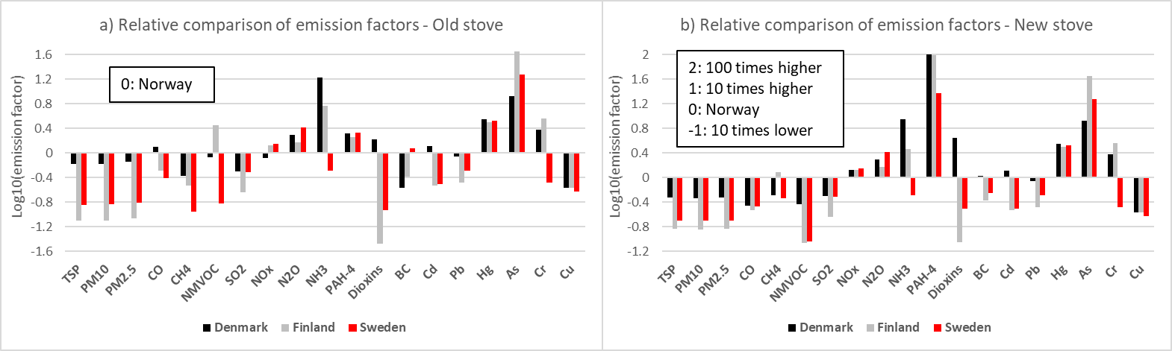

*Figure 2: Relative comparison of emission factors - Old (a) and new (b) stove category*

Figure 2b compares correspondingly the currently used emission factors in the Nordic countries Norway, Denmark, Finland and Sweden for the new stove category. Also for this stove category large deviations in emission factors can be seen for many of the emissions, both for the factors mainly influenced by the fuel used and for the factors mainly influenced by the combustion conditions. Again, especially worrisome are the large deviations found for particles, now with much lower emission factors also in Denmark compared to Norway. This is also the case for CO, but no longer for CH4. For dioxins, the ratio between the Danish emission factor and the other countries' emission factors has increased further. For NMVOC the emission factor in Finland is now on par with those in Denmark and Sweden and is much lower than in Norway. For PAH all the other Nordic countries have much higher emission factors than Norway. For the climate forcer black carbon, now Finland and Sweden have lower emission factors than Norway and Denmark, with Denmark having the highest emission factor, but quite close to the Norwegian emission factor. For NOx, N2O and NH3, large deviations exist due to partly different fuel-N contents, but mainly due to different assumptions regarding the distribution of N between NOx and NH3. Especially Denmark assumes a high NH3 emission factor also for the new stove category, which is hard to defend. Overall, unacceptable deviations exist for a number of the emission factors for also new stoves between the different Nordic countries, which highly influence the outcome of the national emission inventory also for this stove category.

* + 1. Comparison with EU

When comparing with the EMEP/EEA air pollutant emission inventory guidebook (2019) which as Denmark also operates with an ecolabelled stove category, see Figure 3, it becomes clear that a number of the Danish emission factors, both for ordinary and ecolabelled new stoves are based on EMEP. However, for NOx and NMVOC differences can be seen for the ecolabelled stoves, with e.g. reduced NOx emission factor for Denmark and increased for EMEP. It is also worth noting that for CO, PAH-4 and dioxins, there are no reduction in the emission factor for ecolabelled stoves, while in EMEP these emission factors are significantly reduced for ecolabelled stoves. Interestingly, EMEP emission factors for particles are much closer to the Norwegian ones for new stoves.

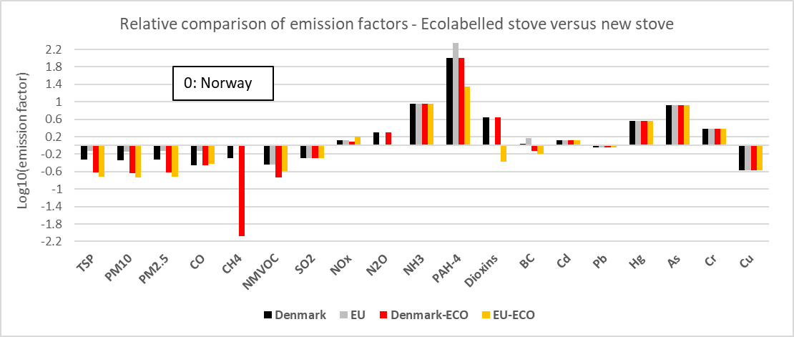

*Figure 3: Comparison with EU, including ecolabelled stoves. EMEP/EEA do not give values for CH4 and N2O*

* 1. A critical discussion
     1. Emission factors

As has been presented in the previous section, up to large uncertainties and for some emission compounds large variations exist in emission factors used in national emission inventories in the Nordic countries as well as when comparing with EMEP emission factors. Emission factors are in some cases taken directly from type approval testing and in other cases from experiments following the type approval test standard but with tests carried out by personnel not being experts on type approval testing, and hence higher emission factors results. In this case the emission factors can be anticipated to be closer to real-life. For most of the emission compounds there are no type approval standard that requires measuring these, and the emission factors are in the best case measured as an add-on when measuring according to the type approval test standard, in the second-best case the result of a research project where the goal has been to map emissions more extensively but not necessarily strictly following a type approval test standard. In the second-worst case the emission factor is borrowed from a database or literature without knowing enough about its origin and representativeness, and in the worst case the emission factor can even be adopted from using a different fuel which might also have been used in a different combustion technology. All these cases are today represented to different degrees in national emission inventories. Hence, there is a real need to derive more representative emission factors for wood stoves and to align these for inclusion in national emission inventories. Of course, there might be to some extent differences between different countries with respect to how wood stoves are operated and especially regarding the preferred wood species, but for similar technology and the same wood specie used, a representative average emission factor should be rather similar: i.e. large differences, as can be seen between the different Nordic countries for some emission compounds, cannot be justified.

* + 1. The sustainability of wood stoves

The sustainability of wood stoves is to a large extent coupled to their emission levels, since the social and economic aspects of using wood stoves are easy to defend. Clearly, the sustainability of new and clean burning wood stoves is much stronger than for open fireplaces and for old wood stoves without staged air combustion. However, as the last decades have shown, emission levels of unburnt compounds have much decreased also because of further development and refinement of these modern wood stoves. This needs to be considered in the national emission inventories that are updated on an annual basis. To increase the sustainability of the wood stove stock, old stoves need to be replaced by new ones and open fireplaces need to be replaced by fireplace inserts. Continuous technology development, automation of air supply, improved user-friendliness, more aware and responsible wood stoves users and secondary flue gas cleaning as well as sufficient maintenance and sweeping of the appliance and chimney will add on to improve the sustainability of the future wood stoves.

* 1. Conclusions

Wood stoves give a very important contribution to domestic heating in many European countries and provides energy security. However, high emissions of especially unburnt compounds as fine particles from old and poor technology or wrong use results, still today, in a negative focus on emissions from wood stoves, even if the modern and clean-burning wood stoves outperform the old and poor technology. As the comparison of emission factors used in national emission inventories in the Nordic countries shows, large uncertainties and large variations in emission factors still exist today, and there is a real need to put more effort into deriving more representative emission factors as well as aligning emission factors between different countries. As the wood stoves are continuously improved, emission factors in national emission inventories should take this improvement into account, either by updating an average emission factor used by a modern stove category, or better, by splitting such a category to showcase the continuous technology improvement resulting in continuously reduced emission levels.

Acknowledgments

The authors acknowledge the financial support by the knowledge building project SusWoodStoves, financed by the Research Council of Norway and industry partners.

References

BLACKOut, 2013, Particle emission factors for wood stove firing in Norway, ISBN 9788259436078.

Danish Centre for Environment and Energy, 2021, Informative inventory report Denmark.

DIN+, 2004, DIN EN 13240 Raumheizer für feste Brennstoffe - Anforderungen und Prüfungen; Deutsche Fassung EN 13240:2001 + A2:2004.

Finnish Environment Institute, 2021, Informative inventory report Finland.

Ecodesign, 2015, eur-lex.europa.eu/legal-content/EN/TXT/?uri=CELEX%3A32015R1185.

EMEP/EEA air pollutant emission inventory guidebook 2019, EEA Report No 13/2019.

EN 13240, 2001, Roomheaters fired by solid fuel, Requirements and test methods.

EN 16510, 2018, CSN EN 16510-1 - Residential solid fuel burning appliances - Part 1: General requirements and test methods.

Norwegian Environment Agency, 2021, Informative Inventory Report Norway.

NS 3058, 1994, Enclosed wood heaters, Smoke emission.

NS 3059, 1994, Enclosed wood heaters, Smoke emission - Requirements.

Seljeskog M., Goile F., Skreiberg Ø., 2017, Recommended revisions of Norwegian emission factors for wood stoves, Energy Procedia, 105, 1022–1028.

Skreiberg Ø., Seljeskog M., 2018, Performance history and further improvement potential for wood stoves, Chemical Engineering Transactions, 65, 199–204.

Swedish Environmental Protection Agency, 2021, Informative Inventory report Sweden.