|  |  |
| --- | --- |
| cetlogo ***CHEMICAL ENGINEERING TRANSACTIONS***  ***VOL. 92, 2022*** | A publication of  aidiclogo_grande |
| The Italian Association  of Chemical Engineering  Online at www.cetjournal.it |
| Guest Editors: Rubens Maciel Filho, Eliseo Ranzi, Leonardo Tognotti  Copyright © 2022, AIDIC Servizi S.r.l. **ISBN** 978-88-95608-90-7; **ISSN** 2283-9216 | |

Biochar from residual lignocellulosic biomass for the cultivation of *Prosopis limensis*

Isabel R. Loyola Saavedra, Juan J. Ochoa Miguel, Carlos A. Castañeda-Olivera\*, Juan J. Ordoñez Galván, Elmer G. Benites Alfaro

Universidad César Vallejo, Campus Los Olivos, Lima, Perú

\*caralcaso@gmail.com

The use of waste as biomass is a sustainable and economically beneficial alternative. Therefore, this research obtained biochar from residual lignocellulosic biomass from the maintenance of public and private green areas to be used as a soil amendment for the cultivation of *Prosopis limensis*. The biochar was obtained by the slow pyrolysis technique using a flame curtain reactor. The biomass and the biochar obtained were physically and chemically characterized to determine their properties such as pH, electrical conductivity, organic matter, nitrogen, ion exchange capacity, P2O5 and K2O. For the cultivation of *Prosopis limensis* seeds, different concentrations (0, 10, 20 and 30 %) of biochar were used and applied in bags containing 2 kg of sandy loam soil. The results showed that *Prosopis limensis* samples with 10 % biochar had better development of their phenological characteristics during the 50 d of experimentation. Finally, it is concluded that biochar as an amendment had a positive effect on soil properties and consequently on *Prosopis limensis* plant growth.

1. Introduction

The generation of solid waste is one of the major problems of social growth in the world, and Peru does not escape this situation, generating some 7,342,713 t annually, of which 58 % is organic waste, 18 % is inorganic waste, and 24 % is non-recyclable waste. In the district of Cieneguilla, about 5 145 t/y of organic waste is generated from weeding and pruning activities in the 214,213,213.06 m2 of green areas that the district has (Municipalidad Distrital de Cieneguilla, 2019). Faced with this problem, the idea of taking advantage of the residual biomass arises through the slow pyrolysis technique. The thermochemical method known as Pyrolysis, allows biomass to be converted into biofuels, biochar and briquettes, among which we can also mention activated carbons, carbon black and printing ink (Elkhalifa et al., 2019). Slow pyrolysis of flax shive and flax shive cellulose residue was carried out at the temperatures of 500 and 750 °C, to investigate the influence on chemical composition and physical properties (Lugovoy et al., 2021). The use of co-pyrolysis in a mixing process between fruit and tire waste has allowed achieving pyrolytic synergism, ensuring the feasibility of treating both wastes to generate bioproducts for alternative use (Mong et al., 2021). The same was appreciated in non-catalytic and catalytic co-pyrolysis (thermal ranges of 240 °C and 500 °C) on fruit bunches and high density polyethylene (Shahdan et al., 2021). Other such applications included obtaining bio-oils from the residual lignocellulosic mass, which is a valuable energy resource (Zadeh et al., 2020).

Thermal variability in the pyrolysis process plays an important factor in the treatment of organic waste, leading to increase the toxicity and decrease the humidity content in the initial material (Yang et al., 2018).

Ecological biochar obtained by the pyrolysis method is used in the remediation of contaminated water and degraded soils, for which its physical and chemical properties are analyzed because they have a direct relationship with the initial conditions of the raw material and the thermal conditions (Islam et al., 2021). This was evidenced in wood-derived biochars from vine shoots and holm oak, performing slow pyrolysis experiments at temperatures of 400 and 600 °C (Videgain et al., 2021).

The use of residual biomass such as wood, textile and food as biochar allowed testing its performance and water absorption capacity, treating it at the temperature of 500 °C (wood and food); wood and textile were treated at temperature values between 300 and 400 °C; this temperature change reduced the performance of wood and textile biochar (Tianhao, 2020). This effect was corroborated with biochar made from residual eucalyptus biomass that was applied as an amendment in corn planting (Iglesias-Abad et al., 2020). The same effect was found by Huertas de la Cruz (2020) when applying biochar from eucalyptus residual biomass and bovine manure in potato cultivation.

Biochar obtained from residual tree pruning biomass presented higher moisture and fixed carbon than that generated by the rest of gramineae and leaf litter; while both presented similar hydrogen content. In relation to micronutrients, pruning biochar presents Ca, Mg and P (Pardavé et al., 2017).

Given the benefits of the use of biochar, this research obtained biochar from residual lignocellulosic biomass from the maintenance of public and private green areas to be used as a soil amendment for the cultivation of *Prosopis limensis*.

2. Experimental

2.1 Raw material

Residual biomass from the district of Cieneguilla, located in the Lurin River basin in Lima, Peru, was used for the development of the research. From the pruning and weeding of green areas, a total of 30 t of leaves, grass clippings, inflorescence, thin woody, medium woody and thick woody, which are transformed into compost and the remaining (not compost) with high content of cellulose, hemicellulose and lignin is subjected to slow pyrolysis to obtain biochar in order to improve the soil. The process is carried out in a pyrolytic reactor with a larger diameter of 1.30 m, a smaller diameter of 0.60 m, a height of 1.00 m and an inclination angle of 63°, which allows oxygen control and the processing of approximately 300 kg of raw material in three hours. The temperature level required for processing was between 650 and 700 °C.

2.2 Elaboration of biochar

For the biochar production process in the pyrolytic reactor, the residual biomass of fine and dry weeds was introduced (Figure 1a and Figure 1b) and then the branches were incorporated until the appropriate biochar formation temperature was reached. Finally, water was added to cool the biochar, as shown in Figure 1c and Figure 1d.

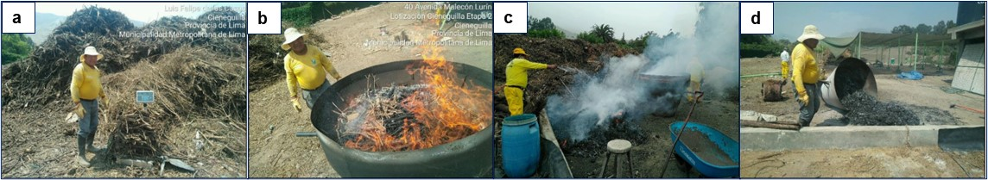

*Figure 1: Biochar elaboration process by slow pyrolysis of the residual mass*

The biochar samples were then separated, one in its natural state and the other subjected to an activation process in a compost pile for 4 months, as shown in Figure 2a and Figure 2b. These samples (Figure 2c and Figure 2d) were sent to the laboratory to determine their physical and chemical properties such as electrical conductivity, pH, humidity (%), cation exchange capacity, organic carbon (%), N, P, K, Ca, Mg, Na, He, Cu, Zn, Mn, B, Pb, Cd, Cr, among others.

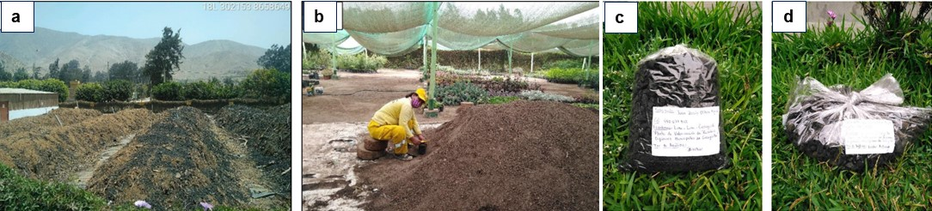

*Figure 2: Samples of biochar in its natural state and activated by biological composting*

2.3 Preparation of substrate and cultivation of forest seeds

The seeds were selected from the fallen nuts of the Huarango (*Prosopis limensis*) (Figure 3a and Figure 3b), which are characterized by their yellowish color and curved shape (pod) of 8 cm x 1 cm, inside which there are 12 seeds of an average diameter of 0.5 cm and brownish color (Figure 3c and Figure 3d). These were subjected to a soaking process for 24 h, in order to accelerate the germination process; those that remained floating were eliminated from the process because they were not suitable.

*Figure 3: Prosopis limensis (Huarango) seed selection process*

The substrate was prepared with sand (Figure 4a) and farmland soil (Figure 4b), which were homogenized in a 2:1 ratio mixture, obtaining 210 kg (Figure 4c). This volume was distributed in three samples: one with substrate as control (Figure 4d), substrate with natural biochar (Figure 4e) and substrate with biologically activated biochar (Figure 4f). The bags (20 cm x 15 cm) were then filled with seedlings.

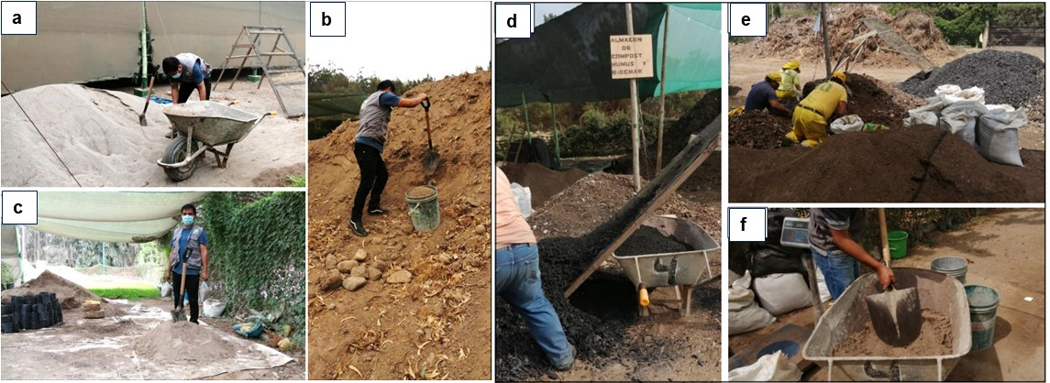

*Figure 4: Preparation of the substrate with sand and farm earth*

2.4 Experimental treatment

Seven treatments (T) were defined according to the percentage of biochar incorporated into the substrate (soil and sand): substrate only (S) (T1), substrate + biochar (T2:10%, T3:20% and T4:30%) and substrate + activated biochar (T5:10%, T6:20 % and T7:30%). For each treatment, fifteen replicates were carried out, as shown in Figure 5.

A total of 2000 g of material was poured into each of the seedling bags and two *Prosopis limensis* seeds were added. The environmental conditions recorded average temperatures of 23 °C and a relative humidity of 71.3 % during the 50 d experimental phase. Irrigation water distribution was uniform with a volume of 500 mm in eleven irrigation intervals. Germinated seedlings were evaluated by considering plant height, root length and number of pinnae or petioles.

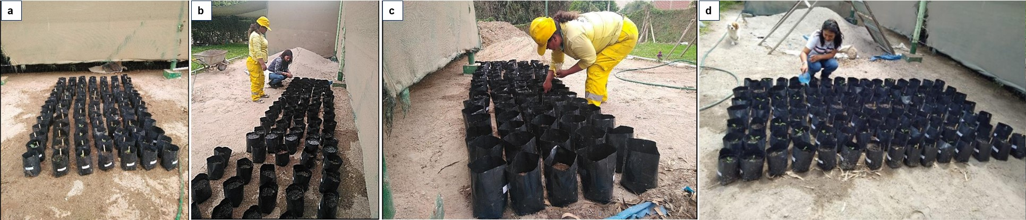

*Figure 5: Experimental process of Prosopis limens seedling germination*

3. Results and discussion

3.1 Characteristics of non-compostable residual biomass

Figure 6a shows the distribution of non-compostable residual biomass, showing a great variety such as laurels, roses, huaranguillo, bamboos and palms in different percentages. Figure 6b shows the different types of residual biomass entering the valorization plant. According to Zadeh (2020), this material basically consists of lignocellulose, which has 40-50 % cellulose, 20-40 % hemicellulose and 10-40 % lignin. This biomass presented a relative humidity of 13.4 % (almost dry) and a pH value of 7.20.

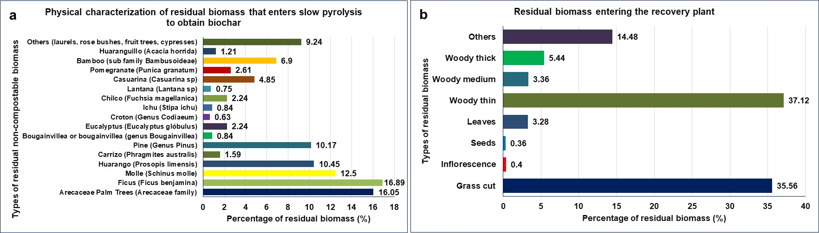

*Figure 6: Characterization of compostable and non-compostable waste biomass*

3.2 Characterization of biochar

A total of 133.80 kg of biochar was produced from 294.30 kg of residual biomass, which is equivalent to a 46 % yield in a time of 3 h, with a thermal variation between 650 and 700 °C, which was controlled by adding water to prevent the biochar from turning into ash. Figure 7a and Figure 7b show the physical and chemical properties of pure biochar and biochar activated by biological composting, showing certain significant differences between them that influence the amendment and consequently the Prosopis limensis seedling cultivation process.

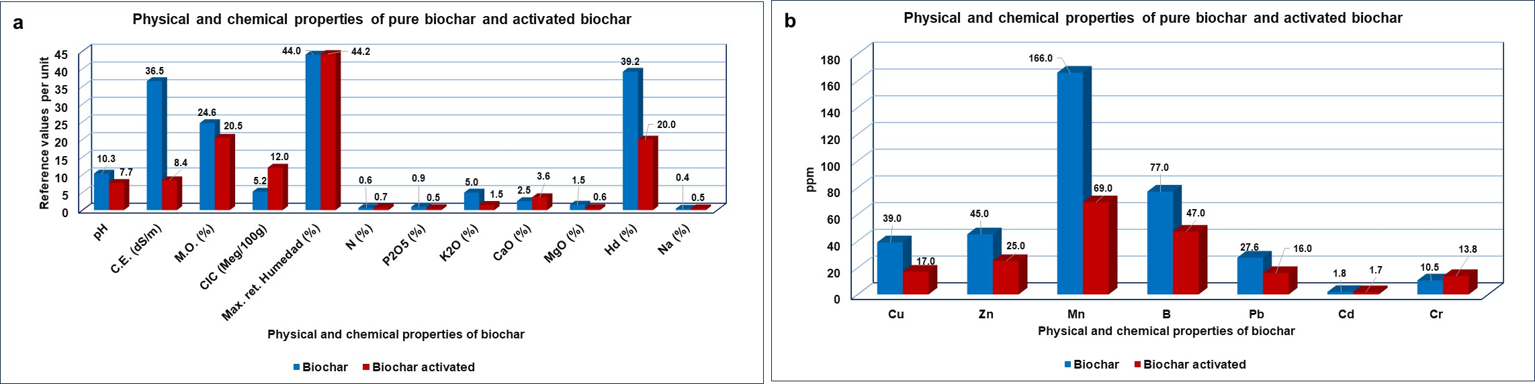

*Figure 7: Physical and chemical properties of pure biochar and activated biochar*

The biomasses treated to generate biochar tend to register high ash, alkaline pH and saline electrical conductivity, which allows controlling soil acidity, increasing its fertility and controlling salinity, as corroborated by García et al. (2021). In relation to NPK, it has been possible to appreciate that in natural biochar and activated biochar, the values achieved allow contributing to the microbial development of the soil by controlling the moisture content in the substrate to avoid eutrophication processes, as corroborated by González-Marquetti (2020) who detected and evaluated the structural modifications of the soil and the improvement of its metabolic components.

3.3 Phenological characteristics of *Prosopis limnesis*

Figure 8a shows the analysis of the germination of *Prosopis limnesis* seeds in each of the treatments developed, reaching a total of 52.4 % active and 547.6 % inactive. From day 5 on, the seedlings began to sprout and their development lasted 20 days. During this period, T2 (S+B10%) and T5 (S+BA10%) achieved the highest percentage of seed flowering (Figure 8b), while T4 and T5 (S+BA10%) achieved the highest percentage of seed flowering (Figure 8b); while, T4 and T7 showed lower seed flowering, this may be due to the fact that biochar in excess has a negative effect generating certain levels of toxicity in the soil such as substrate salinity that did not allow seedling flowering, as manifested by Babalola Aisosa Oni et al. (2019).

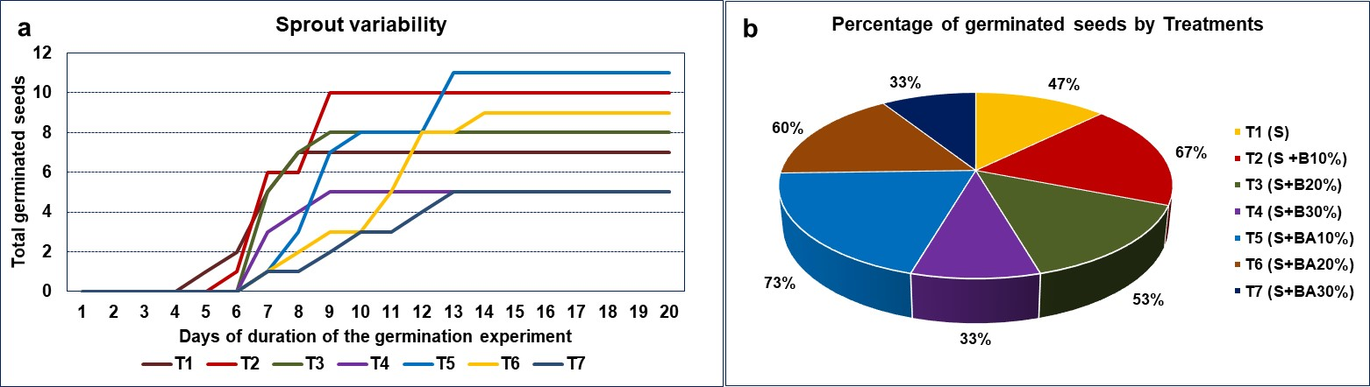

*Figure 8: Behaviour distribution of germinated Prosopis limensis seeds*

The average growth of the seedlings by the action of natural biochar and activated biochar during the 50 d of the experiment was 13.3 cm (T6) and 24.5 cm (T1), as shown in Figure 9a. For those treatments with the greatest amount of biochar, average heights of 13.3 cm (T7) and 13.5 cm (T4) were achieved; while the control treatment achieved the greatest height of 24.5 cm (T1). In relation to the root, average lengths ranging from 24.9 cm to 35.7 cm were achieved, as shown in Figure 9b. This is in agreement with Gonzales I. et al. (2020), who found that biochar manages to increase root mass by up to 32 %. Furthermore, Babalola et al. (2019) indicate that biochar improves soil properties and thus root growth.

*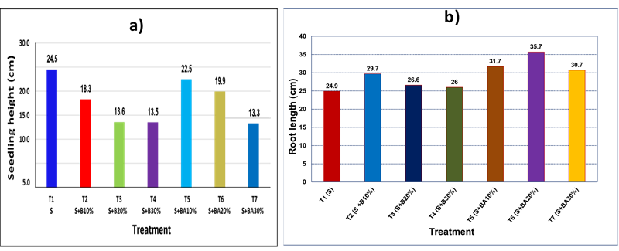*

*Figure 9: Growth of Prosopis limensis: a) Seedlings height and b) Root length*

3.4 Biochar dosage

Based on the analysis of the phenological process of *Prosopis limensis*, it has been determined that the average dose of 10% activated biochar (T5) generated better responses in seedling growth, from the germination phase, height, number of pinnae or nodes and root length, followed by treatments T6 and T7; however, it is important to indicate that in the treatments with substrates and biochar there was also significant growth in roots and germination compared to treatment T1, as shown in Figure 9.

4. Conclusions

The treatment of residual biomass from pruning of green areas in the district of Cieneguillla by slow pyrolysis has allowed the generation of biochar, whose physical and chemical properties improve soil performance. This was evidenced in the cultivation of *Prosopis limenis* using substrate in combination with 10 % activated biochar, achieving a better response in the germination phase, height, number of pinnae or nodes and root length. From this, it can be indicated that the use of non-compostable biomass to enrich amendments to improve soil productivity is viable.

Acknowledgments

The authors would like to thank the Universidad Cesar Vallejo and the municipality of Cieneguilla for their support in the completion of this research.

References

Babalola Aisosa Oni, Olubukola Oziegbe, Obembe O. Olawole, 2019, Significance of biochar application to the environment and economy, Annals of Agricultural Sciences, 64 (2), 222-236.

Elkhalifa Samar, Al-Ansari Tareq, Mackey Hamish, Mckay Gordon. (2019). Food waste to biochars through pyrolysis: A review, Resources, Conservation and Recycling, 144, 310-320.

García Montero, R., Pablo Pizarro Medina, Manuel Rodríguez Rastrero, María José Sierra Herráiz, María Guirado Torres, Rocío Millán Gómez, 2021, Biochar y sus aplicaciones potenciales en el suelo, Técnica Industrial, 328, 44-53.

González-Marquetti, I., Mayra G. Rodríguez, Belkis Peteira Delgado-Oramas y Hans-Peter Schmidt, 2020, Biochar y su contribución a la nutrición, crecimiento y defensa de las plantas, Revista de Protección Vegetal, 35 (2).

Huertas De la Cruz A.J., 2020, Influencia del biocarbón elaborado con residuos sólidos orgánicos sobre la calidad y producción del cultivo de la papa en el centro experimental ecológico de Tuyu Ruri, noviembre 2018 a abril 2019, Repositorio institucional UNASAM, p. 118.

Iglesias-Abad Sergio, Manuel Alvarez-Vera, Jacinto Vázquez, Carlos Salas, 2020, Biochar de biomasa residual de eucalipto (Eucalyptus globulus) mediante dos métodos de pirólisis, Revista de la Universidad Nacional de Tumbes, 17(2) 1816-7667.

Islam, Tariqul, Yanliang Li, and Hefa Cheng. 2021, Biochars and Engineered Biochars for Water and Soil Remediation: A Review, Sustainability, 13 (17), 9932.

Lugovoy Y., Chalov K., Kosivtsov Y.Y., Sidorov A., Sulman M.G., 2021, Slow Pyrolysis of Flax Production Waste, Chemical Engineering Transactions, 88, 331-336.

Mong G.R., Chong W.W.F., Ng J.H., Chong C.T., Idris R., Abas M.A., Chiong M.C., 2021, Co-pyrolysis of Empty Fruit Bunch and Waste Tire: A Kinetics and Synergism Analysis, Chemical Engineering Transactions, 89, 13-18.

Pardavé Walter, Delvasto Pedro, Sánchez Mauricio, 2017, Caracterización fisicoquímica y morfológica de dos muestras de biocarbón producidas mediante pirólisis de residuos de poda y jardinería, Actas de Ingeniería, 3, 304-310.

Shahdan N.A., Balasundram V., Shameli K., Ibrahim N., Isha R., Tamunaidu P., Abdul Manan Z., 2021, Catalytic Copyrolysis of Empty Fruit Bunch and High-density Polyethylene, Chemical Engineering Transactions, 89, 205-210.

Tianhao Han, 2020, Properties of biochar from wood and textile, IOP conferences Series: Earth and environmental Sciencie, 546, 042060.

Videgain María, Joan J. Manyà, Mariano Vidal, Eva C. Correa, Belén Diezma, Francisco J. García-Ramos, 2021, Influence of Feedstock and Final Pyrolysis Temperature on Breaking Strength and Dust Production of Wood-Derived Biochars, Sustainability, 13 (21), 11871.

Yang Y., Heaven S., Venetsaneas N., Banks C.J., Bridgwater A.V., 2018, Slow pyrolysis of organic fraction of municipal solid waste (OFMSW): Characterisation of products and screening of the aqueous liquid product for anaerobic digestion, Applied Energy, 213, 158-168.

Zadeh Z.E., Abdulkhani A., Aboelazayem O., Saha, B., 2020. Recent Insights into Lignocellulosic Biomass Pyrolysis: A Critical Review on Pretreatment, Characterization, and Products Upgrading. Processes, 8 (7), p. 799.