|  |  |
| --- | --- |
| cetlogo ***CHEMICAL ENGINEERING TRANSACTIONS***  ***VOL. 92, 2022*** | A publication of  aidiclogo_grande |
| The Italian Association  of Chemical Engineering  Online at www.cetjournal.it |
| Guest Editors: Rubens Maciel Filho, Eliseo Ranzi, Leonardo Tognotti  Copyright © 2022, AIDIC Servizi S.r.l. **ISBN** 978-88-95608-90-7; **ISSN** 2283-9216 | |

Agro-Industrial Waste from Cocoa Pod Husk (*Theobroma cacao* L.), as a Potential Raw Material for Preparation of Cellulose Nanocrystals.

Adriana Herrera-Barriosa, Juliana Puello-Mendezb, J.C. Pasqualinoc , Henry A. Lambis-Mirandad\*

aChemical Engineering Department, Process Design and Biomass Utilization Research Group (IDAB), University of Cartagena, Avenida del Consulado St. 30, Cartagena de Indias, 130015, Colombia.

bGICI Research Group, Chemical Engineering Department, Universidad de San Buenaventura Cartagena, Diag. 32 # 30-966, Cartagena, Colombia  
cGISAH Research Group, Environmental Engineering Program, Universidad Tecnológica de Bolívar, Campus Tecnológico, km 1 vía Turbaco Cartagena, Cartagena, Colombia.

dProcesses and Systems program, CIPTEC Research Group, Fundación Universitaria Tecnológico Comfenalco, Cartagena, Colombia

\*hlambis@tecnocomfenalco.edu.co

Obtaining cellulose from agro-industrial waste offers the possibility of generating added value to solid biomass that is currently deposited in sanitary landfills. This research performed the evaluation of a residue from cocoa husk pods (*Theobroma cacao* L.), from the agricultural industry. The cellulose fiber was obtained through chemical treatments with KOH at 5% w/v to remove non-cellulosic components and then the fiber was bleached with 3% v/v hydrogen peroxide. The changes in chemical structure were determined through Fourier transform infrared spectroscopy (FTIR). The FTIR analysis confirms the progressive decrease of lignin and hemicellulose after applying chemical treatment. The morphological changes in the surface of the fiber were characterized using the SEM technique. The mass percentage of cellulose increases up to 68 %. It is expected that the Nano-Crystals (NCC) extracted from the biomass of the cocoa husk pods, present a high index of crystallinity and that they are also in suitable conditions to be useful as reinforcing agents in polymeric or mineral matrices, and may have potential application for technology transfer.

Keywords: Nano-Crystals, cocoa, agro-industrial waste, biomass.

* 1. Introduction

At an international level, the cocoa industry is one of the largest producers, because different goods with added value can be obtained from the fruit, such as chocolate, cocoa butter, cocoa powder, cocoa liquor, among others, which they are commercially attractive. In Colombia, the amount of cocoa pod husks (CPH), which is usually burned or left to decompose in the open air on plantations without any environmental control, is expected to reach 2,100,000 tons yr–1 in 2021(Martínez-Ángel et al., 2015).

Harnessing lignocellulosic fractions and bioactive compounds from CPH and shells can lead to the development of profitable commodity products. Consequently, these cocoa pod shells can generate income for farmers and promote economic development (Lu et al., 2018). Each ton of dry cocoa beans generates 10 to 15 tons of wet cocoa residue, consisting mainly of pods. Pods are typically left to decompose on the cocoa farm, producing off-odors and exacerbating the spread of plant diseases, including black pod rot (Mansur et al., 2014)

The extraction of cellulose is of great interest since it can be used as a raw material in processes such as the production of paper, textiles, the cosmetics industry, and the production of nano-materials. Currently, the use of nano-materials has spread in multiple applications and mass consumption products, which can be seen from toothpaste to batteries, paints and clothing (Ferreira-Villadiego et al., 2018). In the field of research, this type of material has taken on great importance in recent years, due to the fact that its characteristics such as size, resistance, low molecular weight, make them special for the incorporation and manufacture of new products (Bian et al., 2019; Srivastava & Majumder, 2008; Tian et al., 2022).

This research work evaluated a source of plant origin (cocoa pod husks) as a raw material to produce nano-crystals of cellulose, through acid hydrolysis, in addition to characterizing the CPH from the cocoa fruit (*Theobroma cacao* L.) by means of the analysis of the content of lignin, hemicellulose, cellulose and ashes. Also, determine relevant changes in its structure, using Fourier transform infrared spectroscopy (FTIR).

* 1. Methodology
     1. Raw material preparation

The cocoa fruit (Figure 1a) comes from the *Montes de María* (an isolated group of small mountains near the northern coast of Colombia in the Caribbean region) area, municipality of San Jacinto town, in the Department of Bolívar. This raw material (*Theobroma cacao* L.) is washed with distilled water to remove dirt. Following the above, cuts were made to the fruit to separate the seeds from the pod husk and then it was cut into small pieces of approximately 1.5 to 2 cm (Figure 1b). The pod husk pieces were immersed in a 1% v/v sodium hypochlorite solution for 4 hours to inhibit oxidation and prevent the growth of microorganisms. Subsequently, the pieces were washed with distilled water and strained to remove excess hypochlorite.

The rinsed pod husks were placed on trays and dried in an oven for 24h at a temperature of 70ºC. Once dry, they are macerated and crushed until obtaining a particle size as small as possible to take advantage of all the dry pod husk. Subsequently, the raw biomass was sieved using an ASTM No 100 sieve (stainless steel mesh, 150 µm).

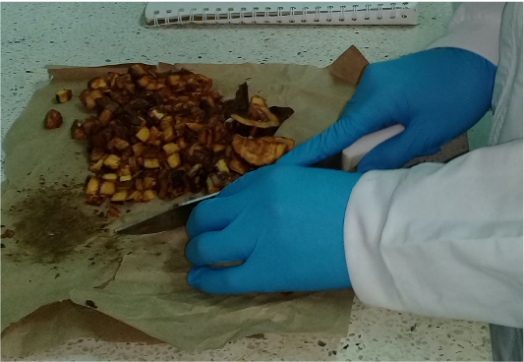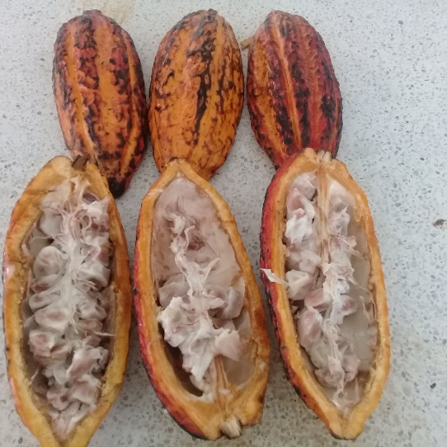

a) b)

Figure 1: a) Cocoa fruit and Cocoa husk pod. b) Cocoa husk preparation.

* + 1. Raw material characterization

2.2.1 Cellulose Content

α-Cellulose determination is carried out following the methodology of the ASTM D1103-60 standard, Method of Test for α-Cellulose in Wood, with a 17,5% of Sodium Hydroxide solution. (Heidarian et al., 2016; Q. Lu et al., 2014)

2.2.2 Hemicellulose content

Hemicellulose content was calculated between differences between the contents of Holocellulose and α-Cellulose (Ogunsuyi & Olawale, 2021).

2.2.3 Lignin Content

Lignin was determined according to TAPPI Standard T-222 or om-83. The carbohydrates in wood and pulp are hydrolyzed and solubilized by sulfuric acid; the acid-insoluble lignin is filtered off, dried, and weighed.

(Dence, 1992; Tappi, 2011)

2.2.4 Ashes

The ashes were determined using the ASTM D 1102-84 standard, in a muffle furnace at 600 oC with a sample weight of 2 g (Álvarez-Álvarez et al., 2018; F. Lu et al., 2018b).

* + 1. Alkali Pretreatments of cocoa husk pod biomass

First, the alkaline treatment of the raw biomass was with a KOH solution at 5% w/v (ratio 1:20) under mechanical agitation at room temperature for 14h, to solubilize pectins and hemicelluloses. It was then washed with distilled water until reaching neutral pH and filtered through a 45 μm filter. The insoluble residue was delignified with 1% w/v NaClO at pH 5.0 (adjusted with 10% v/v acetic acid) at 70 °C, for 1 h. The insoluble residue was bleached with 3% v/v hydrogen peroxide for 2h at 70°C to remove lignin residues. A second treatment with KOH solution was then carried out under the same conditions as in the first step. The bleached fibers were repeatedly washed with distilled water until the pH became neutral, then centrifuged for 10 minutes at 4000 rpm and subsequently dried at 70°C for 8 hours in an oven. (H. Lu et al., 2013; Pelissari et al., 2014)

2.3.1 Characterization of modified cocoa biomass by FTIR.

Samples of cocoa husk pods modified with alkaline treatments were analyzed in a FT-IR SHIMATZU 8400S spectrophotometer, using the KBr pellet method according to the ASTM-E168 and ASTM-E1252 standards, with the objective of obtaining information on the characteristic functional groups. The FTIR spectra of each sample were scanned within a range of 500–4000 cm-1 (Heidarian et al., 2016).

2.3.2 Scanning electron microscopy (SEM)

The morphologies of the modified materials were observed using scanning electron microscopy (SEM, Quanta 200, FEI, USA). Samples were dried on a polished aluminum mount and sputter-coated with gold to provide adequate conductivity.

* 1. Results

Raw cocoa husk pods (biomass) had the following lignocellulosic contents: 48.65% cellulose, 51.13% hemicellulose, and 25.24% lignin, in addition to an ash content of 7.98%. On the other hand, it is observed that in the characterization results of the bleached cellulose pulp there was a significant increase in the percentage of cellulose to 67.99%, and the percentages of hemicellulose and lignin were reduced to 32.1% and 20.2%, respectively (Figure 2).

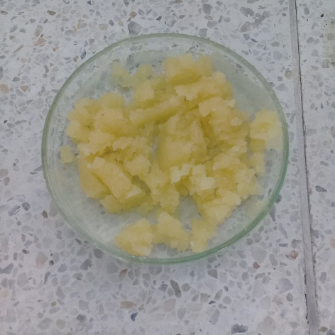

*Figure 2: Biomass from cocoa husk pods after two alkali treatments.*

Changes in chemical structure between the first and second chemical treatments were analyzed by FTIR spectroscopy. FTIR spectra are shown in Figures 3a and 3b (Reddy et al., 2009).

Table 1 shows the typical absorption bands of α-cellulose, hemicellulose, and lignin, which will be used as a reference for the analysis of the spectra obtained in this investigation. For both spectra, a strong absorption band is seen around 3270 cm-1 which corresponds to an -OH type stretching, very typical of the α-cellulose structure.

At the wavenumber close to 2900 cm-1, an increase in the C-H stretching vibrations of the methyl and methylene units is noted in comparison between the first and second chemical treatments. In the 1750–900 cm-1 region of Figure 3a, many absorption peaks are noted whose intensities vary from low, moderate to high. Such as, the values ​​of 1740, 1605, 1372, 1316,1245 and 1027 cm-1. The peak at 1740 cm-1 is attributed to the carbonyl ester component of hemicellulose. Hemicellulose consists of both ester and acid functionality.

In Figure 3b, the decrease of intensity of the bands in the interval from 1800 to 1700 is shown, where the groups CH3COO- and COOH are, which belong to hemicellulose, this is evidenced in the decrease of its content, due the second chemical treatment. The disappearance of the ester and acid carbonyl stretching vibrations are enhanced by the reduction in the intensity of 1246 cm-1 (C-O-C), because of the two chemical treatments.

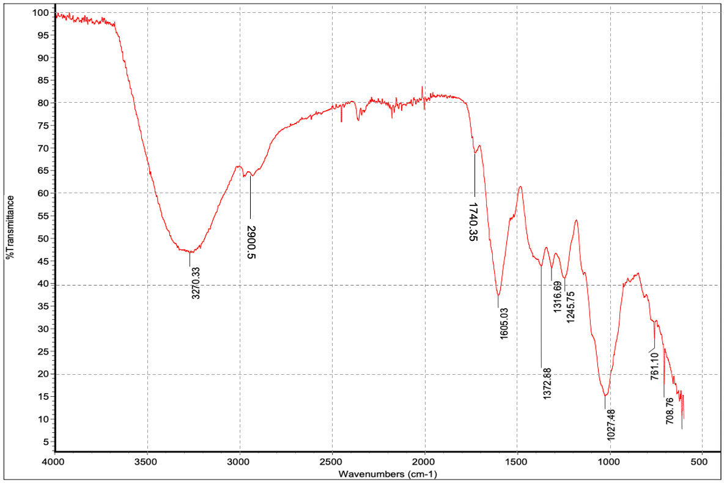

(a)

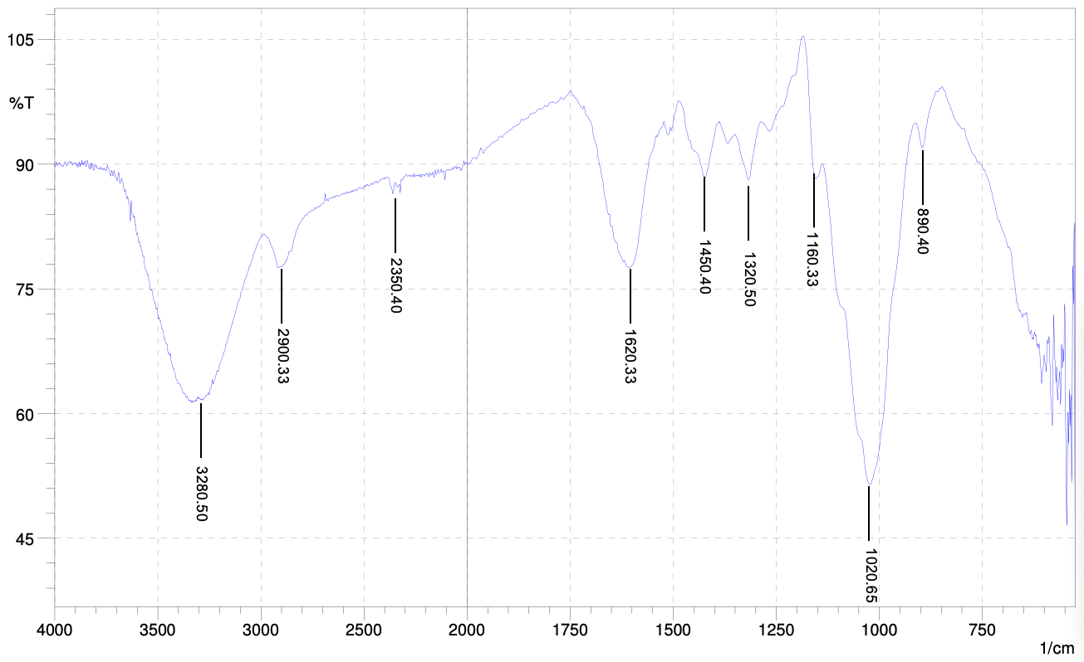

(b)

Figure 3: (a), ﻿﻿FTIR spectra of Cocoa husk pods samples after first alkali-treatment; (b), ﻿ FTIR spectra of Cocoa husk pods samples after second alkali-treatment.

Table 1: ﻿Absorption Bands for Functional Groups of Cellulose, Hemicellulose, and Lignin.

|  |  |  |  |  |  |
| --- | --- | --- | --- | --- | --- |
| **Component** | **Functional** | **Group Wave Number** | | **(cm-1)** |  |
| α-Cellulose. | OH- stretching  OH- bending | | 3270  1372 |  |  |
|  | CH- stretching | 2900 | |  |  |
|  | CH- bending | 1450 | |  |  |
|  | CO- stretching | 1027 | |  |  |
| Hemicellulose | C=O stretching | (carbonyl ester) 1740 | |  |  |
|  | CH- stretching | 2900 | |  |  |
|  | -COC- stretching | 1246 | |  |  |
| Lignin | OH- stretching | 3280 | |  |  |
|  | -COC- stretching | 1160 | |  |  |
|  | -CH2 bending | 1372 | |  |  |
|  | -CH3 bending | 1450 | |  |  |

(b)

(a)

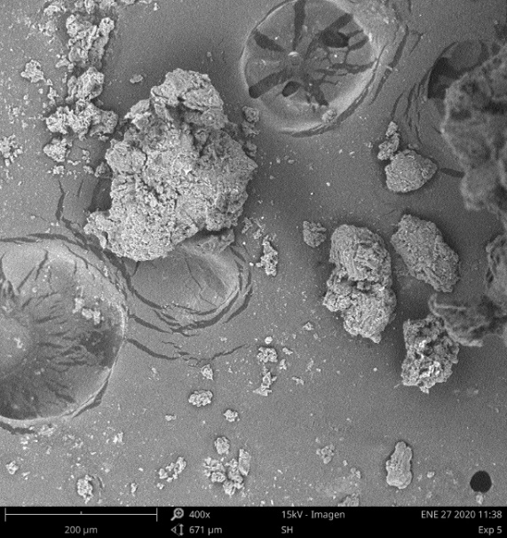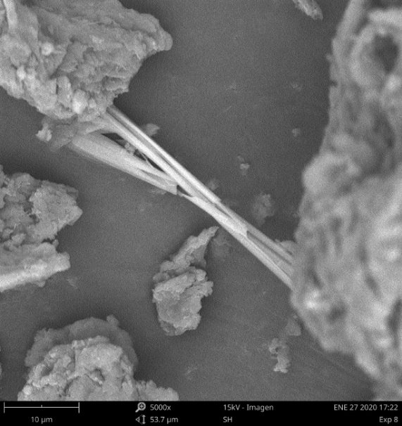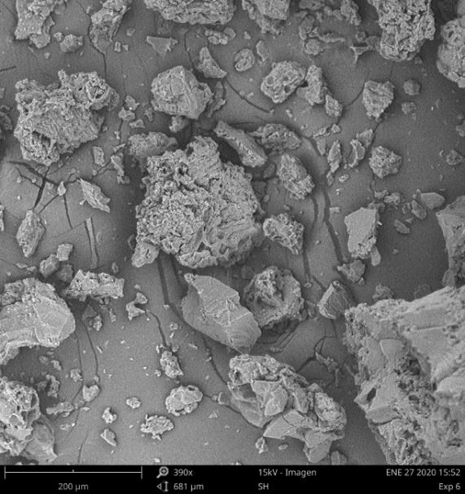

(e)

(c)

d)

Figure 4: (a) and (b), SEM images from Cocoa husk pods after first alkali-treatment; (c) and (d), SEM images after second alkali-treatment.

Scanning electron micrographs (SEM) of the surface and cross section of the treated biomass are shown in Figure 4 at different magnifications. SEM images show an irregular pattern and an amorphous surface. In Figure 4(d), can be seen a microfiber, product of the second alkali treatment (bleaching)(Alemdar & Sain, 2008; Ogunsuyi & Olawale, 2021) .

* 1. Conclusions

The biomass from husks cocoa pod is a good source of cellulose that will be used for the subsequent production of Nanocrystals. By means of alkaline treatments, the percentage of cellulose (68%), the main raw material for the desired product, was increased. Fourier Transform Spectroscopy (FTIR), showed the changes in the functional groups and the decrease of hemicellulose and lignin in the biomass, after the alkaline treatments.

SEM images confirmed the changes in the raw material, this stimulates the use of cocoa husk pods, an agroindustrial residue, as a renewable source of nanocrystals. A future study will be conducted to investigate the potential reinforcement that these nanocrystals promote in composites.

Acknowledgments

This work was funded by the *Fundación Universitaria Tecnólogico Comfenalco* as a part of the project: “Preparation of composite materials from industrial gypsum waste modified with cellulose nanocrystals, natural and synthetic fibers” in an internal call, 2019.

References

Alemdar, A., Sain, M., 2008, Isolation and characterization of nanofibers from agricultural residues - Wheat straw and soy hulls. Bioresource Technology, 99, 1664–1671.

Álvarez-Álvarez, P. et al., 2018, Evaluation of tree species for biomass energy production in Northwest Spain. Forests, 9, 1–15.

Bian, H. el al., 2019, Lignocellulosic nanofibrils produced using wheat straw and their pulping solid residue: From agricultural waste to cellulose nanomaterials. Waste Management, 91, 1–8.

Dence, C. W., 1992, The determination of lignin. In Methods in lignin chemistry (pp. 33-61). Springer, Berlin, Heidelberg, Germany.

Ferreira-Villadiego, J., et al., 2018, Chemical modification and characterization of starch derived from plantain (*Musa paradisiaca*) peel waste, as a source of biodegradable material. Chemical Engineering Transactions, 65, 763-768.

Heidarian, P., Behzad, T., & Karimi, K.,2016, Isolation and characterization of bagasse cellulose nanofibrils by optimized sulfur-free chemical delignification. Wood Science and Technology, 50, 1071–1088.

Lu, F. et al. (2018a). Valorisation strategies for cocoa pod husk and its fractions. Current Opinion in Green and Sustainable Chemistry, 14, 80–88.

Lu, H., Gui, Y., Zheng, L., & Liu, X.,2013, Morphological, crystalline, thermal and physicochemical properties of cellulose nanocrystals obtained from sweet potato residue. Food Research International, 50, 121–128.

Lu, Q., Tang, L., Wang, S., Huang, B., Chen, Y., & Chen, X., 2014, An investigation on the characteristics of cellulose nanocrystals from Pennisetum sinese. Biomass and Bioenergy, 70, 267–272.

Mansur, D., Tago, T., Masuda, T., & Abimanyu, H., 2014, Conversion of cacao pod husks by pyrolysis and catalytic reaction to produce useful chemicals. Biomass and Bioenergy, 66, 275–285.

Martínez-Ángel, J. D., Villamizar-Gallardo, R. A., & Ortíz-Rodríguez, O. O. (2015). Caracterización y evaluación de la cáscara de mazorca de cacao (*Theobroma cacao* L.) como fuente de energía renovable. Agrociencia, 49, 329–345.(in Spanish)

Ogunsuyi, H. O., & Olawale, C. A., 2021, Evaluation of Plantain Biomass (*Musa paradisiaca* L.), as Feedstock for Bio-Ethanol Production. Green and Sustainable Chemistry, 11, 59–71.

Pelissari, F. M., Sobral, P. J. D. A., & Menegalli, F. C.,2014, Isolation and characterization of cellulose nanofibers from banana peels. Cellulose, 21, 417–432.

Reddy, K. O., Guduri, B. R., & Varada Rajulu, A.,2009, Structural Characterization and Tensile Properties of Borassus Fruit Fibers. Journal of Applied Polymer Science, 114, 603–611.

Srivastava, N. K., & Majumder, C. B.,2008, Novel biofiltration methods for the treatment of heavy metals from industrial wastewater. Journal of Hazardous Materials, 151, 1–8.

Tappi, 2011, Lignin in Wood and Pulp. T222 Om-02, 1–7. <tappi.org/content/SARG/T222.pdf> accessed 20.06.2021

Tian, D. et al., 2022, Complete conversion of lignocellulosic biomass into three high-value nanomaterials through a versatile integrated technical platform. Chemical Engineering Journal, 428, 131373.