|  |  |
| --- | --- |
| cetlogo ***CHEMICAL ENGINEERING TRANSACTIONS***  ***VOL. 92, 2022*** | A publication of  aidiclogo_grande |
| The Italian Association  of Chemical Engineering  Online at www.cetjournal.it |
| Guest Editors: Rubens Maciel Filho, Eliseo Ranzi, Leonardo Tognotti  Copyright © 2022, AIDIC Servizi S.r.l. **ISBN** 978-88-95608-90-7; **ISSN** 2283-9216 | |

Photothermal membrane of biochar from pruning residues for the reduction of seawater salinity

Jasmin C. Salazar Rojasa, Frances L. Rojas Ramosa, Carlos A. Castañeda-Oliveraa,\*, Elmer G. Benites Alfaroa, Rita J. Cabello Torresb, Eduardo R. Espinoza Farfanb

aUniversidad César Vallejo, Campus Los Olivos, Lima, Perú

bUniversidad César Vallejo, Campus San Juan de Lurigancho, Lima, Perú

\*caralcaso@gmail.com

Photothermal materials and adsorbents are the main components of solar-driven seawater desalination. This being so, the objective of the research was to determine the effectiveness of a photothermal membrane made of biochar from pruning residues for the reduction of seawater salinity. For the salinity reduction treatment, a stainless steel continuous cell evaporation system including photothermal membranes with 150 g of pruning biochar was constructed, and the physicochemical parameters of the seawater were measured both before and after the treatment. The desalination process was carried out for 6 h per day (10:00 a.m. to 4:00 p.m.) for 3 consecutive days. The results showed a reduction in the values of sulfates, phosphates, turbidity, total solids, dissolved solids and chlorides, with a salinity reduction efficiency of 91.08 %, with a radiation of 0.98 kW/m² and a relative humidity of 49 %. Finally, it was concluded that the evaporation system using pruning biocarbon membranes improved the values of the physicochemical parameters of seawater and could be used as an alternative solution to water scarcity in rural coastal populations.

1. Introduction

The water resource is available in large quantities in the sea, which constitutes more than 97 % of the total amount of water. However, it cannot be directly used for drinking or irrigation because of its high salinity (Zheng, 2017). Thus, freshwater is critical for human survival and its direct per capita availability decreases as population, development, and climate variability increase (Chen et al., 2019; von Medeazza 2004; Giordano, Barron, and Ünver 2019). Globally, 663 million people do not have access to safe drinking water and in 18 countries, at least 5 % rely on water distributed by tankers (UNICEF 2017). This crisis is beginning to become evident in countries such as Brazil, China, India, and Iran, where the demand for drinking water increased relative to availability (Leroux, Martin, and Zheng 2018).

Peru is not exempt from this alarming situation due to the fact that 62.3 % of the Peruvian population is concentrated in the coastal region, where water availability is lower with respect to demand (Instituto de Promoción de la Gestión del Agua, 2017).

The water crisis encourages resorting to the use of seawater after treatment. Seawater is characterized by having a salinity of approximately 3.5 %. This means that each kilogram of seawater has approximately 35 g of dissolved salts, the most predominant being sodium (Na+) and chloride (Cl-). Ocean water is a homogeneous mixture containing 96.5 % water and 3.5 % salts in solution, such as sodium chloride (NaCl), which accounts for 80 % of the minerals contained in seawater. The most important characteristics of seawater are salinity, turbidity, hydrogen potential and electrical conductivity. At present, salinity is determined with reference to electrical conductivity. In the oceans, the range of variation is small since 75 % of ocean waters have salinity between 34.5 and 35 g/L (Barreiro, n.d.), and present turbidity when there is the presence of suspended matter that produces light scattering (IMARPE, 2009).

Desalination is a process that allows fresh water to be obtained from brackish, sea or wastewater. This is achieved by separating salts and other substances contained in the water (Naranjo González, 2007). The methods used to reduce salinity can be thermal and non-thermal. Thermal methods require heat and are governed by the principle of evaporation. Non-thermal methods are performed through membranes and high pressures. Li et al. (2016) designed and tested a solar desalination system containing a graphene oxide-based photoabsorbent membrane, achieving an efficiency of 78 % with a reduction of sodium ions from 1.5228 mg/L to 0.99 mg/L.

The photothermal membrane of activated biochar from pruning is a sheet of resistant organic fabric, coated with a photoabsorbent material, whose function is to capture sunlight and then convert it into thermal energy. In addition, it is used for energy absorption due to the fact that it contains photoabsorbent material (Politano et al. 2017). Therefore, in the present research, a novel, eco-friendly and efficient system was proposed to reduce seawater salinity, using activated biochar, a product of the pyrolysis of pruning remains, as a photoabsorbent material in the elaboration of a photothermal membrane. The main objective of this research was to determine the efficiency of a photothermal membrane made of activated biochar from pruning to reduce the salinity of seawater at Playa Tortugas in Casma, Peru.

2. Materials and methods

2.1 Salinity reduction system design

The salinity reduction system (Figure 1) is composed of 6 parts including: (1) seawater inlet, (2) continuous evaporation cells, (3) photothermal membrane, (4) parabolic solar concentrator, (5) condenser, and (6) treated water collector.

The photothermal membrane was composed of activated biocarbon made from dried Delonix regia (Poinciana) pruning biomass.

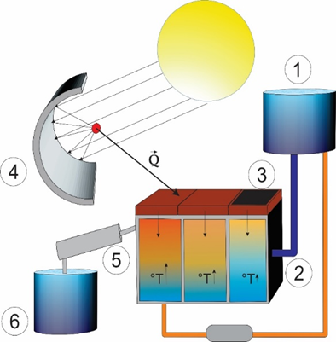

*Figure 1: Salinity reduction system*

2.2 Salinity reduction system installation area

The salinity reduction system was installed at Tortugas Beach in the district of Casma in the province of Chimbote in Ancash, Peru. It was installed in this location because the area has good solar radiation, which allows the system to function properly.

2.3 Seawater treatment

The salinity reduction treatment was carried out in 3 days, with a time of 6 h/day. In the water treatment using the salinity reduction system, physical and chemical parameters were measured both before and after treatment. The parameters evaluated were temperature, pH, electrical conductivity, redox potential, turbidity, chlorides, sodium, alkalinity, phosphates, oxygen, COD, BOD, sulfates, total solids and dissolved solids.

3. Results and discussion

3.1 Characteristics of activated biochar from Poinciana prunings

Figure 2 shows the process of making activated biochar from Poinciana prunings, which was carried out by slow pyrolysis between 500 and 600 °C. Table 1 presents the physical characteristics of pruning activated biochar (Poinciana). It is observed that of the total mass of biochar, 55.77 % is converted to ash when raised to temperatures ˃ 700 °C. On the other hand, biochar has a lower fixed carbon content than other biomasses, represented by 30.81 % and has a calorific value of 902.62 kcal/kg. The particle size of the biochar was 44 µm, classifying it as a powdered activated biochar. Other researchers such as Zaw et al. (2018) made biochar from pruning residues of Japanese pear trees, containing 9.7 % volatile material, 80.5 % fixed carbon and 9.8 % ash, and which had a processing time of 2 h. Abenavoli et al. (2016) made biochar from olive and hazelnut pruning residues, and their physical characterization showed a fixed carbon content of 78.1 % and 90.1 %, respectively. Ash production was between 6.2 to 18.8 %, with a processing time of 3 h.

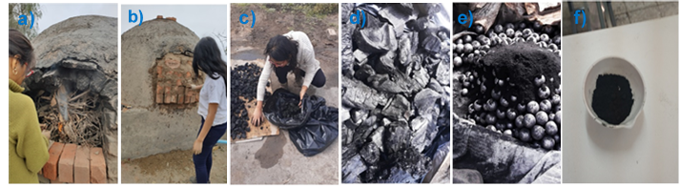

*Figure 1: Production of activated biochar from Poinciana pruning. a) Filling of the pyrolyzing furnace, b) Sealing of the furnace, c) Extraction of the biochar made in 04 h by slow pyrolysis at 500 – 600 °C, d) Stabilization of the biochar before being activated, e) Activated biochar in the milling process, and f) Sample of fine biochar.*

Table 1: Physical characteristics of activated biochar from Poinciana prunings

|  |  |
| --- | --- |
| Physical parameters | Value |
| Humidity (%) | 10.7 |
| Volatile material (%) | 13.78 |
| Ash (%) | 55.77 |
| Fixed carbon (%) | 30.45 |
| Calorific value (kcal/kg) | 4150.5 |
| Particle size (µm) | 44 |
| Processing time (h) | 3 |
| Thermal conductivity (W/mK) | 345.2 |
| Thermal resistance (m2K/ W) | 0.00004 |

The pruning activated biochar presented an electrical conductivity of 345.2 W/mK and a thermal resistance of 0.00004 m2K/W. Xu et al. (2017) obtained thermal conductivities of 0.28 and 0.45 W/mK for natural and carbonized mushrooms, respectively. Similarly, Gong et al (2019) fabricated a porous polyimelamine sponge that had a photothermal efficiency of 92 % and an ultra-low thermal conductivity of 0.038 W/mK.

3.2 Sea water salinity reduction treatment

In the seawater salinity reduction treatment, 3.9 L of treated water was obtained in 6 h, with an incident radiation of 0.98 kW/m2 at 12:00 noon, which increased the surface temperature of the photothermal membrane to 138 °C (see Figure 3). The physical and chemical parameters of the seawater before and after treatment are presented in Table 3. After treatment, on day 3 a reduction in salinity can be observed, where the amount of chlorides was reduced from 19,505.50 mg/L to 28.6 mg/L, with an efficiency of 99.85 %. The other parameters 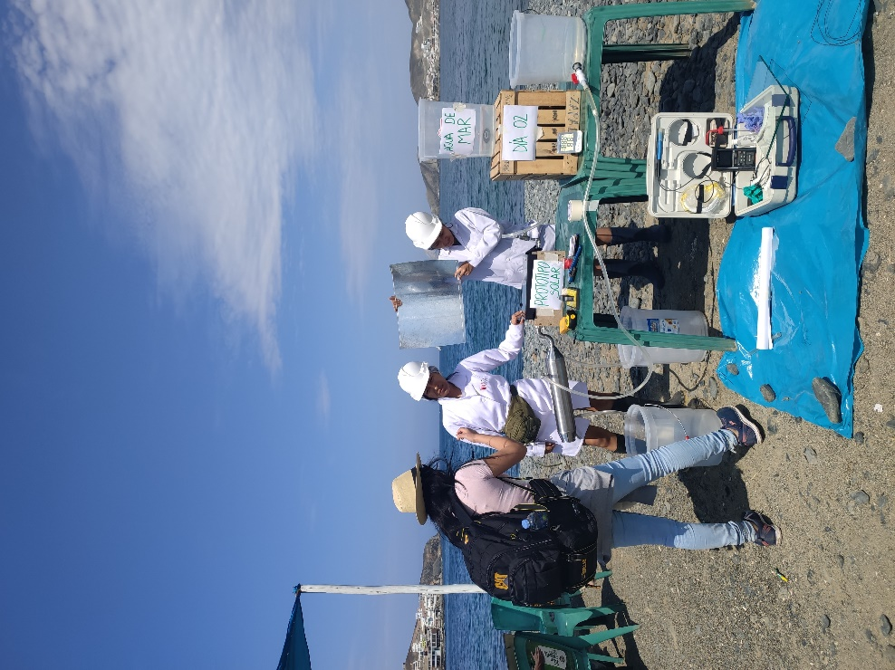such as electrical conductivity, turbidity, sodium, alkalinity, phosphates, dissolved oxygen, sulfates, total solids and dissolved solids also had significant reductions in their values. While, BOD and COD had an increase in their values due to biological oxidation and chemical oxidation of the compounds present in the water, which increase in the exposure period during treatment (Carrillo and Pulido, 2018).

*Figure 3: In-situ salinity reduction treatment*

Table 2: Results of physicochemical parameters

|  |  |  |  |  |
| --- | --- | --- | --- | --- |
| **Parameters** | **Initial** | **Day 1** | **Day 2** | **Day 3** |
| Temperature (ºC) | 17.8 | 17.8 | 18.05 | 18.04 |
| pH | 8.1 | 6.65 | 7 | 7 |
| Electrical Conductivity (µS/cm) | 50,800 | 4,530 | 4,545 | 4,540 |
| Redox Potential (mV) | 215 | 180 | 18 | 18 |
| Turbidity (NTU) | 7.5 | 7 | 6.9 | 6.99 |
| Chlorides (mg Cl-/L) | 19,505.50 | 28.614 | 28.601 | 28.6 |
| Sodium (%) | 23.40 | 12.30 | 12.29 | 12.31 |
| Alkalinity (mgCaCO3/L) | 11.76 | 5.88 | 6 | 6.04 |
| Phosphates (mg/L) | 123.75 | 67.5 | 67.63 | 67.66 |
| Dissolved Oxygen (mgO2/L) | 5.75 | 5.95 | 6 | 6.05 |
| DQO (mgO2/L) | 51.28 | 102,56 | 100 | 100.09 |
| DBO (mgO2/L) | 20.5 | 42.67 | 40.65 | 40.7 |
| Sulfates (mgSO4=/L) | 3,313.48 | 11.078 | 11.055 | 11.045 |
| Total Solids (mg/L) | 38.46 | 14.6 | 14.59 | 14.57 |
| Dissolved Solids (mg/L) | 36.79 | 1.080 | 1.076 | 1.075 |
| **Salinity Reduction (%)** | 99.85 | | | |

In other research, Wang, Zhu and Zheng (2018) worked on a treatment using a solar energy capture and seawater demineralization system using a floating porous film, reaching a water production of 1.19 kg/m2.day and a daily solar-thermal conversion rate of 22.7 %. Meanwhile, Rahaoui et al. (2017) performed direct contact membrane distillation (DCMD) and solar, reaching to produce 1.7 L of freshwater in 15 h of treatment. Yabroudi et al. (2011) and Safaei and Tavakoli (2017) also obtained salinity reductions of 99.8 and 50 % using a tubular solar distiller and graphene oxide nanosheets membranes, respectively. Unlike Ghahari et al. (2019) who worked with a metal-air desalination battery and achieved a salinity reduction efficiency of 37.8 %.

4. Conclusions

The use of the photothermal membrane of activated biochar from pruning reduced seawater salinity by 99.85 % by the third day of treatment, demonstrating a high reduction efficiency. Likewise, the concentration of sulfates and phosphates was improved, whose values were reduced from 3313.48 to 11.045 mgSO4=/L, and 123.75 to 67.66 mg/L, respectively. Chlorides were reduced from 19505.50 to 28.6 mgCl-/L and the percentage of sodium from 23.40 to 12.31 %.

3.9 L of treated water was obtained in 6h, with an incident radiation of 0.98 kW/m2 at 12:00 pm, which increased the surface temperature of the photothermal membrane to 138 °C, reducing the values of turbidity, total solids and dissolved solids to 6.95 NTU, 14.57 mg/L, 1.075 mg/L, respectively.

Acknowledgments

The authors would like to thank "Investiga UCV" of the Universidad César Vallejo for financial support for the publication of this research.

References

Abenavoli, L., Longo, L., Proto, A., Gallucci, F., Ghignoli, A., Zimbalatti, G. y Russo, D., 2016, Procedia, 223, 698-705.

Bereiro M, s.f., Características generales de los océanos, Oceanografía dinámica, 1-12, <https://docplayer.es/14822569-1-caracteristicas-generales-de-los-oceanos.html>

Carrillo, Y. y Pulido A., 2018, Evaluación de un inóculo microbiano comercial para minimizar

la materia orgánica en aguas residuales de una planta Panificadora en Soledad – Atlántico, Tesis de bachillerato. Universidad de San Buenaventura, Colombia.

Chen, C., Kuang, Y. y Hu, L., 2019, Challenges and Opportunities for Solar Evaporation, Joule, 3, 683-718.

Ghahari, M., Rashid-Nadimi, S. y Bemana, H., 2019, Metal-air desalination battery: Concurrent energy generation and water desalination. Journal of Power Sources, 197-203.

Giordano, M., Barron, J. y Ünver, O., 2019, Water Scarcity and Challenges for Smallholder Agriculture, Sustainable Food and Agriculture, 75-94.

Gong, F., Li, H., Wang, W., Huang, J., Xia, D., Liao, J., 2019, Scalable, eco-friendly and ultrafast solar steam generators based on one-step melamine-derived carbon sponges toward water purification, Nano Energy, 58, 322-330.

Imarpe. Calidad del ambiente marino y costero en la región Ancash 2012, Instituto del Mar del Perú, 42, 436-459

Instituto De Promoción De La Gestión Del Agua, 2017, Agenda del Agua 2030: Contribuciones para el cumplimiento de los Objetivo de Desarrollo Sostenible: una propuesta desde la sociedad civil.

Leroux, A.D., Martin, V.L. y Zheng, H., 2018, Addressing water shortages by force of habit, Resource and Energy Economics, 53, 42-61.

Li, X., Xu, W., Tang, M., Zhou, L., Zhu, B., Zhu, S. y Zhu, J., 2016, Graphene oxide-based efficient and scalable solar desalination under one sun with a confined 2D water path, Proceedings of the National Academy of Sciences of the United States of America, 113, 13953-13958.

Naranjo González, M., 2007, La desalinización, Agua y Ambiente, 20, 2.

Politano, A., Argurio, P., Di Profio, G., Sanna, V., Cupolillo, A., Chakraborty, S., Arafat, H.A. y Curcio, E., 2017, Photothermal Membrane Distillation for Seawater Desalination, Advanced Materials, 29, 1603504.

Rahaoui, K., Ding, L., Tan, L., Mediouri, W., Mahmoudi, F., Nakoa, K. y Akbarzadeh, A., 2017, Sustainable Membrane Distillation Coupled with Solar Pond, Energy Procedia, 110, 414-419.

Safaei, S. y Tavakoli, R., 2017, On the design of graphene oxide nanosheets membranes for water desalination, Desalination, 422, 83-90.

Von, G.M., 2004, Water desalination as a long-term sustainable solution to alleviate global freshwater scarcity? A North-South approach, Desalination, 165, 71-72.

UNICEF, 2017, Progress on drinking water, sanitation and hygiene: 2017 update and SDG baselines.

Wang, Q., Zhu, Z. y Zheng, H., 2018, Investigation of a floating solar desalination film, Desalination, 447, 43-54.

Xu, N., Hu, X., Xu, W., Li, X., Zhou, L., Zhu, S. y Zhu, J., 2017, Mushrooms as Efficient Solar Steam-Generation Devices. Advanced Materials, 29, 28.

Yabroudi, S, Cárdenas, C., Aldana, L., Núñez, J. Y Herrera, L., 2011, Desalinización de agua empleando un destilador solar tubular, Interciencia, 36, 731-737.

Zaw, A., Sudo, S., Thuzar, K., Shibata, A. Y Gonai, T., 2018, Influence of pruning waste biochar and oyster shell on N2O and CO2 emissions from Japanese pear orchard soil, Heliyon, 4, 1-27.

Zheng, H., 2017, General Problems In Seawater Desalination. Solar Energy Desalination Technology. S.L.: Elsevier, 1-46.