CHEMICAL ENGINEERING TRANSACTIONS  VOL. | A publication of
The Italian Association
of Chemical Engineering
Online at www.cetjournal.it
Guest Editors:
Copyright © 2021, AIDIC Servizi S.r.l.
ISBN 978-88-95608-84-6; ISSN 2283-9216

Solid Biofuel Spheres for the use of Residual Biomass from Polylepis (Quenual) in rural areas
Deily Morales Quisquiche, Danny Alonso Lizarzaburu Aguinaga*, Carlos Castañeda Olivera, Elmer Benites-Alfaro
Universidad César Vallejo, Av. Alfredo Mendiola 6232 Los Olivos Lima Perú
* corresponding: dlizarzaburu@ucv.edu.pe

In rural high Andean areas, there is a large amount of organic waste from plant species that can be reused as solid biofuel; these low-income areas can benefit from the calorific value of biomass from native forest species, including the tree species Polylepis, commonly known as quenual, queñual, quinual or quewiña (from the Quechua qiwiña). Culturally, low-income families use "Shampo" (a mixture of clay and charcoal) as an alternative energy source. The objective of the research was to find the dosage of Polylepis bark residues for the production of biofuel spheres in combination with shampo that offer the best energy advantage. For this purpose, three mixing ratios of residual Polylepis bark, shampo and clay as a binder were tested. The Polylepis residues were collected in the Andean zone of Huallanca - Ancash, it was ground and sieved in different diameters (2 mm, +1 mm and -1mm); the charcoal samples also collected in the zone were homogenized and sieved with different diameters (+2mm, +1mm and +0. 6mm), then making combinations between Polylepis residues and mineral coal were homogenized to elaborate spheres with three doses of 100 mm in diameter and 100 g each, using clay as a binder. The physicochemical parameters and the calorific value of the mixture in its three doses were determined analytically. The average results found were: moisture 50.31%, volatile matter 15.60%, ash 49.82%, fixed carbon 34.59% and calorific value 4708 kcal/kg. The mixtures of residual biomass for obtaining densified solid fuels resulted in optimum calorific value levels that make them good fuels. It was determined that the best efficiency and the highest calorific value of the biofuel spheres with residual biomass from Polylepis was 8741.88 Kcal/Kg; therefore, it is an alternative solution for the lack of energy in the high Andean rural areas and to improve the quality of life of the inhabitants.
  - Introduction
The tendency to use biomass as an energy source is increasing in many places that have its availability, since with proper use it will provide the calorific power necessary to generate electricity, for example, studies carried out in Asian countries have determined the feasibility of use of bamboo biomass to provide a positive impact aligned with sustainable development goal seven, seek clean and renewable energy (Nur Afrina et al., 2021). The production of biochar from waste materials by pyrolysis, under the concept of circular economy, allows improving the soil in its porosity, functionality and absorption capacity, stability and resistance due to the presence of a greater amount of fixed carbon, contributes to a greater amount of carbon sequestration being suitable for the absorption of plants in agricultural activity. The composition of the raw material and the pyrolysis temperature for obtaining biochar give it certain special characteristics, for example, lignocellulosic biomass provides greater functionality in the retention of soil nutrients, as well as in the absorption of pollutants (Bong et al., 2020).
Biofuels have great energy benefits, especially in low-resource high Andean areas, due to access to a large amount of biomass (firewood, charcoal and other forest residues), the use of this biomass as an energy source (FAO, 2019) requires a process for the densification of material to be used as fuel (Berastegui et al., 2017), the use of the Quenual plant residue (bark detached from the tree) can be used together with mineral carbon and clay (Shampoo) to improve its energy quality and thus make the most of this biomass through the manufacture of solid biofuel spheres for domestic use.
There are experiences for pellets with greater durability made with biomass, binders and mineral carbon that gave it greater energy power, obtaining good fuels with these mixtures (Durango Padilla and Oquendo López, 2016). A higher calorific power is also possible when there is a higher percentage of lignin added, which gives greater density and mechanical resistance (Oliveira Saccol et al., 2020); Likewise, the energetic character of the biomass of three bamboo species have been studied, finding an average higher gross calorific value of 19.35 MJ kg− 1, taking into account the particle size, density, humidity, volatile compounds (74 -85 %), ashes (1%) and fixed carbon on average 16.13% (Rusch et al., 2021); In another case, the elaboration of briquettes with bagasse from cane, cashew and mango pruning has been experimented with, improving energy potential values ​​from 1.79 to 13.55 (kJ cm-3), in relation to non-compacted material, demonstrating the viability of using biomass from the sugar industry to obtain energy (Rodrigues Ponte et al., 2019). Barmina et al., (2021) present a study to evaluate the influence of microwave pretreatment of different lignocellulosic biomass pellets and its effect on combustion characteristics (development of flow dynamics, flame temperature, thermal energy produced and composition of the emissions), resulting in this pretreatment activating the formation of volatile fuels that intensifies their ignition and combustion, thus increasing the calorific value and thermal energy (Russo et al., 2021)
The research carried out by testing the use of vegetable residues from Quenual, charcoal and clay (Shampo) for the manufacturing process of spheres used as solid biofuel, seeks to improve access to energy for 40% of the families in the area of Ancash, which uses mineral coal a lot and also convinces the rest of the population to choose to substitute the use of propane gas, (which due to the covid-19 pandemic increased its sale price); Therefore, if you want to use the residual biomass of the Quenual mixed with other components, it is essential to find the optimal calorific value of this combination, test different granulometries and optimal doses of the components and evaluate their physicochemical characteristics. The use as solid biofuel such as briquettes and pellets has been an economic and viable alternative in areas where these resources naturally exist in quantity, so seeking their best use is a necessity, taking into account the low level of negative impacts they generate on the environment.
  - Methodology
In the elaboration of the solid biofuel spheres, the Quenual litter collected from one hectare with one hundred trees of this species located in the district of Huallanca - Ancash was used. The quantities obtained were: fifteen kilograms of bark, twelve kilograms of clay and twelve kilograms of mineral carbon.
In a second stage, the bark of Quenual was ground with an electric mill, to separate them with a sieve into three different sizes (Figure 1b): more than 2 mm (Mesh 10), more than 1 mm (Mesh 18) and less than 1 mm. (Mesh 18), the mineral coal is separated in a similar way and is sieved (Figure 1c) with size more than 2 mm (Mesh 10), more than 1 mm (Mesh 18) and more than 0.6 mm (Mesh 30); Then, Both elements are manually homogenized by adding clay as a binder (in different doses), to finally obtain spheres with a diameter of 100 mm and a weight of 100 g (Figure 1e).

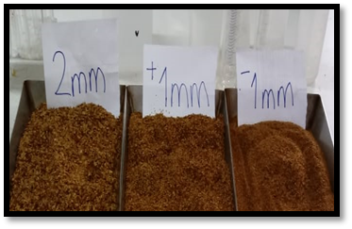  a | 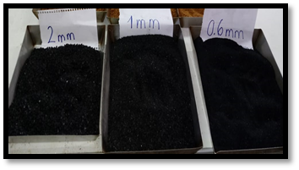  b | 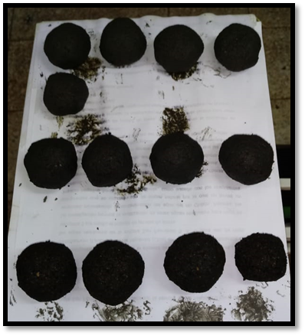  c

Figure 1: Preparation of the spheres: a) Crust sifting, (b) Mineral carbon sifting and c) Spheres.

2.1. Determination of Physicochemical Characteristics
The physicochemical properties determined were: moisture, volatile matter, ash, fixed carbon. All these calculations respond to analytically standardized procedures (Manals-Cutiño et al., 2015).

- Moisture percentage: calculated in Eq. (1), with known weight of each sample previously homogenized from the 3 different mesh sieves, they were placed in a capsule and then dried in an oven at a temperature of 105 °C for 2 hours, then cooled and weighed. The importance of drying these mixtures is that they will provide greater energy efficiency (Rueda Zamora et al., 2016).

$$\% Moisture=\frac{\left(crucible weight+sample \right)-\left(crucible weight+sample weight at 105 °C\right)}{\left(crucible weight+sample weight\right)-crucible weight}x100……(Eq. 1)$$

- Percentage of volatile matter, calculated with the samples obtained with different granulometries, were weighed in the crucibles and then placed in a burner at 900 °C temperature for approximately 7 minutes. Eq. (2) is then used.

$$\% MV=\frac{(crucible weight+sample weight )-(crucible weight+sample weight at 900 °C)}{\left(crucible weight+sample weight\right)-crucible weight}x100…(Eq. 2)$$

- Ash percentage, calculated with Eq. (3) data are the weight of the samples before and after being placed in a crucible to be incinerated at 900 °C for about 1 hour.

$$\%Ceniza=\frac{(crucible weight+sample weight at 900 °C)-crucible weight}{\left(crucible weight+sample weight\right)-crucible weight}x100…………(Eq.3)$$

- Percentage of fixed carbon, determined (Eq. 4) from the percentage of ash and volatile matter by applying the following formula:
$$\% fixed carbon=100-\left(\% ash+\% MV\right)………………(Eq. 4)$$
2.2 Determination of the optimum dose
For the determination of the optimum dose of Quenual residue, mineral coal and clay (Shampoo), it was determined based on the results of the calorific value of each dose of solid biofuel, considering that the one with the highest calorific value will be the best.

2.3 Determination of calorific efficiency
The determination of the calorific value (Eq. 5), is given by the energy released from the biomass when subjected to an energy conversion process (Carvajal-Jara et al., 2018), so a water boiling test method was used (Bailis et al., 2003) whose protocol consists of the calculation of the energy yield transmitted by the pellets through the stove in a heat transfer process and combustion efficiency, the measurement of the boiling time of 500 ml of water and 4 spheres per dose, such measurement will allow the identification of the 3 types of doses which will be the most efficient (Figure 2). The thermochemical process required a drying process to reduce the % of moisture (Álvarez Rodriguez et al., 2012), it is worth mentioning that for the calculation it is necessary to have in advance the values of % CF and % MV.

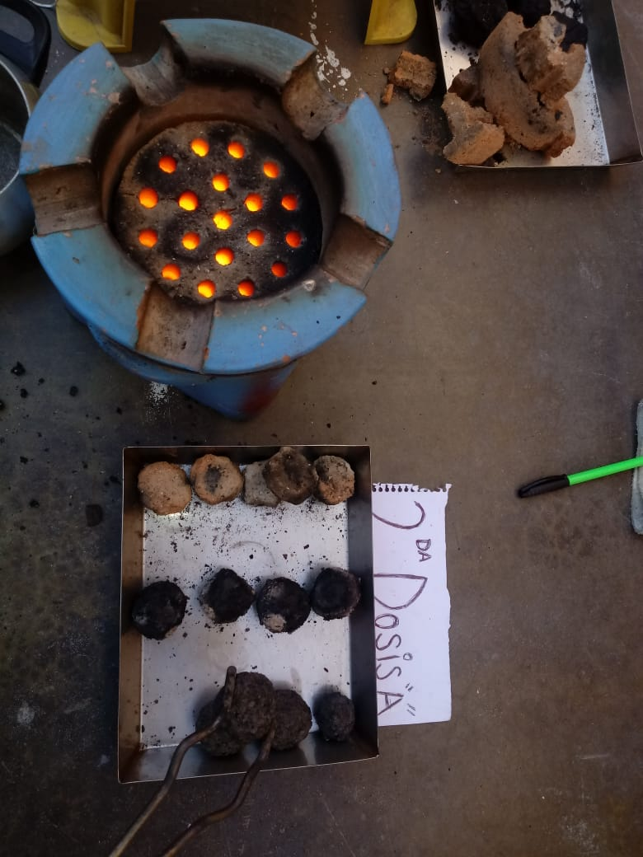
Figure 2: Test of boiling temperature versus burning time of spheres with 500 ml of water
$$Calorific Power =\left(82 x \% fixed carbon\right)+\left(120 x \%MV\right) \frac{Kcal}{Kg} ………… (Eq. 5)$$
  - Results and discussion
Taking advantage of the energy benefit provided by the densified biomass material, biofuel spheres were made from Quenual plant residue, similar to what was done by Berastegui et al., (2017) who made briquettes from corn tuza. Quenual residues with charcoal and clay (Shampo) after sieving, the dimensions are presented in Table 1. These dimensions are similar to the results of crushing and particle classification made by Durango and Oquendo (2016, p.12) in their methodological sequence for the production of Pellets that were between +0.6 mm to + 2 mm and for the mineral coal, -1 mm to + 2 mm for the case of vegetable residue.
Table 1: Granulometry of shampoo components.
Components | N° of mesh | Diameter | component | N° of mesh | Diameter
Carbon minig | 10 | + 2 mm | Quenual Vegetable Waste | 10 | + 2 mm
 | 18 | + 1 mm |  | 18 | + 1 mm
 | 30 | + 0.6 mm |  | 18 | - 1 mm

The fractions and doses used are presented in Table 2. Values similar to those used by Rodrigues Ponte et al. (2019), who used sugarcane bagasse, mango prunings and cashew nuts in different doses, the difference in this research is that charcoal and Quenual residue were used in different granulometric doses and clay was used as binder.

Table 2: Fractions and doses for biofuel sphere formation
Fraction | First Doses |  | Second doses |  | Third Doses
 | Candidates (g) | granulometry | Candidates (g) | granulometry | Candidates (g) | granulometry
Quenual | 100 | - 1mm | 100 | + 2mm | 100 | + 1mm
Carbon minig | 50 | + 2 mm | 50 | + 1 mm | 50 | + 0.6 mm
Clay | 25 |  | 25 |  | 25
3.1 Physicochemical characteristics
Table 3 presents the values of the physicochemical parameters obtained in the laboratory for the three doses with three replicates each. The calculations were performed similarly to the characterization of the biomass obtained from sugarcane bagasse developed by Manals-Cutiño et al. (2015, p.185-186). It is highlighted that the tests were made with the samples before drying, that is why the humidity results high. As for the amount of ash, it has high values due to the presence of mineral coal, which also has a negative influence on the calorific value. It can be observed that the average calorific value of the third dose is 5,038.3 Kcal/Kg, complying with the general classification of charcoal, according to ASTM D388-12 (Barrera Zapata et al., 2014, p.46), determination of the calorific value for charcoal according to NBR 8633 (T. C. G. G. R. de Andrade et al., 2013) and is related to the value of 19.35 MJ/kg found by Rusch et al. (2021).
Table 3: Physicochemical parameters of biofuel "Shampoo" (Quenual with charcoal and clay)
 | First Doses |  |  | Second doses |  |  | Third Doses
Parameters | Repetitions |  |  | Repetitions |  |  | Repetitions
 | 1 | 2 | 3 | 1 | 2 | 3 | 1 | 2 | 3
% of Moisture | 47.47 | 51.54 | 52.97 | 50.34 | 49.96 | 54.83 | 48.25 | 52.47 | 53.96
% Volatile Matter | 12.36 | 20.78 | 15.82 | 13.86 | 12.55 | 17.78 | 12.05 | 18.17 | 16.99
% of Ash | 63.87 | 48.21 | 47.67 | 57.46 | 54.47 | 39.12 | 57.75 | 42.06 | 37.74
% of fixed carbon | 23.77 | 31.01 | 36.51 | 28.68 | 32.98 | 43.10 | 30.20 | 39.77 | 45.27
Power Calorific (Kcal/Kg) | 3,432.34 | 5039.70 | 4892.22 | 4014.96 | 4210.36 | 5667.80 | 3922.40 | 5441.54 | 5750.94

3.2 Calorific value efficiency

To determine the efficiency of the calorific value in biomass spheres using Quenual residue, the WBT test was performed, unlike Andrade et al. (2018) who used correlations in order to predict the higher calorific value in a statistical way. We can observe that the lowest time are third doses, with 6 minutes for water boiling See Table

Table 4: Energy efficiency of biofuel "Shampoo".
 | First Doses |  |  |  | Second doses |  |  | Third Doses
 | Temp.  initial | Temp.  final | Final boiling time | Temp.  initial |  | Temp. final | Final boiling time | Temp.  initial | Temp.  final | Final boiling time
 | 32 | 100 | 7’ 00’’ | 25 |  | 101 | 13’ 23’’ | 21 | 100 | 6’ 15’’
 | 28 | 101 | 11’ 18’’ | 26 |  | 101 | 8’ 34’’ | 21 | 101 | 5’ 36’’
 | 26 | 101 | 11’ 55’’ | 22 |  | 101 | 7’ 13’’ | 21 | 99 | 6’ 15’’
Average | 28 | 100 | 10’ 03” | 24.3 |  | 101 | 9’ 36” | 21 | 100 | 6’ 06”

The results of the research are essential to provide scientific evidence that the combustion of solid biofuels can be a good energy option versus conventional coal, oil and natural gas, since by replacing fossil fuels it is also reducing greenhouse gases. (Manzini Poli et al., 2022), is aligned with SDG7, considering the growing use of biomass that will guarantee sustainable energy (Galantucci and Duong, 2021); on the other hand, another positive environmental impact is in the potential low emissions of solid particles and gaseous pollutants compared to the burning of coal and oil, it is known that biomass ash acts as a sulfur capturing agent and mitigates carbon dioxide emissions. sulfur (Osman et al., 2021). Biofuels are economically beneficial in the economy of rural areas, because they reduce costs in energy consumption and heating; For Kaletnik et al., the use of biofuels for energy use in Ukraine allows the reduction in imports of the cost of energy (natural gas) close to $1.8 billion and improves the balance of payments of the state, making it possible to reduce the tariff by one 10% (2021, p.62). Socially, it will allow the creation of new jobs in deprived areas, in industrial centers it will allow supporting the sustainable transition of energy management in companies, the simple and direct use of uncompacted wood and mineral coal could increase damage to children's health who die due to acute respiratory infections (ARI) as stated by Woolley et al., (2021); Therefore, the use of uncompacted quenual waste in the form of pellets, briquettes or waiting, it will have a health risk, so the research provides information for the production of spheres and making their use more efficient, which will reduce the risk of ARI in this Andean population.
Although these results show viability at the pilot level, at the industrial level, transformed biomass (pellets) is usually offered due to the greater need for these inputs (Cañas Asanza et al., 2015), Spain in particular has the installed capacity of 800,000 tons annual, the environmental economic benefits that these plants have are aligned with the circular economy (Herguedas et al., 2012), due to the fact that recycled wood remains are reused, they agglomerate factories, farms and industries for the manufacture of pellets, they reduce the GHG emissions and sulfur and nitrogen in biomass are lower, therefore, in combustion, it produces less oxides (Liu et al., 2020)
  - Conclusion
y means of the tests carried out, the efficiency of the quenual residue for the elaboration of biofuel spheres together with mineral coal and clay as a binder in the product called "shampoo" was proved, obtaining a calorific value of 5,038.3 Kcal/Kg for the most optimal dose. In addition, the quenual residue presented a calorific value of 8,741.88 Kcal/Kg, higher than that of mineral coal and clay. The efficiency of the binder (clay) for the preparation of the solid biofuel was also proven, providing a better consistency of the spheres, thus avoiding their destruction after the combustion process.
References
Álvarez Rodriguez A., Pizarro Garcia C., y Folgueras Díaz M.-B. (2012). Caracterización química de biomasa y su relación con el poder calorífico. Repositorio Institucional de La Universidad de Oviedo, 1–12.
Andrade T.C.G R., de Barros, N.F., de Dias L.E., y Azevedo M.I.R. (2013). Biomass yield and calorific value of six clonal stands of Eucalyptus urophylla S.T. Blake cultivated in Northeastern Brazil. Cerne, 19(3).
Andrade J., Ávila E., De Barrera E., Cotes M., Ramírez J., y Verdeza A. (2018). Correlaciones para calcular el PCS a partir de los análisis último y próximo de la biomasa proveniente de residuos de la industria agrícola en Colombia Correlations to calculate the PCS from the last and next analysis of the biomass coming from the waste. Revista I+D En TIC, 9(2), 26–33. http://revistas.unisimon.edu.co/index.php/identic
Bailis R., Ogle D., Maccarty N., y Still D. (2003). The Water Boiling Test (WBT) (pp. 1–38).
Barmina I., Valdmanis R., y Zake M. (2021). Thermochemical Conversion of Microwave Pre-treated Biomass Pellets: Combustion of Activated Pellets. Chemical Engineering Transactions (CEt), 86(February), 1477–1482. https://doi.org/10.3303/CET2186247
Barrera Zapata R., Pérez Bayer J. F., y Salazar Jiménez C. (2014). Carbones colombianos : clasificación y caracterización termoquímica para aplicaciones energéticas. Ion, 27(2), 43–54.
Berastegui Barranco C., Ortega Rodriguez J. P., Mendoza Fandiño J. M., González Doria Y. E., y Gómez Vasquez R. D. (2017). Development of densified solid biofuels a from corn cob, cassava starch and mineral coal department of Córdob. Revista Chilena de Ingeniería, 25(4), 643–653.
Bong C. P. C., Lim L. Y., Lee C. T., Ong P. Y., Jaromír Klemes J., Chunjie L., y Gao Y. (2020). Lignocellulosic Biomass and Food Waste for Biochar Production and Application: A Review. Chemical Engineering Transactions (CEt), 81, 427–432. https://doi.org/10.3303/CET2081072
Cañas Asanza M., Reynoso Torres C., Cuartas Hernandez M., Basade Aragón A., Tavara Zanón A., y Modell I Boira G. (2015). Industriambiente: Gestión medioambiental y energética. Infoedita.
Carvajal-Jara C. A., Tafur-Escanta P. M., Villavicencio-Poveda Á. H., y Gutiérrez-Gualotuña E. R. (2018). Caracterización del poder calorífico de la biomasa residual de cacao CCN51 mediante procesos de gasificación anaeróbico y termoquímico. Científica, 22(2), 113–123.
de Oliveira Saccol A. F., Welter C. A., Cortelini da Rosa R., Coldebella R., Longhi S. J., de Farias J. A., y Pedrazzi C. (2020). Aproveitamento da biomassa florestal na fabricação de briquetes. Matéria (Rio de Janeiro), 25(2). https://doi.org/10.1590/s1517-707620200002.1034
Durango Padilla E. R., y Oquendo López J. L. (2016). Caracterización y evaluación energética de biocombustibles sólidos elaborados a partir de biomasa agroindustrial y carbón mineral del departamento de Córdoba. [Universidad de Córdova. https://repositorio.unicordoba.edu.co/handle/ucordoba/704
FAO. (2019). El estado mundial de la agricultura y la alimentación. Progresos en la lucha contra la pérdida y el desperdicio de alimentos. In El Estado Del Mundo (Vol. 32, Issue 3).
Galantucci V., y Duong V. M. (2021). Solid biofuels in residential heating appliances and related air pollution in northern italy. Polish Journal of Environmental Studies, 30(5), 3975–3983. https://doi.org/10.15244/pjoes/132813 A., Taranco C., Rodrígez E., y Paniagua P. (2012). Biomasa, Biocombustibles Y Sostenibilidad. Transbioma, 13(2), 105–109.
Kaletnik G., Pryshliak N., y Tokarchuk D. (2021). Potential of production of energy crops in ukraine and their processing on solid biofuels. Ecological Engineering and Environmental Technology, 22(3), 59–70.
Liu S., Gao Y., Xu B., Deng M., y Jiang J. (2020). Analysis on development path of distributed utilization of biomass energy in China. IOP Conference Series: Earth and Environmental Science, 467(1). https://doi.org/10.1088/1755-1315/467/1/012093
Manals-Cutiño E. M., Penedo-Medina M., y Salas-Tort D. (2015). Caracterización del bagazo de caña como biomasa vegetal. Tecnología Química, 35(2), 244–255. https://doi.org/10.1590/2224-6185.2015.2.%x
Manzini Poli F. L., Islas-Samperio J. M., García Bustamante C. A., Sacramento Rivero J. C., Grande-Acosta G. K., Gallardo-álvarez R. M., Lagunes R. M., Pineda F. N., y Escobedo C. A. (2022). Sustainability Assessment of Solid Biofuels from Agro-Industrial Residues Case of Sugarcane Bagasse in a Mexican Sugar Mill. Sustainability (Switzerland), 14(3), 1–25. https://doi.org/10.3390/su14031711
Nur Afrina K., Azman Shah K., Mohd Yusop M. Z., Mohd Rohani J., Amal Fadil N., Abdul Manaf N., Hartono B., Duc Tuyen N., Masaki T., Samad Ahmad A., y Ramli A. (2021). Feasibility Study on Biomass Bamboo Renewable Energy in. Chemical Engineering Transactions (CEt), 89(September), 127–132. https://doi.org/10.3303/CET2189022
Osman A. I., Mehta N., Elgarahy A. M., Al-Hinai A., Al-Muhtaseb A. H., y Rooney D. W. (2021). Conversion of biomass to biofuels and life cycle assessment: a review. In Environmental Chemistry Letters (Vol. 19, Issue 6). Springer International Publishing. https://doi.org/10.1007/s10311-021-01273-0
Rodrigues Ponte M., Torres Gadelha A. M., de Luna Machado Y., Sanders Lopes A. A., Queiroz Malveira J., Mazzetto S. E., Lomonaco D., y de Sousa Rios M. A. (2019). Blends of sugarcane bagasse with the mango tree and cashew tree’s pruning: Properties characterization and investigation of their energy potentials. Matéria (Rio de Janeiro), 24(2). https://doi.org/10.1590/s1517-707620190002.0687
Rueda Zamora G., Gutiérrez C., Mistretta G., Peralta F., Golato M., Ruiz M., y Paz D. (2016). Determinación del contenido de humedad del bagazo de caña de azúcar por medio de microondas. Revista Industrial y Agrícola de Tucumán (EEAOC), 93(2), 7–12.
Rusch F., de Abreu Neto R., de Moraes Lúcio D., y Hillig É. (2021). Energy properties of bamboo biomass and mate co-products. SN Applied Sciences, 3(6). https://doi.org/10.1007/s42452-021-04584-7
Russo C., Cerciello F., Senneca O., Ciajolo A., y Apicella B. (2021). Formation of Fluorescent Carbon from Fast Pyrolysis of Lignocellulosic Biomass. Chemical Engineering Transactions (CEt), 84(March), 145–150.
Woolley K. E., Bartington S. E., Kabera T., Lao X. Q., Pope F. D., Greenfield S. M., Price M. J., y Thomas G. N. (2021). Comparison of respiratory health impacts associated with wood and charcoal biomass fuels: A population-based analysis of 475,000 children from 30 low-and middle-income countries. International Journal of Environmental Research and Public Health, 18(17), 1–18. https://doi.org/10.3390/ijerph18179305

