CHEMICAL ENGINEERING TRANSACTIONS  VOL. 92, 2022 | A publication of
The Italian Association
of Chemical Engineering
Online at www.cetjournal.it

Guest Editors: Rubens Maciel Filho, Eliseo Ranzi, Leonardo Tognotti
Copyright © 2022, AIDIC Servizi S.r.l.
ISBN 978-88-95608-90-7; ISSN 2283-9216

Semi-continuous Chlorella vulgaris Cultivation Using Anaerobic Digestate Liquid Fraction Pre-treated by Ultrasonic Cavitation to Improve Carbon Dioxide Solubilization
Marco Biasiolo*ª, Marco Ballarin^{b}, Graziano Tassinato^{c}, Anna Stoppato^{b}, Cristina Cavinatoª
ªDipartimento di Scienze Ambientali, Informatica e Statistica, Università Ca’ Foscari Venezia, via Torino 155, Venezia, 30172, Italia
^{b}Dipartimento di Ingegneria Industriale, Università degli Studi di Padova, via Venezia 1, Padova, 35131, Italia
^{c}Green Propulsion Laboratory, VERITAS spa., via della Geologia 31, Fusina, 30176, Italia
marco.biasiolo@unive.it
Nutrients-enriched effluents such as digestate can represent a suitable and economically appealing substrate for microalgae growth since they combine the effluent treatment with biomass production. Then, microalgae biomass can be exploited to produce several bio-based compounds. However, the use of digestate for microalgae cultivation can be challenging due to its high levels of ammonia nitrogen and its low C/N ratio. For this reason, an ultrasonic cavitation (UC) process combined with carbon dioxide (CO₂) insufflation was tested on digestate, in order to obtain a faster solubilization of the CO₂ in the medium and thus an increase in the C/N ratio. The test was carried out growing Chlorella vulgaris on both digestate (mixotrophic condition) and BG-11 medium (autotrophic condition) in 1 L photobioreactors. For the first 14 days of the experiment the reactors were maintained in batch conditions to acclimatize microalgae. Then, they were switched to semi-continuous for 32 days. The reactors were fed three times a week, with an HRT (Hydraulic Retention Time) of 10.5 d as weekly average. Regarding the test on digestate, both UC pre-treated and untreated conditions reached the highest biomass production at the end of the batch (4.8 and 4.1 g L⁻¹ respectively) and a complete ammonium (NH₄⁺) removal after 9 days. The switch to semi-continuous caused an increase in NH₄⁺ concentration and a consistent decrease in biomass concentration. Biomass production reached the steady-state, with a concentration of 1.9 and 1.2 g L⁻¹ for the UC pre-treated and untreated digestate, respectively (+55.6 % biomass production obtained with UC pre-treated digestate). Moreover, an NH₄⁺ removal of 93.5 % and 92.3 % was reached for UC pre-treated and untreated conditions, respectively.
  - Introduction
The anaerobic effluents generated by municipal wastewater treatment need a sustainable management to avoid environmental problems, mainly related to their high nutrient content. Their direct use as fertilizers on agricultural land can cause an excessive nutrient enrichment that can lead to eutrophication of nearby surface and ground waters (Nkoa, 2014). The application of microalgal cultures for simultaneous anaerobic digestate treatment and valuable biomass production has been widely investigated in recent years (Koutra et al., 2021; Scarponi et al., 2021; Stiles et al., 2018).
According to its composition and quality, the microalgal biomass produced with these treatments can be exploited to generate valuable products, such as bio-fertilizers (Hussain et al., 2021), biofuels (Dvoretsky et al., 2015), animal feeds (Lum et al., 2013), polyunsaturated fatty acids (Leone et al., 2019), pigments (Zhang et al., 2020), and biomedical and pharmaceutical compounds (Sathasivam et al., 2019), resulting in a promising candidate for a biorefinery process (Ahmad et al., 2021; Chandrasekhar et al., 2022). However, the utilization of digestate as a medium for microalgal growth can be rather challenging due to the potential presence of pathogens, heavy metals, and toxins (Koutra et al., 2018). Moreover, these effluents have a high ammonia concentration and a low C/N ratio that can inhibit microalgal growth (Xia and Murphy, 2016). This leads to the necessity of various pre-treatments to increase the process outcomes in terms of biomass productivity and quality. Supplying CO₂ to the system is a known method to enhance autotrophic microalgal growth rates and is usually performed by enriching the air flow bubbling into the photobioreactor with different percentages of carbon dioxide (Barahoei et al., 2020). However, these configurations can limit the production of dissolved inorganic carbon, due to the low solubility of CO₂ under atmospheric pressure (Kim et al., 2014), thus resulting in a low availability of this carbon source for microalgae growth.
The use of ultrasounds to maximize gas concentration in gas-liquid mixtures has been recently studied by few authors (Laugier et al., 2008; Stoppato et al., 2021; Tay et al., 2016). It has been observed that ultrasounds, especially at low frequencies (20 kHz), significantly improve gas-liquid mass transfer, most likely due to the kinetic energy imposed on the system by acoustic streaming (Sajjadi et al., 2017). Ultrasounds cause cavitation phenomena in the gas-liquid mixture, due to the compression and rarefaction cycles generated in the liquid by the ultrasonic waves. During the rarefaction cycle, the local pressure becomes lower than the saturation one, causing a phase change in the liquid and thus generating micro-bubbles of vapor. When the bubbles reach a vapor pressure lower than the hydrostatic pressure they implode, generating a local and temporary high-energy spot, where temperatures close to 5000 K and pressures of hundreds of atmospheres are reached. In a gas-liquid mixture, the high pressures generated by the implosion of the cavitation bubbles pushes the gaseous molecules into the aqueous phase. This, together with the increased chemical activity caused by the formation of radicals during the cavitation phenomenon, is considered the main reason of the improved gas-liquid mass transfer (Stoppato et al., 2021).
This study aims at enhancing mixotrophic growth rates by combining digestate treatment and dissolved inorganic carbon enrichment in the substrate through ultrasonic cavitation.
  - Materials and Methods
    - Ultrasonic Reactor
The scheme of the system used to provide ultrasonic cavitation (UC) is shown in Figure 1. Cavitation was obtained using a 5 L vertical tubular reactor (10 cm of inner diameter and 50 cm of height) with 20 external tonpilz sonotrodes (Figure 2). The liquid medium was recirculated with a peristaltic pump through the system at 4.17 L min⁻¹ and collected in a 20 L tank. A CO₂ cylinder was connected downstream of the reactor to inject CO₂ in the liquid medium. The CO₂ flow was set at 1 L min⁻¹ using a Mass Flow Controller (Alicat Scientific MC-20SLPM-D). During the UC pre-treatment, the growth media flowed inside the reactor while the piezoelectric transducers applied acoustic waves to the liquid. The ultrasounds increased the turbulence of the fluid, causing cavitation phenomena. The sonotrodes were set at 23 kHz, and the pre-treatment was run for 5 min. The UC process was applied to enhance CO₂ mass transfer into the liquid medium (Sajjadi et al., 2017).

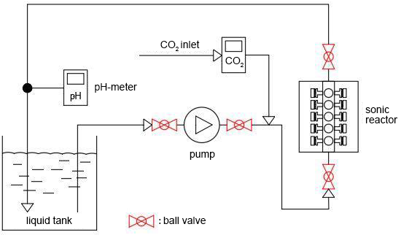
Figure 1: Circuit diagram of the ultrasonic cavitation process
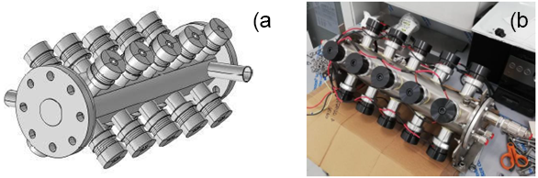
Figure 2: Ultrasonic reactor, 3D model (a) and the built-in prototype used for UC pre-treatment (b)
Table 1: Characterization of the untreated and UC pre-treated media
Medium | pH | sCOD  (mgO₂ L⁻¹) | NH₄⁺  (mgNH₄⁺ L⁻¹)
BG-11 | 7.6 ± 0.1 | - | -
BG-11 (UC) | 5.5 ± 0.1 | - | -
Digestate | 7.3 ± 0.1 | 260 ± 30 | 760 ± 70
Digestate (UC) | 6.5 ± 0.1 | 230 ± 20 | 700 ± 60
    - Growth medium: BG-11 and digestate
In this study two growth media have been used, a standard BG-11 medium (Rippka et al., 1979) and a digestate supernatant. The digestate was supplied by Veritas spa from a WWTP (Fusina, Italy), where a full-scale mesophilic anaerobic digester is fed with municipal sludge. To remove the solid fraction, the digestate was centrifuged (5 min, 9,000 rpm) and the supernatant was filtered with filter paper (12-15 μm pore size).
Both media (BG-11 and digestate) were stored at 4 °C. An aliquot of 10 L of each media was pre-treated with UC and then stored at 4 °C. The characterization of untreated and UC pre-treated media are shown in Table 1.
    - Microalgae strain and experimental setup
Chlorella vulgaris culture used in this study was supplied by ACUF (Algal Collection of University of Federico II, Naples, Italy). The strain was maintained at room temperature (21 °C) in a 5 L flask in autotrophic conditions using standard BG-11 as a medium (Rippka et al., 1979).
The test was run in four identical 1 L glass cylinders (900 mL working volume) which were used as PBRs (Photo Bio Reactors). Each condition was tested in duplicate. The first run was performed on BG-11 untreated and pre-treated with UC. The second run was performed on digestate untreated and pre-treated with UC. Each run started with a 0.125 ± 0.007 g L⁻¹ DW biomass concentration. In the first run, C. vulgaris was inoculated in BG-11 medium as such, while in the second run digestate diluted 1:5 in BG-11 was used. The PBRs were maintained under 24 h illumination using 8 fluorescent lamps (50 μmol s⁻¹ m⁻², 400-700 nm), to provide a homogeneous illumination. Air bubbling was provided continuously at 0.5 vvm with an aquarium aerator connected to a ball shaped air stone. Each run lasted 46 days. In the first 14 days the PBRs were kept in batch condition, to acclimatize the culture to the new medium. Then, the reactors were switched to semi-continuous and fed with BG-11 or digestate as such three times a week, maintaining a weekly average HRT of 10.5 d.
    - Analytical methods
Microalgae growth rate was evaluated determining both dry weight (DW, g L⁻¹) and cell concentration (x10⁶ cells mL⁻¹). The PBRs were sampled three times a week during both the batch and the semi-continuous test conditions. DW was measured with a 0.45 μm cellulose filter (Whatman). Cell concentration was determined with a Bürker counting chamber (BRAND) and an optical microscope (Leica Microsystems DM E) with a 400x magnification.
Growth rate (μ_{max}, d⁻¹) was calculated according to Eq(1):
$$μ_{max}\left(d^{-1}\right)=\frac{lnN_{i}-lnN_{i-1}}{(t_{i}-t_{i-1})}$$ | (1)
where N_{i} and N_{i-1} are the cell concentration at time t_{i} and t_{i-1}, respectively.

Biomass maximum productivity (P_{max}, g L⁻¹ d⁻¹) was calculated using Eq(2):
$$P_{max}\left(gL^{-1}d^{-1}\right)=\frac{X_{i}-X_{i-1}}{(t_{i}-t_{i-1})}$$ | (2)
where X_{i} and X_{i-1} are the dry weight of microalgae cultures at time t_{i} and t_{i-1}, respectively.
Dissolved NH₄⁺ was determined using LC Liquid ion Chromatography on 0.20 μm filtered samples, using an ED50 Electrochemical detector, a GS50 Gradient Pump, and a LC25 Chromatography Oven. H₂SO₄ 22 mM was used as eluent solution, a Guard Ion Pac OG12A (2-50 mm, Dionex) as precolumn, and CSRS ULTRA II (4 mm, Dionex) as eluent suppressor.
The soluble Chemical Oxygen Demand (sCOD, mgO₂ L⁻¹) was determined using a colorimetric method according to Standard Methods for the examination of water and wastewater (Baird et al., 2017)
  - Results and Discussion
    - Microalgae growth with UC pre-treated media
Microalgal growth curves with untreated and UC pre-treated media are shown in Figure 3a (DW) and in Figure 3b (cell concentration). The growth parameters of microalgae cultures are shown in Table 2. In batch conditions, the UC pre-treatment raised the productivity for both BG-11 (+ 5.3 %) and digestate (+ 16.4 %). Moreover, a higher growth rate was obtained in UC pre-treated media, with an increase of 25.8 % and 12.7 % for BG-11 and digestate, respectively. The UC pre-treated digestate showed the overall higher maximum DW (4.8 g L⁻¹) and productivity (0.48 g L⁻¹ d⁻¹). In semi-continuous, the test on BG-11 kept stable values for both DW and cell concentration. Conversely, digestate showed a sudden decrease in DW (70.9 % and 61.3 % lower compared to the maximum DW, for the untreated and UC pre-treated respectively) and in cell concentration (-68.6 % and -34.3 %, respectively). For all media pH did not change significantly during the test, as shown in Figure 4a. Figure 4b shows the NH₄⁺ concentration for untreated and UC pre-treated digestate. After switching to semi-continuous, a significant increase in NH₄⁺ concentration was observed for both untreated and UC pre-treated digestate. This is most likely the cause of the decrease of DW and cell concentration in digestate in the first days after the switch to semi-continuous. In regard to the initial digestate NH₄⁺ concentration, the UC pre-treated and untreated tests showed a 93.5 % and 92.3 % removal at the end of the test.
Table 2: Growth parameters in untreated and UC pre-treated media
Medium | DW _{max}  (g L⁻¹) | cell concentration _{max}  (x10⁶ cells mL⁻¹) | P_{max}  (g L⁻¹ d⁻¹) | μ _{max}  (d⁻¹)
BG-11 | 3.1 ± 0.2 | 130 ± 20 | 0.34 ± 0.07 | 0.73 ± 0.03
BG-11 (UC) | 3.0 ± 0.2 | 135 ± 4 | 0.36 ± 0.06 | 1.0 ± 0.1
Digestate | 4.1 ± 0.6 | 104 ± 3 | 0.40 ± 0.02 | 0.55 ± 0.01
Digestate (UC) | 4.8 ± 0.1 | 134 ± 8 | 0.48 ± 0.01 | 0.63 ± 0.07

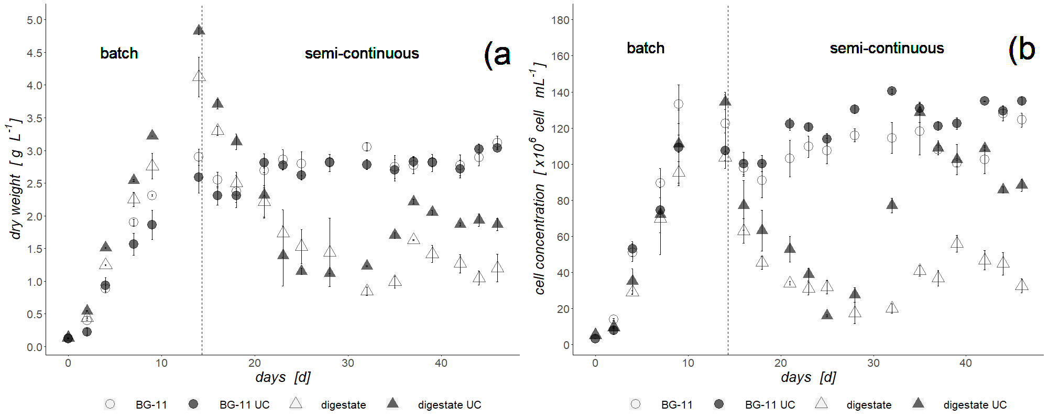
Figure 3: C. vulgaris growth on untreated and UC pre-treated media; dry weight (a) and cell concentration (b)
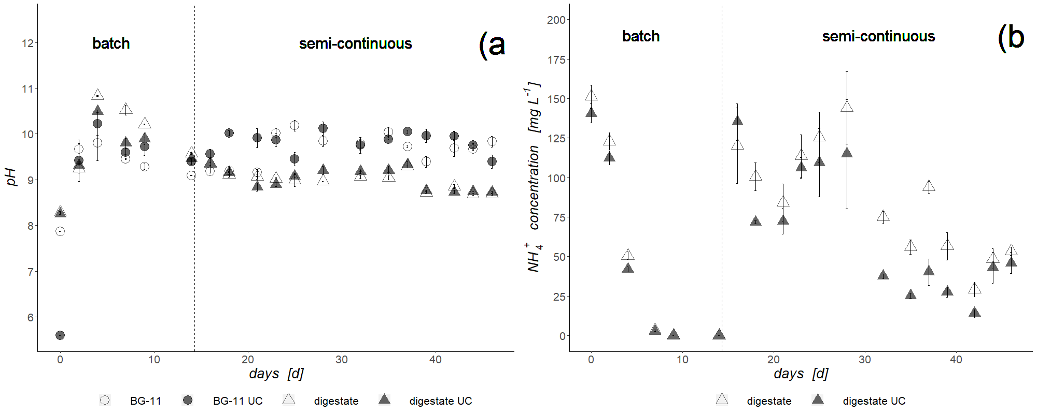
Figure 4: pH (a) and NH₄⁺ concentration (b) of C. vulgaris on digestate
  - Conclusions
An ultrasonic cavitation process was tested to enrich dissolved inorganic carbon in standard BG-11 medium and digestate and to increase growth parameters in microalgal cultures. The tests showed a higher growth rate when using UC pre-treated media (25.8 % and 12.7 % higher for BG-11 and digestate respectively). When coupling UC pre-treatment and digestate in batch conditions, the overall higher maximum productivity (0.48 g L⁻¹ d⁻¹) and maximum DW (4.8 g L⁻¹) were reached. In semi-continuous, the UC pre-treated digestate gave a higher final DW (1.9 g L⁻¹) when compared to untreated digestate (1.2 g L⁻¹). NH₄⁺ was completely removed after 9 days in batch condition. When the system was switched to semi-continuous, an initial rise in the NH₄⁺ concentration was observed, which stabilized at the end of the period. This resulted in an overall 93.5 % and 92.3 % NH₄⁺ removal for UC pre-treated and untreated digestate respectively.
Nomenclature
DW – dry weight, g L⁻¹

HRT – hydraulic retention time, d
LC – liquid ion chromatography, -
PBR – photobioreactor, -
P_{max} – maximum productivity, g L⁻¹ d⁻¹
sCOD – soluble chemical oxygen demand, mgO₂ L⁻¹
UC – ultrasonic cavitation, -
μ_{max} – maximum growth rate, d⁻¹

Acknowledgments
This research was funded by the European Social Fund through the “Programma Operativo Regionale POR-FSE 2014-2020 Regione del Veneto” for the project 2120-0009-1463-2019 “Innovative application of technologies for CO₂ removal from industrial flue gasses and re-utilization in microalgae cultures for energy production”. VERITAS S.p.a. and UNITECH S.r.l. are also acknowledged for their support and hospitality.
References
Ahmad, I., Abdullah, N., Koji, I., Yuzir, A., 2021, The Contribution of Microalgae in Bio-refinery and Resource Recovery: A Sustainable Approach leading to Circular Bioeconomy, Chemical Engineering Transactions, 89, 391–396. DOI:10.3303/CET2189066
Baird, R., Bridgewater, L., American Public Health Association, American Water Works Association, Water Environmental Federation, 2017, Standard methods for the examination of water and wastewater, 23rd ed., American Public Health Association, Washington D.C., United States
Barahoei, M., Hatamipour, M.S., Afsharzadeh, S., 2020, CO2 capturing by chlorella vulgaris in a bubble column photo-bioreactor; Effect of bubble size on CO2 removal and growth rate, Journal of CO2 Utilization, 37, 9–19. DOI:10.1016/j.jcou.2019.11.023
Chandrasekhar, K., Raj, T., Ramanaiah, S. v., Kumar, G., Banu, J.R., Varjani, S., Sharma, P., Pandey, A., Kumar, S., Kim, S.H., 2022, Algae biorefinery: A promising approach to promote microalgae industry and waste utilization, Journal of Biotechnology, 345, 1–16. DOI:10.1016/j.jbiotec.2021.12.008
Dvoretsky, D., Dvoretsky, S., Peshkova, E., Temnov, M., 2015, Optimization of the process of cultivation of microalgae Chlorella vulgaris biomass with high lipid content for biofuel production, Chemical Engineering Transactions, 43, 361–366. DOI:10.3303/CET1543061
Hussain, F., Shah, S.Z., Ahmad, H., Abubshait, S.A., Abubshait, H.A., Laref, A., Manikandan, A., Kusuma, H.S., Iqbal, M., 2021, Microalgae an ecofriendly and sustainable wastewater treatment option: Biomass application in biofuel and bio-fertilizer production. A review, Renewable and Sustainable Energy Reviews, 137, 110603. DOI:10.1016/j.rser.2020.1106039
Kim, J., Lee, J.Y., Lu, T., 2014, Effects of dissolved inorganic carbon and mixing on autotrophic growth of Chlorella vulgaris, Biochemical Engineering Journal, 82, 34–40. DOI:10.1016/j.bej.2013.11.007
Koutra, E., Economou, C.N., Tsafrakidou, P., Kornaros, M., 2018, Bio-Based Products from Microalgae Cultivated in Digestates, Trends in Biotechnology, 36(8), 819–833. DOI:10.1016/j.tibtech.2018.02.015
Koutra, E., Mastropetros, S.G., Ali, S.S., Tsigkou, K., Kornaros, M., 2021, Assessing the potential of Chlorella vulgaris for valorization of liquid digestates from agro-industrial and municipal organic wastes in a biorefinery approach, Journal of Cleaner Production, 280(1), 124352. DOI:10.1016/j.jclepro.2020.124352
Laugier, F., Andriantsiferana, C., Wilhelm, A.M., Delmas, H., 2008, Ultrasound in gas-liquid systems: Effects on solubility and mass transfer, Ultrasonics Sonochemistry, 15, 965–972. DOI:10.1016/j.ultsonch.2008.03.003
Leone, G.P., Balducchi, R., Mehariya, S., Martino, M., Larocca, V., Sanzo, G. di, Iovine, A., Casella, P., Marino, T., Karatza, D., Chianese, S., Musmarra, D., Molino, A., 2019, Selective extraction of ω-3 fatty acids from nannochloropsis sp. using supercritical CO2 Extraction, Molecules, 24, 2406. DOI:10.3390/molecules24132406
Lum, K.K., Kim, J., Lei, X.G., 2013, Dual potential of microalgae as a sustainable biofuel feedstock and animal feed, Journal of Animal Science and Biotechnology, 4(1), 53. DOI:10.1186/2049-1891-4-53
Nkoa, R., 2014, Agricultural benefits and environmental risks of soil fertilization with anaerobic digestates: A review, Agronomy for Sustainable Development, 34, 473–492. DOI:10.1007/s13593-013-0196-z
Rippka, E., Deruelles, J., Waterbury, N.B., 1979, Generic Assignments, Strain Histories and Properties of Pure Cultures of Cyanobacteria, Journal of General Microbiology, 111, 1–61. DOI:10.1099/00221287-111-1-1
Sajjadi, B., Asgharzadehahmadi, S., Asaithambi, P., Raman, A.A.A., Parthasarathy, R., 2017, Investigation of mass transfer intensification under power ultrasound irradiation using 3D computational simulation: A comparative analysis, Ultrasonics Sonochemistry, 34, 504–518. DOI:10.1016/j.ultsonch.2016.06.026
Sathasivam, R., Radhakrishnan, R., Hashem, A., Abd_Allah, E.F., 2019, Microalgae metabolites: A rich source for food and medicine, Saudi Journal of Biological Sciences, 26(4), 709–722. DOI:10.1016/j.sjbs.2017.11.003
Scarponi, P., Volpi Ghirardini, A.M., Bravi, M., Cavinato, C., 2021, Evaluation of Chlorella vulgaris and Scenedesmus obliquus growth on pretreated organic solid waste digestate, Waste Management, 119, 235–241. DOI:10.1016/j.wasman.2020.09.047
Stiles, W.A.V., Styles, D., Chapman, S.P., Esteves, S., Bywater, A., Melville, L., Silkina, A., Lupatsch, I., Fuentes Grünewald, C., Lovitt, R., Chaloner, T., Bull, A., Morris, C., Llewellyn, C.A., 2018, Using microalgae in the circular economy to valorise anaerobic digestate: challenges and opportunities, Bioresource Technology, 267, 732–742. DOI:10.1016/j.biortech.2018.07.100
Stoppato, A., Ballarin, M., Benato, A., Cerchier, P., Tassinato, G., 2021, Use of ultrasonic technology for the maximization of gas concentration in gas-liquid mixtures, Proceedings of Ecos 2021 – The 34th International Conference On Efficiency, Cost, Optimization, Simulation and Environmental Impact of Energy Systems, June 27-July 2, 2021, Taormina, Italy
Tay, W.H., Lau, K.K., Shariff, A.M., 2016, High frequency ultrasonic-assisted CO2 absorption in a high pressure water batch system, Ultrasonics Sonochemistry, 33, 190–196. DOI:10.1016/j.ultsonch.2016.04.004
Xia, A., Murphy, J.D., 2016, Microalgal Cultivation in Treating Liquid Digestate from Biogas Systems, Trends in Biotechnology, 34(4), 264–275. DOI:10.1016/j.tibtech.2015.12.010
Zhang, C., Chen, X., Too, H.P., 2020, Microbial astaxanthin biosynthesis: recent achievements, challenges, and commercialization outlook, Applied Microbiology and Biotechnology, 104(13), 5725–5737. DOI:10.1007/s00253-020-10648-2

