|  |  |
| --- | --- |
| cetlogo ***CHEMICAL ENGINEERING TRANSACTIONS***  ***VOL. 92,2022*** | A publication of  aidiclogo_grande |
| The Italian Association  of Chemical Engineering  Online at www.cetjournal.it |
| Guest Editors: Rubens Maciel Filho, Eliseo Ranzi, Leonardo Tognotti  Copyright © 2022, AIDIC Servizi S.r.l. **ISBN** 978-88-95608-90-7; **ISSN** 2283-9216 | |

Hydrothermal Liquefaction of Agro-Waste Biomass: Design of a Novel Experimental Set Up and Preliminary Results

Antonio Picone, Maurizio Volpe\*, Fabio Codignole Luz, Antonio Messineo

Faculty of Engineering and Architecture, University of Enna Kore, Cittadella Universitaria, 94100 Enna, Italy

maurizio.volpe@unikore.it

Hydrothermal liquefaction (HTL) is a thermochemical processing technology for the conversion of waste biomass in the presence of water near critical condition. HTL is typically carried out between 250 and 350 °C and corresponding water-saturated pressures between 4 and 16 MPa, respectively. The process target product is a high viscous hydrophobic bio-oil called bio-crude. Bio-crude added value has been primarily recognized from bio-fuels perspective as a replacement for bio-diesel and bio-based aviation fuels, however, it can also upgraded into high added value products for the green chemistry and bio-based industries. The present study describes the design and set up of a new HTL experimental apparatus to investigate agro-waste biomass liquefaction at lab scale. The HTL apparatus was tested using tangerine peel waste and castor seeds as feedstock. Raw substrates, solid residues (hydrochars) and bio-oils were characterized in terms of proximate analysis and higher heating value while aqueous liquid residues were analyzed in terms of pH and total organic carbon content (TOC). Preliminary results obtained confirmed that the lab scale HTL apparatus, developed in this work, represents a valuable tool for the study of waste biomass conversion into high-energy dense solid and liquid bio-fuels.

* 1. Introduction

The growing world energy demand and corresponding environmental concerns of the use of natural resources favor the need for alternative energy sources and achieving diversification of the energy mix. Renewable energy transition is a key factor to decarbonize the world economy and to mitigate the global climate change. The use of agricultural and agro-industrial wastes as bio-renewable and carbon-neutral energy source is considered both economically and environmentally sustainable and highly desirable waste management procedure, thanks to the large and global availability of such resources (Nunes et al., 2020). In recent years, different conversion technologies have been developed to obtain valuable products from different kinds of residual biomass for use as fuels and chemicals. Dry thermochemical conversion processes such as pyrolysis and gasification are readily applicable to produce high quality gaseous, liquid, and solid fuels (Volpe et al., 2016). However, these conversion technologies can only work with high efficiency when dry feedstock is used (Kruse et al., 2013).

Hydrothermal processes, compared to their dry counterparts, do not require prior substrate thermal drying and thus result in a reduction of costs for the conversion of wet materials like agro-waste biomass (Khan et al., 2019). Hydrothermal reactions, carried out in the presence of hot compressed water, lead to chemical and physical transformations of biomass mainly depending on the maximum reaction temperature (Wang et al., 2018). Near the critical point (374 °C and 22 MPa), water becomes an excellent reactant and solvent catalyzing biomass decomposition into carbon-rich residues. According to reaction temperature and the main product obtained, hydrothermal technologies can be divided into: hydrothermal carbonization (HTC) carried between 180 and 250 °C, to produce carbon-rich solid (hydrochar) (Merzari et al., 2018), HTL (250-350 °C) for bio-oil production and supercritical water gasification (SWG) with temperatures ranging between 350 and 600 °C yielding gaseous hydrocarbons (He et al., 2014).

During HTL, biomass hydrolyses and decomposes to less stable low molecular weight components which undergo re-polymerization yielding high viscous hydrophobic bio-oil (bio-crude), aqueous soluble organics, solid residue (hydrochar) and gas phase mainly composed of CO2, CH4, H2 and CO (Toor et al., 2011). In comparison to the pyrolysis bio-oil, the HTL bio-crude can be obtained at milder reaction conditions and thus with a considerable energy saving, moreover HTL bio-crude typically shows lower oxygen and moisture content and hence higher heating value (Dimitriadis and Bezergianni, 2017).

HTL purified bio-crude can be used as fuel for burners, stationary diesel engines, turbines and boilers. It can also be further upgraded into transportation fuel (i.e.: diesel and aviation fuel) and high value products, including aromatics compounds, bio-plastic precursors and high valuable lubricants (Pavlovič et al., 2013).

Although the high potentials, HTL process is still a developing technology and its efficient application at industrial scale level is still lacking. For what stated above, it is of considerable importance the development of laboratory-scale systems that can study and appropriately model HTL process. This work describes the design of a novel experimental apparatus to investigate the HTL conversion of agro-waste biomass. The apparatus was designed in order to be easily and safely operated and preliminary experiments, performed using castor seeds and tangerine peel waste as feedstock, demonstrate its reliability and efficacy thanks to the high reproducibility of the experimental data obtained.

* 1. Materials and methods
     1. HTL system set up

The HTL experimental apparatus was designed and set up at LEA laboratory (Laboratorio Energia e Ambiente) of the University Kore of Enna (Italy) for laboratory scale biomass HTL experiments. The apparatus consists of three identical stainless steel (AISI 316) batch reactors (Figure 1), purging and sealing equipment (Figure 2a) and heating system (Figure 2b). The reactors were designed to ensure an internal volume of 25 mL and stand a reaction pressure and temperature up to 15 MPa and 350 °C, respectively. The reactor body is made up of a tube, 66 mm long, 22 mm internal diameter and 36 mm external diameter, and it is provided with two threaded nuts and two AISI 316 stainless steel o-rings for pressure sealing.

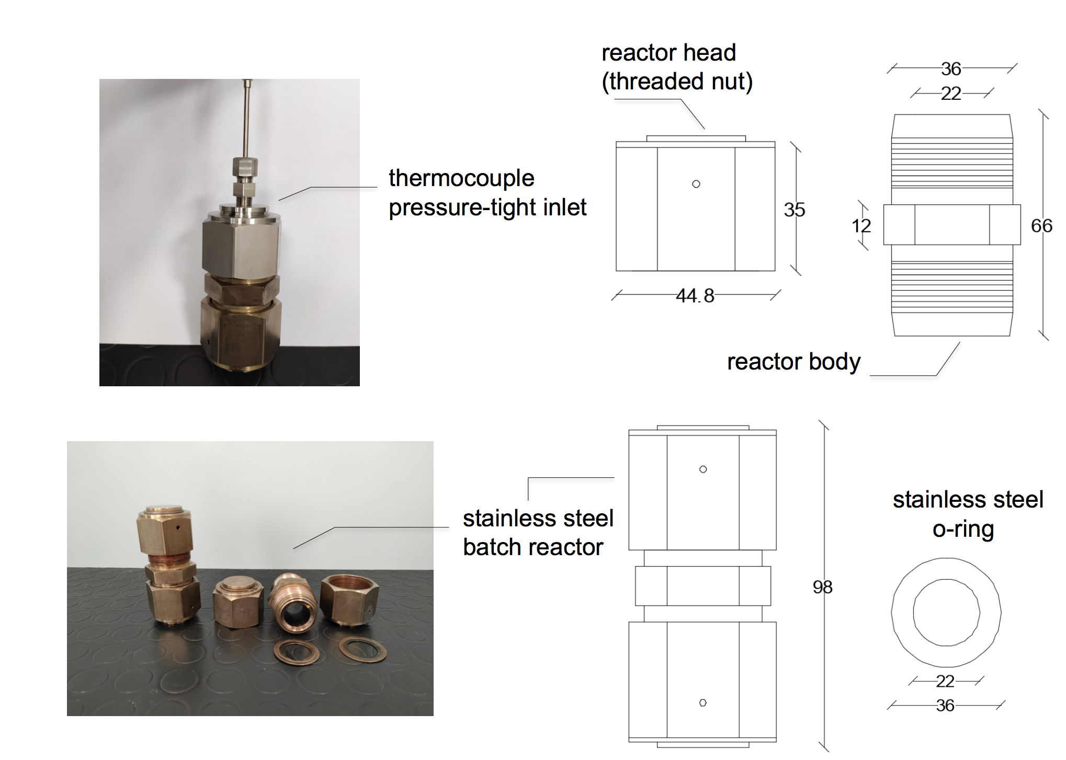

Figure 1: HTL stainless steel (AISI 316) batch reactor: pictures and construction details, (numeric values are expressed in mm).

One of the three reactors head is also provided with a pressure-tight inlet for the thermocouple used to check the temperature of the reaction biomass-water mixture during the process. The reactor head provided with the thermocouple inlet was used in the experimental runs for the testing phase of the apparatus. The testing phase showed that the temperature of the reactor body and the reaction mixture inside the vessel were rapidly equilibrated during HTL experiment carried out at 300 °C. Before the HTL test, the reactors were loaded with the desired starting biomass-water mixture and, with the caps slightly open, placed into a stainless steel cylindrical chamber for purging and sealing (Figure 2a). The residual air trapped in the reactor vessel was evacuated by flushing the chamber, and thus the vessel, with flowing pure nitrogen. After flowing nitrogen for at least 3 min to ensure the elimination of any air, the reactor was sealed using a sliding tube and applying a clockwise torque of 160 Nm. The procedure was repeated for the three reactors that then were placed into the muffle furnace (Carbolite-Gero Ltd, model ELF 11/14B, England) (Figure 2b). The temperature inside the furnace chamber was controlled using a Proportional-Integral-Derivative (PID) controller while the temperature of the reactor was measured and registered via a data logger using a thermocouple directly connected to the reactor wall. Given the small size of the reactors, the measured value was considered representative of the temperature inside the vessel. Reaction starting time was taken as soon as the temperature of reactor wall has reached the desired value.

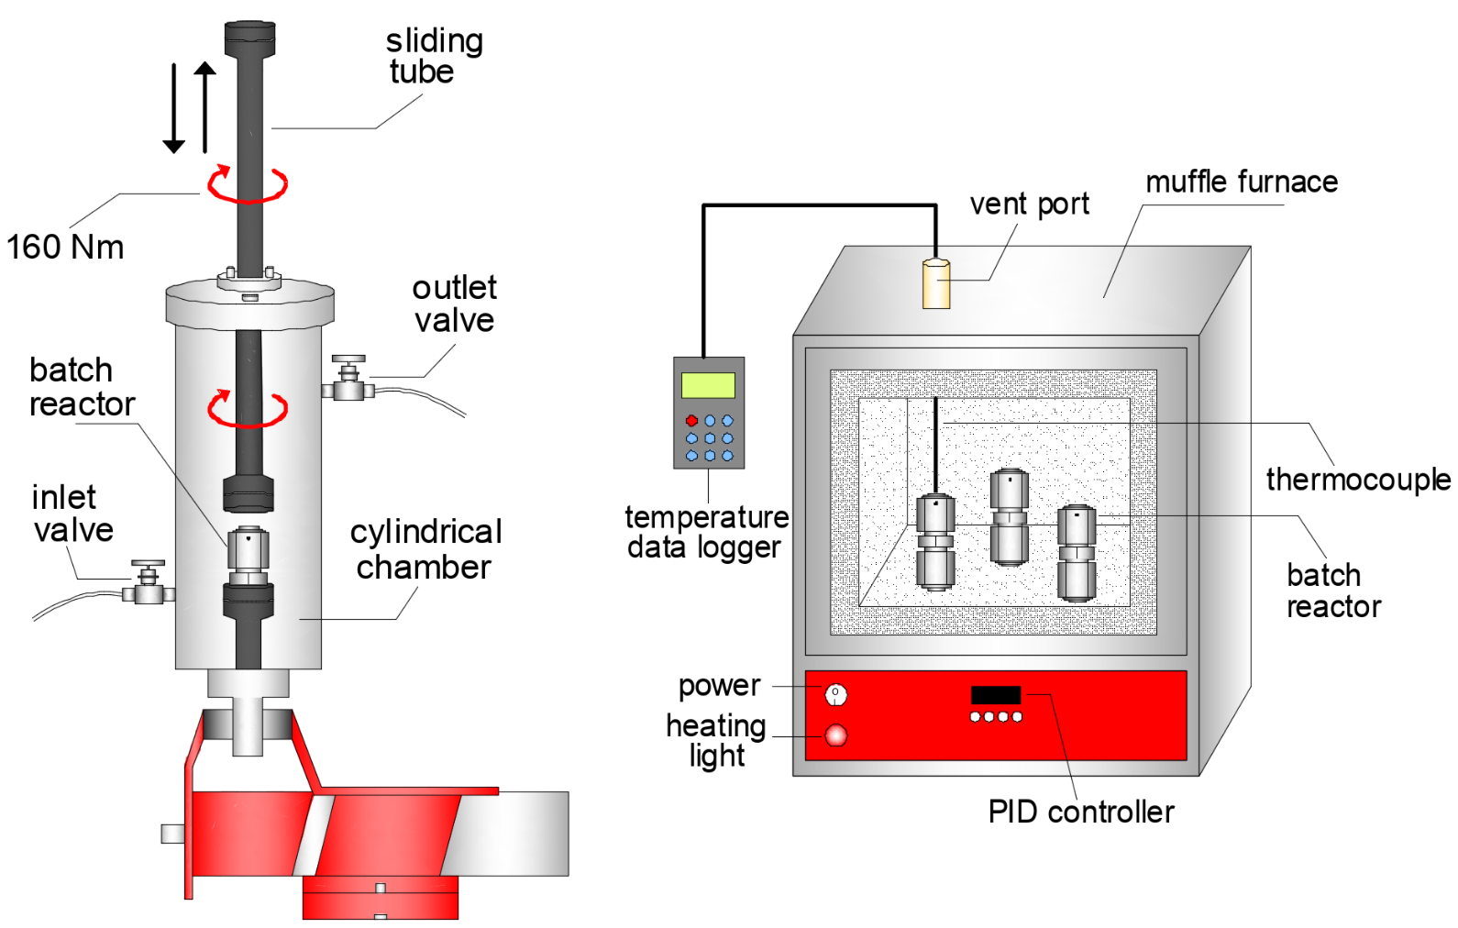

(a) (b)

Figure 2: Schematic representation of (a) the purging and sealing equipment and (b) the heating system.

* + 1. Materials

Castor seeds (Ricinus Communis) and tangerine peel waste (Prematuro di Ciaculli) were used as feedstock for the HTL conversion experiments. Castor seeds (CS) and tangerine peel waste (TPW) were obtained from plants cultivated in the province of Palermo (Italy). Moisture content of raw materials was lower than 1.0 wt% for CS and averagely 77.3 wt% for TPW. Before the HTL runs, TPW samples were ground by using a knife miller in order to provide completely homogeneous and reproducible size reduction, and stored in sealed plastic bags at -20 °C to prevent any degradation before the reaction test. CS were used as received and stored at room temperature in a sealed plastic bag. The two significantly different feedstock were used in order to verify the versatility and the functionality of the HTL apparatus.

* + 1. Experimental procedure

The HTL experiments were carried out at the temperature of 300 °C for a fixed reaction time of 1 h. In order to reach a biomass to water ratio of 0.15, 1.80 ±0.01 g of CS or 6.60 ±0.01 g of TPW were loaded in the reactor vessel adding 12.0 ±0.01 g or 5 ±0.01 g of deionized water, respectively, thus allowing to fill approximately 60% of the reactor internal volume. All the experiments were carried out at least three times to evaluate the deviation of data and ensure their reproducibility (the results were considered valid when showing an Er% < 2.5). The reactors loaded with the starting mixture were purged and sealed as described in the section 2.1 and heated up to the desired reaction temperature.

During the warm-up phase, the furnace temperature was initially set to the value of 450 °C in order to reduce the reactors thermal inertia and thus the time necessary to reach the HTL prefixed temperature (the thermal gradient was approximately of 10 °C min-1). After 26 min, as soon as the reactors reached the targeted temperature of 300 °C, the furnace temperature was also set to 300 °C. Figure 3 shows the temperature profile of the muffle furnace (Tf) and of the reaction vessels (Tr). The furnace and the reactors reached the thermal equilibrium after approximately 60 min. After 1 h of reaction time at 300 °C, the reactors were cooled down to room temperature by placing them in a cold-water bath. Once the reactor reached the room temperature, they were opened using the same system reported in Figure 2a. The residual pressure was released and produced gas phase vented to the hood. The solid-liquid mixture was carefully collected from the reactor for subsequent separation and analysis. Three different residues were collected from each single HTL run. A solid residue (HC) was recovered via vacuum filtration, dried in a ventilated oven at 55 °C until constant weight to remove water and washed few times with acetone to separate the bio-crude; a liquid aqueous phase, named process water (PW), recovered as filtrate during vacuum filtration of reaction mixture and evaporated at 55 °C to quantify the dissolved residual fraction; the bio-crude oil (BO) obtained by evaporating the acetone solution.

The HTL products mass yields were calculated as reported in Eq 1:

|  |  |
| --- | --- |
| $$MY=\frac{M_{idb}}{M_{Rdb}}$$ | (1) |

where *Midb* is the mass of each recovered fraction: PW, HC and BO; *MRdb* is the initial loading mass of the raw feedstock (*db* stands for dry basis). The gas mass yield was evaluated by difference.

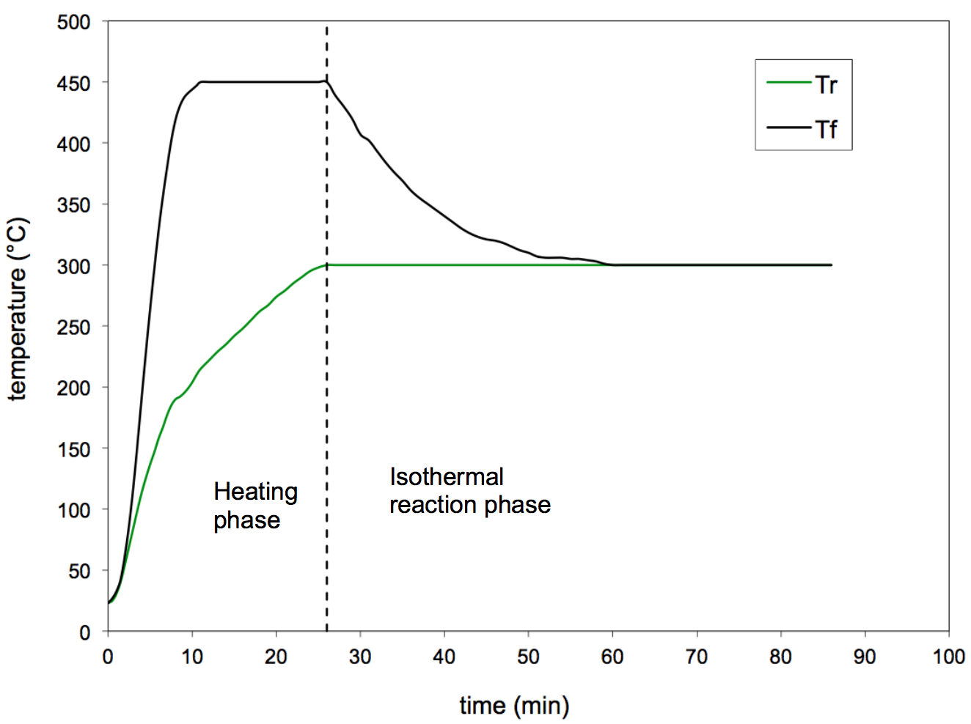

Figure 3: Reactor (Tr) and muffle furnace (Tf) temperature profiles as a function of time.

* + 1. HTL products characterization

Raw materials, hydrochars and bio-crude obtained from HTL runs were characterized in terms of proximate analysis and higher heating value (HHV). Proximate analysis was carried out by a LECO Thermogravimetric Analyser TGA 701. Full details of the thermal program followed are provided and described in a previous work (Picone et al., 2021). HHVs were evaluated according to the CEN/TS 14918 standard by means of a LECO AC500 calorimeter. The energy densification ratio (EDR) and the energy yield (EY) of hydrochars and bio-oils were determined via Eq (2) and Eq (3), respectively:

|  |  |
| --- | --- |
| $$EDR\left(\%\right)=\left(\frac{{HHV}_{idb}}{{HHV}_{Rdb}}\right)∙100$$ | (2) |
| $$EY\left(\%\right)=MY∙EDR$$ | (3) |

where HHVidb and HHVRdb are the higher heating values of hydrochar or bio-oil and raw feedstock db, respectively. Process waters were characterized in terms of pH and TOC. The pH of liquid samples was measured using a XS instruments Bench pH-meter. TOC was measured by a Shimadzu Total Organic Carbon Analyser (liquid samples were previously filtered through 0.45 μm syringe filters).

* 1. Results and Discussion

Distribution and yields of solid, liquid and gaseous products obtained from HTL conversion of CS and TPW are shown in Figure 4. It was observed that the PW mass yields result similar for the two biomasses, however, the PW obtained from liquefied TPW showed a pH acid and a higher TOC compared to CS. This finding could be related to a different chemical composition of PWs and to a larger amount of inorganic compounds leached in the aqueous phase during HTL of CS. As expected, due to the different nature of the feedstock, CS liquefaction led to a BO mass yield significantly higher than TPW, 41.9 and 15.9 wt% respectively; conversely CS showed a solid mass yield much lower if compared to the TPW one, 10.9 and 22.4 wt%, respectively.

The different HTL products distribution found for the two feedstock is clearly due to their different nature and starting mixture composition in terms of biomass macro-components (hemicellulose, cellulose and lignin) but also extractable inorganic compounds and lipids (Cao et al., 2017).

HTL degradation products differ depending process parameters, such as temperature, residence time and biomass to water ratio, and type of substrate. However, the basic HTL reaction pathways comprise: depolymerization of the biomass, decomposition of monomers by cleavage, dehydration, decarboxylation and recombination of reactive fragments (Toor et al., 2011). Depolymerisation follows the dissolution of biomass macromolecules in the liquid phase and changes the structure of long chain polymers to shorter chain hydrocarbons (Gollakota et al., 2018). These smaller compounds can be hydrolysed to form polar monomers which could undergo further degradation into phenolic compounds, furfurals and organic acids (SundarRajan et al., 2021). These oxygenated species could react via dehydration and decarboxylation with loss of water and carbon dioxide molecules, contributing to the increase of carbon and thus energy content of the process residues (Kruse et al., 2013). The reactive fragments soluble in the aqueous phase could be eventually involved in recombination and re-polymerization reactions yielding high molecular weight liquid (bio-crude) and solid (secondary char) compounds. The higher hydrochar and gas yields found for TPW could be related to high content of carbohydrates and lignin in the raw substrate while the greater bio-oil production from CS is probably related to the starting high content of lipids (Ponnusamy et al., 2020).

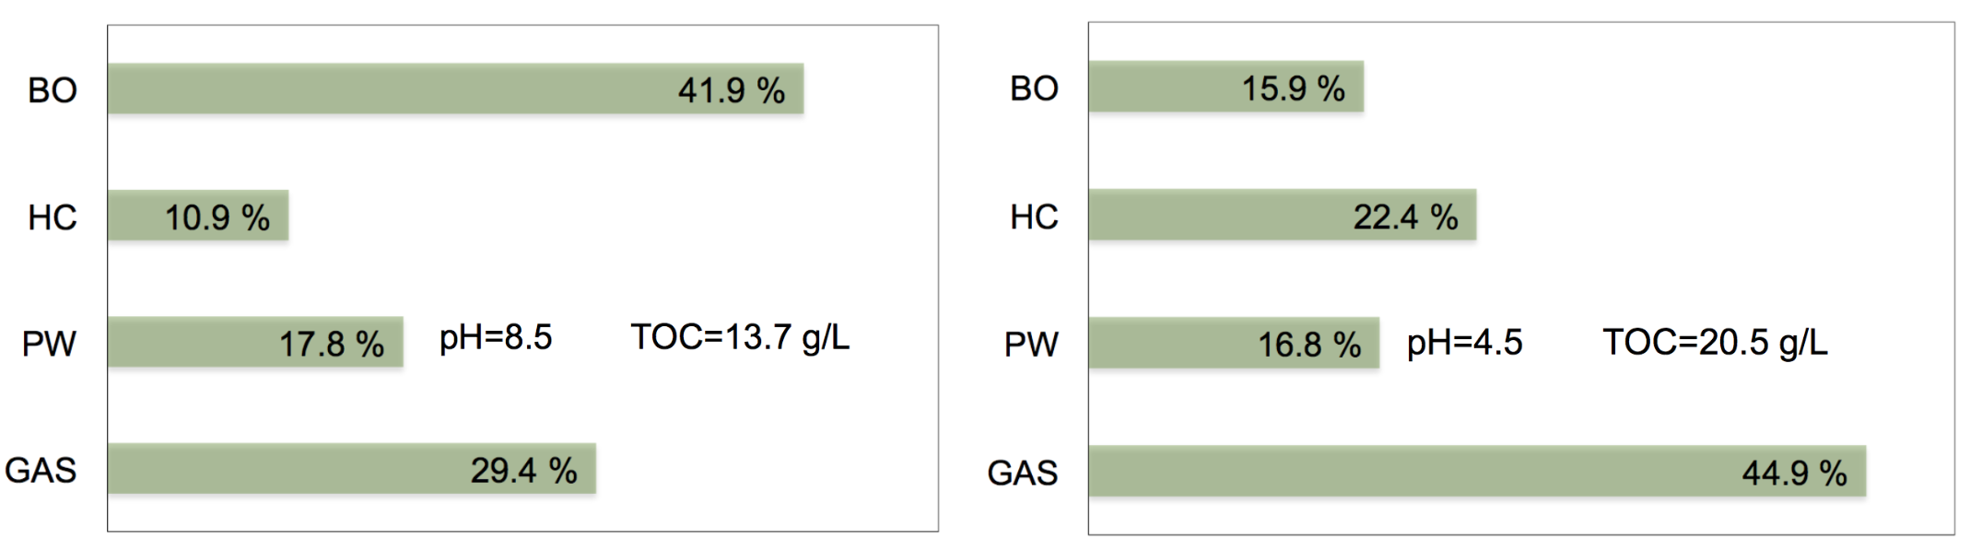

(a) (b)

Figure 4: Mass yields (wt% on dry basis) and process water characterization for (a) CS and (b) TPW. HTL recovered fractions measured after tests conducted in triplicate; average values showed (Er% ≤ 1.8 for BO, 1.2 for HC and 2.4 for PW). Average values of two pH and TOC measurements showed (Er% ≤ 0.4 for pH and 0.5 for TOC).

Proximate analysis results and energy properties of raw feedstock and HTL products are reported in Table 1. CS and TPW hydrochars (CS\_HC and TPW\_HC) showed a considerable increase of fixed carbon (FC) content while a decrease of the volatile matter (VM) content when compared to the corresponding values of raw materials. The solid residues showed also a significant increase in ash content (ASH). Conversely, the bio-oil samples (CS\_BO and TPW\_BO) showed a drastic reduction (0.5 and 0.0 wt% respectively) of ASHs, while, as expected, high values of VM (95.2 and 71.6 wt% respectively). All HC and BO samples exhibited a significant increase of HHV values, and thus EDR, than the parent substrates. The maximum value of EY (63.2%) was found for CS\_BO sample, which showed also the highest HHV value (35.6 MJ kg-1).

Table 1: Proximate analysis and energy properties of raw materials, hydrochars and bio-oils. Proximate analysis performed in duplicate; average values showed (Er% ≤ 2.2%). Higher heating values average of two measurements, Er% ≤ 0.9.

|  |  |  |  |  |  |  |
| --- | --- | --- | --- | --- | --- | --- |
| Sample | Proximate Analysis wt% d.b. | | | Energy Properties | | |
| VM | ASH | FC | HHV (MJ kg-1) | EDR (%) | EY (%) |
| Raw CS | 77.9 | 3.4 | 18.7 | 23.6 | 100.0 | 100.0 |
| CS\_BO | 95.2 | 0.5 | 4.3 | 35.6 | 150.8 | 63.2 |
| CS\_HC | 41.7 | 6.3 | 52.0 | 28.7 | 164.0 | 17.9 |
| Raw TPW | 72.5 | 3.1 | 24.4 | 18.7 | 100.0 | 100.0 |
| TPW\_BO | 71.6 | 0.0 | 28.4 | 32.6 | 174.3 | 27.7 |
| TPW\_HC | 48.1 | 5.3 | 46.6 | 28.2 | 150.8 | 33.8 |

* 1. Conclusions

In this paper, the design and set up of a new HTL experimental apparatus were described. The HTL apparatus was tested using castor seeds and tangerine peel waste as substrates for laboratory scale biomass liquefaction studies. Higher yields of hydrochar and gaseous matter were found from HTL of tangerine peel waste while castor seeds led to considerably higher bio-crude yields. Thermal and energy characterization of HTL residues showed that the process has the potential not only to significantly upgrade high moisture biomass (as citrus peel waste) into solid and liquid bio-fuels with increased energy density, but also the recovery of high oil fraction from low moisture content species as castor seeds. The bio-crudes obtained via HTL in this study showed HHV values of 32.6 and 35.6 MJ kg-1 for TPW and CS respectively, confirming their potential use as liquid bio-fuels. Further experiments are required to optimize the process and investigate the effect of operating conditions, mainly temperature, residence time and biomass to water ratio, on HTL products yields and characteristics testing biomasses of different nature. Beyond the bio-crude use as fuel or substrate for high value chemicals production, future research should focus to solid and liquid process by-products valorization to minimize environmental and economical HTL footprint.

Acknowledgments

The research was carried out in the framework of the Italian research program PRIN (Progetti di Ricerca di Rilevante Interesse Nazionale) 2017 ”BIOmasses Circular Holistic Economy Approach to EneRgy equipments (BIO\_CHEAPER)” – Project code: 20175TXJER.

References

Cao, L., Zhang, C., Chen, H., Tsang, D.C.W., Luo, G., Zhang, S., Chen, J., 2017, Hydrothermal liquefaction of agricultural and forestry wastes: state-of-the-art review and future prospects, Bioresource Technology. 245, 1184-1193.

Dimitriadis, A., Bezergianni, S., 2017, Hydrothermal liquefaction of various biomass and waste feedstocks for biocrude production: A state of the art review. Renew, Sustain. Energy Rev. 68, 113–125.

Gollakota, A.R.K., Kishore, N., Gu, S., 2018. A review on hydrothermal liquefaction of biomass. Renew. Sustain. Energy Rev. 81, 1378–1392.

He, C., Chen, C.L., Giannis, A., Yang, Y., Wang, J.Y., 2014, Hydrothermal gasification of sewage sludge and model compounds for renewable hydrogen production: A review, Renew. Sustain. Energy Rev. 39, 1127–1142.

Khan, T.A., Saud, A.S., Jamari, S.S., Rahim, M.H.A., Park, J.W., Kim, H.J., 2019, Hydrothermal carbonization of lignocellulosic biomass for carbon rich material preparation: A review, Biomass and Bioenergy 130, 105384.

Kruse, A., Funke, A., Titirici, M.-M., 2013, Hydrothermal conversion of biomass to fuels and energetic materials, Curr. Opin. Chem. Biol. 17, 515–521.

Merzari, F., Lucian, M., Volpe, M., Andreottola, G., Fiori, L., 2018, Hydrothermal carbonization of biomass: Design of a bench-scale reactor for evaluating the heat of reaction, Chem. Eng. Trans. 65, 43-48.

Nunes, L.J.R., Causer, T.P., Ciolkosz, D., 2020, Biomass for energy: A review on supply chain management models, Renew. Sustain. Energy Rev. 120, 109658.

Pavlovič, I., Knez, Ž., Škerget, M., 2013, Hydrothermal reactions of agricultural and food processing wastes in sub- and supercritical water: A review of fundamentals, mechanisms, and state of research, J. Agric. Food Chem. 61, 8003–8025.

Picone, A., Volpe, M., Giustra, M.G., Bella, G. Di, Messineo, A., 2021, Hydrothermal Carbonization of Lemon Peel Waste: Preliminary Results on the Effects of Temperature during Process Water Recirculation, Appl. Syst. Innov. 4, 19.

Ponnusamy, V.K., Nagappan, S., Bhosale, R.R., Lay, C.H., Duc Nguyen, D., Pugazhendhi, A., Chang, S.W., Kumar, G., 2020, Review on sustainable production of biochar through hydrothermal liquefaction: Physico-chemical properties and applications, Bioresour. Technol. 310, 123414.

SundarRajan, P., Gopinath, K.P., Arun, J., GracePavithra, K., Adithya Joseph, A., Manasa, S., 2021, Insights into valuing the aqueous phase derived from hydrothermal liquefaction, Renew. Sustain. Energy Rev. 144, 111019.

Toor, S.S., Rosendahl, L., Rudolf, A., 2011, Hydrothermal liquefaction of biomass: A review of subcritical water technologies, Energy 36, 2328–2342.

Volpe, R., Messineo, S., Volpe, M., Messineo, A., 2016, Catalytic Effect of Char for Tar Cracking in Pyrolysis of Citrus Wastes , Design of a Novel Experimental Set Up and First Results Chem. Eng. Trans. 50, 181–186.

Wang, T., Zhai, Y., Zhu, Y., Li, C., Zeng, G., 2018, A review of the hydrothermal carbonization of biomass waste for hydrochar formation: Process conditions, fundamentals, and physicochemical properties, Renew. Sustain. Energy Rev. 90, 223–247.