CHEMICAL ENGINEERING TRANSACTIONS  VOL. 92, 2022 | A publication of
The Italian Association
of Chemical Engineering
Online at www.cetjournal.it

Guest Editors: Rubens Maciel Filho, Eliseo Ranzi, Leonardo Tognotti
Copyright © 2022, AIDIC Servizi S.r.l.
ISBN 978-88-95608-90-7; ISSN 2283-9216

Simulation and Optimization of Waste Heat to Electricity through Organic Rankine Cycles (ORCs): A Case Study in an Oil Refinery
M. A. Sadek^{a,*}, Mamdouh A. Gadalla^{a,b}, N. Shedidª, Dina Ahmedª, Hany A. Elazab^{a,c}
ª Chemical Engineering Department, The British University in Egypt (BUE).
^{b} Chemical Engineering Department, Port Said University.
^{c} Jacobs School of Engineering, University of California San Diego, La Jolla, CA 92093-0403, USA.
* Shahir.Sadek@bue.edu.eg

Energy efficiency has become a global problem that is detrimental to the chemical industries technically, economically and to the environment. Organic Rankine Cycle (ORC) is a promising technology that can solve this problem by recovering heat from low-grade waste heat sources by using organic working fluids. The heat source for the ORC system used in this article is air leaving air coolers in an oil refinery with a temperature of 140 º C. The heat exchanger data for this refinery was used in the simulation of a basic cycle and a regenerative cycle using ASPEN HYSYS V.10. These ORC systems were simulated using hydrocarbons, refrigerants, and alternative refrigerants as the working fluids to compare their performance at three different condensation temperatures which are 15 º C, 35 º C, and 50 º C. The system was optimized using the HYSYS optimizer to reach the optimum conditions for each working fluid. Results of this study have proven that the alternative working fluids R1234ze (Z) and R1224yd (Z) perform very well when compared to hydrocarbon working fluids and outperform the regular refrigerants. For the basic cycle which yielded the optimum results, R1234ze (Z) produced 1258.90 kW of turbine work and has a thermal efficiency of 11.31%. Hence, they are promising working fluids and are highly recommended to be used in the future since they perform highly economically in addition to being environmentally friendly.
  - Introduction
Due to the ever-developing technology and modernization, the demand for fossil fuels witnesses an exponential upsurge year by year. Power consumption in the chemical industries is quickly increasing which leads to severe environmental impacts. Hence, research to reduce fossil fuel consumption is crucial. There are numerous ways through which electricity can be generated from primary energy sources (Gadalla M., 2015a).
The organic Rankine cycle (ORC) is one of the proposed solutions to the above-mentioned problem. Its main advantage over regular Steam Rankine cycle is the use of organic working fluids due to their lower boiling temperatures and higher molecular masses when compared to water. Examples of such organic working fluids include Refrigerant-12 (R12), Refrigerant-11 (R11), R134a, R152a, and Ammonia (Chys et al., 2012). Different working fluids have different thermophysical properties (ex: specific heat, conductivity, and latent heat of vaporization) and lead to changes in the mechanical parameters of the Organic Rankine Cycle (ORC) system such as the network produced and the efficiency. Its configuration is very similar to that of the Rankine cycle utilizing also mainly four different components (pump, evaporator, expander, and condenser) each having its own purpose. ORC systems can also be optimized according to several parameters leading to an increased overall efficiency and maximum output power which is in the form of electricity that can either be sold or sent to the grid for use inside the plant. This technology reduces greenhouse gases, improves energy efficiency, decrease the total power required for a certain process, in addition to making any project more feasible economically (Klemeš et al., 2020). Therefore, many companies and plants are targeting the manufacturing and installation of ORC systems, respectively. Chys et al. discussed the potential of using zeotropic mixtures in ORC as the working fluids (Wang et al., 2021).
The investigated cases were a) a 150 º C temperature source and b) a 250 º C temperature source. In both cases, the use of an appropriate zeotropic mixture had a strong influence on the performance of the cycle by increasing the efficiency and produced electricity. Nevertheless, using zeotropic mixtures could be disadvantageous as it has a higher risk of leakages than pure fluids and could be patented which would incur an extra cost (Roy et al., 2011).
The performance of an ORC was analyzed by Roy et al. when superheating the used working fluids at a constant pressure of 2.50 MPa under variable temperature conditions of the heat source. The employed ORC is of the non-regenerative type and the used fluids are R-12, R-123, R-134a and R-717. For a heat source of variable temperature, irreversibility of the system increased, R-123 provided the highest efficiency contrary to R-134a. In addition, R-12 and R-134a showed similar system performance and may be replaced by each other.
The impacts of the evaporating temperature and the addition of an internal heat exchanger (IHX) on ORC were examined. The study considered three pure fluids which are R123, R245ca, and R141b, and a mixture of R141b and RC318. Among the pure fluids selected, R141b was the most efficient while R245ca provided the poorest efficiency. The ORC utilizing the mixture fluid showed a lower efficiency than that utilizing the pure fluids. Finally, the addition of the IHX considerably improved both the thermal and exergetic efficiencies of the system because of decreasing the heat-transfer temperature difference (Chowdhury et al., 2011). The main objective of this research is to establish a simulation of an organic Rankine cycle (ORC) that utilizes exhaust air from air coolers as the heat source and based on data from an oil refinery. An optimization of this ORC system is predicted by varying different parameters to determine the optimal parameters for achieving the most efficient performance of the system. This approach will enable to develop deep insights and emphasis on the utilization of the different types of working fluids used for this cycle and know which is more efficient and cost-effective, and to compare between the basic cycle and the regenerative cycle both technically and economically.
  - Methodology and System Description
The working fluid is pumped to the evaporator where it is heated using the low-grade waste heat source and consequently turns into a saturated or superheated vapor depending on the amount of heating. This high-temperature and high-pressure vapor then enters through the expander to generate work and leaves as low-temperature and low-pressure vapor. Lastly, the working fluid enters the condenser and is cooled until it reaches the liquid phase again and the cycle is repeated. The input operational data used in the simulations for the ORC model were attained from an operating oil refinery in Kuwait. The proposed organic Rankine cycle for this refinery aims at recovering waste heat from the hot air exiting air coolers used in the process and converting it into electricity. The assumption that the air coolers will be working at their nominal operating conditions throughout the year is made to simplify the simulations and keep the temperature of the heat source constant. The air cooler produces hot air as waste heat having an average temperature of 140 º C. This air is usually dissipated into the environment causing environmental concerns. Hence, using it as a free heat source can have economic as well as environmental benefits as will be shown below. The turbine work produced by the cycle is mainly dependent on the turbine entering temperature of the working fluid. Hence, increasing this temperature will be favorable to the process. Nevertheless, this temperature has some constraints in order to ensure the safe operation of the process.
Table 1: ORC Cycle Specifications
Heat source: Hot air | Entering temperature | 140 º C
 | Pressure | 101.3 kPa
Working fluid | Higher limit of entering temperature | 10% lower than T_{crit,} except for fluids having T_{crit} > T_{HS}
 | Lower limit of entering temperature | Almost 30% lower than T_{crit}
Process | Minimum approach in heat exchangers | 10 º C
Heat source: Hot air | Entering temperature | 140 º C
 | Pressure | 101.3 kPa
Working fluid | Higher limit of entering temperature | 10% lower than T_{crit,} except for fluids having T_{crit} > T_{HS}
 | Lower limit of entering temperature | Almost 30% lower than T_{crit}
The maximum temperature which the fluid can reach depends on both its critical temperature as well as the maximum temperature of the heat source.
Most of the fluids used in this analysis had critical temperatures higher than that of the heat source. Nonetheless, their maximum temperature at which they enter the turbine was limited by the heat source temperature (140 ºC) and the minimum temperature difference (10 ºC) used in the heat exchangers of the process. Hence, these fluids, which were all but R134a, R1234yf, and R1234ze (E), had a maximum turbine entering temperature of 130 ºC. As for R134a, R1234yf, and R1234ze (E) which had lower critical temperatures, their maximum turbine entering temperature was set to 10% below their critical temperature in order to ensure that the normal equations of state are still applicable at these conditions. The simulation and optimization of the organic Rankine cycle were carried out using the Aspen HYSYS V.10 software for process simulation. This was done for both the basic and regenerative ORCs using several working fluids. The Aspen HYSYS multi-variable optimizer was used in manipulating certain variables until a maximum of the objective function was reached. The objective function is maximizing the turbine work, while the manipulated variables which are known as the primary variables, are the mass flow rate of the heat source, the mass flow rate of the working fluid, and the temperature entering the turbine. It is important to note that the values of these variables are interdependent. Nonetheless, it is possible to set the value of any of these variables and the rest of the variables will adjust accordingly and the optimization procedure will proceed after that. Furthermore, constraint functions were added in order to make sure that the minimum temperature difference in the heat exchangers does not exceed the minimum approach which is set to 10 ºC. These constraint functions are as follows for the basic cycle:

$T_{Cold Air}-T_{1}≥10$ (1)
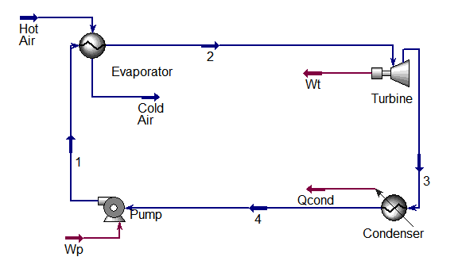
Figure 1: Aspen HYSYS Basic Organic Rankine Cycle Simulation
The process flow diagram of the basic organic Rankine cycle is shown in figure 1, As for the regenerative cycle, which has two heat exchangers, the evaporator and the regenerator, the constraints were as follows:

$T_{Cold Air}-T_{6}≥10$ (2)

$T_{3}-T_{5}≥10$ (3)

The following assumptions were made during the simulations including the assumption that the operation is at steady state conditions with considering that negligible amounts of heat are lost. Also, it is assumed that the change in pressure occurs only in the pump and turbine, and the working fluid enters the turbine as saturated vapor, however, the working fluid exits the condenser as saturated liquid. The value of the thermal efficiency depends on the net work produced which is the difference between the turbine work and the pump work, and the duty of the evaporator as shown in the below equation (Wu et al., 2017).

$$η_{th}=\frac{W_{net}}{Q_{evap}}=\frac{W_{turbine}-W_{pump}}{Q_{evap}}$$ | (4)
The process flow diagram of the regenerative organic Rankine cycle is shown in figure 2.

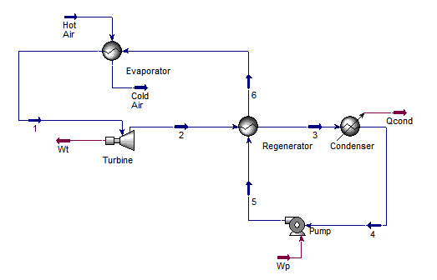
Figure 2: Aspen HYSYS Regenerative Organic Rankine Cycle Simulation
  - Results and Discussion
The representation of every stream and ORC system component for one of the fluids (R1234ze (Z)) at a condensation temperature of 35 º C for both the basic and the regenerative cycle is shown in figure 3 which analyzes the ORC performance for the different utilized fluids at their optimized operational conditions. The obtained turbine power capacities are in the range (431-1722) kW. Pentane produced the greatest turbine output power (1722 kW). This is a reasonable result that matches well with data in the literature as it has one of the highest critical points amongst the selected working fluids. N-hydrocarbons produced the highest turbine power capacities followed by the refrigerants and then the alternative refrigerants. The decrease in the output power from the turbine is usually reflected by a decrease in the critical pressure of the working fluid. The power output from the turbine is in the (663-2234) kW range for a condensation temperature of 15 º C, and in the (458-1722) kW range for a condensation temperature of 35 º C. As for the highest condensation temperature considered, which is 50 º C, the power range is smaller as expected; it ranges from (330-1369) kW.

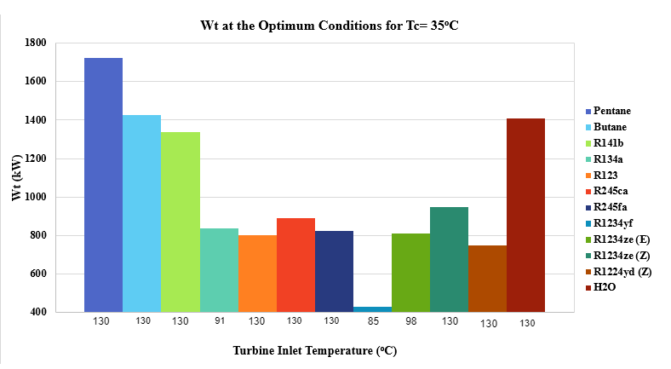
Figure 3: Turbine power at optimum conditions for the basic cycle at Tc=35 ºC
R141b proceeded pentane in this scenario by producing the greatest turbine output power (1664 kW). This is a more reasonable result as it has the highest critical temperature amongst the selected working fluids. The power output from the turbine is in the (587-1664) kW range for a condensation temperature of 15 º C, and in the (533-1153) kW range for a condensation temperature of 35 º C. As for the highest condensation temperature considered, 50 º C, the power range is smaller as expected; it ranges from (353-839) kW. It can be concluded from these power ranges that the regenerative cycle is not better than the basic cycle in terms of the output power from the turbine and hence, might not be cost-effective.
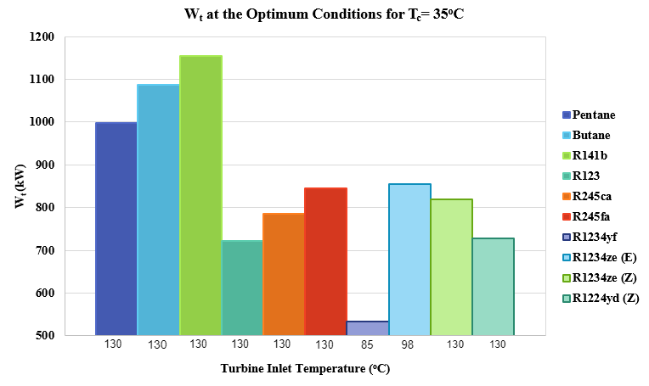
Figure 4: Turbine power at optimum conditions for the regenerative cycle at Tc=35 ºC
The thermal efficiency ranged (3.4-17.1) % for a condensation temperature of 15 ºC with R141b having the highest efficiency followed by n-Pentane and n-Butane. The ranking of the fluids was like that encountered in the output power from the turbine with slight differences. R1234yf also ranked the lowest in the three condensing temperatures. As for the condensation temperatures of 35 ºC and 50 ºC, the efficiencies ranged between (1.75-14.3) % and (0.4-12.2) %, respectively. The good performance of a certain working fluid at a given condensation temperature was present at the other condensation temperatures as well regarding the other working fluids. Nevertheless, when the working fluids were ordered relative to their thermal efficiencies, their relative positions were not precisely the same.

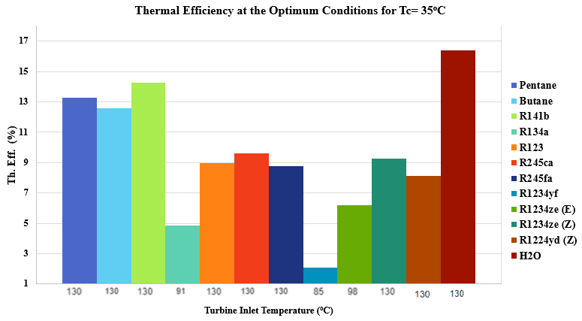
Figure 5: Thermal efficiency of the cycle at optimum conditions for the basic cycle at Tc=35 ºC
Energy performance and thermodynamic properties are not the only values to consider when selecting a proper working fluid for an organic Rankine cycle. It is also very important to consider the flammability and toxicity values of the utilized working fluids. Flammability and toxicity are considered the most important factors to consider for ensuring the safe operation of the cycle and avoiding harm to any of the working personnel. In addition, some of the working fluids that are utilized in ORCs have restrictive toxicology and very low occupational exposure limits. If a certain fluid has a great energy performance but has high flammability and/or toxicity values, this undermines its great performance. For the chosen refrigerants, the American Society of Heating, Refrigerating, and Air-Conditioning Engineers (ASHRAE) 34 standard was used in providing a suitable safety classification. Most of the chosen refrigerants were classified as A1 or A2L refrigerants which are considered the safest groups since they denote low toxicity and flammability values. As for the hydrocarbons used which are highly flammable, their auto ignition temperatures were not exceeded at the highest ORC operating temperature.
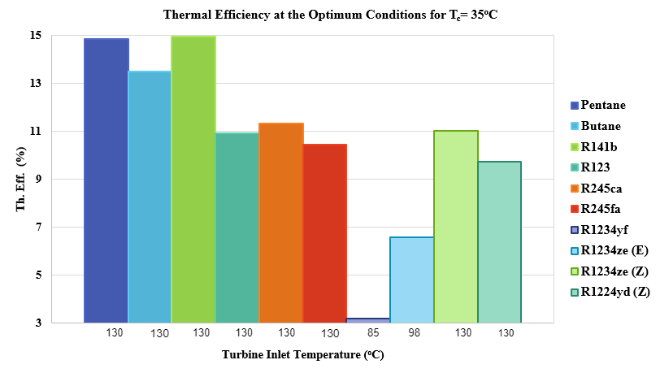
Figure 6: Thermal efficiency of the cycle at optimum conditions for the regenerative cycle at Tc=35 ºC
  - Conclusions
A heat source of air leaving air coolers was used in a huge oil refinery with an average temperature of 140 º C. The heat exchanger data for this refinery was obtained and used in the simulation of a basic cycle and a regenerative cycle using ASPEN HYSYS V.10. These ORC systems were simulated using 11 working fluids including hydrocarbons, refrigerants, and alternative refrigerants to compare their performance at three different condensation temperatures which are 15 º C, 35 º C, and 50 º C. This is a subcritical saturated cycle which means that the working fluid exits the evaporator as saturated vapor and exits the condenser as saturated liquid. The main parameters used in the comparison process were the output power from the turbine and the thermal efficiency of the cycle. Additionally, the working fluids were compared from an economic viewpoint including the net earnings, payback period, and the levelized energy cost. Results of these simulations have shown that hydrocarbons followed by the alternative refrigerants perform the best from a technical and economical perspective. For example, R1234ze (Z) produced 1258.90 kW of turbine work and has a thermal efficiency of 11.31%. Furthermore, the gap between these two types of working fluids is not significant and hence, this proves the competency of alternative working fluids in substituting the current working fluids. The future recommendations for this project include adding another organic Rankine cycle which utilizes the heat of condensation of the first ORC as its heat source, making it a double ORC. In addition, its economics will have to be compared to those of the single ORC to see whether adding another ORC is a cost-effective solution or not.
References
Chowdhury J., Nguyen B., Thornhill D., (2015), Modelling of evaporator in waste heat recovery system using finite volume method and fuzzy technique, Energies, 8, 14078–14097.
Chys M., Van M., Vanslambrouck B., Paepe M., (2012), Potential of zeotropic mixtures as working fluids in organic Rankine cycles, Energy, 44, 623–632.
Gadalla M. (2015a). A new graphical method for pinch analysis and energy integration. Chemical Engineering Transactions, 43, 1291–1296
Klemeš J., Wang Q., Varbanov W, Zeng P., Chin M., Lal N., Wang B., Wang X. , Walmsley T., (2020). Heat transfer enhancement, intensification and optimisation in heat exchanger network retrofit and operation. Renewable and Sustainable Energy Reviews, 120, 1-31
Roy J., Mishra M., Misra A., (2011), Performance analysis of an Organic Rankine Cycle with superheating under different heat source temperature conditions, Appl. Energy, 88, 2995–3004.
Wang B., Klemeš J., Li N., Zeng M., Varbanov P., Liang, Y. (2021). Heat exchanger network retrofit with heat exchanger and material type selection: A review and a novel method. Renewable and Sustainable Energy Reviews, 138, 1-26
Wu D., Aye L., Ngo T., Mendis P., 2017, Optimisation and financial analysis of an organic Rankine cycle cooling system driven by facade integrated solar collectors, Appl. Energy, 185, 172–182.

