CHEMICAL ENGINEERING TRANSACTIONS  VOL. 92, 2022 | A publication of
The Italian Association
of Chemical Engineering
Online at www.cetjournal.it
Guest Editors: Rubens Maciel Filho, Eliseo Ranzi, Leonardo Tognotti
Copyright © 2022, AIDIC Servizi S.r.l.
ISBN 978-88-95608-90-7; ISSN 2283-9216

Synthesis and characterization of a cassava starch (Manihot esculenta) and dried coffee pulp mixture to produce biofilms
Zully Gómez Rosales,*ª Johanna K. Solano,ª David Orjuela,ª Javier Rodrigo Ilarri,^{b} María Elena Rodrigo Clavero^{b}
ª Faculty of Environmental Engineering, Universidad Santo Tomás, Carrera 9 # 51-11. Bogotá, Colombia
^{b} Department of Hydraulic Engineering and Environment Universitat Politècnica de València, Camí de Vera, s/n, 46022 València, Valencia, Spain
zullygomez@usantotomas.edu.co

Currently, implementing strategies to minimize the impacts caused by solid waste is a priority that is integrated into environmental policies and development plans worldwide. Agro-industrial waste is one of many types of waste. This waste is an environmental problem, given that if it is not properly disposed of or reused, it can alter different natural resources, including soil, water and air, in addition to being a possible source of contamination and risk to human health. Notwithstanding, this waste has energetic potential which could be harnessed through different alternatives for its use and therefore reduce its environmental impact. This study presents an alternative strategy to manage the solid waste generated in the pulping stage of coffee processing, which entails incorporating dried pulp to make cassava starch biofilms which use glycerol and Polyvinyl alcohol (PVOH) as a plasticizer.
Following a material synthesis process, its mechanical properties related to stress and impact strength were evaluated. Furthermore, a thermal characterization was performed with differential scanning calorimetry (DSC), a thermogravimetric analysis (TGA), and a dynamic-mechanical analysis (DMA). The prepared films contain 96.3% p/p of gelatinized cassava starch, 0.3% p/p of dry residue, 2.1% of glycerin, and 1.3% of PVOH. The result was a thermoplastic material that can be used to manufacture packaging materials given the values of its mechanical properties.
1. Introduction
The search for solutions to properly manage and dispose of solid waste is viewed as a necessity to minimize its negative environmental impacts. Productive sectors generate a wide variety of wastes according to their nature. Such is the case of agribusiness, which generates a large amount of waste materials that can become a serious problem given increased production and stricter environmental laws that are enacted (Jurado et al., 2011). Currently, from the economic, social and nutritional points of view, there are few alternatives to use these wastes, which coupled with a lack of awareness in environmental care, results in them contaminating natural resources (Rodriguez, 2011).
Thus, it is necessary to utilize the waste generated by this sector. The most widely applied processes are those connected with, "energy production, composting, the textile industry, biofuel production, enzyme production, organic acid isolation, pigment extraction, food flavoring and preservative extraction, production of bioactive compounds, production of biodegradable polyhydroxyalkanoate, agricultural composting, among others," (Yusuf,2017). Among the most significant agro-industrial residues are coffee pulp residues, which represent a considerable source of contamination and have limited options for reuse (Rathinavelu, R., & Graziosi, G, 2005).
An alternative use for these types of waste is creating new materials with them. For example, the development of new materials environmentally friendly can be an alternative for the production of biodegradable food packaging (Betotto et al, 2022).Research has explored incorporating them into production cycles through mechanical or chemical recycling processes that create raw materials that can be used for multiple purposes, such as the polymeric matrix formed by high-density polyethylene and polypropylene waste that incorporate the agro-industrial waste of ground rice husks in its composition (Orjuela et al, 2021), this is an interesting alternative because plastic waste pollution has been identified as a serious global issue, primarily for massive waste generation, ocean pollution, and increases in greenhouse gas emissions (Kumar & Sheela,2020).
Incorporating agro-industrial wastes in polymeric matrices represents a viable alternative that is aligned with trends in developing new materials that integrate the premises of the circular economy in their processes. That said, it is necessary to explore alternatives to make sure that these new materials do not become polluting wastes themselves, given that on occasion, they are non-biodegradable materials. Therefore, this research study sets out to create biofilms from cassava starch, which incorporates a residue generated in the coffee pulping process. This would make it possible to create biodegradable materials and use waste from the coffee agroindustry.
Films made mainly from starch, polysaccharides and proteins can potentially be a partial substitute for plastic films made from hydrocarbons. This would be viable both economically and environmentally, as biofilms are biodegradable, and their raw materials are widely available at a low cost. The starches that have been used the most in experiments to obtain biofilms are from potato, corn, wheat, rice, and cassava. The latter has shown to be the most viable given its transparency and brightness. Regarding the processes, it is important to note that those applied to create biofilms primarily use temperature to gelatinize and produce the biofilm, while incorporating plasticizing substances to improve its mechanical properties. This makes it possible for the biofilm to be manipulated and stored (Buensuceso V, 2010).
Due to the above, this research focused on establishing the technical feasibility of a material with a cassava starch matrix and coffee pulp reinforcement by determining its mechanical and thermal properties.
2. Materials and Methods
Native cassava starch, dry coffee pulp, industrial grade glycerol, PVOH and water were used as the mixture components in the process to manufacture the films. It is important to note that it was developed via a pilot scale, in which the best composition sample was obtained according to its preliminary physical characteristics. To create the films, gelatinized starch suspensions with each component were prepared and then poured into non-stick molds. Afterwards, they were subjected to a drying process at 60°C for 24 hours before being removed from the molds.
Following initial experimental trials, it was determined that the best formulation for the films contained 96.3% p/p of gelatinized cassava starch, 0.3% p/p of dry residue, 2.1% of glycerin, and 1.3% of PVOH. This material formulation was ideal for the synthesis process, since adding more pulp would cause it to agglomerate and a homogeneous material could not be produced. Consequently, the results of the mechanical and thermal tests would not be conclusive. Gelatinized starch was obtained from cassava starch powder with 5.3% p/p in water at a temperature of 67°C. Once the gelatinization point was reached, glycerin, dry coffee mucilage particles approximately 0.297mm in size, and PVOH were added. Subsequently, the suspensions were poured into non-stick molds and dried at 60°C for 24 hours in an oven until the biofilms formed. Once the films were created, their tensile and impact mechanical properties were determined. Additionally, thermal characterization was performed with differential scanning calorimetry (DSC), thermogravimetric analysis (TGA) and dynamic mechanical analysis (DMA). Standardized tests were carried out in accordance with ASTM standards for the characterization tests, as described below.
3. Results and Discussion
3.1 Mechanical Characterization
Tensile Test
The tensile test was performed with an EZ-XL-Shimadzu universal testing machine in accordance with ASTM 882: Standard Test Method for Tensile Properties of Thin Plastic Sheeting. The separation distance between the grips was 50 mm and the testing speed was 5 mm/min.
In this test, the average values of maximum stress at break and elongation were obtained for the composite material and the reference thermoplastic starch (TPS). The stress at break decreased with the addition of the dry pulp inside the material, which is most likely due to the low cohesion between the matrix and the reinforcement particles. The values obtained for this test are presented in Table 1.
Table 1: Tensile Test Results
Material | Strength at break (Mpa) | Deformation (%)
TPS | 2.99 ± 0.46 | 62.49 ± 0.44
TPS + Pulp | 2.44 ± 0.17 | 78.65± 5.86
Hardness Test
Shore hardness
This test was performed following the parameters established by ASTM D2240: Standard Test Method for Rubber Property–Durometer Hardness. A manual durometer was used for the test and ten points were taken on each of the films. Table 2 shows the average hardness values found and based on the ASTM Standard D2240; the two films tested are classified in the range of soft plastics.
Table 2: Hardness Test Results
Material | Shore hardness A
TPS | 81.9
TPS + Pulp | 83.5

3.2 Thermal Characterization
Differential Scanning Calorimetry (DSC)
A Mettler Toledo TGA/DSC 1 differential calorimeter was used for the analysis. The samples were heated from -20°C to 400°C at a heating rate of 5°C/min under inert atmosphere (N2) with a flow rate of 180 mL/min. Table 3 shows the data obtained from the DSC analysis of the study materials.
Table 3: Melting temperature and enthalpies for TPS and TPS + Pulp
Material | Melting Temperature (°C) | Enthalpy  (J/g) | Initial Temperature (°C) | Final Temperature (°C)
TPS | 279.85 | 86.06 | 269.30 | 301.67
TPS + Pulp | 228.61 | 236.60 | 204.38 | 239.38
The films with pulp had lower melting temperature values, which may be due to the low adhesion between the pulp particles and the matrix. However, the material with pulp had a higher enthalpy value, which may be attributed to the fact that the particles did not reach their melting point and have high heat capacity.
Thermogravimetric Analysis (TGA)
The thermogravimetric analysis was performed on a Mettler Toledo TGA/DSC 1 analyzer. The temperature range for the test was 25°C – 600°C at a heating rate of 5°C/min. Figures 1 & 2 are the curves obtained in the tests.
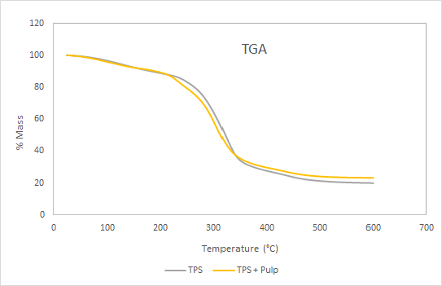

Figure 1. TGA curves

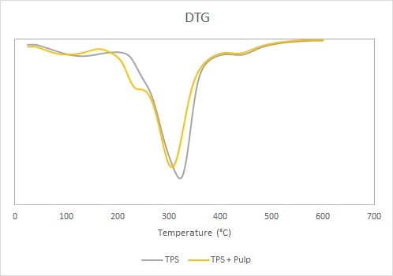
Figure 2. DTGA curves

A loss of mass between 50°C and 180°C was seen in both samples. This may be related to the water evaporation and plasticizers contained in the material. The degradation of the TPS and TPS-pulp samples occurred between 200°C and 380°C, during which a sharp drop in mass occurs, which is due to the decomposition of starch and pulp particles. The maximum decomposition temperature in the DTG thermogram was 322°C for the composite material and 304°C for the reference material. Beyond 380°C, the mass losses were considered to be due to polymer degradation.
Dynamic Mechanical Analysis (DMA)
The storage modulus and the tan delta of the material were obtained by a DMA 850 instrument at a frequency of 1Hz, a heating rate of 5°C/min between -70°C and 100°C, with a deformation of 1 mm. Figure 3 shows the storage modulus (E') while Figure 4 displays the loss tangent, tan δ, as a function of temperature for the films created.
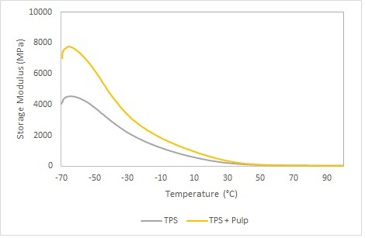
Figure3. Storage module curve
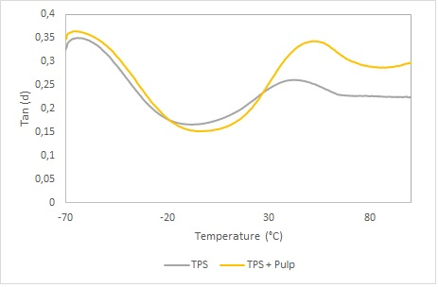
Figure 4. tan δ curve
The tan δ curve has two peaks for TPS and TPS with pulp. The first peak for the two films is at approximately -63°C and the second peak with lower intensity is between 20°C and 60°C. At about -63°C, there is a drop in the storage modulus. Therefore, the first peak can be identified as the glass transition temperature of glycerin, based on what has been reported by other authors (Famá et al., 2006), which can be attributed to the partial miscibility of starch and glycerin.
4. Conclusions
Creating materials that incorporate agro-industrial waste in their matrixes is a viable alternative and a current trend that facilitates using residual material in production cycles to obtain useful products that can be used in different industrial sectors. This approach supports the circular economy model to achieve countries’ proposed goals in terms of minimizing environmental impacts. Along these lines, this study created a thermoplastic material composed of starch matrix and coffee pulp reinforcement plasticized with glycerin, PVOH and water. Its breaking strength of 2.44 Mpa and elongation of 78.65% is an expected plastic deformation percentage for these types of materials. On the Shore Hardness Scale, the material had a value of 83.5, which classifies it as a soft material, while its melting temperature was 228.61°C, indicating that it is resistant to high temperatures.
Synthesizing this material is the primary stage of the process, and its characterization by determining the properties described herein facilitates the process of identifying possible uses to begin. The aim is to substitute conventional plastic materials with the new material to thus contribute towards circular economy strategies. The next stage of the research process will continue with scanning electron microscopy (SEM) analysis will be carried out to evaluate the morphology of the material and the interface between the matrix and the reinforcement to determine the level of adhesion and cohesion between the two materials and tests to determine that material’s environmental behavior, including biodegradability tests and others that will identify its behavior before chemical agents. Similarly, biodegradability tests, among others, will be performed to establish a complete and detailed characterization, to determine the most appropriate application for the film produced.
References

Bertotto, C., Bilck, A. P., Yamashita, F., Anjos, O., Siddique, M. A. B., Harrison, S. M., ... & Carpes, S. T. 2022, Development of a biodegradable plastic film extruded with the addition of a Brazilian propolis by-product, LWT, 67,113124.

Buensuceso V. 2010, Elaboración y caracterización de biopelículas a partir de almidón de Yuca, Professional thesis, Escuela superior de ingeniería química e industrias extractivas. Mexico.
Famá L., Flores S., Gerschenson, L., Goyanes, S., 2006, Physical characterization of cassava starch biofilms with special reference to dynamic mechanical properties at low temperatures, Carbohydrate Polymers, 66, 8-15.
Jurado, P. L., Mutuberría J. F., Oliver, N., Charadia, R., BrühlS., & García M., 2011, Diseño de un proceso de aprovechamiento integral de residuos agroindustriales. Asociación Argentina de Materiales (SAM), Revista Virtual Pro.
Kumar, M. V., & Sheela, A. M., 2020, Effect of plastic film mulching on the distribution of plastic residues in agricultural fields, Chemosphere, 273, 128590.
Orjuela D., Munar D.A., Solano J.K., Becerra A.P., 2021, Evaluation of the Mechanical and Morphological Properties of a Rice Husk Mixture with Recovered Polypropylene and High-density Polyethylene, Using Sulfur-silane as the Coupling Agent, Chemical Engineering Transactions, 87, 559-564.
Rathinavelu, R., & Graziosi, G., 2005, Posibles usos alternativos de los residuos y subproductos del café. Organización Internacional del Café https://www.ico.org/documents/ed1967c.pdf, accessed on 12-18-2021.
Rodríguez Valencia, N. ,2011, Manejo de residuos en la agroindustria cafetera. Biblioteca Virtual de Desarrollo Sostenible y Salud Ambiental BVSDE / Pan American Health Organization, Revista Virtual Pro.
Yusuf, M. ,2017 , Agro-Industrial Waste Materials and their Recycled Value-Added Applications: Review, Handbook of Ecomaterials, 1-11.

