CHEMICAL ENGINEERING TRANSACTIONS  VOL. | A publication of
The Italian Association
of Chemical Engineering
Online at www.cetjournal.it
Guest Editors:
Copyright © AIDIC Servizi S.r.l.
ISBN 978-88-95608-xx-x ISSN 2283-9216

Valorisation of Macroalgae Biomass through Hydrothermal Carbonization for Soil Improvement
Arturo Di Fraia^{a*}, Edoardo Miliottiª, Andrea Maria Rizzo^{a,b}, Giulia Lottiª, Luca Rosi^{c}, David Chiaramonti^{a,d}
ª RE-CORD, Viale Kennedy 182, Scarperia e San Piero, 50038 Florence, Italy
^{b} Department of Industrial Engineering, University of Florence, Viale Morgagni 40, 50135 Florence, Italy
^{c} Department of Chemistry, University of Florence, Via della Lastruccia 3-13, Sesto Fiorentino, 50019 Florence, Italy
^{d} “Galileo Ferraris” Energy Department, Polytechnic of Turin, Corso Duca degli Abruzzi 24, I-10129 Turin, Italy
*arturo.difraia@re-cord.org
In recent years excessive macroalgal growth was observed in the Orbetello lagoon (Tuscany, Italy) due to eutrophication. At present, macroalgae are harvested and landfilled as a waste product. This work aims to investigate the valorisation of the macroalgae through hydrothermal carbonization (HTC) process. The influences of temperature (200 – 240 °C) and residence time (2 – 4 h) on yields and products properties products were investigated. Considering the hydrochar yield, the temperature was the most influencing parameter and the highest value (66.4 wt.% dry basis) was achieved at 200 °C and 4 h. The reaction conditions slightly influenced the organic carbon content of the samples, ranging between 38.8 and 41.4 wt.%, while the highest ash content (28.1 wt.%), pH (7.0) and electrical conductivity (6.2 mS cm⁻¹) were measured at harsher reaction conditions. This study investigated the possible application of macroalgae hydrochar (HC) as soil improver and green peat substitute. Both pH and carbon content of the HC met the limits imposed by the Italian legislation for neutral peat and the concentration of pollutants comply with the limit for utilization as green soil amendment. Moreover, the HC were rich in macronutrients (Ca, K, Mg) and micronutrients (Fe, Mn) and their concentration ranged between 6.5 and 7.5 wt.% suggesting the potential application as a nutrients source for plant growth.
Introduction
Eutrophication is the progressive enrichment of minerals and nutrients in a water ecosystem due to land-based pollution sources such as industrial, domestic and agricultural waste. The Orbetello lagoon located on the west coast of Italy has developed a considerable increment in the proliferation of two dominant species of macroalgae (Migliore et al., 2012). In spring and summer, the decomposition of these macroalgae caused the accumulation of organic matter and consequently an oxygen deficiency and dystrophic crisis. To mitigate this environmental issue, approximately 5000 t of these macroalgae were harvested every year and landfilled with an annual cost of almost 600k€ (Migliore et al., 2012). Some attempts have been made for valorizing this material: biofuel production (Bastianoni et al., 2008), conversion to CH₄ via anaerobic digestion (Migliore et al., 2012) and hydrothermal processing for levulinic acid production (Galletti et al., 2019). This work proposes an alternative pathway through hydrothermal carbonization (HTC). The process is performed in a water medium at mild reaction temperatures (180 – 250 °C) and the main product is hydrochar (HC). Unlike pyrolysis, in HTC the macroalgae could be directly converted without an energy-consuming drying step. HC has a higher heating value (HHV) between 22 – 25 MJ kg⁻¹ and high carbon content (50 – 67 wt.%) (Smith and Ross, 2016). However, there are several issues with its application as solid fuel such as the high chlorine, ash and alkali metal content that could produce bed agglomeration, fouling, corrosion and slagging (Ross et al., 2008). An alternative use of the HC is the application as soil improver as several studies reported that hydrochar could significantly improve the soil’s physical and chemical properties particularly in degraded soil (Khosravi et al., 2022).
  - Materials and methods
    - Feedstock
The macroalgal sample for the HTC tests, mainly consisting of the two dominant species of macroalgae in Orbetello lagoon are Gracilariopsis longissimi and Chaetomorpha linum (Bastianoni et al., 2008; Morand and Briand, 1996), was provided by the University of Siena. Before the analyses, a manual preliminary cleaning was performed to remove the major impurities such as shellfish.
    - Experimental equipment and procedure
Before the HTC tests, the macroalgae were washed in a freshwater bath at 40 °C for 1 h and then filtered (Whatman GF/B glass microfiber filter, 1 µm) to remove the small impurities and chlorine from seawater. After the pre-treatment, the macroalgae were oven-dried at 105 °C until constant weight to obtain a dried sample and milled to reduce the particles dimension. This drying step was necessary at lab scale to ensure the repeatability of the experiments but it won’t be performed at industrial scale, as the main advantage of HTC is the possibility to process wet materials. The batch HTC tests were performed using a 160 ml Parr autoclave (model 4564) equipped with a magnetic stirrer, pressure sensor and thermocouple. During each test, approximately 10 g of macroalgae were mixed with 100 g of DI water to obtain a biomass-to-water mass ratio (B/W) of 10 wt.%. The autoclave was purged with N₂ to ensure an inert atmosphere and to provide an initial pressure of 5 bar. The magnetic stirrer was set to 100 rpm and the reactor was heated and maintained at the desired reaction temperature for the defined residence time (RT). Then the reactor was cooled to room temperature and the gas phase was vented out. The products were collected and vacuum filtered over a Whatman glass microfiber filter (GF/B 1 µm) to separate the aqueous phase (AP) from HC. The latter was then dried at 105 °C to obtain a dried sample. The products yield was calculated with Eq(1), the hydrochar yield was calculated using dried mass while the gas yield was evaluated with ideal gas law. As decarboxylation is the main reaction in hydrothermal processes (Peterson et al., 2008), the gas was considered as composed only of byCO₂. The fraction of soluble organics (water-soluble organics – WSO) in the aqueous phase was calculated by difference, including the unrecovered fraction.
$Yield (\%)= \frac{product mass}{feedstock dry mass}$ $∙100$ | (1)
A full factorial experimental plan with two factors and two levels (temperature: 200-240 °C; RT: 2-4 h) was defined and each experiment was at least duplicated. The influence of temperature, residence time and their mutual interaction on hydrochar yield was assessed using an analysis of variance (ANOVA).
    - Analytical methods and chemicals
Table 1 reports a list of norms and instruments used for each analysis, the oxygen content was determined by difference from ash, CHN and sulphur content.
Table 1: List of instruments and norms used for each analysis. (PAHs: Polycyclic aromatic hydrocarbons)
Analysis | Instrument | Norm
Moisture | Argo Lab TCN 200 plus | UNI EN ISO 18134-2
Volatile matter | Leco TGA 701 | UNI EN ISO 18123
Ash | Leco TGA 701 | UNI EN ISO 18122
Carbon, hydrogen and nitrogen | Leco TruSpec CHN | UNI EN ISO 16948
Inorganic carbon | Laboratory glassware | D.M. 13/09/99 Met. V.1
Sulphur and chlorine | Metrohm 883 Basic IC plus | UNI EN ISO 16994; UNI EN ISO 10304-1
Inorganic elements | ICP-OES Agilent MP4200 | UNI EN ISO 16967; UNI EN ISO 16968
pH | Metrohm 827 Ph-meter | ISO 10390
Electrical conductivity | Eutech Cond 6+ | ISO 11265
PAHs | LC-20 AT Prominence Shimadzu | CEN/TS 16181
FT-IR | Shimadzu IRTracer-100 | n.d.
  - Results and discussion
    - Feedstock characterization
The macroalgae sample was provided as collected from the Orbetello lagoon and therefore it was rich in seawater, indeed, its moisture content was 86.2 wt.% (w.b.). The sample was then pretreated as previously described. Table 2 shows a comparison between the properties of the as-received and pre-treated macroalgae. The as-received sample was characterized by a high ash content (50.9 wt.% d.b.) and the pre-treatment almost halved ash concentration (26.9 wt.% d.b.). The chlorine content was above 25 wt.% d.a.f. and the pre-treatment almost completely removed it, decreasing it to 1.5 wt.% d.a.f.. Other relevant effects of the sample pre-treatment were the reduction of nitrogen and oxygen concentration and the increment of sulphur. This pretreatment was probably too mild to extract sulphur-containing molecules, which were retained in the algae organic matrix.
Table 2: Elemental analysis of as-received and pre-treated macroalgae (values are in wt.% d.a.f.) and ash content (wt.% d.b.).
Parameter | As received | Pre-treated
Carbon | 47.0 | 48.5
Hydrogen | 6.1 | 6.5
Nitrogen | 4.5 | 2.7
Sulphur | 2.7 | 5.7
Chlorine | 25.9 | 1.5
Oxygen | 39.6 | 36.6
Ash | 50.9 | 26.9
    - Yields and influence of operating parameters
Table 3 reports the HTC products yields on a dry basis at different reaction conditions according to the experimental plan defined in section 2.2. The highest hydrochar yield was obtained at reaction conditions of 200 °C and 4 h (66.4 wt.% d.b.), while the lowest was at 240 °C and 4 h. The decrease of the hydrochar yield at harsher reaction conditions was related to an increase in biomass volatilization, confirmed by the increase in gas yield from 3.6 wt.% at 200 °C and 2 h to 6.9 wt.% at 240 °C and 4 h.
Table 3: Products yield at different reaction conditions. (Unre.: unrecovered).
Parameter | 200-2 | 200-4 | 240-2 | 240-4
Hydrochar yield [wt.%] | 65.8 | 66.4 | 61.1 | 57.6
Gas yield [wt.%] | 3.6 | 4.1 | 5.4 | 6.9
Unre.+liquid yield [wt.%] | 30.7 | 29.5 | 33.5 | 35.4
Hydrochar yield [wt.%] | 65.8 | 66.4 | 61.1 | 57.6

Statistical analysis was performed for the determination of significant parameters (temperature, RT and their interaction) on hydrochar yield by considering a significance level of 5 %. The Pareto plot (Figure 1) reports the absolute standardized effect of the process parameters for the hydrochar yields and the reference line indicates the significance limit. It can be noticed that temperature is the only statistically significant parameter, while RT and their interaction are below the reference line. This result confirmed that temperature drives the reaction pathways, as reported in other studies concerning the hydrothermal carbonization of biomass (Mumme et al., 2011; Sabio et al., 2016).
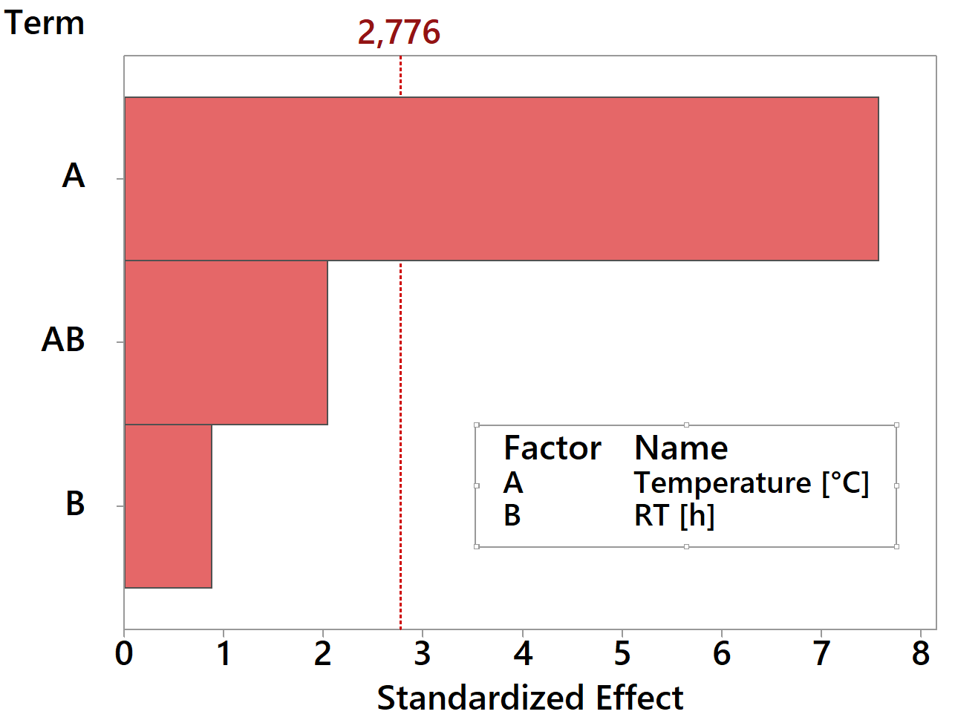
Figure 1: Normal plot of the standardized effects for hydrochar yield.
    - Hydrochar characterization
It can be noticed from Table 4 that the organic carbon content ranged between 38.3 wt.% to 41.4 wt.% d.b., while the inorganic carbon content increased with reaction severity from 0.6 wt.% to 1.0 wt.%. The hydrogen content was almost unaffected by reaction conditions and also sulphur (1.8 – 2.1 wt.%) and nitrogen (1.6 – 2.1 wt.%) contents were only slightly influenced by temperature and residence time variation. The ash content in all the hydrochar samples was considerably high and it was related to the high ash content of the feedstock. Moreover, Table 5 highlights the increase of ash content in hydrochar samples with increasing reaction temperature for both residence times (2 and 4 h). The samples were abundant in macronutrients (Ca, K, Mg) and micronutrients (Fe, Mn) with a concentration between 6.5 and 7.5 wt.% which suggested the application as a source of nutrients for plant growth. The pH of the substrate influences the availability of nutrients and, in this work, the measured pH was almost in the optimal range for plant growth (between 6.5 and 7.5) increasing with reaction severity from 6.0 to 7.0 (Gould and Walker, 1999). A similar trend was observed with electrical conductivity (EC), which increased with reaction temperature from 6.0 to 7.0 mS cm⁻¹ (Table 4), however, these values were low compared to HC from other feedstock suggesting low salt concentration (Celletti et al., 2021). Polycyclic aromatic hydrocarbons (PAHs) are possible phytotoxic compounds that could inhibit plant growth and they were produced during the HTC process via degradation of the polymers of the feedstock. However, their concentration is generally lower in HC than in pyrolysis biochar: Bargmann et al. (Bargmann et al., 2013) investigated the HTC and pyrolysis of various feedstock and observed that the amount of PAHs in hydrochars ranged from 0.3 to 4.9 mg kg⁻¹ d.b., while in biochars ranged from 1.3 to 53.3 mg kg⁻¹ d.b.. In the present study at all reaction conditions the measured PAHs in hydrochar were relatively low, ranging from 0.57 to 2.2 mg kg⁻¹ and below the Italian legislative limit for agricultural use (6 mg kg⁻¹ d.b., see Table 5). The H/C ratio ranged between 1.34 and 1.36, while O/C was between 0.42 and 0.57, suggesting a low degree of decarboxylation and demethylation reactions and low devolatilization and carbonization of initial biomass (McKendry, 2001). As expected, the O/C ratio decreased moving to harsher reaction conditions, the same trend was observed by Smith and Ross although they obtained a higher degree of oxygen removal (O/C=0.2 – 0.34). Similar results were achieved by Xu et al. with the conversion con macroalgae S. horneri (Xu et al., 2013).
The hydrochars FT-IR spectra (Figure 2) showed common peaks and functional groups regions: the zone 2800-3000 cm⁻¹, associated to the aliphatic stretching C-H (Aboulkas et al., 2017), and 3200-3500 cm⁻¹, typical of O-H bond stretching of alcohols and N-H of proteins and peptides (Aboulkas et al., 2017). On the other hand, a loss of the signal around 1600 cm⁻¹ together with peaks around 1055-1130 cm⁻¹ were observed in the samples produced at 240 °C compared to those produced at 200 °C. The former is related to the primary amides (Jebsen et al., 2012) and to the presence of carbonyl groups (Aboulkas et al., 2017), while the latter is in the typical carbohydrates region (Aboulkas et al., 2017; Jebsen et al., 2012). This behaviour can be attributed to a loss of bonds and oxygenated groups. The sample produced at the highest severity conditions presents also a significant loss of the signal around 1315 cm⁻¹, which is associated with both the C-O stretching and the vibrations of the -OH group and of the tertiary amides (Karimi et al., 2016).
Table 5 shows a comparison between the measured chemical and physical parameters of HC samples and the limit imposed by Italian legislation for green soil improver, biochar and neutral peat. Despite HC had comparable characteristics to biochar from pyrolysis in terms of carbon and ash content, EC and pH, its application was limited by the considerably higher H/C ratio (1.32 – 1.36) exceeding the imposed limit (0.7). On the other hand, the HC from macroalgae could be proposed as a possible green and sustainable alternative to peat. At present day, peat is widely used in agriculture both as fertilizer and for the preparation of nutrient soil in horticulture (Alexander et al., 2008).
Peat is generally rich in organic matter and nutrients (e.g. potassium, phosphorus and nitrogen) and it could improve the physical and chemical characteristics of soil (Cao, 2019). However, peat bogs are important habitats for wildlife and biodiversity and the extraction methods cause irreversible damage to the ecosystem. Peat soil stored a large quantity of carbon and its extraction could negatively affect carbon reduction in the atmosphere (Alexander et al., 2008). The hydrochar produced from HTC of macroalgae shows a higher nitrogen content than peat (Cao, 2019) and it also has a relevant content of nutrients and organic carbon. Moreover, the hydrochars pH and the organic carbon content respect the limits imposed by Italian legislation for peat, the pollutants (e.g. heavy metals) and the C/N ratio in HC samples comply with green soil improver limits (D.Lgs n.75, 2010).

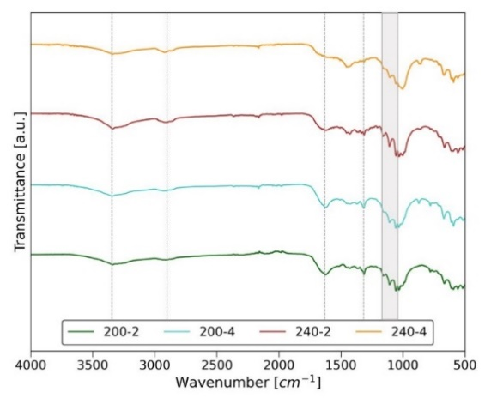
Figure 2: FT-IR spectra of hydrochar samples.
Table 4: Summary of the main properties of hydrochar samples.
Parameter | 200-2 | 200-4 | 240-2 | 240-4 | Neutral peat*** | Soil improver*** | Biochar***
Ash [wt.% d.b.] | 23.2 | 21.8 | 26.0 | 28.1 |  |  | ≤60*
Volatile matter [wt.% d.b.] | 70.0 | n.d. | 67.2 | n.d.
Fixed carbon [wt.% d.b.] | 6.8 | n.d. | 6.8 | n.d.
pH [-] | 6.0 | 6.3 | 6.7 | 7.0 | >5 | 6 – 8.5 | 4 – 12
Electrical conductivity [mS cm⁻¹] | n.d. | 6.0 | n.d. | 7.0 |  |  | <1000
PAHs [mg kg⁻¹] | 1.9 | 0.57 | 0.68 | 2.2 |  |  | <6
C org. [wt.% d.b.] | 38.3 | 41.4 | 39.5 | 39.8 | >20 | >20 | ≥20**
C inorg. [wt.% d.b.] | 0.6 | 0.7 | 0.7 | 1.0
H [wt.% d.b.] | 4.4 | 4.7 | 4.4 | 4.5
N [wt.% d.b.] | 2.0 | 2.1 | 1.8 | 1.8
S [wt.% d.b.] | 1.9 | 1.6 | 1.9 | 2.1
O [wt.% d.b.] | 29.6 | 27.6 | 25.7 | 22.6
H/C_{org} | 1.39 | 1.37 | 1.35 | 1.37 |  |  | ≤0.7
O/C_{org} | 0.58 | 0.50 | 0.49 | 0.43
C/N | 19.5 | 20.0 | 22.3 | 22.7 |  | <50
Cd [mg kg⁻¹ d.b.] | 0 | 1 | 0 | 1 |  | ≤1.5 | ≤1.5
Cu [mg kg⁻¹ d.b.] | 18 | 16 | 19 | 16 |  | ≤230 | ≤230
Ni [mg kg⁻¹ d.b.] | 69 | 71 | 69 | 67 |  | ≤100 | ≤100
Pb [mg kg⁻¹ d.b.] | 0 | 21 | 0 | 0 |  | ≤140 | ≤140
Zn [mg kg⁻¹ d.b.] | 80 | 75 | 83 | 99 |  | ≤500 | ≤500
*max. limit for ash content; **min. limit for organic carbon content, ***D.Lgs n.75 2010.
  - Conclusions
The HTC process is a promising alternative for the conversion of the macroalgae of Orbetello lagoon into a valuable product helping also in the management of this solid waste. The hydrochar obtained from macroalgae represent green and sustainable substitute to peat, widely used products for agriculture and horticulture due to its chemical and physical characteristics. The hydrochar obtained in this work complies with all the prescribed limits of the Italian legislation for neutral peat and green soil improver (except for the H/C_{org} ratio). As all the operating conditions produced hydrochars with properties compliant with legislative limits, adopting the lower temperature and shortest residence time, i.e. 200 °C and 2 h would be an economically and environmentally recommended solution. Hydrochars resulted rich in macro and micronutrients important for plant growth and presented very low phytotoxic pollutants concentration (e.g. heavy metals and polycyclic aromatics hydrocarbons). Moreover, as peat isn’t a renewable resource and its extraction caused irreversible damage to fragile ecosystems rich in biodiversity substituting the natural peat with green alternative produced from solid waste could contribute to preserve these carbon stores and mitigate climate change.
Acknowledgements
The authors wish to acknowledge Prof. Annalisa Santucci from the University of Siena for having provided the algae sample. This work was carried out within the framework of the “Prodotti bioattivi da alghe infestanti” project, funded by the Italian Ministry of the Environment and Land and Sea Protection (MATTM).
References

Aboulkas A., Hammani H., El Achaby M., Bilal E., Barakat A., El harfi K., 2017, Valorization of Algal Waste via Pyrolysis in a Fixed-Bed Reactor: Production and Characterization of Bio-Oil and Bio-Char, Bioresource Technology, 243, 400–408.
Alexander P.D., Bragg N.C., Meade R., Padelopoulos G., Watts O., 2008, Peat in Horticulture and Conservation, Mires and Peat, 3, 1–10.
Bargmann I., Rillig M.C., Buss W., Kruse A., Kuecke M., 2013, Hydrochar and Biochar Effects on Germination of Spring Barley, Journal of Agronomy and Crop Science, 199, 5, 360–73.
Bastianoni S., Coppola F., Tiezzi E., Colacevich A., Borghini F, Silvano F., 2008, Biofuel Potential Production from the Orbetello Lagoon Macroalgae: A Comparison with Sunflower Feedstock, Biomass and Bioenergy, 32, 7, 619–28.
Cao S., 2019, Research and Application of Peat in Agriculture, IOP Conference Series: Earth and Environmental Science, 384, 1.
Celletti S., Bergamo A., Benedetti V., Matteo Pecchi, Patuzzi F., Basso D., Baratieri M, Cesco S., Mimmo T., 2021, Phytotoxicity of Hydrochars Obtained by Hydrothermal Carbonization of Manure-Based Digestate, Journal of Environmental Management, 280, 111635.
D.Lgs n.75, 2010, Riordino e Revisione Della Disciplina in Materia Di Fertilizzanti a Norma Dell’articolo 13 Della Legge 7 Luglio 2009, n. 88. Gazzetta Ufficiale n.121, Roma 1–146.
Raspolli Galletti A.M., Antonetti C., Licursi D., Mussi L., Balestri E., Lardicci C., 2019, Levulinic Acid Production from the Green Macroalgae Chaetomorpha Linum and Valonia Aegagropila Harvested in the Orbetello Lagoon, Chemical Engineering Transactions, 74, March 2018, 103–8.
Gould W.A., Walker M.D., 1999, Plant Communities and Landscape Diversity along a Canadian Arctic River, Journal of Vegetation Science, 10, 4, 537–48.
Jebsen C., Norici A., Wagner H., Palmucci M., Giordano M., Wilhelm C., 2012, FTIR Spectra of Algal Species Can Be Used as Physiological Fingerprints to Assess Their Actual Growth Potential, Physiologia Plantarum, 146, 4, 427–38.
Karimi S., Feizy J., Mehrjo F., Farrokhnia M., 2016, Detection and Quantification of Food Colorant Adulteration in Saffron Sample Using Chemometric Analysis of FT-IR Spectra, RSC Advances, 6, 27, 23085–93.
Khosravi A., Zheng H., Liu Q., Hashemi M., Tang Y., Xing B., 2022, Production and Characterization of Hydrochars and Their Application in Soil Improvement and Environmental Remediation, Chemical Engineering Journal, 430, P4, 133142.
McKendry P., 2001, Energy Production from Biomass (Part 2): Conversion Technologies, Bioresource Technology, 95, July 2001, 47–54.
Migliore G., Alisi C., Sprocati A.R., Massi E., Ciccoli R., Lenzi M., Wang A., Cremisini C., 2012, Anaerobic Digestion of Macroalgal Biomass and Sediments Sourced from the Orbetello Lagoon, Italy, Biomass and Bioenergy, 42, 69–77.
Morand P., Briand X., 1996, Excessive Growth of Macroalgae: A Symptom of Environmental Disturbance., Botanica Marina, 39, 6, 491–516.
Mumme J., Eckervogt L., Pielert J., Diakité M., Rupp F., Kern J., 2011, Hydrothermal Carbonization of Anaerobically Digested Maize Silage, Bioresource Technology, 102, 19, 9255–60.
Peterson A.A., Vogel F., Lachance R.P., Fröling M., Antal M.J. Jr., Tester J.W., 2008, Thermochemical Biofuel Production in Hydrothermal Media: A Review of Sub- and Supercritical Water Technologies, Energy & Environmental Science, 1, 1, 32–65.
Ross A.B., Jones J.M., Kubacki M.L., Bridgeman T., 2008, Classification of Macroalgae as Fuel and Its Thermochemical Behaviour, Bioresource Technology, 99, 14, 6494–6504.
Sabio E., Álvarez-Murillo A., Román S., Ledesma B., 2016, Conversion of Tomato-Peel Waste into Solid Fuel by Hydrothermal Carbonization: Influence of the Processing Variables, Waste Management, 47, 122–32.
Smith A.M., Ross A.B., 2016, Production of Bio-Coal, Bio-Methane and Fertilizer from Seaweed via Hydrothermal Carbonisation, Algal Research, 16, 1–11.
Xu Q., Qian Q., Quek A., Ai N., Zeng G., Wang J., 2013, Hydrothermal Carbonization of Macroalgae and the Effects of Experimental Parameters on the Properties of Hydrochars, ACS Sustainable Chemistry and Engineering, 1, 9, 1092–1101.

