|  |  |
| --- | --- |
| cetlogo ***CHEMICAL ENGINEERING TRANSACTIONS***  ***VOL. 92, 2022*** | A publication of  aidiclogo_grande |
| The Italian Association  of Chemical Engineering  Online at www.cetjournal.it |
| Guest Editors: Rubens Maciel Filho, Eliseo Ranzi, Leonardo Tognotti  Copyright © 2022, AIDIC Servizi S.r.l. **ISBN** 978-88-95608-90-7; **ISSN** 2283-9216 | |

Towards a circular economy for plastic packaging: Current practice and perspectives in the City of Oslo

Cansu Birgen\*, Michaël Becidan

SINTEF Energy Research, Sem Saelands vei 11, 7034, Trondheim, Norway

cansu.birgen@sintef.no

There is room for improvement in the current waste management systems to achieve material recycling goals consistent with a Circular Economy. Packaging waste fractions which have specific EU recycling targets constitute a significant part of the waste system. In Norway, the lowest recycling rate is that of plastic packaging compared to other packaging fractions, therefore it was chosen as the focus of this study. The plastic packaging waste was quantified in the different Municipal Solid Waste (MSW) streams, and the recycling rate estimated according to different methods. This work is essential to identify potential improvements in the system and enable increased recycling targets in the City of Oslo, the largest city in Norway with a strong dedication to the Circular Economy principles. This study provided quantitative data for plastic packaging supplied to the market for the City of Oslo, i.e.,11308 tons in 2019. This number, necessary for calculating the recycling rate, was only available at the national level. A finding of this study is that the largest improvement potential for recycling can be found in the mixed household waste fraction that contains 67% of all plastic packaging waste. Increased recycling could be achieved through improved source sorting (dependent on the citizens' behavior) and/or the establishment of a post-sorting facility. Looking at different methods used for recycling rate estimation can open for a better understanding on how to best improve the system. The current recycling waste, calculated using the latest EU method, was estimated as 18.6%. To reach the 2025 target of 50%, this rate will have to almost triple in less than 3 years' time. It is doubtful that it can be achieved with the current system. Results of this study can help to design effective, targeted measures for evaluating and increasing the recycling rate of plastic packaging.

* 1. Introduction

Municipal Solid Waste (MSW) management is an important element for a more circular future since large amounts of materials are handled in the system with a great potential for increased reuse and recycling, before considering energy recovery. This is in line with the waste hierarchy and circular economy principles. The room for improvement is reflected into the key recycling targets for packaging waste fractions in the Circular Economy action plan related to MSW management as given in Table 1 (Klima- og miljødepartementet, 2018) together with current recycling rates (Miljødirektoratet, 2020).

Table 1: Current recycling rates in Norway and targets for packaging waste fractions.

|  |  |  |  |  |  |  |  |  |  |
| --- | --- | --- | --- | --- | --- | --- | --- | --- | --- |
|  | Year | All | Plastic | Wood | Iron | Aluminium | Metal | Glass | Paper |
| Recycling rate (%) | 2020 | 50 | 28 | n/a | n/a | n/a | 93 | 91 | 78 |
| Recycling target (%) | 2025 | 65 | 50 | 25 | 70 | 50 | n/a | 70 | 75 |
| 2030 | 70 | 55 | 30 | 80 | 60 | n/a | 75 | 85 |

The difference between the current recycling rate and target is largest for plastic packaging waste as shown in Table 1. Plastic is the second packaging waste fraction with 248090 tons for Norway in 2020, paper packaging waste being the first with 365341 tons (Miljødirektoratet, 2020), despite the large environmental benefits offered by the replacement of virgin fossil resources by recycled ones. Moreover, most of the sorted plastic packaging waste generated in Norway is exported since there is no large-scale plastic recycling industry. This situation leads to three challenges: missed opportunities for the development of local industry and jobs, an added carbon footprint due to transportation and a loss of control concerning what really happens to the waste.

Recent studies assess quantitatively the plastic packaging waste streams in the entire value chain covering generation, collection, sorting and treatment using various methods, such as material flow analysis (Pincelli et al., 2021), and material recovery calculations (Van Eygen et al., 2018) to evaluate the waste management system with respect to Circular Economy targets (Lombardi et al., 2021). These studies mainly focus on the sorted plastic packaging waste streams without considering the unsorted part i.e., plastic waste found in the mixed fraction of MSW. Moreover, they are conducted at the national level, while consideration of the local conditions at the right geographical resolution is necessary to identify and implement concrete measures for meeting the recycling targets (Wang and Becidan, 2021). Furthermore, the measurement points used for calculating recycling rates can impact which parts of the system should be targeted for improvement e.g., recycling process or source-sorting; therefore, it is important to have an overview of different methods and evaluate its consequences for the system. Aim of this study is to quantify the different plastic packaging-containing MSW streams and to calculate plastic packaging recycling rates based on different measurement points for identification of potential improvement in specific parts of the waste system.

* 1. Methodology

This study investigates the MSW collected, sorted and treated by the Agency for Waste Management (acronym REG) responsible for household waste, and some household-like commercial and industrial (C&I) waste for the City of Oslo, Norway. The analysis was done for 2019 since the pandemic caused disruptions in the data collection and changes in the waste amounts and compositions from early 2020.

* + 1. System boundaries and data description

MSW consists of household waste and household-like C&I waste that is gathered via door-step collection in separate containers for mixed, paper, food, and plastic packaging wastes. Drop-off collection points cover the fractions of garden, combustible, glass and metal packaging, noncombustible, metal, dangerous, electronic, and construction and demolition wastes. Figure 1 shows the sources, amounts (proportional to the streams thickness) and treatments of MSW fractions in tons for 2019. The data is collected from Statistics Norway (2019a) and REG Oslo report (Renovasjonsetaten, 2019a).

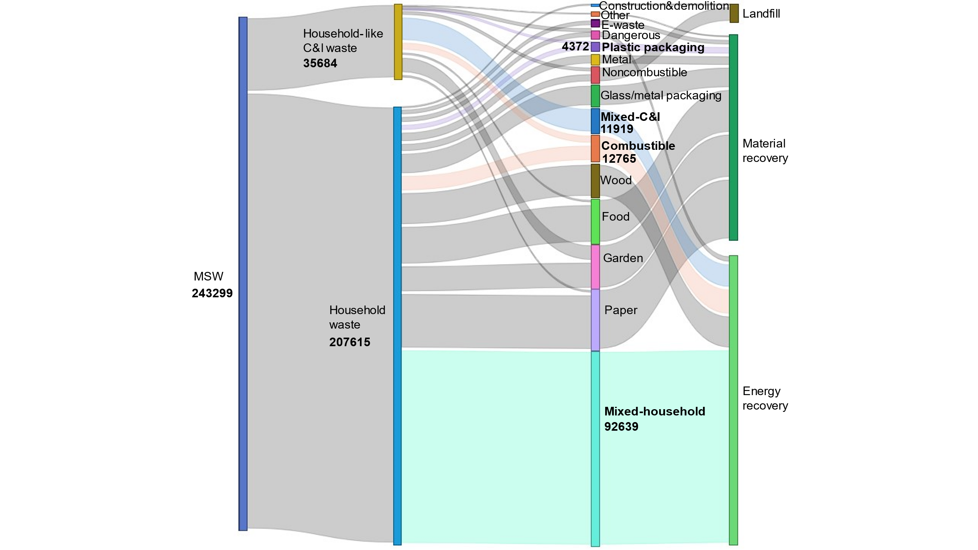

*Figure 1: Sources, amounts and treatment methods of MSW fractions for REG Oslo (in tons, 2019).*

Figure 1 shows the amounts collected in containers specific to the respective fractions; however, source sorting is not always done correctly. For example, household mixed waste contains approximately 29% mixed waste (the fraction of the waste which cannot be source sorted for material recovery because it is not recyclable, too dirty etc.); the remaining 71% could potentially have been source-sorted to be sent to material recycling as evaluated in a waste composition analysis carried out by REG (Renovasjonsetaten, 2019b). MSW composition analysis reports showed that plastic packaging waste is found in mixed-household, combustible and mixed-industrial waste containers due to wrong sorting. Furthermore, the plastic packaging waste container contains some wrongly sorted waste. MSW streams identified as containing plastic packaging are shown in bold with coloured links in Figure 1. Assumptions regarding data and calculations are summarized in the next section.

* + 1. Recycling rate calculation

Material recovery and recycling are often used interchangeably; however, recycling is a more commonly used term regarding packaging, thus it is used in this study. Recycling rate calculation of plastic packaging requires mapping all plastic packaging-containing streams as presented in Figure 2. Plastic packaging supplied to the market is sorted to three different waste containers: (Flow No. 1 in Figure 2); what is thrown into mixed and combustible waste containers is sent to energy recovery (Flow No. 5) and what is sorted as plastic packaging waste is sent to central post-sorting facilities (Flow No. 2) abroad (mainly Germany). In post-sorting, the wrongly sorted fraction (also known as "rejects") is removed (Flow No. 6) and the correctly sorted fraction is sorted into up to 7 subfractions (PET, PP, HPE, LDPE etc.). Then the remaining stream is sent to material recovery (Flow No. 3) where the plastic is melted into granules, then used as raw material in making new plastic products such as flowerpots, chairs, fleece sweaters and football uniforms. In this study, it is assumed that all recycled plastic is used for new packaging production to provide a theoretical basis (Flow No. 4).

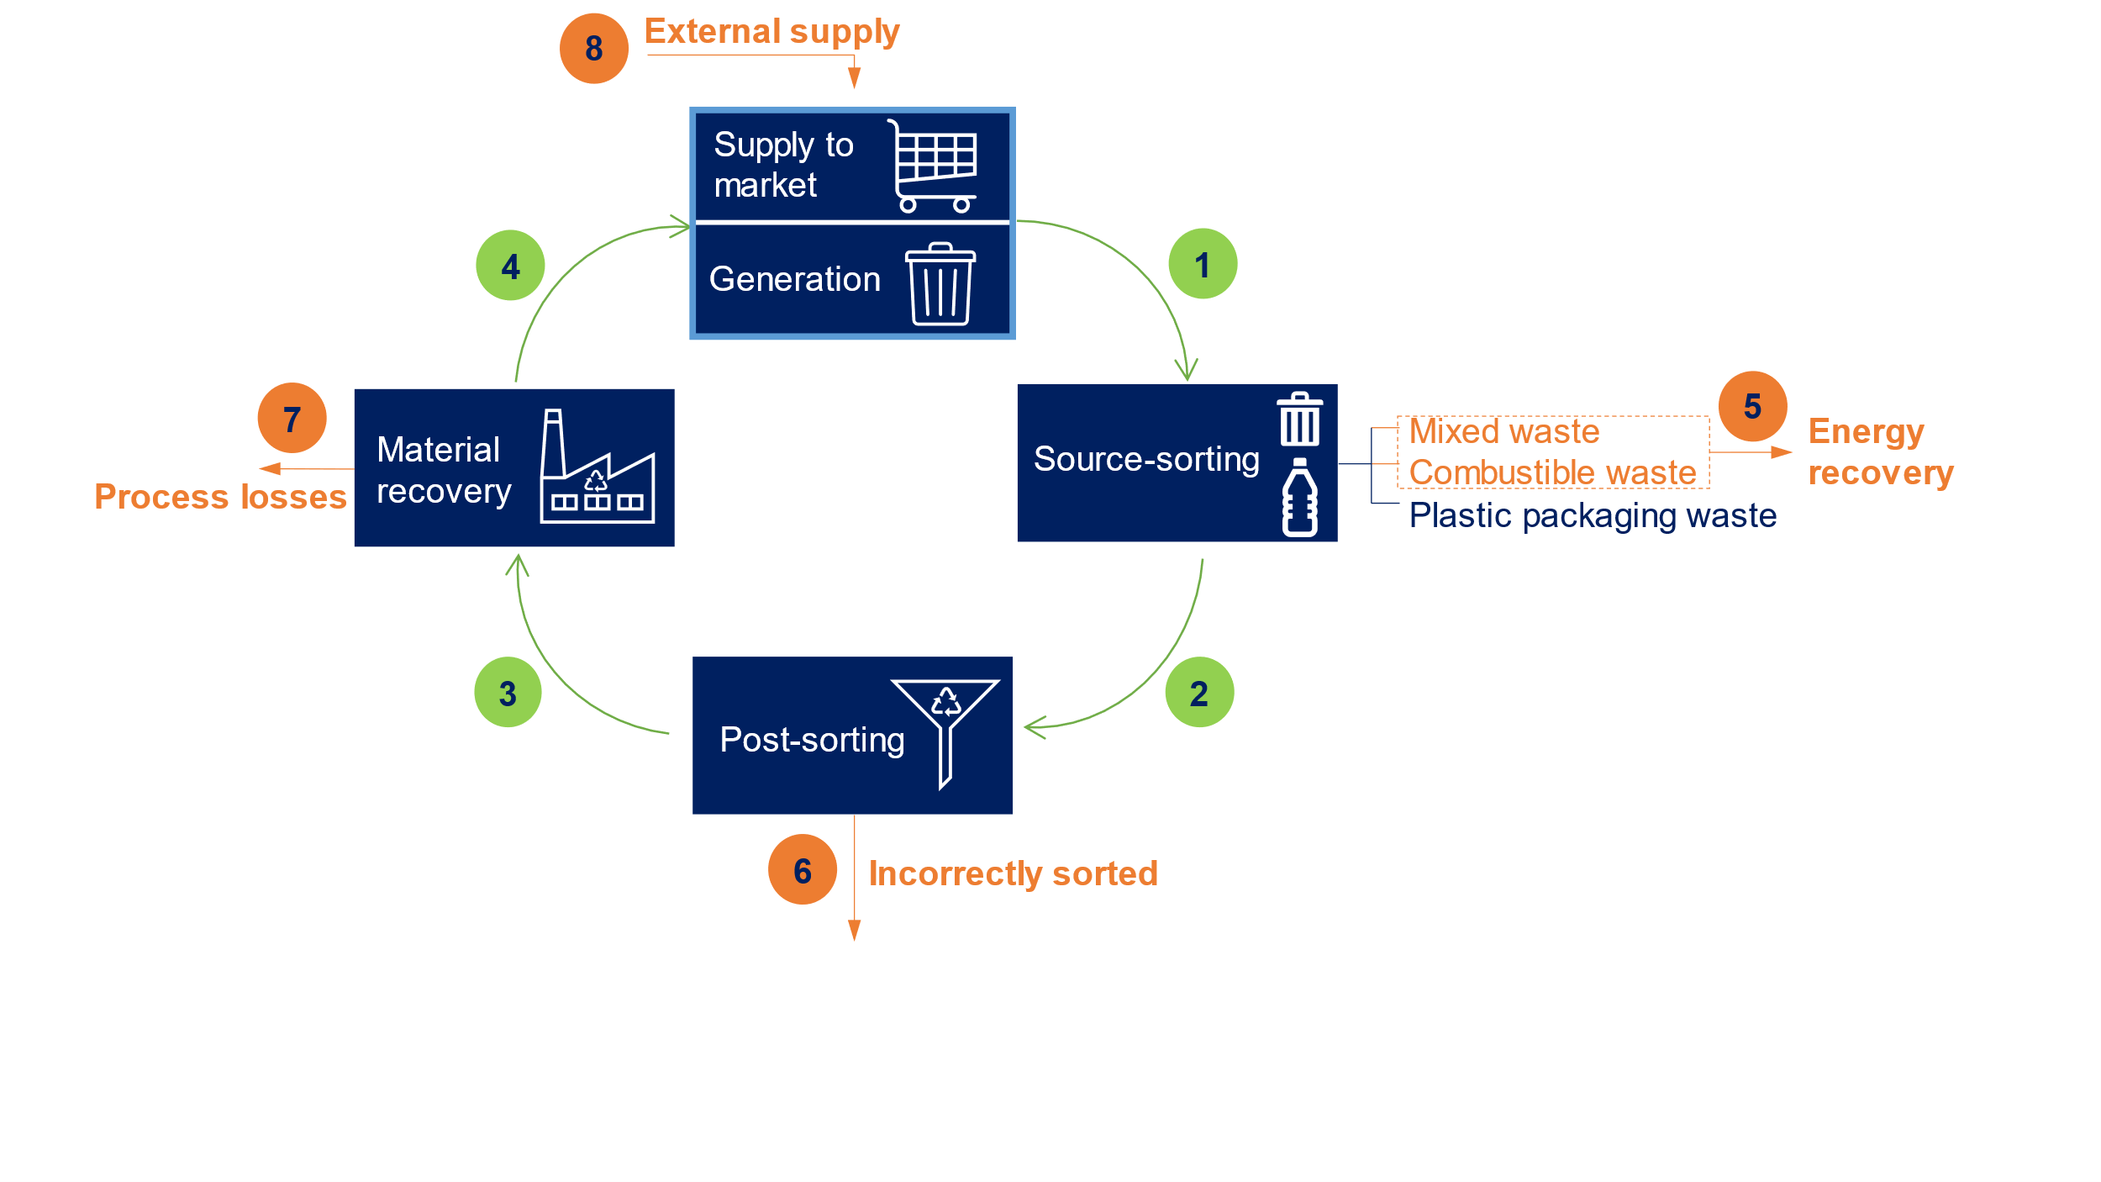

*Figure 2: Representative plastic packaging value chain showing main units and streams with plastic packaging.*

Assumptions are made about the compositions of the different separately collected waste streams (Figure 1), and about the treatment and utilization of those streams (Figure 2). It is important to note that even though the authors are informed that not all plastic waste is recyclable and not all is not /cannot be used in new plastic packaging production, assumptions regarding these were made since quantitative data was not available. Hence, this study provides a theoretical basis for what could be possible. Assumptions:

* All plastic packaging supplied to the market is assumed to be thrown away i.e., the "Generation" box.
* Plastic packaging is found only in mixed, combustible and plastic packaging waste containers.
* The difference between the amounts supplied to market and plastic waste generated is the wrongly sorted fraction of plastic packaging, that is removed in post-sorting and sent to energy recovery (Flow No. 6).
* There is 100% sorting efficiency in post-sorting facilities to remove wrongly sorted fractions found in the plastic packaging waste container with 71% correctly sorted waste (Renovasjonsetaten, 2019b). The same sorting rate is assumed for plastic waste generated by C&I actors.
* The amount of plastic packaging waste generated by C&I actors is calculated based on data provided by REG Oslo and Norsk Gjenvinning (containers' volume, emptying frequency, average waste density).
* The composition of combustible waste is the same for household and C&I (Renovasjonsetaten, 2019c).
* The composition of C&I mixed waste is based on composition analysis (Renovasjonsetaten, 2019d).
* All plastic packaging waste is recyclable and sufficiently clean for recycling.
* Process losses during recycling is 25% - average of value reported by Grønt Punkt Norge (2019).
* Recycled plastic packaging is used as packaging as well – supplied to the market.
* Polyethylene terephthalate (PET) bottles with deposit are out of the scope of this study since they have a separate collection and recycle system, with more than 90% recycling rate.

Three methods for calculation of recycling rate are identified:

|  |  |
| --- | --- |
| *Method 2*  *Recycled*  *=*  *Supplied to the market*  *. 100%*  *=*  *Flow No.4 + Flow No.8*  *Flow No.4*  *Method 1*  *Delivered to recycling*  *=*  *Supplied to the market*  *=*  *Flow No.3*  *Flow No.4 + Flow No.8*  *. 100%* | (1) |
|  | (2) |
| *Method 3*  *Delivered to recycling*  *=*  *Total waste generated*  *. 100%*  *=*  *Flow No.2*  *Flow No.1* | (3) |

Eq(1) is the recycling rate calculation used in Norway before 2020, while Eq(2) is the most recent one as reported by Grønt Punkt Norge to comply with the European Commission regulation (2021) where it is stated that rejects from recycling process shall not be included in the recycled amount. Eq(3) has also been previously used to calculate the material recycling rate, especially when the amount supplied to the market was not available for that specific region e.g., Oslo (Renovasjonsetaten, 2019a).

* 1. Results and Discussion
     1. Material flows

Material flows of plastic packaging in the MSW value chain are estimated to calculate recycling rates. Figure 3 shows the units and flows with thickness proportional to the amounts specified in bold below each unit (in tons).

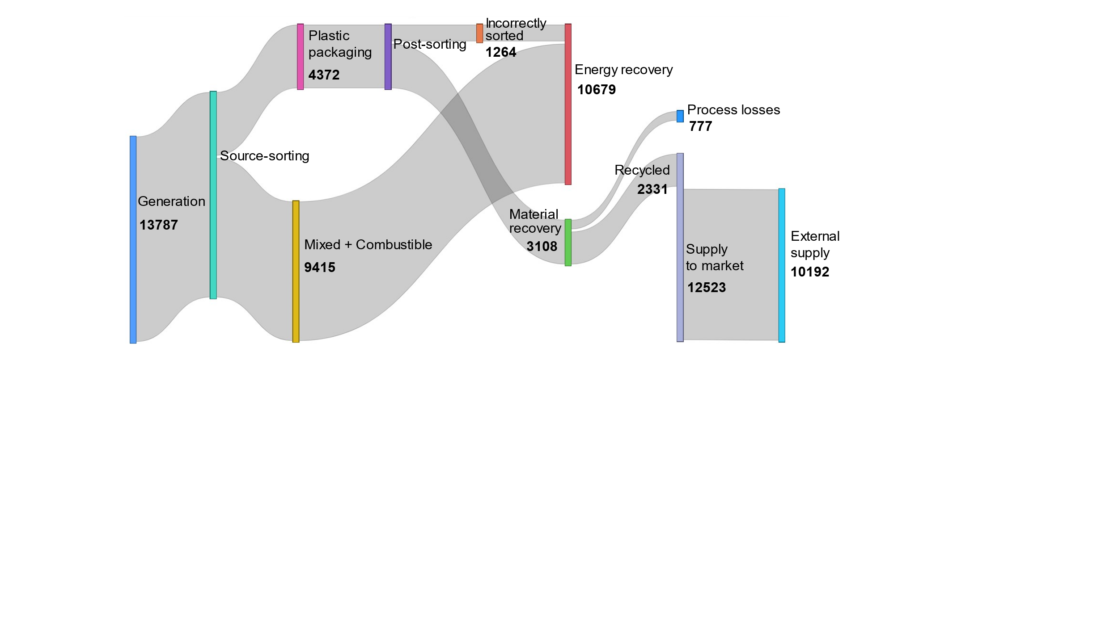

Figure 3: Material flow of plastic packaging for REG Oslo (in tons, 2019).

The amount supplied to the market is necessary for calculation of the recycling rates (Method 1 and Method 2); however, it is available only at the national level. Therefore, amount of plastic packaging supplied to the market for the City of Oslo in 2019 was calculated as 12523 tons based on the total plastic packaging waste. Household-generated plastic packaging waste was estimated as 11308 tons in this study based on the amounts of plastic packaging found in the three aforementioned containers. It was reported as 84733 tons for Norway for the same year (Grønt Punkt Norge, 2019). 13% of all inhabitants in Norway lived in Oslo in 2019 (Statistics Norway, 2019b). Assuming inhabitants have similar consumption behaviour for plastic all over Norway, the resulting tonnage would be 11000 tons for Oslo's population, a value very close to the 11308 independently estimated by this study (3% variation). If all the recycled plastic packaging was used again as plastic packaging, it would constitute 19% of all supply (2331 tons) even though it is not possible as of today considering the legislation and the current technologies as mentioned in the assumptions. This theoretical estimation is larger than the 4% estimated in a 2017 report (Deloitte, 2019).

Figure 4 (left) shows the percentage of total plastic packaging waste that (a) ends up as process losses during recycling, (b) is recycled and (c) sent to energy recovery (WtE). The pie chart on the right details the sources of the plastic waste sent to energy recovery.

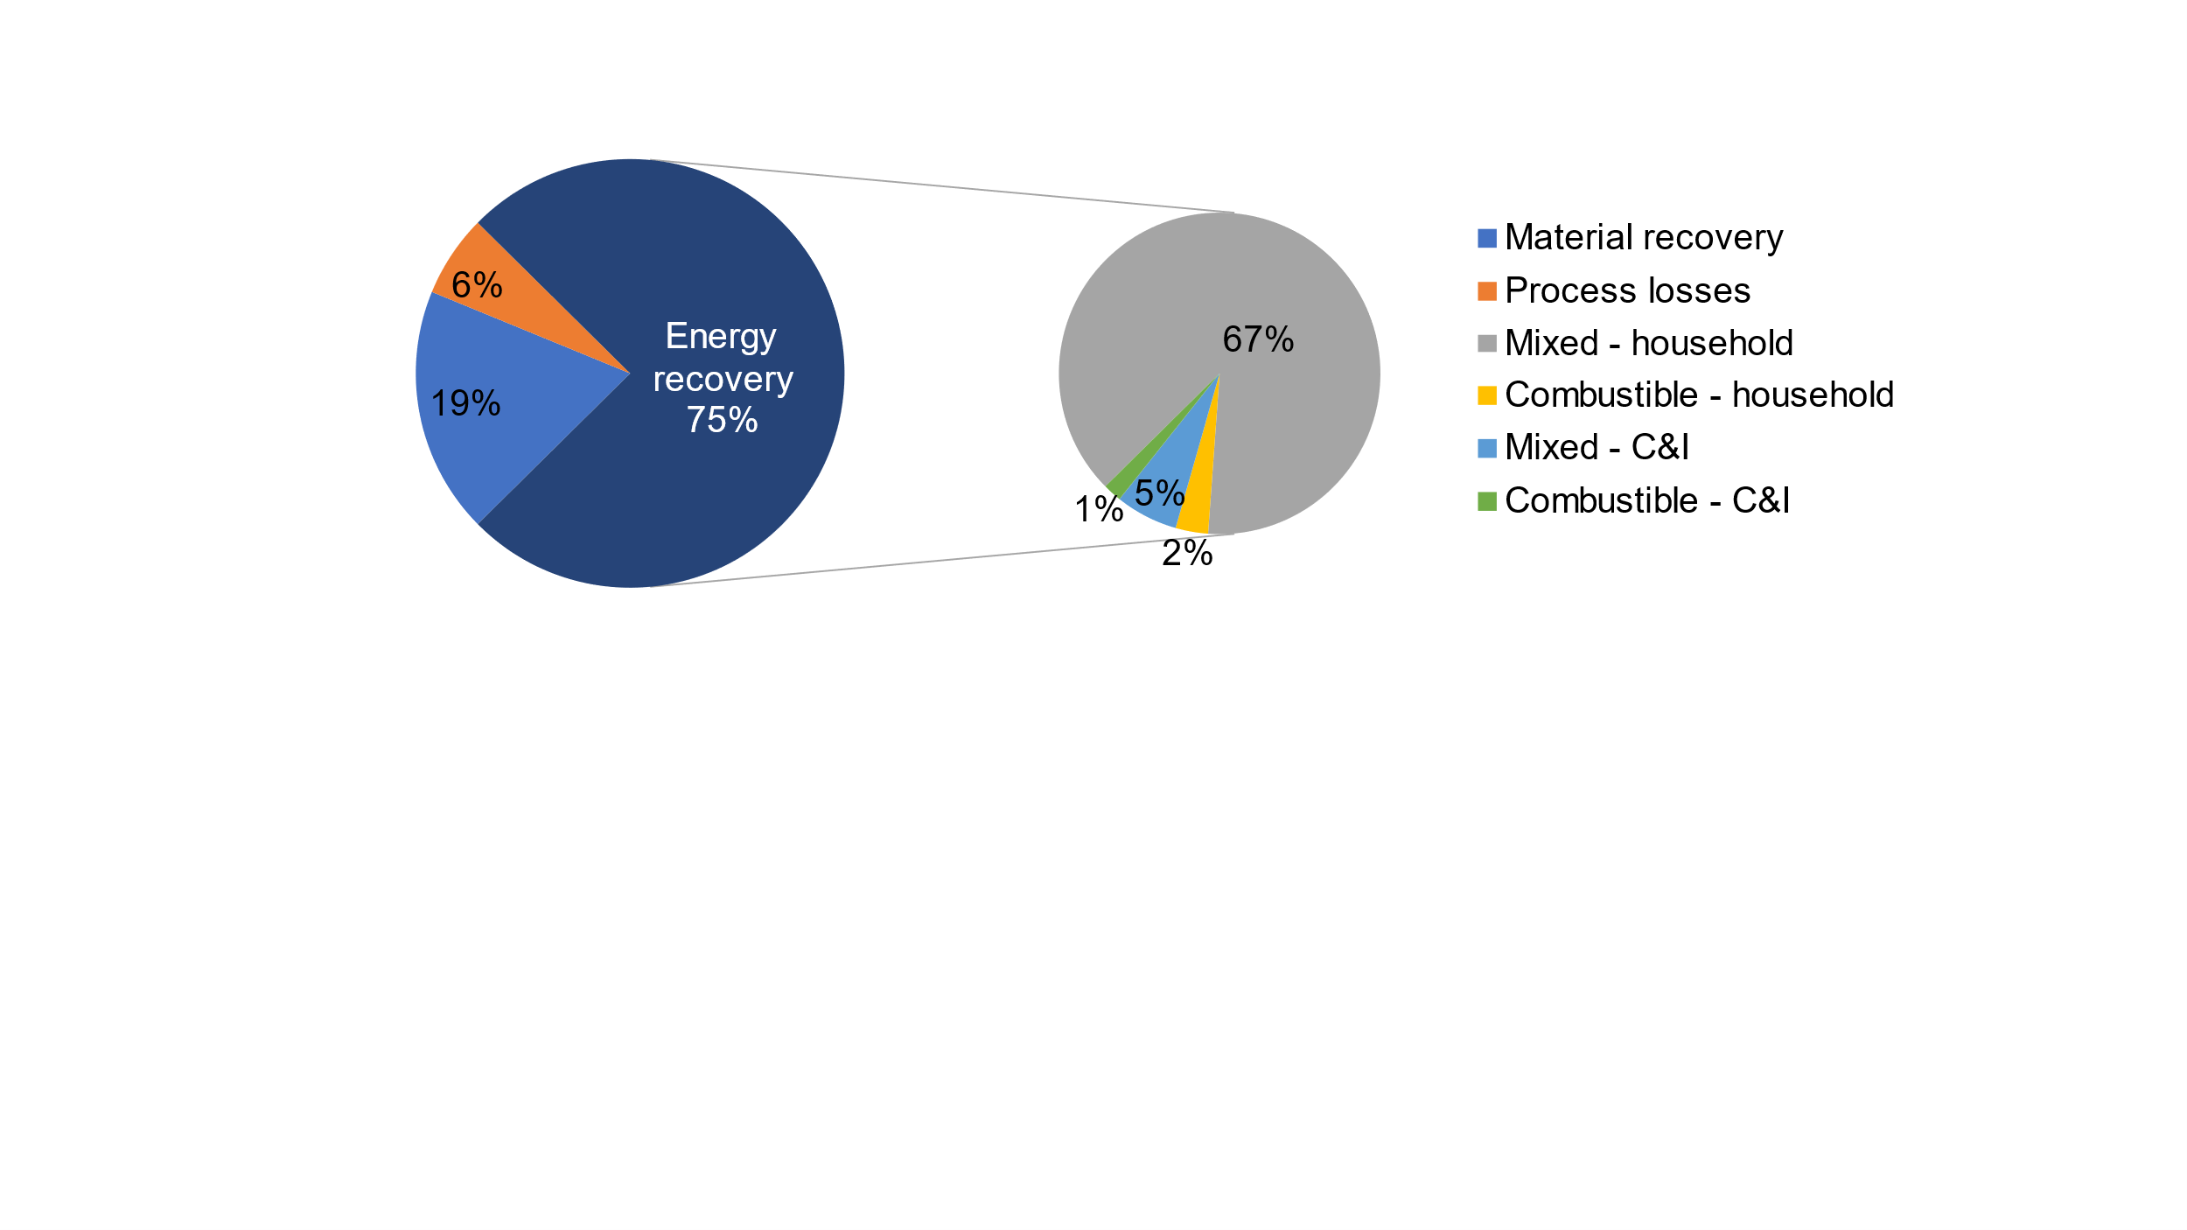

*Figure 4: Distribution of plastic packaging waste according to the treatment method, losses and sources.*

Only 25% of the 12523 tons plastic packaging waste was thrown into the correct container, while the rest was thrown into other containers and was sent to energy recovery as given in Figure 4. It is important to quantify the different sources of plastic waste when considering measures for improved sorting. Figure 4 clearly shows that the largest amount of plastic was found in mixed waste containers from households. If properly sorted and recycled, it would yield the largest impact on the plastic recycling rate. However, composition analysis held every year from 2000 in Oslo unequivocally showed that the plastic packaging percentage found in mixed waste has remained almost constant (10.4%-14.0%) for 20 years, i.e., fluctuations were observed in data but with no clear trend; and these fluctuations were in the range of data uncertainty (Renovasjonsetaten, 2019a). Similarly, the waste thrown into the plastic packaging waste container contains 29% of "other wastes", a proportion in line with the sorting level reported as 65.7% for household plastic packaging waste at the national level in 2019 by Grønt Punkt Norge members that represented 85% of the market at that time (Grønt Punkt Norge, 2019).

Similar to the plastic packaging percentage found in mixed waste, the wrongly sorted fraction in plastic packaging waste did not change significantly over the last 10-20 years. The in-depth analysis carried out in this study clearly shows that (1) the targets cannot be reached without changes in the system and (2) the largest potential is found in household mixed waste. This opens two main avenues of actions can hence be considered: intensify (qualitatively and quantitatively) source-sorting via renewed, differentiated communication campaigns and/or implement a new/improved central post-sorting. Both solutions have pros and cons and can be combined as there is no one-size-fits-all solution and local conditions (housing, population density, existing infrastructure, cooperation, investments capabilities, etc.) must be considered.

* + 1. Recycling rate

After quantifying all relevant plastic packaging containing streams, its recycling rates are calculated using different methods as given in Figure 5.

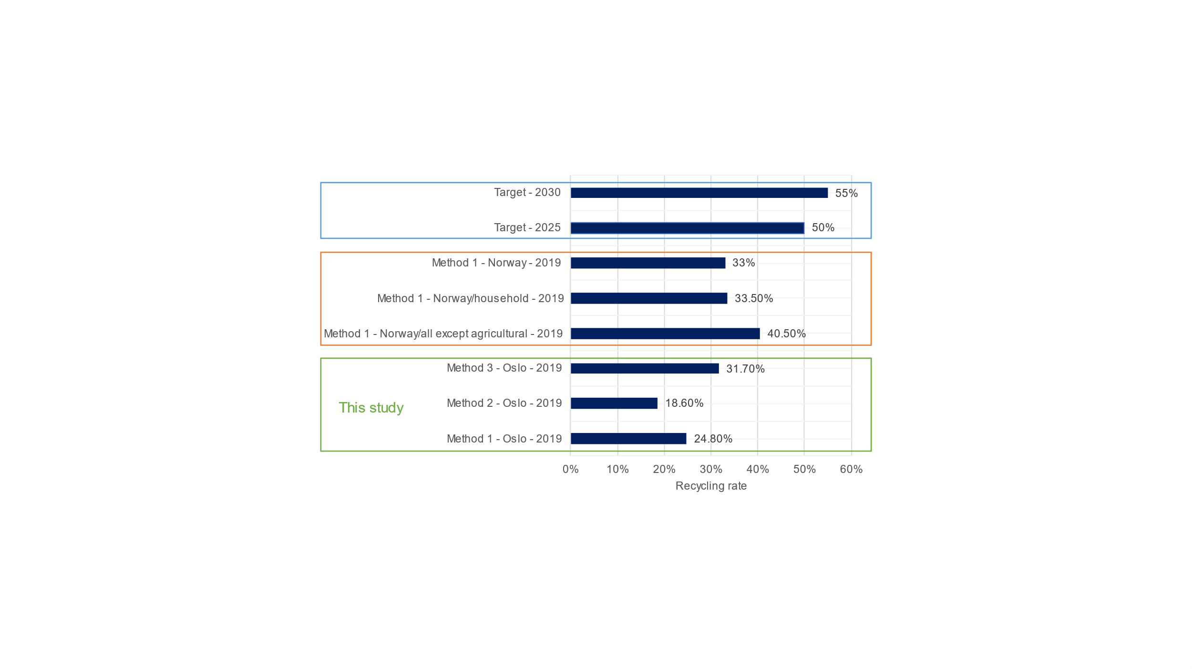

Figure 5: Recycling rates for plastic packaging calculated using different methods.

As mentioned, the amount of plastic packaging supplied to the market is available only at the national level, therefore calculation of recycling rates using Method 1 and 2 was only possible for the entire Norway, see Figure 5. Recycling rates for Norway were reported for three distinct cases: for all plastic packaging, for households and for all plastic packaging *except* agricultural plastic packaging waste. This sector has large amounts of clean (i.e. homogeneous) waste streams that causes a large deviation when estimating the national recycling rate. In 2019, using Method 1, the recycling rate of plastic packaging was estimated as 24.8% for the City of Oslo while reported value for Norway was 33% which is line with earlier observations. This can be explained by the housing characteristics, especially the smaller average dwelling sizes in large cities. The lack of space makes source-sorting challenging as reported by Flygansvær et. al (2021). The currently used Method 2 results in a lower recycling rate of 18.6% since it accounts for process losses occurring during recycling. To reach the recycling target of 50% in 2025, this recycling rate would need to be 2.7 times greater in less than 3 years. It is important to note that 18.6% recycling rate did not account for dirt remaining in plastic packaging that would result in an even lower rate. As discussed above, the largest potential lies in the mixed household waste that can be realized with targeted measures. It is important to note that the comparison of different methods for recycling rate calculation pinpoints potential improvements in the waste systems. For example, there would be less motivation for technological advancements to decrease the process losses in the recycling process if Method 1 is used since it does not consider them, while improving source sorting and post-sorting would have been prioritized. The use of Method 3 is common since it enables estimation of the recycling rate without having to consider the amount supplied to the market for a specific fraction. Comparing the make-up of the various calculation methods and its consequences on the results, it can be stated that the method should (1) not overestimate recycling by including losses, water, rejects, or materials that are not actually recycled or recyclable, (2) be reliable, i.e., based on sound, accurate statistical data, (3) be calculated at the right level to enable efficient decision-taking, i.e. city/region, and (4), have unambiguous measurement points that cannot be open to interpretation or misuse.

* 1. Conclusions

This study quantified the different plastic packaging-containing MSW streams in order to identify potential improvements in specific parts of the waste management system. Thereafter the plastic packaging recycling rates were calculated based on different methods. This study provided a way of quantifying plastic packaging supplied to the market at a lower geographical resolution since current data is only available at the national level, making it difficult to calculate the recycling rate for a specific region and hence to evaluate and improve the current system. The data availability is more limited for C&I waste contributing to the overall uncertainty of the results. Moreover, based on these results and considering historical trends, potential sources of improvement were discussed to help design measures for increasing the recycling rate. In future work, similar analysis will be held for different regions to assess region-specific characteristics. Predictions will be done for future scenarios e.g., recycling targets and new technologies including chemical recycling will be studied.

Acknowledgments

This work is part of the CircWtE project co-funded by industry and public partners and the Research Council of Norway under the SIRKULÆRØKONOMI program (CircWtE - 319795). The authors thank the personnel at REG Oslo for providing data and valuable information on the waste management system.

References

Klima- og miljødepartementet, Endring av emballasjedirektivet (del av pakke sirkulær økonomi), 2018 <www.regjeringen.no/no/sub/eos-notatbasen/notatene/2014/okt/endring-av-emballasjedirektivet-del-av-pakke-sirkular-okonomi/id2502199/> accessed 01.02.2022.

Miljødirektoratet, Emballasjeavfall, 2020 <miljostatus.miljodirektoratet.no/tema/avfall/avfallstyper/emballasjeavfall/> accessed 01.02.2022.

Pincelli, I.P., de Castilhos Júnior, A.B., Matias, M.S. and Rutkowski, E.W., 2021, Post-consumer plastic packaging waste flow analysis for Brazil: The challenges moving towards a circular economy, Waste Management, 126, 781-790.

Van Eygen, E., Laner, D. and Fellner, J., 2018, Circular economy of plastic packaging: Current practice and perspectives I n Austria, Waste management, 72, 55-64.

Lombardi, M., Rana, R. and Fellner, J., 2021, Material flow analysis and sustainability of the Italian plastic packaging management, Journal of Cleaner Production, 287, 125573.

Wang, L. and Becidan, M., 2021, MSW in a Circular Economy: 2020-2035 Scenarios for the City of Oslo, Norway. In IOP Conference Series: Earth and Environmental Science, Vol 691, No 1, IOP Publishing, 012006.

Household waste, by material, treatment, downstream system, contents, year and region, 2019, Statistics Norway, < www.ssb.no/en/statbank/table/13136/> accessed 01.02.2022.

Miljørapport, 2019, Renovasjonsetaten, <ren-miljorapporten2019.herokuapp.com/> accessed 01.02.2022.

Avfallsanalyse 2019 En analyse av husholdningsavfallet fra Oslo kommunes innbyggere, 2019, Renovasjonsetaten,<www.oslo.kommune.no/getfile.php/133524671575467207/Tjenester%20og%20tilbud/Avfall%20og%20gjenvinning/Avfallsanalysen/Avfallsanalyse%202019.pdf > accessed 01.02.2022.

Fakta og tall, 2019, Grønt Punkt Norge, <www.grontpunkt.no/om-oss/fakta-og-tall/arkiv/> accessed 01.02.2022.

Avfallsanalyse av brennbart restavfall fra gjenbruksstasjonene i Oslo, 2019, Renovasjonsetaten.

Avfallsanalyse - Næringsavfall 2019, 2019, Renovasjonsetaten.

Volum- og vektinformasjon, 2019, Norsk Gjenvinning, < www.norskgjenvinning.no/tjenester/avfallstyper/volum-og-vektinformasjon/> accessed 01.02.2022.

Guidance for the compilation and reporting of data on packaging and packaging waste according to Decision 2005/270/EC, 2021, European Comission.

Household waste and reuse, by region, contents and year, 2019, Statistics Norway, <www.ssb.no/en/statbank/table/13035/tableViewLayout1/> accessed 01.02.2022.

Sirkulær plastemballasje i Norge - Kartlegging av verdikjeden for plastemballasje, 2019, Deloitte.

Flygansvær B., Samuelsen A. G., and Støyle R. V., 2021, The power of nudging: how adaptations in reverse logistics systems can improve endconsumer recycling behavior, International Journal of Physical Distribution & Logistics Management, 0960-0035.