 CHEMICAL ENGINEERING TRANSACTIONS  VOL. 92, 2022 | A publication of  
The Italian Association
of Chemical Engineering
Online at www.cetjournal.it

Guest Editors: Rubens Maciel Filho, Eliseo Ranzi, Leonardo Tognotti
Copyright © 2022, AIDIC Servizi S.r.l.
ISBN 978-88-95608-90-7; ISSN 2283-9216

Techno-Economic and Environmental Assessments of Thermochemical Routes Integrated into the Brazilian Sugarcane Industry for the Production of Renewable Jet Fuel
Henrique Real Guimarães*ª, Jéssica Marcon Bressaninª, Ingrid Lopes Motta^{b}, Mateus Ferreira Chagas^{b,c}, Antonio Bonomi^{c}, Rubens Maciel Filho^{b}, Marcos Djun Barbosa Watanabe^{d}
ªSchool of Food Engineering (FEA), University of Campinas (UNICAMP), 13083-862 Campinas, Sao Paulo, Brazil;
^{b}School of Chemical Engineering (FEQ), University of Campinas (UNICAMP), 13083-852 Campinas, Sao Paulo, Brazil.
^{c}Brazilian Biorenewables National Laboratory (LNBR), Brazilian Center for Research in Energy and Materials (CNPEM), 13083-970 Campinas, Sao Paulo, Brazil;
^{d}Industrial Ecology Programme, Department of Energy and Process Engineering, Norwegian University of Science and Technology, Trondheim, Norway
*h_realguimaraes@hotmail.com
Environmental agreements and international concerns on greenhouse gas (GHG) emission reduction policies have pushed for the search for economically viable ways to produce sustainable biofuels, such as renewable jet fuels to decrease fossil fuel-based GHG emissions in the international flight sector. The gasification of lignocellulosic biomass followed by catalytic conversion (Fischer-Tropsch reactions) in Biomass-to-Liquids (BtL) plants is a solution to this demand. However, this process still presents some techno-economic setbacks. Brazil is one of the major players in the biofuels market worldwide, and its existing biorefining infrastructure from the sugarcane sector can be used as the basis to support the large-scale implementation of such advanced biofuel production routes. This study compares a standalone BtL plant configuration to a scenario integrated into a sugarcane mill/ethanol distillery. Both scenarios operate by processing sugarcane bagasse and straw and, through a techno-economic analysis aided by a simulation framework (the Virtual Biorefinery), it was possible to observe that the integration was able to improve the economic performance of the BtL route. A greenfield standalone plant could not achieve economic feasibility, but the integrated configuration achieved internal rates of return of 10-12% per year. Some aspects may improve the viability of BtL plants, such as logistic chain optimizations to reduce costs with feedstock acquisition and the consideration of environmental policies and incentives to help increase revenue.

  - Introduction
The interest in large-scale renewable and sustainable fuel production has grown worldwide as a way to mitigate the effects of climate change. This is particularly the case for fuels used for long-haul transportation, such as jet fuel, which still do not have a consolidated renewable alternative. The thermochemical Biomass-to-Liquids route (BtL) is one of the most likely alternatives to supply this demand (IRENA, 2017). This route can produce green diesel, green gasoline, and biojet fuel with similar characteristics to fossil fuels with the benefit of lower pollutants emission (Rafati et al., 2017). However, high equipment costs (Dimitriou et al., 2018) and dependence upon the biomass supply chain (Motta et al., 2018) make it difficult to successfully implement this route for large-scale applications. In order to increase its efficiency, the gasification could be integrated into other industrial processes (Peres et al., 2013). The Brazilian sugarcane industry presents a well stablished technological infrastructure with large amounts of sugarcane bagasse and straw, lignocellulosic residues available for further valorisation (Leal and Hernandes, 2020). This market can act as a more favourable environment to develop these BtL processes.
The overall objective of this study is to evaluate thermochemical technologies to obtain advanced biofuels, focusing on their economic performance and environmental impacts. This evaluation centers around the large-scale production of biojet fuel in BtL plants (containing gasification and Fischer-Tropsch (FT) conversion units) either integrated into a sugarcane mill/ethanol distillery or working as standalone facilities. The main hypothesis is that the process of gasification/FT conversion has the potential to be a suitable route to produce biojet fuel in a scenario integrated into the Brazilian sugarcane industry.

  - Methodology
Considering the well-stablished infrastructure and consolidated market in Brazil, sugarcane is the main biomass adopted for different biorefinery alternatives, taking into account the ethanol production chain from sugarcane juice (first-generation (1G) ethanol) and the use of bagasse and straw as second-generation feedstock. Two scenarios were evaluated to compare the effects of such integration on the selected technological route, and both are presented in Figure 1. The first scenario is a standalone (SA) thermochemical BtL plant with a processing capacity of 1 Mt of dry lignocellulosic material (LCM) per year. This configuration operates 330 days/year by purchasing sugarcane bagasse and straw from surrounding sugarcane mills. The configuration of this thermochemical process and the biomass characteristics are explained in a previous study (Guimarães et al., 2021). The second case is the same configuration of the BtL plant and integrated (INT) into a 1G ethanol distillery producing hydrous ethanol (93 wt%). This 1G distillery is considered to be the most modern configuration, with further detailing available elsewhere (Bonomi et al., 2016). The mill operates during the sugarcane season (200 days/year), and the bagasse from the mill and the straw collected from the field in the form of bales are stocked and directed to the integrated thermochemical section, which operates 330 days/year. A processing capacity of around 5 Mt of sugarcane per year was chosen to maintain the processing capacity of 1 Mt of dry LCM per year.

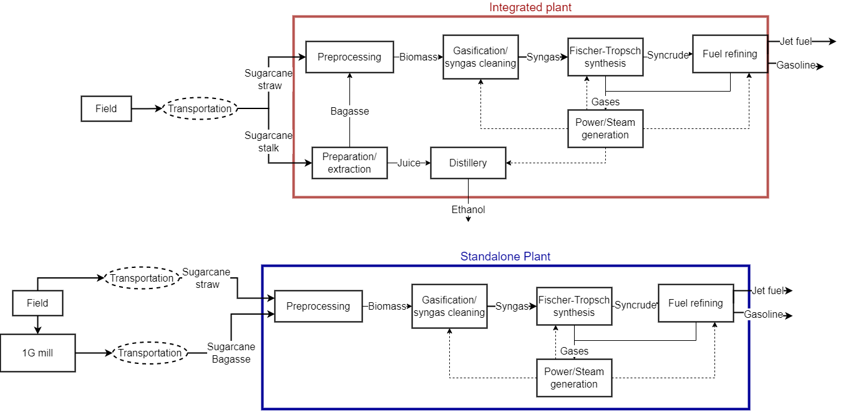
Figure 1 – Simplified process flowchart for the integrated and standalone configurations

The Virtual Biorefinery (VB) (Bonomi et al., 2016) was used as a tool to perform techno-economic and environmental analyses of both SA and INT scenarios. The VB is a software framework developed at the Brazilian Biorenewables National Laboratory (LNBR) from the Brazilian Center for Research in Energy and Materials (CNPEM), which allows the assessment of different biorefinery configurations. The agricultural phase was simulated with the CanaSoft® model, a part of the VB framework (Bonomi et al., 2016). An optimized scenario for sugarcane production was considered, with full mechanization of the agricultural stage and straw collection from the field. All agricultural operations were taken into account, from soil preparation to biomass transportation to the mill. The industrial phase of the biorefinery was simulated with the Aspen Plus® process simulator version 8.6 (AspenTech, Bedford, MA, USA). The simulation and its parameters are described in a previous study (Guimarães et al., 2021). For the economic evaluation of the scenarios, a discounted cash flow analysis was carried out considering a greenfield project. The main metrics adopted are the net present value (NPV), the internal rate of return (IRR), as well as the biofuel production costs.
The Life Cycle Assessment (LCA) tool was used to evaluate the environmental impacts of these scenarios, considering the use of the VB platform, which follows the methodology described by ISO 14000. The ecoinvent database provided the environmental profile of the background products and activities. For this analysis, economic allocation was used to account for the different outputs, and the use of resources and emissions for the whole production chain were included in the system boundaries, from biomass production to fuel use. Life cycle impact assessment were calculated for Climate Change impact category considering the 100-year time horizon global warming potential (GWP 100) from IPCC 2013. These results are used to calculate the avoided GHG emissions compared to fossil equivalent scenarios. Avoided GHG emissions are calculated from the difference between the biofuel and the corresponding fossil fuel – diesel, jet, and gasoline. These carbon intensities (gCO₂ eq MJ⁻¹) from the life cycle of fossil fuels were obtained from RenovaBio/RenovaCalc (ANP, n.d.).
The National Biofuels Policy (RenovaBio) is a policy already in motion in Brazil which imposes the distributors to prioritize the commercialization of a minimum required amount of biofuels via the generation of CBIO (Decarbonization Credit), a tradeable financial asset issued by the biofuel producer (de Souza, et al., 2018). This policy is considered in this study. With this in mind, an average price of 10 US$ per tonne of avoided CO₂ eq emission was considered (1 t of avoided CO₂ eq emission = 1CBio), although volatility in CBio prices have been observed over the last couple of years, with its value ranging from 3-20 US$ t⁻¹ of avoided CO₂ eq (UNICA, n.d.).

  - Results and Discussion
Table 1 presents the main results of both scenarios – standalone (SA) and integrated (INT). Overall, the integrated scenario presents better economic performance, with almost double the IRR of the standalone scenario. This trend is in line with that observed by Klein et al. (2018) and Bressanin et al. (2020) that the commercialization of ethanol can help increase the profitability of the plant. This can be seen for the total revenue, as the ethanol commercialization in the integrated plant more than doubles the revenue of the plant compared to the standalone BtL unit. This improvement also occurs because the production costs of the integrated configuration are 26% lower than those of the standalone configuration. This is mainly due to the influence of ethanol commercialization and, therefore, allocation of costs to this main product. The results of Table 1 also highlight the participation of the decarbonization credits in the total revenue of the plant. In terms of gross value, the annual revenue from CBios is in the range of 4 MUS$ in the standalone scenario and 9 MUS$ in the integrated configuration. This magnitude of revenue helps offset some of the costs, such as the mill inputs and labor expenses.
Table 1 – Main outputs and economic results
Results | SA | INT | Results | SA | INT
Total revenue (MUS$/year) |  |  | Total production costs
Bioethanol | 0 | 190 | Bioethanol (US$/L) | - | 0.43
Biojet fuel | 62 | 49 | Biojet fuel (US$/L) | 0.71 | 0.52
Green gasoline | 20 | 16 | Green gasoline (US$/L) | 0.62 | 0.45
Electricity | 51 | 45 | Electricity (US$/MWh) | 71.83 | 52.58
Carbon credits | 4 | 10 | Total investment costs (MUS$) | 609 | 740
Process outputs |  |  | Fixed capital investment (MUS$) | 553 | 672
Bioethanol (ML/year) | 0 | 440 | Working capital (MUS$) | 55 | 67
Biojet fuel (ML/year) | 119 | 95 | Annual operational costs | 78 | 177
Green gasoline (ML/year) | 45 | 35 | Economic metrics
Total GHG emissions | 0.04 | 0.22 | IRR (%/year) | 5.9 | 11.9
Avoided emissions | 0.36 | 1.02 | NPV (MUS$) | -218 | -7

Figure 2a presents the production costs breakdown of biojet fuel for both scenarios, and it is visible that the integrated plant corresponds to lower production costs than those from the standalone configuration. Figure 2a allows to better evaluate the influence of different factors on the economic feasibility. Capital expenditure (CAPEX) is the largest component of the production costs of the standalone configuration and almost half of the costs of the integrated scenario. The thermochemical route is very intensive in capital due to a large number of reactors and units for syngas cleaning and conditioning (Baliban et al., 2013). The 1G mill technology, however, represents a smaller percentage of the production costs, corresponding to only around 20% of the CAPEX of the integrated scenario. The technology for 1G ethanol production is considerably cheaper than the BtL technology, since second-generation (2G) thermochemical plants are more complex and expensive to build (Bressanin et al., 2020). To better exemplify the differences in technological maturity between 1G and 2G technologies, the 1G technology presents a ratio of 0.3 US$ of capital investment for each liter of fuel produced annually, while in the BtL route this ratio is in the range of 4 US$/L of fuels. Even though the data of Table 1 indicate that the integrated scenario presents higher investment costs than the standalone plant, when comparing the influence of these factor on the total production costs, the overall influence of the total CAPEX is less pronounced. This is due to the allocation of the total production costs along the different products, especially ethanol, which is the main product in the integrated case.
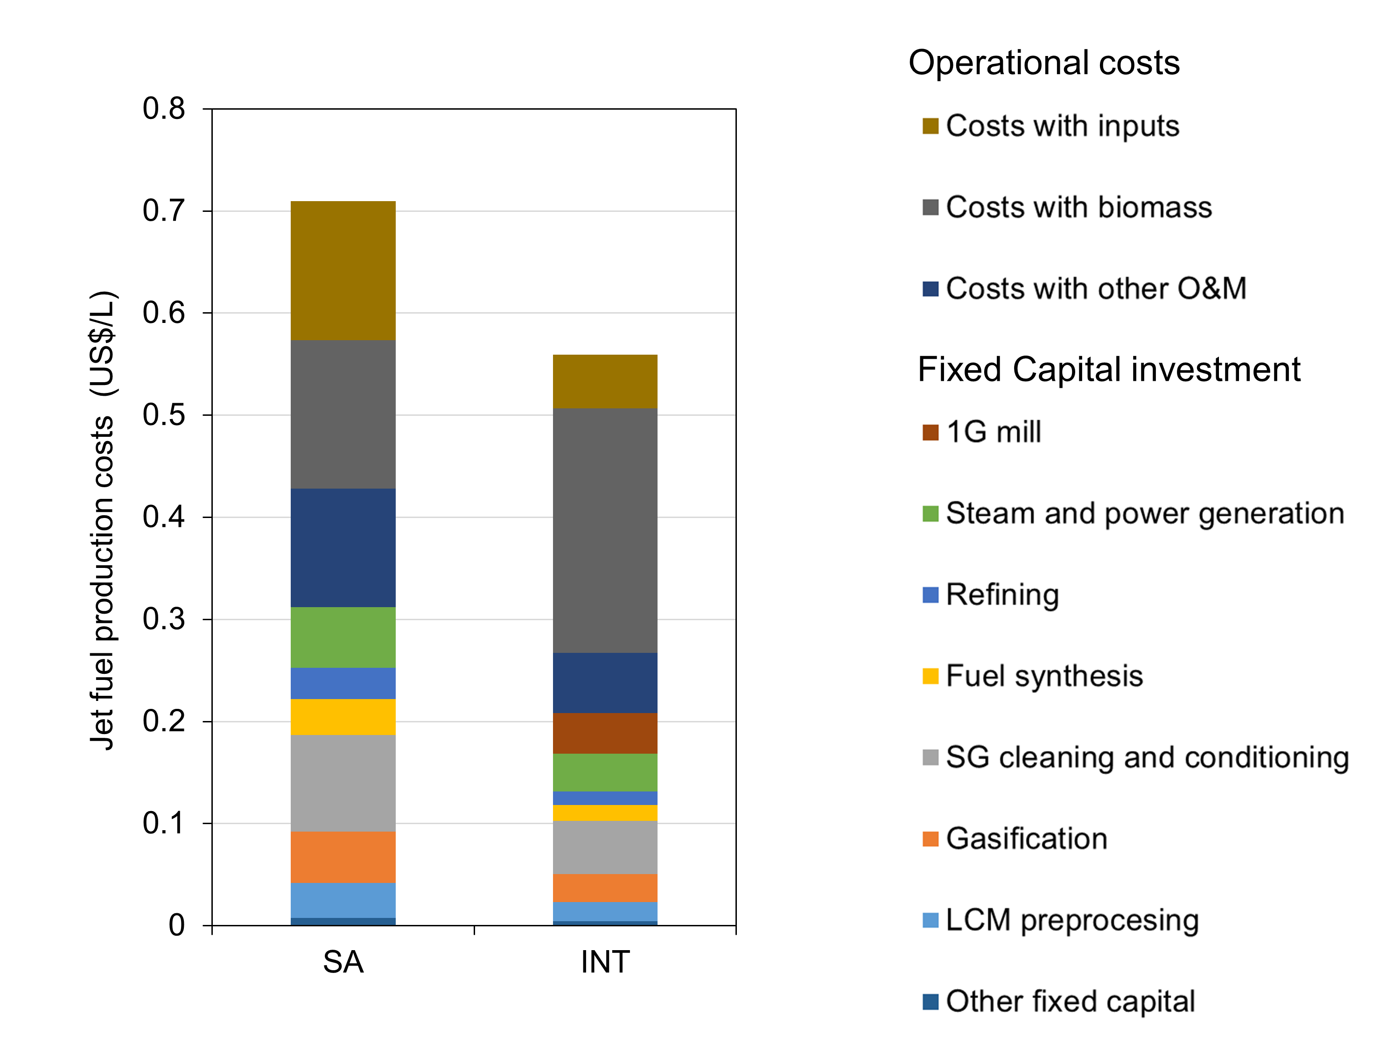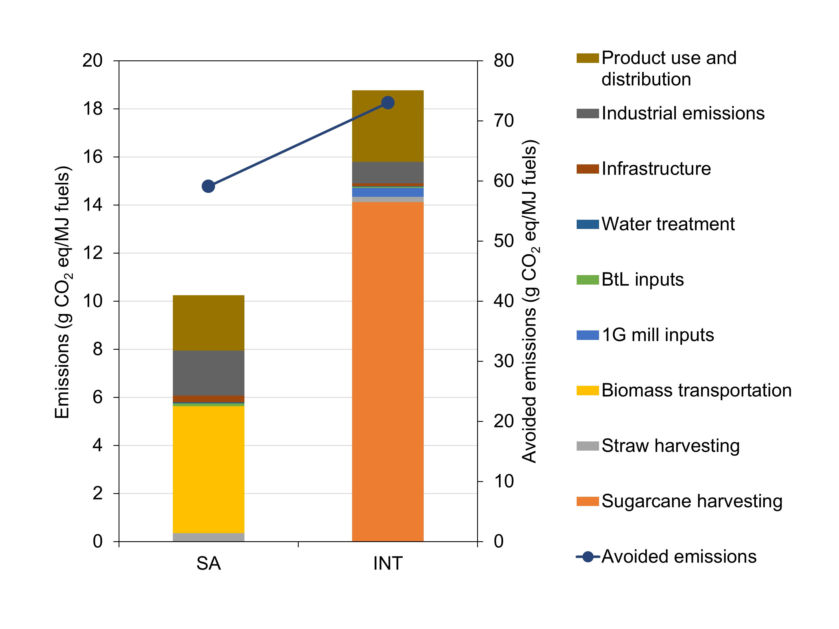Figure 2 – (a) Biojet fuel production costs breakdown and (b) total emissions and avoided emissions (CO₂ eq)

In the case of operational expenditure (OPEX), a major contrast between both configurations is observed in terms of biomass acquisition. Many studies indicate that the expenses associated with feedstock can add up to almost half of the operational costs (Dimitriou et al., 2018; Holmgren et al., 2016) but, as can be seen in Figure 2, such value is below 20% for the standalone plant. This happens because biomass (sugarcane bagasse and straw) is cheaper than other biomasses (such as wood in other countries). For example, the wood prices are in the range of 50 US$/t on a dry basis (d.b.) (Dimitriou et al., 2018) or around 19-36 US$/MWh (Holmgren et al., 2016), while in the current study the LCM cost is in the range of 10-30 US$/t (d.b.) or 2-7 US$.MWh. This lower price leads to a lower participation of biomass costs in the overall production expenses, although sugarcane bagasse prices can vary considerably depending on the intensity of the dry season and the opportunity costs of electricity generation in the context of Brazilian mills.
As for the integrated configuration, higher biomass production costs are observed. The biomass for the standalone configuration is a mixture of bagasse and straw – both residues from sugarcane harvesting and 1G mill processing. As for the integrated plant, the biomass is the whole sugarcane from the fields, and thus the costs associated with cultivation and harvesting are directly linked to the costs of this biomass. This difference in biomass costs is aggravated due to the relatively high capacity of this configuration since that, in order to process 1 Mt dry LCM each year, the annual milling capacity of the integrated 1G mill is around 5 Mt of sugarcane. This means that the production costs of sugarcane – planting area, harvesting operations, and transportation costs – add up to a significant share of the total yearly OPEX. However, it is important to highlight that for Brazilian standards this is an achievable scale, since biomass availability is not a problem and nearly 10% of the sugarcane milling facilities have capacities of over 4 Mt of sugarcane per year (Conab, 2019).
Regarding other operational expenses, for both scenarios the high CAPEX of the BtL process results in high maintenance costs, while expenses on inputs for the thermochemical process are linked with high costs and catalyst consumption rates, especially those made from cobalt used in the FT process, whose price is in the range of 30-70 US$ per kg.
One important conclusion of this comparison is that, even with higher CAPEX and higher operational costs (as seen in Table 1), the integrated plant still presents better economic results thanks to the higher yearly biofuel output, mainly associated with 1G ethanol production. However, as pointed out in a previous study (Guimarães et al., 2021), the high electricity and heat consumptions of the 1G mill increases the demand for syngas diverted for steam and power generation. This results in a less energy-efficient process with lower production of biojet fuel and green gasoline in the integrated scenario. Since more syngas is recycled back to the FT reactor, the total investment of the fuel synthesis stage (FT reactor and syncrude refining) is larger in the standalone plant than in the integrated configuration. The opposite occurs in the steam and power generation unit. However, this difference has a limited effect on the overall investment cost of the BtL plant since the processes in both configurations have investment costs around 500 MUS$.
Figure 2b presents the breakdown of the GHG emissions of both scenarios. Overall, the integrated (INT) configuration presents higher total emissions, mostly due to the agricultural stage of the production chain. Sugarcane planting and harvesting are related to the consumption of fertilizers, pesticides, and fuels for machines. These categories have relatively high environmental impacts, thus increasing the overall carbon discharge. As for the standalone scenario (SA), bagasse is considered a residue from the 1G mill, thus presenting no impact directly associated with it. The straw collection is done in the form of bales, and it is associated with the necessary machines to collect this material, besides the allocation to it of some impacts from sugarcane harvesting. However, the overall impact of the straw collection is far less pronounced than the total impact of sugarcane. The main impact associated with biomass acquisition for the SA configuration is due to biomass transportation from the field and from the 1G mill to the BtL plant, and this section of the production chain corresponds to over half of the SA emissions. However, even though the INT scenario presents higher emissions, there are more avoided emissions compared to fossil fuel sources. This higher reduction is due to the production of 1G ethanol, which is a substitute for fossil gasoline in the Brazilian market.

  - Conclusions
The present study points out the integration with a sugarcane mill is economically and environmentally beneficial to the BtL route. While a standalone plant was only able to obtain internal rates of return below 6%/year, the integrated configuration was able to achieve IRR between 10-12%/year. Also, the integration with a distillery increased 1.6 times the total avoided GHG emissions compared to the standalone BtL plant. The production of ethanol benefits both the direct revenue from fuels and the generation of decarbonization credits, further improving the revenue. Both standalone and integrated configurations can significantly reduce GHG emissions compared to fossil fuel sources and, consequently, the acquisition of carbon credits (CBios) is important to the revenue of both plants. However, it is possible to further reduce the environmental impacts. The standalone plant may focus on reducing emissions associated with biomass transportation by optimizing logistic aspects while also aiming at reducing costs with biomass acquisition. As for the integrated plant, biomass cultivation and harvesting demand some attention, both to reduce emissions (via substation of fossil diesel with green diesel) and operational costs. Overall, integration between thermochemical and biochemical routes has the potential to produce attractive economic results. Special attention should be given to mitigating the high costs with fixed capital, and biomass acquisition and transportation should also be the focus of a detailed evaluation. Incentives and policies are also important to the economic feasibility of the plant; however, some effort is required to fully assess the influence of carbon credits on the revenue of these biorefineries.

Nomenclature

1G – First generation
2G – Second generation
BtL – Biomass-to-Liquids
CAPEX – Capital expenditure
CBio – Decarbonization credits
CNPEM - Brazilian Center for Research in Energy and Materials
CO₂ eq – Equivalent carbon dioxide emission
d.b. – Dry basis
FT – Fischer-Tropsch synthesis
GFT – Gasification/Fischer-Tropsch synthesis
GHG – Greenhouse gases
GWP – Global warming potential
IRR – Internal rate of return
INT – Integrated configuration
LCA – Life cycle assessment
LCM – Lignocellulosic material
LNBR – Brazilian Biorenewables National Laboratory
NPV – Net present value
O&M – operation and maintenance
OPEX – Operational expenditure
RENOVABIO – National Biofuels Policy
SA – Standalone configuration
VB – Virtual Biorefinery

Acknowledgments
This work was possible thanks to funding by Coordenação de Aperfeiçoamento de Pessoal de Nível Superior (CAPES), grant numbers 88882.435527/2019-01 and 88887.489988/2020-00. This research was performed using the facilities and infrastructure of LNBR—Brazilian Biorenewables National Laboratory (CNPEM/MCTIC). This research was also supported by São Paulo Research Foundation – FAPESP,grant #2016/50403-2) along with four Brazilian Companies: EMBRAER S.A., KLABIN S.A., PETROBRAS S.A., and SUZANO S.A, and grant #2015/20630-4. ILM performed this work as part of the “Pesquisador Colaborador” program of the University of Campinas.

References
ANP (Agência Nacional do Petróleo, gás natural e Biodiesel). (n.d.). RenovaBio.<www.anp.gov.br/producao-de-biocombustiveis/renovabio> Accessed January 14, 2020
Baliban R. C., Elia J. A., Floudas C. A., Gurau B., Weingarten M. B., Klotz S. D. 2013. Hardwood biomass to gasoline, diesel, and jet fuel: 1. Process synthesis and global optimization of a thermochemical refinery. Energy and Fuels, 27(8), 4302–4324. <doi.org/10.1021/ef302003f>
Bonomi A., Cavalett O., da Cunha M. P., Lima M. A. (ed), 2016. Virtual Biorefinery. Springer. <doi.org/10.1007/978-3-319-26045-7>
Bressanin J. M., Klein B. C., Chagas M. F., Watanabe M. D. B., de Mesquita Sampaio I. L., Bonomi A., Cavalett O. 2020. Techno-economic and environmental assessment of biomass gasification and fischer-tropsch synthesis integrated to sugarcane biorefineries. Energies, 13(17). <doi.org/10.3390/en13174576>
Conab (Companhia Nacional de Abastecimento). 2019. Profile of the Brazilian sugar and ethanol sector (Perfil do setor do açúcar e etanol no Brasil).Companhia Nacional de Abastecimento, 1, 1–67.
de Souza L. M., Mendes P., Aranda D. 2018. Assessing the current scenario of the Brazilian biojet market. Renewable and Sustainable Energy Reviews, 98, 426–438. <doi.org/10.1016/j.rser.2018.09.039>
Dimitriou I., Goldingay H., Bridgwater A. V. 2018. Techno-economic and uncertainty analysis of Biomass to Liquid (BTL) systems for transport fuel production. Renewable and Sustainable Energy Reviews, 88, 160–175. <doi.org/10.1016/j.rser.2018.02.023>
Guimarães H. R, Marcon Bressanin J., Lopes Motta I., Ferreira Chagas M., Colling Klein B., Bonomi A., … Watanabe M. D. B. 2021. Bottlenecks and potentials for the gasification of lignocellulosic biomasses and Fischer-Tropsch synthesis: A case study on the production of advanced liquid biofuels in Brazil. Energy Conversion and Management, 245(August). <doi.org/10.1016/j.enconman.2021.114629>
Holmgren K. M., Berntsson T. S., Andersson E., Rydberg T. 2016. Comparison of integration options for gasification-based biofuel production systems - Economic and greenhouse gas emission implications. Energy, 111, 272–294. <doi.org/10.1016/j.energy.2016.05.059>
IRENA. 2017. Biofuels for Aviation: Technology brief. Abu Dhabi: International Renewable Energy Agency. <www.irena.org> Accessed January 14, 2020
Klein B. C., Chagas M. F., Junqueira T. L., Rezende M. C. A. F., Cardoso T. de F., Cavalett O., Bonomi A. 2018. Techno-economic and environmental assessment of renewable jet fuel production in integrated Brazilian sugarcane biorefineries. Applied Energy, 209(October 2017), 290–305. <doi.org/10.1016/j.apenergy.2017.10.079>
Leal M. R. L. V., Hernandes T. A. D. 2020. SUCRE: Sugarcane Renewable Electricity. Campinas, SP, BR.
Motta I. L., Miranda N. T., Maciel Filho R., Wolf Maciel M.R. 2018. Biomass gasification in fluidized beds: A review of biomass moisture content and operating pressure effects. Renewable and Sustainable Energy Reviews, 94(June 2017), 998–1023. <doi.org/10.1016/j.rser.2018.06.042>
Peres A. P. G., Lunelli, B.H., Maciel Filho, R. 2013. Application of Biomass to Hydrogen and Syngas Production. Chemical Engineering Transactions, 32, 589-594. < https://doi.org/10.3303/CET1332099>
Rafati M., Wang L., Dayton D. C., Schimmel K., Kabadi V., Shahbazi A. 2017. Techno-economic analysis of production of Fischer-Tropsch liquids via biomass gasification: The effects of Fischer-Tropsch catalysts and natural gas co-feeding. Energy Conversion and Management, 133, 153–166. <doi.org/10.1016/j.enconman.2016.11.051>
UNICA. (n.d.). Dashboard of certifications, target and CBIOS market. <observatoriodacana.com.br/listagem.php?idMn=142> Accessed January 24, 2022

