 CHEMICAL ENGINEERING TRANSACTIONS  VOL. 92, 2022 | A publication of  
The Italian Association
of Chemical Engineering
Online at www.cetjournal.it

Guest Editors: Rubens Maciel Filho, Eliseo Ranzi, Leonardo Tognotti
Copyright © 2022, AIDIC Servizi S.r.l.
ISBN 978-88-95608-90-7; ISSN 2283-9216

Hydrothermal Liquefaction of Bark-containing Nordic Biomass
Judit Sandquist*, Nikalet Everson, Asmira Delic and Maria N.P. Olsen
SINTEF Energy Research, Postboks 4761 Torgarden, Trondheim, Norway
Judit.Sandquist@sintef.no
Hydrothermal liquefaction (HTL) is a thermochemical process that takes advantage of the water present in the feedstock under process conditions where the water is kept as a liquid solvent using pressurized systems, avoiding energy losses to heat of evaporation and allowing for high carbon conversion to liquid fuels. In the Nordic countries, woody biomass residues, originating from pine and spruce, are seen as an abundant biomass feedstock for biofuels and bioenergy production due to the extensive forest industry and the by-products they generate. By using by-products and wastes as the source material, the fuel product becomes more sustainable. Bark is not often included in woody biomass feedstocks for HTL, therefore investigating its addition can provide opportunities for a more effective use of this waste stream.
Spruce and pine stem wood, as well as their bark fractions, received from a Norwegian wood products company was milled and mixed with water to obtain slurries serving as the source material in this study. The stem wood underwent sub- and supercritical HTL conversion, at 350 and 400 °C respectively, in a 1L CSTR reactor operated in batch mode. The bark fractions were mixed with the stem wood at varying percentages to study the effect of bark presence in the slurry at supercritical (400 °C) conditions.
Both the proportions of the HTL products (gaseous, liquid, and solid) and the product components displayed differences when the experiments were performed at sub- and supercritical conditions. Bark addition seemed to increase the gas yields and lower the char yields but did not alter the properties of the liquid products significantly. The results show that bark in the feedstock did not affect the investigated properties negatively, which is promising for biofuel production via HTL.
  - Introduction
Hydrothermal liquefaction (HTL) is seen as a promising technology for the future production of high energy density biofuels from biomass and waste feedstocks due to its relatively short reaction time and a product containing high energy density with relatively low oxygen content (Grande et al., 2021). HTL involves chemical reactions of the feedstock constituents under sub- or supercritical conditions, typically at temperatures between 250-450 °C and pressures between 100-350 bar (Castello et al., 2018). The products of the reactions are gaseous, solid and liquid, the last of which separates into an aqueous and a crude phase. The crude phase then requires upgrading to achieve liquid biofuel quality. The exact reaction pathways during the HTL are still unclear, but there are some suggestions presented in literature based primarily on model compounds (Obeid et al., 2019; Yang et al., 2018). Both the biomass feedstock and its reaction products are complex, and there are several competing reaction pathways which are possible. The basic reaction mechanisms involve a depolymerization step followed by decomposition of the monomers and recombination of the reactive fragments (Toor et al., 2011). Feng et al. (2014) studied the hydrothermal liquefaction of bark material from different tree species, including pine and spruce, in a 100 mL stirred reactor with a water-ethanol solvent mix. They found that the conversion efficiency increased with ash content and decreased with lignin content, while de-ashing the barks resulted in bio-crudes which were richer in higher molecular weight compounds.
In this work, the effect of sub- and supercritical conditions on the HTL of pine and spruce stem wood, as well as the effect of increasing the bark content in the feedstock, is investigated. The mass balance, product yields, biocrude qualities and carbon content of the aqueous phase are evaluated.
  - Materials and Methods
    - Biomass feedstock and slurry preparation
The biomass feedstock consisted of wood chips and bark received from a Norwegian wood product company. Two species of wood were tested, pine and spruce. Each species was tested alone and with varying percentages of bark from the respective species. Before the experiments, the wood and bark samples were air-dried to avoid decomposition during storage and additionally milled in a ball mill. Thereafter, the feedstock was sifted down to particle sizes less than180 μm. The moisture content of the feedstock wood and chips was measured after 24h at 105 °C in a muffle furnace. The HTL reactions were run in a 1 L Continuously Stirred Tank Reactor (CSTR) operated under batch conditions. The slurry for each experiment contained tap water with 10 wt.% dry biomass and K₂CO₃ as a catalyst (10 wt.% of dry biomass). The components of the slurry (shown in Table 1) were weighed separately, then combined and thoroughly mixed. The amount of slurry prepared was calculated using water densities at target temperatures and pressures within the 1 L reactor, assuming the slurry without catalyst had the same density as water. Resulting weights used were 350 g slurry for reactions at 400 °C and 650 g for reactions at 350 °C.
    - Experimental procedures
The slurry was prepared, added to the reactor, and the pH was recorded. Next, the CSTR vessel was closed and sealed. The headspace in the closed reactor was purged using a small flow of nitrogen for 5 minutes and tested for leaks by maintaining a pressure of approximately 10 bar for 5 minutes. The pressure was released before warming up. Cooling water was supplied for the stirrer and stirring at 500 rpm was used during the experiments. It took approximately 1 hour to heat the reactor to the target temperature. The reactor was then held at target temperature for 1 hour. The heating was subsequently turned off and the system was allowed to cool overnight. Cooling water was left on while the stirring motor was off during overnight cooling. The slurry contents, as well as pressures and temperatures reached, are seen in Table 1 for the experiments conducted in this study.
Table 1: Experiment conditions of the reactions in this study. SC indicates spruce and PC indicates pine stem wood, percentages in experiment names refer to bark percentages of wood component of slurry by weight percent. Observed temperatures did not differ from target temperatures.
Experiment | Chips, wet weight (g) | Bark, wet weight (g) | Water (g) | Catalyst (g) | Target temperature (°C) | Target pressure (bar) | Reaction pressure observed (bar)
SC350 | 68.4 | 0 | 571.6 | 6.8 | 350 | 300 | 269.0 - 272.0
SC400 | 37.4 | 0 | 312.6 | 3.7 | 400 | 300 | 301.2 - 312.9
S10% | 33.7 | 3.7 | 312.6 | 3.7 | 400 | 300 | 300.4 - 313.0
S20% | 29.9 | 7.5 | 312.6 | 3.7 | 400 | 300 | 301.5 - 313.3
PC350 | 67.8 | 0 | 572.2 | 6.8 | 350 | 300 | 246.1 - 273.6
PC400 | 37.1 | 0 | 312.9 | 3.7 | 400 | 300 | 300.3 - 313.0
P10% | 33.4 | 3.7 | 312.9 | 3.7 | 400 | 300 | 301.0 - 313.5
P20% | 29.7 | 7.4 | 312.9 | 3.7 | 400 | 300 | 300.8 - 312.5

    - Product Separation
The contents of the reactor were removed by first decanting of the aqueous phase, then removing the remaining non-soluble contents using solvent (acetone or toluene). Both the aqueous and non-aqueous phases were filtered through a 120 μm filter paper using vacuum filtration to separate char. Char removed from the aqueous phase was rinsed with the same solvent used to filter the crude oil from the char of the non-aqueous phase. In some cases (SC350, SC400, and PC350) filtration of crude oil from char was not possible due to filter clogging. In these cases, acetone was added to the char/crude mixture and centrifuged, repeated multiple times. A 2 x 1:1 toluene extraction was performed on the filtered aqueous layer to remove dissolved organic compounds from the HTL water. The solvent was evaporated from both fractions (aqueous and biocrude) in a ventilated hood before weights were measured. Filtered char was allowed to dry overnight at room temperature before being weighed.
The solvent variety between experiments was a result of difficulties faced in the separation of each reaction. The initial plan had been to use toluene as a solvent, based on previous work that indicated the success of toluene as an extraction solvent (Watson et al., 2019; Chan et al., 2014). However, in this work, many experiments revealed difficulties in transfer using toluene and often acetone was used instead. In the S10% experiment, the crude fraction was filtered from char with toluene and then additionally with acetone to reveal 0.2 g additional removal of oil from char with acetone. Based on this information, it is likely that any differences between crude yield filtered with acetone versus toluene filtration are quite small. The use of toluene resulted in longer filtration and evaporation times than acetone, and acetone was generally easier to work with for the transfer of crude.
    - Product analysis
Fourier-transform infrared (FTIR) spectra were recorded using a VERTEX 80v vacuum spectrometer (Bruker Optics), equipped with a Platinum ATR diamond sampling accessory. For each FTIR spectrum, 128 scans with a resolution of 4 cm⁻¹ were acquired.
Simulated distillation of the crude phase was performed in a NETZSCH STA 449 F3 Jupiter. The simulated distillation method developed for TGA was employed as described in a publication by French et al. (2021). Due to instrument failure, some analyses could not be performed.
The aqueous phase was analyzed for total organic carbon (TOC) by using a HACH LCK 387 TOC cuvette test kit with a range of 300-3000 mg/L and a HACH DR 3900 spectrophotometer. All aqueous phase samples were diluted 1:10 before the analysis.
  - Results and Discussion
    - Mass balance
The mass balance after each run based on the slurry input is depicted in Figure 1. As the slurry originally contained only 10% dry biomass, the largest part of the product is the aqueous phase. There were significant differences in gas yields, which increased with increasing temperature and bark content. At higher temperatures, the balance of the reaction pathways in HTL shifts towards more radical reactions resulting in increased gas and char formation (Jensen et al., 2017) which was observed in this study as well. Bark addition, however, reduced the amount of char, but further increased the gas yields. Barks contain more ash compared to stem wood and ash components can catalyze gas-forming reactions which can contribute to the increased gas production with increasing bark content.

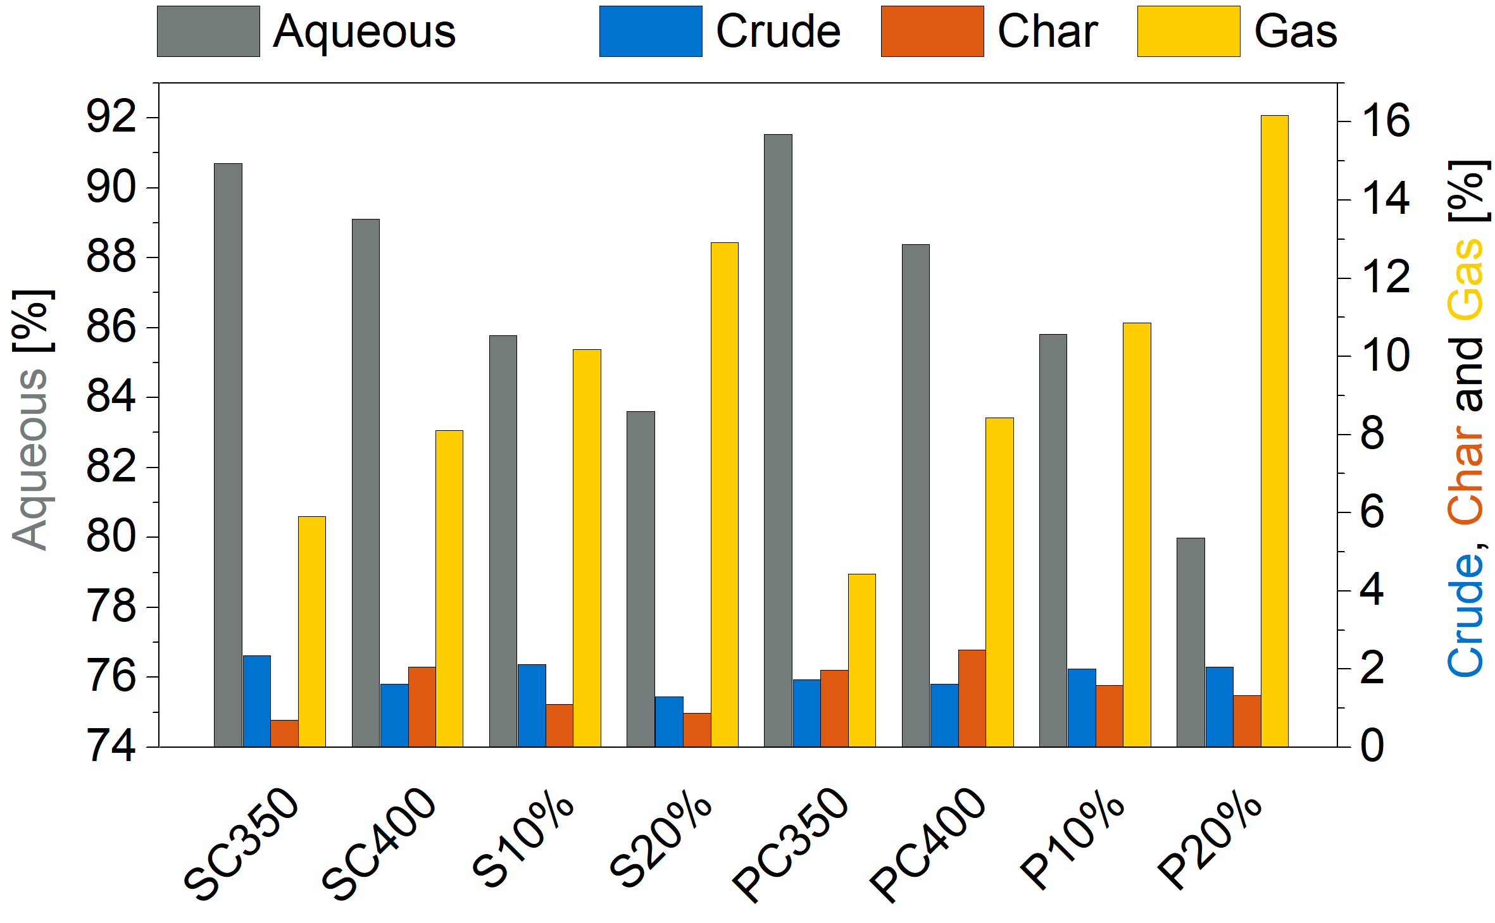 | Figure 1: Yield percentages of the slurry components after the experiments. The values for the aqueous phase are presented on the left Y-axis and the values of crude, char and gas yields are on the right Y-axis.

Due to differences in separation and solvent use between the experiments, differences in results must be considered carefully, but the results indicated that the crude yield was generally higher at subcritical conditions and more pronounced for spruce. No clear trends in crude yields were observed with increasing the spruce bark content. For pine, the crude yield increased with increasing bark concentration. Feng et al. (2014) found that potassium (K⁺) and calcium (Ca²⁺) in bark ashes can catalyze certain reactions that would result in increased biocrude yields. The catalytic effect of K⁺ in bark ashes, however, is expected to be less pronounced in this work, as the amount of bark used in this study was only up to 20 wt%. In addition, K₂CO₃ was added as a catalyst to the slurry that ensured good access to K ions in the reaction mixture for all the samples. The increased biocrude yields are likely better explained by the higher share of extractives found in bark compared with stem wood. Compared to the stem wood, both spruce and pine barks reportedly contain significantly more extractives and lower amounts of cellulose, hemicellulose and lignin (Räisänen and Athanassiadis, 2013). It is assumed that the extractives, which amount to 25-30% of the bark dry weight and consist of fats, oils, resins, etc., are compounds converted to mostly biocrude during HTL (Obeid et al., 2019).
    - Biocrude quality
The quality of biocrudes was evaluated by using FTIR and simulated distillation. FTIR spectra of all the biocrudes are presented in Figure 2a. Figure 2b shows results from the simulated distillation runs of selected samples.

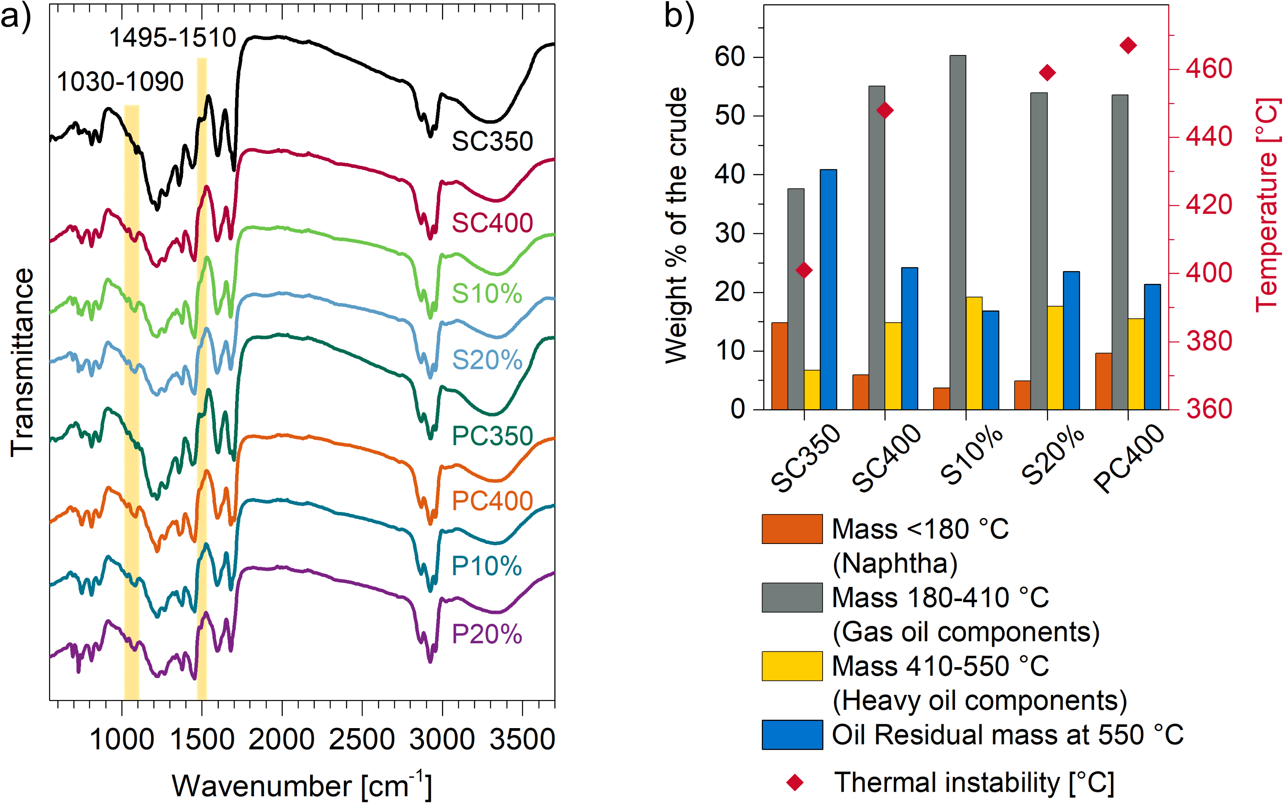
Figure 2: Results of the biocrude quality analyses. a): FTIR spectra of the produced biocrudes; b): Results of the selected thermogravimetric simulated distillation runs. The analysis was carried out with a heating rate of 50 °C/min, and the thermal instability point was determined by the cross section of the 5 and 50 °C TGA curves.

The FTIR spectra showed similar functional group characteristics in the analyzed biocrudes. A summary of the most important functional groups present in the bio-crudes is listed in Table 2.
Table 2: The FTIR functional groups identified in biocrudes in Figure 2a.
Band [cm⁻¹] | Assignments |  | Reference
750 - 850 | Bending vibration of C–H (the aromatic rings). |  | Cui et al., 2017, Domínguez et al., 2013
1030 -1090 | C-O stretching (primary alcohols),  C–O stretching (acids, esters, ethers, phenols) |  | Kline et al., 2013, Wang et al., 2013,  Yang et al., 2011
1220 | C–C, C–O stretch. |  | Scholze et al., 2011
1267-1276 | Methoxyl group, C–O stretch. |  | Cao et al., 2011, Wang et al., 2013
1358 | CH₃ bending, C–H deformation. |  | Nazari et al., 2015, Cao et al., 2011
1375 | Alkanes. |  | Hassan et al., 2019
1450 | Aromatic C=C bending vibrations. Alkenes.  C–H deformations in –CH₃ and –CH₂– . |  | Hassan et al., 2019, Nazari et al., 2015, Scholze et al., 2011, Wang et al., 2013,  Cao et al., 2011
1495-1510 | C=C ring vibrations. |  | Chen et al., 2019, Gupta et al., 2015)
1595 | C=O stretching. |  | Scholze et al., 2011
1680-1700 | C=O stretching (unconjugated ketones, carbonyl and ester group). Alkenes. |  | Hassan et al., 2019, Scholze et al., 2011, Wang et al., 2013, Yang et al., 2011
2860-2925 | C–H stretching. |  | Yang et al., 2011
3350 | O–H stretching (alcohols, phenols, and water). |  | Hassan et al., 2019

Two minor differences in the FTIR spectra were observed, namely the bands at the wavenumber range of 1080 – 1090 cm⁻¹ and 1495 – 1510 cm⁻¹, as marked in yellow in Figure 2a. The former could be assigned to the C–O stretching in acids, esters, ethers, phenols and primary alcohols (Kline et al., 2013, Yang et al., 2011, Wang et al., 2013, Scholze et al., 2011). This band appears in the spectra of samples synthesized at 400 °C (SC400, S10%, S20%, PC400, P10% and P20%) and was nearly absent in the spectra of samples synthesized at 350 °C (SC350 and PC350). The latter band, at 1495 – 1510 cm⁻¹, could be attributed to C=C ring vibrations (Chen et al., 2019, Gupta) and was seen to be more prominent in the spectra of SC350 and PC350 than in the spectra of the remaining samples. Thus, these results indicate that the higher synthesis temperature samples contained more C–O groups, while the lower synthesis temperature samples contained more aromatic compounds.
The simulated distillation reveals that most of the weight of the biocrudes is attributed to the range of gas oil components. The spruce sample produced at 350 °C has a significantly higher percentage of light components and a lower percentage of the gas oil components than the rest of the samples analyzed. It is expected that the error range of the lightest mass range (<180 °C) is quite high, as it includes not only the analysis errors but also any residual solvents present in the samples. Therefore, it is not advisable to draw any conclusions based on this mass range. The components in the oil residual mass are defined as carbon residue, or Conradson Carbon Residue, and are considered responsible for catalyst coking in refinery processes. Therefore, this mass fraction is considered an important quality marker of the crude bio-oils. Based on the analysis, it can be confirmed that the oil produced at supercritical conditions (400 °C) are of higher quality (including samples containing bark) than the biocrude produced at subcritical condition (350 °C) with respect to further upgrading into liquid fuels. Additionally, the increased bark content in the feedstock up to 20 wt% did not significantly alter the biocrude quality.
    - Aqueous phase
Figure 3 shows both the measured total organic carbon (TOC) and an example of the visual differences in the aqueous phase. The visual differences displayed in Figure 3.b was similarly observed for all samples at 350 °C compared to 400 °C. Both the measurements and visual observations indicated, the TOC was dependent on the process temperature. Specifically, samples produced at 350 °C have twice as high TOC compared to the samples produced at 400 °C. This can be explained by conversion of the water-soluble organic components to gas phase or, in some cases, to biocrude. The feedstock and the bark content did not seem to influence the TOC at 400 °C, and the variations were within repeatability ranges. At 350 °C the TOC appeared to be higher for spruce than for pine.

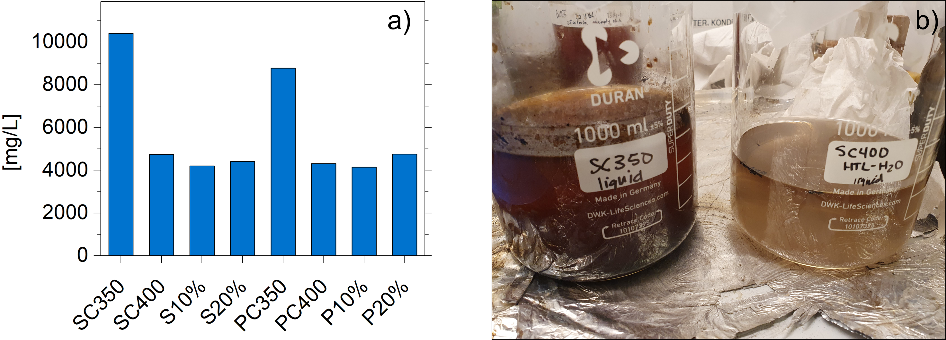
Figure 3: a) TOC analysis of the aqueous phase; b) aqueous phases obtained at 350 and 400 °C
  - Conclusions
The effect of reaction temperature, biomass type, and bark content was studied in this work in HTL under batch conditions. It can be concluded that the temperature had a major effect on the product yields, with a significant difference between the samples produced at subcritical compared to supercritical conditions. The higher temperature decreased the yield of biocrude for spruce and increased the char and non-condensable gas yields. An increase in temperature also decreased the amount of organic compounds in the aqueous phase, resulting in a cleaner by-product, as well as in higher quality biocrude indicating easier downstream processing as shown by simulated distillation into usable liquid fuels. Bark addition to the biomass samples increased the biocrude and non-condensable gas yield and decreased the amount of char produced. An increase in both temperature and bark concentration resulted in a decrease of the aqueous phase weight percentage.
Based on the biocrude analyses in this work, it appears that bark addition up to 20% does not compromise the biocrude quality. The studied properties and chemical composition of the biocrudes were not significantly affected by the bark addition. Increasing the temperature from 350 to 400 °C decreased the amount of aromatic compounds and increased the compounds with C-O functional groups. The 400 °C samples also contained less of the heaviest, possibly multiring aromatic compounds. Because bark is a common byproduct of the wood processing industry, these findings indicating similar quality biocrude from biomass containing bark are promising for sustainable production of biofuels by HTL.
Acknowledgement
This work was supported by the Research Council of Norway's scheme for Centres for Environment-friendly Energy Research (FME) under the FME Bio4Fuels (project number 257622, duration 2016 - 2024).
References
Cao J-P., Xiao X-B., Zhang S-Y., Zhao X-Y., Sato K., Ogawa Y., Wei X-Y., Takarada T., 2011, Preparation and characterization of bio-oils from internally circulating fluidized-bed pyrolyses of municipal, livestock, and wood waste, Bioresource Technology, 102(2), 2009-15.
Castello D., Pedersen T.H., Rosendahl L.A., 2018, Continuous Hydrothermal Liquefaction of Biomass: A Critical Review. Energies. 2018; 11, 3165-3199.
Chan Y.H., Yusup S., Quitain A.T., Uemura Y., Sasaki M., 2014. Bio-oil production from oil palm biomass via subcritical and supercritical hydrothermal liquefaction, Journal of Supercritical Fluids, 95, 407–412.
Chen Y., Cao X., Zhu S., Tian F., Xu Y., Zhu C., Dong L., 2019, Synergistic hydrothermal liquefaction of wheat stalk with homogeneous and heterogeneous catalyst at low temperature, Bioresource Technology, 278, 92-8.
Cui Y., Hou X., Wang W., Chang J., 2017, Synthesis and Characterization of Bio-Oil Phenol Formaldehyde Resin Used to Fabricate Phenolic Based Materials, Materials, 10(6), 668.
Domínguez J.C., Oliet M., Alonso M.V., Rojo E., Rodríguez F., 2013, Structural, thermal and rheological behavior of a bio-based phenolic resin in relation to a commercial resol resin, Industrial Crops and Products, 42, 308-14.
Feng S., Yuan Z., Leitch M, Xu C.C., 2014, Hydrothermal liquefaction of barks into bio-crude – Effects of species and ash content/composition, Fuel, 116, 214-220.
French R.J., Iisa K., Orton K.A., Griffin M.B., Christensen E., Black S., Brown K., Palmer S.E., Schaidle J.A., Mukarakate C., Foust T.D., 2021, Optimizing Process Conditions during Catalytic Fast Pyrolysis of Pine with Pt/TiO2—Improving the Viability of a Multiple-Fixed-Bed Configuration, ACS Sustainable Chemistry & Engineering 9, 1235-1245.
Grande L., Pedroarena I., Korili S.A., Gil A., 2021, Hydrothermal Liquefaction of Biomass as One of the Most Promising Alternatives for the Synthesis of Advanced Liquid Biofuels: A Review. Materials, 14, 5286-5304.
Gupta B.S., Jelle B.P., Gao T., 2015, Application of ATR-FTIR Spectroscopy to Compare the Cell Materials of Wood Decay Fungi with Wood Mould Fungi, International Journal of Spectroscopy, 521938.
Hassan E-b. M., Steele P.H., Ingram L., 2009, Characterization of Fast Pyrolysis Bio-oils Produced from Pretreated Pine Wood, Applied Biochemistry and Biotechnology, 154(1), 3-13.
Jensen C.U., Rodriguez Guerrero J.K., Karatzos S., Olofsson G., Iversen S.B. 2017, Fundamentals of Hydrofaction™: Renewable crude oil from woody biomass, Biomass Conv Bioref 7, 495-509.
Kline L., Hayes D., Womac A., Labbé N., 2010, Simplified determination of lignin content in hard and soft woods via UV-spectrophotometric analysis of biomass dissolved in ionic liquids, BioResources, 5, 1366-83.
Nazari L., Yuan Z., Souzanchi S., Ray M.B., Xu C., 2015, Hydrothermal liquefaction of woody biomass in hot-compressed water: Catalyst screening and comprehensive characterization of bio-crude oils, Fuel, 162, 74-83
Obeid R., Lewis D., Smith N., van Eyk P., 2019, The elucidation of reaction kinetics for hydrothermal liquefaction of model macromolecules, Chemical Engineering Journal, 370, 637-645
Räisänen T, Athanassiadis D., 2013 Basic chemical composition of the biomass components of pine, spruce and birch < http://biofuelregion.se/wp-content/uploads/2017/01/1_2_IS_2013-01-31_Basic_chemical_composition.pdf> assessed 24.01.2022
Scholze B., Meier D., 2001, Characterization of the water-insoluble fraction from pyrolysis oil (pyrolytic lignin), Part I. PY–GC/MS, FTIR, and functional groups, Journal of Analytical and Applied Pyrolysis, 60(1), 41-54.
Toor S.S., Rosendahl L., Rudolf A., 2011, Hydrothermal liquefaction of biomass: a review of subcritical water technologies. Energy 36, 2328–2342.
Wang Y., Wang H., Lin H., Zheng Y., Zhao J., Pelletier A., Li K., 2013, Effects of solvents and catalysts in liquefaction of pinewood sawdust for the production of bio-oils, Biomass and Bioenergy, 59, 158-67.
Watson J., Lu J., de Souza R., Si B., Zhang Y., Liu Z., 2019, Effects of the extraction solvents in hydrothermal liquefaction processes: Biocrude oil quality and energy conversion efficiency. Energy, 167, 189–197.
Yang C., Jia L., Chen C., Liu G., Fang W., 2011, Bio-oil from hydro-liquefaction of Dunaliella salina over Ni/REHY catalyst, Bioresource Technology, 102(6), 4580-4.
Yang J., He Q., Niu H., Corscadden K., Astatkie T., 2018, Hydrothermal liquefaction of biomass model components for product yield prediction and reaction pathways exploration, Applied Energy, 228, 1618-1628,

