|  |  |
| --- | --- |
| cetlogo ***CHEMICAL ENGINEERING TRANSACTIONS***  ***VOL. 92, 2022*** | A publication of  aidiclogo_grande |
| The Italian Association  of Chemical Engineering  Online at www.cetjournal.it |
| Guest Editors: Rubens Maciel Filho, Eliseo Ranzi, Leonardo Tognotti  Copyright © 2022, AIDIC Servizi S.r.l.  **ISBN** 978-88-95608-90-7; **ISSN** 2283-9216 | |

Kinetics analysis of the syngas fermentation to produce acetic acid from cardoon residual biomass

Aristide Giuliano\*, Roberto Albergo, Isabella De Bari

ENEA, Italian National Agency for New Technologies, Energy and Sustainable Economic Development, S.S. 106 Ionica, km 419+500, Rotondella, MT, Italy

\*aristide.giuliano@enea.it

Lignocellulosic biomass can be converted to biofuels and biochemicals through several process pathways: pretreatment and sugars fermentation, thermochemical conversion (pyrolysis, gasification) and syngas synthesis. A promising syngas valorization process consists of the syngas fermentation, able to maximize the biomass fraction used for the fermentation. The limits of this process are the need for high-quality syngas, fermentation rate optimization and the two-phase bioreactor design. This work aims to analyze the two effects (fermentation and gas to liquid mass transfer) distinctly. A syngas fermentation kinetics was modeled in order to optimize the fermentation conditions in terms of substrate and microorganism concentrations maximizing the acetic acid yield. Under the hypothesis of constant CO and H2 concentration, the gas-liquid mass transfer coefficients were estimated considering a syngas composition coming from the *Cynara cardunculus* L. residual biomass gasification. Results presented identify the optimal CO and H2 concentrations 0.01 and 0.1 mmol/L respectively, with an initial microorganism concentration equal to 2 g/L, obtaining a maximum acetic acid yield and an acetic acid maximum concentration of 12.5 % and 4.2 g/L respectively.

* 1. Introduction

Syngas fermentation is a more recent biorefinery approach for the production of biobased products (Li et al., 2018). The main advantage of this biorefinery scheme is that gasification (Sofia et al., 2013) can transform up to 90% of the biomass into a fermentable platform (syngas) (Sivalingam Vasan and Dinamarca Carlos, 2021). Depending on the type of micro-organism used in fermentation, several bioproducts, like ethanol, acetic acid, PHA, BDO, can be obtained (Asimakopoulos et al., 2018). The limits of this process are the need for high-quality syngas and the bioreactors geometry. In particular, in these bioreactors, the syngas compounds (CO, CO2, H2), with very low solubility in water, need to be transferred in the liquid phase where the fermentation reaction takes place by means of micro-organisms (Pardo-planas et al., 2017). In the last years, several works aimed to obtain a modeling or process simulation of syngas fermentation to ethanol or chemicals. Almeida Benalcázar et al. built a thermodynamics-based black-box model of main microbial reactions with a mass transfer-based model of a bubble column bioreactor (2020) and they analyzed the gas production processes as the main process parameter of the syngas fermentation (2022). More innovative bioreactor configurations were studied by Jang et al. (2018), considering a hollow fiber membrane bioreactor (HFMBR) for microbial CO conversion to ethanol. Inhibition of *C. autoethanogenum* cell growth was observed in proportion to the electrolyte concentration, while the kinetic simulations predicted that overall reactor performances using the electrolytes increase compared to the that obtained in an acid-buffered basal medium. This suggests the applicability of this approach for biofuel production. Phillips et al. (2017) developed the *Wood–Ljungdahl* biochemical pathway model used by chemoautotrophs. Important concepts discussed include gas solubility, mass transfer, thermodynamics of enzyme-catalyzed reactions, electrochemistry and cellular electron carriers and fermentation kinetics. Potential applications of these concepts include acid and alcohol production, hydrogen generation and conversion of methane to liquids or hydrogen. A review of techno-economic analysis of gasification-syngas fermentation showed a competitive advantage of the hybrid gasification-syngas fermentation technology to make biofuels compared to gasification-mixed alcohol catalytic conversion and enzymatic hydrolysis fermentation processes. Safarian et al. (2021) developed a simulation model based on the non-stoichiometric equilibrium method via ASPEN Plus® was established to analyze the gasification performance of 20 herbaceous and agricultural biomasses linked with syngas fermentation and product purification units for ethanol production. Further, Kennes et al. (2016) carried out the comparison between the bioethanol production via sugars platform and via syngas fermentation. In particular, they assessed a comparison between the economic analysis of both processes, individuating a similar production cost, essentially, else two processes have many differences. In the present work, a syngas fermentation kinetics model was used to assess the main fermentation conditions making optimal acetic acid production. Under the hypothesis of constant CO and H2 concentration, the gas-liquid mass transfer coefficients were estimated considering a syngas composition coming from the *Cynara cardunculus* L. residual biomass gasification. In particular, the kinetics model developed by (Medeiros et al., 2019) considers the bacterium *Clostridium ljungdahlii* and initial microbial concentration, CO and H2 liquid concentrations and the fermentation time were evaluated and optimized in order to obtain the maximum acetic acid yield.

* 1. Modeling approach

The modeling approach was performed using two distinct equation sets, one for the liquid phase, where the biological reactions happened, and another for the syngas phase. Syngas data were from the Serrano et al. (2016) work, in order to consider the worst case the air biomass gasification was considered, composition and process conditions are listed in Table 1.

Table 1: Syngas composition (Serrano et al., 2016) and process conditions

|  |  |  |  |  |  |
| --- | --- | --- | --- | --- | --- |
| Compound | %volDRY *(yi)* | Compound | %volDRY *(yi)* | Process condition |  |
| CO | 17.0 | CO2 | 16.9 | Pressure (bar) | 1.025 |
| H2 | 16.7 | N2 | 44.4 | Temperature (°C) | 37 |
| CH4 | 5.0 |  |  |  |  |

The substrate for the bacteria growth is represented by CO, H2, CO2 (also reaction product), following a simplified reaction network is shown (Medeiros et al., 2019):

|  |  |
| --- | --- |
| $$4CO+2H_{2}O→ C_{2}H_{4}O_{2}+2CO_{2}$$ | (1) |
| $$4H_{2}+2CO_{2}→ C_{2}H_{4}O_{2}+2H_{2}O$$ | (2) |
| $$C_{2}H_{4}O_{2}+2CO+ H_{2}O→ C_{2}H_{4}O+2CO_{2}$$ | (3) |
| $$C_{2}H_{4}O_{2}+ 2H_{2}→ C_{2}H_{4}O+2H_{2}O$$ | (4) |

In particular, reactions (1) and (3) produce CO2, while reaction (2) consume it. This point is fundamental for the increasing of the yield to ethanol and/or acetic acid reaction (2) has to be favorite to reduce the global CO2 production and increase the target product yields.

* + 1. Fermentation model implementation

For the fermentation model implementation, the kinetics model proposed by (Medeiros et al., 2019) was adapted. In particular, the C1 bacteria of *Clostridium ijungdahlii* was considered because for this also the ethanol inhibition was studied. Since the differential equation system is not analytically resolvable it was formulated by Excel using a time integration. The aim of this step of the modeling consists in the individuation of the optimal condition of the fermentation broth without considering the gas-liquid mass transfer, so the main hypothesis was fixing the substrate concentration for the liquid phase. In particular, a sensitivity analysis was performed changing the CO, H2 concentrations until to the saturation value (calculated for 1 atm of partial pressure) and the saturation concentration for the CO2, in that CO2 is present in the gas phase (passing to liquid) and it is also a fermentation product.

Table 2 shows the value range for CO, H2, bacteria concentration and for the reaction time.

Table 2: Value ranges of substrates liquid concentrations, initial bacteria concentrations and the reaction time

|  |  |  |  |
| --- | --- | --- | --- |
|  | Range |  | Range |
| CO (mmol/L) | 0.005 – 0.79 | Initial *Clostridium ijungdahlii* concentration (g/L) | 1 - 4 |
| H2 (mmol/L) | 0.01 – 0.98 | Reaction time (h) | 0 - 250 |

* + 1. Gas-liquid Mass transfer coefficient calculation

The gas phase was modeled considering the mass balance equations on each compound. The hypothesis of the equimolar gas-liquid exchange was necessary in order to suppose CO/H2 partial pressures decreasing for the effect of the phase change from gas to liquid. The driving force of the mass transfer effect consists of the gap between the interfacial liquid concentration and the bulk concentration.

The general mass balance equation is:

|  |  |
| --- | --- |
| $$\frac{dC_{i,L}}{dt}=υ_{i}(t)+{\left(k_{L}a\right)}_{i} (C_{i}^{*}(t)- C_{i,L}(t))$$ | (5) |

Where *Ci,L* is the concentration in the liquid phase of component *i*, *vi(t)* is the consumption rate of the substrate *i*, *kLa* is the mass transfer coefficient and *C\*i* is the phase interfacial concentration of component *i*.

Substituting to the interfacial concentration the Henry Law parameters:

|  |  |
| --- | --- |
| $$\frac{dC_{i,L}}{dt}=υ_{i}(t)+{(k_{L}a)}_{i} (\frac{ρ_{L}P_{TOT}y_{i}(t)}{H_{i}{MW}_{L}}- C_{i,L}(t))$$ | (6) |

Where *PTOT* is the gas pressure, *yi* is the molar fraction of the gas component *i*, *Hi* is the Henry constant for the species *i*.

Simplifying using the water density and molecular weight for the liquid density *ρL* and liquid molecular weight *MWL* and imposing the total pressure of the gas equal to 1 atm:

|  |  |
| --- | --- |
| $$\frac{dC_{i,L}}{dt}=υ_{i}(t)+{(k_{L}a)}_{i} (5.69 {10}^{9}\frac{y_{i}(t)}{H_{i}}- C_{i,L}(t))$$ | (6) |

Using *Hi* values of (Medeiros et al., 2019):

|  |  |
| --- | --- |
| $$\frac{dC_{CO,L}}{dt}=υ_{CO}(t)+{(k_{L}a)}_{CO} (1.15 y_{CO}(t)- C_{CO,L}(t))$$ | (7) |
| $$\frac{dC_{H2,L}}{dt}=υ_{H2}(t)+{(k_{L}a)}_{H2} (0.85 y_{H2}(t)- C_{H2,L}(t))$$ | (8) |

For the minimum/optimal *kLa* calculation the previous hypothesis of substrate concentration as constant was imposed:

|  |  |
| --- | --- |
| $$\frac{dC_{CO,L}}{dt}=0=υ_{CO}(t)+{\left(k_{L}a\right)}_{CO} (1.15 y_{CO}(t)- C_{CO,L})$$ | (9) |
| $$\frac{dC_{H2,L}}{dt}=0=υ_{H2}(t)+{(k_{L}a)}_{H2} (0.85 y_{H2}(t)- C_{H2,L})$$ | (10) |

Then, considering the initial and final values for the consumption rate the value of the minimum (with relationship to the maximum driving force) gas-liquid mass transfer coefficient can be calculated:

|  |  |
| --- | --- |
| $${\left(k_{L}a\right)}_{CO,MIN} =\frac{-υ_{CO}(t_{0})}{1.15 y_{CO}(t_{0})- C_{CO,L}}$$ | (11) |
| $${\left(k_{L}a\right)}_{H2,MIN} =\frac{-υ_{H2}(t_{0})}{1.15 y_{H2}(t_{0})- C_{H2,L}}$$ | (12) |

Finally, having a sensitivity analysis on microorganism (initial), CO and H2 concentrations the optimal values can be individuated maximizing the acetic acid yield and maximum concentration, with sustainable *kL\*a* values, having a microorganism growing rate higher than the death rate.

* 1. Results
     1. Fermentation model parameter optimization

Figure 1 shows the main results of the kinetics analysis in terms of carbon yield (CO to acetic acid containing two carbon atoms) to acetic acid, maximum acetic acid concentrations and the fermentation time corresponding to the maximum acetic acid concentration, varying the substrate (CO and H2) and the initial microorganism concentrations.

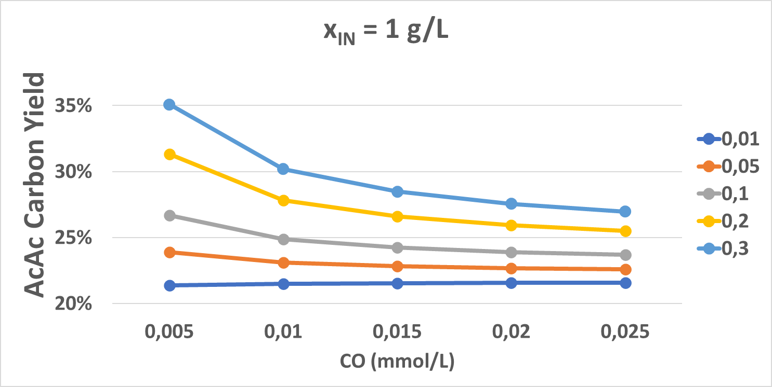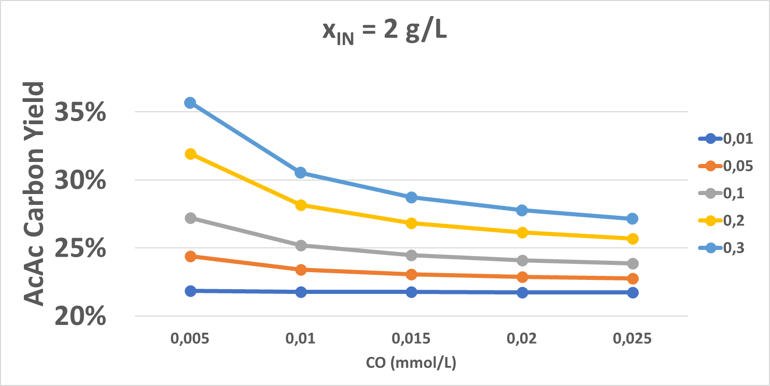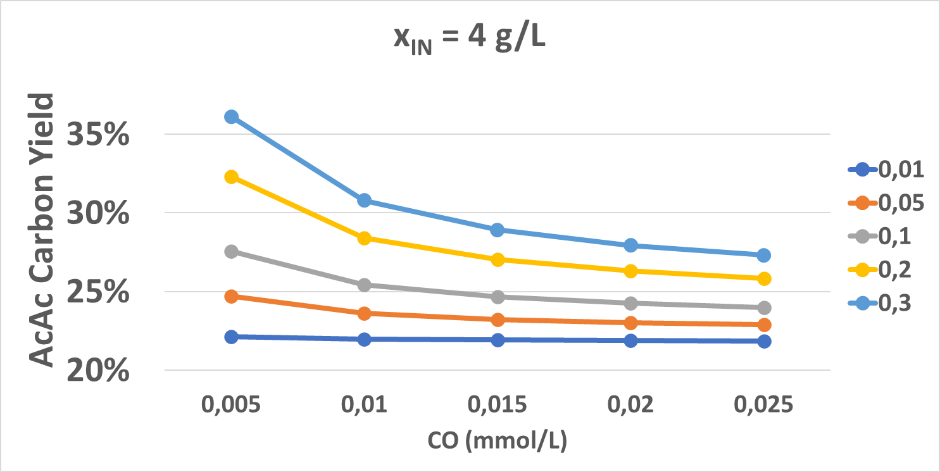

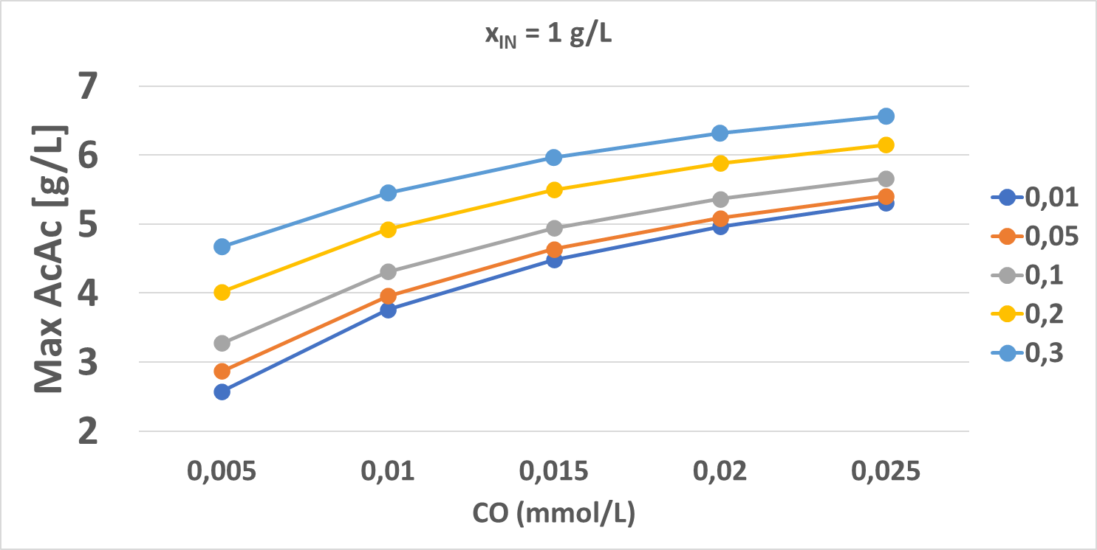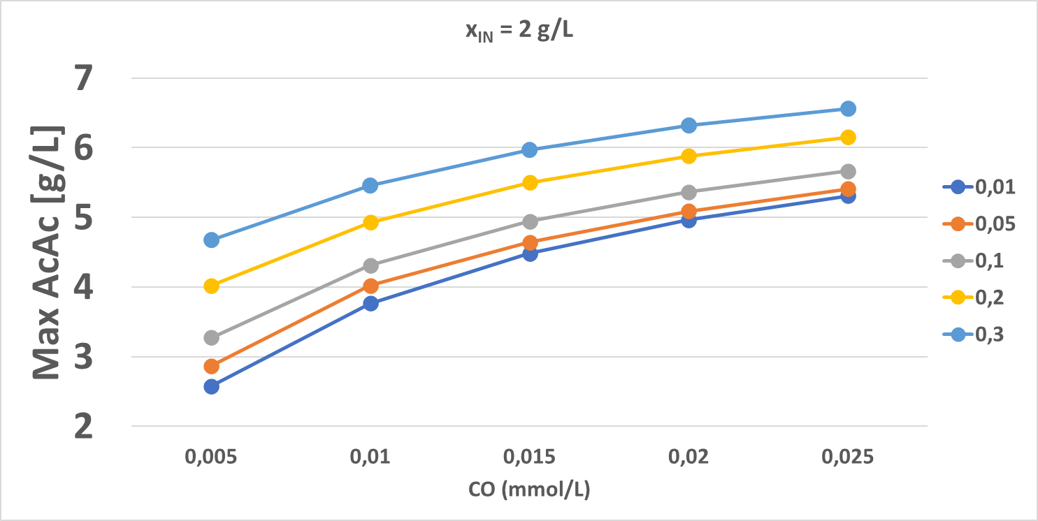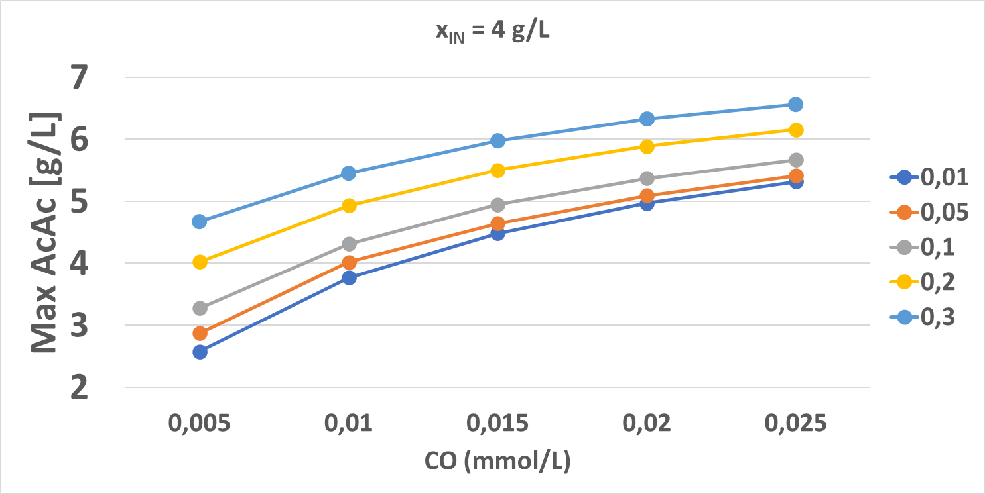

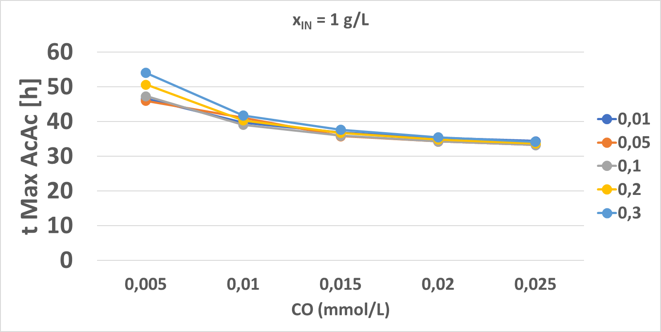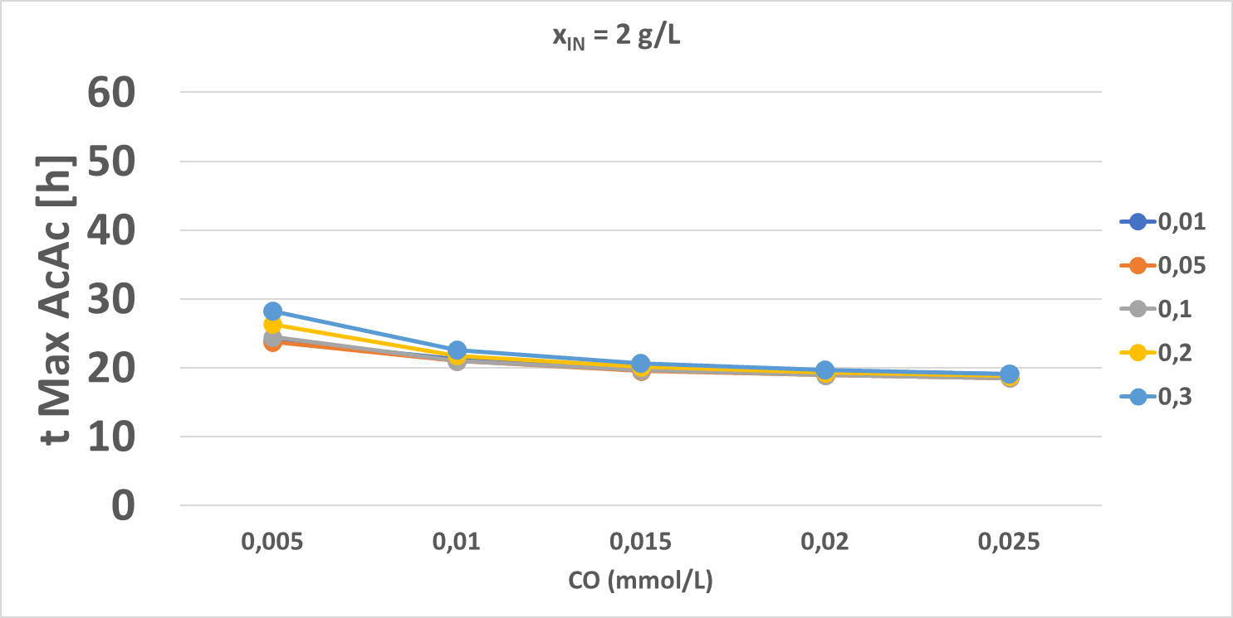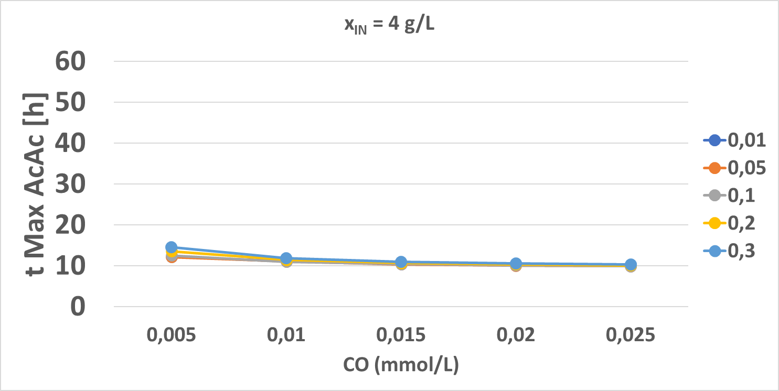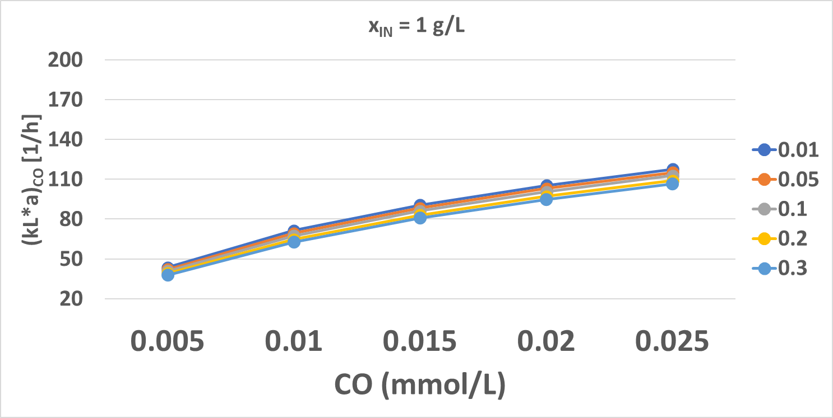

*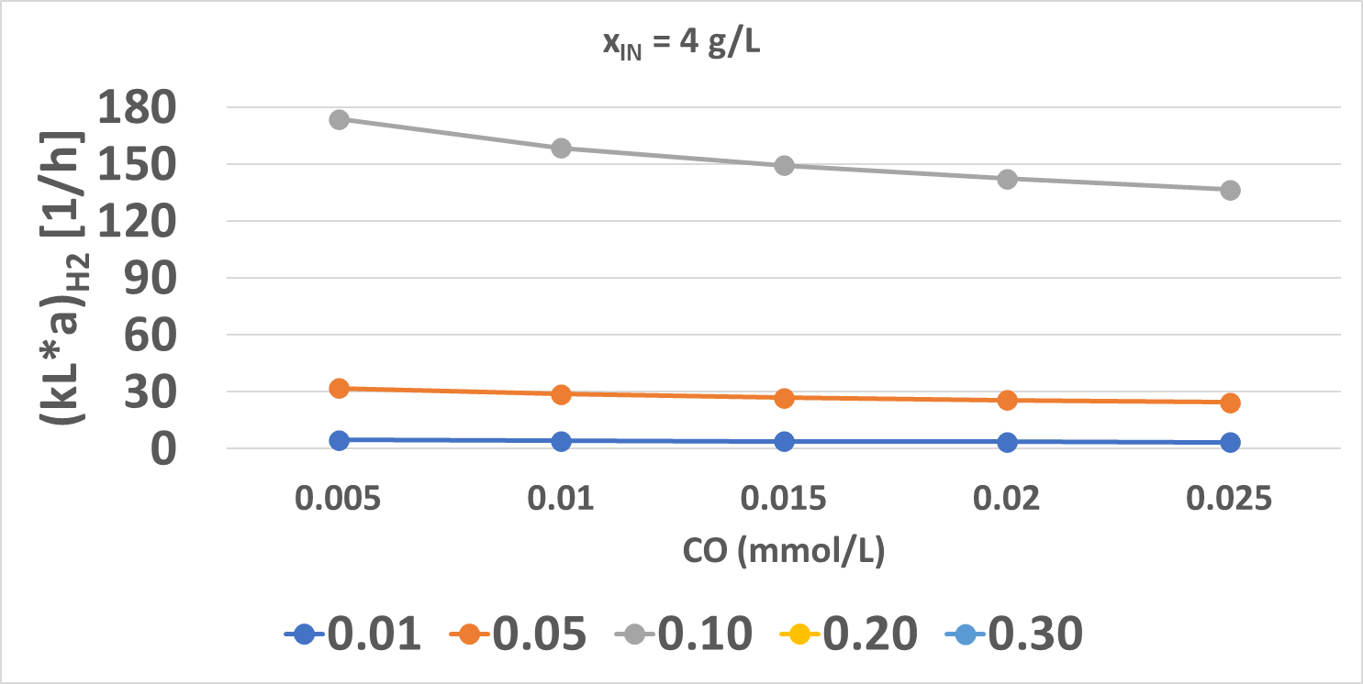*

*Figure 1: Fermentation model results maximizing the Acetic Acid concentrations varying the liquid CO concentration (x-axes), the liquid H2 concentration (different colored lines) and the initial microorganism concentration.*

The main parameter changing the acetic acid yield consists in the H2 concentration, this is because of the reaction network. For low H2 concentrations, the reaction rates of reactions (2) and (4) are lower, in particular, reaction (2) is the only one able to convert CO2. So, for low H2 concentration values, the conversion of CO is to CO2 (until to 66 %). Increasing the H2 concentration the yield to acetic acid can reach 35 % on a carbon basis.

The impact of the initial microorganism concentration has an impact only on the fermentation time to reach the maximum value of acetic acid concentration.

The CO concentration has a big impact on the maximum acetic acid concentration, it doubles by varying the CO concentration from 0.005 mmol/L to 0.025 mmol/L for 0.01 mmol/L of H2 concentration. Maximum acetic acid concentration increases from 4.8 g/L to 6.6 g/L for an H2 concentration of 0.3 mmol/L.

Globally, the effect of the increasing of H2 concentration is positive for each one acetic acid yield and maximum concentration, increasing CO concentration the maximum acetic acid concentration increase, but the acetic acid yield decreases because of the ratio between the reaction rate (1) and (2), so if CO concentration increases also the H2 concentration has to increase, if not more CO2 is produced by reaction (1).

For CO concentrations lower than 0.01 and for initial microorganism concentration (*xIN*) higher than 2 g/L the dead velocity results are faster than growth velocity, so these conditions have to be discarded.

* + 1. Bioreactor configuration analysis

Figure 2 shows the *kL\*a* values for CO and H2 corresponding to initial CO/ H2 partial pressures. These values are the minimum ones to sustain the hypothesis of constant values of CO and H2 concentration, deriving from equations (11) and (12). The minimum mass transfer coefficients of CO have a low variation with H2 concentration (having an impact only on the reaction rates, not on the driving force), while the behavior is increasing with the CO concentration because of the decreasing of driving force $1.15 y_{CO}(t_{0})- C_{CO,L}$.

Lower values are for 1 g/L of initial microorganism concentration between 35 h-1 and 115 h-1. Unsustainable (higher than 120 h-1, (Asimakopoulos et al., 2018)) *(kL\*a)CO* values are for CO concentrations higher than 0.015 mmol/L, so these CO concentrations values have not been utilized in the bioreactor modeling and design.

The minimum hydrogen mass transfer coefficients are constant changing the CO concentrations, but have a high variability changing the H2 concentration (because of the driving force on H2 mass transfer). In particular, values of H2 concentration higher than 0.1 mmol/L carry out negative hydrogen driving force $1.15 y_{H2}(t_{0})- C_{H2,L}$ because of low H2 partial pressure. Considering H2 concentration values higher than 0.1 mmol/L the hydrogen can move from liquid phase to gas phase and not the other way around. Considered values 0.01 and 0.05 can involve very low minimum *(kL\*a)H2* values, lower than 30 h-1. For these H2 concentrations the mass transfer is favored, but Figure 1 shows too low values of acetic acid yield and maximum concentration. So, the optimal value of H2 concentration could be 0.1 mmol/L.

According to literature (Devarapalli et al., 2017), the best bioreactor configuration could be a trickle bed reactor, in which higher *kL\*a* values can be reached, a simple set of the reactor can be performed (without moving parts) also in order to manage the fermentation time, and flat profiles of CO and H2 can be obtained.

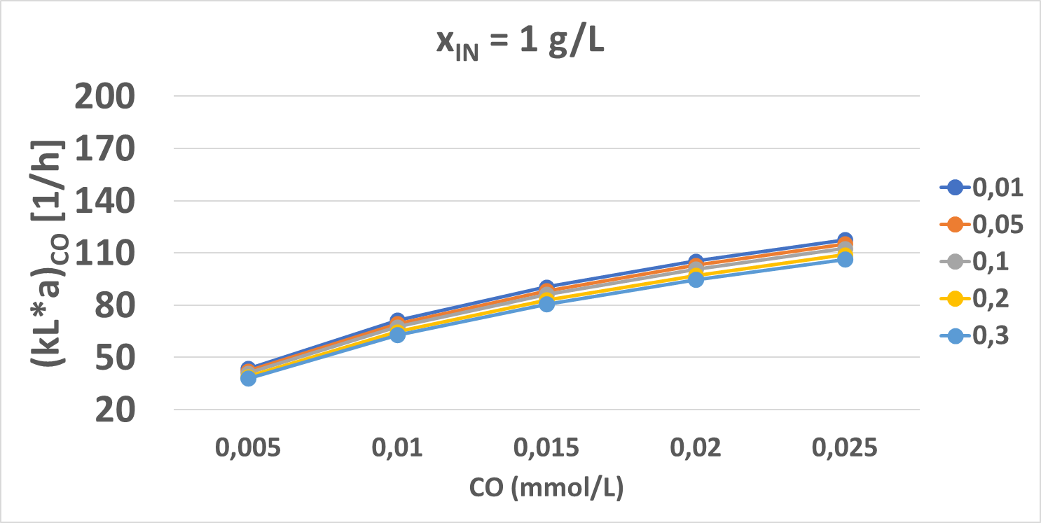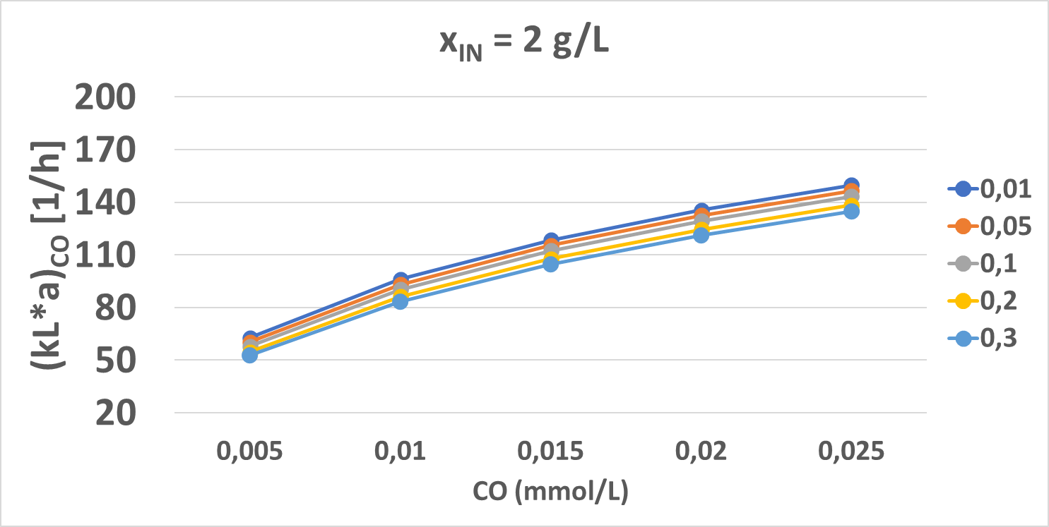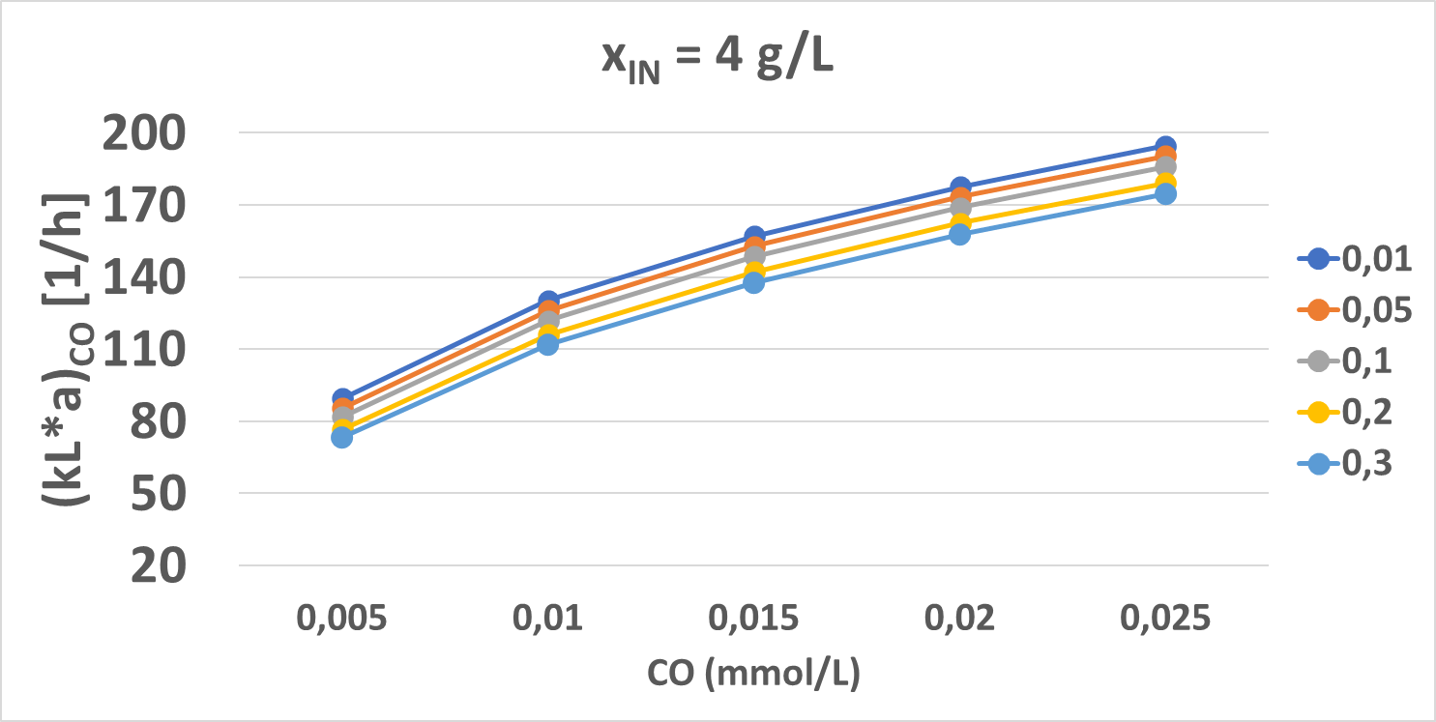

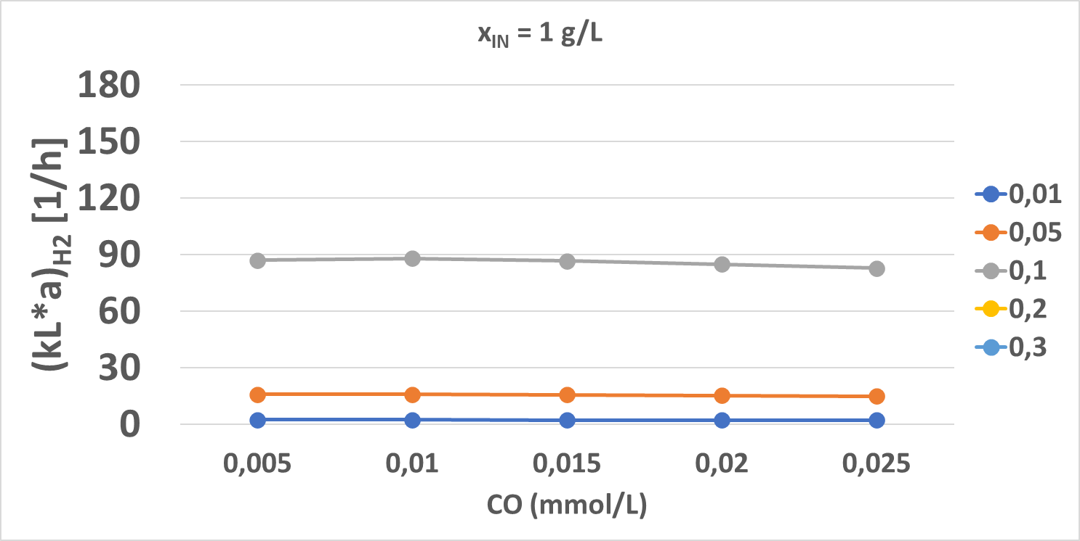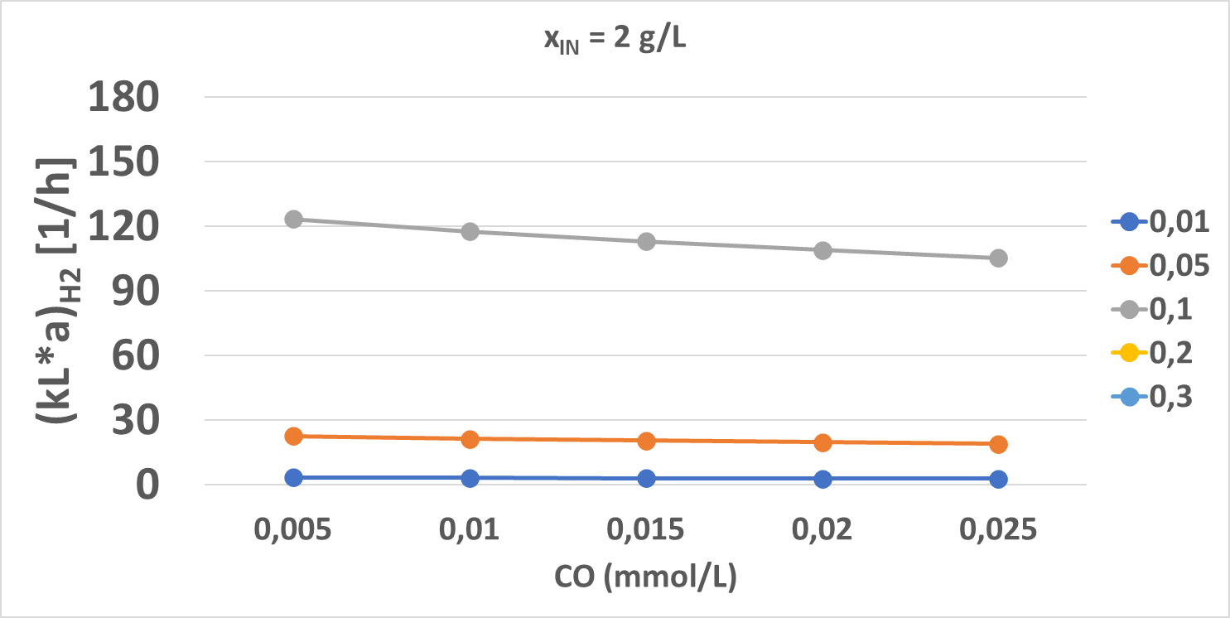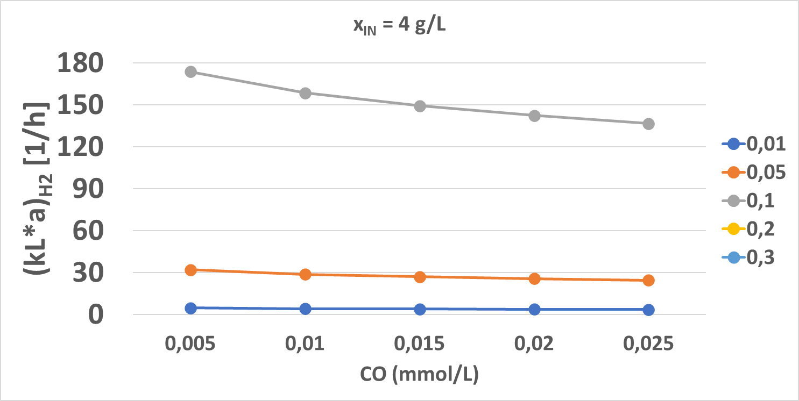





*Figure 2: Minimum gas-to-liquid mass transfer coefficient for CO and H2 changing the initial microorganism concentration, the CO and H2 concentration.*

* 1. Conclusions

The analysis of results of the syngas fermentation model under several hypotheses was performed. In particular, substrate concentration values were considered as a constant. A sensitivity analysis on the initial microorganism concentration and CO and H2 concentrations were carried out, individuating the best CO and H2 concentration values to maximize the acetic acid yield and maximum concentration. From the mass transfer model, the minimum gas-to-liquid mass transfer coefficients were calculated. Imposing the maximum *kL\*a* values equal to 120 h-1, optimal CO and H2 concentrations were found 0.01 and 0.1 mmol/L, respectively. For these substrate concentration values, the microorganism can decrease if its initial concentration is higher than 2 g/L, because of the death rate is higher than the growth rate. So, finally, the optimal conditions were individuated as 0.01 and 0.1 mmol/L for CO and H2, respectively, 2 g/L as the initial microorganism concentration. From this, an acetic acid yield and a maximum acetic acid concentration equal to 25 % and 4.2 g/L, respectively were found, corresponding to an optimal fermentation time of about 22 h and *(kL\*a)CO* and *(kL\*a)H2* about 100 and 120 h-1, respectively.

Nomenclature

*Ci,L* - concentration in the liquid phase of component *i,* mmol/L

*C\*I* - phase interfacial concentration of component *i,* mmol/L

*Hi* - Henry constant for the species *i, Pa*

*kLa* – mass transfer coefficient, h-1

*(kLa)CO,MIN and (kLa)H2,MIN – minimum* mass transfer coefficient for CO and H2, h-1

*MWL* - water molecular weight, kg/mmol

*PTOT* - global gas pressure, Pa

*vi* - consumption rate of the substrate *i, mmol/(L\*h)*

t – fermentation time,h

*xIN* – initial microorganism concentration, g/L

*yi* – molar fraction of the component *i*

*ρL* - water density, kg/m3

Acknowledgments

The present work is part of the national project COMETA funded through the program PON 2014-2020.

References

Almeida Benalcázar E., Noorman H., Maciel Filho R., Posada J.A., 2022. Decarbonizing ethanol production via gas fermentation: Impact of the CO/H2/CO2 mix source on greenhouse gas emissions and production costs. Computers & Chemical Engineering 159, 107670.

Almeida Benalcázar E., Noorman H., Maciel Filho R., Posada J.A., 2020. Modeling ethanol production through gas fermentation: a biothermodynamics and mass transfer-based hybrid model for microbial growth in a large-scale bubble column bioreactor. Biotechnol Biofuels 13, 59.

Asimakopoulos K., Gavala H.N., Skiadas I.V., 2018. Reactor systems for syngas fermentation processes : A review. Chemical Engineering Journal 348, 732–744.

De Bari I., Giuliano A., Petrone M.T., Stoppiello G., Fatta V., Giardi C., Razza F., Novelli A., 2020. From cardoon lignocellulosic biomass to bio-1,4 butanediol: An integrated biorefinery model. Processes 8, 1–18.

Devarapalli M., Lewis R., Atiyeh H., 2017. Continuous Ethanol Production from Synthesis Gas by Clostridium ragsdalei in a Trickle-Bed Reactor. Fermentation 3, 23.

Jang N., Yasin M., Kang H., Lee Y., Woo G., 2018. Bioresource Technology Bubble coalescence suppression driven carbon monoxide ( CO ) -water mass transfer increase by electrolyte addition in a hollow fi ber membrane bioreactor ( HFMBR ) for microbial CO conversion to ethanol. Bioresource Technology 263, 375–384.

Kennes D., Abubackar H.N., Diaz M., Veiga M.C., Kennes C., 2016. Bioethanol production from biomass: Carbohydrate vs syngas fermentation. Journal of Chemical Technology and Biotechnology 91, 304–317.

Li Xiangan, Chen J., Griffin D., Li Xueliang, Henson M.A., 2018. Integrated Metabolic and Process Modeling of Bubble Column Reactors for Gas Fermentation. pp. 2491–2496.

Medeiros E.M., Posada J.A., Noorman H., Filho R.M., 2019. Dynamic modeling of syngas fermentation in a continuous stirred‐tank reactor: Multi‐response parameter estimation and process optimization. Biotechnology and Bioengineering 116, 2473–2487.

Pardo-planas O., Atiyeh H.K., Phillips J.R., Aichele C.P., Mohammad S., 2017. Bioresource Technology Process simulation of ethanol production from biomass gasification and syngas fermentation. Bioresource Technology 245, 925–932.

Phillips J.R., Huhnke R.L., Atiyeh H.K., 2017. Syngas Fermentation : A Microbial Conversion Process of Gaseous Substrates to Various Products.

Safarian S., Unnthorsson R., Richter C., 2021. Bioethanol Production via Herbaceous and Agricultural Biomass Gasification Integrated with Syngas Fermentation. Fermentation 7, 139.

Serrano D., Kwapinska M., Horvat A., Sánchez-Delgado S., Leahy J.J., 2016. *Cynara cardunculus* L. gasification in a bubbling fluidized bed: The effect of magnesite and olivine on product gas, tar and gasification performance. Fuel 173, 247–259.

Sivalingam Vasan Dinamarca Carlos, 2021. High Pressure Moving Bed Biofilm Reactor for Syngas Fermentation. Chemical Engineering Transactions 86, 1483–1488.

Sofia D., Giuliano A., Barletta D., 2013. Techno-economic assessment of co-gasification of coal-petcoke and biomass in IGCC power plants. Chemical Engineering Transactions 32, 1231–1236.