CHEMICAL ENGINEERING TRANSACTIONS  VOL. 92, 2022 | A publication of
The Italian Association
of Chemical Engineering
Online at www.cetjournal.it

Guest Editors: Rubens Maciel Filho, Eliseo Ranzi, Leonardo Tognotti
Copyright © 2022, AIDIC Servizi S.r.l.
ISBN 978-88-95608-90-7; ISSN 2283-9216

Optimization of cellulignin production from sugarcane bagasse autohydrolysis for advanced biofuels
Diego M. Chavesª, Ana B. M. X. Rufinoª, Tales R. Antunesª, Igor M. Gonçalvesª, Jussara V. Roqueª, Luiz A. Peternelli^{b}, Reinaldo F. Teófilo^{a*}
ª Multivariate Chemical Data Analysis Laboratory, Department of Chemistry, Universidade Federal de Viçosa. 36570-900, Viçosa, MG, Brazil
^{b} Laboratório de Análises e Pesquisas em Estatística Aplicada, Department of Statistic, Universidade Federal de Viçosa. 36570-900, Viçosa, MG, Brazil
*rteofilo@ufv.br
Optimization procedures such as experimental designs (DOE) improve pretreatment efficiency, and chemical characterization of the starting material becomes necessary to assess the efficiency. Hydrothermal pretreatment (HTP), also called auto-hydrolysis (AH), is one of the most economically interesting pretreatments since only water work as reactant. AH pretreatment optimization can reach a liquor rich in monosaccharide units at the same time that a low content of toxic compounds to biological processes (i.e., 2-furfuraldeído (FUR) e 5-hidroximetil-2-furfuraldeído (HMF). Early, AH pretreatment variables temperature (T), time (t), solid-liquid ratio (SLR) and stirring (RPM) were studied by a 2⁴ factorial design. A new HPLC analytical method for quantifying acids that can be formed during AH (i.e., formic, acetic, glucuronic and levulinic acids) has been developed using Bio-Rad Aminex HPX-37H column in a Shimadzu Prominence HPLC. In general, the most significant factors were T and t; higher levels of T improved hemicellulose depolymerization whereas lower levels of t disfavoured pentoses degradation to FUR. At 220 ºC, 60 min, 20 % of SCB and 60 rpm it was possible to achieve a yield of 109.84 g kg⁻¹ of pentoses (i.e., xylose and arabinose) with only 14.42 g kg⁻¹ of FUR. Under these same conditions, the acid content in the liquor was 15.1 g kg⁻¹, 12.2 g kg⁻¹, 39.8 g kg⁻¹ and 55.5 g kg⁻¹ for glucuronic, formic, acetic and levulinic acids, respectively.
  - Introduction
Lignocellulosic biomass residues represent a low-cost, clean, and environmentally friendly option as a renewable energy source (Santos et al. 2016). Sugarcane bagasse (SCB), a residue from the sugar-alcohol industry, has high sugar content in the form of cellulose and hemicellulose and shows great potential for the production of second-generation biofuels, such as ethanol and biogas. However, the complex organization between cellulose, hemicellulose, and lignin, in the cell wall represents a barrier to biotechnological processes in the conversion of these materials. Pretreatments are often used to improve enzyme digestibility, improve conversion and remove hemicellulos. However, finding the optimal condition is not easy. Thus, experimental design is used as a statistical tool for optimization and variables interactions analysis to reduce the number of experiments and understand interactions between process variables. Hydrothermal pretreatment (HPT), also known as autohydrolysis, is one of the most economical pretreatments, since it uses only water, with no need for the addition of more reagents. In the HPT process, the deconstruction of the hemicellulose structure in pentoses is performed by water molecules (Yu et al. 2010). This process produces a liquor rich in carbohydrates and a solid fraction rich in cellulose and lignin, called cellulignin. Cellulignin has a more accessible structure for the production of biofuels (Yang, Tao and Wyman, 2018). In this work, the HPT process optimization was carried out to obtain cellulignin and a liquor rich in monosaccharides and with a low content of enzyme inhibitors, i.e., furfural (FUR) and 5-hydroxymethylfurfural (HMF).

  - Methodology and methods
The SCB was provided by the Laboratório Nacional de Biorrenováveis (LNBR) in Campinas (SP/Brazil). It was composed of 7.08 % of extractives, 21.27 % of insoluble lignin, 2.78 % of soluble lignin, 3.17 % of ash, 32.10 % of cellulose and 16.31 % of hemicellulose. Ultrapure water was used in all SCB autohydrolysis experiments. D-glucose, D-xylose, D-arabinose, 5-hydroxymethylfurfural (HMF), 2-furfuraldehyde (Furfural), acetonitrile, formic acid, acetic acid, levulinic acid, and α-D-glucuronic acid were purchased from Sigma-Aldrich (San Luis, EUA).
  - Complete factorial design 2⁴ of autohydrolysis pretreatment
A complete factorial design 2⁴ was carried out with three repetitions in the central point to find the most important variables for reaching high hemicellulose conversion, high carbohydrates, and low furanic concentration. The variables studied were temperature (T/ °C), time (t/ min), solid-liquid ratio (LSR/ %), that is, the percentage of bagasse with a fixed volume of water (45 mL), and agitation (Rpm). The variables and levels studied are shown in Table 1 and were chosen based on the literature (Mosier, 2005; Satari et al., 2019). Hemicellulose conversion and yields (g kg⁻¹) of glucose, xylose, arabinose, HMF, and furfural were used as responses. An ANOVA of the regression was performed to assess the fit of the model.
Table 1: Variables and levels studied in the complete factorial design 2⁴
Variables | Levels
 | -1 | 0 | +1
Temperature/ ºC | 200 | 220 | 240
Time/ min | 30 | 60 | 90
SLR/ % | 10 | 20 | 30
Agitation/ rpm | 20 | 60 | 100

The experimental points of the design are presented in Table 2
Table 2: Complete factorial design 2⁴ decoded
Exp. | Temperature  (ºC) | Time  (min) | SLR | Agitation  (rpm)
1 | 200 | 30 | 10 | 20
2 | 240 | 30 | 10 | 20
3 | 200 | 90 | 10 | 20
4 | 240 | 90 | 10 | 20
5 | 200 | 30 | 30 | 20
6 | 240 | 30 | 30 | 20
7 | 200 | 90 | 30 | 20
8 | 240 | 90 | 30 | 20
9 | 200 | 30 | 10 | 100
10 | 240 | 30 | 10 | 100
11 | 200 | 90 | 10 | 100
12 | 240 | 90 | 10 | 100
13 | 200 | 30 | 30 | 100
14 | 240 | 30 | 30 | 100
15 | 200 | 90 | 30 | 100
16 | 240 | 90 | 30 | 100
17 | 220 | 60 | 20 | 60
18 | 220 | 60 | 20 | 60
19 | 220 | 60 | 20 | 60

The SCB (100 g) was washed with successive washings with water (8 x 2 L) and ethanol (6 x 1.8 L) until solvents be clear, and used without further milling. The autohydrolysis pretreatment reactions were carried out in a Shanghai Yanzheng RP-300 Homogeneous Reactor (stainless steel reactors with a polytetrafluoroethylene (PTFE) canister with a capacity of 200 mL, suspended by a rotating shaft inside an oven). The bagasse mass corresponding to the SLR of the experiment was added to the reactor, followed by a fixed volume of water (45 mL). Biomass was mixed with water using a glass rod. Then, the reactor was closed and taken to the oven to heat up to the temperature defined by the design. After It reached the desired temperature, the rotation started along with the counting of the determined time. After the reaction time, the reactor was immediately cooled in an ice bath. Then the content was transferred to a 50 mL syringe for extraction of the liquid phase (liquor).
  - Liquid phase analysis (liquor)
Before analysis, the liquor was diluted by an adequate factor so that it could be quantified by the analytical curve. The sample was filtered with a 3 mL disposable syringe in a 22 µm nylon filter. Two methods were used for the chemical analysis of the liquor. Method A for the analysis of glucose, xylose, arabinose, HMF, and FUR and a unprecedented method B for the analysis of formic, acetic, levulinic, and glucuronic acids. In both methods, the compounds were quantified after separation in a high-performance liquid chromatography (HPLC) by Shimadzu, model Prominence. The detectors used were the evaporative light scattering detector (ELSD) and photodiode array (PDA). Aminex® HPX-87H Bio-Rad column was used to perform the separation. The following configuration was used in method A: Oven temperature 65 ºC, injection volume 20 μL, flow 0.80 mL min⁻¹. Carbohydrates were detected by ELSD and furanic compounds by PDA at 305 nm. The solution of acetonitrile and acetic acid (0.08% v/v) in the proportion of 15:85 was used in isocratic mode. The running time was 21 min. The following configuration was used in method B: Oven temperature 55 ºC, injection volume 20 μL, flow 0.80 mL min⁻¹. PDA detector at 210 nm. An acetonitrile gradient with 5 mM H₂SO₄ solution was used. Acetonitrile ranged from 0 to 25 % between times 8 to 10 min (Xie et al., 2011). The running time was 30 min.
  - Conversion and yield calculations
The responses used in the experimental design were calculated from the concentrations obtained in the HPLC analysis, using the following equations:
$$C=\frac{m_{p}}{m_{h}}.100$$ | (1)
$$Y=\frac{conc}{m_{scb}}.1000.v$$ | (2)
where C is the hemicellulose conversion in % (m/m); Y is the product yield in g kg⁻¹ of dry bagasse; m_{h} is the mass of hemicellulose in grams; m_{p} is the mass of pentose in grams; m_{scb} is the mass of sugarcane bagasse in grams; conc is the concentration in mg mL⁻¹.
- Results and discussions
Hemicellulose is a heteropolysaccharide composed of several substances, and its deconstruction can release, in addition to several sugars, uronic acids, and acetic acid. The formation of formic and levulinic acid is also possible, as degradation products (Gírio et al., 2010; Harahap, 2020).
The acid content produced in the factorial design experiments 2⁴ is presented in Figure 1 (a-d). The literature lacks data about acids quantification for comparison. Nonetheless we detected the formation of larger amounts of acids, especially acids acetic and glucuronic, present in experiments nº 4, 8, 10, 12, 14, and 16. All these experiments had in common the highest temperature level-tested (240 ºC). Therefore, high temperatures lead to greater hemicellulose solubilization.
The experimental responses to hemicellulose conversion and pentoses yield (i.e. xylose, arabinose) and furfural are shown in Figure 1-e. At 220° C, 60 min, 20 % bagasse, and 60 rpm (exp. nº 18) the xylose production was favored, reaching 81.1 % of hemicellulose conversion. Under these conditions, it reaches a yield of 109.9 g kg⁻¹ of pentoses and only 14.4 g kg ⁻¹ of furfural.
The images of solid fractions (cellulignin) are shown in Figure 2. It was observed that the variation in color and granulometry of the resulting material is dependent on the experimental conditions to which the bagasse was subjected. Experiments with higher temperatures and time (nº 4, 8, 10, and 16) lead to darker colors due to the shift of lignin to the surface and small particles. The cellulignins resulting from the experiments at the highest levels of temperature and time tested (240 º C and 90 min) had a darker color and smaller particle size (nº 4, 8, 10, and 16). The highest furfural yield was observed in these materials (Table 2). Cellulignins obtained at the lowest experimental levels of temperature and time (200 ºC and 30 min) showed practically no visible changes about the SCB used in the experiments (nº 1, 5, 9, and 13). These experiments that showed the lowest conversion of hemicellulose and the lowest yields for furfural.

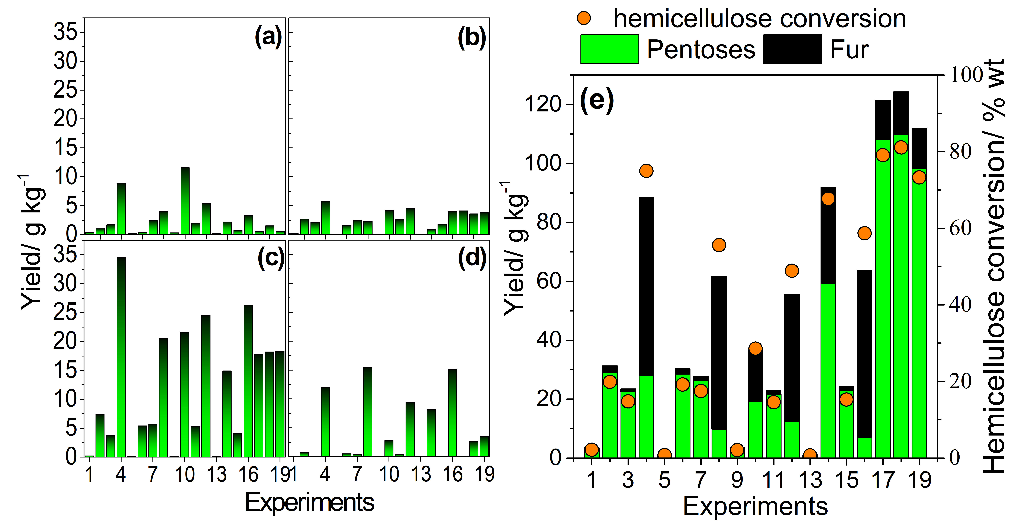
Figure 1: Degradation products (left), pentoses and Furfural yields and hemicellulose conversion (right) for factorial design experiments 2⁴. Glucuronic acid (a), formic acid (b), acetic acid (c) and levulinic acid (d)
The darker color of cellulignins subjected to higher levels of time and temperature can be attributed to two phenomena: First, the solubilization of hemicellulose guarantees more access to lignin, which, after being solubilized in the reaction medium, can condense again on the fibers, giving a dark color (Nitsos, Matis and Triantafyllidis, 2013). And second, parallel condensation and polymerization reactions of the furanic compounds (i.e.; HMF and furfural) occur forming dark hydrophobic solids known as hydrochar (Wang et al., 2018).
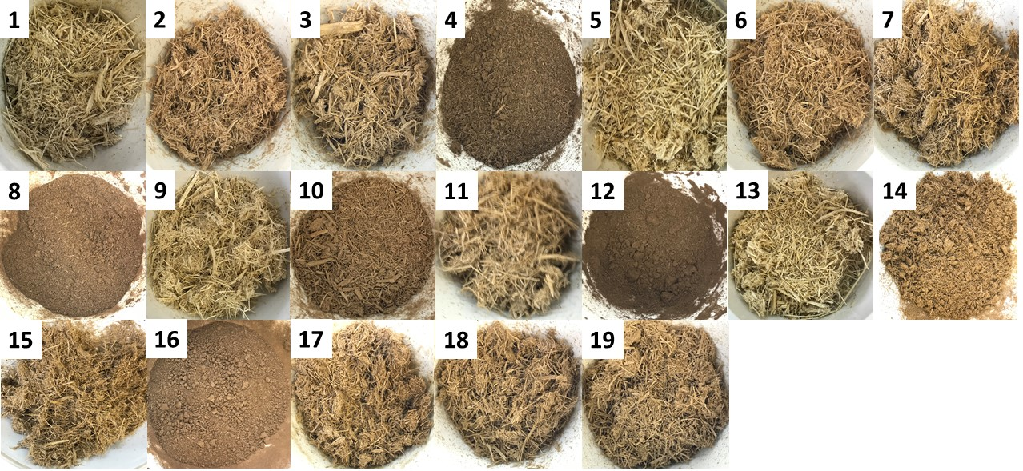
Figure 2: Solid fraction of 2⁴ factorial design experiments
  - Complete factorial design 2⁴ analysis
Figure 3 shows Pareto charts at a significance level of 0.065 for the main hemicellulose products. Because a lack of fit of the model it was not possible to make predictions. Therefore, only the coefficients weight were analyzed. The variables time and temperature were the most important and positive variables for furfural (Figure 3-c), and hemicellulose conversion (Figure 3-a). Thus, within the levels studied, when passing from the lowest level of temperature and time to the highest one, there was an increase in the hemicellulose conversion and furfural yield. This temperature effect was also observed to glucose yield (not showed here), and unlike xylose yield, for glucose the time was not significant. During the autohydrolysis reaction, to access the amorphous portion of cellulose and the consequent release of glucose, it is necessary to initially consume the hemicellulose, from which xylose molecules are released (Hernandéz-Beltrán et al., 2019). The interaction between temperature and time was negative and the most significant for xylose yield (Figure 3-b) and also for arabinose (not showed here). Therefore, keeping the highest temperature level studied adn going from the highest to the lowest time level, pentoses yield is positively impacted. The interaction between time and temperature was also significant and positive for the furfural yield. This result indicates that going from the lowest level to the highest of both simultaneously, a higher furfural yield was achieved. Longer exposure times of xylose molecules to high temperatures favor their consumption in dehydration reactions to form furfural. The same behavior was observed in HMF (not shown here) production from glucose molecules (Yemis and Mazza, 2012).
The interaction between time and agitation variables was significant and negative for hemicellulose conversion (Figure 3-a). Therefore, in the shortest reaction time and highest agitation level tested, a higher hemicellulose conversion was favored. We assume that higher levels of agitation promote a higher rate of effective collisions between reactant molecules allowing reactions to occur in a shorter time.
These results confirm published results in the literature. Vallejos et al. (2012) and Baêta et al. (2016) identified the variables temperature, time, and SLR as significant, at a significance level of 0.05, for obtaining carbohydrates. Our results, the SLR was not significant, since the parameters used were the yield standardized by the sugarcane bagasse mass (i.e.; g kg⁻¹). The cited authors used the concentration of these compounds in the liquor as analytical response.
Figure 3: Pareto charts of standard effects for temperature (T), time (t), SLR e agitation (Rpm) in hemicellulose conversion (a), release of xylose (b) and furfural (c) with a significance level of 0.065
The results presented in Figure 3 indicate the temperature and time are the most important variables of the process and must be used in their higher levels to convert the maximum hemicellulose. However, these conditions also favor the higher yields of furanic compounds, and that are not suitable for the use of liquor (Klinket al., 2004, Palmqvist and Hahn-Hägerdal, 2000). The xylose formation was higher when higher temperature levels and lower time levels were studied (Figure 3-b). Therefore, variables times and temperatures must be further optimized with lower time and higher temperature to obtain a liquor that is richer in carbohydrates and less concentrated in furanics.
- Conclusion
The best experimental condition of the complete factorial design 2⁴ (220 ºC, 60 min, 20 % of bagasse, and 60 rpm) allowed to obtain cellulignin with solubilization of a large part of the original hemicellulose (i.e., 81.1% of conversion) and high selectivity for xylose production (73.9 %). Under these conditions, it was possible to obtain a liquor rich in pentoses and poor in furfural (i.e., 109.9 g kg⁻¹ of pentoses and 14.4 g kg⁻¹ of furfural). Among the acids produced in the HPT process, acetic acid is produced in the greatest amount, i.e., 18.2 g kg⁻¹ under the conditions mentioned above. The color of cellulignins is directly related to the hemicellulose conversion and the furanic yield, being darker as it increases. The most significant variables for hemicellulose conversion, carbohydrate, and furanics production were time and temperature. An increase in temperature results in an increase in these responses. However, for the xylose production, higher temperature levels accompanied by a higher level of time decrease its production. The future development of this research is going to focus on the effect of temperature and time variables for cellulignin production and for obtaining a pentose-rich liquor.

Acknowledgments
This study is supported by Biovalue Project (Petrobras, Suzano Papel e Celulose, Klabin, Embraer), FAPEMIG, FAPESP, FACEPE and FAPERGS.
References

Baêta B.E.L., lima D.R.S., Adarme O.F.H., Gurgel L.V.A., de Aquino S.F., 2016, Optimization of sugarcane bagasse autohydrolysis for methane production from hemicellulose hydrolyzates in a biorefinery concept, Bioresource Technology, 200, 137–146.
Gírio, F.M., Fonseca C. Carvalheiro F., Duarte L.C., Marques S., Bogel-Lukasik R., 2010, Hemicelluloses for fuel ethanol: a review, Bioresource Technology, 101(13), 4775-4800.
Harahap B.M., 2020, Degradation techniques of hemicellulose fraction from biomass feedstock for optimum xylose production: a review, Jurnal Keteknikan Pertanian Tropis dan Biosistem, 8(2), 1-18.
Hernández-Beltrán J.U., Lira H.D., Omar I., Cruz-Santos M.M. Saucedo-Luevanos A., Hernadéz-Terán F., Balagurusamy N., 2019, Insight into pretreatment methods of lignocellulosic biomass to increase biogas yield: current state, challenges, and opportunities, Applied Sciences, 9(18), 3721.
Klinke H.B., Thomsen A.B., Ahring B.K., 2004, Inhibition of ethanol-producing yeast and bacteria by degradation products produced during pretreatment of biomass, Applied Microbiology and Biotechnology, 66(1), 10-26.
Mosier N., 2005, Features of promising technologies for pretreatment of lignocellulosic biomass, Bioresource Technology, 96(6), 673–686.
Nitsos, C.K., Matis K.A., 2013, Triantafyllidis K.S., Optimization of hydrothermal pretreatment of lignocellulosic biomass in the bioethanol production, 6, 110-122.
Palmqvist E., Hahn-Hägerdal B., 2000, Fermentation of lignocellulosic hydrolysates. II: inhibitors and mechanisms of inhibition, Bioresource technology, 74(1), 25-33.
Santos V.E.N., Ely R.N., Szklo A.S., Magrini A., 2016, Chemicals, electricity and fuels from biorefineries processing Brazil׳s sugarcane bagasse: production recipes and minimum selling prices, Renewable and Sustainable Energy Reviews, 53, 1443-1458.
Satari B., Karimi K., Kumar R., 2019, Cellulose solvent-based pretreatment for enhanced second-generation biofuel production: A review, Sustainable Energy & Fuels, 3(1), 11–62.
Vallejos M.E., Zambon M.D., Area M.C., da Silva C.A.A., 2012, Low liquid–solid ratio (LSR) hot water pretreatment of sugarcane bagasse, Green Chemistry, 14(7), 1982-1989.
Wang T., Zhay Y., Zhu Y., Li C., Zeng G., 2018, A review of the hydrothermal carbonization of biomass waste for hydrochar formation: Process conditions, fundamentals, an physicochemical properties, Renewable and Sustanable Energy Reviews, 90, 223-247.
Xie R., Tu M., Wu Y., Adhikari S., 2011, Improvement in HPLC separation of acetic acid and levulinic acid in the profiling of biomass hydrolysate, Bioresource Technology, 102(7), 4938-4942.
Yang B., Tao L, Wyman C.E., 2018, Strengths, challenges, and opportunities for hydrothermal pretreatment in lignocellulosic biorefineries, Biofuels, Bioproducts and Biorefining, 12(1), 125-138.
Yemis O., Mazza G., 2012, Optimization of furfural and 5-hydroxymethylfurfural production from wheat straw by a microwave-assisted process, Bioresource Technology, 109, 215-223.
Yu Q., Xinshu Z., Shuangliang Lv., Minchao He, Yu Z., Zhenhong Y., Wei Qi, Qiong W., Wen W., Xuesong T., 2013, Liquid hot water pretreatment of sugarcane bagasse and its comparison with chemical pretreatment methods for the sugar recovery and structural changes, Bioresource Technology, 129, 592–598.
Yu Q., Zhuang X., Yuan Z., Wang Q., Wang W., Zhang Y., Xu J., Xu H., 2010, Two-step liquid hot water pretreatment of Eucalyptus grandis to enhance sugar recovery and enzymatic digestibility of cellulose, Bioresource Technology, 101(13), 4895-4899.

