|  |  |
| --- | --- |
| cetlogo ***CHEMICAL ENGINEERING TRANSACTIONS***  ***VOL. 92, 2022*** | A publication of  aidiclogo_grande |
| The Italian Association  of Chemical Engineering  Online at www.cetjournal.it |
| Guest Editors: Rubens Maciel Filho, Eliseo Ranzi, Leonardo Tognotti  Copyright © 2022, AIDIC Servizi S.r.l. **ISBN** 978-88-95608-90-7; **ISSN** 2283-9216 | |

Multi-Biomass Refinery Siting: A GIS Geospatial Optimisation Approach

Mohammad Alherbawia, Gordon McKaya, Hamish R. Mackeya, Tareq Al-Ansaria,\* aCollege of Science and Engineering, Hamad Bin Khalifa University, Qatar Foundation, Doha, Qatar.

talansari@hbku.edu.qa

**Abstract**

Biomass feedstock is a key sustainable alternative to the finite fossil resources to produce fuels and chemicals. Biomass sources vary from energy crops to a wide range of municipal, agricultural, and industrial wastes. Therefore, it is attracting growing attention due to its wide availability in almost every country worldwide. However, due to the irregular generation and the scattered distribution of biomass resources, the design of supply chains and the selection of refinery sites become a challenging task. As such, this study presents a framework for an optimal site selection of a multiple biomass refinery. Qatar is chosen as the case study, whereby, its main sources and locations of biomass are identified. While a mathematical optimisation model is established by utilising the geographic information system (GIS) and analytical hierarchy process (AHP) to spot optimal biorefinery sites that may enhance the supply chain of available biomass. Multiple criteria are considered in the model including the site accessibility to key infrastructural facilities, as well as biomass locations, availability, and calorific values. While several constraints are employed to alleviate social and environmental concerns. The model generates several candidate sites, which are then reduced to a single optimal site (at coordinates: 25.144, 51.351). The selected optimal site is believed to maximise the potential biomass energy supply and enhance the biomass supply chain through minimising biomass transportation cost, which is evaluated at an average of 7 $/tonne.

**Keywords:** Biomass, Biorefinery siting, Supply chain, GIS, AHP, MCLP, Qatar.

* 1. Introduction

The continuous development of biomass processing technologies created great momentum for biorefineries establishment, especially in countries with depleting or no oil resources. Biomass-based biofuels occupies nearly 70% of global gross renewable mix (WBA, 2019), which is expected to increase with the great price fluctuation of fossil-based fuels and the global rising concerns on climate change issues.

Meanwhile, several technologies have been developed to accommodate different biomass categories, including the traditional anaerobic digestion to valorise putrescible materials (Mubeen and Buekens, 2019), gasification and pyrolysis to accommodate low-moisture lignocellulosic biomass (AlNouss et al., 2020b; Elkhalifa et al., 2019), hydrothermal liquefaction to liquefy wet biomass (Alherbawi et al., 2021), as well as incineration for direct power generation.

In addition, a considerable effort has been made to develop integrated technologies that combine multiple processes to valorise different biomass types (Al-Ansari et al., 2020; Baliban et al., 2010; Dias et al., 2014; Floudas et al., 2012; Magdeldin et al., 2018; Neves et al., 2020).

In this context, the identification of biomass refinery sites is becoming more important and challenging due to the extremely irregular generation and scattered distribution of biomass resources. Several approaches have been earlier proposed for biorefinery siting. Martinkus et al. (2017) combined social and biogeophysical analysis to spot and evaluate pulp mills potential to be turned into biorefineries. Whereas, Marvin et al. (2013) and Ng and Maravelias (2017) proposed different mixed integer linear program (MILP) models to identify an economic biorefinery site through enhanced supply chains. Meanwhile, AlNouss et al. (2020a) developed a computational intelligence framework for the design of biomass supply chains based on the artificial neural network (ANN) approach.

This study proposes a multi-criteria GIS-approach based on the maximal coverage location problem (MCLP) models to identify an optimal multiple biomass refinery site in the State of Qatar. A wide-range biomass availability and geospatial data are collected and mapped, while an optimised initial infrastructure map of Qatar is developed considering developmental, social and environmental aspects. Candidate nodes are identified based on suitability analysis with the aid of the analytical hierarchy process (AHP), while a mathematical MCLP model is solved in ArcGIS (V10.7.1) to identify the optimal biorefinery site amongst the candidate nodes, in which the biomass supply chain is enhanced, transportation costs into the refinery are minimised, and potential biomass energy supply is maximised.

* 1. Methodology

Identification of the optimal site for a biorefinery setup is dependent on multiple criteria including the availability, distribution, and calorific value of biomass resources, as well as the accessibility of the proposed site to electricity, water, and roads network, in addition to several other environmental and social criteria. The methodological framework to define the optimal biorefinery site is detailed out through the following subsections.

* + 1. Data collection

The sources of different municipal, industrial and agricultural wastes are selected carefully to ensure a regular and long-term biomass generation in the State of Qatar. Amongst the selected sources are large scale facilities such as wastewater treatment plants (WWTPs), oil and gas refineries, municipal waste collection and landfill sites, as well as key agricultural, poultry and dairy production farms. The data on the availability and distribution of biomass are collected and evaluated in terms of potential annual generation (tonnes/y) and calorific values (GJ/y) (AlrayyanTV, 2018; MDPS, 2018; Ministry of Development Planning and Statistics, 2013; Planning and Statistics Authority of Qatar, 2021; Qatarpetroleum, 2019). In addition, the spatial distribution of the selected biomass is mapped in ArcGIS as illustrated in Figure 1. The targeted biomass categories comprise industrial wastes, sewage sludge, tires, municipal solid wastes (MSW), agro-wastes and five different types of livestock manures.

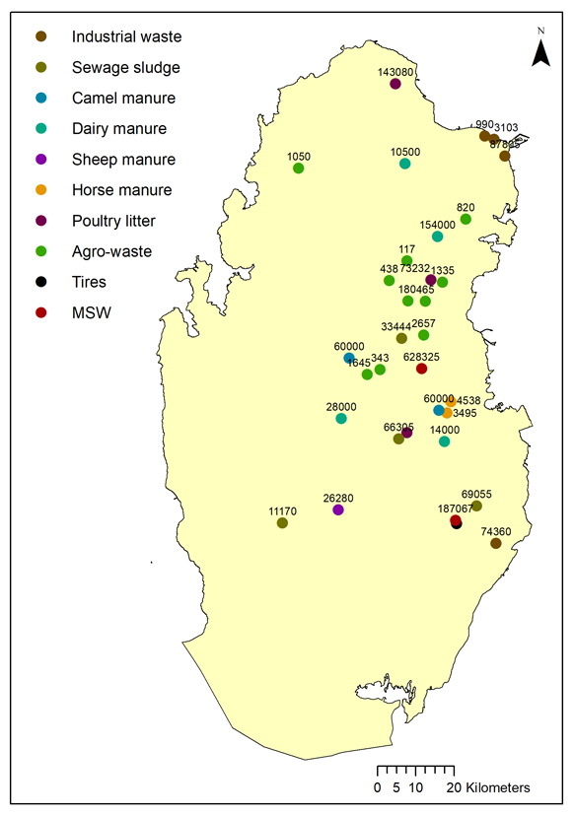

*Figure 1: Geospatial distribution of key biomass resources and quantities in Qatar.*

* + 1. Infrastructure’s mapping

A biorefinery access to key infrastructural facilities is crucial to define its initial candidate sites. As such, this study identified three key infrastructural criteria: roads, electricity and water networks. The detailed extent of the aforementioned networks in Qatar are adapted from Qatar’s Atlas (Qatar Statistics Authority, 2013) and re-mapped in ArcGIS as presented in Figures 2a, 2b and 2c.

The Euclidean distance function of ArcGIS is utilised to plot a criteria map for each network, which is calculated from the Cartesian coordinates for each point in the network using the Pythagorean theorem. All areas that are within 2 km of each network are defined as “highly suitable” to establish the biorefinery, while the areas located between 2-4 km of each network are defined as “moderately suitable”. Whereas all the remaining area is identified as “non-suitable” due to the lack of access to key infrastructural facilities.

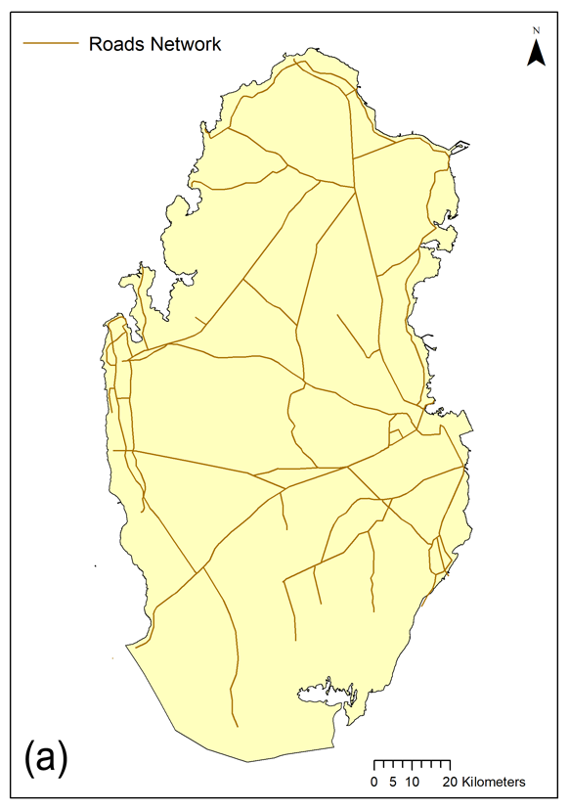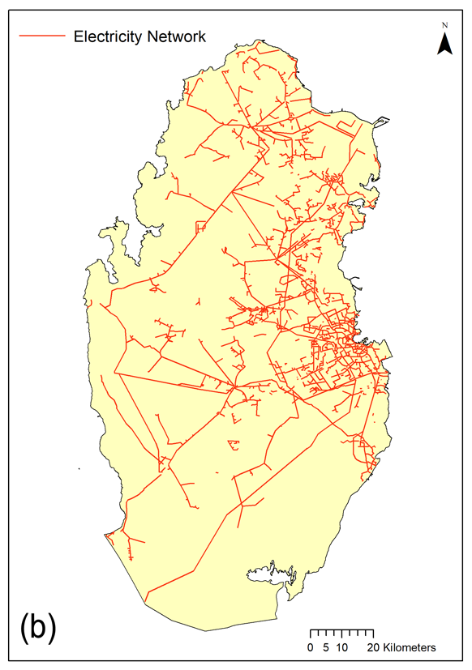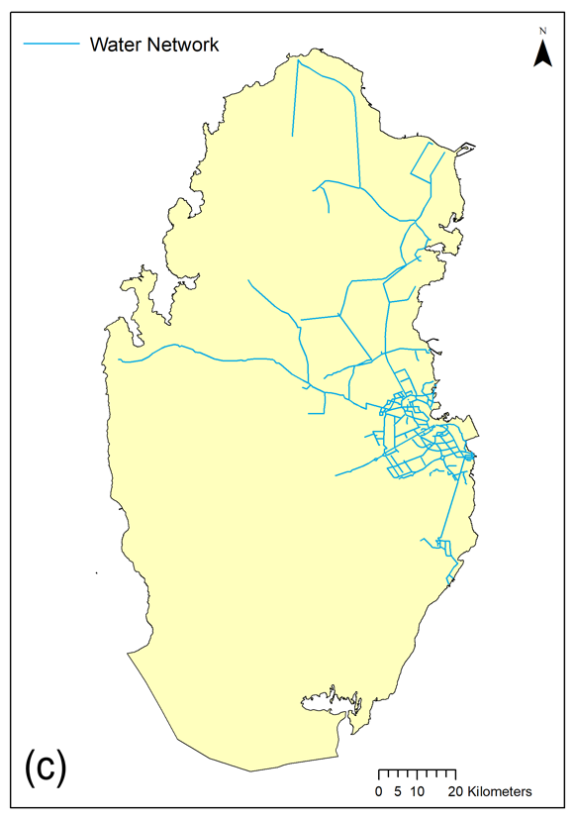 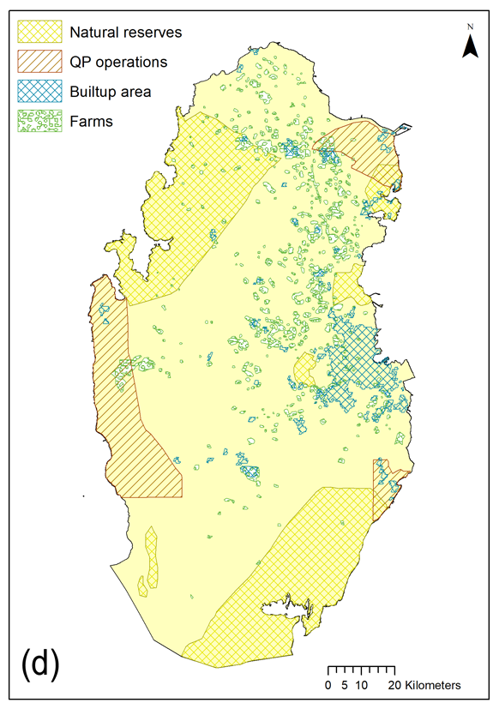

Figure 2: Key infrastructural facilities in Qatar including a) roads network, b) electricity network, c) water network, and d) defined restricted areas.

A composite suitability map optimising the accessible area based on the three criteria maps is generated using the map algebraic function of ArcGIS based on Eq(1).

|  |  |
| --- | --- |
| *Site suitability = $\sum_{i=1}^{3}{({RW}_{i}* C_{i})}$*  Where, *RWi*: is the relative weight of criterion *Ci*. | (1) |

The relative weight of each criterion is estimated with the aid of the analytical hierarchy process (AHP) (Saaty, 1999), through which a pair-wise comparison table is developed (Table 1). Using AHP tool, both qualitative and quantitative characteristics of the problem are collectively regarded.

The pair-wise comparison is conducted through comparing each criterion in the left column to the criteria in the top row in terms of relative importance for the problem in hand. A value from 1 to 9 is allocated to indicate the relative importance, with 1 indicating equal importance, and 9 indicating the highest importance gap between the criteria pair. The pair-wise matrix presented in Table 1 is then normalised by dividing each cell by the column’s sum, in which the cell exists. Finally, the average of each row in the normalised pair-wise matrix is calculated, which represents the relative weight of the corresponding criterion. The consistency of the estimated relative weights is tested using the consistency ratio approach (Saaty, 1988). Consistency ratios below 10% indicate a valid pair-wise comparison and reasonable obtained criteria relative weights.

Furthermore, several restricted areas are defined to alleviate social and environmental concerns as illustrated in Figure 2d. Whereby all settlements and agricultural areas are restricted with an additional 1 km buffer zone beyond them. Besides, natural reserves and Qatar Energy concessions area (formerly known as Qatar Petroleum) are completely restricted to avoid being selected in the process.

The obtained final composite infrastructural criteria map is reclassified into 10 classes of suitability, with classes 9 and 10 representing the highly suitable areas for biorefinery establishment. A fishnet of nodes’ matrix with (1x1 km) actual spacing is created over the composite suitability map, whereby the value of each node is extracted based on its position in the map. All nodes that scored (≥9) are considered as initial potential candidate sites, while the remaining nodes are excluded from the process.

Table 1: AHP’s pair-wise comparison matrix of identified infrastructural criteria.

|  |  |  |  |
| --- | --- | --- | --- |
|  | Road network | Electricity network | Water network |
| Road network | 1.00 | 3.00 | 5.00 |
| Electricity network | 0.33 | 1.00 | 3.00 |
| Water network | 0.20 | 0.33 | 1.00 |

* + 1. Optimal site selection

The final stage of siting optimisation process is established using the location-allocation function of ArcGIS considering the previously obtained candidate sites with reference to biomass spatial distribution, potential gross calorific value and associated costs of their transportation into the biorefinery.

The biomass transportation cost is evaluated using Eq(2):

|  |  |
| --- | --- |
| *Cost($) =*  Where, *Qi*: is the biomass quantity at site (*i*) (tonnes), *Di:* is the site (*i*) distance from biorefinery (km), L: is regular freight load (tonnes), and C: is transportation cost per km travelled ($/km). | (2) |

The location-allocation function of network analyst module is meant to find the site that can effectively accommodate the supply/demand points. The algorithm solves for the different candidate sites to select one or more sites that can best achieve the objective. The aim in this problem is to minimise the overall travelling distance and therefore transportation costs, while maximising the gross calorific value of collected biomass. As such, it is a maximal coverage location problem (MCLP), which can be defined as per the following mathematical model in Eq(3-5) (Church and ReVelle, 1974):

|  |  |
| --- | --- |
| *Maximise $\sum_{i=1 }^{n}{\left(E_{i}*B_{i}\right)}$*  *Subject to: $\sum_{j∊Ni}{S_{j}}≥ B_{i}$ $∀i$*  (Accounts for biomass supply sites within the biorefinery coverage) $\sum_{j}{S_{j}}=1$ *(Only 1 biorefinery site to be selected)*  *Decision variables:*  *Sj* =  *Bi* =  Where,  *i*: is the set of biomass supply sites.  *j*: is the set of initial biorefinery candidate sites.  *Ei*: potential gross energy content of biomass (GJ/y) at site *“i”.*  *Bi*: Biomass supply site *“i”.*  *Sj*: Candidate biorefinery site *“j”.*  *dij*: the shortest distance from site *“i”* to site *“j”.*  *D: distance beyond the biorefinery coverage.*  *Ni=*{*j∊J | dij ≤D*} | (3)  (4)  (5) |

* 1. Results and Discussion

The AHP’s relative weights of infrastructural criteria achieved a consistency ratio of 3.34%, which is way below the threshold of 10%, indicating a consistent and reasonable pairwise comparison. The resulting relative weights are 63%, 26% and 11% for roads, electricity, and water networks, respectively. Roads’ network is given the highest importance due to the high associated costs for paving new roads in distant areas, followed by electricity and then water connection to main supplying nodes. Besides, electricity can be generated on-site as commonly practiced in biorefineries.

* + 1. Composite infrastructure suitability map

The composite suitability map is illustrated in Figure 3a, presenting different site suitability levels, as well as restricted areas. Whereas Figure 3b represents the initial candidate sites based on the suitability map. The model identified 166 candidate sites with excellent access to roads, electricity, and water infrastructures. The candidate sites are concentrated in northern, southeastern, western, and central parts of Qatar. While they are relatively close to many of the biomass supplying sites.

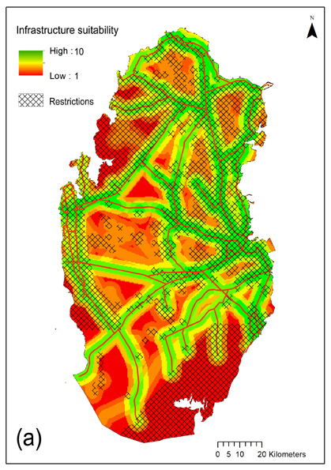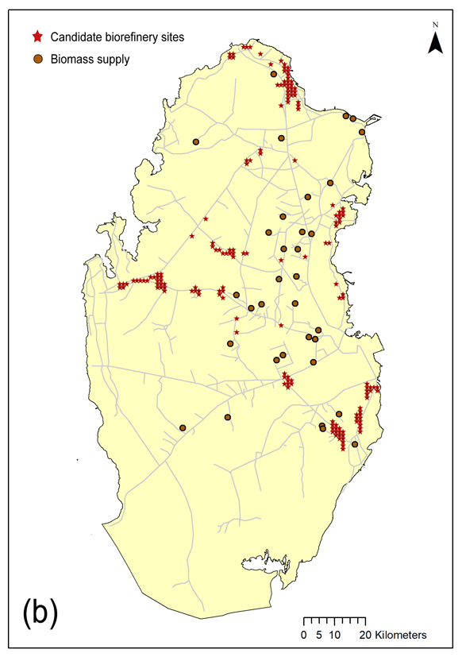

Figure 3: a) Composite suitability map for biorefinery establishment, and b) candidate biorefinery sites.

* + 1. Optimal biorefinery site

The MCLP model in ArcGIS selected the candidate site (25.144, 51.351) as the optimal biorefinery site. The selected site is located in the south-eastern part of Qatar, around 5 km west of the Doha industrial area. The site has a perfect access to the infrastructural facilities considered in this study, whereby it has a direct access to the Abu-Nakhla Road, while it is 1.2 km away from the Orbital Highway, which is one of the most vital highways and truck routes (195 km-long) that connects between the northern and southern parts of Qatar, bypassing the jammed Doha capital. Nevertheless, the site has a relatively close access to the highest energy generating biomass sites as presented in Figure 4.

Considering an LZV freight load of 18.7 tonne and an average cost of 2 $/km (Meulen et al., 2020), biomass can be transported from the various supplying sites to the selected biorefinery site with an average cost of 7.03 $/tonne.

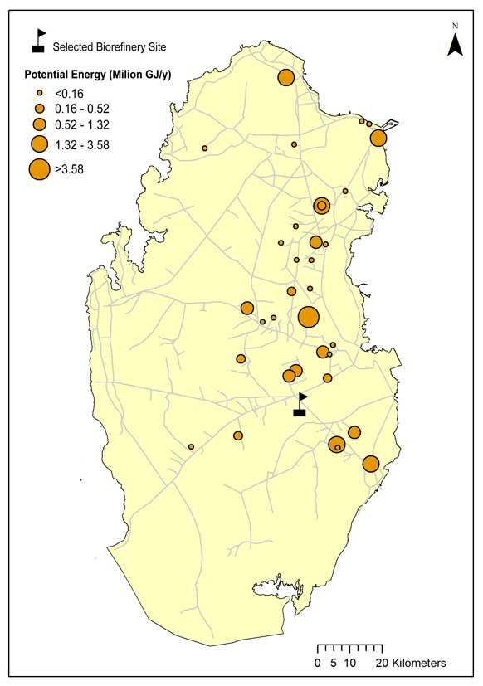

Figure 4: Final selected biorefinery site, and the energy supply potential at different biomass sites.

* 1. Conclusions

This study presented an ArcGIS-based framework for biorefinery siting based on multiple economic, developmental, social and environmental criteria. The framework integrates the AHP process, suitability analysis and network analysis using MCLP models. The optimal selected site (at 25.144, 51.351) is believed to maximise biomass energy supply with the least transportation cost, which is evaluated at an average of 7 $/tonne biomass.

References

Al-Ansari, T., AlNouss, A., Al-Thani, N., Parthasarathy, P., ElKhalifa, S., Mckay, G., Alherbawi, M., 2020. Optimising Multi Biomass Feedstock Utilisation Considering a Multi Technology Approach, in: Pierucci, S., Manenti, F., Bozzano, G.L., Manca, D.B.T.-C.A.C.E. (Eds.), 30 European Symposium on Computer Aided Process Engineering. Elsevier, pp. 1633–1638. https://doi.org/https://doi.org/10.1016/B978-0-12-823377-1.50273-1

Alherbawi, M., Parthasarathy, P., Al-Ansari, T., Mackey, H.R., McKay, G., 2021. Potential of drop-in biofuel production from camel manure by hydrothermal liquefaction and biocrude upgrading: A Qatar case study. Energy 121027. https://doi.org/https://doi.org/10.1016/j.energy.2021.121027

AlNouss, A., Govindan, R., McKay, G., Al-Ansari, T., 2020a. Development of a Computational Intelligence Framework for the Strategic Design and Implementation of Large-scale Biomass Supply Chains, in: Pierucci, S., Manenti, F., Bozzano, G.L., Manca, D.B.T.-C.A.C.E. (Eds.), 30 European Symposium on Computer Aided Process Engineering. Elsevier, pp. 1627–1632. https://doi.org/https://doi.org/10.1016/B978-0-12-823377-1.50272-X

AlNouss, A., McKay, G., Al-Ansari, T., 2020b. Production of syngas via gasification using optimum blends of biomass. J. Clean. Prod. 242, 118499. https://doi.org/https://doi.org/10.1016/j.jclepro.2019.118499

AlrayyanTV, 2018. Made in Qatar Series.

Baliban, R.C., Elia, J.A., Floudas, C.A., 2010. Toward Novel Hybrid Biomass, Coal, and Natural Gas Processes for Satisfying Current Transportation Fuel Demands, 1: Process Alternatives, Gasification Modeling, Process Simulation, and Economic Analysis. Ind. Eng. Chem. Res. 49, 7343–7370. https://doi.org/10.1021/ie100063y

Church, R., ReVelle, C., 1974. The maximal covering location problem, in: Papers of the Regional Science Association. Springer-Verlag, pp. 101–118.

Dias, M., Cavalett, O., Maciel Filho, R., Bonomi, A., 2014. Integrated first and second generation ethanol production from sugarcane. Chem. Eng. Trans. 37, 445–450.

Elkhalifa, S., Al-Ansari, T., Mackey, H.R., McKay, G., 2019. Food waste to biochars through pyrolysis: A review. Resour. Conserv. Recycl. 144, 310–320. https://doi.org/https://doi.org/10.1016/j.resconrec.2019.01.024

Floudas, C.A., Elia, J.A., Baliban, R.C., 2012. Hybrid and single feedstock energy processes for liquid transportation fuels: A critical review. Comput. Chem. Eng. 41, 24–51. https://doi.org/https://doi.org/10.1016/j.compchemeng.2012.02.008

Magdeldin, M., Kohl, T., Järvinen, M., 2018. Techno-economic Assessment of Integrated Hydrothermal Liquefaction and Combined Heat and Power Production from Lignocellulose Residues. J. Sustain. Dev. Energy, Water Environ. Syst. 6, 89–113.

Martinkus, N., Rijkhoff, S.A.M., Hoard, S.A., Shi, W., Smith, P., Gaffney, M., Wolcott, M., 2017. Biorefinery site selection using a stepwise biogeophysical and social analysis approach. Biomass and Bioenergy 97, 139–148. https://doi.org/https://doi.org/10.1016/j.biombioe.2016.12.022

Marvin, W.A., Schmidt, L.D., Daoutidis, P., 2013. Biorefinery Location and Technology Selection Through Supply Chain Optimization. Ind. Eng. Chem. Res. 52, 3192–3208. https://doi.org/10.1021/ie3010463

MDPS, 2018. Water Statistics in the State of Qatar 2017.

Meulen, S. van der, Grijspaardt, T., Mars, W., Geest, W. van der, Roest-Crollius, A., Kiel, J., 2020. Cost Figures for Freight Transport.

Ministry of Development Planning and Statistics, 2013. Environment Statistics Annual Report 2013.

Mubeen, I., Buekens, A., 2019. Chapter 14 - Energy From Waste: Future Prospects Toward Sustainable Development, in: Kumar, S., Kumar, R., Pandey, A.B.T.-C.D. in B. and B. (Eds.), . Elsevier, pp. 283–305. https://doi.org/https://doi.org/10.1016/B978-0-444-64083-3.00014-2

Neves, R.C., Klein, B.C., da Silva, R.J., Rezende, M.C.A.F., Funke, A., Olivarez-Gómez, E., Bonomi, A., Maciel-Filho, R., 2020. A vision on biomass-to-liquids (BTL) thermochemical routes in integrated sugarcane biorefineries for biojet fuel production. Renew. Sustain. Energy Rev. 119, 109607. https://doi.org/https://doi.org/10.1016/j.rser.2019.109607

Ng, R.T.L., Maravelias, C.T., 2017. Design of biofuel supply chains with variable regional depot and biorefinery locations. Renew. Energy 100, 90–102. https://doi.org/https://doi.org/10.1016/j.renene.2016.05.009

Planning and Statistics Authority of Qatar, 2021. Statistical Maps of Qatar [WWW Document]. URL https://gis.psa.gov.qa/QatarAtlas/StatisticalSector?Left\_Menu\_DIV=Settlements\_Census1986\_2020&Left\_Menu\_DIV\_SubItem=MenuItem\_Settlements\_0 (accessed 3.20.21).

Qatar Statistics Authority, 2013. Qatar Atlas.

Qatarpetroleum, 2019. Qatar Petroleum Sustainability Report 2019.

Saaty, T.L., 1999. Basic theory of the analytic hierarchy process: How to make a decision. Rev. la Real Acad. Ciencias Exactas Fis. y Nat. 93, 395–423.

Saaty, T.L., 1988. What is the analytic hierarchy process?, in: Mathematical Models for Decision Support. Springer, pp. 109–121.

WBA, 2019. Global Bioenergy Statistics 2019.