CHEMICAL ENGINEERING TRANSACTIONS  VOL. 92, 2022 | A publication of
The Italian Association
of Chemical Engineering
Online at www.cetjournal.it

Guest Editors: Rubens Maciel Filho, Eliseo Ranzi, Leonardo Tognotti
Copyright © 2022, AIDIC Servizi S.r.l.
ISBN 978-88-95608-90-7; ISSN 2283-9216

Advanced biomass-to-value chains by integrating hydrothermal carbonization into complex conversion process schemes
Alberto Gallifuoco*, Luca Taglieri, Alessandro A. Papa, Andrea Di Carlo
Department of Industrial and Information Engineering & Economics, University of L’Aquila, Piazzale Ernesto Pontieri 1, Monteluco di Roio, 67100 - L'Aquila, Italy

This study explores the potential of biomass hydrothermal carbonization (HTC) for developing innovative, integrated waste-to-value conversion chains. Experiments with two lignocellulosic residuals, silver fir sawdust (FIR) and wheat straw (STRAW), give valuable hints for foreshadowing novel process schemes. The batch carbonization reactions lasted from 0 to 120 min, at constant water/biomass ratios (FIR, 7/1; STRAW, 5/1), at 180, 200, and 230 °C, and autogenous pressure. Within the first 60 min of reaction, both biomasses release green platform chemicals in the liquid phase at increasing concentrations without resorting to catalysts or additives. Longer reaction times cause the depletion of liquid-phase chemicals due to secondary hydrochar production. The highest concentrations of 5-hydroxymethylfurfural (80 mM) and furfural (400 mM) detected with FIR suggest exploiting this biomass in a short-time HTC, renouncing the improvement of the solid fuel. Waste-to-energy is unanimously considered the route of choice for STRAW. In this case, the conventional use of HTC would be pre-treating the biomass for feeding a gasification stage properly. Evidence of this study suggests that a two-step HTC would combine the requirements of fuel production with those of recovery of value-added chemicals from the liquid phase. During the reactor warm-up to 230 °C, furfural concentration builds up to 300 mM, then halves within the first 15 min of the HTC process and drops to zero at 120 min, a reaction time required for a satisfactory STRAW energy densification (raw biomass, 15 MJ/kg; 120 min hydrochar, 21 MJ/kg). The results of this study pave the way for further investigation aiming to set the optimal operational conditions.
  - Introduction
The sustainable exploitation of residual biomasses is a crucial issue for mitigating the impact of human activities on the climate. Thus, chemical engineering needs to design efficient, intensified, and integrated processes to boost cleaner conversions while preserving competitiveness through innovation (Fankhauser et al., 2013). Biomass-to-energy chains with negative net carbon emissions are not per se devoid of bottlenecks and potential environmental issues (Cheong and Apblett, 2022). As a typical example, although biomass gasification technology came to maturity (Heidenreich et al., 2016), the processing of high moisture and ash containing residuals entails costly pre-drying and off-specification tar and sulfur content in the raw gas from the gasifier. A pre-treatment with hydrothermal carbonization (HTC) would be the proper recipe for overcoming these bottlenecks (Erlach et al., 2012). In a timescale of 1-2 hours, the reactions occurring in crude biomass and hot compressed water slurries would produce a coal-like solid (hydrochar) adequate for feeding advanced gasifiers (Prifti et al., 2021). The accurate tuning of HTC operational conditions is primary, as they affect the performance of the downstream gasifier (Quadi et al., 2019). Advanced gasification processes could also benefit from the integration with HTC. A previous paper demonstrated a satisfactory energy analysis of a combined process scheme with lignocellulosic biomass HTC, gasification, and solid oxide fuel cell technology (Papa et al., 2021), thus encouraging further investigation on this way. HTC is a mild, versatile process that adapts to a wide range of raw biomasses and fits nicely into the biorefinery concept. In the authors' opinion, it would be simplistic to use it only as a pre-treatment for confining unwanted chemical moieties into its process water. More advanced, integrated process schemes pivoting on HTC are conceivable and worth investigating by expressly designed experiments. The present paper steps following the search for combined process schemes, pivoting on HTC, which pursue the complete sustainability of biomass chains integrating non-energy utilizations of the hydrochar and the recovery of platform chemicals from the liquid phase. The experiments took place in a 250 ml batch reactor, at 180, 200, and 230 °C and analyzed the time course of the solid and liquid phase up to 2 hours. The study focuses on wood residuals, silver fir (FIR) and wheat straw (STRAW), abundant raw biomasses from the Mediterranean agro-industrial activities. FIR, already characterized for the kinetics of hydrochar formation (Gallifuoco et al., 2018), is commonly available in bulk quantities and potentially interesting for developing innovative biomass-to-value chains exploiting the HTC liquid phase. STRAW is carbon-neutral agricultural biomass worldwide produced in massive amounts (Singhal et al., 2021). Compared to woody biomass, STRAW has poorer combustion properties that force researching the proper pretreatment, most likely a tailored HTC.
This study highlights the importance of monitoring the reacting system during the HTC process and the possibility to control the process by measuring lumped properties of the liquid phase. The results furnish valuable information for foreshadowing some innovative process schemes, illustrated in detail, for the integrated use of HTC in the industrial conversion of biomass to energy and value-added products.
  - Materials and methods
    - Materials
All experiments and analyses used reagent-grade chemicals from the laboratory products market and ultrapure demineralized water. From local forest maintenance activities, FIR was rasped to needle-shaped particles, on average 0.5x0.2 cm. STRAW, collected from the regional agroindustry, is in the form of rods (1x0.3 cm). The raw biomasses were oven-dried at 105 °C up to constant weight and stored at room temperature in sealed vessels for the subsequent experiments.
    - HTC reactions
A detailed description of the HTC apparatus appears elsewhere (Gallifuoco et al., 2017). Briefly, the equipment consists of two twin 250 cm³ stainless-steel vessels. The first one is the reactor, the second one, used optionally, allows the end-reaction quenching by a flash expansion. The water/biomass ratios were 7/1 and 5/1 for FIR and STRAW, respectively. Ten grams of dry solid and the amount of water for the proper ratio were loaded into the reactor; the vessel was sealed and evacuated of air with a vacuum pump (ABM model 3EKF56). A temperature ramp of 9 °C/min warmed the reactor to the setpoint temperature. The study concerned six reaction times (0, 10, 15, 30, 60, and 120 min) and autogenous equilibrium pressure.
Time zero means that the reactor is quenched upon reaching the setpoint temperature. The reactor quenching follows two different procedures at the end of the reaction. The first one (NoExp) lasts 4 min and involves two steps: compressed air external blowing (down to 150 °C) and cold-water bath immersion up to room temperature. In the second quenching procedure (Exp), an initial flash step lasts ten seconds. The reactor fluid expands into the twin vessel, which recovers most of the liquid phase. The final cooling down from 150 °C to room temperature occurs in the water bath. In this case, the total quenching time is 1 min. Before opening the reactor, the gas phase is recovered in a balloon in both procedures. The total gas formed (2% w/w of the dry biomass, on average, prevalently CO₂) is the sum of that recovered plus the aliquot contained at atmospheric pressure in the known dead volume. The separation of condensed products by filtration gave the liquid, stored at 4 °C, and the solid, oven-dried at 105 °C up to constant weight and stored at room temperature. All kinetic runs were conducted once, provided that the overall relative error is about 4% in hundreds of previous experiments.
    - Analytical
Hydrochar ultimate analyses went according to ASTM D3176-89-2002 using a Perkin Elmer 2400 Series II elemental analyzer. Solid yields and dry weight determination followed UNI EN ISO 18134-2, 2015. The optical density of HTC liquids (OD) was measured, using water as a reference, with a Perkin-Elmer Lambda 1050 spectrometer, 100 mm PbS integrating sphere. The liquid phases were assayed for the selected platform chemicals via GC-MS with a Gas Chromatograph Agilent 7890A equipped with the Agilent MSD-Triple Axis Detector 5975C. The column was an Agilent 19091S-433 HP (5% Phenyl-ethyl polysiloxane, 30 m x 0.25 mm, film thickness 0.25 μm). The carrier gas was Helium, 1 ml/min, temperature ramp 36 – 220 °C at 7 °C/min. The concentrations detected in the samples were calculated by reference to pure standard solutions. According to Nelson's method, the reducing power (RP) was measured by the OD at 520 nm using D-glucose as standard. The electrical conductivity (EC) was measured with the Amel Instruments 96117. Total organic carbon (TOC) and total carbon (TC) were determined with the Hac-Lange procedure (Spectrophotometer DR 6000 and analytic kit LCK 381). Each of the previously described analyses was in triplicate.
  - Results and discussion
By inserting a downstream flash expansion step, the industrial HTC reactor would benefit from reducing cooling time. Besides, the hydrochar dry substance content would increase to that usually obtained by mechanical drying without additional costs. Given an integrated process devoted to enhancing biomass combustion properties and producing value-added chemicals, it would be worth investigating the effect of the flash on the liquid phase composition. Hence, the study compares the liquid phases obtained with FIR under the same conditions but with and without expansion. Lumped measurements would be a precious tool for monitoring and controlling the HTC time course before a detailed analysis of the products. Figure 1 exemplifies this philosophy showing the UV absorption spectra of the liquid phases after the different reaction times with (a) and without (b) the expansion. In both cases, the optical density (OD) depends strongly on the wavelength and increases with the reaction time up to 60 min of reaction, then decreases sensibly.

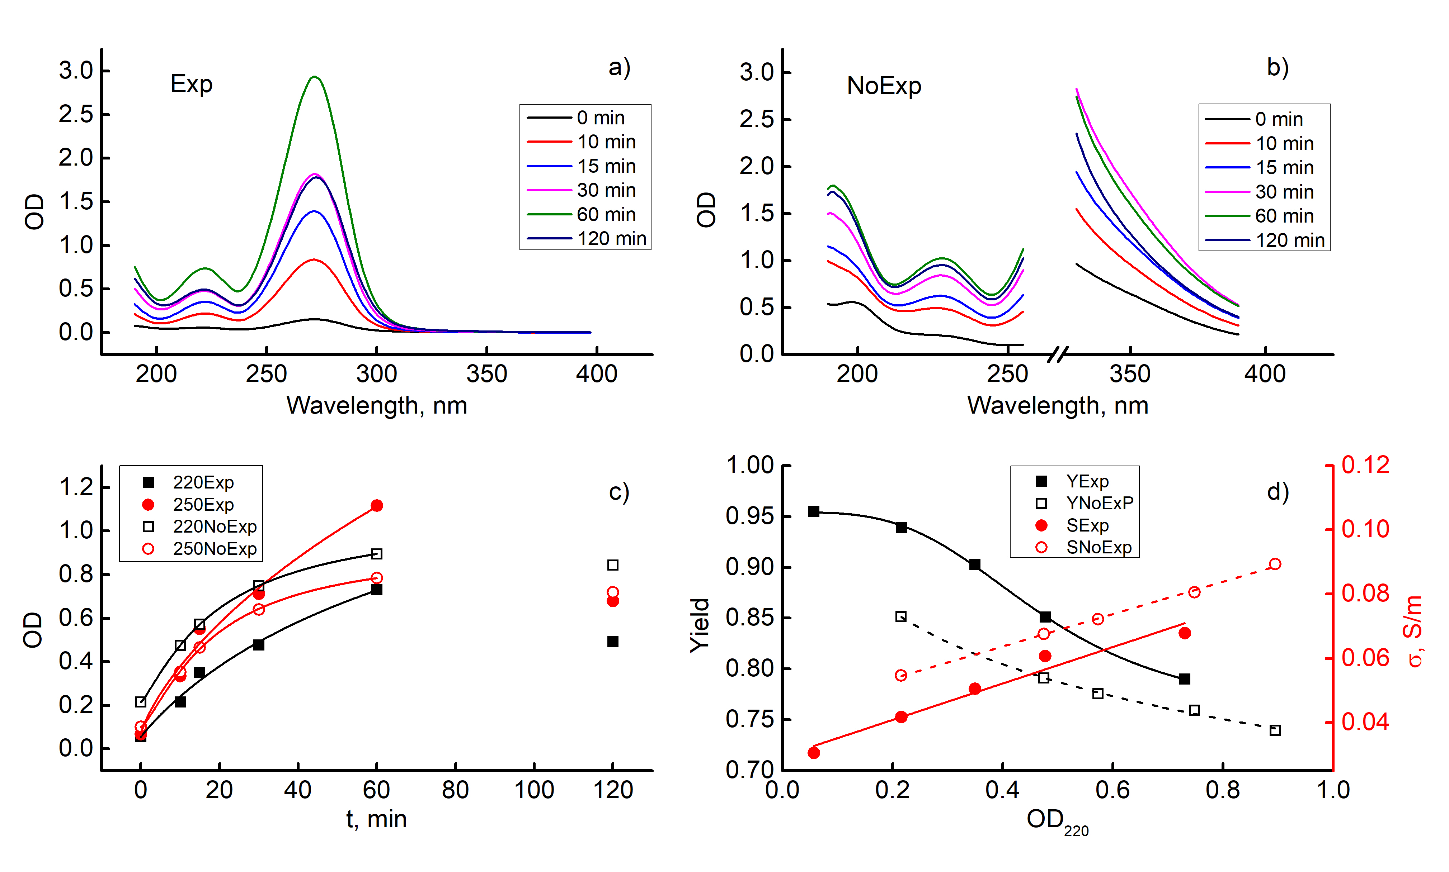
Figure 1. UV absorption of FIR liquid phases. Effect of reaction time: a) expansion; b), no expansion. c) time course of optical density at 220 and 250 nm. d) solid yields as a function of optical density.
The expansion affects the spectra strongly. In the range 200 – 250 nm, the difference is quantitative, being the NoExp OD roughly twice those Exp with a similar shape. Between 300 and 400 nm, part a) shows no absorption, while part b) exhibits a giant peak (not reported for the sake of readability), followed by a high-absorbance long tail. These neat variations signal that the expansion strongly affects the partition of chemicals between the liquid and the solid. The OD could efficiently monitor the HTC time-course by accurately selecting the wavelength, as part c) shows.
The diagram reports the absorbance at 220 and 250 nm for both modalities as a function of reaction time. The lines connecting points of the first 60 min of HTC trace the data fitting (R² from 0.95410 to 0.99997) with Eq(1), of general validity (Gallifuoco et al., 2018).
$p\left(t\right)=p_{∞}+\frac{\left(p_{0}-p_{∞}\right)}{1+{\left(\frac{t}{τ}\right)}^{a}}$ | (1)
In Eq(1), p(t) is the current value of a generic property, p_{o} and p∞ its initial and final value, τ a characteristic time, and b a kinetic parameter.

Part d) shows the hydrochar solid yields (left Y-axis) and the liquid-phase electrical conductivity (right Y-axis) as a function of the OD at 220 nm. The expansion increases the solid yields due to the additional precipitation of non-volatile compounds. Data points are connected to the OD via Eq(1) with excellent fittings as in the previous case. The electrical conductivity, another lumped measure that proved helpful in monitoring the HTC process (Gallifuoco et al., 2018), is linearly dependent on the OD. Overall, Figure 1 shows the possibility to monitor an industrial HTC reactor simply withdrawing a liquid sample and measuring its OD for predicting the current solid yield obtainable both with and without a downstream expansion.
Platform chemicals appear in the HTC liquid as produced by initial hydrolysis and dehydration and disappear, acting as precursors of the so-called secondary hydrochar (Pacheco Antero et al., 2020). HTC processes designated for platform chemical production are studied worldwide (Pfersich et al., 2020). GC-MS analyses clarified the time-depending composition of the FIR process liquids: Figure 2 concerns 5-hydroxymethylfurfural (HMF) and furfural (FF) central compounds for green chemistry (Bashkar et al., 2020).

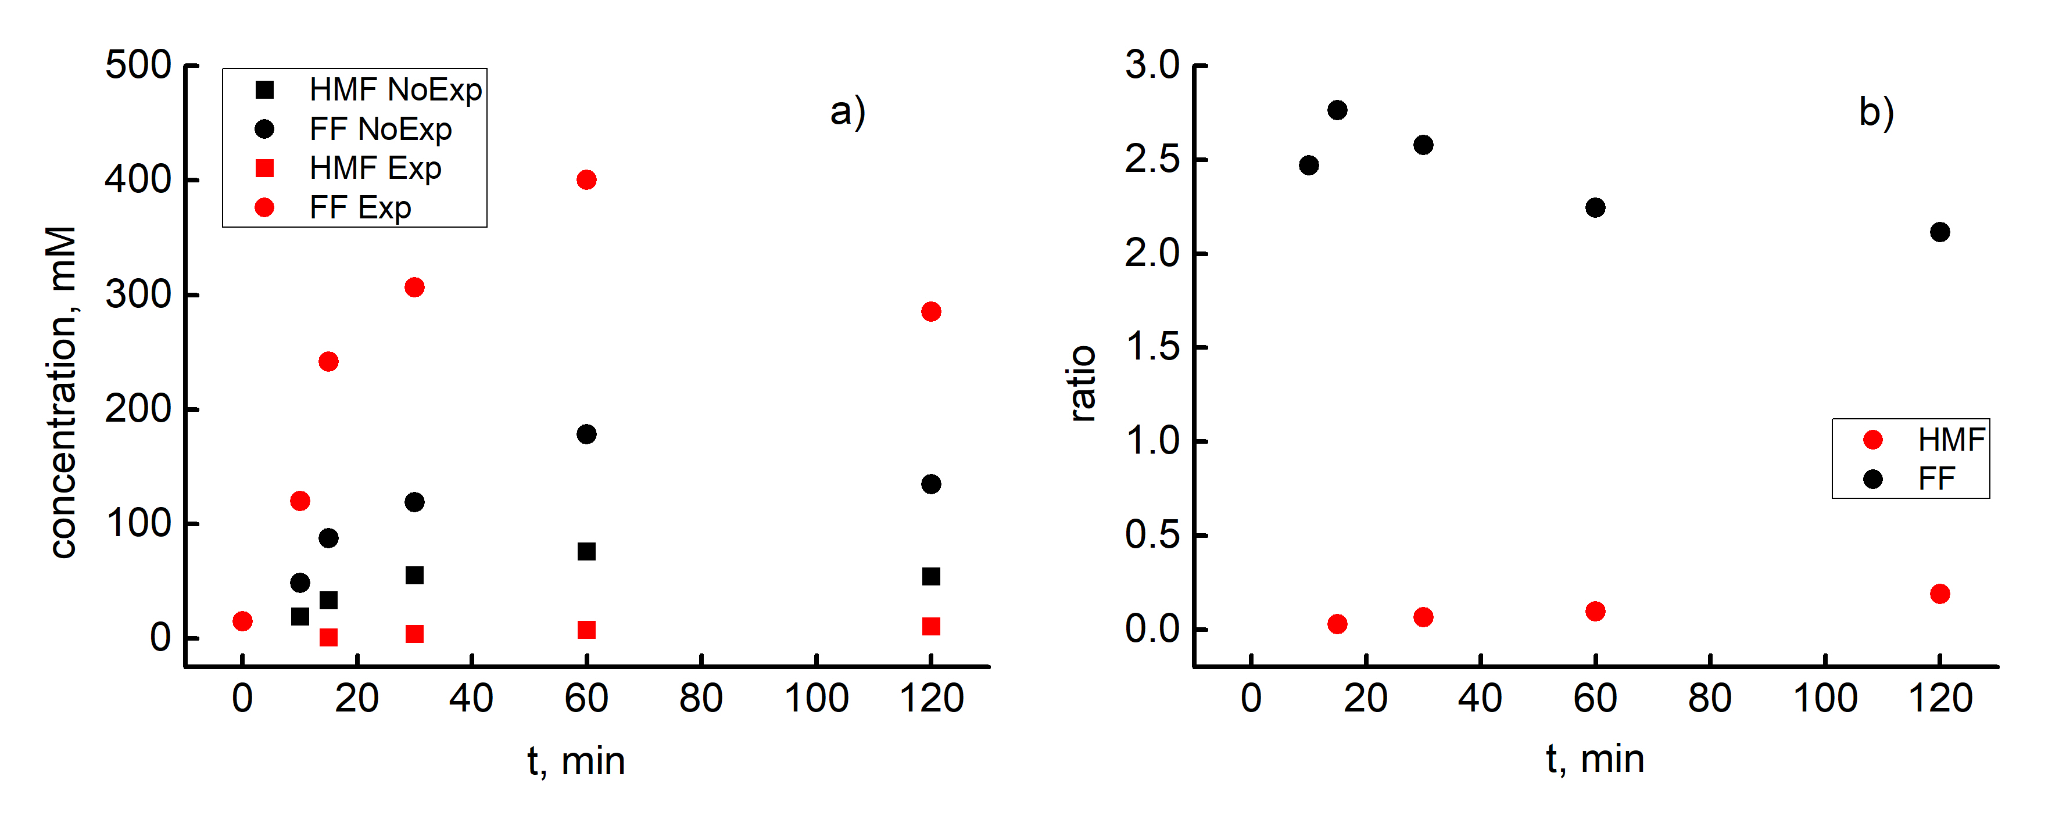
Figure 2. Dynamics of selected chemical in FIR process waters. a) HMF and FF time course. b) partition caused by the expansion.
The time course (part a) shows that concentrations peak at 60 min. A short-time HTC process would be adequate for recovering chemicals, even at the expense of a minor hydrochar productivity. Part b) shows the partition of the chemicals caused by the expansion. The concentrations ratio (Exp/NoExp) is entirely different for the two chemicals. Interestingly, the expansion could facilitate the downstream separation operations.
HTC of wooden materials like FIR is conceivable to produce platform chemicals. For STRAW, HTC draws attention as a pretreatment for making the biomass feedable to thermal conversion such as gasification. Nevertheless, an integrated strategy for fully exploiting STRAW would be possible, as Figure 3 shows.

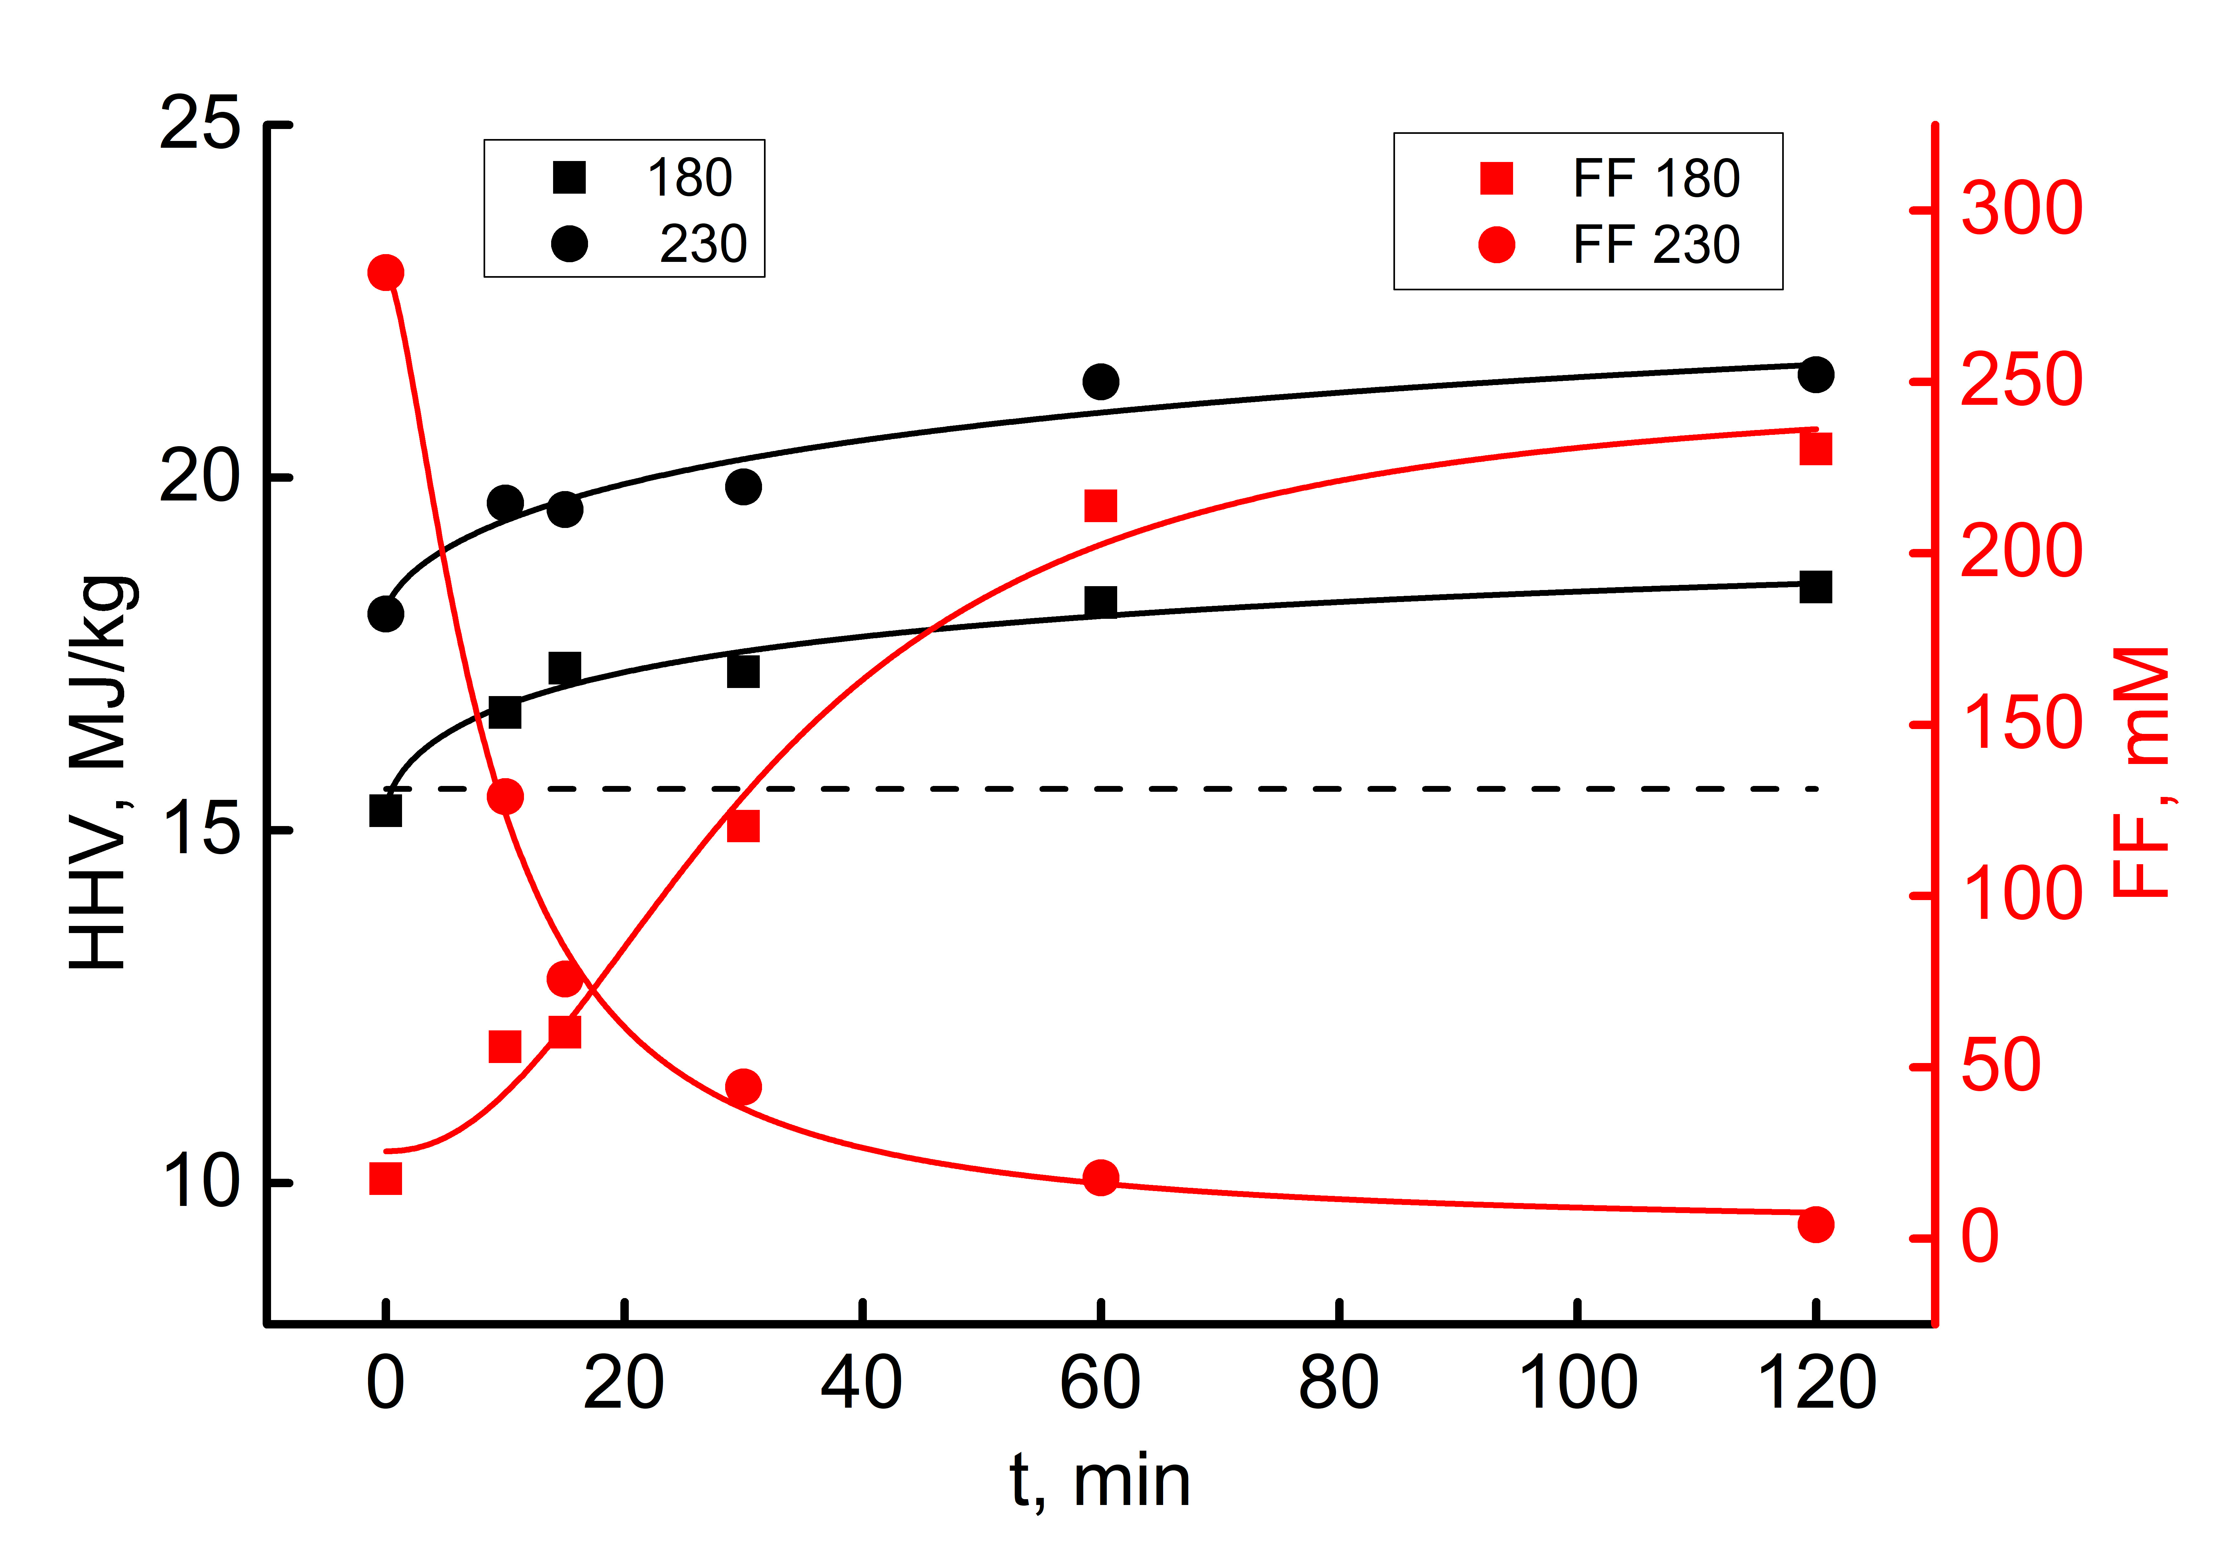

Figure 3. Effect of HTC temperature on the evolution of STRAW reacting system. Hydrochar energy content (black) and furfural concentration (red) as a function of process time.
The plot exhibits selected data on the time evolution of the solid hydrochar and the process water and refers to two reaction temperatures, 180 and 230 °C. The left Y-axis reports the higher heating value (HHV) of the hydrochar deduced from the ultimate analysis through conventional calculations (Demirbaş and Demirbaş, 2004). The dashed line represents the HHV of the untreated STRAW. A long-time treatment is necessary to improve the energy content of the raw material. After 120 min, the relative increase is 18.3 % and 37.6 % at 180 and 230 °C, respectively. Besides, preliminary thermodynamic simulations (Aspen plus® V11, 37.0.0.395) show that a gasifier processing STRAW pretreated at 120 min and 230 ° C would produce less than a quarter of the H₂S generated with the raw material. A complete set of data is currently under analysis, and results confirm that 230 °C would be the optimal HTC temperature for exploiting STRAW in a clean energy chain. Figure 3 clearly shows that getting energy and liquid-phase chemicals are antithetical goals if pursued in a single HTC reactor. Data in red (right Y-axis) trace the dynamics of FF. At 180 °C, the concentration rises from 17 mM (time zero) to 230 mM (120 min). Longer reaction time would produce the depletion of the chemical to the advantage of the improvement of hydrochar energy properties. The peak concentration would occur after 120 min. Data not shown confirm that one would get a slightly higher quantity of FF, prolonging the process to 180 min. The increase obtainable would not justify the additional operating cost.
At 230 °C, the scenario changes noticeably. At time zero, the FF concentration (280 mM) is the highest detected, halves within the first 15 min of reaction, and decreases continuously up to 120 min, when the residual concentration is 4 mM. FF was forming (and possibly degrading) in the warmup transient, a condition seldomly investigated in the literature on kinetics (Bassani et al., 2021). Data of the present study suggest the logical furtherance of research in the low-temperature range, say from 150 to 230 °C. Detailed experiments are ongoing this way. Noticeably, Eq(1) nicely describes the entire set of data in Figure 3, making it possible to predict the time course completely. Overall, the findings of Figure 3 allow speculating on a strategy for optimizing both FF production and energy improvement. Innovative process schemes would involve a two-step HTC. The idea of an HTC double reactor already appeared in the literature, as applied to catalytic processes (Arauzo et al., 2018) and pretreatments for enhancing cellulose enzymatic digestibility (Yu et al., 2010). To the best of the authors’ knowledge, the approach of this study is a total novelty. The current experiments aim to detail the possible layouts and will be the subject of future publications. In the authors’ opinion, one could perform a first, ultrashort time HTC, separate furfural from the process water, and feed the solid and the purified liquid to a second reactor for boosting the hydrochar production.In the context of this work, it is possible to outline a general scheme.
A first, short-time, low-temperature reactor processes repeated loads of raw biomass and sends the products to a solid-liquid separator. Understudy is the advantage of recirculating process water (up to 5 times) for accumulating chemicals. The solids from the first reactor feed the second one, which boosts hydrochar production operating at severer conditions (presently, the best set is 230 °C and 120 min). The liquid of the first reactor enters an extraction stage (green solvent) for FF recovery. The exhaust liquid, plus a water make-up, could feed the second reactor. The final products undergo different fates. The solid, previously dried, enters a gasification section; the liquid goes to a membrane processing stage to reduce the environmental impact and conceivably recirculated to the second reactor. The new experimental data address the energy analyses of the HTC-gasification integrated process.
Based on these results, research is in progress aiming to assess the dependence of process performances on lignocellulosic biomass, clarify optimal HTC temperatures, and investigate product separation under the green chemistry paradigm. By extending the experiments on the way here paved, innovative processes for a fully sustainable, intensified conversion of lignocellulosic residuals and diverse residuals are in progress.

  - Conclusions
Exploratory experiments foreshadow innovative processes for the biomass-to-value chains. The focus is on versatile hydrothermal carbonization (HTC). The idea comes out of integrating HTC and gasification beyond the respective conventional roles of pretreatment and primary process. Experiments with abundant lignocellulosic residuals, silver fir sawdust (FIR) and wheat straw (STRAW) demonstrated the simultaneous conversion to energy and value-added chemicals, furfural and 5-hydroxymethylfurfural. The lumped measure of UV-absorption spectra easily monitors the progression of FIR conversion, and a single equation fits data nicely (R² as high as 0.9997). A flash expansion step downstream from the HTC reactor provokes a favorable partition of the chemicals between liquid and solid phases. The expanded liquid contained up to three times the furfural than the non-expanded liquid. The suggested use of FIR would be the production of platform chemicals.
Experiments with STRAW highlighted novel exploitation possibilities by a two-step, isothermal (230 °C) HTC process. The first, ultrashort residence time reactor produces furfural up to 280 mM; the second reactor, in 120 min of reaction, enhances the hydrochar energy content from 15 to 21 MJ/kg while reducing sulfur content by 75 %. The initial discussion of possible process layouts for complete integration of HTC to gasification is also presented.

Acknowledgments
The research was funded by EC’s program Horizon 2020 Research and Innovation, grant agreement 101006656, GICO project.

The authors dedicate this paper to the memory of Prof. Ida De Michelis.
References
Arauzo P.J., Olszewski M.P., Kruse A., 2018, Hydrothermal Carbonization Brewer’s Spent Grains with the Focus on Improving the Degradation of the Feedstock, Energies, 11, 3226-3240.
https://doi.org/10.3390/en11113226.
Bashkar T., Pandey A., Rene E.R., Tsang (Eds.), Waste biorefinery, 2020, Elsevier, Amsterdam, The Netherlands.
Bassani A., Fiorentini C., Duserm Garrido G., Carullo D., Spigno G., 2021, Kinetic Model of Wheat Straw Autohydrolysis Considering Heating and Cooling Phases, Chemical Engineering Transaction, 87, 199-204. DOI:10.3303/CET2187034.
Spigno G., Cheong K. and Apblett A. (Eds.), Sustainable Materials and Green Processing for Energy Conversion, 2022, Elsevier, Amsterdam, The Netherlands.
Demirbaş, A., Demirbaş, A.H., 2004, Estimating the Calorific Values of Lignocellulosic Fuels. Energy Explor. Exploit., 22(2), 135–143. http://www.jstor.org/stable/43754627.
Erlach B., Harder B., Tsatsaronis G., 2012, Combined hydrothermal carbonization and gasification of biomass with carbon capture, Energy, 45, 329-338. https://doi.org/10.1016/j.energy.2012.01.057.
Fankhauser S., Bowen A., Calel L., Dechezleprêtre A., Grover D., Rydge J., Sato M., 2013, Who will win the green race? In search of environmental competitiveness and innovation, Global Environmental Change, 23, 902–913. http://dx.doi.org/10.1016/j.gloenvcha.2013.05.007.
Gallifuoco A., Taglieri L., Scimia F., Papa A.A., Di Giacomo G., 2017, Hydrothermal carbonization of Biomass: New experimental procedures for improving the industrial Processes, Bioresour. Technol., 244, 160–165. http://dx.doi.org/10.1016/j.biortech.2017.07.114.
Gallifuoco A., Taglieri L., Scimia F., Papa, A.A., Di Giacomo G., 2018, Hydrothermal conversions of waste biomass: Assessment of kinetic models using liquid-phase electrical conductivity measurements, Waste Manage., 77, 586–592. https://doi.org/10.1016/j.wasman.2018.05.033.
Heidenreich S., Müller M., Foscolo P.U. 2016, Advanced Biomass Gasification, Elsevier, Amsterdam, The Nederlands.
Pacheco Antero R.V., Fonseca Alves A.C., Botelho de Oliveira S., Ojala S.A., Brum S.S., 2020, Challenges and alternatives for the adequacy of hydrothermal carbonization of lignocellulosic biomass in cleaner production systems: A review, J. Cleaner Prod., 252, 119899-119911. https://doi.org/10.1016/j.jclepro.2019.119899.
Papa A.A., Di Carlo A., Bocci E., Taglieri L., Del Zotto L., Gallifuoco A., 2021, Energy Analysis of an Integrated Plant: Fluidized Bed Steam Gasification of Hydrothermally Treated Biomass Coupled to Solid Oxide Fuel Cells, Energies, 14, 7331-7343. https://doi.org/10.3390/en14217331.
Pfersich J., Arauzo P.J., Lucian M., Modugno P., Titirici M-M., Fiori L., Kruse A, 2020, Hydrothermal Conversion of Spent Sugar Beets into High-Value Platform Molecules, Molecules, 25, 3914-3929. https://doi.org/10.3390/molecules25173914.
Prifti K., Basso D., Pavanetto R., Manenti F., 2021, Improving hydrothermal carbonization (HTC) processes by hydrochar gasification, Chemical Engineering Transactions, 86, 925-930.
https://doi.org/10.3303/CET2186155.
Qadi N., Takeno K., Mosqueda A., Kobayashi, M., Motoyama Y., Yoshikawa K., 2019, Effect of Hydrothermal Carbonization Conditions on the Physicochemical Properties and Gasification Reactivity of Energy Grass, Energy Fuels, 33, 6436−6443. https://doi.org/10.1021/acs.energyfuels.9b00994.
Singhal A., Konttinen J., Joronen T., 2021, Effect of different washing parameters on the fuel properties and elemental composition of wheat straw in water-washing pre-treatment. Part 2: Effect of washing temperature and solid-to-liquid ratio, Fuel, 292, 120209-120216. https://doi.org/10.1016/j.fuel.2021.120209.
Yu Q., Zhuang X., Yuan Z., Wang Q., Qi W., Wanga W., Zhang Y., Xu J., Xu H., 2018, Two-step liquid hot water pretreatment of Eucalyptus grandis to enhance sugar recovery and enzymatic digestibility of cellulose, Bioresour. Technol., 101, 4895–4899. https://doi.org/10.1016/j.biortech.2009.11.051.

