CHEMICAL ENGINEERING TRANSACTIONS  VOL. | A publication of
The Italian Association
of Chemical Engineering
Online at www.cetjournal.it
Guest Editors:
Copyright © AIDIC Servizi S.r.l.
ISBN 978-88-95608-xx-x ISSN 2283-9216

Advanced porous particle model in biomass pyrolysis
Andrea Dernbecher*, Alba Dieguez-Alonso
Institute of Fluid Dynamics and Thermodynamics, Faculty of Process and Systems Engineering, Otto-von-Guericke Universität Magdeburg, Universitätsplatz 2, Magdeburg, DE-39106, Germany
andrea.dernbecher@ovgu.de
In order to decrease anthropogenic CO₂ emissions and to become independent from fossil resources, one alternative for energy generation and production of platform-chemicals is the usage of biomass. There are multiple process routes for the exploitation of biomass for energetic or material usage. For biomass with low water content, thermo-chemical conversion such as pyrolysis, gasification or combustion is the preferred treatment to gain energy or material products. The challenges in this field are to reduce unwanted emission of pollutants from the conversion process and to design devices that achieve high conversion efficiency. Simulations of the biomass conversion processes inside reactors are a valuable tool to overcome those challenges. Apart from the usage in industrial applications, there are models that have a high level of detail including complex reaction mechanisms for the decomposition of the biomass and advanced description of the physical changes of the biomass structure during thermo-chemical conversion. They help to deepen the understanding of the conversion process. However, for most commercial simulation software, biomass conversion remains a niche application, and models have to be implemented to simulate the process correctly.
In this study, the pyrolysis behaviour of beech wood particles was simulated with a three-dimensional modelling approach in the open source computational fluid dynamics (CFD) software OpenFOAM. The implementation of the model included the biomass as porous reacting medium that changed the chemical composition and the solid properties during pyrolysis due to decomposition reactions. This modelling approach can in the future be used for the simulation of devices for thermo-chemical conversion of biomass with a fixed bed such as wood burning stoves or gasifiers. On the other hand, the model will be further developed to investigate the thermo-chemical conversion on a very detailed level with complex chemical and physical models, also considering the anisotropic structure of the biomass.
  - Introduction
Thermo-chemical conversion of biomass is a process that is commonly used in both biomass energetic utilization and material synthesis. In the field of energy generation technologies based on combustion and gasification are used to provide heat or as combined heat and power to also generate electricity. In this field biomass is an important non-fossil energy source that leads to almost CO₂-neutral energy generation. However, biomass combustion in non-optimal conditions can lead to emission of pollutants such as soot or fine dust. In material utilization the thermo-chemical processes pyrolysis and gasification are used to generate char, pyrolysis oil or syngas. The properties and the yield of the products depend strongly on the operation conditions in which the thermo-chemical conversion is performed. Syngas can be further used for the production of platform-chemicals such as methane, dimethyl ether or methanol (Giuliano et al. 2020).
Simulations are an important tool to design tailored equipment for thermo-chemical conversion processes and reactors for the individual process-steps with high efficiency and minimal emissions. Additionally, simulations can be used to investigate the influence of operation conditions on the thermo-chemical conversion and to adapt the operation conditions based on simulation results in order to achieve specific products. However, from a modelling point of view, the simulation of thermo-chemical conversion is very challenging, since it is a multi-phase problem in which many species are involved, and a multi-scale approach is needed for the simulation. Also, different time-scales occur with very small time steps for chemical reactions and relatively long durations for transient batch processes, that should be simulated completely from start to finish.
During combustion biomass undergoes the steps drying, pyrolysis, gasification and char combustion. In the case of complete combustion, only ash, CO₂ and H₂O would remain. In real processes, however, many intermediate products and different species can be found. Intermediate products during combustion include tar, light hydrocarbons, syngas, and char and incomplete combustion may lead to formation of pollutants like polycyclic aromatic hydrocarbons (PAH), soot, and NO_{x}. Inorganic components in biomass can act as catalyst on pyrolysis and additionally lead to formation of aerosols and fine ashes. Operation conditions and biomass properties strongly influence the outcome and the types of generated products (Almuina-Villar et al. 2018). Especially the step pyrolysis is sensitive to operation conditions and should be investigated carefully. Modelling of pyrolysis is currently researched and many different mechanisms for the kinetics are proposed in literature and are continuously improved (Anca-Couce 2016).
Besides the chemical reactions biomass undergoes during pyrolysis, there are also physical changes of the structure that are observed during the conversion (Caposciutti et al. 2019). Due to mass loss biomass particles shrink and porosity increases. The release of volatiles through small pores can lead to swelling or cracking of the material. These phenomena have to be included in modelling approaches in addition to the chemical transformation.
Many models for thermo-chemical conversion of single biomass particles have been developed and published (Haberle et al. 2017). Most of the single particle models are based on a one-dimensional modelling approach. These models are ideal to investigate all steps of pyrolysis including chemical and physical transformations with minimum computational effort. The models contribute greatly to the development of kinetic mechanisms and are often a starting point for further simulations of technical applications. However, there are some limitations regarding one-dimensional models. The majority of the stand-alone single particle models do not cover the interaction of the particle with the surrounding gas phase or the reactor and boundary conditions at the surface of the particle have to be provided. The one-dimensional models are not able to represent the anisotropic properties of wood and physical or structural changes that are also driven by the direction of the fibers of the wood. One-dimensional models for the conversion of biomass particles have been used for the simulation of large firing systems with moving grate and bulk biomass to describe the decomposition of each individual particle. In this case particles are often assumed to be thermally thin to reduce computational effort (Mahmoudi et al. 2016). The one-dimensional modelling approach was also used to describe combustion of wood logs in a domestic stove, in which the wood logs were assumed to be thermally thick (Galgano et al. 2006). In both cases interaction of gas phase and solid phase was implemented to simulate the whole device.
Continuum models for three-dimensional simulations get around the above-mentioned challenges by adding key sub-models. The models simulate the biomass particle as porous medium in a computational fluid dynamic (CFD) environment. For example, the single particle models developed by Mehrabian et al. (2012) Corbetta et al. (2014) or Gentile et al. (2015) are continuum models and were implemented in Fluent and OpenFOAM respectively. The porous medium modelling approach was used for example for the simulation of combustion in a pellet boiler to represent the biomass bed formed from pellets (Gómez et al. 2017).
The aim of the study is to provide a particle model that is suitable for the simulation of biomass thermochemical conversion and could be used as a basis for future improvement and adaption to similar multi-phase problems. To this end, a model was implemented in the open-source CFD software OpenFoam. It was based on the solver reactingFoam and represented biomass as a porous medium. The overall structure of the modelling approach was based on the model published by Kwiatkowski et al. (2013). From a chemical perspective, the decomposition of biomass was described based on its three main macro-components (cellulose, hemicellulose and lignin). The model included the biomass particle as well as the surrounding gas phase. The interaction of the particle with the gas phase and reactor boundary conditions is important for future applications at the reactor level.
  - Modelling approach
    - OpenFoam model
The governing equations used in the OpenFOAM simulation are shown in Equations (1) to (7), they include conservation equations for gaseous and solid phase. Equations (1) and (5) are the mass conservation equations for the gas and solid phase, respectively. Eq (1) includes the porosity ε that takes the value one for regions that contain gas phase only and the volume fraction of gas phase in the regions with porous medium.$ρ_{g}$ is the density of the gas phase and $\vec{u_{g}}$ is the velocity of the gas flow. In Eq (5) the solid fraction $ϕ=1-ε$ is used instead of the porosity and $ρ_{s}$ is the density of the solid. The source terms $S_{g}$ and $S_{s}$ include the mass gains and losses of species generated from homogeneous and heterogeneous reactions.
$$\frac{∂(ερ_{g})}{∂t}+∇\left(ρ_{g}\vec{u_{g}}\right)=S_{g}$$ | (1)
$$\frac{∂(ερ_{g}\vec{u_{g}})}{∂t}+∇\left(ρ_{g}\vec{u_{g}} \vec{u_{g}}\right)-∇(μ∇\vec{ u_{g}} )={-∇p_{g}+ρ_{g}\vec{g}+f}_{g}$$ | (2)
$$\left(ερ_{g}c_{p,g}\right)\left(\frac{∂T_{g}}{∂t}+\vec{u_{g}} ∇T_{g}\right)=∇\left(α_{g,eff}∇T_{g}\right)+h_{g-s}\left(T_{s}-T_{g}\right)+ΔH_{r,g}+{Γ+ \dot{Q}}_{rad,g}$$ | (3)
$$\frac{∂(ερ_{g}Y_{g,i})}{∂t}+∇\left(ρ_{g}\vec{u_{g}} Y_{g,i}\right)=∇(ρ_{g}D_{g,i}∇Y_{g,i})+R_{g,i}$$ | (4)
$$\frac{∂(ϕρ_{s})}{∂t}=S_{s}$$ | (5)
$$\frac{ϕρ_{s}c_{p,s}∂T_{s}}{∂t}=∇\left(k_{s}∇T_{s}\right)+h_{g-s}\left(T_{g}-T_{s}\right)+ΔH_{r.s}+{\dot{Q}}_{rad,s}$$ | (6)
$$\frac{∂\left(ϕρ_{s}Y_{s,k}\right)}{∂t} =R_{s,k}$$ | (7)
The momentum conservation equation of the gas phase is written as Eq (2), it contains the source term $f_{g}$ that describes the losses due to flow through the porous medium. This term was described by the Darcy-Forchheimer approach (Eq (8)). In which $μ_{g}$ was the viscosity of the gaseous phase, $D_{ij}$ and $F_{ij}$ describe the permeability of the porous medium. They can be determined from experiments or derived of properties of the biomass for example based on Ergun equation.
$$f_{g} =-\left(μ_{g}D_{ij}+\frac{1}{2}ρ_{g}\left|u_{g}\right|F_{ij}\right)u_{g}$$ | (8)
The solid phase is assumed to be fixed and therefore no momentum equation is provided. Eq (3) is the conservation equation for energy for the gas phase. It contains a term for heat exchange with the solid energy conservation equation (Eq (6)), heat of reaction, heat from radiation ${ \dot{Q}}_{rad,g}$ and the term Γ that describes the energy that is used to bring gaseous species formed from solid reactions to the same temperature as the gas phase. The heat up of the gaseous species was described by Equation (9), in which $R_{g,i}$ is the change rate of density of one component i and $H_{s,i}$ is the sensible enthalpy of a component i.
$$Γ =\sum_{i}{\left(H_{s,i}\left(T_{s}\right)-H_{s,i}\left(T_{g}\right)\right) R_{g,i}}$$ | (9)
According to Klason et al. (2008) the boundary condition for the radiative heat transfer with the P1 radiation model on the surface of the solid, can best be described by the Marshak boundary condition (Equation (10)). In which $ε_{s}$ is the emissivity of the solid, $σ$ is the Stefan-Boltzmann constant, $T_{s}$ is the temperature of the solid and $G$ is the radiation field calculated by OpenFOAM from the P1 radiation model.
$${\dot{Q}}_{rad,s} =\frac{ε_{s}}{2+2\left(1-ε_{s}\right)}\left(G-4σT_{s}^{4}\right)$$ | (10)
The calculation of radiation is especially important, when combining the porous medium model with a gas phase combustion model to simulate the radiative heat transfer from flame to biomass correctly. The species conservation equations for the gas phase Eq (4) and solid phase Eq (7) each include a source term for the solid $R_{s,k}$ and gaseous $R_{g,i}$ species formed and consumed during heterogeneous and homogeneous reactions. They are calculated from the kinetics of the decomposition reactions of the biomass. In the modelling approach used in this paper a kinetic reaction scheme for pyrolysis with three parallel reactions (Eq (11) to Eq (13)) was used.
$$cellulose→volatiles+char$$ | (11)
$$hemicellulose→volatiles+char$$ | (12)
$$lignin→volatiles+char$$ | (13)
The decomposition reactions were described by Arrhenius equations from which the mass change rates and the heat of reaction were calculated. The mass change rates of the solid components were calculated according to Eq (14). Since the calculations in governing equations are mass based, the mass change rates $R_{s,k}$ were calculated as the product of the kinetic coefficient $k_{f}$ and the partial density of the decomposing component $ρ_{s,k}$. The kinetic scheme from literature (Branca and Di Blasi 2016) used for the present simulations was based on first order reactions. The partial density of the solid component k was calculated from the cell wall density of the wood $ρ_{s}$ and the mass fraction of the component in the solid phase $Y_{s,k}$. The Arrhenius equation for the kinetic coefficient contains the kinetic parameters $A_{k}$ and $E_{a,k}$,the general gas constant R and depends on the temperature of the solid phase $T_{s,k}$. Based on the mass change rate of the solid components and the user defined amount of the released gaseous species, the mass change rates of the gaseous components $R_{g,i}$ were calculated.
$$R_{s,k}=k_{f}⋅ρ_{s,k}=ρ_{s}⋅Y_{s,k}⋅A_{k}⋅\exp\left(-\frac{E_{a,k}}{RT_{s}}\right)$$ | (14)
The mass source terms $S_{g}$ and $S_{s}$ in the mass conservation equations Eq. (1) and (5) were a summation of the decomposition terms of each solid reaction. The calculation of heat of reaction was changed from the original model of Kwiatkowski et al. (2013) towards Equation (15). Heat of reaction for the solid reactions was calculated as a sum over the heat of reaction contributions of each reaction n$, Δh_{r,n}$. The values for $Δh_{r,n}$ should be provided by the user together with the other kinetic parameters and can be taken from literature or determined by thermogravimetric analysis (TGA) and differential scanning calorimetry (DSC).
$$ΔH_{r,s} =\sum_{n}{k_{f,n}Y_{s,n}}ρ_{s}Δh_{r,n}$$ | (15)
Homogeneous reactions of the gas phase are implemented in the governing equations but were not used in the simulations presented in this paper.
    - Simulations
The simulation of a thermally thin beech wood particle was used as test case for the OpenFOAM solver. A thermally thin particle with small sample size was chosen to reduce the influence of transport processes inside the particle and minimize simulation time. The initial mass of the particle was 25 mg, it had the shape of a cube with an edge length of 3.2 mm and a volume of 33 mm³. The sample size and heating rate were similar to operation conditions used in TGA experiments. The particle was placed in a box, through which a constant flow of nitrogen with velocity of 0.1 m/s streamed. The walls of the box as well as the nitrogen flow had a fixed temperature value as boundary condition and that value increased with a heating rate of 20 K/min starting from room temperature up to 873.15 K. Properties of the biomass were taken form literature (Kwiatkowski et al. 2013) and (Park et al. 2010). Since the given composition of pseudo-components in the used pyrolysis model did not add up to unity, humidity was added to the biomass composition, however drying was not simulated.

Table 1: Kinetic parameters used for the simulation of beech wood pyrolysis (Branca and Di Blasi, 2016)
Parameter | Unit | Value | Parameter | Unit | Value
Mass fraction celluloses | kg/kg | 0.48 | A_{cel} | s⁻¹ | 2.55 ⋅ 10¹³
Mass fraction hemicellulose | kg/kg | 0.24 | E_{a,cel} | J/mol | 1.88 ⋅ 10⁵
Mass fraction lignin | kg/kg | 0.11 | ΔH_{R,cel} | J/kg | 6.01 ⋅ 10⁵
Mass fraction ash | kg/kg | 0.016 | A_{hem} | s⁻¹ | 1.07 ⋅ 10⁹
Mass fraction humidity | kg/kg | 0.154 | E_{a,hem} | J/mol | 1.23 ⋅ 10⁵
 |  |  | ΔH_{R,hem} | J/kg | 2.48 ⋅ 10⁵
 |  |  | A_{lig} | s⁻¹ | 1.38 ⋅ 10¹²
 |  |  | E_{a,lig} | J/mol | 1.79 ⋅ 10⁵
 |  |  | ΔH_{R,lig} | J/kg | -9.23 ⋅ 10⁵
  - Results and discussion
Figure 1 shows the temperature profile at the center of the particle in the OpenFOAM simulation in comparison to the temperature ramp that was introduced at the walls and the nitrogen flow inlet. The temperature profile of the particle center was affected by heat transfer through the gas phase, heat transfer in the solid phase, radiation and heat of reaction. The overall endothermicity of pyrolysis can clearly be seen in the region between 1000 and 1300 seconds. Towards the end of pyrolysis, the increase in temperature was accelerated due to the exothermicity in the decomposition of lignin. After pyrolysis the temperature of the particle got closer to the boundary temperature due to the smaller mass of the particle and change of the solid phase properties from biomass to char.
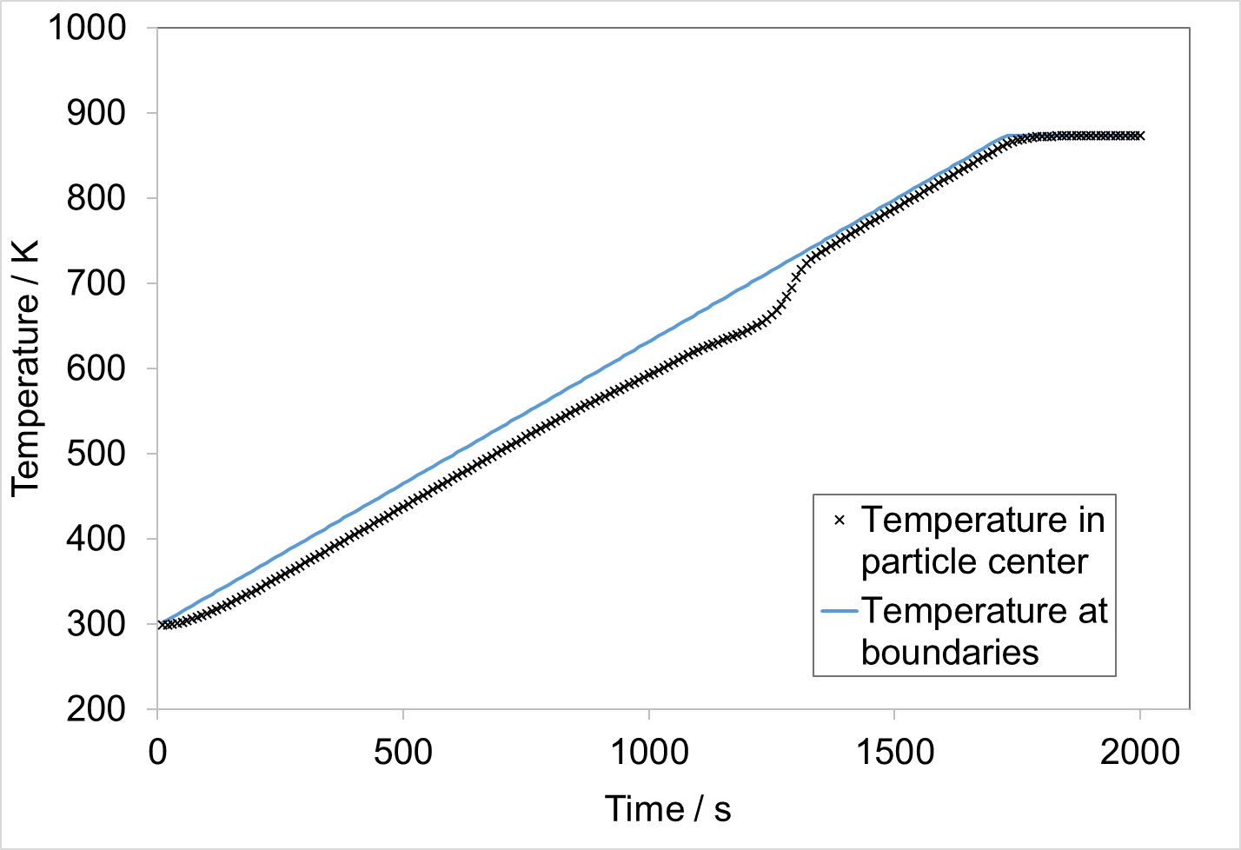  Figure 1: Temperature profile at the center of the particle in the simulation with OpenFOAM | 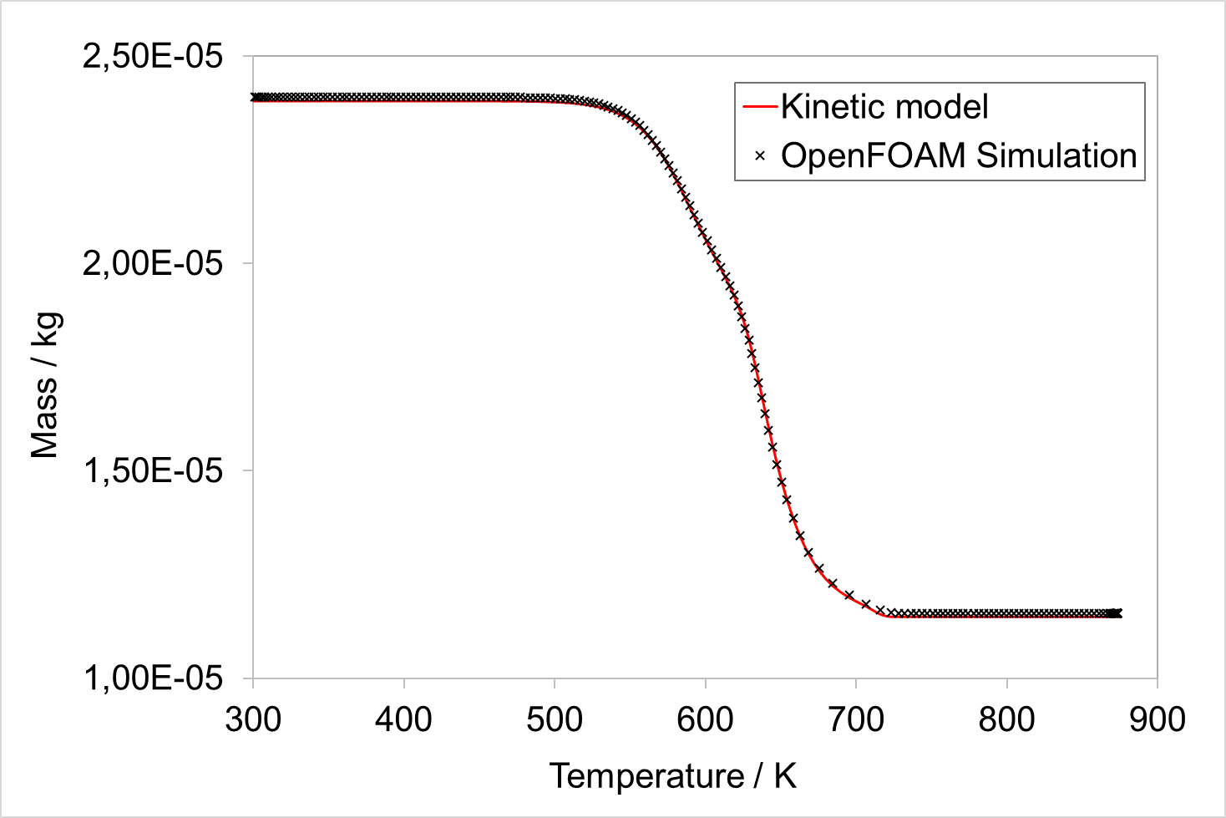  Figure 2: Comparison of particle mass loss during pyrolysis from OpenFOAM simulation and kinetic model
To investigate the performance of the model with regard to pyrolysis kinetics and mass loss of the solid phase, the OpenFOAM simulation results were compared to results of the study by Branca and Di Blasi (2016). This model was derived directly from experimental data and validated by TGA experiments. The kinetic model used Eq. (16) to describe the change in the mass fraction of each pseudo-component during pyrolysis. Based on these reaction rates, the overall mass loss and the heat of reaction of the sample was calculated and compared to experimental results. The modelling approach used by Branca and Di Blasi did not consider the formation of char and pyrolysis gases, and neglected transport phenomena. The implementation of the kinetics in OpenFOAM was more complex, since the mass balances had to be closed and heat and mass transfer were calculated. For the comparison of the two models the kinetic model shown in Eq (16) was used to calculate the mass loss of each individual pseudo-component for a biomass particle with the same initial mass and composition as the one used in the OpenFOAM simulations. The temperature profile of the center of the particle obtained by the OpenFOAM simulation was used for the calculations with the kinetic model. In this way it was possible to check, if kinetics were implemented correctly in OpenFOAM.
$$\frac{dY_{i}}{dt} =-A_{i}\exp\left(-\frac{E_{a,i}}{RT}\right)Y_{i}$$ | (16)
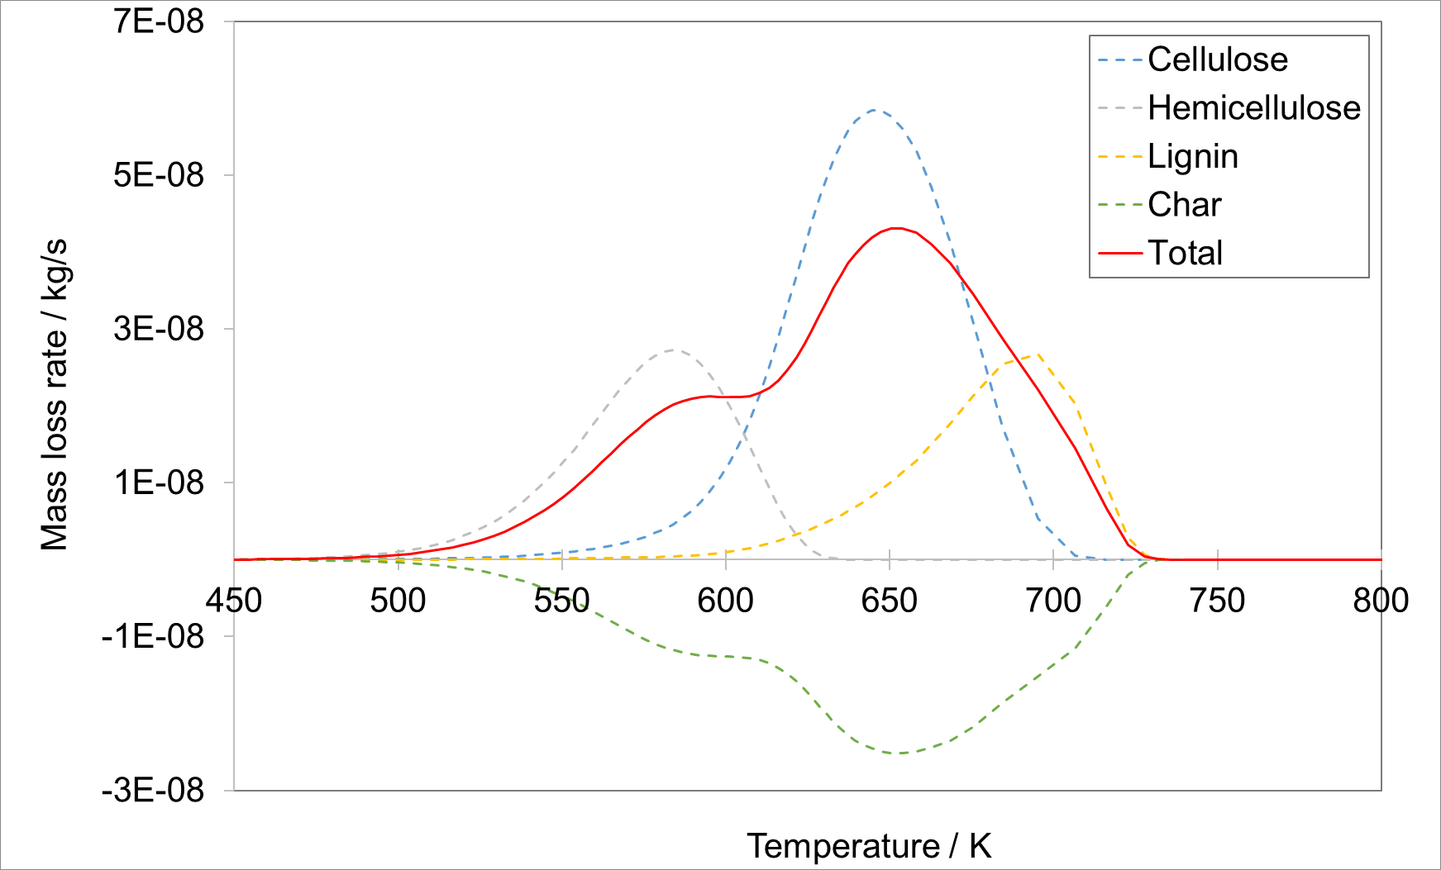  Figure 3: Mass loss rate of the solid components in the simulation with OpenFOAM | 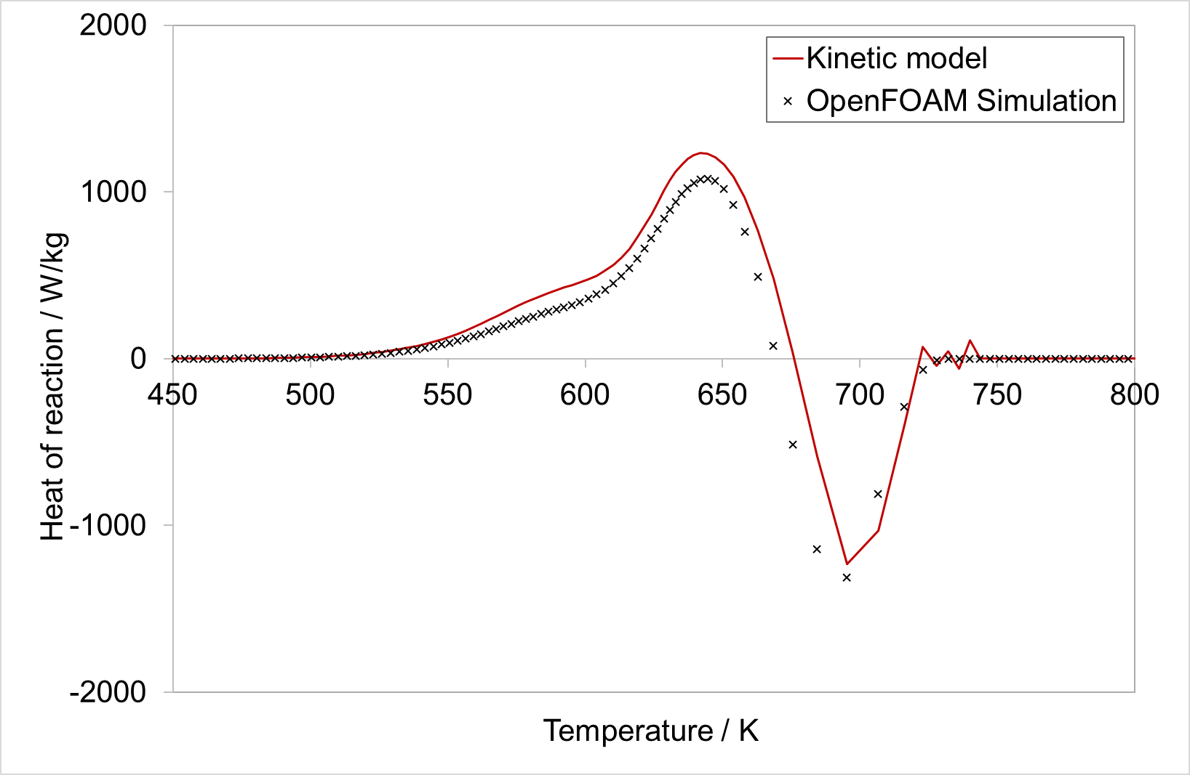  Figure 4: Comparison of heat of reaction during pyrolysis from OpenFOAM simulation and kinetic model
The mass loss during pyrolysis is shown in Figure 2. Kinetic model and OpenFOAM simulation are in very good agreement with each other, indicating correct implementation of the kinetics of the decomposition reactions. Figure 3 illustrates how the decomposition reactions of each component add to the overall mass loss of the particle. Hemicellulose reacts first, starting at a temperature of approximately 500 K. This is followed by the decomposition of cellulose and finally the pyrolysis of lignin. The reaction rates merge into each other and form the overall profile with the characteristic shoulder for hemicellulose decomposition. The heat of reaction resulting from the pyrolysis reactions is shown in Figure 4, calculated with the data of the kinetic model and taken from the results of the OpenFOAM simulation. In Figure 4 the particle mass was used as reference value for the heat of reaction, towards the end of the pyrolysis, the particle mass got very small, which led to some instabilities in the calculation. Figure 4 shows only a small deviation between heat of reaction calculated with the kinetic model from Branca and Di Blasi (2016) and the results of the OpenFOAM simulation. The results show that the new calculation method for heat of reaction introduced to the OpenFOAM model led to the correct description of heat of reaction and can be used further in future development and application of the model.
  - Conclusions
Implementation of the porous medium model into OpenFOAM was successful and the results for thermally thin particles are promising. Future work will include the improvement of the physical model, implementation of detailed reaction mechanisms and validation with experiments for thermally thick particles. One objective of the work is to develop a model that can be used for the simulation of technical applications for fixed bed biomass pyrolysis, gasification or combustion with low computational effort. Another objective is to refine the model with additional levels of detail regarding the biomass structure and decomposition kinetics to enable the precise description and deeper understanding of biomass decomposition on particle level. The presented OpenFOAM model should be the basis for both modelling approaches and allow for the adaption for both cases.
Acknowledgments
This CFD model has been developed in close cooperation with the Deutsches Biomasseforschungszentrum gemeinnützige GmbH (DBFZ), research focus area Catalytic Emission Control.
References
Almuina-Villar H., Anca-Couce A., Lang N., Röpcke J., Behrendt F., Dieguez-Alonso A.,2018, Laser-Based Spectroscopy Diagnosis and Detailed Numerical Models to Gain Understanding on the Slow Pyrolysis Behavior of Thermally Thick Wood Particles, Chemical Engineering Transactions (65), S. 109–114.
Anca-Couce A., 2016 Reaction mechanisms and multi-scale modelling of lignocellulosic biomass pyrolysis, Progress in Energy and Combustion Science 53, 41–79.
Branca C., Di Blasi C., 2016, A summative model for the pyrolysis reaction heats of beech wood, Thermochimica Acta, 638, 10-16.
Caposciutti G., Almuina-Villar H., Dieguez-Alonso A., Gruber T., Kelz J., Desideri U. et al., 2019, Experimental investigation on biomass shrinking and swelling behaviour: Particles pyrolysis and wood logs combustion, Biomass and Bioenergy 123, 1–13.
Corbetta, M., Frassoldati, A., Bennadji, H., Smith, K., Serapiglia, M. J., Gauthier, G., Melkior, T., Ranzi, E., Fisher, E. M., 2014, Pyrolysis of Centimeter-Scale Woody Biomass Particles: Kinetic Modeling and Experimental Validation. Energy & Fuels 28, 6, 3884–3898.
Galgano A., Di Blasi C., Horvat A., Sinai Y., 2006, Experimental Validation of a Coupled Solid- and Gas-Phase Model for Combustion and Gasification of Wood Logs, Energy & Fuels 20 (5), S. 2223–2232.
Gentile G., Cuoci A., Frassoldati A., Faravelli T., Ranzi E., 2015, A Comprehensive CFD Model for the Biomass Pyrolysis, Chemical Engineering Transactions (43), S. 445–450.
Giuliano A., Freda C., Catizzone E., 2020, Techno-Economic Assessment of Bio-Syngas Production for Methanol Synthesis. Bioengineering 7 (3) 1-19.
Gómez M. A., Porteiro J., de La Cuesta D., Patiño D., Míguez J. L., 2017, Dynamic simulation of a biomass domestic boiler under thermally thick considerations, Energy Conversion a. Management 140, S. 260–272.
Haberle I., Skreiberg Ø., Łazar J., Haugen N. E. L., 2017, Numerical models for thermochemical degradation of thermally thick woody biomass, and their application in domestic wood heating appliances and grate furnaces, Progress in Energy and Combustion Science 63, 204–252.
Klason T., Bai X. S., Bahador M., Nilsson T. K., Sundén B., 2008, Investigation of radiative heat transfer in fixed bed biomass furnaces, Fuel 87, Nr. 10-11, 2141–2153.
Kwiatkowski K., Górecki B., Korotko J., Gryglas W., Dudyński M., Bajer K. 2013, Numerical Modeling of Biomass Pyrolysis - Heat and Mass Transport Models, Numerical Heat Transfer, Part A: Applications 64, 3, 216–234.
Mahmoudi A. H., Besseron X., Hoffmann F., Markovic M., Peters B., 2016, Modeling of the biomass combustion on a forward acting grate using XDEM, Chemical Engineering Science 142, S. 32–41.
Mehrabian R., Zahirović S., Scharler R., Obernberger I., Kleditzsch S., Wirtz S., et al. 2012, A CFD model for thermal conversion of thermally thick biomass particles. Fuel Processing Technology 95, 96–108.
Park, W. C.; Atreya, A.; Baum, H. R. 2010, Experimental and theoretical investigation of heat and mass transfer processes during wood pyrolysis. Combustion and Flame 157 (3), 481–494.

