|  |  |
| --- | --- |
| cetlogo ***CHEMICAL ENGINEERING TRANSACTIONS***  ***VOL. 92, 2022*** | A publication of  aidiclogo_grande |
| The Italian Association  of Chemical Engineering  Online at www.cetjournal.it |
| Guest Editors: Rubens Maciel Filho, Eliseo Ranzi, Leonardo Tognotti  Copyright © 2022, AIDIC Servizi S.r.l. **ISBN** 978-88-95608-90-7; **ISSN** 2283-9216 | |

An Aspen Plus Kinetic Model for the Gasification of Biomass in a Downdraft Gasifier

Elena Catalanotti\*, Richard T.J. Porter, Haroun Mahgerefteh

Department of Chemical Engineering, University College London, Torrington Place, London WC1E 7JE, UK

\*e.catalanotti@ucl.ac.uk

Gasification is a useful technology to recover energy from renewable biomass by producing a versatile syngas which can be converted into useful chemicals or fuels, or used directly for energy generation. The quality and composition of the syngas is highly dependent on the biomass feedstock, design parameters and process conditions, such as temperature, gasifying agent and Equivalence Ratio (ER). Downdraft gasifiers are considered to be a good option for low tar syngas production. In this work, a kinetic model for a downdraft gasifier is assembled and incorporated into a flowsheet using Aspen Plus with the aim of performing detailed process analysis. The model is organised according to the assumption that in a downdraft gasifier pyrolysis, oxidation and reduction occur almost as separate consecutive processes, with the pyrolysis considered as an instantaneously occurring process while oxidation and reduction are governed by chemical kinetics. The model has been validated against experimental data for different conditions of ER ranging from 0.2 to 0.35. The results show an overall agreement of the main species, with slight discrepancies in the prediction of CH4, which is over-predicted at lower ERs and under predicted at ER 0.345. This has an effect on the calculated Lower Heating Value (LHV) of the syngas which is generally higher than the experimental value. A set of sensitivity analyses were performed to investigate the impact of the value of the Char Reactivity Factor (CRF) on the composition of the producer gas and the kinetic parameters used in the model on the production of CH4. Sensitivity analyses show that a CRF of 14 gives the best prediction of the syngas composition and that the kinetics of the reactions in the reduction zone do not have a large impact on the final levels of methane in the syngas. More important is the sensitivity to variation of the kinetic parameters in the oxidation stage. By doubling the rate of oxidation of CH4 in the oxidation zone, the final levels of CH4 in the syngas are reduced by almost 20%.

**1. Introduction**

Biomass is plant or animal material that can be used as a fuel-based source of energy and it has attracted increasing interest due to its characteristics; it is renewable and considered to be ‘carbon neutral’, meaning that the CO2 released when treating the biomass had previously been taken up by the organisms during photosynthesis, so no net additional carbon is added to the atmosphere when burnt as a fuel. Biomass gasification has been the focus of many studies in the past decades because of its ability to produce a versatile syngas which can be converted into useful chemicals or fuels or used directly for energy generation. With Lower Heating Value (LHV) typically ranging from about 4 to 18 MJ/Nm3 (Gallucci etal., 2020), biomass-derived syngas is mainly composed of H2, CO, CO2 and small amounts of CH4, in concentrations which vary according to the type of biomass used, the gasifying agent (such as air, O2-enriched air, steam), ER and the temperature of the process. The type of gasifier used and its design also have an impact on syngas composition and level of by-products produced, such as tar and unconverted char. Given the large interest attracted by the topic and the large amount of work available, several review articles have been published recently which help to identify the areas needing further development, which are summarised below.

Although limited to small-scale application, biomass gasification in a downdraft gasifier has the benefit of producing low levels of tar (Puig-Arnavat et al., 2010) due to the high temperature oxidation and cracking reactions happening in a specific section of the gasifier immediately after tar is formed during pyrolysis. Baruah & Baruah (2014) have reviewed numerous biomass gasification studies and analysed the influence of different parameters on syngas quality and offered an overview of the types of models published for different overall process configurations. They identified that equilibrium models have been widely used to study the process in downdraft gasifiers with satisfying results in predicting the composition of the syngas. The limitation of this type of modelling approach is, however, the inability to predict tar and to work in conditions far from equilibrium, for example for low temperature processes. A similar conclusion was drawn in the review from Mutlu & Zeng (2020), which focuses on process simulation models developed using Aspen Plus. Smith et al. (2019) developed and compared an equilibrium model based on the Gibbs energy minimisation method with a kinetic model for the gasification of biomass in a downdraft gasifier and found that the kinetic model was more accurate in predicting the experimental data used for validation. Despite the large number of models developed, experimental data on downdraft gasifiers are less available and sometimes design details are not adequately described. This presents an obstacle for the validation of a model over a large number of conditions, including feedstock types and gasifying agents.

In this work, a kinetic mechanism previously developed by the authors (Catalanotti et al., 2020) was incorporated into Aspen Plus with the aim of reproducing the sequence of three thermochemical stages for design of a downdraft gasifier, which are described here. Biomass is fed at the top of the gasifier and first it encounters a hot region, typically with temperatures between 500 and 700 °C. In this condition, the complex structure of the feedstock is broken down to form a mixture of gases, comprising mainly H2, CO, CO2, CH4 andH2O, along with char, mainly composed of carbon, and tar, a liquid by-product composed of a mixture of aromatic hydrocarbons. This process, called pyrolysis, occurs very quickly and is therefore often simulated using equilibrium models. As the hot pyrolysis products travel downwards, they enter a second zone, in the throat of the gasifier, where air or O2-enriched air is injected and oxidation reactions take place. This section of the gasifier reaches temperatures of around 1000 °C (Zainal et al., 2002) and provides the necessary energy for the entire process. In order to obtain a high energy syngas, oxidation must be incomplete and a large amount of char must be left uncombusted. Typically, the optimal amount of O2 fed to the system is just under a third of the stoichiometric value for a given feedstock. In this stage, part of the tar formed is also combusted and a kinetic approach can be used to assess the impact of variation of ER and temperature on the production rate of tar. Once the O2 has been consumed completely, the gases, char and tar left, keep travelling downwards and enter the reduction zone. Here the temperature reaches values of about 700 – 800 °C (Zainal et al., 2002) and the endothermic gasification reactions take place, along with steam methane reforming and water gas shift reactions, resulting in the production of the final syngas product. A schematic of the process and the reactions considered in this study are presented in Figure 1.

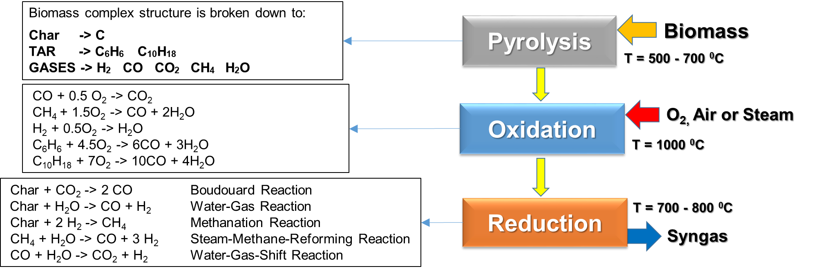

Figure 1: Schematic of the consecutive stages occurring during biomass gasification in a downdraft gasifier.

2. The Aspen Plus model

Aspen Plus is a process simulation software used to model, simulate, and optimise complex processes such as biomass gasification. Biomass has a complicated structure made of large polymeric molecules such as lignin, which can vary drastically for different feedstocks. It cannot therefore be found as a pure chemical compound in any database but it must be defined in Aspen Plus as a nonconventional fuel, characterised by its proximate and ultimate analyses, which are used to generate material balance calculations in later stages. The model proposed here follows the rationale described above for a downdraft gasifier. Figure 2 shows the flowsheet built to simulate the sequence of thermochemical stages biomass undergoes, from wet biomass to the produced syngas. The red streams represent the biomass and the species it converts into, while the blue streams represent external inputs. Table 1 presents the list of units employed in the flowsheet with a short description of each block.

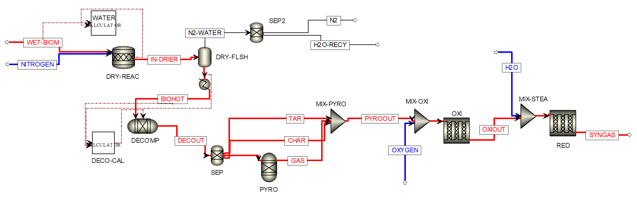

Figure 2: Aspen Plus flowsheet constructed for the present work. Red streams represent the motion of the biomass material and derivatives.

Table 1: List of units used in the Aspen Plus flowsheet.

|  |  |  |
| --- | --- | --- |
| Block name | Type | Description |
| WATER-CALCULATOR | Fortran Calculator | Controls the fraction of water removed during the drying step. |
| DRY-REAC | RStoic | Simulates the drying process. |
| DRY-FLSH | Flash 2 | Separates the solid dry biomass from the hot gas and water vapour. |
| SEP2 | SSOLID | Separates the hot gas from the water extracted from the biomass. |
| HEATER | HEATER | Heats the biomass to the temperature chosen for pyrolysis. |
| DECO-CAL | Fortran Calculator | Controls the conversion of nonconventional component into tar, char and conventional components. |
| DECOMP | RYield | Converts the nonconventional component into tar, char and conventional components. |
| SEP | SSOLID | Separates char, tar and mixture of conventional components. |
| PYRO | RGibbs | Simulates the reactions between conventional components through Gibbs free energy minimisation. |
| MIX-PYRO | Mixer | Mixes char, tar and gas producing the pyrolysis products stream. |
| MIX-OXI | Mixer | Mixes the pyrolysis products with air or oxygen. |
| OXI | RPlug | Computes the kinetics of the oxidation zone. |
| MIX-STEAM | Mix | Optional: Mixes oxidation products with additional steam. |
| RED | RPlug | Computes the kinetics of the reduction zone. |

* + 1. Physical Properties Model and Model Assumptions

Aspen Plus allows the user to select several sets of property calculation methods. The choice depends on the specific process studied, the conditions used (temperature and pressure ranges) and the nature of the components involved. In this work, the IDEAL property method has been chosen as the process involves low pressure and relatively small quantities of condensable components (tars). Since biomass and ash were defined as nonconventional components, the density and enthalpy calculation methods must be specified, which were DCOALIGT and HCOALGEN, respectively. The stream class was defined as MCINCPSD, for the presence of both conventional and nonconventional streams with solid particles. Given the complexity of the process, a set of assumptions was adopted: the process described is steady-state, pyrolysis is considered instantaneous while oxidation and reduction are governed by chemical kinetics and each block is modelled as isothermal. Char is modelled as carbon (graphite) and tars are represented by a surrogate mixture of benzene and naphthalene, in a ratio of 3:7. The chemistry of minor species, such as sulfur compounds, is neglected.

* + 1. Model development

A first step is sometimes included for drying biomass. This step is not needed if dry biomass is fed into the system instead of the wet biomass. Hot air or nitrogen is mixed with biomass to remove a portion of the moisture. The fraction removed depends on the temperature and the amount of hot gas used. Since specifications for drying were not available in the set of experimental data employed in this work for model validation, a general approach was used when modelling this step (Aspen Technology, Inc., 2013). The drying step produces a water stream which can potentially be recycled back into the reduction zone for steam gasification. The dry biomass is heated to the temperature at which pyrolysis occurs.

Since biomass is defined as a nonconventional component, before modelling a chemical process, it needs to be ‘decomposed’ into its elemental constituents. This can be done in an RYield block (DECOMP) where the output is defined through a Fortran calculator block as derived from the ultimate analysis. The standard subroutine described in Aspen Technology, Inc. (2013) was modified to account for the formation of specified yields of tar and char, according to the empirical formula reported by Gomez-Barea et al. (2010). The DECOMP stream output was then separated into three sub-streams, CHAR, TAR and a mixture of elemental species (C, H2, O2 and S) and ash. The latter stream was inputted in an RGibbs reactor unit to calculate the composition at equilibrium of the expected mixture of pyrolysis gases, H2, CO, CO2 and CH4, based on the minimisation of the Gibbs free energy of the system. The product streams from the pyrolysis stage, TAR, CHAR and GAS, were mixed before entering the oxidation zone. The pyrolysis products were mixed with air (or oxygen) before entering the oxidation reactor (named OXI). In this work, oxidation is assumed to be governed by chemical kinetics. An RPlug reactor was chosen for this section of the model and the reaction scheme is that proposed by Gerun et al. (2008) and includes oxidation of the tar species benzene and naphthalene. The reactor was modelled as isothermal. Details of the size of the oxidation zone are difficult to retrieve in literature. The actual length of the zone is quite small in comparison to the reduction zone as the oxygen is consumed relatively quickly by reacting with H2, CO, CH4 and tar. In this work, the experimental data from Sheth and Babu (2009) were used to validate the model and the sizes of the reactors are based on their findings as will be discussed in Section 2.3. Oxidation products exit the OXI block and can be mixed with steam for steam enhanced gasification before entering the reduction zone, modelled with a second Rplug reactor (named RED). The heterogeneous reactions in the reduction zone were modelled according to a Langmuir-Hinshelwood mechanism as shown in equations 1.

|  |  |
| --- | --- |
| $rate= \frac{[Kinetic Factor][Driving Force]}{[Adsorption]}$ | (1) |

where the Kinetic Factor is defined by the Arrhenius parameters, i.e. the pre-exponential factor k and the activation energy Ea, the Driving Force is a function of the concentration of the species and the Adsorption Factor takes into account competitive adsorption on the char surface due to the co-presence of several gases. The reaction scheme, along with the kinetic parameters and adsorption constants, were based on the work published by the authors (Catalanotti et al., 2019). The parameters were recast for compatibility with the Aspen Plus format and are reported in Table 2. The factor k is a combination of the frequency factor of the reaction (Wang and Kinoshita, 1993) and a Char Reactivity Factor (CRF), which is a function of char density and particle size, for which a reference value of about 15 was calculated based on the expressions and values of char characteristics used in Catalanotti et al. (2019) and extensively described in Wang and Kinoshita (1993).

Table 2: Kinetic parameters used in reduction reactor (RED).

|  |  |  |  |  |
| --- | --- | --- | --- | --- |
| Reaction | Frequency factor (s-1) | CRF | k (s-1) | E (kJ/kmol) |
| C+CO2 → 2 CO | 36.16 | 14.8 | 535 | 77,390 |
| C+H2O → CO + H2 | 15,170 | 14.8 | 224,705 | 121,620 |
| C+2H2 → CH4 | 0.004 | 14.8 | 0.062 | 19,210 |

* + 1. Model validation

The model was validated against experimental data provided by Sheth and Babu (2009) which investigated the syngas composition and heating value obtained from biomass gasification in a downdraft gasifier for different values of ER, ranging 0.2 to 0.35. The composition of the biomass was the same reported in Sheth and Babu (2009), with the proximate analysis (% by wt. dry basis) reporting fixed carbon 15.70%, volatile matter 80.40% and ash 3.90% and the ultimate analysis (% by wt. dry basis) reporting carbon 48.6% hydrogen 6.2% oxygen 44.87% and nitrogen 0.33%. A scale-up of the whole system was necessary to avoid computational errors encountered when the flow rates of the feed were as low as those employed in the experiments. The sizes of the reactors were enlarged accordingly to retain equivalent residence time in each section. Details of the conditions and the calculations used for the scale-up are listed in Table 3 for ER = 0.2533.

Table 3: Experimental and model gasifier design parameters.

|  |  |  |  |
| --- | --- | --- | --- |
| Parameter | Sheth & Babu (2009) | Current Model |  |
| Biomass Flowrate (kg/hr) | 2.1 | 21 |  |
| Air (kg/hr) | 4.9 | 49 |  |
| ER | 0.253 | 0.253 |  |
| Oxidation zone Volume (mm3) | 937 | 4,683 |  |
| Reduction zone Volume (mm3) | 1,767 | 22,443 |  |
| Overall Calculations for Scale-up |  |  |  |
| Tot Vol m3 | 2.7 | 27 |  |
| Biomass/Air | 0.43 | 0.43 |  |
| Air/Volume | 1.81 | 1.81 |  |

The same approach was used to run the cases with different flowrates and ERs. A comparison of the model results with the experimental data is reported in Figure 3. The results in Figure 3a show the composition of the syngas at the exit of the gasifier. The model is able to satisfactorily predict the relative levels of the main species responsible for the energy content of the syngas, H2 and CO. However, an accurate comparison reveals slight discrepancies in the prediction of CH4, which is over predicted at lower ERs and under predicted at ER 0.345, while N2 levels are overall under predicted by the model. The LHV for the gas was calculated according to the composition and the values published in Waldheim and Nilsson (2001) for H2, CO and CH4 (Figure 3b). The discrepancies described above have a direct impact on the LHV of the producer gas which is higher than the experimental value for ER = 0.2054 and 0.2533 as CH4 has a relatively high heating value for unit of volume in comparison to H2 and CO, so small variations in the composition have a visible effect.

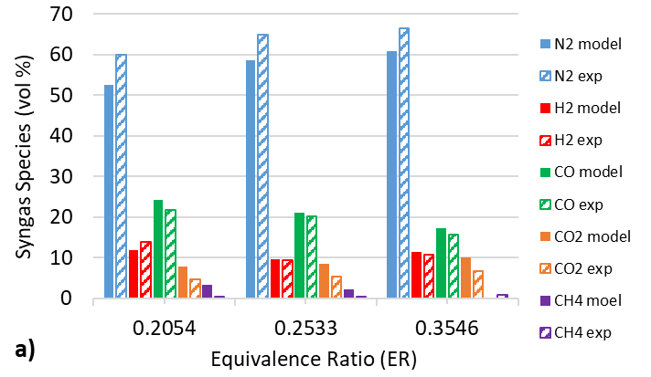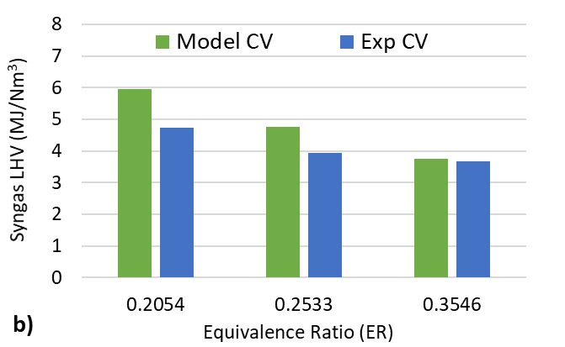

Figure 3: Comparison of model predictions with experimental data from Sheth and Babu (2009); a) presents the syngas composition for different values of ER; b) presents the LHV calculated for the gas at different ER values.

3. Sensitivity Analyses

In order to investigate the effect of the kinetic parameter variation on the syngas composition and, in particular, on the concentration of CH4, sensitivity analyses were performed and the results are shown in Figures 4 and 5. Since information on the char was not given in the experiments, the main uncertainty was the CRF. The impact of varying the CRF from 1 to 45 on all the species compared with the experimental data is shown in Figure 4 for ER = 0.2533. The CFR initially chosen as a reference value of roughly 15 gives already a good representation of the main species (Figure 4a) with deviations from the experimental data of CO and H2 equal to 3.7% and 2.3% respectively, with the best results obtained for CRF 14 where the deviations are 1.4% and 1%, while there is negligible effect on methane concentration. Moreover, while reducing the CRF to about 7-8 improves the prediction of N2, as less char is converted to gas, it also negatively affects the accuracy of predicting the concentration of most important components H2 and CO.

The effect of the variation of the pre-exponential factor for each reaction on the final concentration of methane in the syngas was also investigated with the most influential reactions plotted in Figure 5. The oxidation reaction of CH4 was found to be highly sensitive, with doubling the reaction rate leading to final levels of methane in the syngas being reduced by almost 20% (Figure 5a). For the reduction zone the pre-exponential factor of each reaction was varied in the range from 1 to 100. The results showed that the Water-Gas reaction (i.e. the reaction of water with char) has the greatest effect on methane formation (Figure 5b). This is mostly due to the increase of H2 which in turn shifts the Steam-Methane-Reforming reaction towards the production of more CH4. The value used for the base-case scenario gives, however, the minimum CH4 levels already. The kinetics of the other reactions in the reduction zone do not have a large impact on the final levels of methane in the syngas.

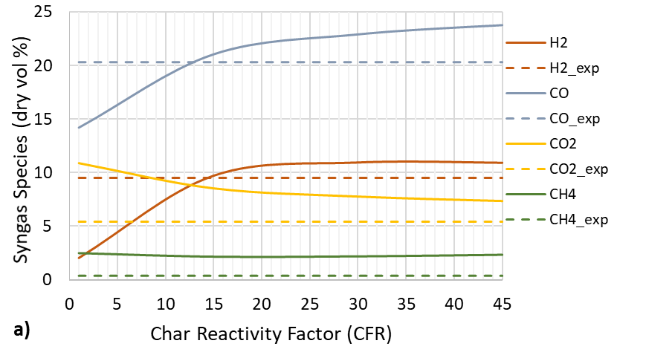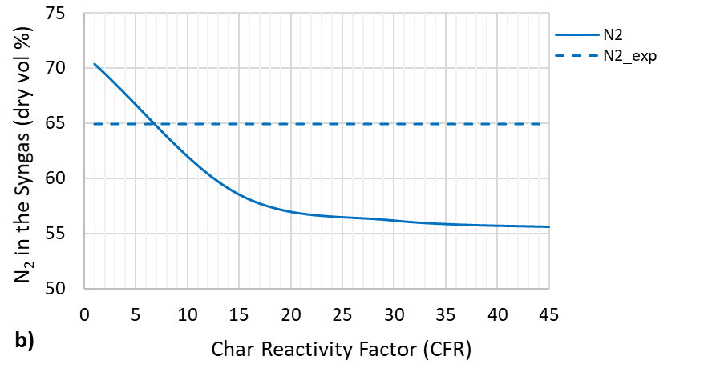

Figure 4: Sensitivity of syngas composition on value of CRF for the heterogeneous reactions. The dotted lines represent the experimental values while the plain lines are the model predictions for different CRF values.

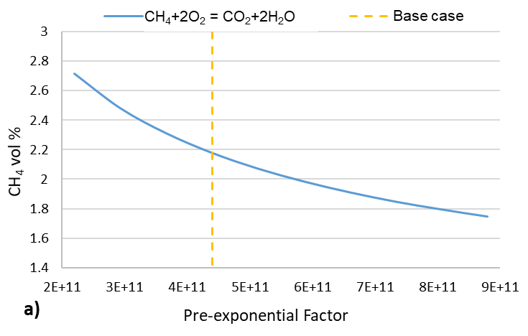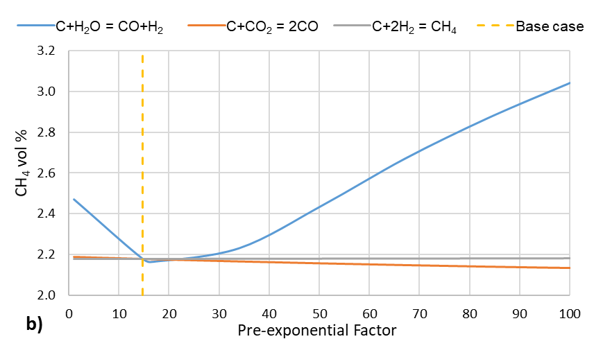

Figure 5: Sensitivity of pre-exponential parameter value for selected chemical reactions on CH4 concentration vol% in syngas, i.e.; a) CH4 oxidation; b) three heterogeneous reactions. The dotted line represents the nominal parameter value.

4. Conclusions

A kinetic scheme was incorporated into Aspen Plus to simulate and predict the syngas product composition of biomass gasification in a downdraft gasifier. In the model, the layout of the gasifier is taken into consideration and pyrolysis, oxidation and reduction are modelled as consecutive stages. Pyrolysis is considered to occur instantaneously and is modelled through a combination of temperature dependent empirical relationships to generate tar and char. An RGibbs reactor is used to define the composition of the pyrolysis gas, while oxidation and reduction are modelled in two consecutive RPlug reactors and are governed by chemical kinetic reactions. A comparison with experimental data reveals that the performance is satisfactory in regards to the main species with minor deviation in the prediction of CH4. Sensitivity analyses performed on kinetic parameters identified that the rate of methane oxidation is the most influential factor in the model governing the predicted CH4 syngas concentration.

Acknowledgements: This work was supported by a Daphne Jackson Trust Postdoctoral Fellowship, funded by EPSRC and University College London.

**References**

Aspen Technology, Inc., 2013, Getting Started Modeling Processes with Solids, Version Number: V8.4.

Baruah, D. and Baruah, D.C., 2014, Modeling of biomass gasification: A review, Renewable and Sustainable Energy Reviews, 39, 806-815.

Catalanotti, E., Porter, R.T.J., Chalchooghi, M.M. and Mahgerefteh, H., 2020, Biomass Gasification in a Downdraft Gasifier with In-situ CO2 Capture: a Pyrolysis, Oxidation and Reduction Staged Model, Chemical Engineering Transactions, 80, 85-90.

Gallucci, F., Liberatore, R., Sapegno, L., Volponi, E., Venturini, P., Rispoli, F., Paris, E., Carnevale, M., Colantoni A., 2020, Influence of Oxidant Agent on Syngas Composition: Gasification of Hazelnut Shells through an Updraft Reactor, Energies, 13, 102-115.

Gerun, L., Paraschiv, M., Vîjeu, R., Bellettre, J., Tazerout, M., Gøbel, B., and Henriksen, U., 2008, Numerical investigation of the partial oxidation in a two-stage downdraft gasifier, Fuel, 87(7), 1383-1393.

Gomez-Barea, A., Nilsson, S.; Barrero, F.V. and Campoy, M., 2010, Devolatilization of wood and wastes in fluidized bed, Fuel Processing Technology, 91(11), 1624–1633.

Mutlu, Ö.Ç. and Zeng, T., 2020, Challenges and Opportunities of Modeling Biomass Gasification in Aspen Plus: A Review. Chemical Engineering Technology, 43, 1674-1689.

Puig-Arnavat, M., Bruno, J.C., and Coronas, A., 2010, Review and analysis of biomass gasification models, Renewable and Sustainable Energy Reviews, 14, Issue 9, 2841-2851.

Sheth, P.N., and Babu, B.V., 2009, Experimental studies on producer gas generation from wood waste in a downdraft biomass gasifier, Bioresource Technology, 100, 3127-3133.

Smith, J.D., Alembath, A., Al-Rubaye, H., Yu, J., Gao, X. and Golpour, H. 2019, Validation and Application of a Kinetic Model for Downdraft Biomass Gasification Simulation. Chemical Engineering Technology, 42, 2505-2519.

Zainal, Z.A., Rifau A., Quadir G.A. and Seetharamu, K.N., 2002, Experimental investigation of a downdraft biomass gasifier, Biomass and Bioenergy 23, 283-289.

Waldheim, L., Nilsson, T., 2001, Heating Value of Gases from Biomass Gasification, Report prepared for: IEA Bioenergy Agreement, Task 20 - Thermal Gasification of Biomass.

Wang, Y., and Kinoshita, C., 1993, Kinetic model of biomass gasification, Solar Energy, 51(1), 19-24.