|  |  |
| --- | --- |
| cetlogo ***CHEMICAL ENGINEERING TRANSACTIONS***  ***VOL. 92, 2022*** | A publication of  aidiclogo_grande |
| The Italian Association  of Chemical Engineering  Online at www.cetjournal.it |
| Guest Editors: Rubens Maciel Filho, Eliseo Ranzi, Leonardo Tognotti  Copyright © 2022, AIDIC Servizi S.r.l. **ISBN** 978-88-95608-90-7; **ISSN** 2283-9216 | |

Microalgae growth in physically pre-treated wastewater generated during hydraulic fracturing

Giovanni Antonio Lutzua\*, Alessandro Concasb,c, Nurhan Turgut Dunforda,d

aRobert M. Kerr Food & Agricultural Products Center, FAPC Room 13, Oklahoma State University, Stillwater, OK 74078-6055, US

bDepartment of Mechanical, Chemical and Materials Engineering, University of Cagliari, Piazza d’Armi, 09123 Cagliari (CA), Italy

cCentro di Ricerca, Sviluppo e Studi Superiori in Sardegna, (CRS4), Loc. Piscina Manna, Edificio 1, 09050 Pula (CA), Italia

dDepartment of Biosystems and Agricultural Engineering, Oklahoma State University, Stillwater, OK 74078-6055, US

\*gianni.lutzu@teregroup.net

Hydraulic fracturing technique frequently used during gas and oil production generates large amounts of wastewaters (WWs). High cost of the conventional techniques used to treat such waters adversely affect their economic feasibility. Hence, novel technologies that will facilitate remediation and subsequent re-use of these WWs are welcomed. In this study, growth profile of four Oklahoma native microalgae (*Geitlerinema carotinosum*, *Komvophoron* sp., *Pseudanabaena* sp., *Picochlorum oklahomensis*) cultivated in physically pre-treated flowback and produced water generated during hydraulic fracturing were characterized. A mechanical step based on oil removal by an oil skimmer was introduced during pre-treatment. The experimental results demonstrated that all four strains could grow in pre-treated flowback and produced water. Biomass productivity varied significantly with the microalgae strain and type of the WW used in the growth experiments. The best performing strain, cyanobacterium *Komvophoron* sp., was able to grow with a specific growth rate ranging from 0.03 to 0.18 day-1 depending on the type of WW. The process was capable of removing ammonium and phosphorus with efficiencies up to 99 and 63%, respectively.

* 1. Introduction

Hydraulic fracturing, also referred to as fracking, is frequently used to stimulate oil and gas production, especially in North America (Sun et al., 2019). Large volumes of freshwater are used and about 3 million of megaliters of wastewater (WW) are generated only in US during the fracking process (Sullivan Graham et al., 2017). Two main streams originate by this activity, flowback water (FW) and produced water (PW). Fracking fluid (FF) which is injected into the well bore during the process contains sand and a number of chemicals to control pH, microbial growth, gelling, and corrosion. FW refers to the WW returning to the surface right after fracking before oil or gas production starts and consists of hydraulic FF and formation brines. PW usually contains some hydraulic FF, crude oil, grease as well as formation water. Presence and concentrations of various inorganic and organic compounds including hydrocarbons (Maguire-Boyle and Barron, 2014) in PW depend on the geological formation fractured. The environmental impact of PW depends on the number and types of wells, local geology, hydrology, proximity to freshwater sources, existence and location of water treatment facilities, the chemical makeup of PW, management practices, land availability for surface storage, and availability of deep-disposal wells (Mauter et al., 2014). High cost of the current treatment technologies is limiting recycle and re-use of the generated WW and constraining the management options available to the fracking industry. Biological treatment of FW and PW using algae has gained attention during the last decade (Lutzu et al., 2020a). Recently, effect of algae growth in FW (Lutzu and Dunford, 2019a) and PW (Lutzu et al., 2020b; Lutzu and Dunford, 2019b) on residual water quality has been reported. The latter studies demonstrated that microalgae can grow in PW and remove some of the inorganic contaminants, but cell growth was constrained by the low concentrations of nitrogen (N) and phosphorous (P). Chemical composition of WW from different wells and geographical regions may be significantly different (Ferrer and Thurman, 2015). Therefore, further research and development studies are vital for a better understanding of these water streams as potential algae growth media and WW remediation. Successful cultivation of microalgae in PW and FW depends on chemical composition of WW as well as strain selection. Hence, the main goal of this study was to fill the scientific knowledge gap in the field by investigating the potential of four Oklahoma native microalgae strains for remediation of PW and FW generated in the same region and producing biomass. Effect of physical WW pre-treatment on water quality and biomass production was evaluated based on a preliminary removal of oil and geese from the WW samples by an oil skimmer. Characteristics of the algal biomass grown in FW and PW were assessed and compared to previous studies were WWs were not subjected to mechanical oil removal.

**Material and Methods**

**2.1 Inoculum, culture medium and wastewater preparation**

Three of the four algae strains examined in this study, *Geitlerinema carotinosum* (SP28), *Komvophoron* sp. (SP33), and *Pseudanabaena* sp. (SP46) were obtained from the culture collection of the University of Texas at Austin, US (UTEX, 2019). *Picochlorum oklahomensis* (CCMP2329) was provided by the culture collection of the National Center for Marine Algae and Microbiota, Boothbay, Maine, US (NCMA, 2019). Detailed chemical composition of the culture maintenance media is available on the UTEX and NCMA official websites. The strains were maintained in 50 mL glass tubes containing the growth medium recommended by UTEX and NCMA at room temperature. Two 32 W white fluorescent tubes provided a photosynthetic photon flux density (PPFD) of 40 µmol m−2 s−1 during the 12 h light period/day. The light was off during the remaining 12 h/day (dark period) of the growth period. WW samples were collected from oil-producing wells operating in Okarche, OK, US. An oil skimmer (Mighty Mini SS2, Abanaki Corporation, OH, US) was used to remove oil from the samples. Then, water was filtered through a filter paper disk (#1, Whatman, UK), and subsequently treated for 20 min at 121°C and 0.1 MPa in an autoclave before microalgae cultivation.

**2.2 Algae Cultivation**

2 L glass reactors, thereafter denominated PBRs, were used for algae cultivation and maintained in a closed chamber under controlled conditions. A detailed description of the cultivation systems, growth conditions and chamber dimensions has been provided in previous works carried out by our research team (Lutzu et al., 2020b; Lutzu and Dunford, 2019b). The initial working volume of the PBR and cell concentration were 1.2 L and 0.1 g L-1, respectively. After one month of cell growth, the cultures were centrifuged at 9722 g RCF-1 for 10 min. The liquid phase was separated and used for WW analysis.

**2.3 Characterization of microalgae growth pattern**

Microalgae growth in the culture was monitored by measuring the optical density (OD) at 680 nm. The detailed procedure adopted to monitor algal growth was reported in Lutzu et al. (2020b). Cell concentration on dry weight basis X (gdw L−1) and specific growth rate (μ) calculations were performed according to the procedures reported elsewhere (Zhu and Dunford, 2013). The maximum biomass productivity (∆X) was expressed as:

 (1)

The pH of the cultures was also recorded using a pH-meter (model AR20, Fisher Scientific, Waltham, MA, US).

**2.4 Wastewater quality**

Chemical compositions of the WW samples were analyzed before and after microalgae cultivation according to the standard analytical water quality methods proposed by the American Public Health Association (Eaton et al., 2005). Chemical Oxygen Demand (COD) of the WW samples was determined according to a method developed by the US Environmental Protection Agency (USEPA, 1980). Water samples were centrifuged at 8,000 rpm for 10 min and filtered through a glass microfiber filter (GF/CTM, Whatman, UK) before chemical tests were performed.

**2.5 Data Analysis**

All the experiments with algae and analytical tests were carried out at least in duplicate, typically in triplicate, and for all of them the mean values were reported. SAS 9.3 (SAS Institute Inc., Cary, NC, US) was used for the statistical analyses of the data. The regression equations correlating dry biomass concentration to OD, and to µ were calculated using Microsoft Office Excel program (Excel 2016 Ink, Microsoft, US).

* 1. Results and Discussion

**3.1 Chemical composition before and after pre-treatment**

# All the WW samples examined in this study were collected from wells producing oil at the time of sampling. Na+ and Cl- were the major ions in all the WW samples (Table 1). In general, order of the relative abundance of the ions in WW were as follows: Na+, Cl-, Ca2+, Mg+, K+, SO42-, Br- and HCO3-. Although many of these ions at high concentrations contribute to the aquatic toxicity of a WW (Pillard et al., 1996), they may also be nutrients enhancing microalgae growth. Mg2+, K+ and NH4+ contents of PW-A were much higher than those of the other samples. Growth of living cells in PW may be inhibited by the presence of free oil, dissolved solids, suspended solids, metals, organics and volatile organic compounds (VOCs).

Table 1: Chemical composition before and after pre-treatment of produced and flowback wastewaters

|  |  |  |  |  |
| --- | --- | --- | --- | --- |
| PW-A PW-B FW-A FW-B  BPT APT BPT APT BPT APT BPT APT |  |  |  |  |
| Sodium 10452 11729 3332 3732 3309 3666 2242 2358  Calcium 979 1018 68 41 92 69 49 50  Magnesium 135 140 12 11 13 13 5 5  Potassium 160 161 63 71 42 49 53 56  Nitrate-N 0.1 0.1 0.1 0.1 0.1 0.2 0.2 0.1  Chloride 13348 19906 3473 3495 3824 4354 1406 758  Sulfate 651 683 816 906 283 328 1012 1064  Boron 51 53 49 55 48 56 64 67  Bicarbonate 570 587 1258 1356 1130 1193 1577 1506  Carbonate n.a n.a n.a n.a n.a 24 n.a 70  Ammonium 24 15 6 3 0.3 0.7 0.3 1.3  ICAP\_P 0.29 0.27 0.20 0.29 0.15 0.15 0.28 0.62  TDS 31218 34225 9246 10309 9986 11240 6345 6488  BOD5 n.a 21 n.a 14 n.a 14 n.a 13  COD n.a 2645 n.a 1083 n.a 2770 n.a 1964  pH 7.1 7.8 7.7 7.7 7.6 8.5 7.4 8.7 |  |  | 3.536 4.222 |  |

Note: PW-A and -B: Produced water sample A and B, FW-A and -B: Flowback water sample A and B, BPT = Before Pre-treatment, APT = After Pre-treatment, na: Not available, ICAP\_P: Total P determined by Inductively Coupled Argon Plasma ion chromatography method, TDS = Total Dissolved Solids, BOD5 = Biological Oxygen Demand, COD = Chemical Oxygen Demand. All the values are expressed in terms of mg L-1. All data were obtained as means from at least two experiments.

WW samples were subjected to a pre-treatment before using for microalgae growth to reduce the amount of oil, suspended solids, and dark coloured grease present in the samples. Heat treatment was done to ensure axenic cell growth. Although, air floatation technique can be a more practical alternative for oil removal at large scale commercial operation, a mechanical rotatory disc oil skimmer was chosen for this study due to the relatively small size of the samples available for the experiments. The recovery performance of this type of oil skimmer depends on the number of disks and their rotating velocity (Supriyono and Nurrohman, 2020). Presence of oil in PW was expected, because, the samples were taken from an oil producing well. A considerable amount of oil, 5.94% by weight, was removed from PW during pre-treatment. In addition, about 3% of solids and 2.4% of volatile compounds were removed by filtration and heat treatment, respectively. Compared to PW the amount of oil removed from FW was lower and this aspect was somehow expected since disc oil skimmers works well with heavy crude oil characterized by high viscosity. The amount of solids removed during filtration (1.1%) was about three times lower than that found for PW, while heat treatment caused the same amount of volatile loss from both FW and PW (Figure 1).

**3.2 Microalgae growth in produced and flowback water**

On average, the four strains grown in PW (Figure 2) showed lower µ than the respective rates achieved in regular media (MAS and A+) (Zhu and Dunford, 2013). The higher growth rates found in regular media are expected because they are formulated to optimize the growth of specific strains. It is well established that algae growth rate is positively correlated with N/P ratio in the growth medium (Whitton et al., 2016). In both MAS and A+ media used in the study by Zhu and Dunford (2013) NO3- and PO43- represented the sources of N and P with the same N/P ratio of 20. When CCMP2329 was grown in f/2 medium with a similar N/P ratio (15), maximum µ value achieved was 0.84 day-1 (Mayers et al., 2018). Other authors (Concas et al., 2016) have shown that *Pseudochloris wilhelmii* (belonging to the genus *Picochlorum*) had the highest µ when cultivated in the standard Brackish Water Medium with a N/P ratio of 10. SP46 cultivated in A+ with a N/P ratio of 20 (Zhou and Dunford, 2017) and in another standard medium with a N/P ratio of 12 (Liu and Vyverman, 2015) resulted in µ of 0.61 and 1.10 day-1, respectively. SP28, SP33 and SP46 when cultivated in PW-A exhibited lower µ compared those obtained when grown with another PW from a different well operating in Oklahoma which was not mechanically pre-treated by an oil skimmer (Lutzu and Dunford, 2019b).

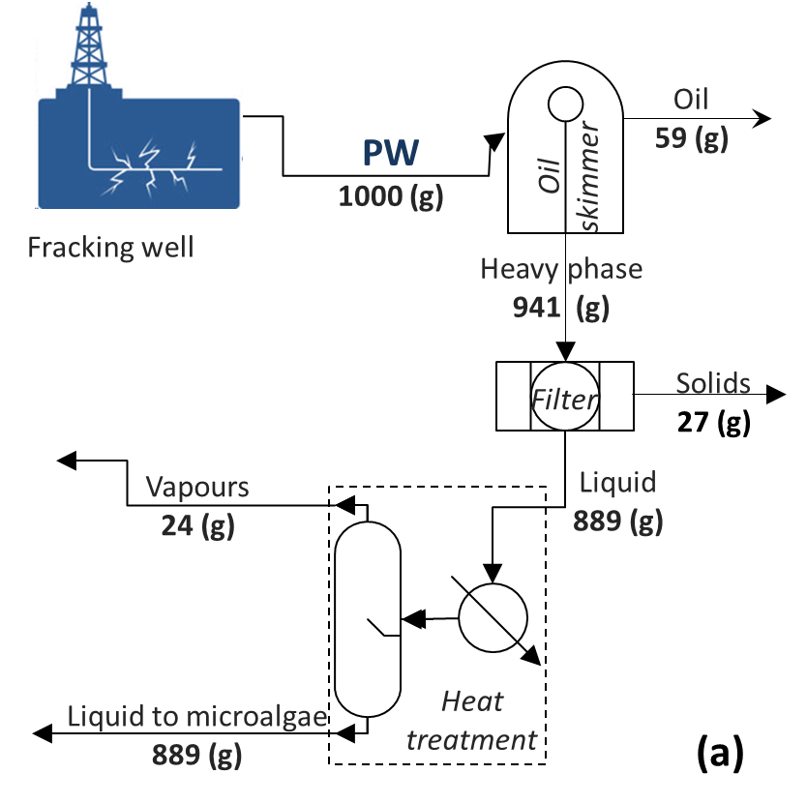 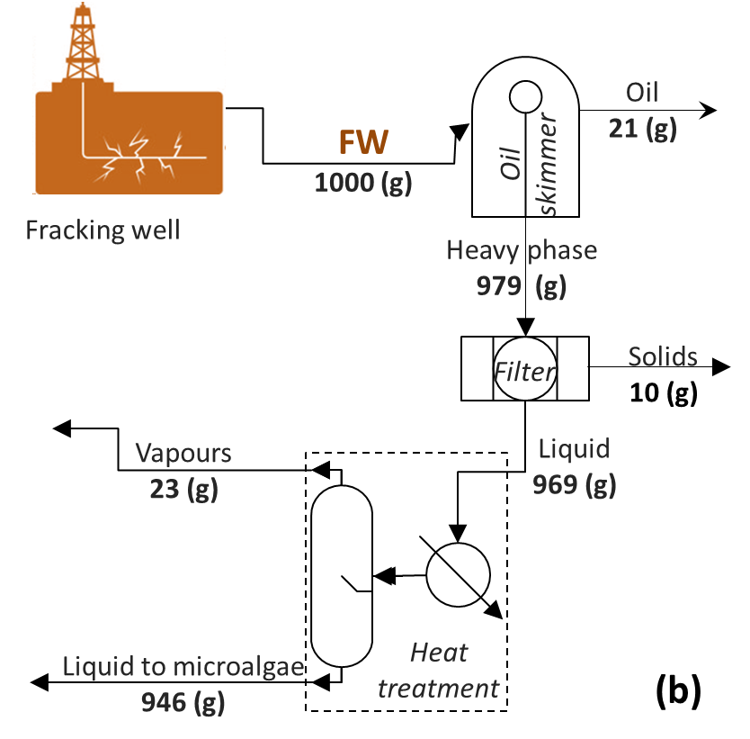

*Figure 1. Mass balances around the unit operations used for the pre-treatment of PW (a) and FW (b)*

There was no specific trend for the Xmax determined the four strains grown in PW. The highest Xmax in PW-A was obtained by CCMP2329while SP33 exhibited the highest Xmax in PW-B. SP46 achieved in PW-A a Xmax of 1.96 g L-1 which was 4 times higher than the lowest Xmax, produced by the same strain in FW-B (Figure 2a). Indeed, all four strains produced significantly higher Xmax, in PW-A than they didin other WWs examined in this study. In previous studies carried out in our laboratory under similar growth conditions used in this study except for the PW composition (which was collected from another well in OK), CCMP2329 produced Xmax of 1.87 g L-1 (Lutzu and Dunford, 2019b) while in another study the same strain attained a maximum biomass concentration of 2.10 g L-1 in the standard growth medium MAS (Zhu and Dunford, 2013). CCMP2329 produced Xmax of 1.77 g L-1 in PW-A, which is similar to the values reported in the latter studies. Similar Xmax values to the ones obatined in PW-A with SP28, SP33 and SP46 were reported earlier (Lutzu and Dunford, 2019a). Lower Xmax values for CCMP2329 in FW than those in PW were obtained in this study and in FW from a different well (Lutzu and Dunford, 2019a). The Xmax of SP46 cultivated in FW-B, 0.45 g L-1, was similar to that of SP46 grown in FW obtained from a different well, 0.40 g L-1 (Lutzu and Dunford, 2019a). It is important to note that the latter wells were operating in two Oklahoma counties 14 miles away from each other and Na+, Cl-, HCO3, and TDS contents of FW from both wells were similar. Moreover, since FWs were from oil producing wells, the growth of the four strains might have been supported by the presence of organic compounds such as petroleum hydrocarbons (Miazek et al., 2017).



*Figure 2. Maximum concentration and growth rate with the different media and strains investigated. Green bar = FW-A, blue bar = FW-B, Grey bar = PW-A, red bar = PW-B*

**3.3 Produced and flowback water composition after microalgae growth**

The analysis of the chemical composition for PWs after algae growth has been assessed. Considering that a potential re-use option for treated PW is irrigation, water quality parameters used to evaluate irrigation water was used in this study. In general, nitrate was completely removed from all the WW samples after algae growth due to the cell uptake. A large portion of N in the form of ammonium was also taken up by the four strains in PW-B (Figure 3). CCMP2329 was the highest consumer of ammonium, 100%, in FW-A. The largest portion of P was taken up from PW-B by SP28, SP33 and SP46 (Figure 3). The reduction in TDS content was quite low due to the very low cell growth and uptake (data not shown). It has been reported that a high salt concentration, about 10 g L-1, adversely affect performance of biological WW treatments due to plasmolysis and/or loss of cell activity (Abou-Elela et al., 2010). High salinity of the WW investigated in this study led to a low COD reduction during algal treatment (data not shown). According to the literature, COD removal from a synthetic WW sample decreased from 85 to 59% during biological treatment when the salinity increased from 0 to 5% (Dinçer and Kargi, 1999). Boron (B) concentration is one of the important quality parameters for irrigation water. Presence of B in soil or water can severely affect plant growth and production. The B reduction achieved by algae cultivation in PW and FW was quite low (<10%) (data not shown). Algae strains as well as cyanobacteria show specific requirement for B and for many of them the metabolic pathways involved in B uptake are not completely understood (Brdar-Jakanović, M., 2020). Heavy metals such as zinc, copper, manganese were removed with efficiencies up to 75, 67, 99%, respectively (data not shown). The possibility to find new opportunities for WW reuse instead of their disposal is of great interest. In the U.S., Australia and Middle East examples of WW reuse in agriculture and for wetlands management have been documented (Sullivan Graham et al., 2017). In summary, the contaminant removal efficiency varied with the strains grown in WW. The macronutrients composition of the growth medium and the amount of biomass present in the culture are the two key factors affecting contaminant uptake by microalgae. It is important to note that biochemical pathways involved in the absorption of contaminants from WW by green algae (CCMP2329) and cyanobacteria (SP28, SP33 and SP46) may be quite different. Therefore, further research is needed to decipher the metabolism of these species. Efficiency of the proposed process of the WW treatment can be enhanced by supplementing N poor PW and FW with other WW sources rich in N, i.e. agricultural run offs and animal WW (Lutzu et al., 2020b).



*Figure 3. Effect of algae growth on the removal rate of relevant contaminants in the wastewaters*

**Conclusions**

Four Oklahoma native microalgae strains were grown in two different types of WWs (PW and FW) generated during fracking process used for oil and gas production. The results demonstrated that all the four strains can grow in these harsh WWs. The concentration of contaminants in original WW was decreased by the proposed pre-treatment to the point that microalgae can survive and grow in WW. Relatively low biomass productivities were mainly due to the low availability of N. However, such a drawback could be easily fixed by mixing PW and FW with other WW, such as the agricultural run offs and animal WW, characterized by high N content. Indeed, an earlier study demonstrated the viability of animal WW addition to PW and FW for increasing biomass productivity. High ammonium, nitrates, P and Fe removal efficiencies of WWs were attained through the integrated process involving pre-treatment and algal cultivation. This study generated the basic experimental data needed for optimization of an integrated process involving WW pre-treatment and subsequent algae growth, technical and economic evaluation and process scale up.

**Acknowledgements**

This research was supported by the Oklahoma Center for the Advancement of Science and Technology, Basic Plant Science Program, Project # PS13-007 and Oklahoma Water Resources Center.

**References**

Abou-Elela, S.I., Kamel, M.M., Fawzy, M.E., 2010, Biological treatment of saline wastewater using a salt-tolerant microorganism. Desalination, 250, 1-5.

Brdar-Jakanović, M., 2020, Boron toxicity and deficiency in agricultural plants. International Journal of Molecular Sciences, 21, 1424.

Concas A., Pisu M., Cao G., 2016, A novel mathematical model to simulate the size-structured growth of microalgae strains dividing by multiple fission, Chemical Engineering Journal, 287, 252-268.

Dinçer, A.R., Kargi, F., 1999, Salt inhibition of nitrification and denitrification in saline wastewater. Environmental Technology, 20, 1147-1153.

Eaton, A.D., Clesceri, L.S., Rice, E., Greenbaerg, A.E., Franson, M.A.H., 2005, Standard Methods for Examination of Water and Wastewater: Centennial Edition, American Public Health Association (APHA): Washington, DC, USA.

Ferrer, I., Thurman, E. M., 2015, Chemical constituents and analytical approaches for hydraulic fracturing waters, Trends in Environmental Analytical Chemistry, 5, 18-25.

Liu, J., Vyverman, W., 2015, Differences in nutrient uptake capacity of the benthic filamentous algae *Cladophora* sp., *Klebsormidium* sp. and *Pseudanabaena* sp. under varying N/P conditions. Bioresource Technology, 179, 234-242.

Lutzu, G.A., Dunford, N. T., 2019a, Algal treatment of wastewater generated during oil and gas production using hydraulic fracturing technology. Environmental Technology, 40(8), 1027-1034.

Lutzu, G.A., Dunford, N. T., 2019b, Growing algae in produced water generated during oil and gas production using hydraulic fracturing technique. Chemical Engineering Transactions, 74, 1261-1266.

Lutzu, G.A., Ciurli, A., Chiellini. C., Di Caprio, F., Concas, A., Dunford, N. T., 2020a, Latest developments in wastewater treatment and biopolymer production by microalgae, Journal of Environmental Chemical Engineering, 9(1), 104926.

Lutzu, G.A., Marin, M.A., Concas, A. Dunford, N. T., 2020b, Growing *Picochlorum oklahomensis* in hydraulic fracturing wastewater supplemented with animal wastewater. Water Air & Soil Pollution, 231, 457.

Maguire-Boyle, S. J., Barron, A. R., 2014, Organic compounds in produced waters from shale gas wells. Environmental Science: Processes and Impacts, 16(10), 2237-2248.

Mauter, M.S., Alvarez, P.J.J., Burton, A., Cafaro, D.C. et al, 2014, Regional variation in water-related impacts of shale gas development and implications for emerging international plays. Environmental Science and Technology, 48(15), 8298-8306.

Mayers, J.J., Vaiciulyte, S., Malmhäll-Bah, E., Alcaide-Sancho, J., Ewald, S., et al., 2018, Identifying a marine microalgae with high carbohydrate productivities under stress and potential for efficient flocculation. Algal Research, 31, 430-442.

Miazek, K., Kratky, L., Sulc, R., Jirout, T., Aguedo, M., Richel, A. et al., 2017, Effect of organic solvents on microalgae growth, metabolism and industrial bioproduct extraction: A review. International Journal of Molecular Science, 18(7), 1429,

NCMA, The National Center for Marine Algae and Microbiota at Boothbay, Maine (NCMA),

[https://ncma.bigelow.org/products/algae. Accessed 17.04.2019](https://ncma.bigelow.org/products/algae.%20Accessed%2017.04.2019).

Pillard, D.A., Tietge, J.E., Evans, J.M., 1996, Estimating the acute toxicity of produced waters to marine organisms using predictive toxicity models, Ed.: Reed, M. And Johnsen, S., in: Produced Water 2. Environmental Issues and Mitigation Technologies, 49-59.

Sullivan Graham, E.J., Dean, C.A., Yoshida, T.M., Twary, S.N., Teshima, M. et al., 2017, Oil and gas produced water as a growth medium for microalgae cultivation: A review and feasibility analysis. Algal Research, 24, Part B, 492-504.

Sun, Y., Wang, D., Tsang, D.C.W., Wang, L., et al., 2019, A critical review of risks, characteristics, and treatment strategies for potentially toxic elements in wastewater from shale gas extraction. Environment International, 125, 452–469.

Supriyono, S., Nurrohman, D.T., 2020, Floating oil skimmer design using rotary disc method. Journal of Physic: Conference Series, 1450, 012046.

USEPA, US Environmental Protection Agency, 1980, Standard Method 5220 D. Washington D.C., USA.

UTEX, The Culture Collection of Algae at the University of Texas at Austin (UTEX), <http://web.biosci.utexas.edu/utex/media.aspx>. Accessed 04.04.2019.

Zhou, N., Dunford, N. T., 2017, Characterization of green microalgae and cyanobacteria isolated from Great Salt Plains. Transaction of the ASABE, 60(2), 283-290.

Zhu, Y., Dunford, N. T., 2013, Growth and biomass characteristics of *Picochlorum oklahomensis* and *Nannochloropsis oculata*. Journal of the American Oil Chemists’s Society, 90(6), 841-849.

Whitton, R., Le Mével, A., Pidou, M., Ometto, F., Villa, R., Jefferson, B., 2016, Influence of microalgal N and P composition on wastewater nutrient remediation. Water Resource, 91, 371-378.