CHEMICAL ENGINEERING TRANSACTIONS  VOL. 92, 2022 | A publication of
The Italian Association
of Chemical Engineering
Online at www.cetjournal.it

Guest Editors: Rubens Maciel Filho, Eliseo Ranzi, Leonardo Tognotti
Copyright © 2022, AIDIC Servizi S.r.l.
ISBN 978-88-95608-90-7; ISSN 2283-9216

Laboratory-Scale Study of Nickel-Catalyst Pellets Performance for Tar Steam Reforming Obtained from Biomass Gasification
Alessandra Tacconi*, Elisa Savuto, Andrea Di Giuliano, Andrea Di Carlo
Department of Industrial and Information Engineering and Economics-University of L’Aquila, Piazzale E. Pontieri 1, Monteluco di Roio, 67100 L’Aquila
alessandra.tacconi@graduate.univaq.it
Biomass steam gasification is a promising solution to obtain an H₂-rich syngas to be exploited in high temperature SOFC to produce electricity with high efficiency and a reduced environmental impact. The aim of the H2020 BLAZE project is to integrate a dual fluidized bed biomass gasifier with a 25 kWe SOFC.
Tars, in any case, have been identified as one of the major impurities in biomass gasification fuel gas, causing degradation of the anodes of the SOFC due to carbon deposition. Hot gas cleaning and conditioning using ceramic filter candles, filled with an annular packed-bed of commercial nickel-based catalyst, has been identified as the best solution to convert tars and reduce them to few hundreds of mg Nm⁻³.
This work reports the results obtained in one task of the BLAZE project, in which two different commercial catalysts supplied by Johnson Matthey (catalyst A and catalyst B) have been tested at micro-reactor scale to evaluate their activity for the steam reforming of tar with the presence of sulfur compounds, which act as catalyst deactivators, and at temperatures comparable with those obtainable in biomass steam gasification. The main objective of this work was to evaluate which catalyst could be used inside the filter candles in the BLAZE power plant and which are the best operating conditions to have a conversion of tar as required for the SOFC. Twelve tests were conducted, six for each catalyst, varying both the temperature (750, 800 and 850 °C) and the concentration of thiophene in the pseudo-tar solution fed, a compound used to simulate the sulfur compounds deactivators of the catalyst (one with 50 ppm of thiophene, the other with 100 ppm). The results show that the hydrocarbons conversion increases (reaching 100%) with increasing temperature and decreasing thiophene concentration. Furthermore, catalyst A showed better performance than B.
  - Introduction
Gasification of biomass is a very promising process to produce energy from agricultural and woody waste materials, but the main pollutants produced during the process, tar, and particulate, have to be removed from the product syngas in order to make it exploitable.
The H2020 BLAZE project (https://cordis.europa.eu/project/id/815284) aims at feeding a SOFC with the syngas produced by biomass steam gasification in an innovative dual fluidized bed reactor (Di Carlo et al., 2019) for this reason, the syngas has to undergo several steps of cleaning and conditioning in order to remove the compounds that could damage the SOFC or compromise its operation (Ouweltjes, 2019). Furthermore, the presence of tar among the products of gasification reduces gas yield and conversion efficiency. Therefore, the gas cleaning units play an important role, in order to reach the limits imposed by the downstream units.
Catalytic filter candles inserted directly in the freeboard of the gasifier are an innovative solution for a first step of hot gas cleaning and conditioning. These components can remove the particulate thanks to their porous filtering structure, and then their internal cavity can be used to place commercial catalyst pellets in order to perform catalytic tar steam reforming directly in the freeboard of the gasifier (Heidenreich and Foscolo, 2015).
One of the aspects that must be considered during the catalytic steam reforming of tar is the presence of sulfur compounds in the gas (H₂S, COS) that easily deactivate the catalyst. Ma et al. (2005) found that the sulfur deactivation of Ni is surely reversible up to H₂S concentration of 200 ppmv at process conditions similar to those expected in BLAZE project, as only physical adsorption of H₂S on Ni catalytic sites occurs. Depner and Jess (1999) investigated the tar steam reforming on a commercial Ni-catalyst and determined the upper limit of reversible H₂S deactivation at 0.1 vol% of H₂S; for higher concentrations, Ni-sulphide formation was reported. Along the lines of these findings, in this work it is assumed to deal with a reversible deactivation of the commercial Ni-catalyst.
The aim of the work was to investigate experimentally the best operating conditions (temperature, space velocity, sulfur content) and the most suitable commercial catalyst, to obtain a tar concentration outcoming the gas cleaning and conditioning in line with the limits required for the safe operation of the SOFC; this threshold values, investigated in D3.2 (Ouweltjes, 2019), are toluene < 250 mg Nm⁻³ and naphthalene < 25 mg Nm⁻³.
  - Materials and Methods
In this work two commercial catalysts have been tested (catalyst A and catalyst B), using the same micro-reactor test rig shown in the work of Di Giuliano et al. (2021). As shown by XRF analyses the catalysts have about 8% of Ni that is recognized as an efficient metal for the steam reforming of hydrocarbons at high temperature. The XRD analysis showed that the support of the two catalyst is a calcium aluminate compound. The use of a similar support is chosen to reduce the effect of carbon deposition and sulfur poisoning (Li, Hirabayashi, & Suzuki, 2009). The main difference between the two catalysts is the shape and the presence on the catalyst B of small amount of potassium that should further increase the resistance to carbon deposition.
The micro-reactor is a vertical stainless-steel pipe with an internal diameter of 1.6 cm, 0.5 m long, heated by a cylindrical electrical furnace. The catalyst bed (few grams of catalyst) is placed at middle height of the micro-reactor, in the central part of the furnace. The temperature control is carried out using a thermocouple with its tip located inside the catalyst bed. The operating temperature for the tests was varied between 750 °C and 850 °C: this range, in fact, is of interest for the in-situ syngas cleaning by filtering-catalytic candles. Two stainless-steel pressure syringes, driven by electric engines KDS LEGATO 110, are used to pump water and a synthetic solution of tar key-compounds into a vaporization chamber at 220 °C. These syringes control the volumetric flow of water and of the synthetic tar compounds solution. The density of the pumped synthetic tar solution has been determined by a pycnometer in order to compile mass balances for each test. This solution was made up by toluene and naphthalene. The toluene/naphthalene molar ratio was 3.7, that is close to the naphthalene solubility in toluene at ambient temperature; this ensured that the synthetic tar was fed liquid, without any solid precipitate that could clog the syringe pump. Small amount of thiophene (0.02 or 0.04 molar fraction) was also added to simulate the presence of sulfur compounds.
More details about the test rig can be found in the work of Di Giuliano et. al. (2021). Thiophene was added to evaluate the deactivation of Ni-catalyst due to sulfur species in concentrations of 50 and 100 ppm. In addition, the toluene/naphthalene ratio utilized in this work is close to that found in the product gas of steam biomass gasification tests, before any catalytic treatment (Rapagnà et al., 2018).
N₂ was used as a carrier gas, in order to convey vaporized fluids to the reactor. N₂ was selected to simulate the flow rate of the actual syngas, in order to allow the specific quantification of tar conversion due to catalytic steam reforming by carbon balance, being an inert gas.
The flow rates for liquids and gases, were chosen to make the content of steam, heavy hydrocarbons and sulfur species comparable with those of the raw syngas obtained in the biomass gasification tests of Savuto et al. (2019) and to have contact times between inlet gas stream and catalytic bed as expected in the catalytic filter candles. The concentration of tar key-compounds was equal to 13 g Nm⁻³_{dry}. The amount of water injected was that necessary to obtain a molar concentration of steam in the gas equal to 25%.
The chosen flow rates allowed to have the necessary thiophene in order to develop 50 or 100 ppmv of equivalent H₂S in the inlet stream; the complete conversion of thiophene into H₂S was assumed (1:1 atomic ratio of S between thiophene and H₂S). This is ensured by the high excess of steam and the reductive environment inside the packed-bed rig.
A glass double-pipe condenser is equipped downstream the microreactor to separate the unreacted water and the condensable hydrocarbons from the product stream. Ethylene glycol at 0 °C was used as the cooling fluid. A BRONKHORST mass flow meter is used to measure the overall molar flow rate (F_{tot,out}) of the dried outlet stream. Finally the gas volumetric percentage (y_{i,out}) of CO, CO₂, CH₄ and H₂ of this outlet stream was analyzed by an ABB online system. This on-line analyser is equipped with an ADVANCE OPTIMA URAS 14 module for CO, CO₂, CH₄ (non-dispersive infrared detector) and an ADVANCE OPTIMA CALDOS 17 module for H₂ (thermal conductibility detector). The values of F_{tot,out} and y_{i,out} were sampled with a period of 5 s. From the knowledge of F_{tot,out} and y_{i,out} during time it was possible to calculate the outlet molar flow rates (F_{i,out}, Eq. (1)) and percentages on dry, dilution-free basis (Y_{i,out}, Eq. (2)) of CO, CO₂, CH₄ and H₂.

$$F_{i, out}= \frac{y_{i,out}}{100}F_{tot,out} ; i=CH_{4},H_{2}, CO, CO_{2}$$ | (1)

$$Y_{i, out}= \frac{F_{i,out}}{\sum_{j}{F_{j,out}}}100 ; i or j=CH_{4},H_{2}, CO, CO_{2}$$ | (2)

From the knowledge of gas carbon species flowrate, the tar conversion was finally obtained using Eq. (3):

$$χ_{C_{tar},out}=\frac{\int_{τ}{\left(F_{CO,out}+F_{CO_{2},out}\right) dt}}{\int_{τ}{F_{Ctar,in} dt}}$$ | (3)

Where F_{Ctar,in} is the molar flowrate of the inlet carbons entering with tar.
The catalytic pellets were pre-reduced before any experiment, in order to obtain Ni⁰, that is the actual catalytic active phase for reforming. A heating ramp at 10 °C min⁻¹ was set from room temperature up to 900 °C, followed by a 30 min dwell at 900 °C;150 Nml min⁻¹ of a mixture of H₂ and N₂ (10 vol% of H₂ in N₂) was used as reducing stream through the packed-bed.
Each experiment lasted long enough to observe the stabilization of products formation, in order to have an adequate amount of data in steady-state conditions and be sure to observe the sulfur deactivation. Test durations were comparable to those of the gasification tests with the catalytic filter candle carried out by Savuto et al. (2019).
  - Results and Discussion
The following table summarizes the operating conditions and the conversions obtained in the tests of tar steam reforming performed with the bench scale packed bed rig. The tests conditions, for both catalysts, are the same, only the temperatures and the concentration of thiophene change, since the goal is to study how much their variation can affect the tar conversion.
Table 1: Operating conditions and test results for catalyst A.
TEST Catalyst A | 1 | 2 | 3 | 4 | 5 | 6
Pressure P [atm] | 1 | 1 | 1 | 1 | 1 | 1
Temperature T [°C] | 850 | 800 | 750 | 850 | 800 | 750
GHSV [h⁻¹] | 4500 | 4500 | 4500 | 4500 | 4500 | 4500
Toluene/Naphthalene [g/g] | 70/30 | 70/30 | 70/30 | 70/30 | 70/30 | 70/30
Thiophene (H₂S equiv) [ppm] | 50 | 50 | 50 | 100 | 100 | 100
Inlet tar concentration C_{tar} [g Nm⁻³_{dry}] | 13 | 13 | 13 | 13 | 13 | 13
Inlet steam/carbon ratio α_{in} [mol/mol] | 19.3 | 19.3 | 19.3 | 19.3 | 19.3 | 19.3
CH to CO_{x} conversion χ_{Ctar, out} [%] | ∼100 | 92.5 | 79.1 | ∼100 | 60.2 | 52.9

Table 2: Operating conditions and test results for catalyst B.
TEST Catalyst B | 7 | 8 | 9 | 10 | 11 | 12
Pressure P [atm] | 1 | 1 | 1 | 1 | 1 | 1
Temperature T [°C] | 850 | 800 | 750 | 850 | 800 | 750
GHSV [h⁻¹] | 4500 | 4500 | 4500 | 4500 | 4500 | 4500
Toluene/Naphthalene [g/g] | 70/30 | 70/30 | 70/30 | 70/30 | 70/30 | 70/30
Thiophene (H₂S equiv) [ppm] | 50 | 50 | 50 | 100 | 100 | 100
Inlet tar concentration C_{tar} [g Nm⁻³_{dry}] | 13 | 13 | 13 | 13 | 13 | 13
Inlet steam/carbon ratio α_{in} [mol/mol] | 19.3 | 19.3 | 19.3 | 19.3 | 19.3 | 19.3
CH to CO_{x} conversion χ_{Ctar, out} [%] | 96.0 | 64.6 | 36.2 | 86.4 | 57.3 | 32.0

As the following graphs show, it is evident that catalyst A is more efficient than catalyst B. The conversions reported are those relating to the final and stable part of the tests.

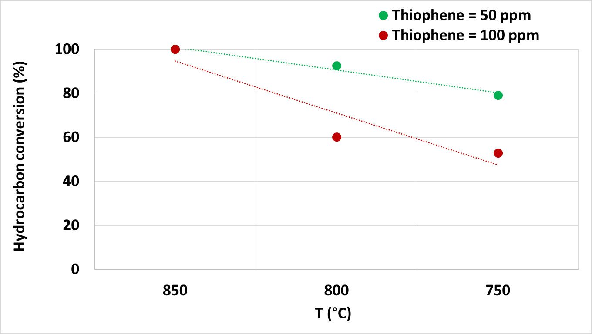
Figure 1: Inlet carbon conversion as a function of temperature for two different thiophene concentrations using catalyst A.
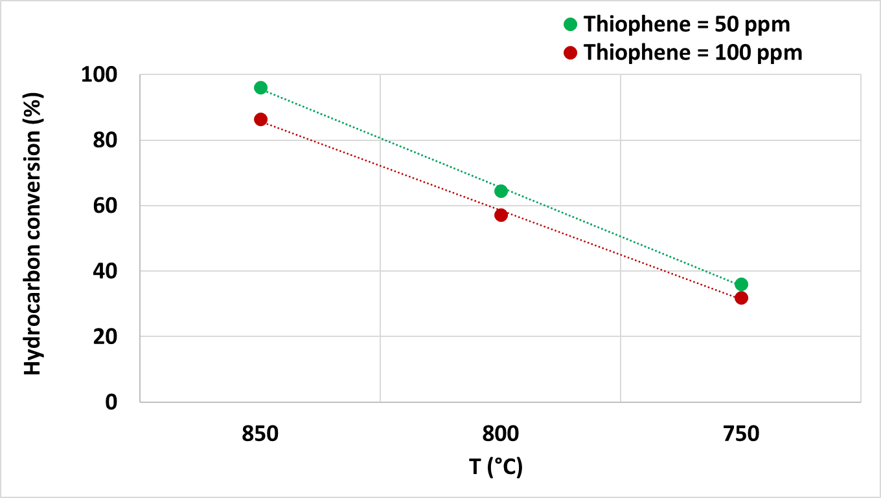
Figure 2: Inlet carbon conversion as a function of temperature for two different thiophene concentrations using catalyst B.
Furthermore, higher temperatures and lower amounts of thiophene favor the tar conversion process. As a matter of fact, a greater quantity of sulfur inhibits in any case the conversion of the inlet hydrocarbons, sooner deactivating the catalyst: in the worst condition studied, namely at 750 °C (the decrease in temperature thermodynamically and kinetically disfavors reforming), conversions of 79% and 53% were obtained with catalyst A, respectively with 50 ppm and 100 ppm of thiophene in the feed solution. On the other hand, 36% and 32% are obtained with catalyst B. To have a tar conversion close to 100%, the operating temperature must be close to 850 °C, but only for catalyst A in the presence of both equivalent H₂S concentrations. In the previous work by Di Giuliano et al. (2021), the behavior of the same catalyst A was evaluated at different operating conditions varying the temperature between 700 and 800 °C, with a GHSV between (10000-12000 h⁻¹) and with an equivalent concentration of H₂S between 40 and 100 ppm. In that case the space velocity was 2-3 times higher than in this work (4500 h⁻¹) and the tar conversion was for this reason lower. Such higher space velocities were chosen because the main purpose was to derive a lumped kinetics, referred to a pseudo-component representing tar. In this work the goal was instead to evaluate the best operating conditions to have a tar conversion close to 100% for two different catalysts (the same catalyst A and another catalyst B, always supplied by Johnson Matthey) with a GHSV equal to 4500 h⁻¹: such lower space velocity is that expected in a filter candle as shown in the work of Savuto et. al. (2019). The results obtained in this work are in line with those obtained in the work of Rapagnà et al. (2018) where catalytic and non-catalytic filter candles were tested in a bench scale biomass fluidized bed gasifier for different bed inventories (olivine or olivine/dolomite) with air and/or steam as the gasification media. The comparison of the gasification results with non-catalytic and catalytic filter candles, using steam as gasification media, demonstrated that at temperatures higher than 800 °C the conversion of tar varied between 91 to 96 %. These results are comparable with the results obtained in this work with catalyst A, even though the concentration of H₂S in the raw syngas obtained by Rapagnà et al. (2018) was not measured.
To further highlight the deactivating effect of sulfur, the following graph of the conversion as a function of time is shown.

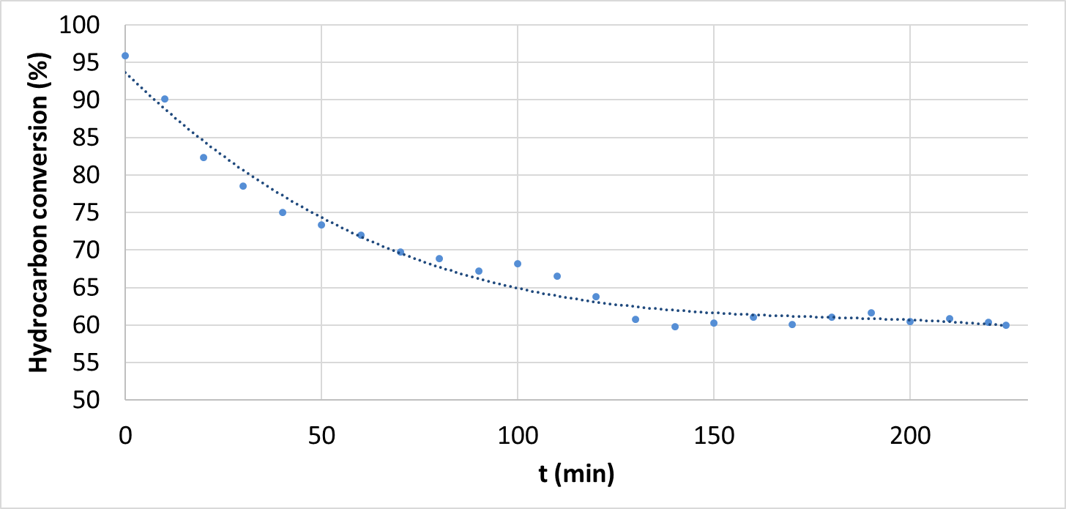
Figure 3: Inlet carbon conversion as a function of time using catalyst A at 800°C in presence of 100 ppm of H₂S.
This is the tar conversion of the test at 800 °C with 100 ppm of sulfur using catalyst A. As is evident, the conversion at the beginning is equal to approximately 96%, during the test it decreases until it reaches a plateau of about 60%.
BET and XRF analyses were carried out on the two catalysts before and after tests. The BET analyses showed that the surface area of the two catalysts were for both around 15 m²/g. The same analysis carried out for the spent catalysts showed that the surface area of catalyst A was around 11 m²/g, while that for catalyst B was around 8 m²/g, showing a greater sintering effect for this last catalyst. This could explain the worst performance of catalyst B. XRF confirmed for both catalysts the presence of S that was evidently absorbed on Ni sites.
  - Conclusions
This work was dealt with studying of tar steam reforming process, in order to obtain, more generally, a syngas with a higher added value. To do this it is necessary to use catalysts. In this case, two different commercial nickel-based catalysts were studied and compared, using a laboratory micro-reactor. The main aim of the experiments was to assess their behavior with varying temperature and sulfur content, which acts as a catalyst deactivator. Specifically, this research, carried out as part of the European project BLAZE, has as its final objective the insertion of this catalyst inside the filter candles in the gasification plant on a pilot scale. Particular attention must be paid to identifying the best operating conditions to have a high tar conversion to make the syngas usable in its subsequent processing, in this specific case for SOFC.
Twelve different tests were performed, at three different temperatures (750, 800, 850 °C) and with two different pseudo-tar solutions, containing the same amounts of toluene and naphthalene, but different concentrations of the sulfur deactivating element. The results showed that the tar conversion process is favored at higher temperatures and in the presence of lower thiophene quantities. In addition, catalyst A was found to perform better than catalyst B.
Nomenclature
BLAZE – Biomass Low cost Advanced Zero Emission
BET – Brunauer-Emmett-Teller surface area analysis
XRF – X-ray fluorescence
SOFC – Solid Oxide Fuel Cell
GHSV – Gas Hourly Space Velocity, h⁻¹
C_{i} – molar concentration of gas species i, mol m⁻³
F – molar flowrate of species i, mol h⁻¹
P – pressure, atm
T – temperature, °C
y_{i} – molar fraction of species i, mol mol⁻¹
Y_{i} – molar percentage dry, dilution-free of gaseous species I, vol%
α – molar steam to carbon ratio, mol mol⁻¹
χ_{i} – conversion of species i
in – inlet
out – outlet
Acknowledgments
The authors would like to acknowledge Johnson Matthey to have supplied the catalysts for the tests.
The authors also kindly acknowledge the financial support of R&D Project BLAZE G.A. 815284 funded by the European Union’s Horizon 2020 research and innovation program.
References
Depner H., Jess A., 1999, Kinetics of nickel-catalyzed purification of tarry fuel gases from gasification and pyrolysis of solid fuels. Fuel, 78(12), 1369–1377. https://doi.org/10.1016/S0016-2361(99)00067-8
Di Carlo A., Moroni M., Savuto E., Pallozzi V., Bocci E., Di Lillo P., 2019, Cold model testing of an innovative dual bubbling fluidized bed steam gasifier. Chemical Engineering Journal, 377. https://doi.org/10.1016/j.cej.2018.08.075
Di Giuliano A., Foscolo P. U., Di Carlo A., Steele A., Gallucci, K., 2021, Kinetic characterization of tar reforming on commercial Ni-Catalyst pellets used for in situ syngas cleaning in biomass gasification: Experiments and simulations under process conditions. Industrial and Engineering Chemistry Research, 60(18), 6421–6434. https://doi.org/10.1021/acs.iecr.0c05131
Heidenreich S., Foscolo P. U., 2015, New concepts in biomass gasification. Progress in Energy and Combustion Science, 46, 72–95. https://doi.org/10.1016/J.PECS.2014.06.002
Li C., Hirabayashi D., Suzuki, K., 2009, A crucial role of O2- and O22- on mayenite structure for biomass tar steam reforming over Ni/Ca12Al14O33. Applied Catalysis B: Environmental, 88(3–4), 351–360. https://doi.org/10.1016/J.APCATB.2008.11.004
Ma L., Verelst H., Baron G. V., 2005, Integrated high temperature gas cleaning: Tar removal in biomass gasification with a catalytic filter. Catalysis Today, 105(3–4), 729–734. https://doi.org/10.1016/J.CATTOD.2005.06.022
Ouweltjes J. P., 2019, Deliverable D3.2-BLAZE Selection of Representative Syngas Compositions including Organic and Inorganic Contaminants.
Rapagnà S., Gallucci K., Foscolo, P. U., 2018, Olivine, dolomite and ceramic filters in one vessel to produce clean gas from biomass. Waste Management, 71, 792–800. https://doi.org/10.1016/j.wasman.2017.07.038
Savuto E., Di Carlo A., Steele A., Heidenreich S., Gallucci K., Rapagnà S., 2019, Syngas conditioning by ceramic filter candles filled with catalyst pellets and placed inside the freeboard of a fluidized bed steam gasifier. Fuel Processing Technology, 191(March), 44–53. https://doi.org/10.1016/j.fuproc.2019.03.018

