CHEMICAL ENGINEERING TRANSACTIONS  VOL. 92, 2022 | A publication of
The Italian Association
of Chemical Engineering
Online at www.cetjournal.it

Guest Editors: Rubens Maciel Filho, Eliseo Ranzi, Leonardo Tognotti
Copyright © 2022, AIDIC Servizi S.r.l.
ISBN 978-88-95608-90-7; ISSN 2283-9216

Techno-economic Analysis of a Lignocellulosic Biorefinery producing Microbial Oils by Oleaginous Yeasts
Antonio Caporusso^{a,b}, Aristide Giulianoª*, Federico Liuzziª, Isabella De Bariª
ªENEA, Italian National Agency for New Technologies, Energy and Sustainable Economic Development, S.S. 106 Ionica, km 419+500, Rotondella, MT, Italy
^{b}School of Agricultural, Forest, Food and Environmental Sciences, University of Basilicata, Viale dell'Ateneo Lucano 10, Potenza, 85100, Italy
aristide.giuliano@enea.it
The lignocellulosic biomass valorisation is a central challenge of the bioeconomy transition, which passes through optimization of the entire value chain, from feedstock availability, sustainable conversion processes, to final target products. In this framework, the oleaginous yeasts represent a versatile tool to produce biobased chemicals and intermediates. They are flexible microbial factories able to grow on different side-stream carbon sources such as those deriving from lignocellulosic biomass, and this characteristic makes them excellent candidates for integrated biorefinery processes through the production of microbial lipids/oils. This work aims at a techno-economic analysis of a lignocellulosic biorefinery producing microbial oils by oleaginous yeasts (Lipomyces tetrasporus). The wheat straw residues were considered as the lignocellulosic feedstock thanks to a huge amount in the European territory. Experimental data obtained by a complete lab-scale 2G-sugars platform (steam explosion pretreatment, enzymatic hydrolysis, fermentation) were used for the analysis until microbic growth. Commercial/literature data were considered for the lipids extraction and purification stages. An assessment of the mass and energy balances, equipment sizing, costs estimation was carried out with the main results showing a production cost of the microbial oil about 4 €/kg with the enzymes supply as the major cost contribution.
  - Introduction
To complete the bioeconomy transition, the valorisation of each renewable carbon source is necessary. In this framework, the lignocellulosic biorefineries play the main role thanks to their abundance and composition (cellulose, hemicellulose, lignin) for specific utilisation in the conversion processes (Sofia et al., 2013). The whole value chain can be considered sustainable and the conversion processes are economically convenient under particular conditions (Usmani et al., 2021). The oleaginous yeasts can be converted to biofuels (e.g. biodiesel, jet-fuel) or chemicals (e.g. dicarboxylic acids) (Judith Cano-Ruiz et al., 2017). The growing interest in microbial oils has led to the production of various technical and economic evaluations in recent years. In particular, the work aims to evaluate the economic convenience of producing microbial oil or its derivatives (e.g. biodiesel) as a substitute for fossil-based compounds or vegetable oils (Giuliano et al., 2015). In particular, Bonatsos et al. (2020) aimed a detailed techno-economic analysis of the microbial oil production using process simulation methods and varying the plant size between 2 and 40 kt/y of microbial oil. After the detailed synthesis, optimization and cost estimation of the general process, the investment costs of the overall process were calculated to be approximately 27 M$. The minimum selling price of the oil was calculated to be between 2.4 and 5.8 $/kg. A process simulation for the biodiesel production by oleaginous yeasts using the cardoon stalks as raw material was studied by Castellini et al. (2021). The yield to biodiesel was found equal to 4.1 %. Their economic analysis indicated a biodiesel production cost equal to 12.8 $/kg and 3.63 $/kg for a plant treating 10’000 t/y and 100’000 t/y of lignocellulosic biomass, respectively. Karamerou et al. (2021) studied the theoretically lowest possible lipid price for the microbial oils under several scenarios and compared it with the palm oil market price. That found was still gave a lipid price approximately 2–3 times higher than palm oil. The base case gave a lipid selling price of $1.81/kg for ~ 8’000 tonnes/year production, which could be reduced to $1.20/kg on increasing production to ~ 48’000 tonnes of lipid a year. Parsons et al. (2019) based their research on a model for a bioethanol biorefinery, studying the impact of feedstock choice and fermentation method on costs considering also the co-production of microbial oils. The work studied microbial oil production from the oleaginous yeast Metschnikowia pulcherrima using sucrose, wheat straw and distillery waste. At a scale of 100 t/year oil production, a minimum estimated selling price of 14.00 €/kg was determined for sucrose. This reduced to 4.00–8.00 €/kg on scaling to 10'000 t/year, with sucrose and wheat straw. In this work, a specific block flow diagram was considered for the production of microbial oils from lignocellulosic biomass. This work aims at a techno-economic analysis of a lignocellulosic biorefinery producing microbial oils by oleaginous yeasts (Lipomyces tetrasporus). The feedstock consisted of wheat straw residues that are widely available in Europe (Galanopoulos et al., 2020). Experimental data covering all the productions steps (steam explosion pretreatment, enzymatic hydrolysis, fermentation) were used for the analysis until the microbial growth (Caporusso et al., 2021b). Commercial/literature data were considered for the lipids extraction and purification stages (Zapata-Boada et al., 2021). An assessment of the mass & energy balances, equipment sizing, costs estimation was carried out.
  - Block Flow Diagram description and production cost calculation
As follows, in Figure 1 the block flow diagram considered in this work is shown and explained. The wet biomass is sent to the steam explosion where it underwent a chemical and mechanical pretreatment and it was separated into cellulose, hemicellulose and lignin. The hemicellulose is sent to enzymatic hydrolysis and to fermentation in the right amount to obtain the optimal cellulose/sugars concentration for the referred process. The unconverted lignin is sent to the lignin combustion section where is burned in order to produce vapor and electric energy. Experimental data obtained by a complete lab-scale 2G-sugars platform (steam explosion pretreatment, enzymatic hydrolysis, fermentation) were used for the analysis until microbic growth. The biomass pretreatment is an essential stage in order to have lignin, hemicellulose and cellulose from the biomass matrix. All the operations below are strongly influenced by the efficacy of this pretreatment section. We projected this section in order to obtain a high level of yield at a low cost. In general, biomass pretreatments are physical, chemical and thermochemical operations. Based on the experimental activities described previously, the pretreatment chosen for the study under examination is the steam explosion. The steam explosion is one of the most widely used pretreatment methods to destroy the plant's cell walls and fractionate biomass components (Bertini et al., 2019). This method involves the exposure of biomass to water vapor at a temperature of 195 ◦C and a pressure of about 15 bar in a closed reactor for 7.5 min. Biomass is cooked and ejected instantly through a valve and explodes. This mechanism separates cellulose, hemicellulose and lignin and mechanically deflects the molecules. The steam explosion is the result of two parallel mechanisms (Verardi et al., 2016):
- Physical mechanism: changing from operating to atmospheric temperature and pressure, a sudden change in the state of water into the fibers occurs;
- Chemical mechanism: the short molecules are separated from the polymer skeleton, driven by the acidic environment generated in the reactor. This results in the catalytic fracture of cellulose and hemicellulose in smaller units, C6 and C5, respectively.

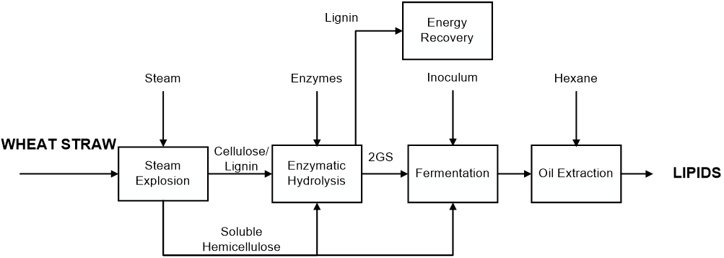
Figure 1: BFD for microbial oils production from lignocellulosic biomass
Table 1: Wheat Straw data, technical input and economic parameters used in the analysis
Feedstock data |  | Technical input |  | Economic data
Feedstock flowrate (t_{WET}/h) | 33 | Steam to biomass ratio | 1.0 | Inoculum (€/t) | 728
Water (%_{WET}) | 8.0 | Water impregnation ratio | 2.1 | Enzyme (€/kg) | 3.00
Cellulose (%_{DRY}) | 39.6 | H2SO4/Feedstock (%) | 5.0 | Biomass Price (€/t) | 40
Hemicellulose (%_{DRY}) | 19.8 | Hexane/dry cells | 10 | Discount Rate (%) | 5
Lignin (%_{DRY}) | 25.7 | Hexane recovery heat  (kWh/kg_{DRY}) | 1.3 | Thermal energy (€/MWht) | 20
Ashes (%_{DRY}) | 6.2 | Cells disruption efficiency (%) | 90 | Electricity (€/MWhe) | 50
Other compounds (%_{DRY}) | 8.7 | Extraction efficiency (%) | 80 | Maintenance & Labor (% CC) | 10

The steam explosion is a good pretreatment method because it can also be used when biomass has a very high lignin percentage. It is also a method that has a low environmental impact, low investment costs, limited use of harmful chemicals, and is easily scalable at the industrial level. One of the last but important advantages of the steam explosion is its versatility.
After mixing with the hemicellulose-rich stream, the solid content cellulose and lignin are fed to the enzymatic hydrolysis reactor. The stream of sugars (produced by hydrolysis) is sent to the fermentation section. The rest of the hemicellulose-rich liquid stream is added to the hydrolyzed and solid lignin is separated by filtration. The fermentation occurs in a fed-batch bioreactor, in which the sugars are converted from the microorganism Lipomyces tetrasporus into lipid accumulation (Caporusso et al., 2021a). The residence time is fixed to 150 h. Instead, commercial/literature data were considered for the lipids extraction and purification stages. This section of the plant is considered commercial/literature-based data (Kang et al., 2019). It allows separating the fermentation stock in wastewater, cell residues and purified microbial lipids. There is a high-pressure and a homogenizer for the cell disruption, an extraction column to perform the hexane lipid extraction, a distillation column for the recovery of hexane at 100% (Zapata-Boada et al., 2021). The combustion of lignin residual coming from all other sections of the plant is carried out. Given the high vapor requirement of the process and without having the section more complex, a backpressure configuration was chosen. During the steam expiration, two extractions are performed. The first one is at 40 bar and the second one at 16 bar available for any utilities. Finally, there is a reintegration current for the fluid that performs the thermodynamic cycle.
    - Economic analysis
An economic analysis of several cases was performed by estimating capital and operating costs. Capital costs were estimated by power-law correlations based on unit capacity. Data relevant to biorefinery sections were taken from the literature (Hamelinck et al., 2005). The factorial method was applied to obtain the total investment cost. The plant size was fixed to 33 t/h of wheat straw (Table 1) to study a medium-size lignocellulosic biorefinery. Operating costs are mainly given by raw materials such as wheat straw and enzymes for hydrolysis. The other operative costs estimated in the economic analysis are the utility costs calculated as the difference between the heat production from the lignin section and steam necessary for the steam explosion and the hexane recovery essentially. Maintenance, labor and general costs and taxes are calculated as a percentage of the capital cost. Depreciation was considered linear over 10 years.
  - Results
    - Mass and energy balances
Global technical results consist in yields to lipids equal to 8 %. Figure 2 shows a comparison between technical yields between microbial oil production (this work) and ethanol production in lignocellulosic biorefineries. The mass yield for the case ethanol is higher to 25 %. This result is not characteristic of these kinds of biorefineries because the energy content of oil and ethanol is different. So, the energy content yield was also considered, it increases until 17 % and 36 % for microbial oil and ethanol, respectively. A discussion can be approached on the net energy yield, considering also the energy consumption to produce lipids or ethanol using a lignocellulosic material. Fixing the pretreatment process for both (steam explosion) for the case microbial oils the purification is not energy stressed because the extraction by hexane does need energy compared to the ethanol distillation (azeotropic mixture). To have an environmentally sustainable process, hexane has to be fully recovered, because of its toxicity.
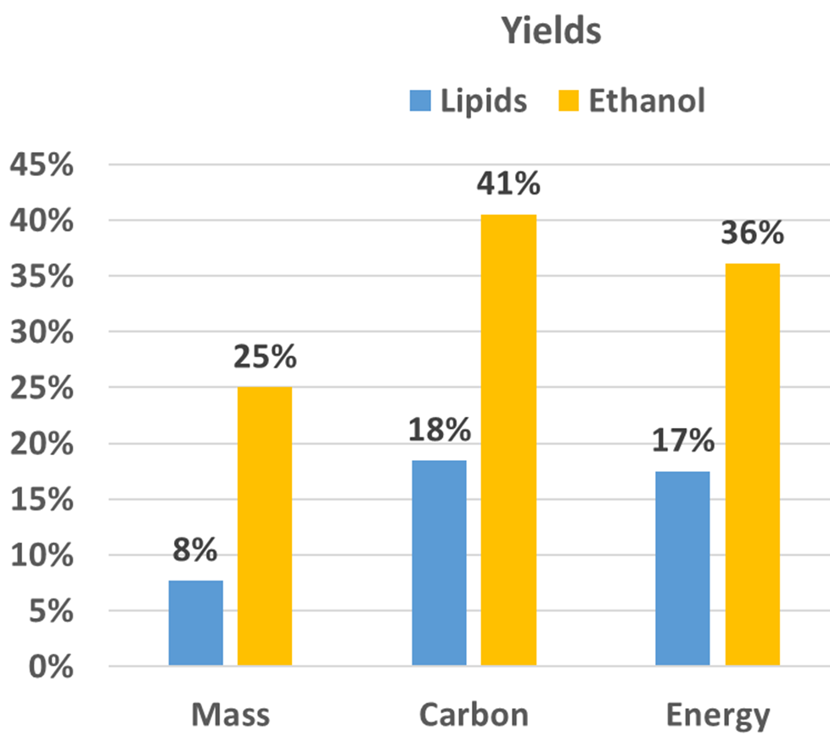
Figure 2: final yields of microbial oil production in terms of mass, carbon, or energy content yields. Source data are from da Silva et al. (2018) for ethanol and this work for lipids.
Considering the thermal energy balances of the biorefinery, the request for medium pressure steam necessary for the steam explosion process and the recycling of hexane, and finally the thermal energy that can be obtained from the combustion of the lignin. The latter value is greater than the thermal energy demand for the processes, this difference is assessed as being used to produce green electricity to be sold as a co-product of the biorefinery. The system's thermal energy needs are met by the lignin stream, the system is thermally independent.
    - Cost analysis
The investment costs are obtained based on the relationships between the main equipment dimension and the cost using economy-of-scale relationships. Figure 3a shows the total capital costs for the biorefinery studied. The purification section is the most expensive due to the homogenizer equipment for separating lipids from the cells mechanically. The energy enhancement of lignin represents about 38% of the total capital cost due to the high cost of the boiler and steam turbines. The sugar production and fermentation sections are the cheapest. The steam explosion pre-treatment is worth 15 M€ to treat 33 t/h of biomass, hydrolysis and fermentation reach 20 M€, both around 10% of the total. The operating costs are shown in Figure 3b, the total is approximately 59 M €/y. Maintenance and labor, calculated as a percentage of investment costs, are expensive while the inoculum weighs less than 10% of the total OC. The acid cost to add in the pre-treatment process is minimal, the costs of utilities (both steam and electricity) are zero thanks to the cogeneration section, while the make-up costs of the hexane solvent are negligible as its recycling is close to 100%. The operating costs that weigh the most consist of the purchase of enzymes (more than 40% of the total OC) and the supply of biomass (about 16%). These cost items are further increased if we consider the variability of the biomass and enzymes market, in this regard a sensitivity analysis is developed later.
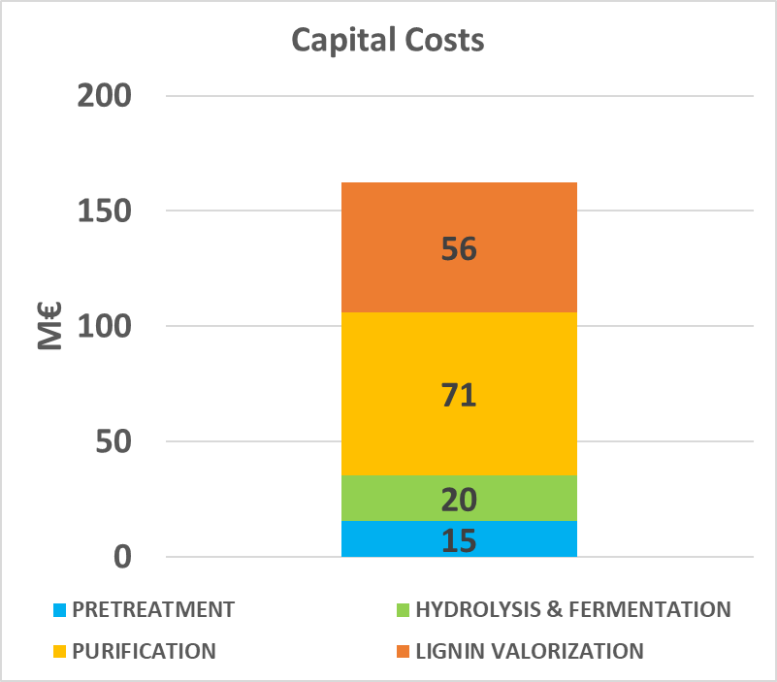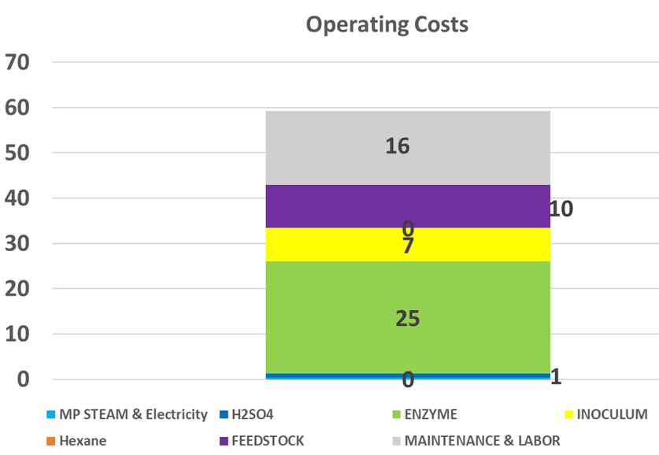
(b)
(a)
Figure 3: Capital (a) and operating (b) costs for microbial oil production
    - Sensitivity analysis on enzymes market price and wheat straw supply costs
Figure 4 shows the cumulative cash flows over the 20-year life of the biorefinery. Three years are considered for the construction and start-up of the plant. By setting the Net Present Value to zero, it is possible to identify the Payback Selling Price, the minimum selling price to have an economically advantageous biorefinery. In the basic case considered, the PSP of lipids is equal to 4.04 €/kg, a value in line with the results of other similar analyses discussed in the introduction, since lower values were obtained by Karamerou et al. (2021) thanks to the lower cost of sugars, considered equal to 140 $/t. A sensitivity analysis on the supply values of the most expensive raw materials was carried out. In particular, the cost of enzymes and the cost of lignocellulosic biomass has varied up to double the value of the base case. The cost of wheat straw is considered from a minimum of 40 €/t up to 80 €/t, the cost of enzymes from a minimum of 3 €/kg to a maximum of 7 €/kg. from the sensitivity analysis a maximum value of lipid production cost equal to 6.37 €/kg is obtained, approximately double the base case. The greatest variability is found for the modification of the cost of the enzymes which indexes the variation for about 40-45% of increase concerning the value of the base case. The variation of wheat straw affects up to 13%.
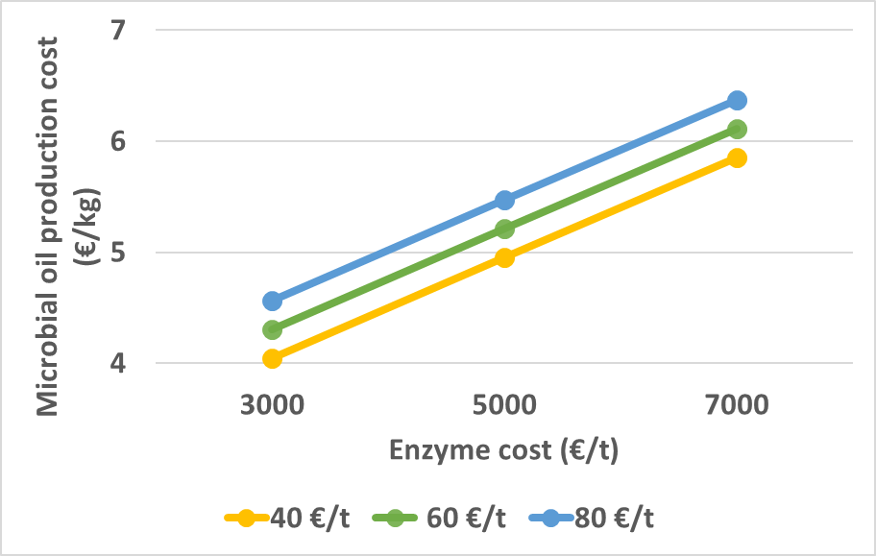
Figure 4: Payback Selling Price of the microbial oil
  - Conclusions
In conclusion, a lignocellulosic biorefinery producing microbial oils as the main product can be economically convenient with minimum production costs using lignocellulosic raw material with a low cost (lower 40 €/t) and a cost of enzymes lower than 3 €/kg. The economic analysis highlights the sugar production process is too expensive, while the most important problem of lipids production consists in the disruption of the cells to allow the lipids extraction by solvents. In terms of yields, microbial oil production leads to low mass yields (lower than 10 %) but a higher energy density of the products.
References
Bertini A., Gelosia M., Cavalaglio G., Barbanera M., Giannoni T., Tasselli G., Nicolini A., Cotana F., 2019. Production of carbohydrates from cardoon pre-treated by acid-catalyzed steam explosion and enzymatic hydrolysis. Energies 12.
Bonatsos N., Marazioti C., Moutousidi E., Anagnostou A., Koutinas A., Kookos I.K., 2020. Techno-economic analysis and life cycle assessment of heterotrophic yeast-derived single cell oil production process. Fuel 264, 116839.
Caporusso A., Capece A., De Bari I., 2021a. Oleaginous Yeasts as Cell Factories for the Sustainable Production of Microbial Lipids by the Valorization of Agri-Food Wastes. Fermentation 7, 50.
Caporusso A., De Bari I., Valerio V., Albergo R., Liuzzi F., 2021b. Conversion of cardoon crop residues into single-cell oils by Lipomyces tetrasporus and Cutaneotrichosporon curvatus: process optimizations to overcome the microbial inhibition of lignocellulosic hydrolysates. Industrial Crops and Products 159, 113030.
Castellini M., Ubertini S., Barletta D., Baffo I., Buzzini P., Barbanera M., 2021. Techno-Economic Analysis of Biodiesel Production from Microbial Oil Using Cardoon Stalks as Carbon Source. Energies 14, 5, 1–21.
da Silva A.R.G., Errico M., Rong B.-G., 2018. Techno-economic analysis of organosolv pretreatment process from lignocellulosic biomass. Clean Technologies and Environmental Policy 20, 1401–1412.
Galanopoulos C., Giuliano A., Barletta D., Zondervan E., 2020. An integrated methodology for the economic and environmental assessment of a biorefinery supply chain. Chemical Engineering Research and Design 160, 199–215.
Giuliano A., Poletto M., Barletta D., 2015. Process Design of a Multi-Product Lignocellulosic Biorefinery, in: Computer Aided Chemical Engineering. Elsevier B.V., pp. 1313–1318.
Hamelinck C.N., Van Hooijdonk G., Faaij a. P.C., 2005. Ethanol from lignocellulosic biomass: Techno-economic performance in short-, middle- and long-term. Biomass and Bioenergy 28, 384–410.
Judith Cano-Ruiz Teresa Nunziata, Gaetano Zuccaro, Pedro Vicente Mauri, M Carmen Lobo, Domenico Pirozzi, 2017. Production of single-cell oils from lignocellulosic biomass from arundo donax l. Chemical Engineering Transactions 57, 1861–1866.
Kang S., Heo S., Lee J.H., 2019. Techno-economic Analysis of Microalgae-Based Lipid Production: Considering Influences of Microalgal Species. Ind. Eng. Chem. Res. 58, 944–955.
Karamerou E.E., Parsons S., McManus M.C., Chuck C.J., 2021. Using techno-economic modelling to determine the minimum cost possible for a microbial palm oil substitute. Biotechnol Biofuels 14, 57.
Parsons S., Abeln F., McManus M.C., Chuck C.J., 2019. Techno-economic analysis (TEA) of microbial oil production from waste resources as part of a biorefinery concept: assessment at multiple scales under uncertainty: Assessment at multiple scales under uncertainty. J. Chem. Technol. Biotechnol. 94, 701–711.
Sofia D., Giuliano A., Barletta D., 2013. Techno-economic assessment of co-gasification of coal-petcoke and biomass in IGCC power plants. Chemical Engineering Transactions 32, 1231–1236.
Usmani Z., Sharma M., Awasthi A.K., Lukk T., Tuohy M.G., Gong L., Nguyen-Tri P., Goddard A.D., Bill R.M., Nayak S.C., Gupta V.K., 2021. Lignocellulosic biorefineries: The current state of challenges and strategies for efficient commercialization. Renewable and Sustainable Energy Reviews 148, 111258.
Verardi A., Blasi A., De Bari I., Calabrò V., 2016. Steam pretreatment of Saccharum officinarum L. bagasse by adding of impregnating agents for advanced bioethanol production. Ecotoxicology and Environmental Safety 134, 293–300.
Zapata-Boada S., Gonzalez-Miquel M., Jobson M., Cuéllar-Franca R.M., 2021. A Methodology to Evaluate Solvent Extraction-Based Processes Considering Techno-Economic and Environmental Sustainability Criteria for Biorefinery Applications. Ind. Eng. Chem. Res. 60, 16394–16416.

