|  |  |
| --- | --- |
| cetlogo ***CHEMICAL ENGINEERING TRANSACTIONS***  ***VOL. 92, 2022*** | A publication of  aidiclogo_grande |
| The Italian Association  of Chemical Engineering  Online at www.cetjournal.it |
| Guest Editors: Rubens Maciel Filho, Eliseo Ranzi, Leonardo Tognotti  Copyright © 2022, AIDIC Servizi S.r.l. **ISBN** 978-88-95608-90-7; **ISSN** 2283-9216 | |

Conversion of lignin to chemical intermediates: a study of pyrolysis of Kraft lignin.

Matteo Borellaa, Alessandro A. Casazzaa, Gabriella Garbarinoa, Paola Rianib and Guido Buscaa\*

a Department of Civil, Chemical and Environmental Engineering, University of Genoa, Via Opera Pia 15, 16145 Genoa (Italy)

b Department of Chemistry and Industrial Chemistry, University of Genoa, via Dodecaneso 31, 16146 Genoa (Italy) Guido.Busca@unige.it

Experiments of pyrolysis of commercial Kraft lignin have been realized in the 250-550 °C range. Product analyses have been performed by FTIR, GC-MS, EDX analyses. The main goal of the work is to optimize the experiments in terms of liquid yield, reduction of oxygen content in the resulting biochar, and removal of sulfur, found mainly in the gas phase. It has been concluded that the amount of the starting lignin charged in the reactor must be limited to be fully positioned in the heating chamber also during high temperature treatment. Sulfur may be partially removed in the gas phase as H2S and CH3SH mainly, by a pre-treatment at 250 °C. The maximum amount of liquid product, mainly constituted by methoxy- and alkyl-methoxy-phenols, and the maximum solid deoxygenation are both obtained at 550 °C.

* 1. Introduction

Nowadays, it is well established that the employment of fossil resources must be strongly reduced and that renewable raw materials will be largely employed in the near future to produce chemical products. It is also clear that industrial chemistry based on renewables must not compete with the food chain. For these reasons, lignin wastes, such as those produced by the papermaking industry (Haq et al. 2020) and those coming from bioethanol manufacture (Liu et al., 2021), are considered to be best suited for the production of chemicals (Li et al., 2015). In particular, due to their aromatic character, lignins are reported to be promising sources of aromatic compounds, i.e. phenol compounds (Kleinert and Barth, 2008) and aromatic hydrocarbons as well (Busca, 2021).

As it is well-known, lignin is one of the three main components of lignocellulosic biomass, together with cellulose and hemicellulose, whose content can span from 10 to 40 wt.% depending on the feedstock (Giudicianni et al. 2020). These compounds consist in the structural frame of the plant cell walls, where lignin role is to increase the strength and the resistance of the cell. However, despite its potential from a scientific and industrial point of view, lignin utilization has been always limited, also because of its chemical recalcitrance mainly due to its complex structure.

The isolation and the separation of lignin from cellulose and hemicellulose is performed with different techniques, even if almost 90% of the available commercial lignin is obtained from Kraft pulping process, where it is mainly produced as by-product and then it is burned for heat recovery (Lai, 2017). The isolation in Kraft process is obtained using a soda-sodium sulfide solution which allow better recovery yields but results in a lignin with a high content in sulfur (2-4 wt.%) (Ház et al. 2019).

Pyrolysis is a useful technique to depolymerize, at least partially, complex organic materials, such as biomasses and plastic wastes (Sannita et al., 2012; Kim and Choi, 2018). A systematic study of the conversion of Kraft lignin by pyrolysis was recently undertaken (Borella et al., 2022). Pyrolysis of lignin produces, depending on reaction conditions, liquid molecules together with a gas and a solid biochar residue. One of the open points on which we would like to go deeper is the behavior of sulfur impurities upon the pyrolysis of Kraft lignin. In this paper, it is also reported the investigation to optimize reaction conditions in our experimental setup.

* 1. Materials and methods
     1. Materials

In this study, a commercial Kraft lignin received from StoraEnso® (LineoTM Classic Lignin, Kotka, Finland) has been adopted. Fresh lignin has been characterized by quantifying its ash and moisture content. The produced bio(oil) has been diluted in chloroform (assay 99.9 %, Carlo Erba reagents, France) in order to be characterized in GC-MS. KBr disks have been used as support to perform FT-IR liquids and solids analyses. SEM analyses were realized with a Zeiss Evo 40 equipped with a Pentafet Link Energy Dispersive X-ray Spectroscopy system managed by the INCA Energy software (Oxford Instruments, Analytical 95 Ltd., Bucks, U.K.).

* + 1. Lignin characterization

Fresh Kraft lignin (KL) characterization has been carried out with a particular focus on the morphology, elemental composition, ash, and moisture content. The latter has been measured according to Spennati et al. (2020). KL morphologies have been studied with scanning electron microscopy (SEM) whereas energy-dispersive X-ray spectroscopy (EDX) analysis was performed to assess the chemical elemental composition. To better understand the influence of the temperature on SR composition and morphological properties, EDX analyses have been performed both on fresh lignin and pyrolytic residues, focusing on the content of C, Na, S, and O in the samples.

* + 1. Pyrolysis setup

In Figure 1 the pyrolysis setup adopted in this work has been presented. The quartz tubular reactor charged with the sample is collocated inside a furnace (Carbolite, MTF 10/25/130, Pocklington, UK).

Tests have been performed using different lignin masses in order to establish the influence of the starting mass of sample on the product yields. Two different sets of tests have been carried out using 5.0 g and 10.0 g of fresh lignin respectively. In order to avoid combustion reactions and guarantee an inert atmosphere, the setup has been purged with nitrogen for 10 minutes before each test. The tubular reactor was connected to a Liebig condenser where the condensation and the separation of cracked compounds occurred. Condensed liquid has been collected in a flask while non-condensable gases have been collected in a latex balloon. Once the reaction is over, the remaining solid residues have been collected from the bottom of the reactor. These carbonaceous solids will be referred to as biochar.



*Figure 1. Reactor setup for Kraft lignin pyrolysis*

* + 1. Test procedures

In this work, tests have been performed experimenting different temperature ranges in order to understand which is the influence of process conditions on the reaction products. In particular, the first series of tests have been carried out comparing the behavior of KL at isothermal conditions in the same reactor configuration charged with 10 and 5 grams of KL, respectively. This parameter may have a remarkable impact on product yields due to the variation of the encumbrance of the reacted lignin inside the reactor and possibly different fluid dynamic conditions in terms of contact in between the gas, liquid, and solid phase. These tests have been performed at 350, 450, and 550°C and maintained at the set temperature for 3 hours.

Then, a wider range of temperature has been investigated in tests carried out starting from 250 °C with a progressive increase of temperature up to 550 °C. The temperatures that have been investigated are 250, 300, 350, 400, 450, and 550°C. During each step, the reaction takes place for 90 minutes allowing two measurements of the gas phase with GC-MS, one every 45 minutes. After the second GC-MS measure, a nitrogen purging has been performed in order to remove all the gas produced. After gas purging, the temperature has been increased up to the next reaction step. This procedure allowed to perform GC-MS analysis only on the gas produced at the set temperature and to separate its contribution from the gas produced at lower temperatures.

* + 1. Equipment and characterization procedures

Both reaction products (SR, G, L) and fresh lignin have been characterized using Fourier transform infrared spectroscopy (FT-IR) using a Nicolet 380 instrument (Thermo Scientific, Madison, WA, USA). KBr pressed disks (disk weight 1.000g) have been prepared for the FT-IR analysis of liquid and solid products. Liquids have been analyzed spreading on the KBr disk surface while solids have been analyzed using a pressed disk made of samples mixed with the KBr powder (1:100, w/w). Gaseous products were analyzed by forcing them to flow in a glass IR cell equipped with KBr windows.

Gas chromatography-mass spectrometer (GC-MS) analysis was performed on liquid and gaseous products using a Focus-ISQ instrument (Thermo Scientific, Milan, Italy). 10-4 L injections have been performed every 45 minutes of the reaction time for the GC-MS quantitative analysis of pyrolytic gas. Areas beneath peaks in the chromatogram have been normalized with the total area, in order to obtain a relative abundance parameter (R) showing a quantitative measure of the relative amount of the species detected in the sample.

Using a similar procedure, liquid products have been analyzed diluting the sample in CHCl3 (1:10, v/v) and performing a 10-6 L injection in the GC-MS.

* 1. Results and discussions

*Table 1: EDX analysis on Biochar materials.*

|  |  |  |  |  |  |  |
| --- | --- | --- | --- | --- | --- | --- |
| Name | Lignin Charge [g] | Pyrolysis temperature  [°C] | C (wt.%) | O (wt.%) | Na (wt.%) | S (wt.%) |
| ----- | --------- | Lignin as received | 67.1 | 31.6 | 0.2 | 1.1 |
| A | 10 g | 350 | 74.0 | 24.7 | 0.3 | 1.0 |
| B |  | 450 | 76.3 | 22.0 | 0.5 | 1.2 |
| C |  | 550 | 79.0 | 19.5 | 0.5 | 1.0 |
| D | 5 g | 350 | 72.6 | 26.6 | 0.3 | 0.5 |
| E |  | 450 | 81.5 | 17,0 | 0.5 | 1.0 |
| F |  | 550 | 89.7 | 7.7 | 0.7 | 1.9 |



*Figure 2: Product yields in pyrolysis experiments*

In Figure 2 the yields in gas, liquid, and solid products obtained by heating KL, as a function of reaction temperature and amount of lignin charged to the reactor, are reported. The amount of liquid and gas products increases significantly both by increasing the reaction temperature, and by decreasing the reactant amount charged. Obviously, the amount of the produced biochar is reduced at higher temperature and when less lignin is treated. In Table 1, the carbon and oxygen content in the resulting biochar is reported, as analyzed by EDX for the same experiments. It is evident that pyrolysis results in solid deoxygenation. However, such deoxygenation is definitely more abundant at higher temperatures and with smaller lignin charged on the reactor.

EDX analysis cannot reveal hydrogen: it shows the presence of small amounts of sulfur and sodium impurities in the biochar. The wt.% amount of sodium as expected tends to increase with lignin conversion, due to the likely non-volatility or poor volatility of sodium compounds in this temperature range. The wt.% amount of sulfur in the resulting biochar has a more complex behavior. This suggests that part of sulfur is released in the liquid and gaseous phases, in particular upon experiments D and E, i.e. at 350-450 °C using 5 g of lignin in the reactor. However, part of sulfur is certainly strongly retained in the biochar, even after pyrolysis at 550°C.

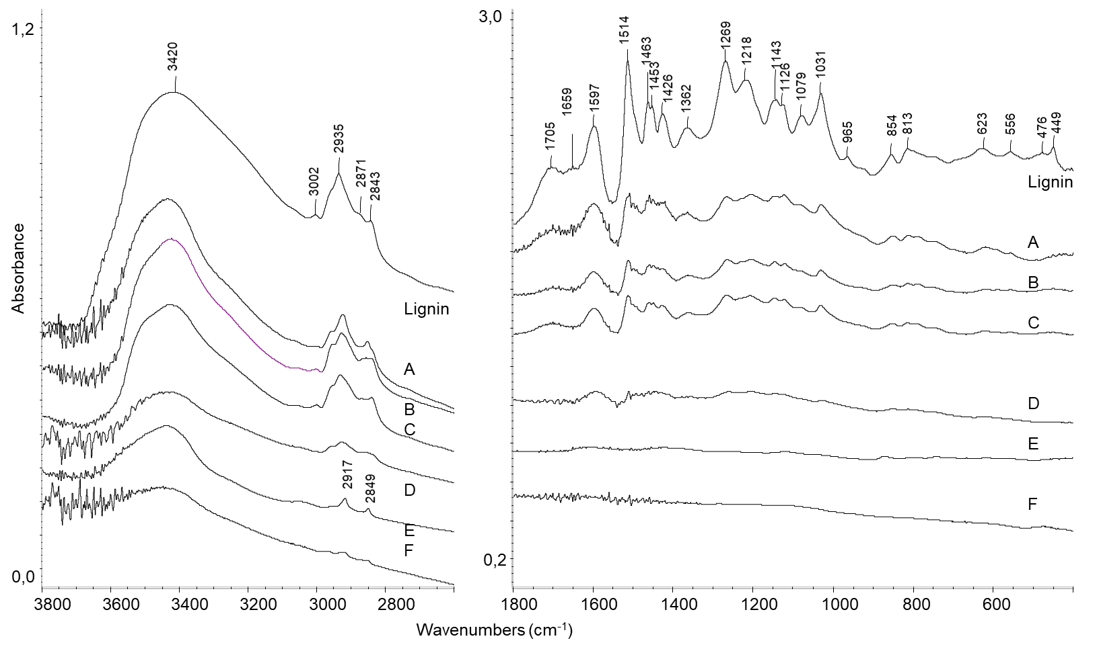

*Figure 3: FT-IR spectra of as-received Kraft lignin and pyrolysis residues (biochars).*

The FT-IR spectra of the obtained biochar samples are reported in Fig. 3, where they are compared with the spectrum of the as-received Kraft lignin sample. The spectrum of Kraft lignin closely corresponds to that reported in the literature (Amit et al., 2021). The absorption bands are those typical of aromatic rings, methoxy groups, and phenolic compounds, as discussed elsewhere (Borella et al., 2022). The spectra of the residues from experiments A to C are essentially the same, although the intensities of the bands are decreased in intensity. This is in agreement with the occurred limited conversion during these experiments. In contrast, the spectra of the samples resulting from experiments D to F are much different, showing the quite complete disappearance of the bands. This agrees with the likely formation of carbon-rich matter and the loss of oxygen-containing functional groups.

The analysis of liquid products, realized by GC-MS, shows that the most abundant components are those reported in Fig. 4. In particular, the main peak corresponds to 3 methoxy - 5-methyl-phenol, while strong peaks are also those corresponding to the two isomeric compounds 2-methoxy-phenol (guaiacol) and 4-methoxy-phenol and to 4-ethyl-2-methoxy-phenol. The peaks of these four compounds correspond to more than 65% of all GC spectrum in the liquid obtained by pyrolysis at 450°C and 550°C, 5 g (experiments E and F). In any case, several sulfur compounds have been observed in the liquid products, in particular thiols, sulfides and polysulfides.

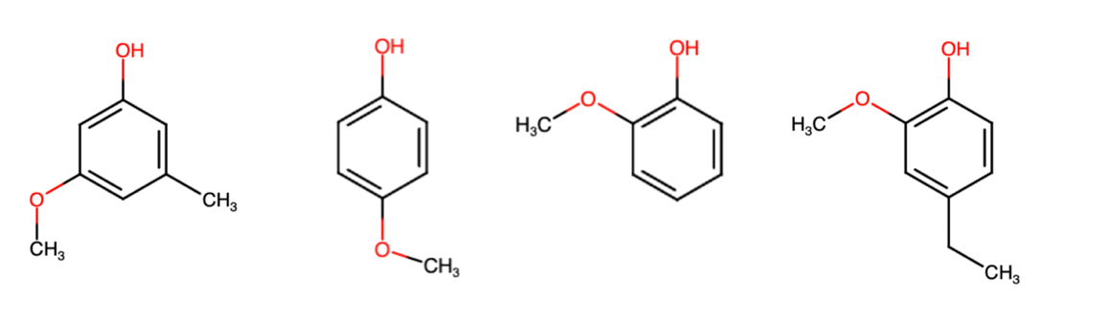

Figure 4: Structure of the main components of liquid products.

The produced gases have been analyzed using FT-IR and GCMS techniques. The main observed products are CO2, CO, methane, ethylene, propylene, and several sulfur compounds, in particular hydrogen sulfide, H2S, methanethiol, CH3SH, dimethyl sulfide (CH3)2S, and carbonyl sulfide, COS. To go deeper into the behavior of sulfur impurities in Kraft lignin, sequential pyrolysis experiments have been performed at 250, 300, 350, 400, 450, and 550°C, analyzing the evolved gas in each single step, as reported in the methods section.

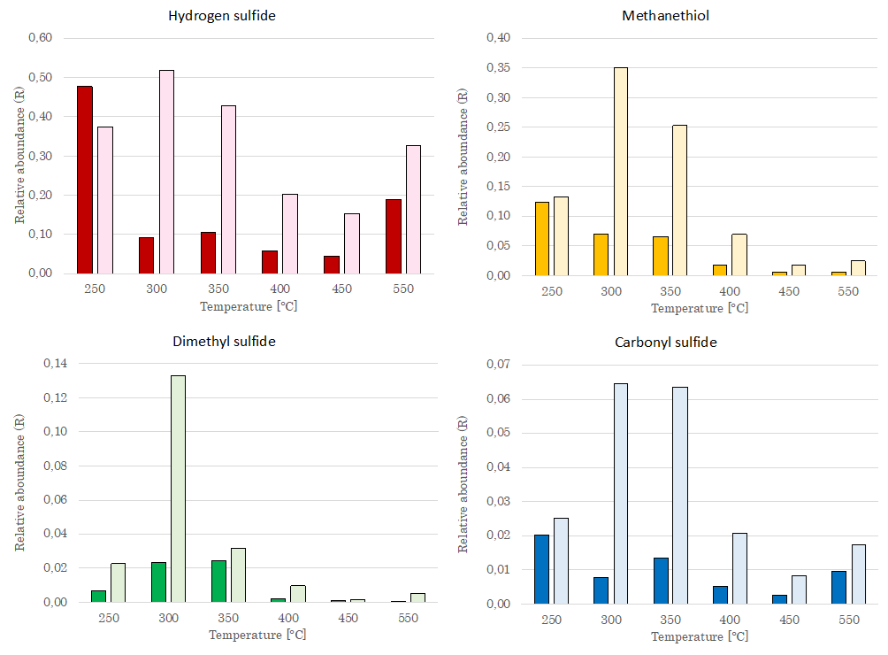

*Figure 5. Relative abundance (% of GC area) of sulfur compounds in the gases evolved in sequential pyrolysis experiments. Deep colors: 5 g. Light colors: 10 g of starting lignin.*

From the data reported in Fig. 5, it results that the different sulfur compounds behave in a partially different way. Taking into account the experiments realized with 5 g of starting lignin (deep colors), which correspond to higher lignin conversion, gaseous sulfur compounds, in particular H2S and CH3SH which are the most abundant, are predominantly emitted at the lower temperatures, starting already at 250 °C. Instead, with experiments performed with 10 g of starting lignin, where lignin conversion is lower, the maximum emission of the sulfur compounds is slightly shifted to a higher temperature (mainly 300-350 °C). This might be related to the fact that upon pyrolysis the expansion of the reaction medium for the evolution of gas and liquids produces a different temperature gradient in the reactor itself, suggesting that pyrolysis reaction might occur with a more complex situation far from full isothermicity.

* 1. Conclusions

From the present work, we concluded that experiments realized with 5g starting lignin in our reactor allow higher conversion, probably because the solid matter is better positioned in the heating region of the reactor. The pyrolysis allows very large solid deoxygenation if treated at 550 °C for 3 h. The maximum liquid product yield obtained in our experiments is 28.7 %, with methoxy-, methoxy-methyl- and methoxy-ethyl phenols as the main liquid components. The obtained char in these conditions still retains a limited oxygen content (7.6 %) and appears to be largely carbonized. The sulfur impurities typical of Kraft lignin distribute between gaseous, liquid, and solid products. However, it seems that a previous step of treating at 250 °C could allow the release in the gas phase of a large part of sulfur as H2S and CH3SH. Further experiments are programmed to release sulfur in the gas phase as much as possible in a previous pyrolysis pre-treatment step, and to later increase the liquid yields by a second higher temperature pyrolysis step.

Nomenclature

KL– Kraft Lignin

G – Pyrolytic gas product

L – Pyrolytic liquid product

SR- Solid residue product

GC-MS- Gas chromatography–mass spectrometer

FT-IR – Fourier transform infrared spectroscopy

SEM– Scanning electron microscopy

EDX – Energy-dispersive X ray spectroscopy

R – Relative abundance parameter

Acknowledgments

The StoraEnso company is acknowledged for supplying lignin samples.

References

Amit T.A., Roy R., Raynie D.E., 2021, Thermal and structural characterization of two commercially available technical lignins for potential depolymerization via hydrothermal liquefaction, Curr. Res. Green Sust. Chem. 4, 100106.

Borella M., Casazza A.A., Garbarino G., Riani P., Busca G., 2022, A study of pyrolysis products of Kraft lignin, Energies, in press

Busca G., 2021, Production of Gasolines and Monocyclic Aromatic Hydrocarbons: From Fossil Raw Materials to Green Processes, Energies, 14, 4061.

Giudicianni, P.; Ferreiro, A.I.; Gargiulo, V.; Alfè, M.; Costa, M.; Rabaçal, M.; Ragucci, R., **2020**, Effect of KCl Doping on the Slow Pyrolysis of Lignin. Chemical Engineering Transactions, *80*, 109–114.

Haq I., Mazumder P., Kalamdhada A.S., 2020, Recent advances in removal of lignin from paper industry wastewater and its industrial applications – A review, Bioresource Technology, 312, 123636

Ház A., Jablonský M., Šurina I., Kačík F., Bubeníková T., Jaroslav Ďurkovič J., 20219, Chemical Composition and Thermal Behavior of Kraft Lignins, Forests, 10, 483

Kim J.-S., Choi G.-G., 2018, Pyrolysis of Lignocellulosic Biomass for Biochemical Production, in Bhaskar T., Pandey A., Mohan S.V., Lee D.-J-, Khanal S.K., (eds). Waste Biorefinery, Elsevier, Amsterdam, pp. 323-348.

Kleinert M., Barth T., 2008, Phenols from Lignin, Chem. Eng. Technol. 31, 736–745.

Lai Y-Z., 20217, Wood and wood products, in: Kent J.A., Bommaraju T.V., Barnicki S.D, (eds.) Handbook of Industrial Chemistry and Biotechnology, Springer, pp 215-283

Li C., Zhao X., Wang A., Huber G.W., Zhang T., 2015, Catalytic transformation of lignin for the production of chemicals and fuels, Chem. Rev., 115, 11559-11624.

Liu Y., Cao C., Wang Q., Zheng W, Shen J., Chen Y., Gua F., Han M., Rocchi I., 2021, Utilization of bioethanol industry recycled waste for sustainable soil improvement: A win-win application, Engineering Geology, 289, 106192.

Sannita E., Aliakbarian B., Casazza A. A., Perego P., Busca G., 2012, Medium-temperature conversion of biomass and wastes into liquid products. A review, Renewable and Sustainable Energy Reviews, 16, 6455-6475.

Spennati, E.; Casazza, A.A.; Converti, A.; Busca, G., 2020, Thermocatalytic Pyrolysis of Exhausted Arthrospira Platensis Biomass after Protein or Lipid Recovery. Energies,13, 5246.