 CHEMICAL ENGINEERING TRANSACTIONS  VOL. 92, 2022 | A publication of  
The Italian Association
of Chemical Engineering
Online at www.cetjournal.it

Guest Editors: Rubens Maciel Filho, Eliseo Ranzi, Leonardo Tognotti
Copyright © 2022, AIDIC Servizi S.r.l.
ISBN 978-88-95608-90-7; ISSN 2283-9216

Preliminary Techno-economic and Sensitivity Analysis of Spirulina Powder Production Using a Short-tank Internally Illuminated Concentric-tube Airlift Photobioreactor
Butch G. Bataller^{a,}*, Sergio C. Capareda^{b}
ªUniversity of the Philippines Los Baños, Laguna, Philippines
^{b}Texas A&M University, Texas, USA
bgbataller@up.edu.ph
A bench-scale 3-L internally illuminated concentric-tube airlift photobioreactor with an aspect ratio (H/D) ratio of approximately 2.0 and riser-to-downcomer area (A_{r}/A_{d}) ratio of 0.42 was designed, fabricated, and tested for the cultivation of Spirulina platensis. Using the results of the bench-scale experiments, a preliminary techno-economic analysis of producing dried Spirulina biomass in a larger scale (in four 20-m³ photobioreactors) was conducted. For this analysis, the aspect ratio and A_{r}/A_{d} were maintained. The selling price of the Spirulina powder was based on literature. For the preliminary techno-economic evaluation, 300 days per year production and continuous operation was assumed. Results show that Spirulina powder production plant with a total photobioreactor capacity of 80-m³ revealed an attractive venture. The profit margin is positive, and the payback period is 6.34 years. A sensitivity analysis was also conducted. The effects of total photobioreactor capacity and operating conditions on net income, profit margin, and payback period were determined. The minimum selling price at various total photobioreactor capacities were also calculated.
  - Introduction
Algal cultures are traditionally grown in open ponds, either in natural waters or in artificial ponds due to their simplicity and inexpensiveness (Ugwu, Aoyagi, and Uchiyama, 2008). Larger production capacity can also be achieved relative to photobioreactors (PBRs) of comparable cost (Singh and Sharma, 2012). However, open pond systems suffer from poor light utilization and environmental control, uneven light intensity, evaporative losses, diffusion of CO₂ to the atmosphere, low cell densities, contamination, and requirement of large land areas (Cuaresma et al., 2011; Acién et al., 2017). To overcome these limitations, the use of closed systems such as PBRs gained attention. PBRs minimize contamination and allow axenic algal cultivation of monocultures (Singh and Sharma, 2012). Better control of growth conditions such as pH, temperature, light, CO₂ level, and biomass concentration can be achieved (Ugwu, Aoyagi, and Uchiyama, 2008). For these reasons, PBRs can support much higher photosynthetic efficiency and biomass productivity (Wang, Lan, and Horsman, 2012).
In this study, a concentric-tube airlift photobioreactor was chosen due to its simple design and cost-effectiveness. One major advantage of airlift reactors is the flashing light effect leading to better photosynthetic efficiency and higher biomass productivity (Barbosa et al., 2003). Yustinadiar, Manurung, and Suantika (2020) observed a significant increase in Nannochloropsis sp. Production in an airlift PBR using low-frequency flashing light. It is also characterized by high mass transfer rates, low cell stress, large surface area to volume ratio, and ease of operation and sterilization (Taisir et al., 2016; Huang et al., 2017). Oncel and Sukan (2008) obtained higher dry biomass weight and chlorophyll-a concentration in an airlift PBR than in a bubble column. Airlift columns can also achieve better CO₂ and O₂ gas exchange between the liquid medium and aeration gas (Eriksen, 2008).
The design configuration of a PBR is one of the factors that affect its performance. Several configurations have been proposed, but there is still no single optimal design (Acién et al., 2017). Hwang and Cheng (1997) tested the effect of riser-to-downcomer area (A_{r}/A_{d} = 1.0 to 3.0) on the hydrodynamic properties of the photobioreactor and found that decreasing the A_{r}/A_{d} may be advantageous due to less bubble entrainment in the downcomer. So, this study designed and fabricated an airlift reactor with an A_{r}/A_{d} of less than 1.0 (actual A_{r}/A_{d} is 0.42) that may lower mixing time and attain a high liquid velocity. Hwang and Cheng (1997) also tested the effect of aspect ratio (H/D = 3.7, 5.8, and 7.9) and found that more gases are entrained in the downcomer region, resulting to less liquid circulation, for airlift PBRs with high H/D. So, an airlift PBR with H/D = 2.0 was constructed instead in this study to achieve better liquid circulation. The hydrodynamic and mass transfer properties of this new design were measured by the authors (data not shown here). Another key feature of the airlift reactor in this study was that it was constructed with internal lighting installed at the center of the reactor. In this case, light will radiate from the center radially outwards ensuring that most irradiance will be captured by the algal cells.
This design was used to grow Spirulina in 3-L batch experiments to determine its performance. The biochemical composition of the algal biomass was measured using a novel method using FTIR spectroscopy coupled with PLS-regression (Bataller and Capareda, 2018), which was shown to have similar results with conventional methods. This novel method has also been shown to be advantageous in the real-time monitoring of the algal biomass (Bataller and Capareda, 2020). The results from these experiments are then used in a preliminary techno-economic analysis of a scaled-up system that produces dried Spirulina biomass. The net income, profit margin, and payback period were determined. Sensitivity analyses were also conducted. This preliminary techno-economic analysis determines if growing Spirulina in the new design of an airlift PBR is a worthy venture.

  - Methodology
    - Bench-scale batch cultures
Bench-scale cultures were performed in a 3-L internally illuminated concentric-tube airlift photobioreactor with with A_{r}/A_{d} = 0.42 and H/D = 2.0. Spirulina was grown at 166 μmol photons m⁻² s⁻¹ light intensity, 0.3 vvm air flow rate, and 0.20 g l⁻¹ initial biomass concentration. These values were determined and selected from batch experiments since these gave the highest biomass productivity (data not presented in this paper).
In the batch culture, the light intensity was controlled by an LED dimmer. Air that is not supplemented with CO₂ was supplied by an air compressor and controlled using a gas rotameter. The incoming air was filtered using a 0.2 µm air venting filter. In maintaining the initial biomass concentration, the optical density of Spirulina stock culture was determined first and the volume of Zarrouk’s medium and stock culture were computed to make 3 liters of 0.20 g l⁻¹ Spirulina aliquot. A 60-ml sample was taken after inoculation and after 5 h. Samples were then taken every 24 h, thereafter. The sample’s optical density was read at 680 nm using a UV-Vis spectrophotometer (VWR UV-Vis Scanning UV-3100). The protein, carbohydrate, and lipid content of the sample were then obtained using the method and PLS-regression model in Bataller and Capareda (2018).
Spirulina was grown for 8 days. The specific growth rate was computed using:
$$μ=slope of \ln\left(X/{X_{o}}\right) versus time curve$$ | (1)
The overall volumetric biomass productivity was computed using:
$$Qx=\left(X_{f}-X_{o}\right){\left(t_{f}-t_{o}\right)}^{-1}$$ | (2)
    - Preliminary techno-economic evaluation
The first step was to scale up the airlift PBR and size a 20-m³ internally illuminated concentric-tube airlift photobioreactor. The aspect ratio = 2 and A_{r}/A_{d} = 0.42 were maintained. A total of four reactors was employed so that the total PBR capacity is 80 m³. Then a process flow for biomass production was developed from inoculation to production and then to harvesting, drying, and packaging. The main product was the dried Spirulina biomass. Its selling price was taken from the feasibility study report of Piccolo (2012) to the European Union.
For the preliminary techno-economic evaluation, 300 days per year production and continuous operation was assumed. The remaining days will be devoted to startup and maintenance. Equipment costs were gathered from manufacturer’s quotes except for the photobioreactor cost which was computed from the price of stainless steel. Equipment with different capacities were corrected using the six-tenth factor rule (Peters, Timmerhaus and West, 2003). The cost of internal and auxiliary components of the photobioreactor was assumed to be 60% of the cost of the main chamber. The installation, instrumentation, and piping costs were also assumed to be 50%, 26%, and 31%, respectively, of the total purchased equipment cost. Buildings and land costs were also assumed to be 47% and 8% of the total purchased equipment cost, which were computed as percentage of the purchased equipment cost as provided by Peters, Timmerhaus and West (2003). The cost of materials was computed from the industrial cost of chemicals needed for the medium, and cost of reverse osmosis (RO) water. The amounts of these materials were computed from material balance wherein the dilution rate will be equivalent to the highest specific growth rate attained. The cost of process water was also computed from Texas water and wastewater rates. The utilities cost was computed from each equipment’s power rating except for the lighting and aeration requirements in the photobioreactor. Lighting power requirement was computed from actual measurement of voltage and resistance passing through the light chamber of the bench-scale reactor. This power requirement was scaled-up to the capacity needed by the 20-m³ photobioreactor. The power required by aeration was computed from the aeration rate. For the labor cost, it was assumed that the plant will need three plant operators for each shift for a total of three shifts each day. The unit labor cost (19.60 $ h⁻¹) was taken from Texas’ May 2017 Occupational Employment and Wage Estimates for Plant and System Operators (Occupational Group 51-4011). The supplies cost was estimated from the yearly requirement of gas-barrier bags. The net profit, net profit margin, and payback period were determined.
The profit margin was computed using:
$$Profit Margin=\frac{Net Income}{Revenue}×100\%$$ | (3)
The payback period was computed using:
$$Payback Period=\frac{FCI}{Net Income}$$ | (4)
Sensitivity analysis was then conducted to determine the effect of total photobioreactor capacity and of reactor operating conditions on the net income, profit margin, and payback period. The minimum selling price to make the project feasible at different total photobioreactor capacities was also determined.
  - Results and Discussion
    - Bench-scale batch cultures
The growth of Spirulina was tested in batch cultures at varying growth conditions but only those that gave the highest biomass productivity were used in the preliminary techno-economic analysis. The highest biomass productivity was obtained at 166 µmol photons m⁻² s⁻¹ light intensity, 0.3 vvm aeration rate, and 0.20 g l⁻¹ initial biomass concentration and gave 0.526 ± 0.027 d⁻¹ specific growth rate, 0.181±0.016 g L⁻¹ d⁻¹ overall biomass productivity, 59.7 ± 2.34 %w/w protein, 36.6 ± 2.43 % w/w carbohydrates, and 3.72 ± 0.09 %w/w lipids.

    - Preliminary techno-economic evaluation
Base Case Analysis
In the base case analysis, the 3-L photobioreactor used in the batch experiments was scaled-up only up to 20-m³ since low surface area-to-volume ratio (S/V) was obtained at higher reactor size. A continuous process for the Spirulina powder production plant was then devised (Figure 1).

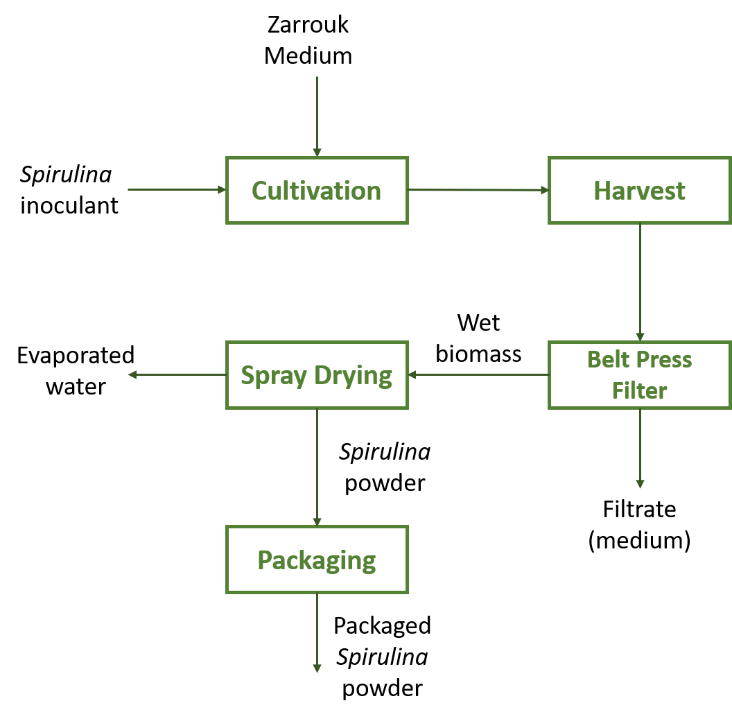
Figure 1: Process flow of Spirulina powder production.
The upstream process consists of biomass production using the scaled-up airlift photobioreactor, which will be operated at the same operating conditions as the batch culture in 3.1. These operating conditions were expected to produce 14,500 kg yr⁻¹ Spirulina powder at 70% biomass recovery.
The downstream process includes biomass harvesting, dewatering, drying, and packaging. Harvesting will be achieved through three stages of filtration. Continuous belt filters with decreasing mesh size will be used for this purpose. The final slurry was assumed to contain 20% solid content, which is the typical solid content after the belt filters (Vonshak, 1997). Freeze drying would be the best choice for drying the biomass, but it is expensive. Instead, a spray dryer will be used where the biomass is exposed to 60 °C heat for a few seconds as it falls to the bottom. No preservatives, additives, stabilizers nor irradiation are used in drying. The quick spray drying process guarantees preservation of heat sensitive nutrients, pigments, and enzymes. The powder exiting the dryer will be immediately vacuumed away to a collection hopper in the packaging drum and will be sealed under vacuum with special gas-barrier bags to minimize the oxidation of certain vital pigments like carotenoids.
The summary of the results of the preliminary techno-economic evaluation was presented in Table 1. According to Table 1, the total fixed capital investment is $ 382,520. With a net income of $60,340 per year, this cost will be recovered in 6.34 years. Furthermore, the net income is 7.14% of the total revenue. Since the profit margin is positive, we can say that the venture is feasible.
Table 1: Summary of preliminary techno-economic analysis of a continuous Spirulina powder production plant installed with 80-m³ photobioreactor total capacity.
Component | Amount
- Equipment Cost
Purchased Equipment | $ 146,000
Installation (50% of purchased equipment cost)ª | $ 73,000
Instrumentation (26% of purchased equipment cost) ª | $ 37,960
Piping (31% of purchased equipment cost) ª | $ 45,260
Total Equipment Cost | $ 302,220
- Building Cost (47% of total equipment cost) ª | $ 68,620
- Land Cost (8% of total equipment cost) ª | $ 11,680
- Fixed Capital Investment (A+B+C) | $ 382,520
- Raw Material Cost | $ 117,800
- Utilities | $ 107,700
- Labor | $ 423,360
- Supplies | $ 136,400
- Total Production Cost (E+F+G+H) | $ 785,260
- Revenue^{b} | $ 845,600
- Net Income (J – I) | $ 60,340
- Profit Margin | 7.14 %
- Payback Period | 6.34 y
ªPeters, Timmerhaus, and West (2003)
^{b}Selling price of Spirulina biomass is $58.3 per kg or €50 per kg (Piccolo, 2012)

Cost analysis revealed that labor cost is the major cost contributor. It consists 53.72% of the total production cost. This is followed by supplies cost (17.31%) then by raw material cost (14.94%). Utilities cost (14.03% of the total production cost) is the least among the cost components. This share in cost may change depending on the production capacity of the plant. The selling price used in this study is significantly higher than the minimum biomass selling price estimated by Clippinger and Davis (2019), which is equivalent to $1.91 per kg dry biomass for microalgae grown in horizontal helical tubular PBR. This is due to the large difference in the production capacities of the two studies. The production capacity in the report by Clippinger and Davis (2019) is 190,000 tons per year, but only 1,500 kg per year in the report by Piccolo (2012). This study adopted the selling price reported by Piccolo (2012) since the expected production capacity in this study is closer.
There are a few ways to reduce the cost of production. Water cost can be cut down by recycling it back to the photobioreactor. However, organic matter that remained in the medium may accumulate resulting to autoinhibition and lower biomass yield. Pre-filters and UV system in the RO unit may also be needed to prevent contamination. Power cost can be reduced by utilizing solar energy for the power requirement of the plant. But the additional capital investment requirement of the solar plant should be considered. Scaling up may also be beneficial due to economies of scale. But the PBR should be designed in such a way that light can still be efficiently utilized by a larger reactor. Internal lighting also adds constraint in scaling up. Many large chambers will be needed for larger reactors. Another possible modification in the design of the PBR is to consider the installation of an airlift evacuated head which was shown to improve liquid circulation (Marotta et al., 2017).

Sensitivity Analysis

Effect of Total PBR Capacity
Photobioreactor capacity is one of the major factors that affects project feasibility since equipment specifications, utilities, raw material, and supplies requirements will change with the capacity with or without change in the labor requirements. Other fixed capital requirements such land and buildings cost will also change accordingly.
For each photobioreactor capacity considered (40, 60, 80, 100, and 120 m³), the reactor’s dimensions and specifications were recalculated, and the number of light chambers were changed to maintain the surface-to-volume ratio of the photobioreactor. The equipment, raw material, utilities and supplies costs were recalculated based on the capacity. The Spirulina powder unit price of $58.3 per kilogram was maintained for all cases. It was found that profitability increases with photobioreactor capacity. The 120-m³ photobioreactor capacity has the most attractive financial indicators. It has the highest net income ($307,940), highest profit margin (24.28%), and shortest payback period (1.48 years). This is followed the 100-m³ total photobioreactor capacity ($182,740 net income, 17.29% profit margin, and 2.17 years payback period). The base case (80-m³ photobioreactor capacity) is also feasible ($57,640 net income, 6.82% profit margin, and 5.83 years payback period). Whereas the venture with 40-m³ and 60-m³ photobioreactor capacity are not feasible. These cases have net losses and negative profit margins. The payback period also cannot be computed due to negative net income.
It can be inferred from the results that increasing the photobioreactor capacity more than 100 m³ may result to better profitability. The only challenge in scaling up is in maintaining high surface-to-volume ratio. To do this, many internal light chambers will be needed. This will lead to higher fabrication and maintenance cost.

Effect of PBR Operating Conditions
Operating conditions also majorly affect project feasibility as these directly affect biomass yield. The sensitivity analysis was performed at the base case photobioreactor capacity (80 m³). Also, the highest light intensity (166 μmol m⁻² s⁻¹) and optimum aeration rate (0.3 vvm) were maintained. Only the initial biomass concentration (0.05, 0.10, and 0.20 g L⁻¹) was changed since this factor had a positive effect on final biomass concentration but a negative effect on specific growth rate based on the batch experiments (data not shown in this paper).
Results show that profitability increases with initial biomass concentration as a direct consequence of the increase in the final amount of Spirulina biomass produced. However, this result does not guarantee better profitability at even higher initial biomass concentration. The trade-off between the final biomass concentration and the specific growth rate must always be considered when working with higher initial biomass concentration at the same light intensity and aeration rate. For example, if a culture will be started at an initial biomass concentration higher than 0.20 g L⁻¹ at constant light intensity (166 μmol m⁻² s⁻¹) and aeration rate (0.3 vvm), the final biomass concentration may not be as high due to the lower specific growth rate than the one grown at lower initial biomass concentration. The culture may be photo-limited due to the lower photon dose per cell mass and the aeration rate may not be enough to lift the cells due to the higher population density. Further, the project is not feasible if the culture is to be grown at 0.05 g L⁻¹ and 0.10 g L⁻¹ initial biomass concentration.

Minimum Selling Price at Various Total PBR Capacity
The minimum selling price for each total photobioreactor capacity considered (40, 60, 80, 100, and 120 m³) was also determined. In this analysis, the minimum selling price is defined as the selling price in US dollar per kilogram of Spirulina powder that will result to zero net income such that a selling price lower than the minimum selling price will render the project not profitable.
Results show that the minimum selling price decreases with total photobioreactor capacity. In fact, the minimum selling prices when working at 40 m³ and 60 m³ total PBR capacities, respectively, are $30.46 kg⁻¹ and $10.17 kg⁻¹, more expensive than the base case ($54.34 kg⁻¹ at 80 m³ total PBR capacity). At 100 m³ and 120 m³ total PBR capacities, the minimum selling prices, respectively, are $6.12 kg⁻¹ and $10.20 kg⁻¹ cheaper than the base case. It must be noted that these selling prices are only applicable for 166 μmol m⁻² s⁻¹ light intensity, 0.3 vvm aeration rate, and 0.20 g L⁻¹ initial biomass concentration. Minimum selling price may be different for different operating conditions since the overall biomass yield will also be different.
  - Conclusions
The preliminary techno-economic evaluation on a Spirulina powder production plant with a total photobioreactor capacity of 80-m³ revealed an attractive venture since net profit and profit margin are positive and the payback period is only 6.34 years. It should be noted, however, that these values are true only for the operating conditions considered in the study. Different operating conditions may give different results since the biomass productivity is directly affected.
In the sensitivity analysis, it was found that profitability increases with photobioreactor capacity. But the challenge in scaling up the reactor is in maintaining the surface-to-volume ratio which can easily be achieved in smaller reactors. It was also found that, at the operating conditions considered, profitability increases with initial biomass concentration as a direct consequence of the increase in the final amount of Spirulina biomass produced. The minimum selling price can also be reduced by increasing the reactor capacity.

Nomenclature
$X$ = biomass concentration (g l⁻¹) at time, t
$X_{o}$ = initial biomass concentration (g l⁻¹)
$X_{f}$ = final biomass concentration (g l⁻¹)
$μ$ = specific growth rate (d⁻¹)
$t$ = time (d)
$t_{o}$ = initial time (d)
$t_{f}$ = final time (d)

References
Acién F.G., Molina E., Reis A., Torzillo G., Zittelli G.C., Sepúlveda C., Masojídek J., 2017, Photobioreactors for the Production of Microalgae, Microalgae-Based Biofuels and Bioproducts, 1-44, https://doi.org/10.1016/B978-0-08-101023-5.00001-7.
Bataller B.G., Capareda S.C., 2018, A Rapid and Non-Destructive Method for Quantifying Biomolecules in Spirulina Platensis via Fourier Transform Infrared – Attenuated Total Reflectance Spectroscopy, Algal Research, 32, 341-352.
Bataller B.G., Capareda S.C., 2020, Use of FTIR Spectroscopy and PLS-Regression in Monitoring Biomolecules in Spirulina platensis during its Growth in an Internally-Illuminated Photobioreactor, Chemical Engineering Transactions, 80, 103-108.
Clippinger J., Davis R., 2019, Techno-Economic Analysis for the Production of Algal Biomass via Closed Photobioreactors: Future Cost Potential Evaluated Across a Range of Cultivation System Designs, Technical Report NREL/TP-5100-72716, National Renewable Energy Laboratory, https://www.nrel.gov/docs/fy19osti/72716.pdf.
Cuaresma M., Janssen M., Vílchez C., Wijffels R.H., 2011, Horizontal or vertical photobioreactors? How to improve microalgae photosynthetic efficiency, Bioresour. Technol., 102(8), 5129–5137.
Eriksen N.T., 2008, The technology of microalgal culturing, Biotechnol. Lett., 30(9), 1525–1536.
Huang Q., Jiang F., Wang L., Yang C., 2017, Design of Photobioreactors for Mass Cultivation of Photosynthetic Organisms, Engineering, 3, 318-329.
Hwang S.J., Cheng Y.L., 1997, Gas holdup and liquid velocity in in three-phase internal-loop airlift reactors, Chem. Eng. Sci., 52(21–22), 3949–3960.
Marotta G., Scargiali F., Lima S., Caputo G., Grisafi F., Brucato A., 2017, Vacuum Air-lift Bioreactor for Microalgae Production, Chemical Engineering Transactions, 57, 925-929.
Oncel S., Sukan F.V., 2008, Comparison of two different pneumatically mixed column photobioreactors for the cultivation of Artrospira platensis (Spirulina platensis), Bioresour. Technol., 99(11), 4755–4760.
Peters M.S., Timmerhaus K.D., West R.E., 2003, Plant Design and Economics for Chemical Engineers, 5th ed, New York: McGraw-Hill.
Piccolo A., 2012, Spirulina a livelihood and a business venture, www.fao.org/3/a-az386e.pdf.
Singh R.N., Sharma S., 2012, Development of suitable photobioreactor for algae production - A review, Renew. Sustain. Energy Rev., 16(4), 2347–2353.
Taisir M., Teo C.L., Idris A., Yusuf A.M., 2016, Cultivation of Nannochloropsis sp. using narrow beam angle light emitting diode in an internally illuminated photobioreactor, Bioresources and Bioprocessing, 3:35, 1-8.
Ugwu C.U., Aoyagi H., Uchiyama H., 2008, Photobioreactors for mass cultivation of algae, Bioresource Technology, 99(10), 4021-4028.
Vonshak A., 1997, Spirulina platensis (Arthrospira): Physiology, Cell Biology and Biotechnology, London:Taylor & Francis.
Wang B., Lan C.Q., and Horsman M., 2012, Closed photobioreactors for production of microalgal biomasses, Biotechnol. Adv., 30(4), 904–912.
Yustinadiar N., Manurung R., Suantika G., 2020, Enhanced biomass productivity of microalgae Nannochloropsis sp. in an airlift photobioreactor using low-frequency flashing light with blue LED, Bioresources and Bioprocessing, 7:43, 1-15.

