 CHEMICAL ENGINEERING TRANSACTIONS  VOL. 92, 2022 | A publication of  
The Italian Association
of Chemical Engineering
Online at www.cetjournal.it

Guest Editors: Rubens Maciel Filho, Eliseo Ranzi, Leonardo Tognotti
Copyright © 2022, AIDIC Servizi S.r.l.
ISBN 978-88-95608-90-7; ISSN 2283-9216

PERFORMANCES OF A BIOMASS POWERED MICRO-CHP SYSTEM IN A DEMONSTRATIVE ENVIRONMENT
M.A. Costagliolaª, G. Di Blasioª, R. Iannielloª, G.Martoriello^{a*}, M.V. Pratiª, G. Ruoppoloª, M.Urciuoloª
ªCNR – Istituto di Scienze e Tecnologie per l’Energia e la Mobilità Sostenibili, Dipartimento di Ingegneria, Viale Marconi, 4, 80125 Naples,
* g.martoriello@im.cnr.it
A viable solution for residual biomass exploitation to reduce the cost related to biomass disposal and simultaneously create profit by electrical and thermal energy use is combined heat and power generation over the micro-scale of power (m-CHP) based on biomass gasification. The exploitation and improvement of these systems were the main objectives of the Italian project “PROMETEO – Production of electrical, thermal and cooling energy with m-CHP fueled by residual biomass”, funded by the local Ministry of Economic Development (MISE). The present work shows an extended experimental activity based on a 20kW micro-cogeneration system as powered by two types of residual lignocellulosic biomasses briquettes in a demonstrative environment site identified in a waste management and storage plant in the Municipality of Mugnano, Naples, in the south of Italy. The m-CHP plant is made of a gasifier, a syngas cleaning circuit and a spark ignition (SI) internal combustion engine (ICE) connected to an electric-generator. The electrical output was meant to power the plant machines for the operations of waste storage. For both biomasses, tests were conducted for the complete characterization of the system in low and medium load and in different spark ignition timing to assess the system sensitivity. The m-CHP performance was investigated with a complete characterization of the syngas and tar compositions, main pollutant emissions and internal combustion engine analyses, aimed at the evaluation of the energetic and environmental efficiencies. An analysis of the air quality near the site by evaluating CO, O₃, NO₂, C₆H₆ and PM10 concentration was also carried out. The ultimate purpose of the present work is the demonstration of the advantages of the employment of biomass-powered cogeneration systems in the Mediterranean regions.
Introduction
Modern bioenergy is currently the largest renewable energy source, with a share in final energy consumption five times greater than wind and solar PV combined (Frankl, 2017). Because of its broad availability, woody biomass has gotten a lot of interest, especially if gasification is involved, even though itis only been used for energy production in a few places so far. Biomass derived syngas is a low-energy and adaptable fuel gas that can be used in spark ignition internal combustion engines (ICEs) (Costa et al., 2020) that were designed to run on gasoline or diesel fuels to decrease or eliminate the need for petroleum-based fuels. Lund’s paper (Lund, 2014) shows an analysis of smart energy systems synergies, highlighting the possible infrastructures for biomass to energy systems and the use of gasification in the cogeneration technology. The exploitation of electrical generation employing a syngas-powered engine in combined heat and power assets can be used in both the developed and developing countries to reduce greenhouse gas emissions and to provide electricity in rural locations where biomass is normally available. The main goal of this work is to show the benefits of using biomass-powered air cogeneration systems in Mediterranean regions as part of biomass-to-energy chains that can be set up in rural areas and to serve municipalities that need to dispose of green waste from pruning and maintenance operations.
Experimental layout
A micro-cogeneration system based on biomass gasification, whose description and main specification are reported in ref. (Costa et al., 2020), was characterized in a demonstrative environment aiming at concretely verifying the sustainability of whole biomass-to-energy chains and understanding its viability as a green energy system in a waste management and storage plant. The micro-cogeneration plant is made of a gasifier, a syngas cleaning circuit and a spark ignition ICE connected to an electric generator. Gasifycation agents is air with an equivalence ratio – the ratio between gasifyication agents-to-biomass to their stoichiometric mixture – of 0.3. Compared to steam gasification (Stark et al., 2019), air gasification is a cheaper but less efficient alternative, leading to a syngas with a high percentage of nitrogen (>45%) that reduce the overall LHV. Figure 1a shows the experimental setup. The properties of biomasses were determined by means of proximate analysis (TGA 701 LECO thermogravimetric analyzer), ultimate analysis (CHN 628 LECO analyzer; SC 144 DR LECO analyzer). All the analyses were performed in triplicate at least. The analysis of syngas composition is made by online measurement (O₂, CO, CO₂, CH₄ and H₂) by Vario Luxx analyser and an off-line sampling in Tedlar bags the stream which is subsequently analyzed through a by a micro gas chromatograph (micro-GC) (Agilent 3000A) providing the concentration of light hydrocarbons (CxHy). The syngas sampling (Figure 1b) was performed with a probe heated to 463K, positioned on the syngas supply duct to the engine. Before the analysis, the syngas was forced to pass through a quartz fiber filter, to restrain any solid particles and then to a double condensation stage: (the first happens at room temperature, and the second stage at about 273 K) to condense the tar and to perform its quantification weighting the condensation train before and after the sampling. The experimental setup used for the analysis of the tar concentration is shown in Figure 1d. Exhaust gases composition is analyzed through a direct measurement with Sensors Semtech analyzer. The analysis system is equipped with a NDIR infrared absorption analyzer to measure CO, CO₂, a Non-Dispersive Ultra-Violet (NDUV) detector for NO/NO₂ measurement and an electrochemical sensor for O₂. A volumetric flow meter (0-4.96 m³/min) was also installed (Figure 1c), operating using the Pitot principle. The exhaust gas temperature was measured near the exhaust gas flow measurement section. An NOx/O₂ sensor (Continental UniNOx) was also mounted.
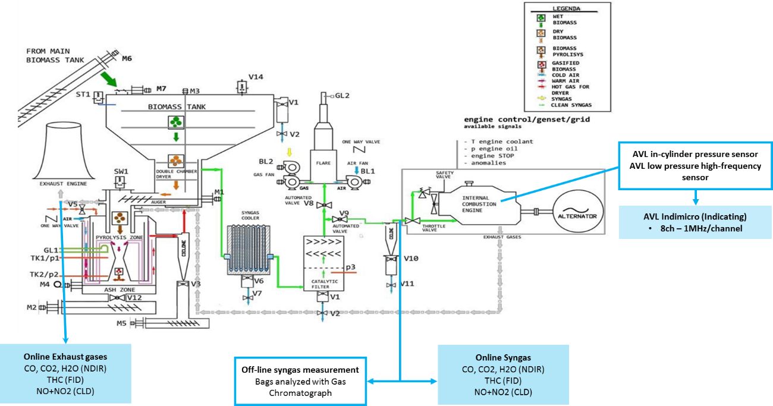
a)
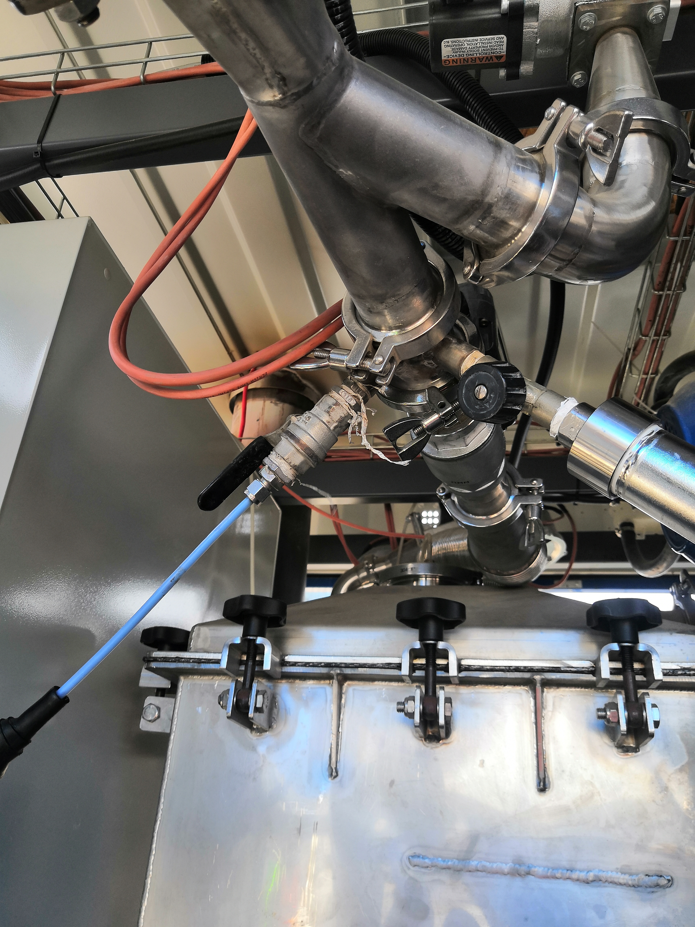 | 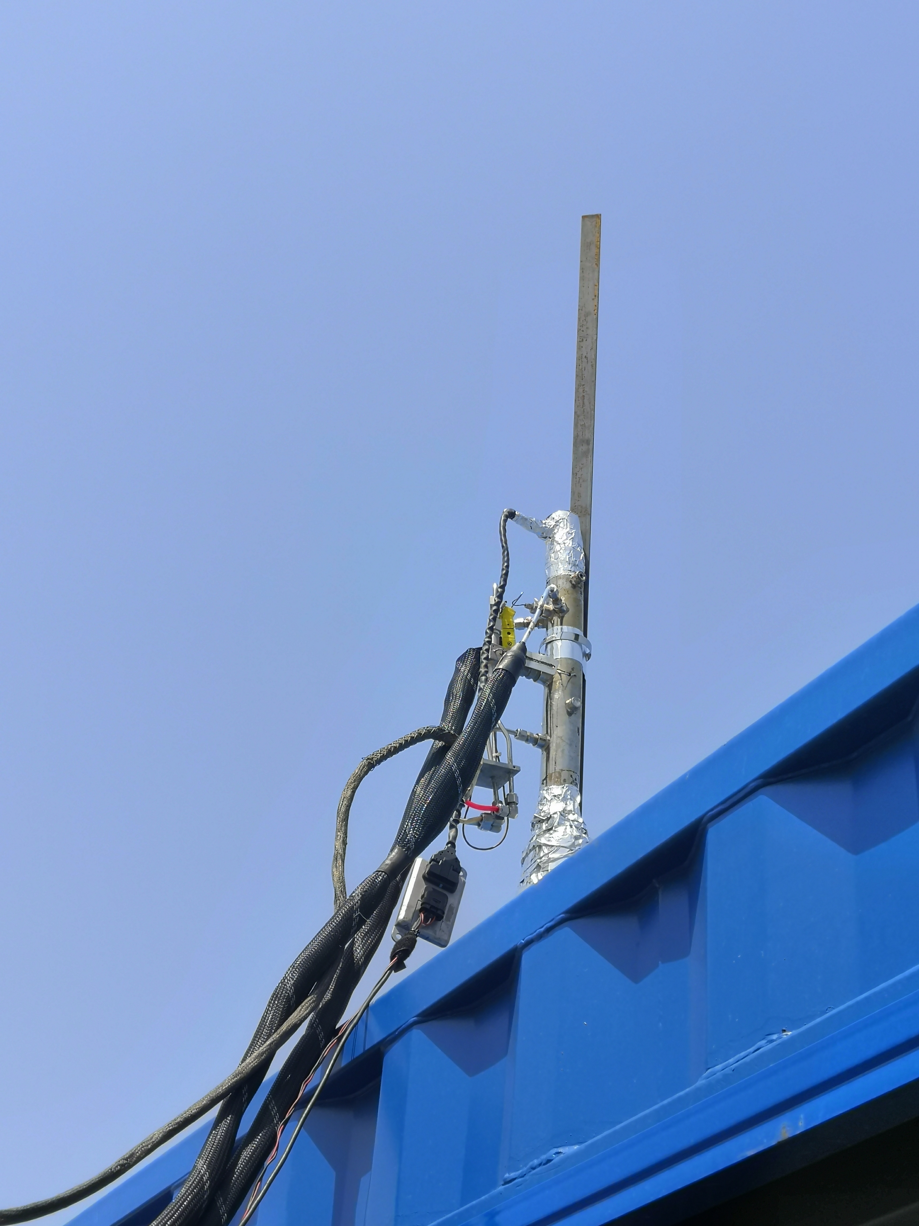 | 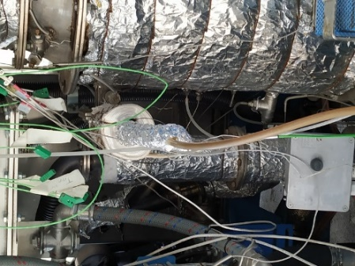
b) | c) | d)
Figure 1: Experimental setup(a), probe for syngas sampling (b), duct for exhaust volumetric flow meter (c) and quartz fiber filter (d)
In order to measure the ICE indicated pressure cycle, the engine was equipped with properly defined and/or designed sensors, specialized for non-traditional gaseous fuels:
- a spark plug relative pressure sensor, type AVL ZI45-F5D, for the high-frequency measurement of the indicated pressure cycle, placed in the spark-plug seat, based on the piezo-quartz principle, very precise and robust;
- a low-pressure absolute sensor, type AVL LP12DA-05, for the high-frequency measurement of the dynamic pressure in the intake duct, necessary for referencing the indicated pressure cycle, based on the piezo-resistive principle. It was placed in a proper realized threatened hole in the intake runner.
A multiparametric station (ETL-One) with Unitec SENS-IT technology for continuous gas and dust monitoring was hired from the Orion company for air quality assessment analysis of the micro-cogeneration system installed in the waste management and storage plant of Mugnano, Napoli. The experimental campaign was performed in two days, during which the prevailing wind is was a wind that blew from the SOUTH-WEST. Therefore, the monitoring station was located in a NORTH, NORTH-EAST position related to the location of the plant in order to be downwind of the polluting emissions.
Results
Table 1 reports the proximate and ultimate analysis of the used feedstocks: sawdust (Biomass 1) and straw (Biomass 2) while Table 2 shows the average syngas compositions and the tar concentration. As aforementioned, the nitrogen percentage higher than 45% is due to air used as the gasifier agent.The ultimate analysis of the two feedstocks is similar to each other, except for the greater nitrogen concentration observed in sawdust. A higher presence of ash and moisture in the Biomass 2, which is slightly over the systems’ limits has been also evidenced. Syngas compositions do not differ much; lower heating values and stoichiometric ratios are comparable even if tar concentration obtained using the Biomass 2 is three times higher than that obtained for Biomass 1. Despite that, the cleaning circuit ran well, as no plant stop is noticed during both days.

Table 1: Biomass proximate and ultimate analyses
 | Biomass 1 | Biomass 2
Proximate Analysis (%)
Moisture | 7.2 | 23.9
Ash | 2.5 | 5.1
Fixed Carbon | 18.0 | 14.1
Volatile matter | 72.3 | 57.0
Ultimate Analysis (%) ash and moisture free
C | 48.1 | 46.7
N | 4.5 | 0.2
O | 41.4 | 46.7
H | 6.0 | 6.3

Table 3: Engine operating condition test matrix
Load | kWe | Spark Advance (°CAD) | λ (-)
L | 4-6 | -20 | 1.03
M | 14-15 | -15, -20  -25, -30 | 1.03

Table 2: Syngas compositions and lower heating values
 | Biomass 1 | Biomass 2
O₂ (%vol) | 1.64 | 1.26
CO₂ (%vol) | 11.48 | 12.02
CO (%vol) | 18.77 | 18.35
H₂S (ppm) | 9.65 | 12.82
CH₄ (%vol) | 2.05 | 1.82
H₂ (%vol) | 16.74 | 16.94
N₂ (%vol) | 49.32 | 49.61
LHV (MJ/kg) | 4.21 | 4.13
α_{st} | 1.45 | 1.42
Tar concentration (g/m³) | 2.13 | 8.57

Table 3 reports the engine operating condition test matrix adopted for both biomasses. It should be noted that the table shows a range of load, low or medium, due to the variability of load required by plant machines for the operations of waste storage during the execution of the experimental tests. Figure 2 shows the exhaust mass flow (a) and temperature (b) of both feedstocks. No difference between sawdust and straw arises for exhaust mass flow ratio, which appears to not be influenced by the initial feedstock. Biomass 2 presents a slightly higher exhaust temperature than Biomass 1 for medium load and a spark advance of -20 ° CAD. However, these values remain in the range of effective exhaust temperature for the reduction of CO emissions, as they indicate temperature higher than 250°C and lower than 650°C in the after-treatment system. An extreme exhaust temperature, indeed, could destroy the catalytic converter. The measured emission species are summarized in Figure 3. The emissions have been recalculated on a wet basis as required by the Italian legislation Dlgs. 11/15/2017, no. 183 – Fixed engine in cogenerative asset (D.lgs. n. 183). In the M load condition and -15 °CAD spark advance, a high variability is found in the determination of CO due to a sudden and fast load variation, so the data were recalculated only in the times with a fairly constant load condition.
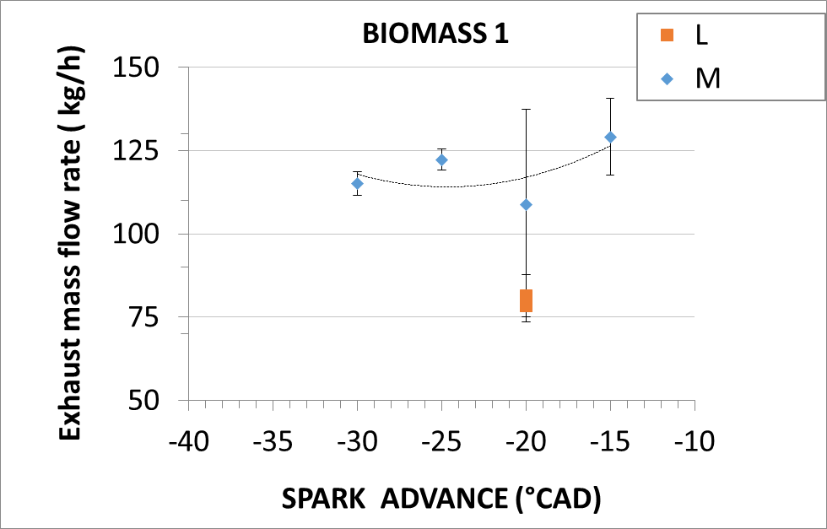 | 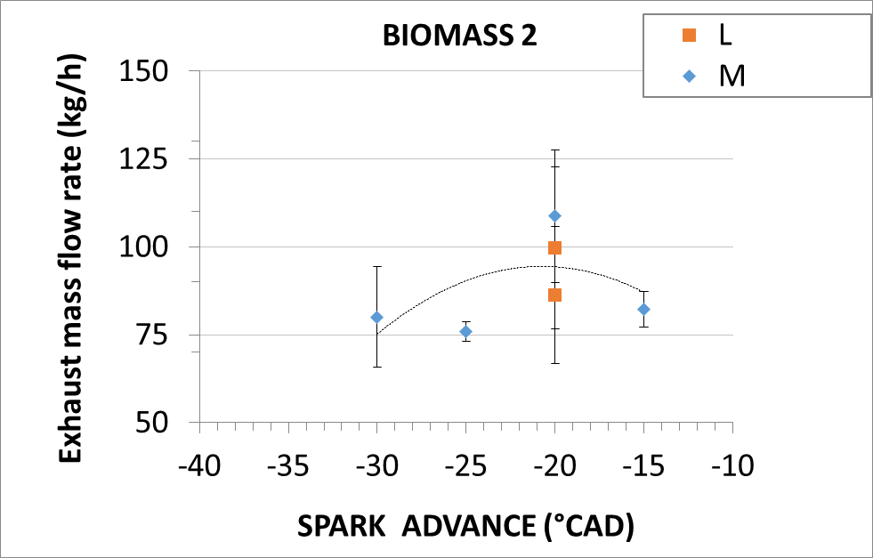
a)
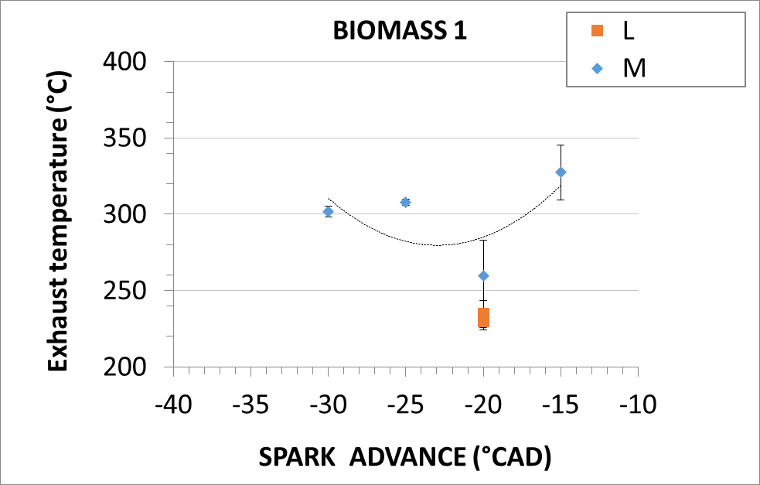 | 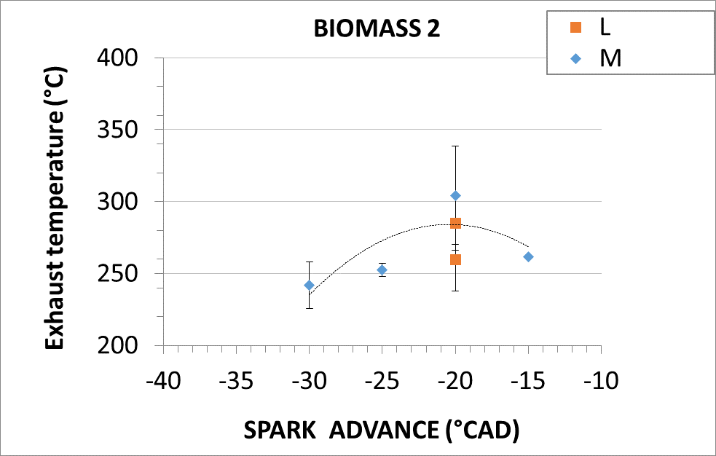
b)
Figure 2: Exhaust mass flow rate (a), temperature (b) for both processed feedstocks.
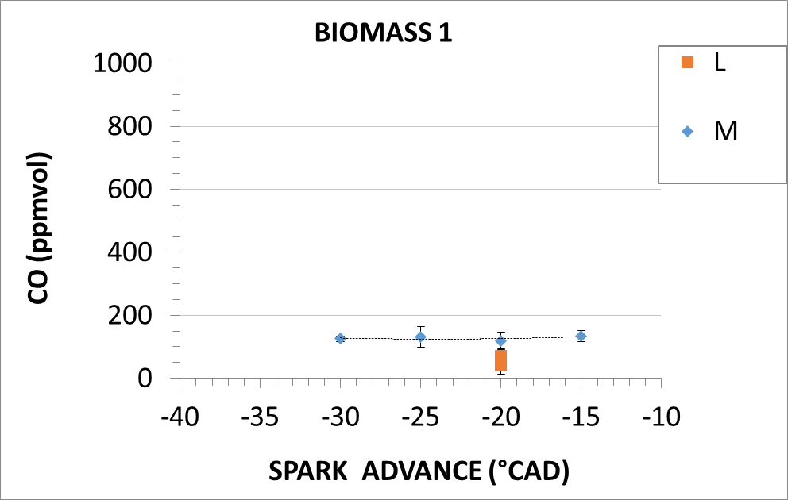 | 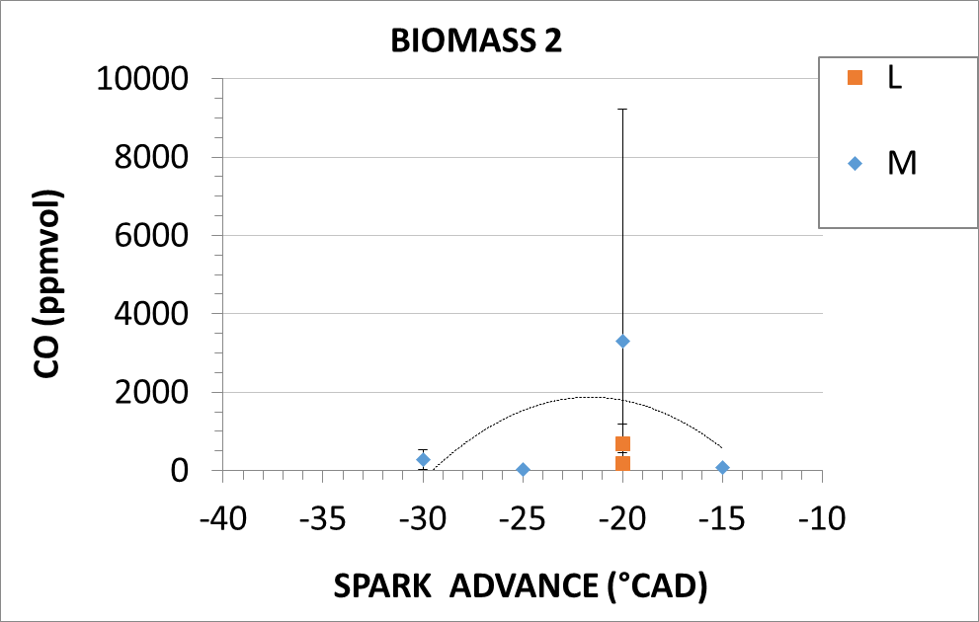
a)
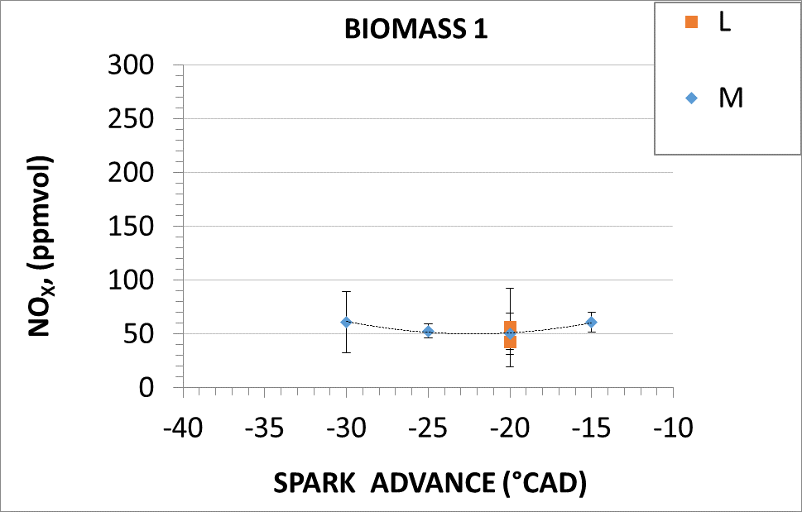 | 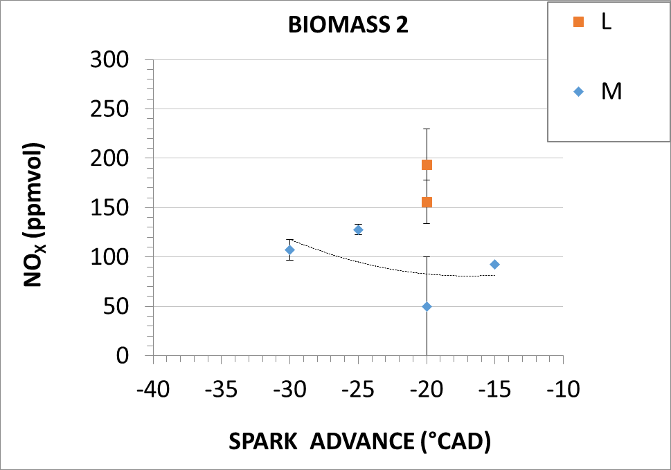
b)
Figure 3: CO (a) and NOx (b) for both processed feedstocks.
CO and NOx concentrations are not particularly variable with the ignition advance. For Biomass 1 CO and NOX emissions are below 70 mg/m³ in all tested conditions, below the limits set by Dlgs. no. 183. Even in the most critical condition for CO, which occurred at M load and advance -15 ° with a sudden load variation, the CO remains below the limits. It should be noted that on the Biomass 2 test day there was a concurrence with a small fire in a close area (south) which influenced the air quality assessment (in terms of CO) and, therefore, also the air sucked by the system itself. Furthermore, there were problems on the lambda control which in some conditions dropped to 0.9. In the conducted analyses, it is not always possible to filter the data to eliminate these effects. This is highlighted in the Biomass 2 CO emission that presents high variability and, in some cases, also overtakes Italian limits. NOx for Biomass 2 was always below limits.
Engine sensibility analysis
The following analysis show the engine response varying biomasses, loads and spark timing. Figure 4 shows the trend of the Mean Indicated Pressure (IMEP), covariance of the IMEP (IMEP_{COV}), the maximum pressure (P_{max}), the combustion phasing (MFB50), and the combustion duration (MFB10-90) calculated from the measured pressure curve in the combustion chamber. MFB50 is defined as the crank angle in which 50% of the fuel is burned. MFB10-90 is the crank angle interval between 10% and 90% of the burned fuel mass. The IMEP values fluctuate in the range 1-1.5 bar with a maximum pressure value of about 10 bar, and due to the electrical real-time request from the municipal site. As regards the IMEP_{COV}, as well as the MFB50 and the MFB10-90, an important variability is highlighted. They vary due to the non-constant syngas composition. Indeed, the covariance, which is indicative of the combustion stability, oscillates between 8-12% for Biomass 1 and 10-13% for Biomass 2, much higher values compared to automotive or natural gases applications, whose maximum values set about 5% (Heywood, 2018). This instability is partially transferred to MBF10-90 and MBF50 values, which highlights a more delayed combustion phase in low loads.
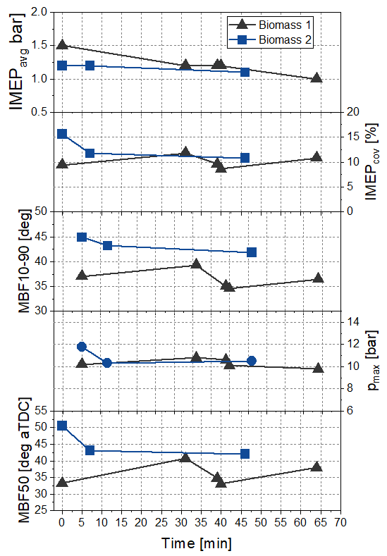 |  | 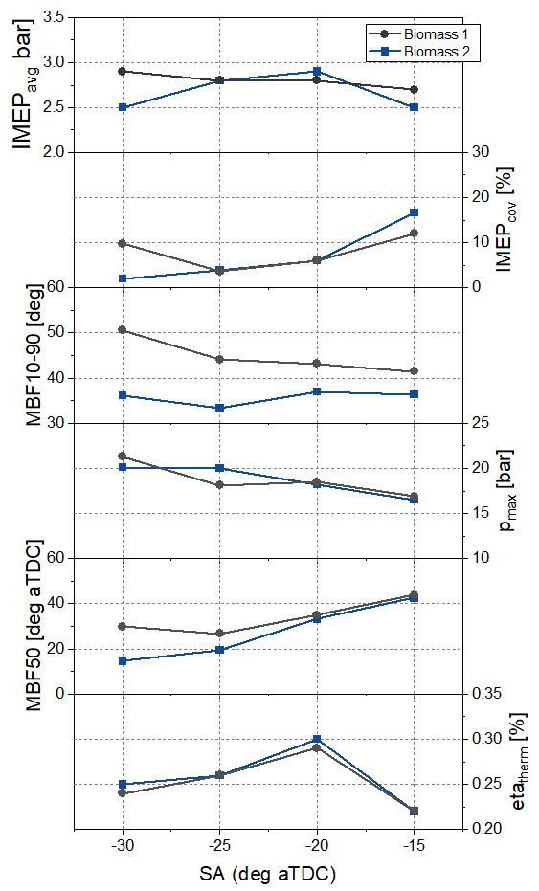
Low load | Medium load
Figure 4: IMEP, IMEP_{COV}, Pmax, MFB50 and MFB10-90 for both biomasses (low and medium load).
For the medium load condition, the thermodynamic efficiency trends, and the combustion main parameters at the different start of spark are shown in Figure 4 (on the right). There are no radical differences between the two fuels; the thermodynamic efficiencies are in line with those present in the literature (Caputo et al., 2019; Costa et al., 2020). Thermodynamic efficiency is sensitive to the ignition advance and has an optimal value for both biomasses for values around 20 crank angle degrees aTDC. This demonstrates the optimal calibration obtained by both numerical models and experimental measurement. The IMEP values for Biomass 2 are less sensitive to the variation of the spark advance. Indeed, a rather flat trend is observed. Combustion stability, on the other hand, is markedly sensitive to early ignitions, with values almost in line with the previous case (sawdust), except for the most anticipated case. Regarding the maximum peak pressure, values and trends between the two fuels are aligned. MFB50 is in line with the low load cases. Syngas deriving from Biomass 1 presents a higher burn duration than Biomass 1 for all spark advances.
Air assessment analysis
The air quality assessment analysis is carried out for both test days and ETL-One is leaved in its position overnight, with the system shut off, to have the full-scale measurement to understand the effect of the installation of the micro-cogeneration system in the area. The hourly average concentrations of carbon monoxide (CO), nitrogen dioxide (NO₂), benzene (C₆H₆), ozone (O₃) and dust (PM10) are obtained for both test days.The following Table 4 shows the hourly average measured concentrations measured in μg/m³. A conclusion that can be drawn in relation to the environmental impact of the CMD ECO20x mCHP system, it seems not to influence the air quality.
Table 4: Air quality assessment during the two test days and full-scale measurement.
- | CO (μg/m³) | NO₂ (μg/m³) | C₆H₆ (μg/m³) | O₃ (μg/m³) | PM10 (μg/m³)
Biomass 1 test day | 350 | 44.2 | 0.50 | 97.6 | 15.30
Biomass 2 test day | 1150 | 67.0 | 0.60 | 26.4 | 1,5
Full-scale | 300÷1700 | 37÷100 | 0.3÷2,9 | 6÷95 | 0.6÷22
Limit (D.lgs. n. 155)  (Sampling time) | 10000  (8h Moving average) | 200  (1h) | 5  (1year) | - | 50  (24h)
Conclusions
The experimental analysis of a micro-combined heat and power generation unit powered by biomass is discussed to estimate the effects of different feedstocks in terms of overall performances and reliable operation and the possibility of employment in a waste management and storage system in the locality of Mugnano, Naples, Italy. The strict link between feedstock composition and ICE performance in terms of efficiency, tar quantity and emissions are found to underline the possibility of using biomass-based microcogeneration plant in a real demonstrative environment. The here analysed system is shown to be a versatile plant as different biomasses can be processed. Through the proposed analysis, the following considerations could be drawn:
- Biomass composition influences tar percentages in syngas sampling;
- CO and NOx emissions are below limits when ICE syngas-air mixture is lean.
- Engine performance and operative conditions are reliable regardless of the initial feedstocks.
- The micro-cogeneration system does not have an impact on the air quality.
The described methodology is universal and can show the potentiality of micro cogeneration system based on biomass gasification.
Acknowledgments
Authors gratefully acknowledge the financial support of project PROMETEO - Production of electrical, thermal and cooling energy with m-CHP fueled by residual biomass - by the Italian Ministry of Economic Development (MISE). A particular greeting goes to the Costruzioni Motori Diesel S.p.A. and eng. Domenico Cirillo, for their supports to the experimental work by using their micro-cogeneration system, the CMD ECO20x.
References
Bates, R. and Dölle, K. (2017) ‘Syngas Use in Internal Combustion Engines - A Review’, Advances in Research, 10(1), pp. 1–8. doi:10.9734/AIR/2017/32896.
Caputo, C. et al. (2019) Multi-Level Modeling of Real Syngas Combustion in a Spark Ignition Engine and Experimental Validation. SAE Technical Paper 2019-24–0012. Warrendale, PA: SAE International. doi:10.4271/2019-24-0012.
Costa, M. et al. (2020) ‘Multi-objective optimization of a syngas powered reciprocating engine equipping a combined heat and power unit’, Applied Energy, 275, p. 115418. doi:10.1016/j.apenergy.2020.115418.
Italian Legislation, Dlgs 13 agosto 2010, n. 155 - Normattiva [Online], https://www.normattiva.it/uri-res/N2Ls?urn:nir:stato:decreto.legislativo:2010;155 , 2010 (accessed 1.9.22) - Italy.
Italian Legislation, Dlgs 15 novembre 2017, n. 183 - [Online] https://www.normattiva.it/uri-res/N2Ls?urn:nir:stato:decreto.legislativo:2017-11-15;183 , 2017 (accessed 11.12.21) - Italy.
Frankl, P., (2017). IEA Technology Roadmap: The need to scale up sustainable bioenergy.
Heywood, J.B. (2018) Internal Combustion Engine Fundamentals. McGraw-Hill Education. Available at: https://www.accessengineeringlibrary.com/content/book/9781260116106 (Accessed: 20 December 2021).
Lund, H., (2014).”Renewable energy systems: a smart energy systems approach to the choice and modeling of 100% renewable solutions”. Chemical Engineering Transaction. doi: https://doi.org/10.3303/CET1439001 2014.
Stark, M., et al. (2019) "Design Parameters of Steam Accumulators for the Utilization in Industrial Solid Biomass-Fuelled CHP Plants." CHEMICAL ENGINEERING, 76. doi: https://doi.org/10.3303/CET1976137

